Supplementary Fig. 1. Sample preparation.
A: The prostate specimen from RP (black lines indicate the resected parts for cryosections). B: The prostate specimen was cut from base to apex and perpendicular to the long axis of the urethra. C: Every 2nd slice of the specimen was fixed in a sealed plastic bag filled with 10% neutral-buffered formalin for ARG.
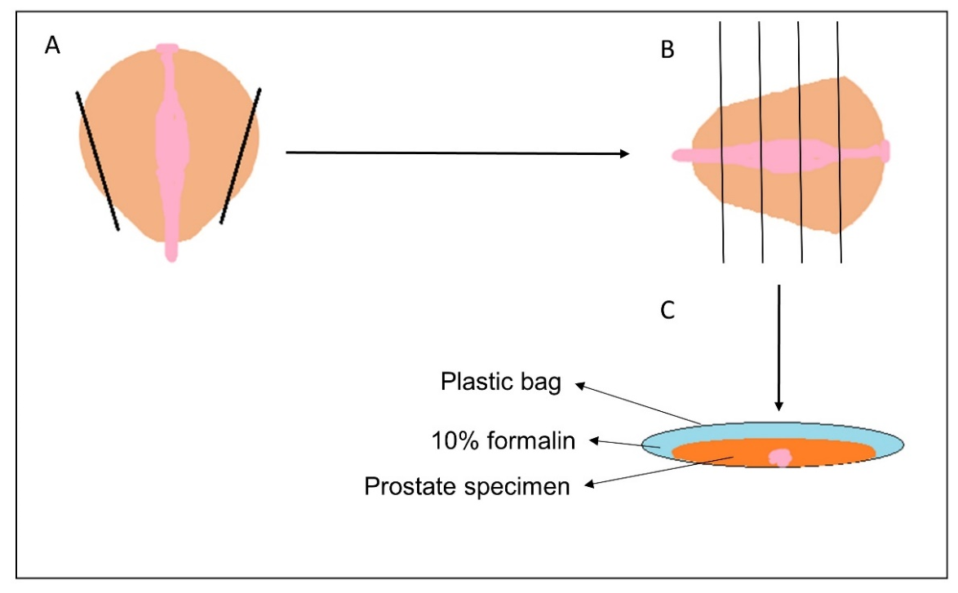

Supplementary Fig. 2. Schematic diagram of ARG for in vivo PSMA-ligand uptake analysis.
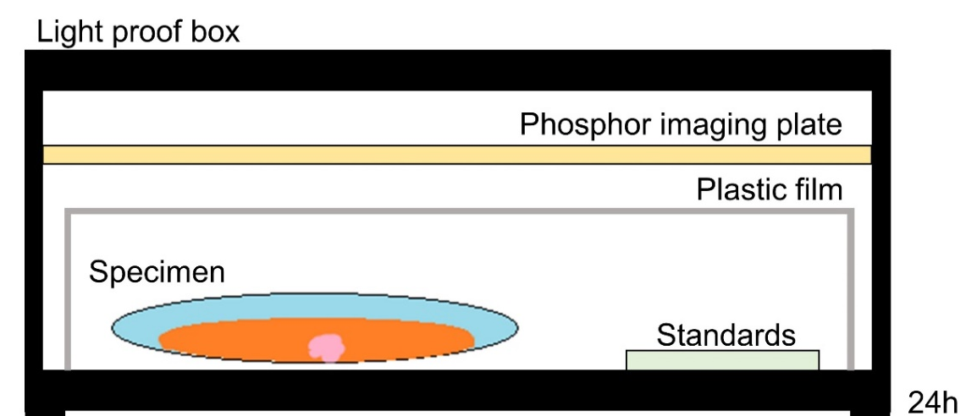

Supplementary Fig. 3. Representative tissue samples for ARG. Black star standards.
