Supplementary Materials
Title: Personalized functional network mapping for typical neurodevelopmental disorders
Jiang Zhang^{1,2}, Zhiwei Zhang¹, Yingzi Ma^{3,4}, Jing Su^{3,4}, Jia Yang^{3,4}, Kexuan Chen⁵, Xiaohui Yu^{3,4}, Futing Yang^{3,4}, Tianyu Zhao¹, Jingyue Zhang¹, Congying Chu⁶, Jiaojian Wang^{3,4*}
Figure S1. The schematic diagram for Nonnegative Matrix Factorization (NMF) analysis in this study.
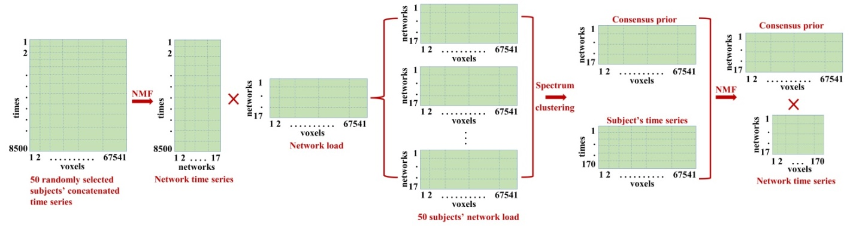
Figure S2. The similarities between original and reconstructed signals for the 17 functional networks.

Figure S3. Voxel-wise individual variability of the 17 functional networks across all the subjects.
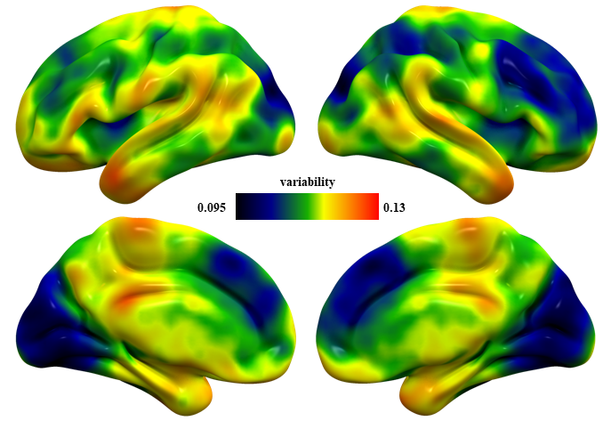
Figure S4. Correlations analyses between changed neuroimaging measurements and clinical performances.
Materials and Methods
Network attributes calculation
Degree is the index to analyze the connection of different nodes and is defined as the number of edges that connect to nodes directly. Clustering coefficient implies the local information transmitting ability of networks, measuring the degree of network collectivization, defined as:
$$C_{i}=\frac{2E_{i}}{K_{i}(K_{i}-1)}$$
where $K_{i}$ is the number of edges that connect to nodes directly, and $E_{i}$ is the number of edges i that truly connect to its neighbors.
Since the clustering coefficient only consider the connection between neighbors, we also calculate the local efficiency which is the measurement of local information transmitting in the network, defined as:
$$E\left(i\right)=\frac{1}{N_{G_{i}}(N_{G_{i}}-1)}\sum_{j≠k∈G_{i}}{\frac{1}{l_{j,k}}}$$
where $G_{i}$ is the sub-graph constructed by the neighbors of node i. $l_{j,k}$ is the shortest path length of node j and k. The local efficiency of a network is the mean of all nodes’ local efficiency, the local efficiency of node i is defined as:
$$E_{local}=\frac{1}{N}\sum_{i∈V}{E(i)}$$
Shortest path length is the length of a path which have minimum edges, defined as:
$$L=\frac{1}{N(N-1)}\sum_{i,j∈V,i≠j}{l_{ij}}$$
Global efficiency is the measurement of global information transmission in the network, defined as:
$$E_{global}=\frac{1}{N(N-1)}\sum_{i,j∈V,i≠j}{\frac{1}{l_{ij}}}$$
Betweenness centrality can measure the function and status of a node, defined as:
$$N_{bc}\left(i\right)=\sum_{j≠i≠k∈G}{\frac{σ_{jk}(i)}{σ_{jk}}}$$
where $σ_{jk}$ is the number of shortest paths of node j to node k, and $σ_{jk}(i)$ is the number of these path passing node i.
The conception of the small world was introduced by Watts DJ and Strogatz SH who insisted small world is a network between a random network and regularized network and has a smaller mean path length and higher clust efficiency. The former study demonstrated that the small-world networks offer a structural substrate for functional segregation and integration of the brain and facilitate rapid adaptive reconfiguration of neuronal assemblies in support of changing cognitive states(Liu et al., 2008). The small-world property consists of 3 sub-properties:$γ$, $λ$, and $σ$. $γ$ indicates the ratio of the clustering coefficients in real and random network, while $λ$ indicates the ratio of the path length in real and random networks and $γ$ indicates the scalar measurement of small-world network. These properties can be defined by clustering coefficients as:
$$γ=\frac{C_{p}}{C_{r}}$$
$$λ=\frac{L_{p}}{L_{r}}$$
$$σ=\frac{γ}{λ}$$
where $C_{p}$ is the research network, $C_{r}$ is the random network, $L_{p}$ is the research network from the average path length, $L_{r}$ is the random network from the average path length, $γ$ reflects the change in the real brain network to the random network, and $λ$ reflects the change in the real brain network to the regular network.
Differences in node- and edge-wise network topology
To determine the node-wise and edge-wise network topology differences, graph-theory based complex brain network analysis was performed for TD, ASD, ADHD-Combined, and ADHD-Inattentive. For node-wise network topological characteristics, ADHD-Combined has a larger Gamma value compared to TD while no significant differences in Gamma were found between other groups. Both ADHD-Combined and ADHD-Inattentive have larger Lambda compared to TD while no significant differences in Lambda were found between other groups. For Sigma, only ADHD-Combined showed larger Sigma compared to TD. In addition to small worldness, all ASD, ADHD-Combined, and ADHD-Inattentive showed reduced network global efficiency compared to TD whereas no significant differences were found among ASD, ADHD-Combined, and ADHD-Inattentive (Figure 2A).
For edge-wise network topological properties, all ASD, ADHD-Combined, and ADHD-Inattentive showed increased Gamma, Lambda, clustering coefficient, and shortest path length compared to TD, while there were no significant differences among ASD, ADHD-Combined, and ADHD-Inattentive. Both ADHD-Combined and ADHD-Inattentive showed higher Sigma than TD while no significant differences between ASD and TD, and among ASD, ADHD-Combined, and ADHD-Inattentive were found (Figure 2B).
In addition to network global topological differences, node-wise and edge-wise local topological differences were also found. Subjects with ASD, ADHD-Combined, and ADHD-Inattentive have significantly increased local efficiency and clustering coefficient of networks of DMN-1, VIS-1 and VIS-2 compared to TD. ADHD-Inattentive also showed increased local efficiency of network of VIS-2 compared to ADHD-Combined. Individuals with ADHD-Combined showed increased local efficiency of networks of LMB-1 and CR compared to TD. Subjects with ASD and ADHD-Combined exhibited higher clustering coefficients of networks of LMB-1 compared to TD. There were no other differences in nodal local topological properties (Figure 3).
For the edge-wise network local toplogical parameters, there were significant differences in edges’ local efficiency (Figure 4). All subjects with ASD, ADHD-Combined, and ADHD-Inattentive have increased local efficiency of edges between DAT-1 and LMB-1, MOT-3, CR, between DMN-1 and VAT compared to TD. Both subjects with ADHD-Combined and ADHD-Inattentive have increased local efficiency of edges between DMN-1 and DAT-1, VIS-2, between DAT-2 and VAT, between MOT-1 and DMN-2, between MOT-3 and VIS-2, and between CR and VIS-2, VIS-3 compared to TD. Individuals with ASD showed increased local efficiency of edge between LMB-1 and PFN-3 compared to TD. Both subjects with ADHD-Combined and ADHD-Inattentive had increased local efficiency of edge between MOT-1 and DMN-2 compared to ASD. Subjects with ADHD-Combined showed increased local efficiency of edge between CR and VIS-2 while subjects with ADHD-Inattentive showed increased local efficiency of edge between CR and VIS-3 compared to ASD. No other significant differences were found between TD, ASD, ADHD-Combined and ADHD-Inattentive.

References
Buckner, R.L., Andrews-Hanna, J.R., Schacter, D.L., 2008. The brain's default network: anatomy, function, and relevance to disease. Ann N Y Acad Sci 1124, 1-38.
Carter, A., Patel, K., Astafiev, S., Snyder, A., Rengachary, J., Strube, M., Pope, D., Shimony, J., Shulman, G., Corbetta, M., 2010. Role of Corticospinal Tract Damage in Somatomotor Network Functional Connectivity after Stroke.
Dosenbach, N.U.F., Fair, D.A., Miezin, F.M., Cohen, A.L., Wenger, K.K., Dosenbach, R.A.T., Fox, M.D., Snyder, A.Z., Vincent, J.L., Raichle, M.E., Schlaggar, B.L., Petersen, S.E., 2007. Distinct brain networks for adaptive and stable task control in humans. Proceedings of the National Academy of Sciences 104, 11073-11078.
Fox, M.D., Corbetta, M., Snyder, A.Z., Vincent, J.L., Raichle, M.E., 2006. Spontaneous neuronal activity distinguishes human dorsal and ventral attention systems. Proc Natl Acad Sci U S A 103, 10046-10051.
Liu, Y., Liang, M., Zhou, Y., He, Y., Hao, Y., Song, M., Yu, C., Liu, H., Liu, Z., Jiang, T., 2008. Disrupted small-world networks in schizophrenia. Brain 131, 945-961.
Qi, Z., An, Y., Zhang, M., Li, H.J., Lu, J., 2019. Altered Cerebro-Cerebellar Limbic Network in AD Spectrum: A Resting-State fMRI Study. Front Neural Circuits 13, 72.
Sporns, O., Faskowitz, J., Teixeira, A.S., Cutts, S.A., Betzel, R.F., 2021. Dynamic expression of brain functional systems disclosed by fine-scale analysis of edge time series. Netw Neurosci 5, 405-433.
Yeo, B.T., Krienen, F.M., Sepulcre, J., Sabuncu, M.R., Lashkari, D., Hollinshead, M., Roffman, J.L., Smoller, J.W., Zöllei, L., Polimeni, J.R., Fischl, B., Liu, H., Buckner, R.L., 2011. The organization of the human cerebral cortex estimated by intrinsic functional connectivity. J Neurophysiol 106, 1125-1165.

