Supplementary Materials for the article “Changes in serum oxylipin profile after one anastomosis gastric bypass” by Pakiet et al.
Contents:
Supplementary Table S1. Oxylipin nomenclature and fatty acid of origin.
Supplementary Table S2. Metabolic characteristics of study patients.
Supplementary Table S3. MS working parameters in MRM mode.
Supplementary Table S4. LC-MS/MS instrument parameters.
Supplementary Table S5. Results of quantification of oxylipins in serum of bariatric patients.

Supplementary Figure S1. Skeletal formulas of analytes.
Supplementary Figure S2. Chromatograms of oxylipins obtained in MRM mode
Supplementary Figure S3. Relative peak intensities of oxylipin standards depending on phase B composition.
Supplementary Figure S4. Relative peak intensities of oxylipin standards injected in different solvent compositions.
Supplementary Figure S5. Recovery of deuterated internal standards (IS) used for quantification of oxylipins.
Supplementary Figure S6. Variables plots corresponding to PCA projections given in the main article.
Supplementary Figure S7. Discriminant analysis of bariatric patients before (pre-OAGB), 2 weeks after (FU1) and 6-9 months after (FU2) OAGB surgery, based on oxylipins concentrations.

Supplementary Table S1. Oxylipin nomenclature and fatty acid of origin.
Abbreviation | Cat. no. | Origin | Common name | IUPAC name
12-HETE-d8 | 334570 |  | (±)15-HETE-d₈ | (5Z,8Z,10E,12S,14Z)-12-hydroxy-5,8,10,14-icosatetraenoic-5,6,8,9,11,12,14,15-d₈ acid
12-HETE | sc-200942 | ARA | 12(S)-HETE | (5Z,8Z,10E,12S,14Z)-12-hydroxy-5,8,10,14-icosatetraenoic acid
20-HETE | sc-205102 | ARA | 20-HETE | (5Z,8Z,11Z,14Z)-20-hydroxy-5,8,11,14-icosatetraenoic acid
14(15)-DiHET-d11 | 10008040 |  | (±)14(15)-DiHET-d₁₁ | (5Z,8Z,11Z)-14,15-dihydroxy-5,8,11-icosatrienoic-16,16,17,17,18,18,19,19,20,20,20-d₁₁ acid
PDX | 10008128 | DHA | protectin DX / 10(S),17(S)-DiHDHA | (4Z,7Z,10S,11E,13Z,15E,17S,19Z)-10,17-dihydroxy-4,7,11,13,15,19-docosahexaenoic acid
RvD1 | sc-204877 | DHA | resolvin D₁ | (4Z,7S,8R,9E,11E,13Z,15E,17S,19Z)-7,8,17-trihydroxy-4,9,11,13,15,19-docosahexaenoic acid
RvD2 | sc-351847 | DHA | resolvin D₂ | (4Z,7S,8E,10Z,12E,14E,16R,17S,19Z)-7,16,17-trihydroxy-4,8,10,12,14,19-docosahexaenoic acid
5-HETE-d8 | 334230 |  | 5(S)-HETE-d₈ | (6Z,8Z,11Z,14Z)-5S-hydroxy-6,8,11,14-icosatetraenoic-5,6,8,9,11,12,14,15-d₈ acid
15-HETE | sc-205023 | ARA | (±)15-HETE | (5Z,8Z,11Z,13E)-15-hydroxy-5,8,11,13-icosatetraenoic acid
5-HETE | sc-205136 | ARA | (±)5-HETE | (6E,8Z,11Z,14Z)-5-hydroxy-6,8,11,14-icosatetraenoic acid
LXA4 | sc-201060 | ARA | 5(S),6(R)-lipoxin A₄ | (5S,6R,7E,9E,11Z,13E,15S)-5,6,15-trihydroxy-7,9,11,13-icosatetraenoic acid
LXB4 | sc-205151 | ARA | lipoxin B₄ | (5S,6E,8Z,10E,12E,14R,15S)-5,14,15-trihydroxy-6,8,10,12-icosatetraenoic acid
8-iso-PGF2α-d4 | 316350 |  | 8-epi PGF_{2α}-d₄ | (5Z,8β,9α,11α,13E,15S)-9,11,15-trihydroxyprosta-5,13-dien-1-oic-3,3,4,4-d₄ acid
15d-PGJ2 | sc-201262 | ARA | 15-deoxy-Δ^{12,14}-PGJ₂ | (5Z,12E,14E)-11-oxoprosta-5,9,12,14-tetraen-1-oic acid
2,3-dinor-8-iso-PGF2α | sc-205096 | ARA | 2,3-dinor-8-iso-PGF_{2α} | (3Z)-5-{(1S,2R,3R,5S)-3,5-dihydroxy-2-[(1E,3R)-3-hydroxy-1-octen-1-yl]cyclopentyl}-3-pentenoic acid
8-epi-PGF2α | sc-201261 | ARA | 8-iso prostaglandin F_{2α} | (5Z,8β,9α,11α,13E,15S)-9,11,15-trihydroxyprosta-5,13-dien-1-oic acid
PGD2 | sc-201221 | ARA | prostaglandin D₂ | (5Z,9α,13E,15S)-9,15-dihydroxy-11-oxoprosta-5,13-dien-1-oic acid
PGD3 | sc-205449 | EPA | prostaglandin D₃ | (5Z,9α,13E,15S,17Z)-9,15-dihydroxy-11-oxoprosta-5,13,17-trien-1-oic acid
PGE2 | sc-201225 | ARA | prostaglandin E₂ | (5Z,11α,13E,15S)-11,15-dihydroxy-9-oxoprosta-5,13-dien-1-oic acid

Supplementary Table S1. Cont. Oxylipin nomenclature and fatty acid of origin.
Abbreviation | Cat. no. | Origin | Common name | IUPAC name
8-iso-PGF2α-d4:
PGF2α | sc-201227 | ARA | prostaglandin F_{2α} | (5Z,8β,9β,11β,12α,13E,15S)-9,11,15-trihydroxyprosta-5,13-dien-1-oic acid
TXB2 | sc-201452 | ARA | thromboxane B₂ | (5Z,9β,13E,15S)-9,11,15-trihydroxythromboxa-5,13-dien-1-oic acid
9-HODE-d4 | 338410 |  | 9(S)-HODE-d₄ | (10E,12Z)-9S-hydroxy-10,12-octadecadienoic-9,10,12,13-d₄ acid
12-HHT | sc-200969 | ARA | 12(S)-HHT /  12(S)-HHTrE | (5Z,8E,10E,12S)-12-hydroxy-5,8,10-heptadecatrienoic acid
13-HODE | sc-204991 | LA | (±)13-HODE | (9E,11E)-13-hydroxy-9,11-octadecadienoic acid
15-HETrE | sc-205043 | DGLA | 15(S)-HETrE | (8Z,11Z,13E,15S)-15-hydroxy-8,11,13-icosatrienoic acid
9(10)-EpOME | sc-221169 | LA | (±)9(10)EpOME | 8-{3-[(2Z)-2-octen-1-yl]-2-oxiranyl}octanoic acid
9-HODE | sc-205184 | LA | (±)9-HODE | (10E,12Z)-9-hydroxy-10,12-octadecadienoic acid
LTB4-d4 | 320110 |  | leukotriene B₄-d₄ | (5S,6Z,8E,10E,12R,14Z)-5,12-dihydroxy-6,8,10,14-icosatetraenoic-6,7,14,15-d₄ acid
LTB4 | sc-201043 | ARA | leukotriene B₄ | (5S,6Z,8E,10E,12R,14Z)-5,12-dihydroxy-6,8,10,14-icosatetraenoic acid
RvE1-d4 | 10009854 |  | resolvin E₁-d₄ | (5S,6Z,8E,10E,12R,14Z,16E,18R)-5,12,18-trihydroxy-6,8,10,14,16-icosapentaenoic-6,7,14,15-d₄ acid
18-HEPE | sc-205067 | EPA | (±)18-HEPE | (5Z,8Z,11Z,14Z,16E)-18-hydroxy-5,8,11,14,16-icosapentaenoic acid
7S-Mar1 | sc-358748 | DHA | 7-epi maresin 1 | (4Z,7S,8E,10E,12Z,14S,16Z,19Z)-7,14-dihydroxy-4,8,10,12,16,19-docosahexaenoic acid
Mar1 | 10878 | DHA | maresin 1 | (4Z,7R,8E,10E,12Z,14S,16Z,19Z)-7,14-dihydroxy-4,8,10,12,16,19-docosahexaenoic acid
Mar2 | 16369 | DHA | maresin 2 | (4Z,7Z,9E,11E,13R,14S,16Z,19Z)-13,14-dihydroxy-4,7,9,11,16,19-docosahexaenoic acid
RvE1 | 10007848 | EPA | resolvin E₁ | (5S,6Z,8E,10E,12R,14Z,16E,18R)-5,12,18-trihydroxy-6,8,10,14,16-icosapentaenoic acid
Oxylipins are sorted according to deuterated internal standard used for their quantification. ARA – arachidonic acid; DGLA – dihomo-γ-linoleic acid; DHA – docosahexaenoic acid; EPA – eicosapentaenoic acid; LA – linoleic acid.

Supplementary Table S2 Metabolic characteristics of study patients.

 | pre-OAGB | FU1 | FU2 | pre-OAGB vs FU1 | pre-OAGB vs FU2 | FU1 vs FU2
hsCRP [mg/L] | 0.51 ± 0.13 | 1.01 ± 1.41 | 0.43 ± 0.23 | NS | NS | NS
LDL-C [mg/dL] | 94.2 ± 15.2 | 106 ± 20.6 | 90.1 ± 19.4 | NS | NS | NS
HDL-C [mg/dL] | 53.6 ± 13.9 | 55.3 ± 10.8 | 66.1 ± 14.9 | 0.006 | 0.003 | 0.637
total cholesterol [mg/dL] | 207 ± 35.7 | 215 ± 31.3 | 223 ± 38.6 | NS | NS | NS
triglicerides [mg/dL] | 111 ± 42.1 | 118 ± 33.4 | 105 ± 50.5 | NS | NS | NS
glucose [mg/dL] | 135 ± 48.3 | 108 ± 10.4 | 95.4 ± 16.3 | 0.022 | 0.002 | 0.227
albumin [g/dL] | 4.29 ± 0.26 | 5.02 ± 0.53 | 4.87 ± 0.37 | < 0.001 | < 0.001 | 0.296
total protein [g/dL] | 7.03 ± 0.51 | 8.03 ± 0.95 | 7.92 ± 0.68 | 0.001 | 0.007 | 0.528
p-value from RM ANOVA followed by post-hoc test with Holm-Sidak method, pre-OAGB – patients before bariatric surgery, FU1 – patients at 2 weeks follow-up, FU2 – patients at 6-9 months follow-up.
Supplementary Table S3. MS working parameters in MRM mode.
Oxylipin | MRM transition ^{A}  [m/z] | Dt [ms] | Q1  [V] | CE  [eV] | Q3  [V]
12-HETE-d8 | 327.10 > 184.50 | 22 | 15 | 15 | 12
 | 327.10 > 264.50 | 22 | 28 | 18 | 20
12-HETE | 319.20 > 179.50 | 22 | 20 | 14 | 11
 | 319.20 > 257.50 | 22 | 16 | 15 | 11
20-HETE | 319.20 > 289.45 | 22 | 15 | 16 | 20
 | 319.20 > 301.45 | 22 | 16 | 18 | 13
14(15)-DiHET-d11 | 348.40 > 207.45 | 22 | 22 | 20 | 20
 | 348.40 > 140.45 | 22 | 23 | 21 | 14
PDX | 359.40 > 153.45 | 22 | 23 | 17 | 14
 | 359.40 > 206.45 | 22 | 24 | 17 | 13
RvD1 | 375.30 > 141.35 | 42 | 24 | 16 | 13
 | 375.30 > 215.50 | 42 | 24 | 19 | 13
RvD2 | 375.20 > 175.40 | 42 | 18 | 24 | 11
 | 375.20 > 141.40 | 42 | 18 | 17 | 28
5-HETE-d8 | 327.20 > 309.50 | 22 | 15 | 13 | 14
 | 327.20 > 116.35 | 22 | 19 | 16 | 18
15-HETE | 319.20 > 301.50 | 22 | 30 | 13 | 18
 | 319.20 > 219.45 | 22 | 16 | 13 | 21
5-HETE | 319.20 > 301.50 | 22 | 12 | 15 | 10
 | 319.20 > 115.25 | 22 | 12 | 16 | 14
LXA4 | 351.30 > 115.30 | 42 | 23 | 20 | 22
 | 351.30 > 217.50 | 42 | 23 | 22 | 14
LXB4 | 351.30 > 221.40 | 27 | 22 | 17 | 14
 | 351.30 > 233.45 | 27 | 22 | 15 | 15
8-iso-PGF2α-d4 | 357.20 > 313.40 | 42 | 17 | 21 | 14
 | 357.20 > 197.35 | 42 | 17 | 26 | 12
15d-PGJ2 | 315.30 > 271.50 | 22 | 20 | 14 | 12
 | 315.30 > 203.45 | 22 | 20 | 21 | 12
2,3-dinor-8-iso-PGF2α | 325.30 > 237.50 | 122 | 22 | 14 | 24
 | 325.30 > 137.40 | 122 | 21 | 19 | 29
8-epi-PGF2α | 353.20 > 193.40 | 42 | 17 | 26 | 12
 | 353.20 > 309.45 | 42 | 17 | 21 | 10
PGD2 | 351.30 > 271.45 | 27 | 23 | 18 | 25
 | 351.30 > 189.40 | 27 | 23 | 21 | 12
PGD3 | 349.30 > 269.50 | 34 | 23 | 16 | 12
 | 349.30 > 233.40 | 34 | 23 | 13 | 10
PGE2 | 351.30 > 271.50 | 27 | 23 | 18 | 18
 | 351.30 > 315.40 | 27 | 22 | 13 | 10
PGF2α | 353.30 > 309.45 | 42 | 23 | 19 | 14
 | 353.30 > 193.40 | 42 | 17 | 26 | 12
TXB2 | 369.30 > 169.45 | 42 | 24 | 18 | 17
 | 369.30 > 195.40 | 42 | 24 | 15 | 12

Supplementary Table S3 Cont. MS working parameters in MRM mode.
Oxylipin | MRM transition ^{A}  [m/z] | Dt [ms] | Q1  [V] | CE  [eV] | Q3  [V]
9-HODE-d4 | 299.20 > 281.50 | 22 | 19 | 19 | 12
 | 299.20 > 172.40 | 22 | 19 | 20 | 11
12-HHT | 279.40 > 179.40 | 22 | 18 | 14 | 12
 | 279.40 > 217.50 | 22 | 19 | 15 | 21
13-HODE | 295.20 > 195.45 | 22 | 18 | 18 | 18
 | 295.20 > 277.40 | 22 | 18 | 19 | 12
15-HETrE | 321.50 > 221.30 | 22 | 12 | 15 | 10
 | 321.50 > 303.40 | 22 | 12 | 16 | 14
9(10)-EpOME | 295.20 > 171.40 | 22 | 15 | 14 | 12
 | 295.20 > 277.40 | 22 | 16 | 16 | 16
9-HODE | 295.20 > 171.30 | 22 | 18 | 20 | 10
 | 295.20 > 277.40 | 22 | 29 | 18 | 26
LTB4-d4 | 339.30 > 197.45 | 22 | 22 | 17 | 12
 | 339.30 > 321.50 | 22 | 12 | 14 | 15
LTB4 | 335.20 > 195.40 | 22 | 21 | 16 | 12
 | 335.20 > 317.50 | 22 | 21 | 15 | 21
RvE1-d4 | 353.20 > 197.30 | 122 | 11 | 17 | 12
 | 353.20 > 109.30 | 122 | 17 | 22 | 10
18-HEPE | 317.20 > 299.35 | 22 | 15 | 12 | 14
 | 317.20 > 215.40 | 22 | 15 | 13 | 13
7S-Mar1 | 359.10 > 177.45 | 13 | 10 | 17 | 11
 | 359.10 > 246.35 | 13 | 30 | 16 | 20
Mar1 | 359.10 > 177.45 | 22 | 10 | 17 | 11
 | 359.10 > 250.30 | 22 | 10 | 15 | 17
Mar2 | 359.40 > 221.40 | 22 | 12 | 12 | 10
 | 359.40 > 232.30 | 22 | 14 | 15 | 23
RvE1 | 349.20 > 195.30 | 97 | 10 | 17 | 12
 | 349.20 > 107.25 | 97 | 17 | 22 | 15
^{A} Q1>Q3 parent>daughter transitions, bolded – transition used for quantification.
Abbreviations: CE – collision energy; Dt – dwell time; Rt – retention time; Q1 – first quadrupole voltage; Q3 – second quadrupole voltage. For names of the analytes please refer to Supplementary Table S1.

Supplementary Table S4. LC-MS/MS instrument parameters.

Parameter | Value
Interface temperature | 300°C
Desolvation temperature | 526°C
Desolvation line temperature | 250°C
Heat block temperature | 400°C
Drying gas flow | 10 L/min
Nebulizing gas flow | 3 L/min
Heating gas flow | 10 L/min
Interface voltage | 4 kV

Supplementary Table S5. Results of quantification of oxylipins in serum of bariatric patients.
 | pre-OAGB (n = 15) |  |  | FU1 (n = 15) |  |  | FU2 (n = 15) |  |  | p-value ^{A}
 | > LOD ^{B} | > LLOQ ^{C} | Concentration ^{D}  [nM] | > LOD ^{B} | > LLOQ ^{C} | Concentration ^{D}  [nM] | > LOD ^{B} | > LLOQ ^{C} | Concentration ^{D}  [nM] | pre-OAGB vs FU1 | pre-OAGB vs FU2 | FU1  vs FU2
12-HETE | 10 | 10 | 32.4 ± 11.0 | 14 | 14 | 27.5 ± 3.90 | 12 | 12 | 20.0 ± 3.92 | NS | NS | NS
20-HETE | 9 | 9 | 2.71 ± 0.300 | 12 | 12 | 3.79 ± 0.367 | 11 | 11 | 2.71 ± 0.213 | 0.017 | 0.375 | 0.003
PDX | 1 | 0 | < LOQ | 1 | 0 | < LOQ | 1 | 0 | < LOQ | NS | NS | NS
RvD1 | 0 | 0 | ND | 0 | 0 | ND | 0 | 0 | ND | NS | NS | NS
RvD2 | 0 | 0 | ND | 0 | 0 | ND | 0 | 0 | ND | NS | NS | NS
15-HETE | 12 | 11 | 1.46 ± 0.187 | 14 | 14 | 1.76 ± 0.214 | 13 | 13 | 1.25 ± 0.128 | NS | NS | NS
5-HETE | 15 | 11 | 1.32 ± 0.313 | 14 | 14 | 2.49 ± 0.318 | 14 | 13 | 1.45 ± 0.243 | 0.002 | 0.271 | 0.025
LXA4 | 1 | 0 | < LOQ | 0 | 0 | ND | 0 | 0 | ND | NS | NS | NS
LXB4 | 0 | 0 | ND | 0 | 0 | ND | 0 | 0 | ND | NS | NS | NS
15d-PGJ2 | 13 | 2 | 6.12 ± 0.239 | 0 | 0 | ND | 7 | 0 | < LOQ | < 0.001 | < 0.001 | 0.530
2,3-dinor-8-iso-PGF2α | 0 | 0 | ND | 0 | 0 | ND | 0 | 0 | ND | NS | NS | NS
8-epi-PGF2α | 0 | 0 | ND | 0 | 0 | ND | 0 | 0 | ND | NS | NS | NS
PGD2 | 0 | 0 | ND | 7 | 1 | < LOQ | 10 | 1 | < LOQ | 0.019 | 0.022 | 0.799
PGD3 | 0 | 0 | ND | 0 | 0 | ND | 0 | 0 | ND | NS | NS | NS
PGE2 | 3 | 0 | < LOQ | 8 | 0 | < LOQ | 15 | 1 | < LOQ | NS | NS | NS
PGF2α | 0 | 0 | ND | 0 | 0 | ND | 3 | 0 | < LOQ | NS | NS | NS
TXB2 | 5 | 3 | < LOQ | 14 | 13 | 2.55 ± 0.488 | 13 | 13 | 2.44 ± 0.398 | < 0.001 | 0.001 | 0.822
12-HHT | 4 | 4 | 4.07 ± 0.107 | 12 | 12 | 10.9 ± 1.49 | 14 | 14 | 14.6 ± 2.90 | 0.015 | < 0.001 | 0.144
15-HETrE | 13 | 13 | 0.513 ± 0.045 | 13 | 13 | 0.383 ± 0.024 | 14 | 14 | 0.329 ± 0.028 | 0.096 | 0.004 | 0.134
13-HODE | 13 | 13 | 18.6 ± 1.79 | 14 | 14 | 13.0 ± 1.14 | 15 | 15 | 18.4 ± 2.12 | NS | NS | NS
9(10)-EpOME | 11 | 11 | 1.54 ± 0.332 | 11 | 9 | 0.969 ± 0.121 | 10 | 9 | 1.26 ± 0.270 | NS | NS | NS
9-HODE | 13 | 13 | 12.2 ± 0.831 | 14 | 14 | 10.2 ± 0.703 | 14 | 14 | 11.4 ± 1.18 | NS | NS | NS
LTB4 | 9 | 4 | 0.822 ± 0.151 | 10 | 10 | 1.11 ± 0.254 | 12 | 11 | 0.637 ± 0.071 | NS | NS | NS

Supplementary Table S5 Cont. Results of quantification of oxylipins in serum of bariatric patients
 | pre-OAGB (n = 15) |  |  | FU1 (n = 15) |  |  | FU2 (n = 15) |  |  |  | p-value ^{A}
 | > LOD ^{B} | > LLOQ ^{C} | Concentration ^{D}  [nM] | > LOD ^{B} | > LLOQ ^{C} | Concentration ^{D}  [nM] | > LOD ^{B} |  | > LLOQ ^{C} | Concentration ^{D}  [nM] | pre-OAGB vs FU1 | pre-OAGB vs FU2 | FU1  vs FU2
18-HEPE | 8 | 6 | 1.55 ± 0.106 | 9 | 8 | 1.87 ± 0.289 | 10 | 10 |  | 1.25 ± 0.175 | NS | NS | NS
7S-Mar1 | 0 | 0 | ND | 0 | 0 | ND | 0 | 0 |  | ND | NS | NS | NS
Mar1 | 0 | 0 | ND | 0 | 0 | ND | 0 | 0 |  | ND | NS | NS | NS
Mar2 | 0 | 0 | ND | 0 | 0 | ND | 0 | 0 |  | ND | NS | NS | NS
RvE1 | 0 | 0 | ND | 0 | 0 | ND | 0 | 0 |  | ND | NS | NS | NS
^{A} p-value from RM ANOVA followed by post-hoc test with Holm-Sidak method.
^{B} Number of samples above limit of detection calculated from calibration curve.
^{C} Number of samples in which quantification was possible.
^{D} Mean ± standard error of the mean of samples above lower limit of quantification (LLOQ).
ND – not detected; NS – significance above 0.05 or not calculated. For names of the analytes please refer to Supplementary Table S1.

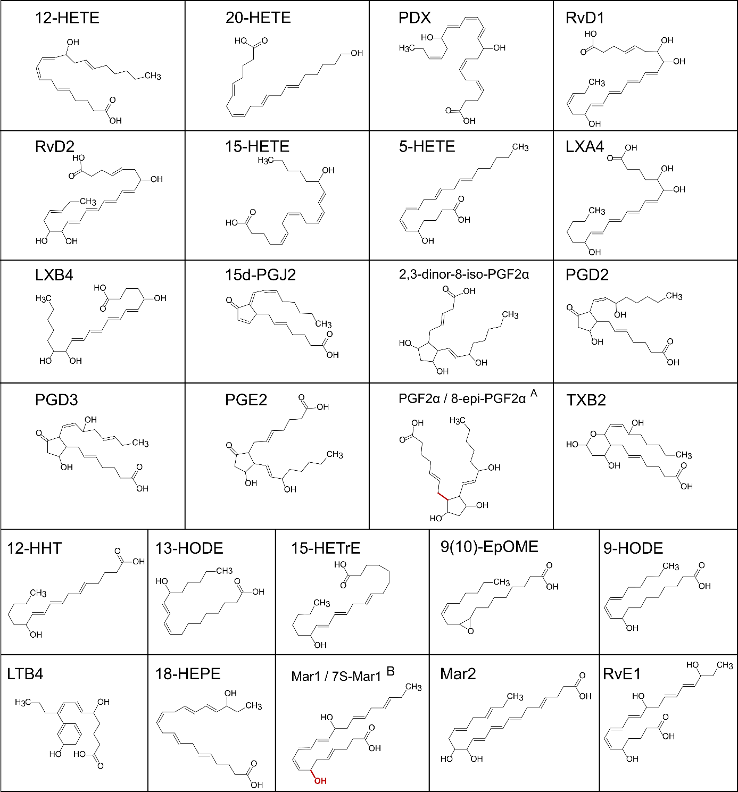
Supplementary Figure S1. Skeletal formulas of analytes.
A - 8-epi-PGF2α is a PGF2α isomer with inverted stereochemistry at the 8-position (in red); B – Mar1 and 7S-Mar1 are epimers with differing stereochemistry at carbon with hydroxyl group.

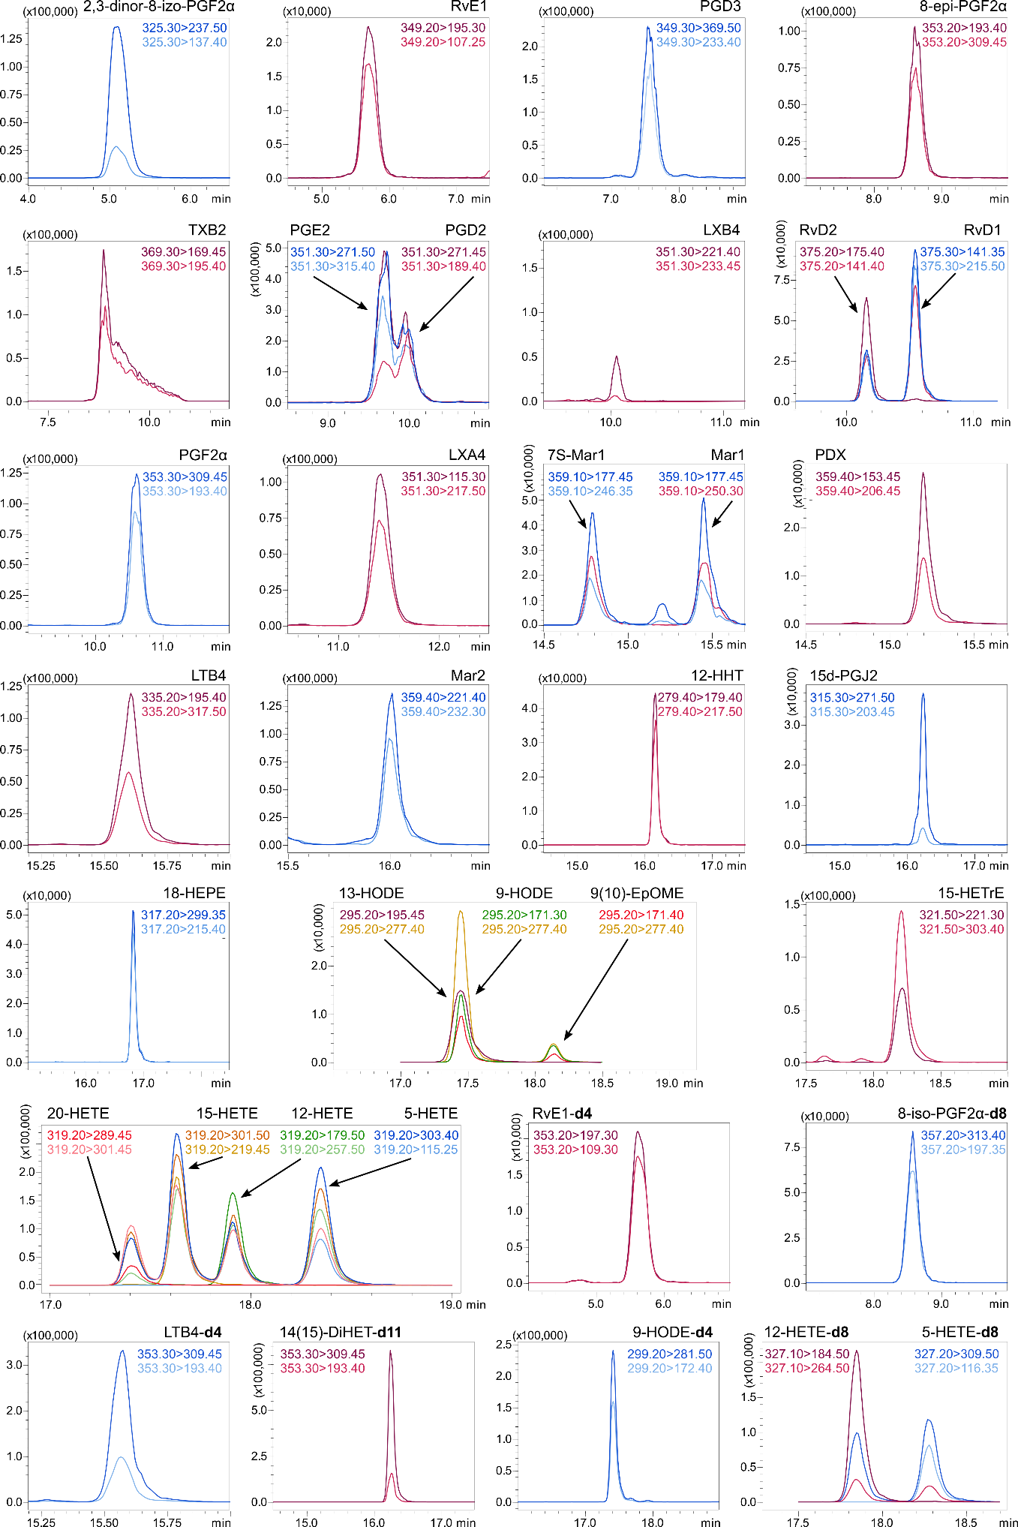
Supplementary Figure S2. Chromatograms of oxylipins obtained in MRM mode. For names of the analytes please refer to Supplementary Table S1. Axis X – retention time, axis Y – signal intensity.

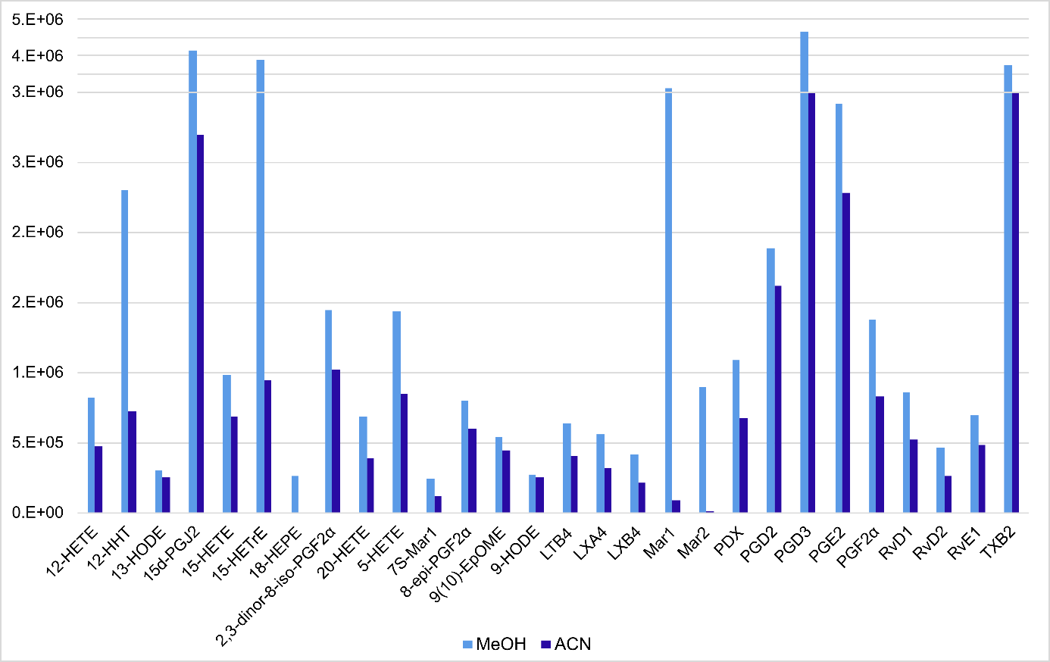
Supplementary Figure S3. Relative peak intensities of oxylipin standards depending on phase B composition. For names of the analytes please refer to Supplementary Table S1.

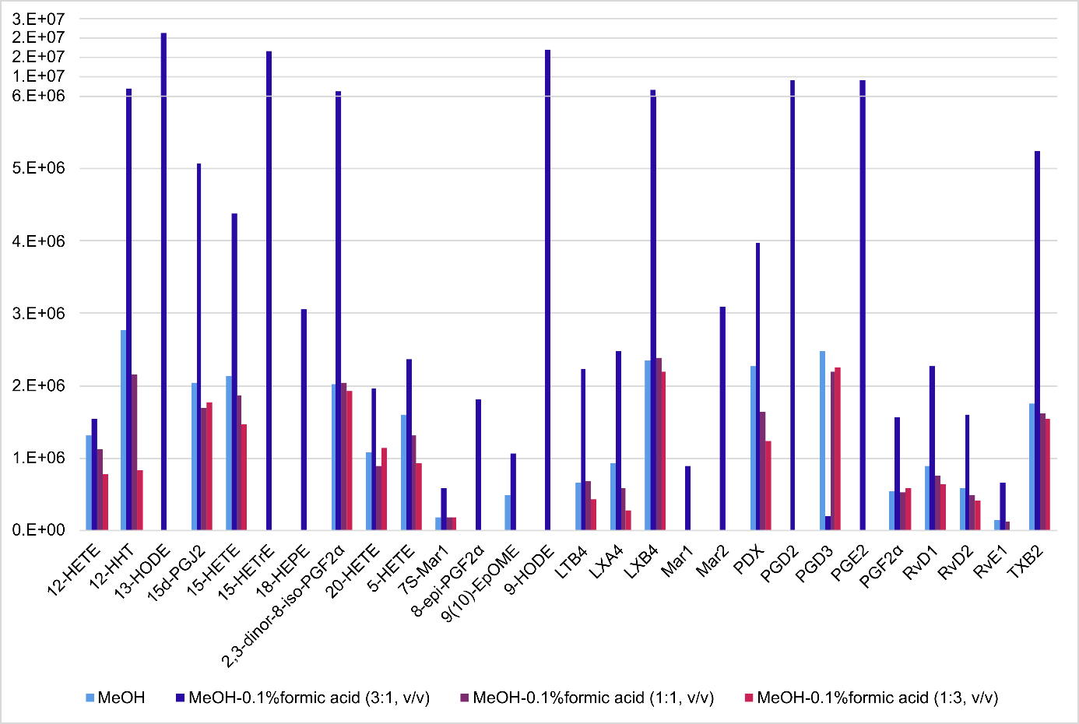
Supplementary Figure S4. Relative peak intensities of oxylipin standards injected in different solvent compositions. For names of the analytes please refer to Supplementary Table S1.

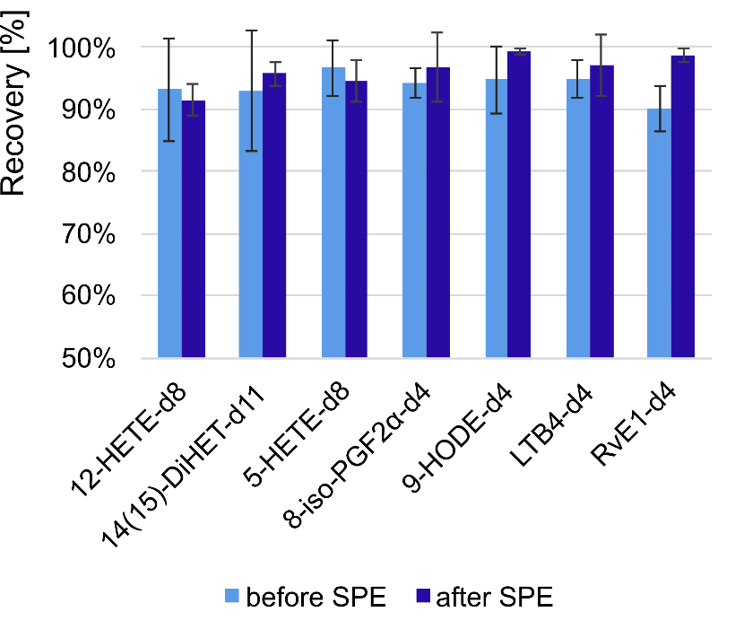
Supplementary Figure S5. Recovery of deuterated internal standards (IS) used for
quantification of oxylipins.
IS recovery was a ratio between peak intensity in samples where IS were added directly to serum (before SPE) to peak intensity in samples where IS were added to the SPE eluent. The recovery was determined at one level – addition of 10 ng of each IS to sample in three independent replicates. For names of the analytes please refer to Supplementary Table S1.

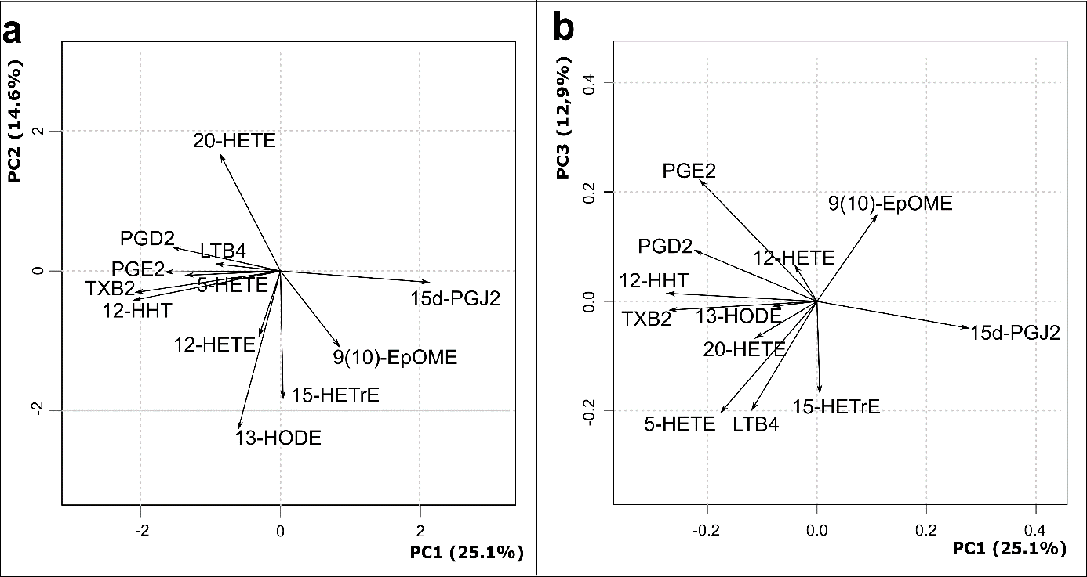
Supplementary Figure S6. Variables plots corresponding to PCA projections given in the main article.
(a) projection along PC1 and PC2, (b) projection along PC1 and PC3. For names of the analytes please refer to Supplementary Table S1.

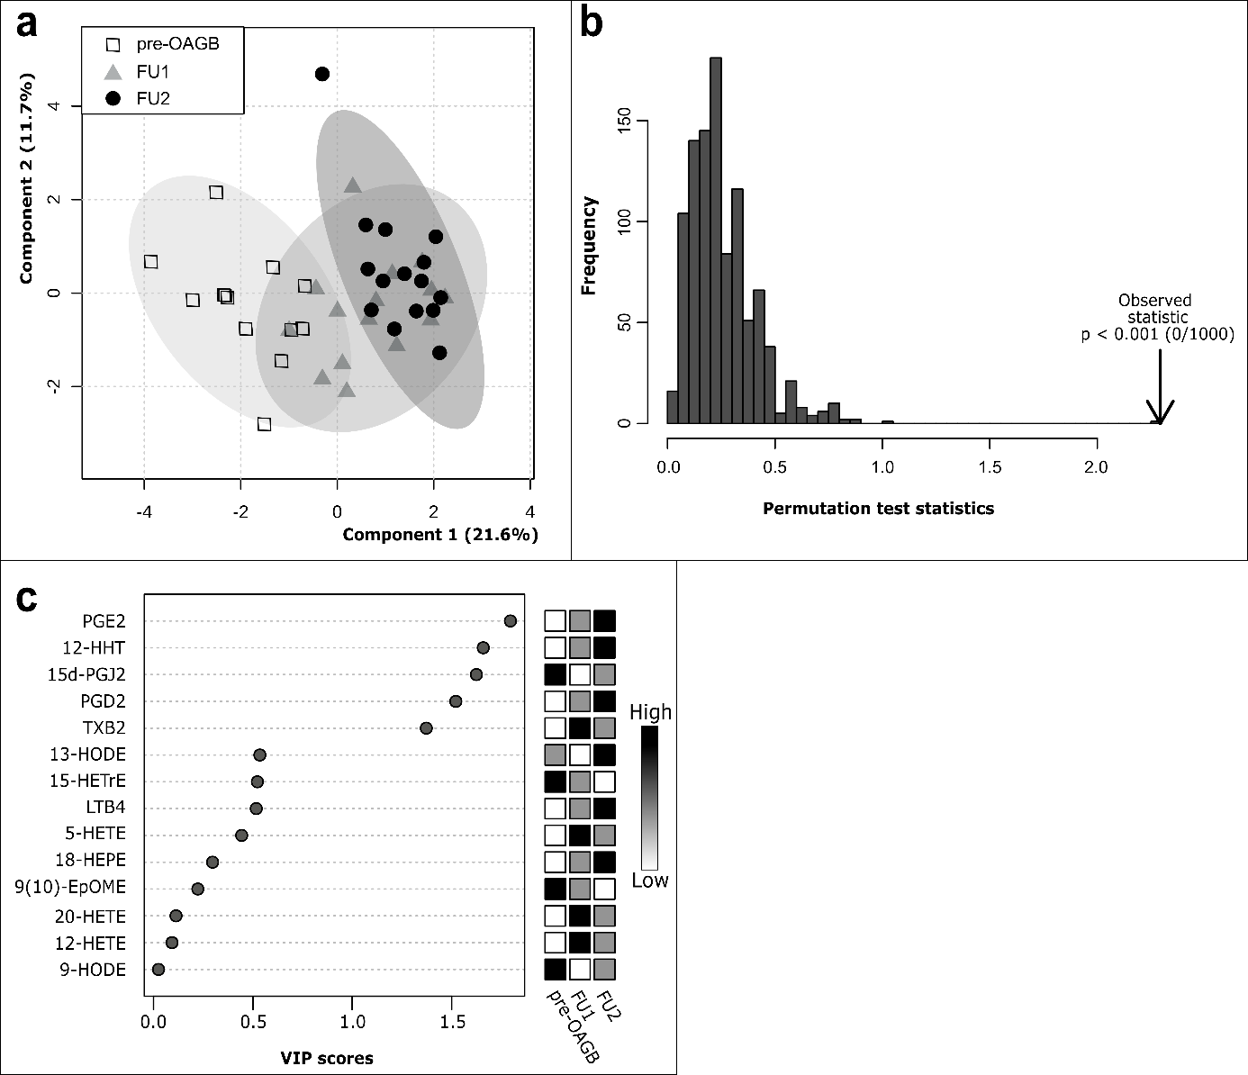

Supplementary Figure S7. Discriminant analysis of bariatric patients before (pre-OAGB), 2 weeks after (FU1) and 6-9 months after (FU2) OAGB surgery, based on oxylipins concentrations.
PLS-DA plot (a), permutation test with separation distance as selected statistic, 1000 permutations (b), and variable importance projection (VIP) scores (c). For names of the analytes please refer to Supplementary Table S1.

