Fig 1 b
- KYNU
HeLa-DDP | HeLa | HeLa
- KYNU
GAPDH
HeLa-DDP | HeLa-DDP | HeLa-DDP | ,HeLa | HeLa | HeLa
3.KYNU
GAPDH
HeLa-DDP | HeLa-DDP | HeLa-DDP | ,HeLa-DDP | HeLa | HeLa | HeLa | HeLa | HeLa

4.KYNU
GAPDH
HeLa-DDP | HeLa-DDP | HeLa-DDP | ,HeLa-DDP | HeLa | HeLa | HeLa

Fig 2b

p-gp
HeLa-DDP | GV208-NC | GV208-KYNU | ,GV248-KYNU | GV248-NC
kynu

gapdh
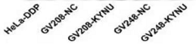
GV208-KYNU: KYNU mRNA overexpression lentivirus, GV204-KYNU was not needed in this manuscript.
GV248-KYNU: KYNU mRNA knockdown lentivirus,

Pgp
Fig 2b：p-gp
1.Pgp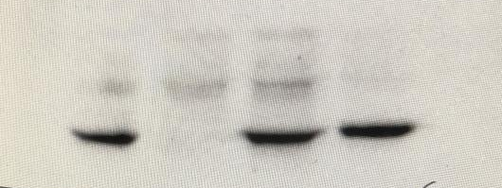
2.pgp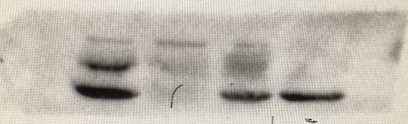
Kynu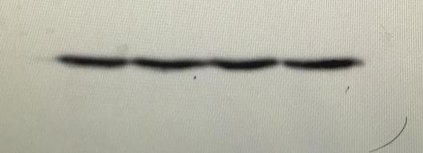
GV248-NC | ,GV248-KYNU | HeLa-DDP | HeLa-DDP

Fig 2b：KYNU
1.kynu
2.kynu
HeLa-DDP | GV208-NC | GV208-KYNU | ,GV248-NC | GV248-KYNU

