Supporting Information

High-dimensional anticounterfeiting nanodiamonds authenticated with deep metric learning

Lingzhi Wang ^{1,^}, Xin Yu^{1,^}, Tongtong Zhang¹, Yong Hou¹, Dangyuan Lei², Xiaojuan Qi^{1,*}, Zhiqin Chu^{1,3,*}

¹ Department of Electrical and Electronic Engineering, The University of Hong Kong, Hong Kong, China
² Department of Material Science and Engineering, City University of Hong Kong, Hong Kong, China
³ School of Biomedical Sciences, The University of Hong Kong, Hong Kong, China
^ Equal contribution
* Correspondence and requests for materials should be addressed to X.J.Q. (xjqi@eee.hku.hk), and Z.Q.C. (zqchu@eee.hku.hk).

Supplementary figures
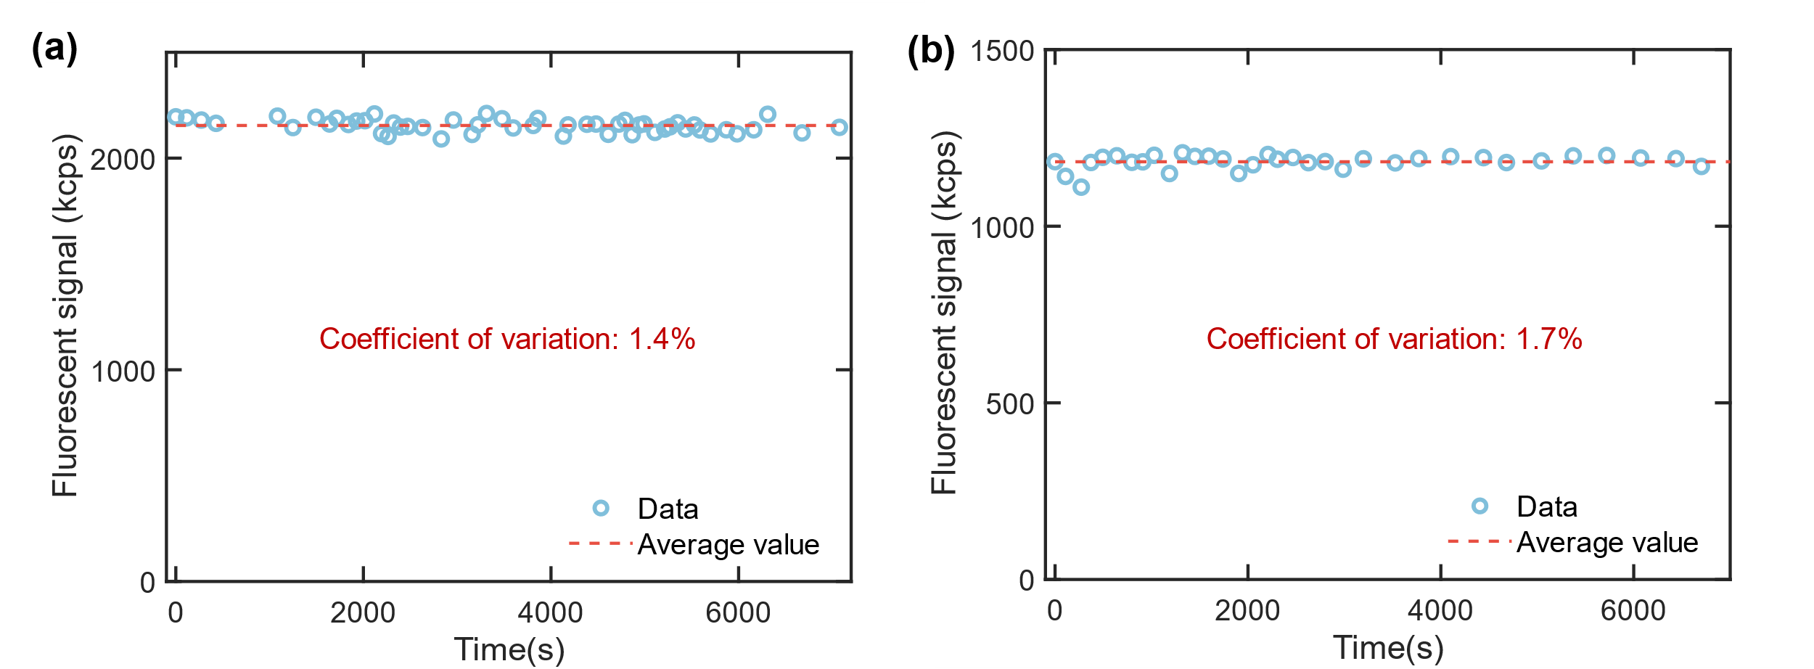
Figure S1. Long-term detection results for the diffraction-limited bright spots of FNDs.
Scatterplots showing the relationships between measurement time and fluorescent signal for two diffraction-limited bright spots in a and b, respectively. The long-term detection was done via a homemade confocal microscope. Before each detection, the bright spot is tracked with a gap of 50 nm to reduce the error caused by sample drift.

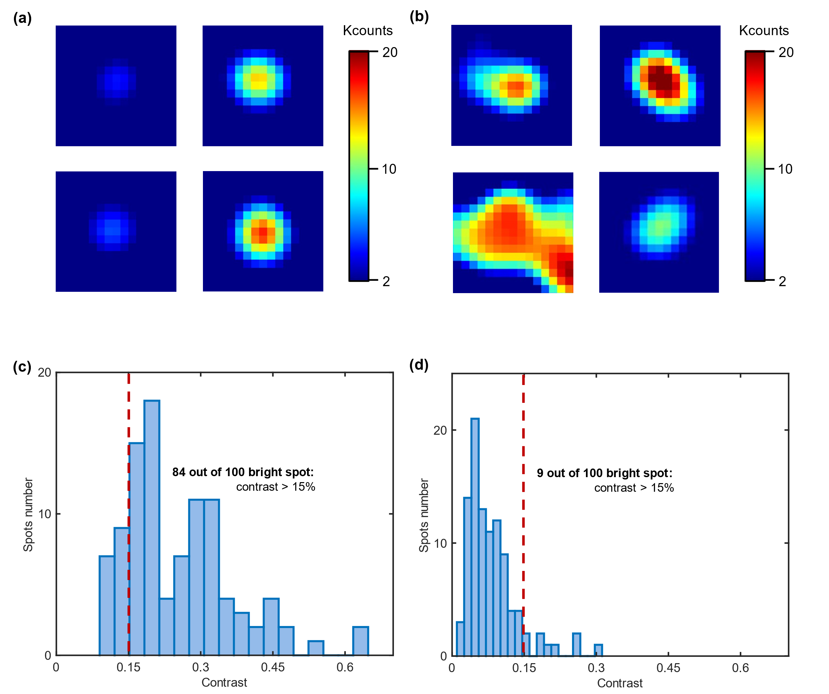
Figure S2. Statistics of LPM contrast distribution for bright spots with different sizes.
Wide-field fluorescent images showing typical bright spots of FNDs, close to diffraction-limited size (a) and bigger than diffraction-limited size (b). Pixel size is around 59 nm. Histogram of LPM contrast distribution among 100 randomly chosen bright spots. c and d corresponding to bright spots close to diffraction-limited size and bright spots bigger than diffraction-limited size, respectively.

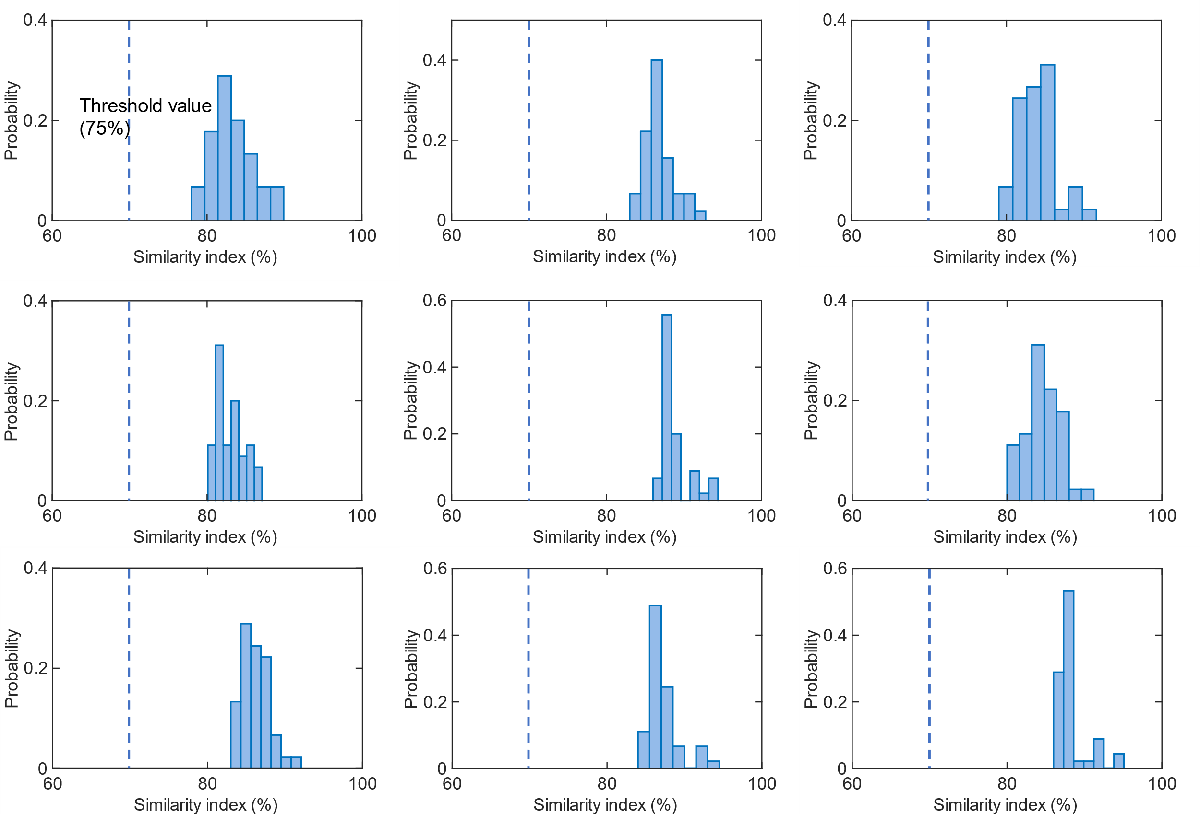
Figure S3. Authentication results for reproducibility of nine PUF labels.
Histograms showing the statistics of similarity indexes among 10 times of digitized readout results for the same PUF label.

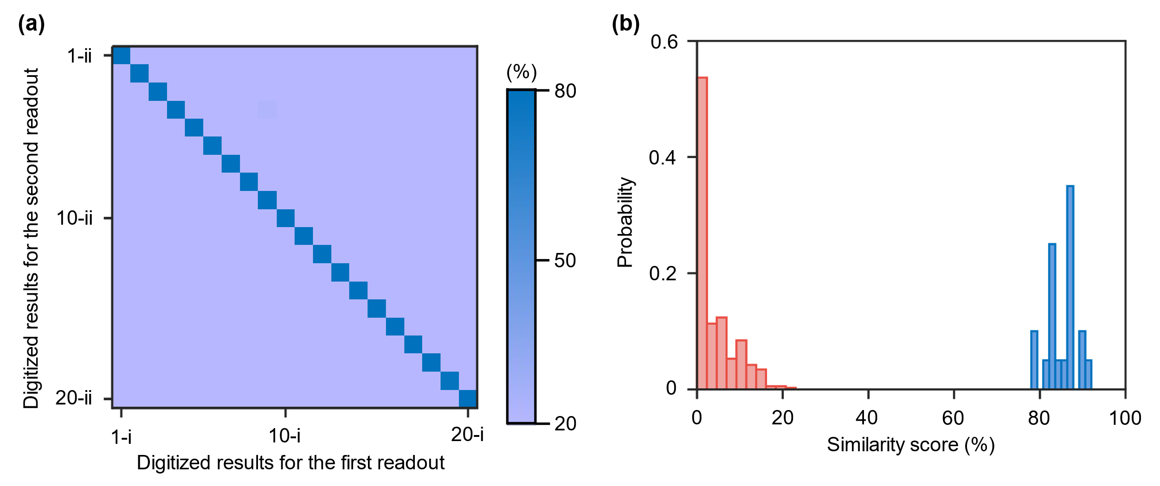
Figure S4. Authentication via metric learning method for digitized images readout under ideal lab condition.
Authentication results for two groups of digitized readouts results of 20 PUF labels. Left panel: heating map showing pairwise match. Color bar represents the similarity score. Right panel: histogram showing the statistics of similarity scores among digitized readout results for the different PUF labels (red bars) and the same PUF labels (blue bars).

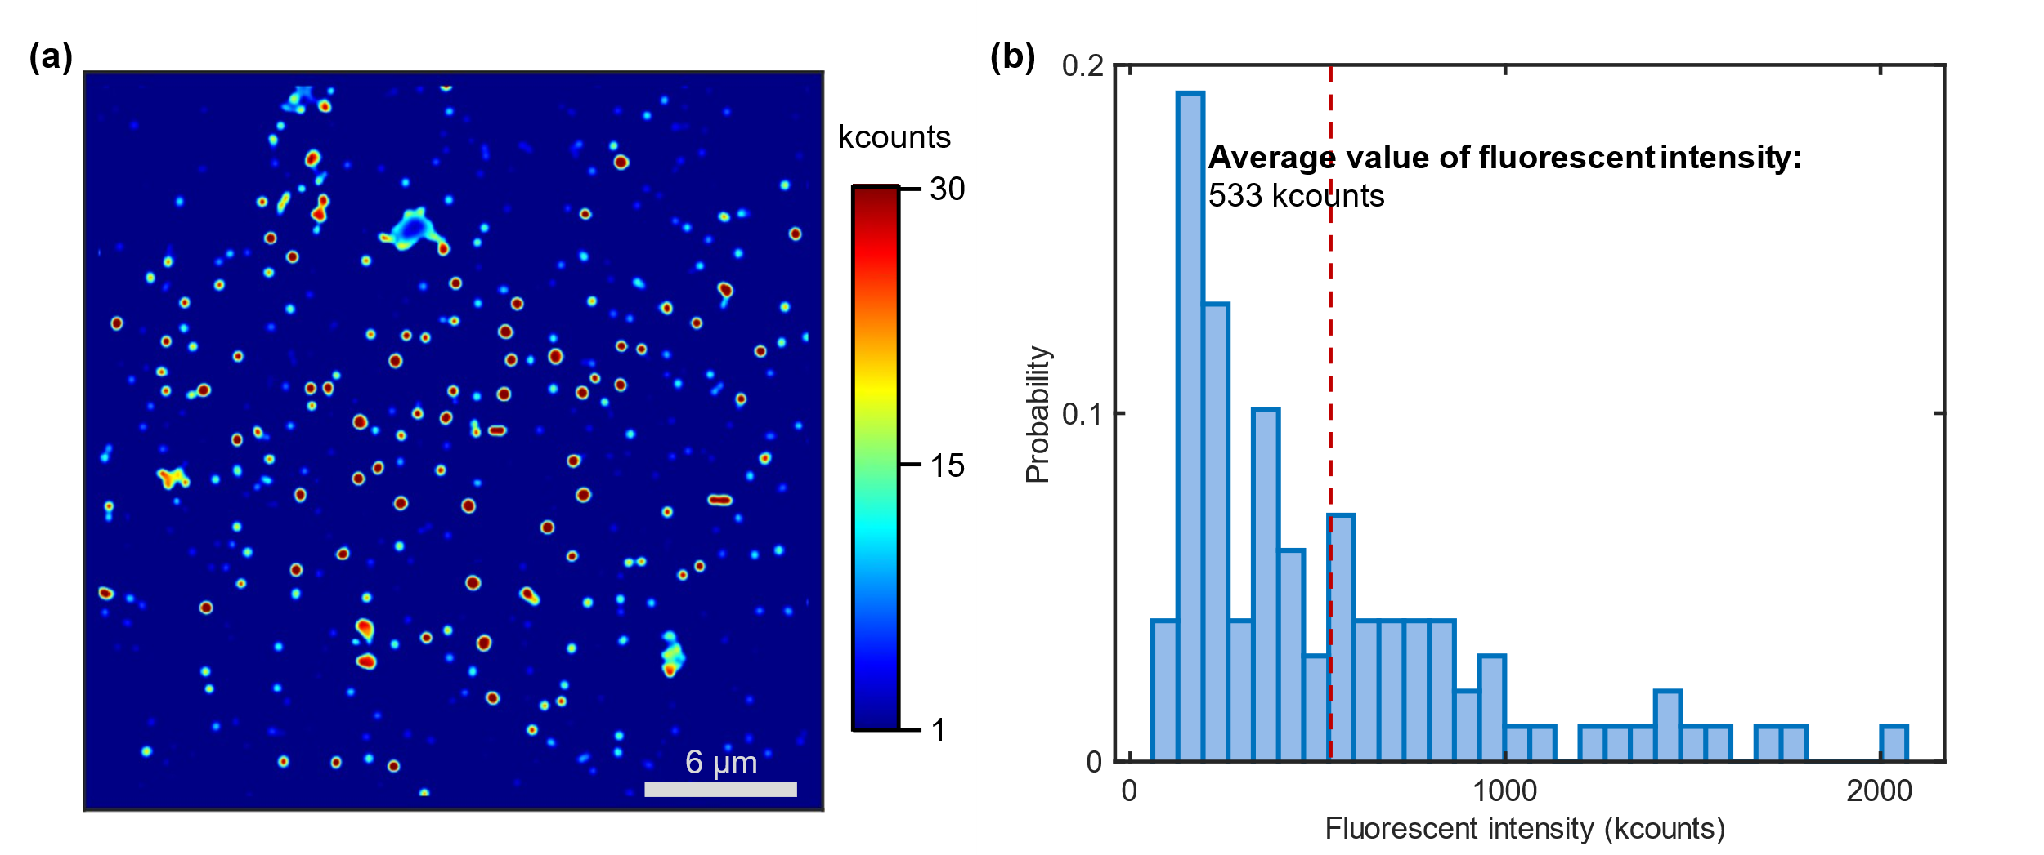
Figure S5. Brightness for the diffraction-limited bright spots of FNDs.
a A typical wide-field fluorescent image of FNDs was measured with 10 mW laser power and 50 ms integration time. b Histogram showing fluorescent intensity distribution among 50 randomly chosen diffraction-limited bright spots in a. Fluorescent intensity was calculated via the total signals of the 11×11 pixels matched with the location of identified BSs.

Supplementary Table
Item | Price (USD) | Remarks
Substrate | 0.12 | The chosen substrate is cover glass (production number 260341, Ted Pella, Inc.), whose price is around 0.12 USD/piece.
FND | 0.07 | The price of FND (BR100, FND Biotech, Inc.) is 35 USD/mg. A piece of FND PUF label consumes around 0.002 mg FND.
PDMS | 0.00126 | The price of PDMS is around 126 USD/kg. A piece of FND PUF label consumes PDMS with a weight of less than 10 mg.
Total | 0.19126 | In our article, the chosen working area is just 30 µm × 30 µm. In theory, a cover glass can be cut into maximum of around $5×{10}^{5}$ working labels. Therefore, the actual cost of a working label is much lower than the estimated value.
Table S1. The estimated cost for fabricating a piece of FND PUF label.

Supplementary Notes 1. Relationship between the number of bright spots and distinguishability
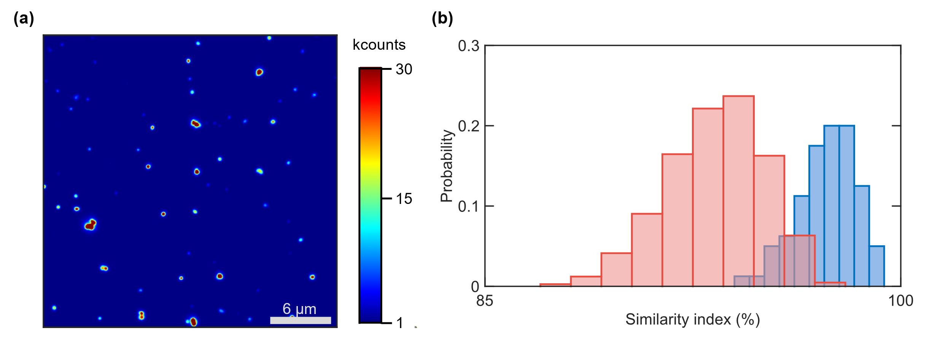
Figure S6. Distinguishability of digitized fluorescent images with a few bright spots
a A fluorescent image of FND PUF labels used for authentication in b, showing the typical number of bright spots in 30 μm × 30 μm area. b Authentication results for two groups of digitized readouts results of 80 PUF labels. Histogram showing the statistics of similarity indexes among digitized readout results for the different PUF labels (red bars) and the same PUF labels (blue bars).

We found that the distinguishability is related to the number of bright spots in the fluorescent images of PUF labels. Specifically, when the number of bright spots in the fluorescent images is too small (less than 100), the distinguishability of 3D encoded images of FND PUF labels will be low.(Figure S6) When the number of bright spots in the fluorescent images is big (around 200-450), the distinguishability of 3D encoded images of FND PUF labels will be high.(Figure 3b)

The above phenomenon may be analyzed via an evaluation parameter (called uniqueness¹) for binary digitized images of PUF labels. In theory, when the uniqueness of binary digitized images of PUF labels is close to 0.5, these binary digitized images will show high distinguishability. Uniqueness is defined via the following equation:
$$Uniqueness=\frac{2}{k(k-1)}\sum_{i}^{k-1}{\sum_{j=i+1}^{k}{\frac{HD(R_{i},R_{j})}{n}}}$$
$k$ is the total number of FND PUF label; $HD(R_{i},R_{j})$ means the number of pixels with different digitized values for digitized images of FND PUF labels with indexes of $i$ and $j$; $n$ is the pixel number in a digitized image ($32×32=1024$). As for the condition in Figure 3b with high distinguishability proved, the calculated uniqueness value is 0.46, close to the ideal value (0.5). However, as for the condition in Figure S6 with low distinguishability proved, the calculated uniqueness value is 0.14, much less than the ideal value (0.5).

Supplementary Notes 2. Scheme for digitization of contrast value
According to Figure S2, the upper limit of LPM contrast values for diffraction-limited spots is around 60%. Using the upper limit, we can calculate the range of contrast values in an image pixel via equation 2 in formal content. The calculated range is from -60% to 150%.

We use the coefficient of variation to describe the precision of contrast values. Specifically, the precision of contrast value is close to fluorescent signal fluctuation for FNDs during the optical readout process of FND PUF labels. We design the following scheme to test the fluorescent signal fluctuation. First, optical images are taken with most parameters kept same as the readout process, but the change of linear polarization direction of the excitation laser is canceled. Then, for the obtained optical images, the coefficient of variation of identified bright spots is calculated to represent the fluorescent signal fluctuation. As shown in Figure S7, the average value of the coefficient of variation is around 2.0% with a standard error as 1.2%.
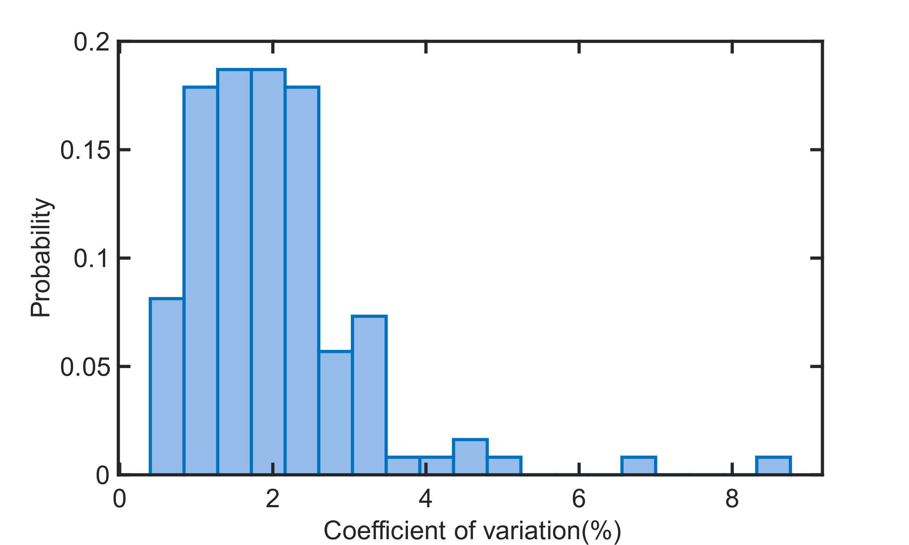
Figure S7. Fluorescent signal fluctuation for FNDs in the readout process.
Histogram showing the statistics of coefficient of variation for fluorescent signals of 123 identified bright spots. Fluorescent signal was calculated via the sum signal of 13 pixels × 13 pixels corresponding to the identified bright spot.

According to the range of contrast values and fluorescent signal fluctuation, we design Table S2 to digitize contrast values for the readout images with pixel resolution as 32 × 32. Specifically, for ensuring the precision of digitization, we choose 20%, 10 times of 2% (the average value of the coefficient of variance), as the length of a contrast level. In addition, we set the low limit as 50% and the upper limit as 90% to contain the most contrast values. Especially, when the total signal in a pixel is less than 50000 counts, the digitization value is always zero. The corresponding reason is that in the above condition, no bright spots are regarded as being contained in this pixel, so we need to set an additional rule to digitize it.

Contrast value (C) | Digitization value
C<-50% | -3
-50%<C<-30% | -2
-30%<C<-10% | -1
-10%<C<10% | 0
10%<C<30% | 1
30%<C<50% | 2
50%<C<70% | 3
70%<C<90% | 4
C>90% | 5
Table S2. Rules for digitizing contrast values.

Supplementary Notes 3. Design for noise resilience evaluation
1) Readout under ideal laboratory condition
For the working areas of FND PUF labels, we find the optimal focus position with a gap of 50 nm and readout the labels in laboratory condition with brightfield illumination off. The process of finding focal position is based on a precise nanopositioning stage (P561.3CD, Physik Instrumente) with position resolution as 0.8 nm in all XYZ directions (Z direction is perpendicular to the sample plane).

2) Readout under laboratory condition with three kinds of additional noise sources
Noise source 1: out of focus
Using the nanopositioning stage, we move PUF label 200 nm away from the optimal focus position.

Noise source 2: background light
During the readout process, we keep the brightfield illumination on to mirror the background light.

Noise source 3: sample drift
When we adjust the manual stage on the microscope frame to find a working area of FND PUF label, the manual stage will cause evident random sample drift during the next several minutes. As for the above sample drift obtained during around 45 seconds, we use the nanopositioning stage to double it as the simulated sample drift. The typical value of simulated drift distance in XY directions is around 100-400 nm.

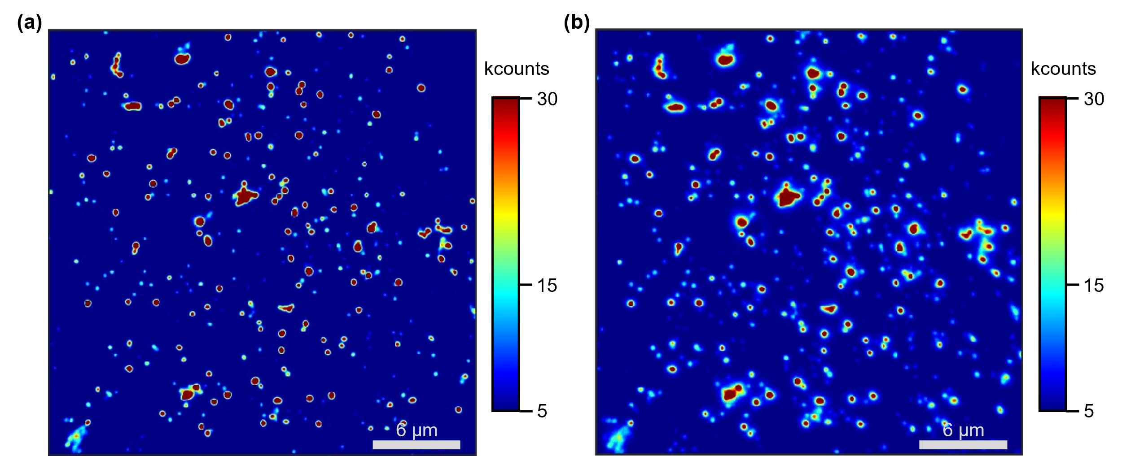
Figure S8. Examples of readout images for the same PUF label under different readout conditions.
a Ideal laboratory environment. b Laboratory environment with three kinds of additional noise sources. Readout images aren’t processed via the bandpass filter.

Supplementary Notes 4. Analysis of authentication speed
In the common authentication process^{2,3,4,5}, the user-provided label is tried to be matched with all sets of stored objects in the database of manufacture. In the above condition, when the readout results of many labels are stored in the database, classification-based authentication method has evidently faster authentication speed than our metric learning-based authentication method. The reason is as follows. For a complete verification, we need to pass the user-provided label through the neural network and then calculate the cosine similarity between the resulting deep features and each deep feature in the database one by one. The time complexity of our method is linearly dependent on the number of PUF tags stored in the database. In contrast, a classification-based approach^{4,5,6} can predict the outcome with a single forward pass through its model, which is independent of the size of the database during the test.

We implement our algorithm using PyTorch on an NVIDIA RTX 3090 GPU card. In this condition, our metric learning method consumes 1.3 ms for extracting features from one set of digitized readout results, and 0.08 ms was consumed for comparing extracted features with one set of stored objects. For point-by-point comparison methods, 0.017 ms is consumed for comparing one set of digitized readout results with one set of stored objects.

In practical application, lots of labels (e.g., 10,000,000) are produced. In this condition, 10,000,000 sets of objects are stored in the database by manufacturers, the authentication time for our method is around 800 s, which is too long time. Fortunately, manufacturer can conveniently solve this problem via setting a serial number for each label. For example, when a user knows that his serial number is 900,245, he can compare the features of a set of digitized readout results with just one set of stored objects, whose serial number is also 900,245. Therefore, he just needs 1.38 ms to complete the authentication.

Supplementary Notes 5. Deep Metric Learning with Convolutional Neural Networks (CNNs)
Our deep metric learning approach relies on a convolutional neural network (CNN) model to extract the deep feature. The overall architecture of our network is shown in Figure S9, and here we elaborate each component within it and illustrate the procedure of feature extraction.

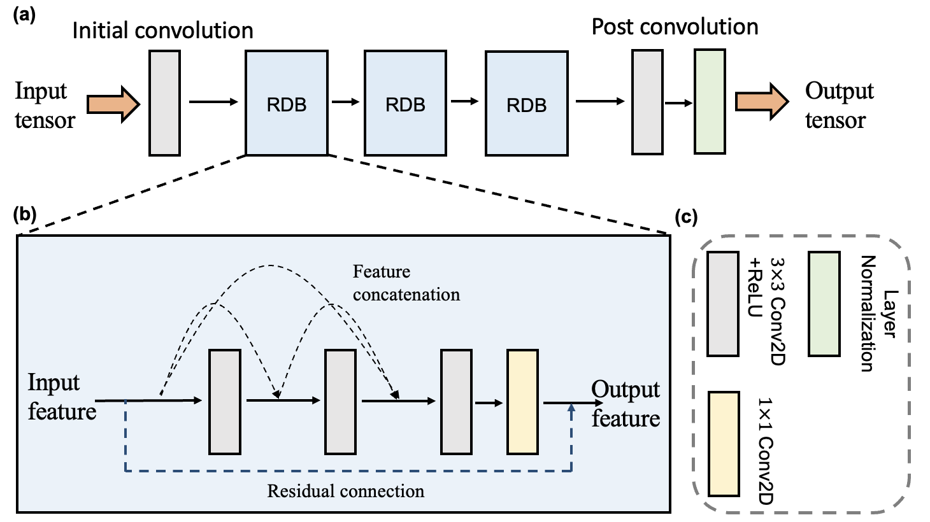
Figure S9. Architecture of our neural network.
a The overall structure of our network is displayed, which includes an Initial Convolution, three Residual Dense Blocks (RDB), and a Post Convolution. b The internal structure of an RDB is shown, which comprises three convolution layers followed by a 1 × 1 convolution. The features generated by each convolution layer are concatenated with the inputs of subsequent layers (i.e., dense connection). c Providing the captions of the various components within a and b.

Input Tensor: The input to the network is a 4D tensor representing a batch of digitized images. Each tensor has dimensions (batch_size, 10, 32, 32), indicating that each image has a resolution of 32 × 32 pixels and consists of 10 channels.

Initial Convolution: The tensor first passes through a 2-Dimensional Convolution (Conv2d) layer with a kernel size of 3, a stride of 1, and padding of 1. This operation expands the number of output channels to 160, effectively increasing the feature space for subsequent operations while preserving the spatial resolution due to the use of padding.

Residual Dense Blocks (RDBs): The feature maps then go through three successive Residual Dense Blocks (RDBs) ⁷, which benefits from the DenseNet⁸ and ResNet⁹ architectures. The primary goal is to facilitate the flow of information and gradients through the network, which is particularly beneficial in deep networks where vanishing/exploding gradients can be a problem. In an RDB, three convolutional layers are stacked, and each layer receives the feature maps from all preceding layers as input, which is known as "dense connection". Specifically, each RDB consists of three Conv2d layers with a kernel size of 3 and dilation rates of 1, 2, and 1, respectively. Each Conv2d layer is followed by the Rectified Linear Unit (ReLU) activations. The output features from all the layers are then concatenated and passed through a 1 × 1 Conv2D layer to reduce the number of channels back to the original number, enabling the output to be added to the original input to form a residual connection. This "shortcut" connection allows the gradient to backpropagate directly to earlier layers and helps the network to learn identity functions, thereby combating the problem of degradation.

Post Convolution: After the RDBs, the feature maps are processed by another Conv2d layer with a kernel size of 3 and padding of 1, followed by a ReLU activation. Finally, a Layer Normalization¹⁰ is then applied to reduce internal covariate shift and stabilize the distribution of activations across the feature maps, which is proved to be effective to speed up convergence.

Output Tensor: The final output tensor maintains the same spatial resolution as the input (32 × 32) but with a higher number of channels (160), each encoding high-level features of the input images.

Similarity Score: The similarity score of two digitized images is the cosine similarity of their extracted deep features. Specifically, for two feature tensors, A and B, which have the shape (160,32,32), representing feature channels and spatial dimensions, we first apply the cosine similarity calculation across the channel dimension. Given two corresponding channel vectors in the same spatial location $(i, j)$ from A and B, which are denoted as $A_{ij} = \{a_{1}, a_{2}, ..., a_{n}\}$ and $B_{ij} = \{b_{1}, b_{2}, ..., b_{n}\}$, the cosine similarity ($cos( θ_{ij})$) for them is calculated as:

$$cos\left( θ_{ij}\right)=\frac{\sum_{k=1}^{160}{{(a}_{k}×b_{k}) }}{\sqrt{(\sum_{k=1}^{160}{a_{k}^{2} )×}(\sum_{k=1}^{160}{b_{k}^{2} )}}}$$

Where $i,j$ denotes the spatial index. Thus, we get a 2D similarity map of shape (32,32). We then take the average over the spatial dimensions to obtain a single similarity score for each pair of images, i.e.,
$$sim=\frac{\sum_{i=1,j=1}^{i=32,j=32}{cos⁡(θ_{ij})}}{32×32}$$

To ensure the numerical stability during subsequent computation of logarithms in the loss function, we clamp the resultant similarity scores within a safe range of $[1e^{-8}, 1-1e^{-8}]$.

Loss Function: During loss computation, we extract features from two digitized images, evaluate their similarity, and compute the loss based on the provided label. Recognizing the varying degrees of difficulty in discriminating between inter-class samples compared to intra-class samples, the model adopts a distance-weighted loss function inspired by Focal Loss¹¹. In each iteration, cosine similarity (sim) is calculated between feature representations of each image pair. Next, two sets of weights are computed: one for pairs considered to be dissimilar, given by $w_{1} = {\left(1-sim\right)}^{2}$, and another for pairs deemed similar, determined by $w_{2} = {\left(sim\right)}^{2}$.

These weights are then incorporated into the computation of cross-entropy loss as follows:
$$loss=-[w_{1}×log(sim)×(1 - label) + w_{2}×log(1 - sim)×label]$$
Where the label equals 0 if the two digitized images originate from the same PUF label, and 1 if they come from different PUF labels. The loss function is designed to heavily penalize incorrect similarity estimations, driving the network to generate more accurate similarity scores.

References:
1. Maiti, A., Gunreddy, V. & Schaumont, P. A systematic method to evaluate and compare the performance of physical unclonable functions. In Embedded Systems Design with FPGAs 245-267 (Springer, 2013).
2. Gu, Y. et al. Gap-enhanced Raman tags for physically unclonable anticounterfeiting labels. Nat. Commun. 11, 516 (2020).
3. Wu, J. et al. A High-Security mutual authentication system based on structural color-based physical unclonable functions labels. Chem. Eng. J. 439, 135601 (2022).
4. Liu, Y. et al. Inkjet-printed unclonable quantum dot fluorescent anti-counterfeiting labels with artificial intelligence authentication. Nat. Commun. 10, 2409 (2019).
5. Sun, N. et al. Random fractal-enabled physical unclonable functions with dynamic AI authentication. Nat. Commun. 14, 2185 (2023).
6. Smith, J. D. et al. Plasmonic anticounterfeit tags with high encoding capacity rapidly authenticated with deep machine learning. ACS Nano 15, 2901-2910 (2021).
7. Zhang, Y., Tian, Y., Kong, Y., Zhong, B. & Fu, Y. Residual dense network for image super-resolution. In Proc. IEEE Conference on Computer Vision and Pattern Recognition 2472-2481 (IEEE, 2018).
8. Huang, G., Liu, Z., Van Der Maaten, L. & Weinberger, K. Q. Densely connected convolutional networks. In Proc. IEEE Conference on Computer Vision and Pattern Recognition 4700–4708 (IEEE, 2017).
9. He, K., Zhang, X., Ren, S. & Sun, J. Deep residual learning for image recognition. In Proc. IEEE Conference on Computer Vision and Pattern Recognition 770–778 (IEEE, 2016).
10. Ba, J. L., Kiros, J. R. & Hinton, G. E. Layer normalization. Preprint at https://arxiv.org/abs/1607.06450 (2016).
11. Lin, T. Y., Goyal, P., Girshick, R., He, K. & Dollár, P. Focal loss for dense object detection. In Proc. IEEE International Conference on Computer Vision 2980–2988 (IEEE, 2017).

