SUPPORTING INFORMATION
for
Mur Ligase F as a New Target for the Flavonoids Quercitrin, Myricetin and (-)-Epicatechin

Martina Hrast¹ Irena Zdovc² Nina Kočevar Glavač³ Stanislav Gobec^{1*}, Rok Frlan^{1*}

¹ University of Ljubljana, Faculty of Pharmacy, Department of Pharmaceutical Chemistry, Aškerčeva 7, 1000 Ljubljana, Slovenia,
² University of Ljubljana, Veterinary Faculty, Institute of Microbiology and Parasitology, Gerbičeva ul. 60, Ljubljana, Slovenia,
³ University of Ljubljana, Faculty of Pharmacy, Ljubljana, Slovenia, Department of Pharmaceutical Biology, Aškerčeva 7, 1000 Ljubljana, Slovenia,

* Corresponding authors: University of Ljubljana, Faculty of Pharmacy, Aškerčeva 7, 1000 Ljubljana, Slovenia, Department of Pharmaceutical Chemistry, Ljubljana, Slovenia, rok.frlan@ffa.uni-lj.si, 0000-0003-0956-5537; stanislav.gobec@ffa.uni-lj.si, 0000-0002-9678-3083
Contents
1. SiteMap analysis 2
2. Docking analysis of (-)-quercitrin (10) 3

SiteMap analysis
Table S1. Analysis of the druggability, ligandability and physicochemical properties of the binding sites with Sitemap.

Title | SiteScore | Dscore | Volume (Å³) | exposure | enclosure | contact | phobic | philic | balance
Site 1 | 1.044 | 0.936 | 872 | 0.541 | 0.764 | 0.944 | 0.265 | 1.418 | 0.187
Site 2 | 0.897 | 0.888 | 139 | 0.538 | 0.765 | 1.051 | 1.46 | 0.824 | 1.772
Site 3 | 0.874 | 0.881 | 236 | 0.642 | 0.677 | 0.834 | 0.707 | 0.814 | 0.868
Site 4 | 0.677 | 0.633 | 92 | 0.654 | 0.576 | 0.753 | 0.225 | 1.052 | 0.214
Site 5 | 0.656 | 0.63 | 72 | 0.713 | 0.609 | 0.811 | 0.61 | 0.688 | 0.887
Site 6 | 0.655 | 0.657 | 105 | 0.822 | 0.534 | 0.628 | 0.764 | 0.574 | 1.331
Site 7 | 0.570 | 0.301 | 52 | 0.64 | 0.582 | 0.826 | 0.082 | 1.645 | 0.05

Docking analysis of (-)-quercitrin (10)
The 3D representation of the best evaluated binding mode of (-)-quercitrin (10) can be seen in Figure 1 where the protein structure is shown as a green ribbon diagram. In our model, (-)-quercitrin (10) was able to bind with similar binding mode to (-)-epicatechin (21) at site 1, with the glycoside moiety pointing to the exterior of the enzyme and the phenolic ring positioned in close proximity of the γ-phosphate group of ATP. It did not bind to any other binding sites probably because of its larger volume due to the additional glycoside moiety. Compound 10 formed several hydrogen bonds with the surrounding amino acids, for example Glu363, Ala362, Tyr333, Lys 111 and Arg316 as well as a π-π stacking interaction with Tyr333. A salt bridge between the phenolic hydroxyl group and Mg is also formed.
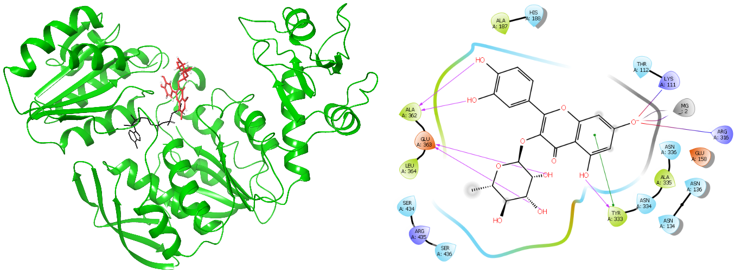
Figure S1. Docking of quercitrin (10) to MurF. (a) The 3D binding mode of (-)-quercitrin (10) at site 1. Native ATP binding is shown in black sticks for comparisson. (b) 2D interaction diagram between (-)-quercitrin (10) and surrounding residues shown as colored dotted lines.

Compound characterization
Compounds were obtained from commercial sources (i.e., Acros Organics, Apollo Scientific, BLD Pharmatech, Fluorochem, MedChemExpress, Merck, TargetMol, TCI Europe) and used as received. ¹H and ¹³C NMR spectra were recorded in a deuterated solvent on a Bruker Avance III 400 MHz spectrometer, operating at 400 and 101 MHz frequency. NMR spectra were measured at room temperature (25 °C) in deuterated DMSO. Chemical shifts (δ) are expressed in parts per million (ppm) referenced to TMS or residual solvent signals. Spectral data are reported in the following format: chemical shift (multiplicity, coupling constants, number of hydrogens). All coupling constants (J) are reported in Hertz. Compound purity was determined by HPLC analysis on Thermo Scientific Dionex UltiMate 3000 modular system (Thermo Fisher Scientific Inc.) with Waters Acquity UPLC® HSS C18 SB column (2.1 × 50 mm, 1.8 µm) thermostated at 40 °C, injection volume, 1 µL; flow rate, 0.3 mL/min; detector λ, 254 nm; mobile phase A: 0.1% TFA (v/v) in water; mobile phase B: MeCN. Method: 0–5 min, 5%–30% B; 5-9 min, 100% B; 9-10 min, 100% B. Compounds are >95% pure by HPLC analysis, unless stated otherwise
Myricetin (12)
¹H NMR (400 MHz, DMSO-d₆): δ 12.51 (s, 1H), 10.80 (s, 1H), 9.37 (s, 1H), 9.24 (s, 2H), 8.83 (s, 1H), 7.25 (s, 2H), 6.38 (d, J = 2.0 Hz, 1H), 6.19 (d, J = 2.0 Hz, 1H) ppm. ¹³C NMR (101 MHz, DMSO-d₆): δ 175.8, 163.9, 160.7, 156.1, 146.8, 145.7, 135.9, 135.9, 120.8, 107.2, 103.0, 98.2, 93.2 ppm. HPLC purity: 99.6 %.
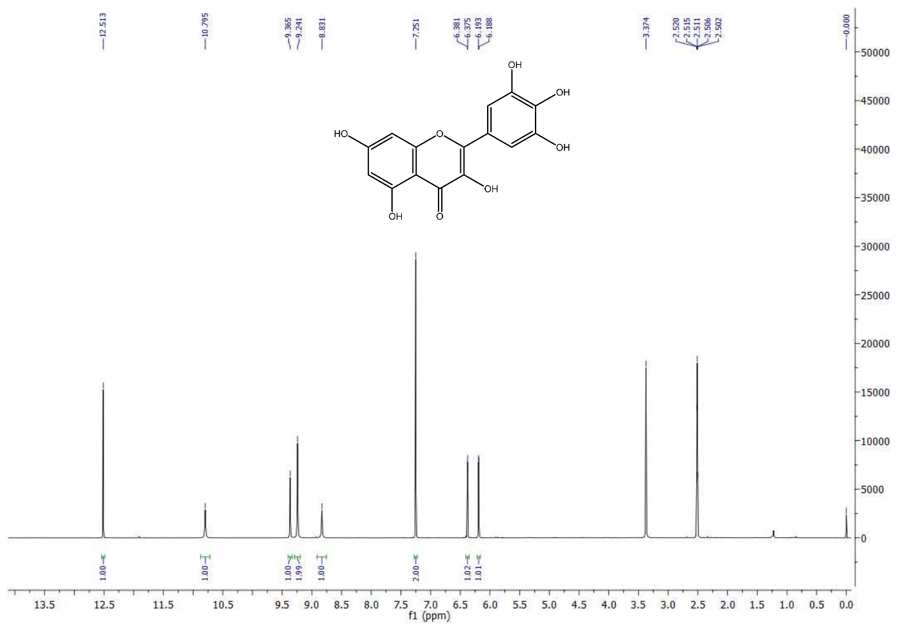
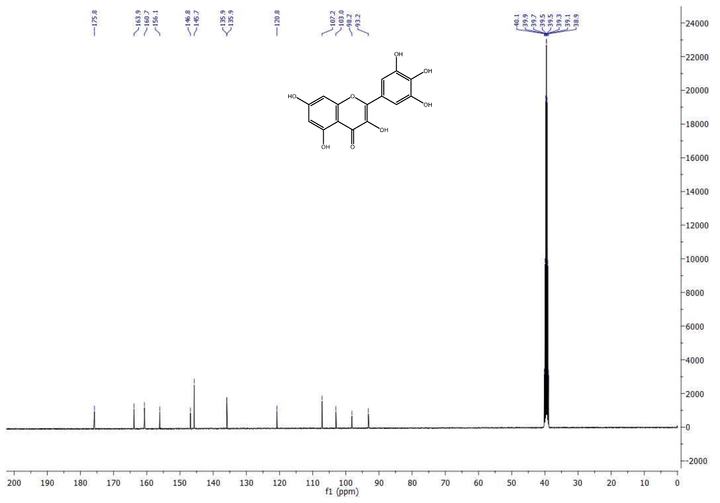
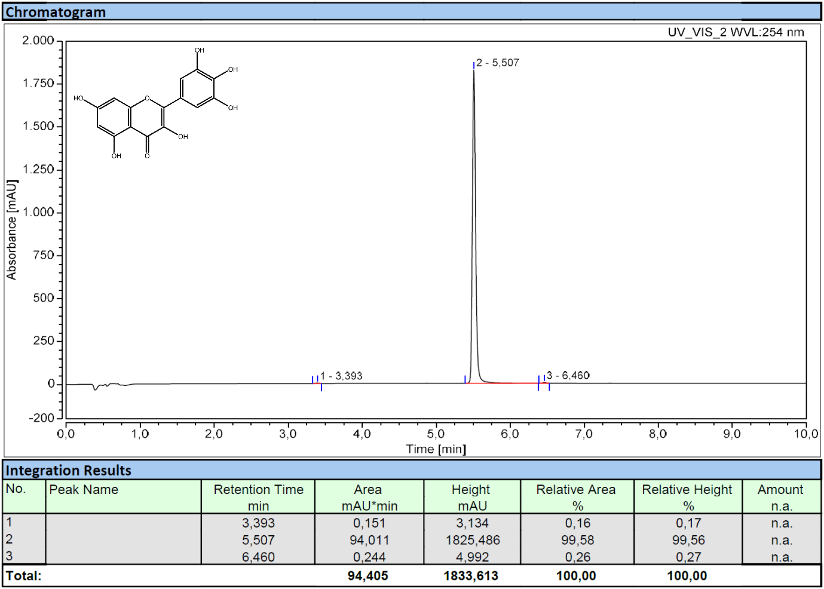
Quercitrin (19)
¹H NMR (400 MHz, DMSO-d₆): δ 12.67 (s, 1H), 10.89 (s, 1H), 9.73 (s, 1H), 9.36 (s, 1H), 7.30 (d, J = 2.1 Hz, 1H), 7.26 (dd, J = 8.3, 2.1 Hz, 1H), 6.87 (d, J = 8.3 Hz, 1H), 6.40 (d, J = 2.1 Hz, 1H), 6.21 (d, J = 2.1 Hz, 1H), 5.26 (d, J = 1.3 Hz, 1H), 4.96 (d, J = 4.3 Hz, 1H), 4.74 (d, J = 4.6 Hz, 1H), 4.63 (d, J = 5.8 Hz, 1H), 3.98 (t, J = 4.3 Hz, 1H), 3.51 (ddd, J = 8.9, 5.6, 3.4 Hz, 1H), 3.27 – 3.07 (m, 2H), 0.82 (d, J = 6.0 Hz, 3H) ppm. ¹³C NMR (101 MHz, DMSO-d₆): δ 177.8, 164.2, 161.3, 157.3, 156.5, 148.4, 145.2, 134.2, 121.1, 120.7, 115.6, 115.5, 104.1, 101.8, 98.7, 93.6, 71.2, 70.6, 70.3, 70.1, 17.5 ppm. HPLC purity: 99.7 %.
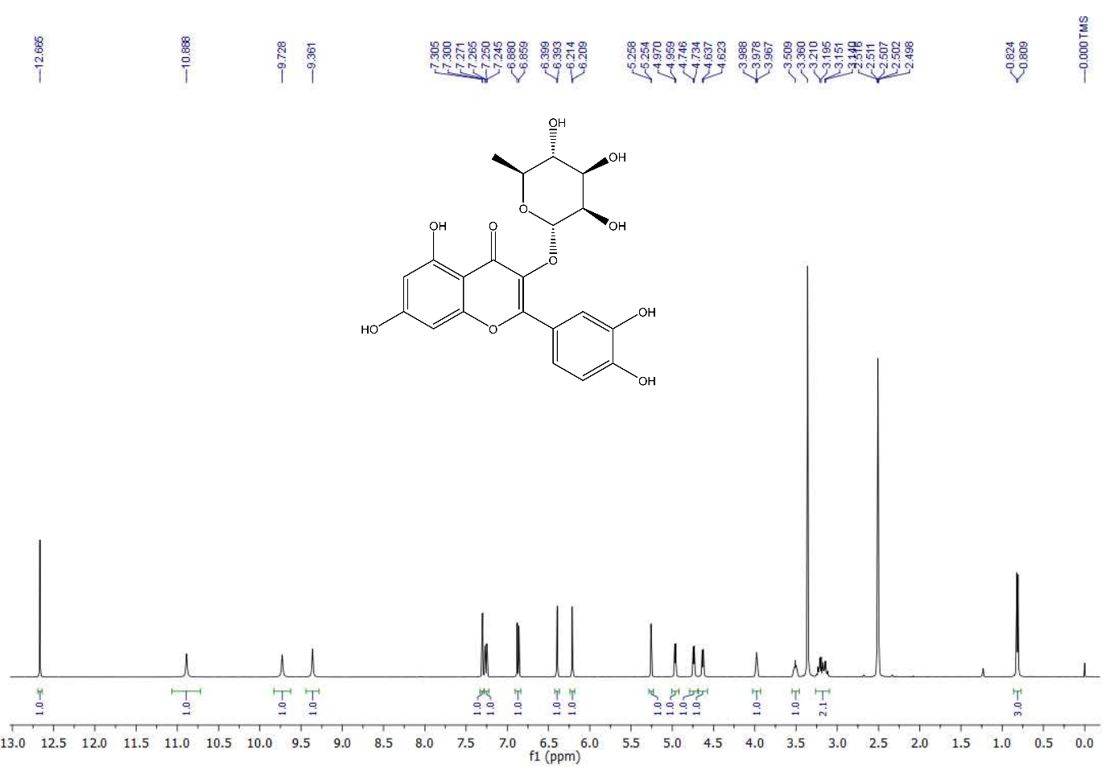
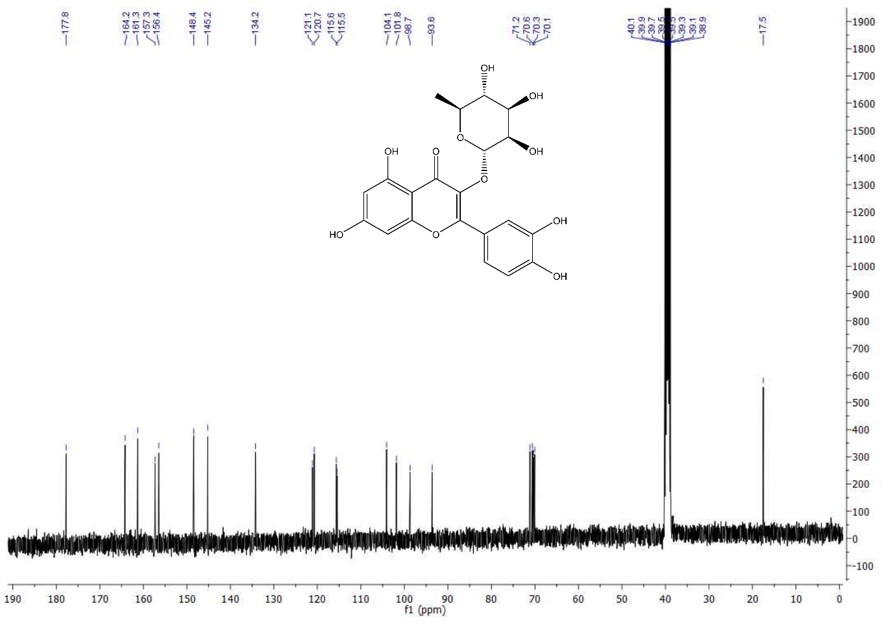
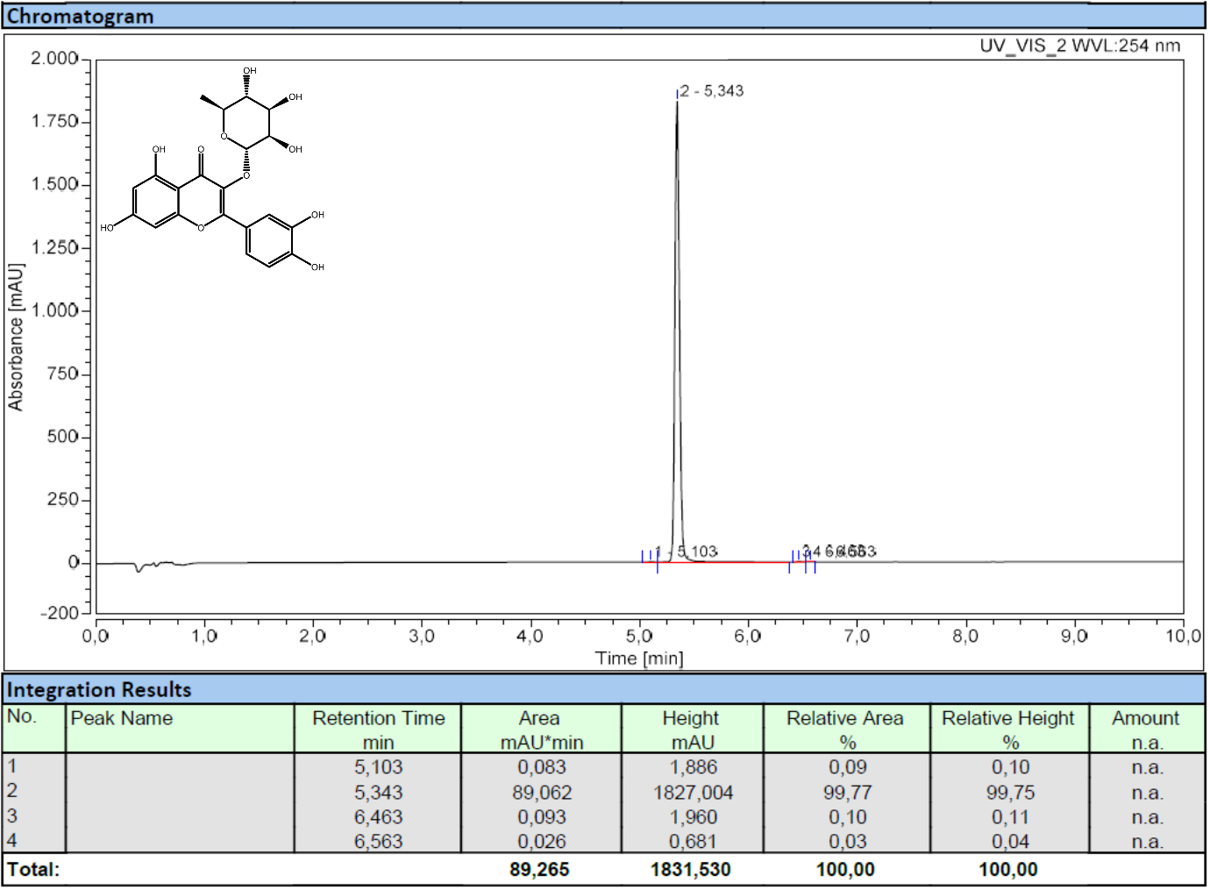

(-)-epicatechin (21)
¹H NMR (400 MHz, DMSO-d₆): δ 9.12 (s, 2H), 8.91 (s, 2H), 8.81 (s, 2H), 8.73 (s, 2H), 6.88 (d, J = 1.5 Hz, 2H), 6.69 – 6.60 (m, 4H), 5.88 (d, J = 2.3 Hz, 2H), 5.71 (d, J = 2.3 Hz, 2H), 4.73 (s, 2H), 4.67 (d, J = 4.6 Hz, 2H), 4.05-3.95(m, 2H), 2.67 (dd, J = 16.3, 4.4 Hz, 2H), 2.53 – 2.41 (m, 1H) ppm. ¹³C NMR (101 MHz, DMSO-d₆): δ 156.5, 156.2, 155.8, 144.5, 144.4, 130.6, 118.0, 114.9, 114.8, 98.5, 95.0, 94.1, 78.1, 64.9, 28.2 ppm. HPLC purity: 96.8 %.
