3D Electrospinning of Al₂O₃/ZrO₂ Fibrous Aerogels for Multipurpose Thermal Insulation

Shiling Dong ¹, Barbara Maciejewska ^{1*}, Robert Millar ², Nicole Grobert ^{1,2*}

¹ Department of Materials, University of Oxford, Parks Road, Oxford OX1 3PH, UK
² WAE Technologies Ltd, Grove, Wantage, Oxfordshire, OX12 0DQ, UK

E-mail: barbara.maciejewska@materials.ox.ac.uk; nicole.grobert@materials.ox.ac.uk

This PDF file includes:
Supplementary text………………………….…………………………….………......……...… 2
Figure S1 to S16…………………………….…………………………….………......……...… 4
Tables S1 to S4………………………….……………………………….…..……....……...… 20
Captions for Movies S1 to S8…………………..……………………………...…..………..… 25
Reference…………………………………………….……………………...…….…...….……26

Other Supplementary Materials for this manuscript include the following:
Movies S1 to S8

SUPPLEMENTARY TEXT
Solution chemistry and fiber structures.
Both macro and microstructures of the electrospun fibers depend on the properties of the precursor solution. The spinning solutions used in this work contain three Al sources, aluminum isopropoxide (AiP), aluminum nitrate (AN), and aluminum chloride (AC), and one Zr source, zirconium acetate (ZrAc). Electrospinning the solution given in the manuscript directly creates ultralight 3D fiber assemblies with height in centimeter scale. Gentle modulation of the concentrations of these ceramic precursors changes the solution viscosity and electrical conductivity simultaneously, but 3D fiber macro-assemblies could still be produced by optimizing the high voltage.
When the solution properties change significantly, different fiber structures are formed. Three typical fiber structures are observed as shown in Figure S1, (a) loosely attached cloud-shaped fiber pile consisting of microfibers and micro-droplets visible to the naked eye. (b) Thin and densely packed 2D mats constructed by sub-micron fibers with bulk thickness limited to about 0.4 cm. (c) Centimeter-high self-supporting 3D macro-assembly with uniform fiber entanglement and interconnected macropores, which we used for creating AZFA.
To unveil the correlation between precursor content and solution properties, Table S1 compares eight solutions. Each has one ceramic precursor either doubled or halved the amount of that given in the MATERIALS AND METHODS section, displayed as the relative concentration (rel. conc.). The other solution components are kept unaltered. Because these four ceramic precursors, AiP, AN, AC, and ZrAc, are all engaged in the sol-gel reactions and interact with the polymer chains in solution, modulating their concentrations leads to significant differences in solution’s electrical conductivity and viscosity. Several trends are observed, (i) increasing AC and AN concentration increases the solution viscosity and electrical conductivity simultaneously; (ii) AiP content non-monotonically influences the solution parameters; and (iii) increasing ZrAc concentration decreases the electrical conductivity and vastly increases the solution viscosity.
It is extremely challenging to define and verify the sol-gel reactions of each precursor, considering the complex reactions of each chemical and their potential interplay. Yet, the realization of the correlation between the chemical composition and solution properties is sufficient for tunning the solution towards desired fiber structures. We find that more viscous solutions generate thicker fibers that can support a free-standing 3D structure. However, such solutions tend to have a larger surface tension that promotes beads formation. [1] On the other side, less electrically conductive solutions undergo a conventional 2D electrospinning regime, yielding thin fiber mat. [2] When solutions have optimal parameters located in the ranges as we identified in Figure 1b, 3D fiber assemblies could be directly formed.

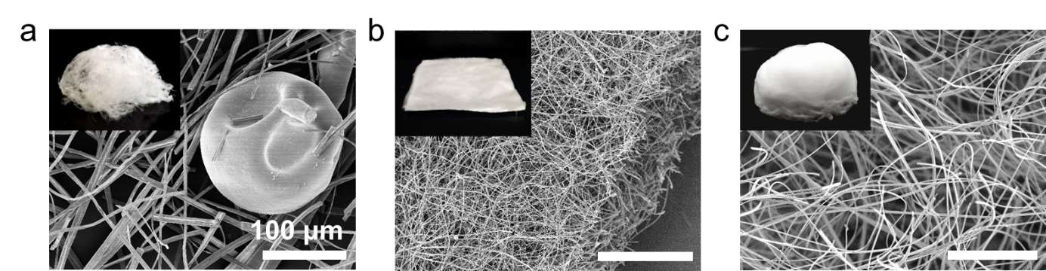
Figure S1. SEM images and digital photographs of three different fiber products resulted from spinning solutions with different electrical conductivity and viscosity. These distinct fibers are categorized into (a) a cloud-shaped macrostructure consisting of a mixture of fibers and droplets, (b) a flat 2D mat, and (c) a 3D assembly. Scale bar in a-c: 100 μm.

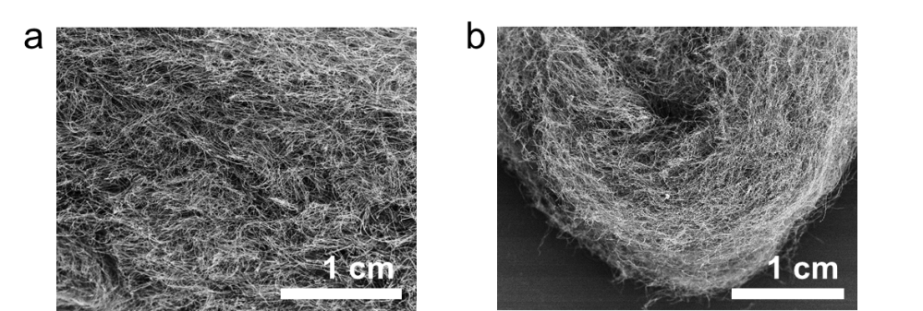

Figure S2. Low magnification SEM images of (a) as-obtained AZFA and (b) AZFA being bent to a high angle. Such bending process causes no observable structural crack, suggesting the superior flexibility of AZFA.
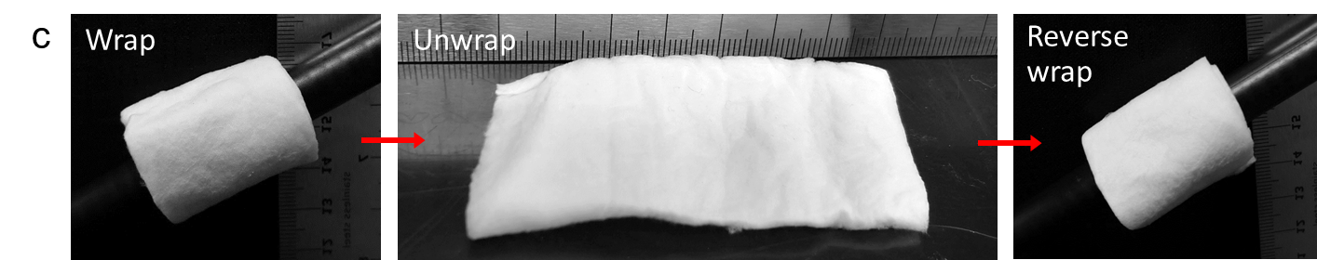
Figure S3. AFZA has been pressed into a fibrous mat of about 0.5 cm thick and cut into a rectangular shape. It could wrap a plastic stick, back to flat, then warp the stick reversibly. No visible damage is caused, suggesting good deformability of AZFA.

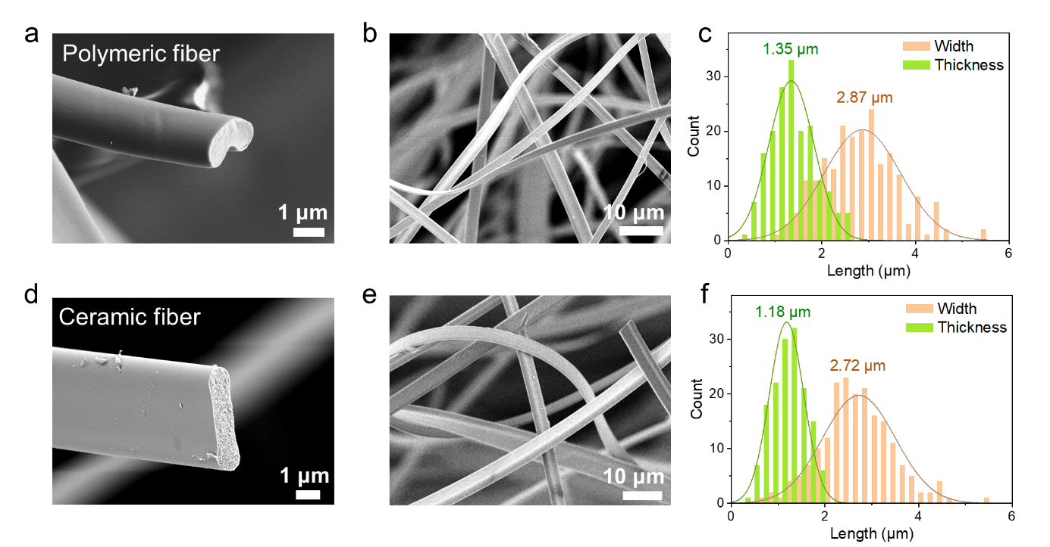
Figure S4. SEM images of (a, b) as-electrospun polymeric fiber and (d, e) calcined Al₂O₃/ZrO₂ ceramic fiber. Both types of fibers show ribbon-shaped morphology with flat cross-sections. The polymeric fibers have smooth surface and solid interior, whereas the ceramic fibers present slightly rough surface and mesoporous core. (c, f) The histograms of the fiber size distributions, where the width and thickness were counted respectively. The smaller size of the ceramic fiber is due to the removal of organic components.

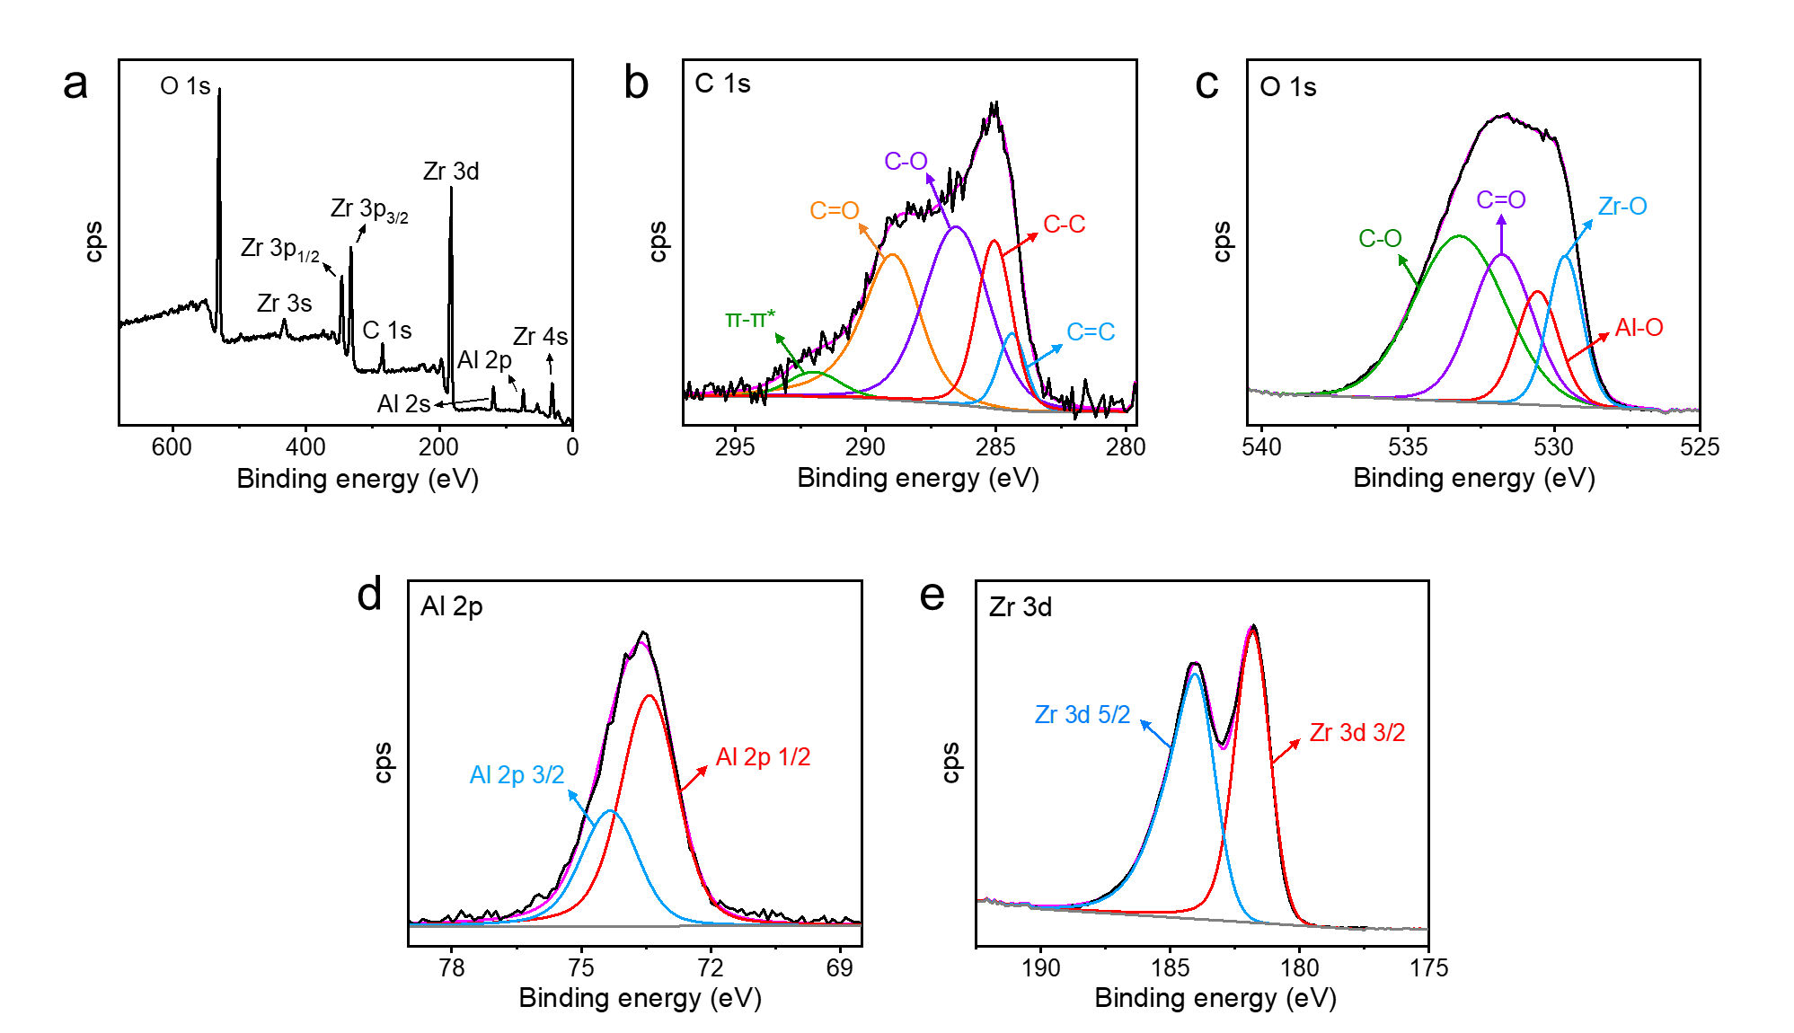
Figure S5. (a) XPS survey spectrum and the deconvolution of (b) C 1s, (c) Al 2p, (d) O 1s, and (e) Zr 3d spectrum show the chemical composition and bonding states. The peak deconvolutions are referred from [3–5].
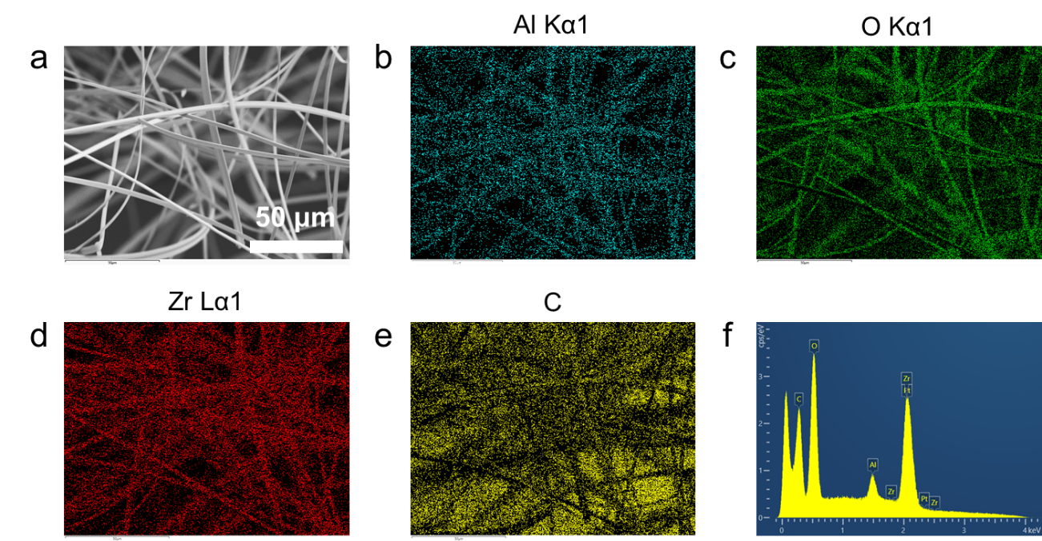
Figure S6. (a) SEM image of AZFA and (b-e) the corresponding energy-dispersive X-ray spectroscopy (EDS) mapping of each element. (f) EDS spectra of the AZFA sample, including 5 nm Pt coating.

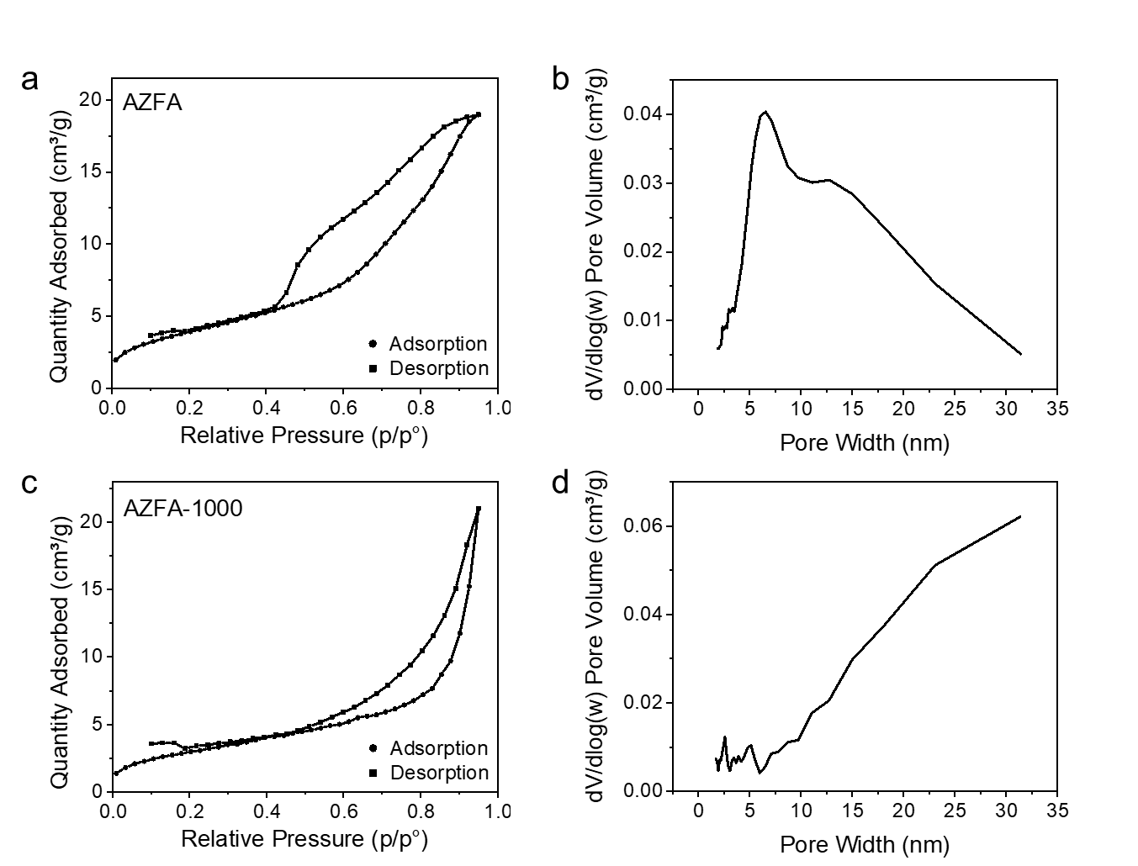
Figure S7. N₂ adsorption/desorption isotherm and Barrett-Joyner-Halenda (BJH) mesopore size distribution curves of (a, b) AZFA and (c, d) AZFA-1000.
Figure S8. Fourier transform infrared (FTIR) attenuated total reflection (ATR) spectra of as-electrospun precursor fiber of AZFA. The board peaks in the range of 3500-3000 cm⁻¹ were attributed to adsorbed water molecules. The absorption peaks at 630 and 823 cm⁻¹ were assigned to Al–O stretching in AlO₆ and AlO₄ respectively, suggesting the condensation of aluminum precursors. [6] The peaks at 1034 cm⁻¹ and 1418 cm⁻¹ correspond to Al-OH bending mode, and 1386 cm⁻¹ was linked to N=O from aluminum nitride. [6, 7] The absorption bands located at 1294 cm⁻¹ are assigned to C–N vibrations in PVP, and the peaks at 1560 cm⁻¹ and 1634 cm⁻¹ are contributed C=O of the carboxylate group. [8]

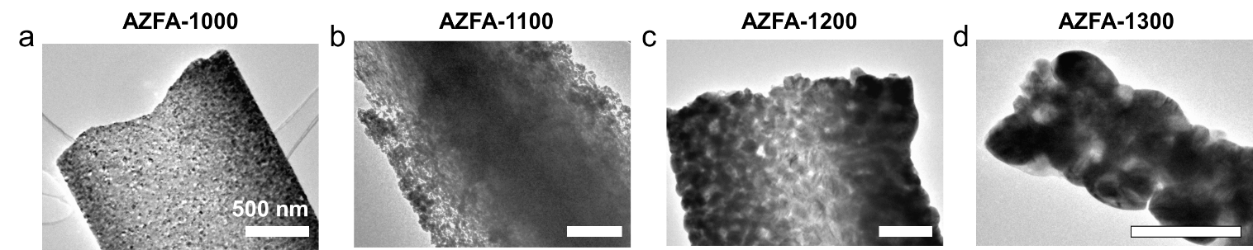
Figure S9. TEM images show the microstructure of AZFA fibers after heat treatment at (a) 1000 °C, (b) 1100 °C, (c) 1200 °C, and (d) 1300 °C for one hour. (Scale bar a-d: 500 nm)

Figure S10. FTIR-ATR spectra of AZFA samples after heat treatment. The broad absorption band in the range of 1000 to 600 cm⁻¹ is the signature of poorly crystallized Al₂O₃. [9] The adsorption peaks at 628 and 663.2 cm⁻¹ are associated with the Zr-O bond. [10, 11] The emergence of these two peaks suggests the ZrO₂ crystal becomes detectable at temperatures beyond 1200 °C. The multiple peaks in the range of 600-750 cm⁻¹ are ascribed to the Al-O stretching mode in octahedrons. [12] The broadness of these peaks indicates the nanocrystalline form of Al₂O₃. [13] The band at around 842 cm⁻¹ is assigned to the Al-O stretching mode in tetrahedral coordination sites. [12]

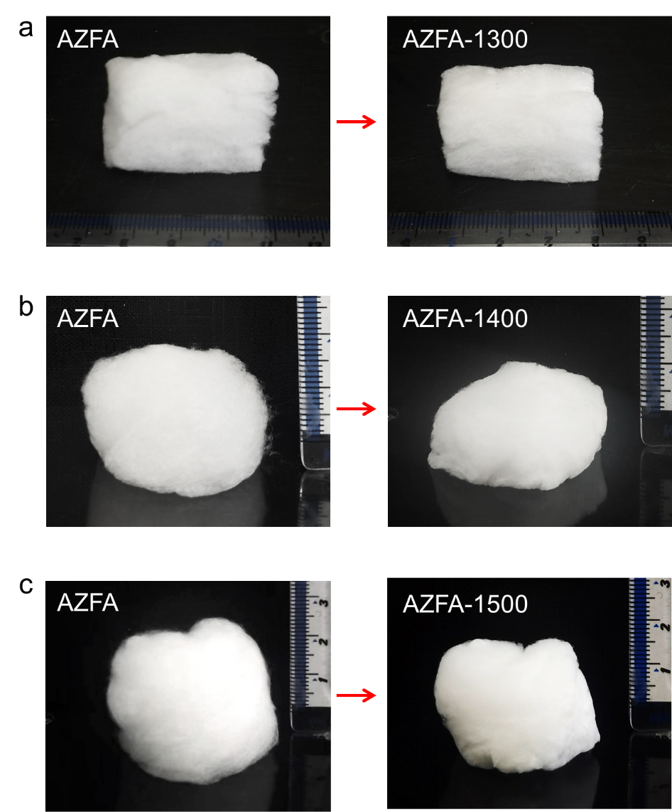
Figure S11. The digital photos of AZFA before and after 1 h heat treatment at (a) 1300 °C, (b) 1400 °C, and (c) 1500 °C. AZFA-1400 and AZFA-1500 show overall size shrinkages and density increases.
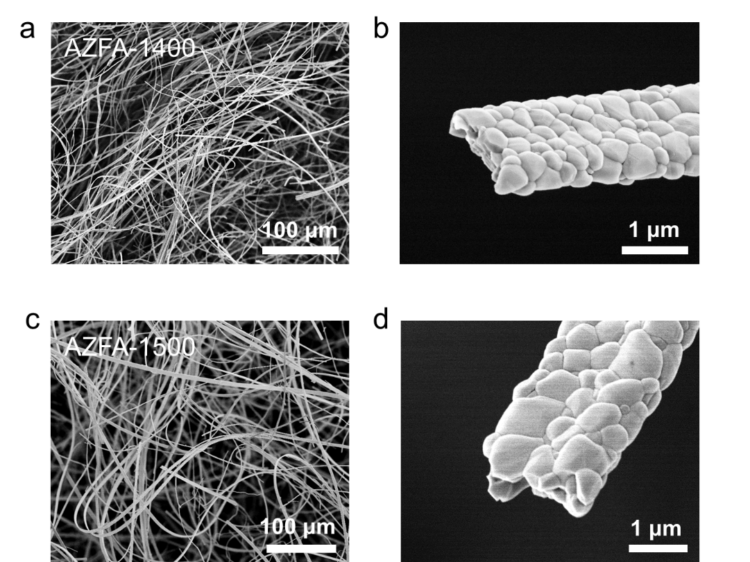
Figure S12. SEM images of AZFA after 1 h heat treatment at (a, b) 1400 °C and (c, d) 1500 °C present the resulting fiber structures at low and high magnification respectively.

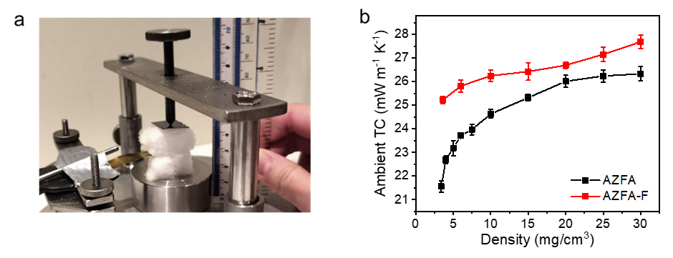
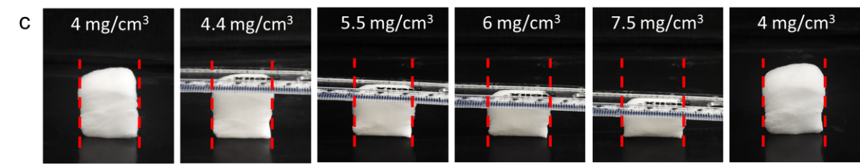
Figure S13. (a) Sensor/sample assembly in the transient plane source (TPS) measurement. A hot disk sensor (2.0 mm in radius) is sandwiched between two AZFA pieces in centimeter sizes. By changing the screw position, a uniaxial force is applied to the sample surface to tune the sample density and minimize the contact resistance between the sample and the sensor. A pressed AZFA sample with density of 15 mg cm⁻³ is shown. (b) Ambient thermal conductivities (TCs) of AZFA and AZFA-F as functions of the overall density. (c) The compression and recovery processes of AZFA. Two red lines in each photo have the same distance in between, suggesting the fiber material has a near-zero Poisson’s ratio. Thus, the overall density of aerogel bulk is reversibly proportional to the height of AZFA.
Note that the TCs are measured by treating the pressed fiber materials as an isotropic bulk. Although TPS system also provides the anisotropic module, performing such measurement needs to input specific heat capacitance, which unfortunately, still relies on the results from bulk isotropic measurement, so the results from the anisotropic module are not reliable unless combined with modeling. [14]
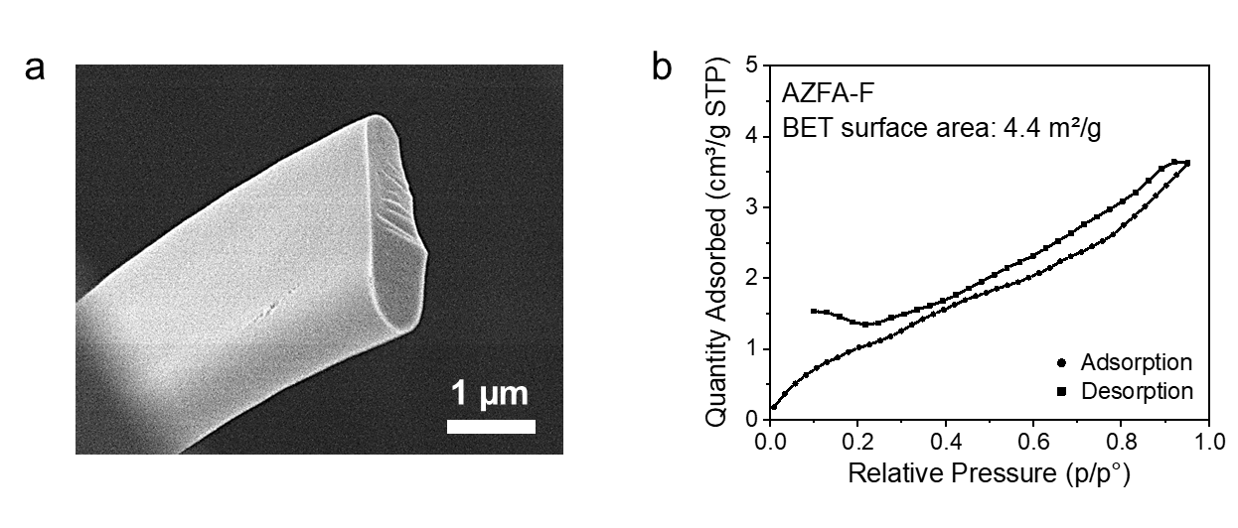
Figure S14. (a) SEM image and (b) N₂ adsorption/desorption isotherm of AZFA-F. The fluorinated fibers show combined characteristics of Type II isotherm (indicative of nonporous or macroporous adsorbent) and Type H4 loop (often associated with narrow slit-like mesopores). [15]

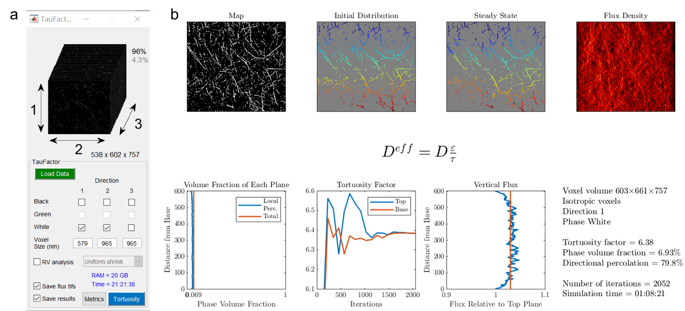

Figure S15. An example of the (a) input image stack and (b) output tortuosity factors (τ) using the MATLAB app, TauFactor [16]. In this case, the white phase presents the solid fiber and the black phase presents the gas. τ is calculated along direction 1, i.e., z direction. The voxel size in direction 1 is decreased from 965 nm to 579 nm to model the fiber macrostructure being pressed along z axis.

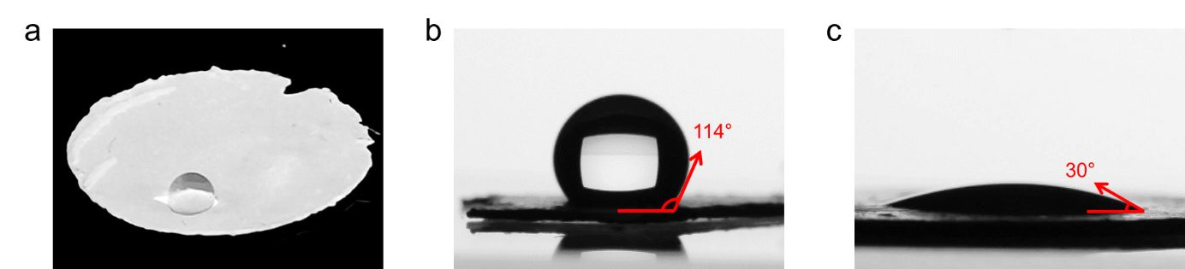
Figure S16. AZFA and AZFA-F are pressed into dense pellets by a pellet pressing machine with 14 tons of force applied. (a) Photograph of a water droplet on AZFA-F pellet. The water contact angle (WCA) measurements on (b) AZFA-F pellet, and (c) AZFA pellet. AZFA pellet shows an initial WCA of 30°, and the water droplet was absorbed within about 16 s.

Table S1. A summary of solution parameters and electrospun fiber macrostructures of solutions with varied precursor ratios.
AC | AN | AiP | ZrAc | Electrical conductivity | Viscosity | Fiber macrostructure
rel. conc. | rel. conc. | rel. conc. | rel. conc. | mS cm⁻¹ | cP
1 | 1 | 1 | 1 | 3.42 | 297.935 | (c) 3D macro-assembly
0.5 | 1 | 1 | 1 | 2.63 | 457.62 | (b) 2D thin mat
1 | 0.5 | 1 | 1 | 2.51 | 387.364 | (b) 2D thin mat
1 | 1 | 0.5 | 1 | 2.96 | 370.667 | (b) 2D thin mat
1 | 1 | 1 | 0.5 | 3.76 | 212.387 | (c) 3D macro-assembly
2 | 1 | 1 | 1 | 3.7 | 733.71 | (a) Cloud-like fiber piles
1 | 2 | 1 | 1 | 4.07 | 622.658 | (a) Cloud-like fiber piles
1 | 1 | 2 | 1 | 2.56 | 743.9 | (a) Cloud-like fiber piles
1 | 1 | 1 | 2 | 1.103 | 2568.9 | Not spinnable

Table S2. Various methods/protocols in fabricating ceramic aerogels (CAs) and ceramic fibrous aerogels (CFAs). The processing times are broken down into the necessary fabrication steps according to the Method section in each reference. Each protocol starts with either solution (sol) or scaffold preparation. The fabrication of CFA includes a ‘spinning’ step using electrospinning (ES) or solution blow spinning (SBS). Furnace treatment is either in high temperature or vacuum. For materials produced through freeze drying (FD), a solution processing step is normally required to induce inorganic binders.
Several assumptions are made when calculating the time: (i) assuming 1 mL solution has been electrospun. The spinning process only accounts for a short time consumption, so such an assumption will not significantly affect the comparison. (ii) The heating and cooling rates of the furnaces are 10 °C s⁻¹ unless specified otherwise, which is a typical rate for muffle furnaces. (iii) Due to the non-specified or ambiguous description in some work, we estimate the ‘shortest’ processing time according to the general knowledge (denoted by ‘>’). (iv) Some steps (e.g., weighting chemicals, sample loading, transfer, manually cutting or stacking the fiber pieces, etc.) that have not been documented in the original work are not included, which may lead to underestimation of the overall fabrication time.
Aerogel | Method | Sol/scaff prep | Spinning | CVD | Furnace treatment | Solution process | Freeze dry (FD) | Furnace treatment | Total | Ref
Aerogel | Method | h | h | h | h | h | h | h | h
AZFA (this work) | 3D ES | 4.0 | 0.2 |  | 5.1 |  |  |  | 9.3
Mullite CFA | 3D ES | 18.0 | 0.1 |  | 3.7 |  |  |  | 21.8 | [17]
Zircon CFA | Blow ES | 2.3 | 0.5 |  | 11.8 |  |  | 11.8 | 26.3 | [18]
Layered ZrO₂/ TiO₂ CFA | Coaxial ES | 8.0 | 1.0 |  | 11.1 |  |  |  | 20.1 | [19]
YSZ CFA | SBS | 20.0 | 0.3 |  | 11.1 |  |  |  | 31.4 | [20]
ZrO₂ CFA | SBS | 6.0 | 0.3 |  | 11.1 |  |  |  | 17.4 | [21]
Lamellar SiO₂/Al₂O₃ CFA | SBS | 3.0 | 0.2 |  | 5.9 |  |  |  | 9.1 | [22]
Mullite CFA | SBS | 5.0 | 0.1 |  | 10.1 |  |  |  | 15.2 | [23]
hBN CA | CVD | 52.8 |  | 10.8 | > 3.5 |  |  |  | > 67.1 | [24]
SiC nanowire CA | CVD | 4.0 |  | 9.1 | 2.8 | assume 3 CVD cycles to have enough layers for a bulk aerogel |  |  | 39.6 | [25]
SiC nanowire CA | CVD | > 6 |  |  | 12.7 |  |  |  | > 18.7 | [26]
Si₃N₄ nanobelt CA | CVD | 4.3 |  | 9.4 | 3.4 | 0.5 |  | 4.4 | 22.0 | [27]
SiO₂ CFA | ES + FD | 16.0 | 1.0 |  | 6.1 | 4.4 | 18.0 | 3.4 | 48.9 | [28]
SiO₂ CFA | ES + FD | 16.0 | 1.0 |  | > 4.6 | 0.5 | 24.0 | 5.4 | > 51.5 | [29]
SiO₂ CFA | ES + FD | 16.0 | 1.0 |  | 6.1 | 4.5 | 24.0 |  | 51.6 | [30]
SiO₂ CFA | ES + FD | 12.0 | 1.0 |  | 3.9 | 0.5 | 24.0 | 3.4 | 44.8 | [31]
Lamellar ZrO₂/Al₂O₃ CFA | ES + FD | 18.0 | 0.3 |  | 5.6 | 0.5 | 30.0 | 28.0 | 82.3 | [32]
Al₂O₃-carbon nanorod CA | Hydrothermal + FD | 66.0 |  |  |  |  | > 12 | 12.3 | > 90.3 | [33]

Table S3. A summary of the crystallite sizes, Brunauer-Emmett-Teller (BET) surface area, averaged grain size, and crystallinity of AZFA samples after each heat treatment.
 | Crystallite size (nm) |  | Surface area | Grain size | Crystallinity
 | t-ZrO₂ | m-ZrO₂ | m²/g | nm | %
AZFA | 8.9 | - | 14.43 | 10 | N/A from XRD
AZFA-1000 | 16.1 | 14 | 11.09 | 35 | 45.3
AZFA-1100 | 16.62 | 20.3 | 6.19 | 54 | 47.8
AZFA-1200 | N/A | 31.3 | 4.02 | 127 | 62.1
AZFA-1300 | - | 38.7 | 3.20 | 163 | 62.3

Table S4. The properties of various hydrophobic aerogels for thermal insulation application. T_{max} is the maximum working temperature in air, which, if not clearly stated in the paper, is estimated based on thermal analysis data of similar material systems.
Aerogel materials | Density | WCA | TC | T_{max} | Ref
 | mg cm⁻³ | ° | mW m⁻¹ K⁻¹ | °C
AZFA-F in this work | 3.6 | 140 | 25.2 | 1300 - 1500  (Hydrophilic above 400 °C)
Polybenzoxazine | 240 - 460 | 159 | 97 | 250 | [34]
Polysilsesquioxane | 50 - 82 | 148 - 165 | 18 - 21 | 300 | [35]
Polyimide/Reduce graphene oxide/Cobalt | 38 | 146.1 | 40 | 300 | [36]
Polybenzazole/MXene | 30 - 70 | 141 | 44.57 | 600 | [37]
Silica/Polyurethane | 33 | 72 - 90 | 26.8 - 31.4 | 200 (estimated) | [38]
Sodium alginate/Sodium lignosulfonate/Phytic acid/Methyltrichlorosilane | 43 - 69 | 145 - 150 | 37 | 242 - 296 | [39]
Silylated cellulose nanofibrils | 6.8 - 17.4 | 132 - 141 | N/A | 322.4 - 341.2 | [40]
Cellulose/SiO₂ | 233 - 450 | 132 | 26 - 31 | 300 (estimated) | [41]
Cellulose/Polyvinyl alcohol | 16 - 112 | 150.5 | 31 - 42 | 320 | [42]
Bagasse/Alkyl ketene dimer | 47.3 | 148 | 36.3 - 42.8 | 300 (estimated) | [43]
Hybrid silica | 96 - 252 | 66 - 147 | 10 - 45 | 500 - 700 (estimated) | [44]
Palygorskite/Methyltrimetho-xysilane | 35 - 52 | 130 | 33.2 | 1000 | [45]

Supplementary Movies

Movie S1. Cyclic compression recovery test of AZFA.
Movie S2. Cyclic compression recovery test of AZFA-1300.
Movie S3. Cyclic compression recovery test of AZFA-1500.
Movie S4. Digital and infrared video of AZFA exposed to a butane blow torch.
Movie S5. Infrared camera video of AZFA exposed to a flame and fast cooling down, where the fiber material is put inside an alumina crucible and fixed using a metal clamp.
Movie S6. Infrared video of AZFA protecting the vial under the flame.
Movie S7. Instant water absorption of AZFA indicates superhydrophilicity.
Movie S8. WCA measurement on AZFA pellet shows the water absorption process of AZFA pellet.

REFERENCES
1. Fong H, Chun I, Reneker DH (1999) Beaded nanofibers formed during electrospinning. Polymer (Guildf). 40:4585–4592
2. Dong S, Maciejewska BM, Lißner M, Thomson D, Townsend D, Millar R, Petrinic N, Grobert N (2023) Unveiling the Mechanism of the in Situ Formation of 3D Fiber Macroassemblies with Controlled Properties. ACS Nano. https://doi.org/10.1021/acsnano.3c00289
3. Chen X, Wang X, Fang D (2020) A review on C1s XPS-spectra for some kinds of carbon materials. Fullerenes, Nanotub Carbon Nanostructures 28:1048–1058
4. Cho SW, Kim KS, Jung SH, Cho HK (2017) Towards environmentally stable solution-processed oxide thin-film transistors: a rare-metal-free oxide-based semiconductor/insulator heterostructure and chemically stable multi-stacking. J Mater Chem C 5:10498–10508
5. Lackner P, Zou Z, Mayr S, Diebold U, Schmid M (2019) Using photoelectron spectroscopy to observe oxygen spillover to zirconia. Phys Chem Chem Phys 21:17613–17620
6. Tan H-B, Guo C-S (2011) Preparation of long alumina fibers by sol-gel method using malic acid. Trans Nonferrous Met Soc China 21:1563–1567
7. Wen Z, Song X, Chen D, Fan T, Liu Y, Cai Q (2020) Electrospinning preparation and microstructure characterization of homogeneous diphasic mullite ceramic nanofibers. Ceram Int 46:12172–12179
8. Kumar MS, Rao MC (2019) Effect of Al2O3 on structural and dielectric properties of PVP-CH3COONa based solid polymer electrolyte films for energy storage devices. Heliyon 5:e02727
9. Djebaili K, Mekhalif Z, Boumaza A, Djelloul A (2015) XPS, FTIR, EDX, and XRD analysis of Al2O3 scales grown on PM2000 alloy. J Spectrosc 2015:
10. Balraj B, Arulmozhi M, Siva C, Krithikadevi R (2017) Synthesis, characterization and electrochemical analysis of hydrothermal synthesized AgO incorporated ZrO2 nanostructures. J Mater Sci Mater Electron 28:5906–5912
11. Das RS, Warkhade SK, Kumar A, Wankhade A V (2019) Graphene oxide-based zirconium oxide nanocomposite for enhanced visible light-driven photocatalytic activity. Res Chem Intermed 45:1689–1705
12. Ahmed MI, Jahin HS, Dessouki HA, Nassar MY (2021) Synthesis and characterization of γ-Al2O3 and α-Al2O3 nanoparticles using a facile, inexpensive auto-combustion approach. Egypt J Chem 64:2509–2515
13. Shek CH, Lai JKL, Gu TS, Lin GM (1997) Transformation evolution and infrared absorption spectra of amorphous and crystalline nano-Al2O3 powders. Nanostructured Mater 8:605–610
14. Elkholy A, Sadek H, Kempers R (2019) An improved transient plane source technique and methodology for measuring the thermal properties of anisotropic materials. Int J Therm Sci 135:362–374
15. Thommes M, Kaneko K, Neimark A V, Olivier JP, Rodriguez-Reinoso F, Rouquerol J, Sing KSW (2015) Physisorption of gases, with special reference to the evaluation of surface area and pore size distribution (IUPAC Technical Report). Pure Appl Chem 87:1051–1069
16. Cooper SJ, Bertei A, Shearing PR, Kilner JA, Brandon NP (2016) TauFactor: An open-source application for calculating tortuosity factors from tomographic data. SoftwareX 5:203–210. https://doi.org/https://doi.org/10.1016/j.softx.2016.09.002
17. Cheng X, Liu Y-T, Si Y, Yu J, Ding B (2022) Direct synthesis of highly stretchable ceramic nanofibrous aerogels via 3D reaction electrospinning. Nat Commun 13:1–8
18. Guo J, Fu S, Deng Y, Xu X, Laima S, Liu D, Zhang P, Zhou J, Zhao H, Yu H (2022) Hypocrystalline ceramic aerogels for thermal insulation at extreme conditions. Nature 606:909–916
19. Dong J, Xie Y, Liu L, Deng Z, Liu W, Zhu L, Wang X, Xu D, Zhang G (2022) Lightweight and resilient ZrO2–TiO2 fiber sponges with layered structure for thermal insulation. Adv Eng Mater 24:2101603
20. Wang H, Lin S, Yang S, Yang X, Song J, Wang D, Wang H, Liu Z, Li B, Fang M (2018) High‐temperature particulate matter filtration with resilient yttria‐stabilized ZrO2 nanofiber sponge. Small 14:1800258
21. Wang H, Zhang X, Wang N, Li Y, Feng X, Huang Y, Zhao C, Liu Z, Fang M, Ou G (2017) Ultralight, scalable, and high-temperature–resilient ceramic nanofiber sponges. Sci Adv 3:e1603170
22. Jia C, Li L, Liu Y, Fang B, Ding H, Song J, Liu Y, Xiang K, Lin S, Li Z (2020) Highly compressible and anisotropic lamellar ceramic sponges with superior thermal insulation and acoustic absorption performances. Nat Commun 11:1–13
23. Li L, Jia C, Liu Y, Fang B, Zhu W, Li X, Schaefer L, Li Z, Zhang F, Feng X (2022) Nanograin–glass dual-phasic, elasto-flexible, fatigue-tolerant, and heat-insulating ceramic sponges at large scales. Mater Today 54:72–82
24. Xu X, Zhang Q, Hao M, Hu Y, Lin Z, Peng L, Wang T, Ren X, Wang C, Zhao Z (2019) Double-negative-index ceramic aerogels for thermal superinsulation. Science (80- ) 363:723–727
25. Su L, Wang H, Niu M, Fan X, Ma M, Shi Z, Guo S-W (2018) Ultralight, recoverable, and high-temperature-resistant SiC nanowire aerogel. ACS Nano 12:3103–3111
26. Lu D, Su L, Wang H, Niu M, Xu L, Ma M, Gao H, Cai Z, Fan X (2019) Scalable fabrication of resilient SiC nanowires aerogels with exceptional high-temperature stability. ACS Appl Mater Interfaces 11:45338–45344
27. Su L, Li M, Wang H, Niu M, Lu D, Cai Z (2019) Resilient Si3N4 Nanobelt Aerogel as Fire-Resistant and Electromagnetic Wave-Transparent Thermal Insulator. ACS Appl Mater Interfaces 11:15795–15803. https://doi.org/10.1021/acsami.9b02869
28. Si Y, Wang X, Dou L, Yu J, Ding B (2018) Ultralight and fire-resistant ceramic nanofibrous aerogels with temperature-invariant superelasticity. Sci Adv 4:eaas8925
29. Dou L, Zhang X, Shan H, Cheng X, Si Y, Yu J, Ding B (2020) Interweaved cellular structured ceramic nanofibrous aerogels with superior bendability and compressibility. Adv Funct Mater 30:2005928
30. Wang F, Dou L, Dai J, Li Y, Huang L, Si Y, Yu J, Ding B (2020) In situ Synthesis of Biomimetic Silica Nanofibrous Aerogels with Temperature‐Invariant Superelasticity over One Million Compressions. Angew Chemie Int Ed 59:8285–8292
31. Dou L, Zhang X, Cheng X, Ma Z, Wang X, Si Y, Yu J, Ding B (2019) Hierarchical cellular structured ceramic nanofibrous aerogels with temperature-invariant superelasticity for thermal insulation. ACS Appl Mater Interfaces 11:29056–29064
32. Zhang X, Wang F, Dou L, Cheng X, Si Y, Yu J, Ding B (2020) Ultrastrong, superelastic, and lamellar multiarch structured ZrO2–Al2O3 nanofibrous aerogels with high-temperature resistance over 1300° C. ACS Nano 14:15616–15625
33. Liu F, He C, Jiang Y, Yang Y, Peng F, Liu L, Men J, Feng J, Li L, Tang G (2023) Carbon layer encapsulation strategy for designing multifunctional core-shell nanorod aerogels as high-temperature thermal superinsulators. Chem Eng J 455:140502
34. Malakooti S, Qin G, Mandal C, Soni R, Taghvaee T, Ren Y, Chen H, Tsao N, Shiao J, Kulkarni SS (2019) Low-cost, ambient-dried, superhydrophobic, high strength, thermally insulating, and thermally resilient polybenzoxazine aerogels. ACS Appl Polym Mater 1:2322–2333
35. Zou F, Yue P, Zheng X, Tang D, Fu W, Li Z (2016) Robust and superhydrophobic thiourethane bridged polysilsesquioxane aerogels as potential thermal insulation materials. J Mater Chem A 4:10801–10805
36. Zhang X, Li W, Song P, You B, Sun G (2020) Double-cross-linking strategy for preparing flexible, robust, and multifunctional polyimide aerogel. Chem Eng J 381:122784. https://doi.org/https://doi.org/10.1016/j.cej.2019.122784
37. Wu Z-H, Feng X-L, Qu Y-X, Gong L-X, Cao K, Zhang G-D, Shi Y, Gao J-F, Song P, Tang L-C (2023) Silane modified MXene/polybenzazole nanocomposite aerogels with exceptional surface hydrophobicity, flame retardance and thermal insulation. Compos Commun 37:101402
38. Nazeran N, Moghaddas J (2017) Synthesis and characterization of silica aerogel reinforced rigid polyurethane foam for thermal insulation application. J Non Cryst Solids 461:1–11
39. Cen Q, Chen S, Yang D, Zheng D, Qiu X (2023) Full Bio-Based Aerogel Incorporating Lignin for Excellent Flame Retardancy, Mechanical Resistance, and Thermal Insulation. ACS Sustain Chem Eng 11:4473–4484
40. Zhang X, Liu M, Wang H, Yan N, Cai Z, Yu Y (2019) Ultralight, hydrophobic, anisotropic bamboo-derived cellulose nanofibrils aerogels with excellent shape recovery via freeze-casting. Carbohydr Polym 208:232–240
41. Shi J, Lu L, Guo W, Zhang J, Cao Y (2013) Heat insulation performance, mechanics and hydrophobic modification of cellulose–SiO2 composite aerogels. Carbohydr Polym 98:282–289
42. Thai QB, Nguyen ST, Ho DK, Du Tran T, Huynh DM, Do NHN, Luu TP, Le PK, Le DK, Phan-Thien N (2020) Cellulose-based aerogels from sugarcane bagasse for oil spill-cleaning and heat insulation applications. Carbohydr Polym 228:115365
43. Li W, Li Z, Wang W, Li Z, Li Q, Qin C, Cao F (2021) Green approach to facilely design hydrophobic aerogel directly from bagasse. Ind Crops Prod 172:113957
44. Rezaei S, Zolali AM, Jalali A, Park CB (2021) Strong, highly hydrophobic, transparent, and super-insulative polyorganosiloxane-based aerogel. Chem Eng J 413:127488
45. Jin H, Zhou X, Xu T, Dai C, Gu Y, Yun S, Hu T, Guan G, Chen J (2020) Ultralight and hydrophobic palygorskite-based aerogels with prominent thermal insulation and flame retardancy. ACS Appl Mater Interfaces 12:11815–11824

