Supplemental Table. 1.Characteristics of studies included for meta-analysis
First Author | Publication year | Country | No. of patients | Male | Age (years) | DWI lesion (ml) | Deterioration time | Preop NHISS | postop NHISS | Follow-up  (months) | No. of  good outcome
Y Yoshimoto | 1995 | Japan | 35 | 24 | 63 | NA | 5 hours to 7 days | NA | NA | 3 | 15
Hwang G | 2011 | Korea | 9 | 8 | 64.1 (38-76) | 15.0±8.87 | NA | 12.4±4.88 | 8.6±6.39 (after 3 days) | 3 | 6
Sang-Bok Lee | 2012 | Korea | 20 | 15 | 50.7 | 8.68±2.61 | 4.6 days | 7±3.68 | 3.57±2.52 | 27.5 (23, 61) | 14
Hyun-Seok Park | 2017 | Korea | 21 | 13 | 62 (49-66） | 13.8 (7.5-26.0) | less than 9h | 10 (8-14） | NA | 3 | 16
Toshikazu Kimura | 2020 | Japan | 35 | 24 | 70.4 | NA | 9.0 hours | 7.8 | 5.2 (after 2 weeks) | 3 | 25
Jang Hun Kim | 2021 | Korea | 18 | 11 | 65.33±12.46 | NA | 2.61±2.21 days | 12.11 ± 4.84 | 9.89 ± 6.52 (after 1 week) | 9.72 ± 5.00 | 12
Yun Ho Noh | 2021 | Korea | 10 | 5 | 70.9±14.7 | 11.3 | 12(6-18) hours | 7.7±7.49 | NA | 6 | 8
Deterioration time, time from onset/aggravation to surgery; preNIHSS, preoperative NIHSS score; postop NHISS, postoperative NIHSS score; Good outcome: mRS score of 0–2 at the last follow-up .

Supplemental Table. 2 MINORS index for included non-randomized studies.
Study | Q1 | Q2 | Q3 | Q4 | Q5 | Q6 | Q7 | Q8 | Q9 | Q10 | Q11 | Q12 | Total
Y Yoshimoto, 1995 | 2 | 2 | 1 | 2 | 0 | 2 | 2 | 0 | 2 | 2 | 2 | 2 | 19
Hwang G, 2011 | 2 | 2 | 2 | 2 | 1 | 1 | 2 | 0 |  |  |  |  | 12
Sang-Bok Lee, 2012 | 2 | 2 | 2 | 2 | 2 | 2 | 2 | 0 |  |  |  |  | 14
Hyun-Seok Park, 2017 | 2 | 2 | 2 | 2 | 2 | 2 | 2 | 2 | 2 | 2 | 1 | 2 | 23
Toshikazu Kimura, 2020 | 2 | 2 | 0 | 2 | 2 | 2 | 2 | 0 | 1 | 2 | 1 | 2 | 18
Jang Hun Kim, 2021 | 2 | 2 | 2 | 2 | 2 | 2 | 2 | 2 |  |  |  |  | 16
Yun Ho Noh, 2021 | 2 | 2 | 0 | 2 | 2 | 2 | 2 | 2 | 2 | 2 | 1 | 0 | 19

The items are scored 0 (not reported), 1 (reported but inadequate) or 2 (reported and adequate).

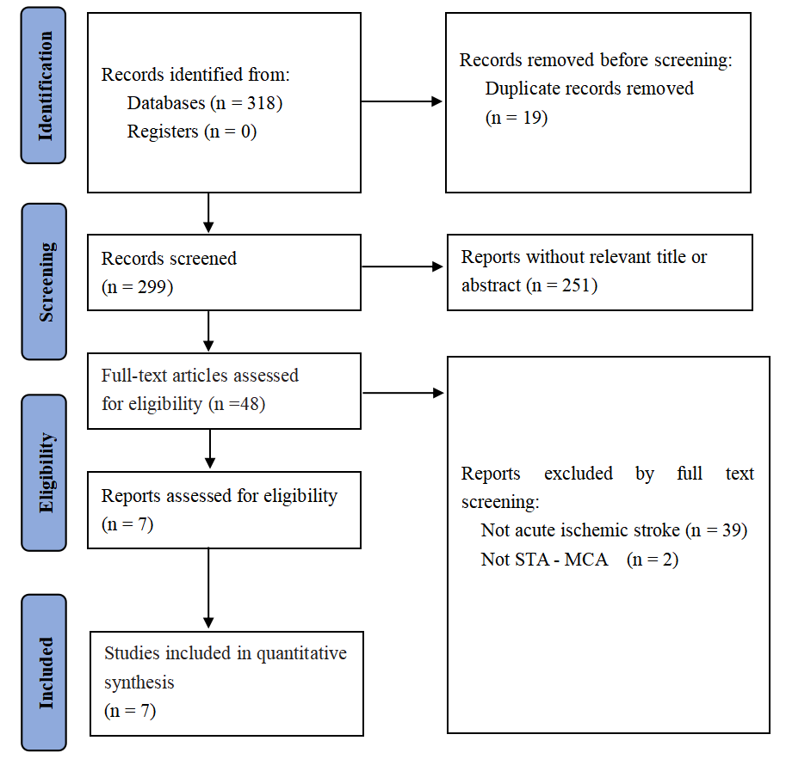
Supplemental fig. 1 Literature search flow chart.
Note: Flowchart of the literature search and selection for systematic review and meta-analysis.
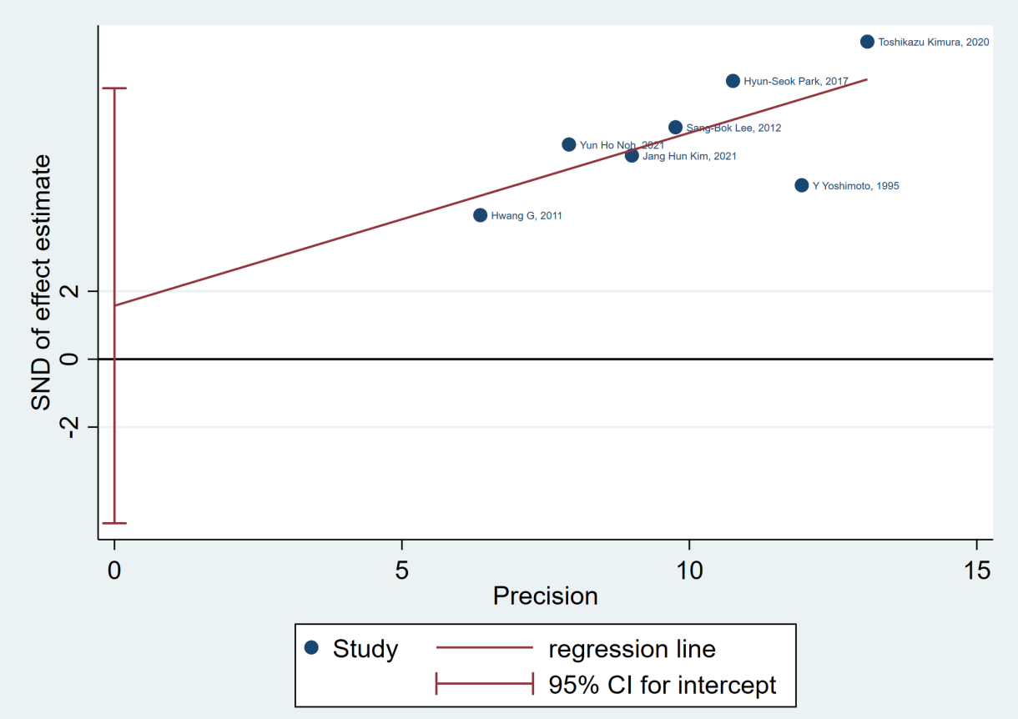
Supplemental fig. 2 Egger’s test with the pseudo 95%CI (P = 0.555).

Note: The Egger’s test showed no publication bias and small-study effects.

