Title: Clinical efficacy analysis of percutaneous "tripod" combined with radiofrequency ablation and bone cement filling in the treatment of periacetabular metastases.

Author information : Yun Lan ^{1,2△}, Ruoyu Li ^{1△} , Linheng Jiang ², Nannan Zhou ¹, Mincon He ³, Bin Fang ¹, Chunzhi Yi ^{1*}

- Department of Orthopedic Oncology, the First Affiliated Hospital of Guangzhou University of Chinese Medicine, Guangzhou 510000, Guangdong, China
- The First Clinical Medical College of Guangzhou University of Chinese Medicine, Guangzhou 510000, Guangdong, China
- Guangdong Academy of Traditional Chinese Medicine Orthopedics and Traumatology, Guangzhou 510000, Guangdong, China

△Co-first author: Yun Lan, Ruoyu Li.
*Corresponding author：Chunzhi Yi , ORCID: 0000000329701575 E-mail: 531667142@qq.com

Typical cases
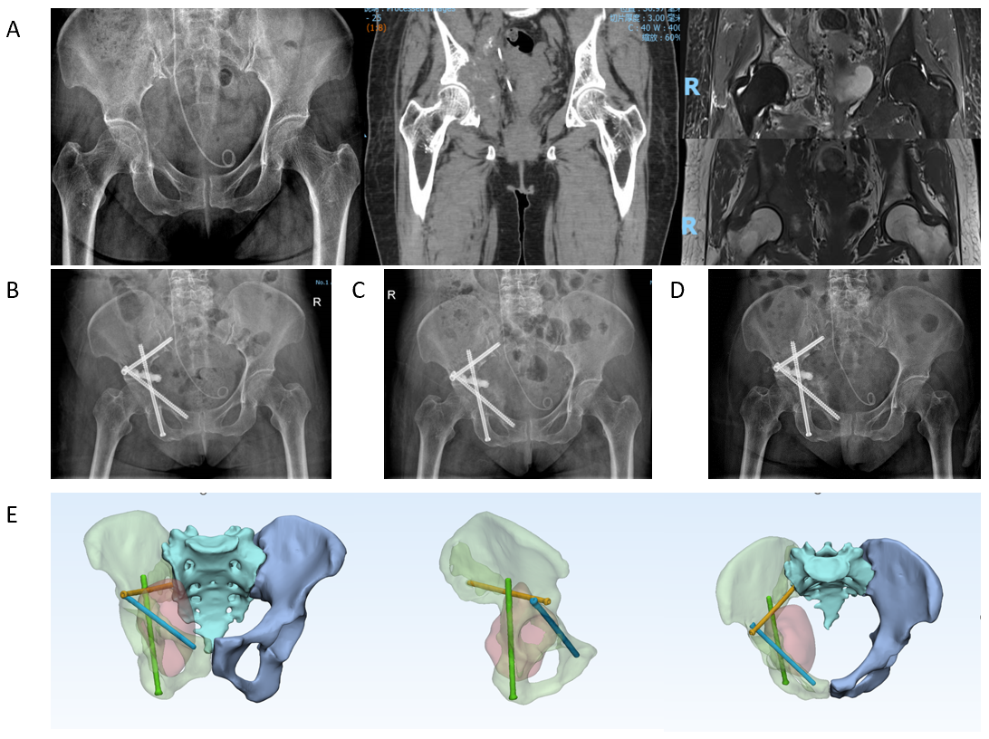

Figure 1 A 72-year-old female patient with a previous history of bladder cancer for more than 2 years and hip pain for 3 months was diagnosed with multiple metastases from bladder cancer. A: Preoperative lesion X-ray, CT and MRI, which showed osteolytic destruction of the inner wall of the patient's right acetabulum and above, with a soft tissue mass protruding into the pelvis; Harington type 3; B: X-rays 3 days after surgery showed good screw fixation and cement protruding into the pelvis along the lesion, and the patient had no obvious discomfort ;C: Postoperative 2-month x-ray, no change in screw position and osteogenic changes within the medial acetabular lesion; D: On postoperative X-ray review in 6 months, the internal fixation was secure and the local lesion was further osteogenic; E: Post-operative 3D reconstruction schematic, which can understand the position of the screw from different angles.

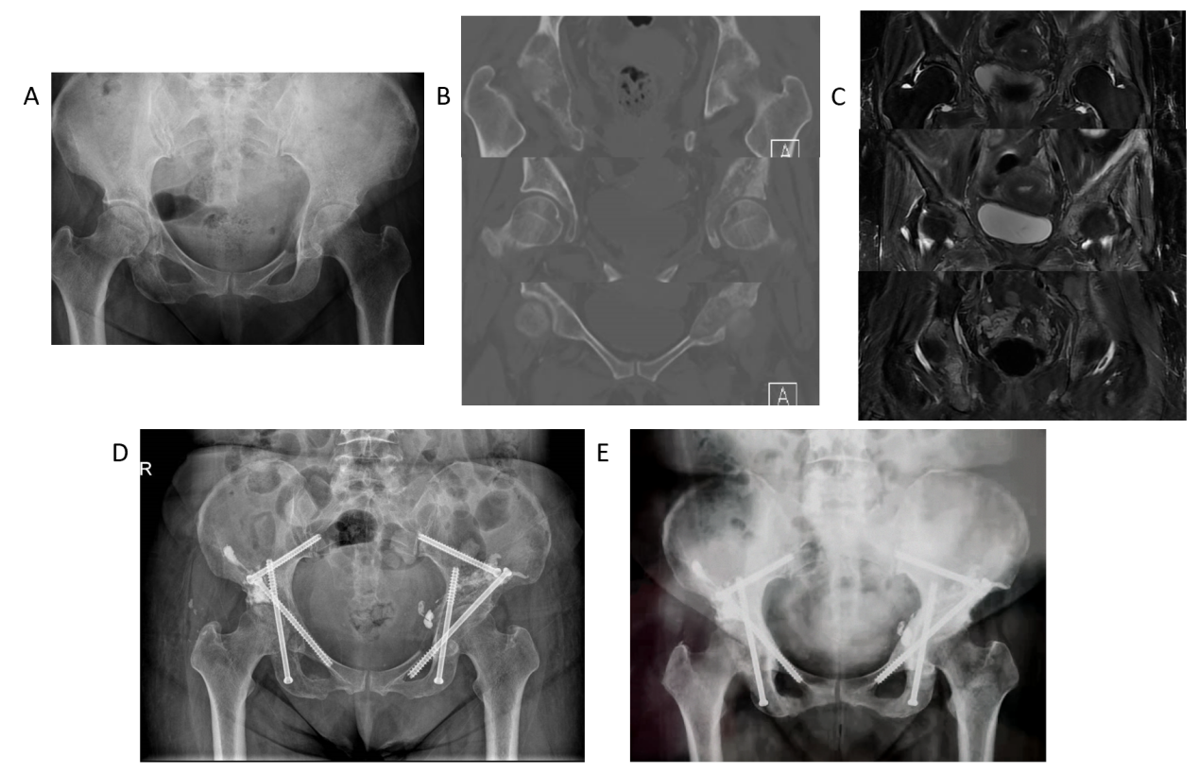
Figure 2 A 54-year-old female patient with a history of lung cancer for 1 year, bilateral hip pain and limited mobility for 4 months, was diagnosed with multiple metastasis of lung cancer. A, B, C: X-ray, CT, MRI at the affected area before surgery, bilateral osteolytic destruction of the medial wall and upper acetabulum, all Harington type 3; D: X-ray 1 day after surgery, bilateral acetabulum, iliac screw fixation and bone cement filling, a slight bone cement exudation from the inner edge of the left acetabulum, and the position of both hip joints is normal; E: X-rays were re-examined three months after surgery, and the screw position did not change, and the osteogenesis of the lesion changed.

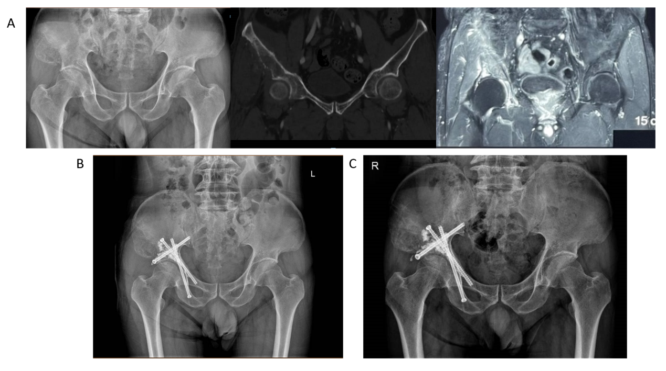

Figure 3 A 64-year-old male patient with a history of prostate cancer for more than 1 year, right hip pain and limited mobility for 1 year, was diagnosed with prostate cancer and metastases to the right pelvis.A: X-ray, CT, and MRI of the affected area before surgery, visible osteolytic destruction above the right acetabulum and inner wall, Harington type 3; B: X-ray 3 days after surgery, it can be seen that the screw position is good, and the bone cement is evenly diffused above the acetabulum; C: X-ray was re-examined two months after surgery, the screw position did not change, and the local osteogenesis of the lesion above the acetabulum changed.

