Supplemental Material
Table S1: Number of replicates in the field experiment.
Treatment | Number of replicates
FB_100 | 1
FB_100_SW_SUAh_100 | 1
FB_33_SW_SUAh_33 | 2
FB_33_SW_Ana_33 | 1
FB_50_SW_SUAh_50 | 3
FB_50_SW_Ana_50 | 1
SW_SUAh_100 | 1
SW_Ana_100 | 3

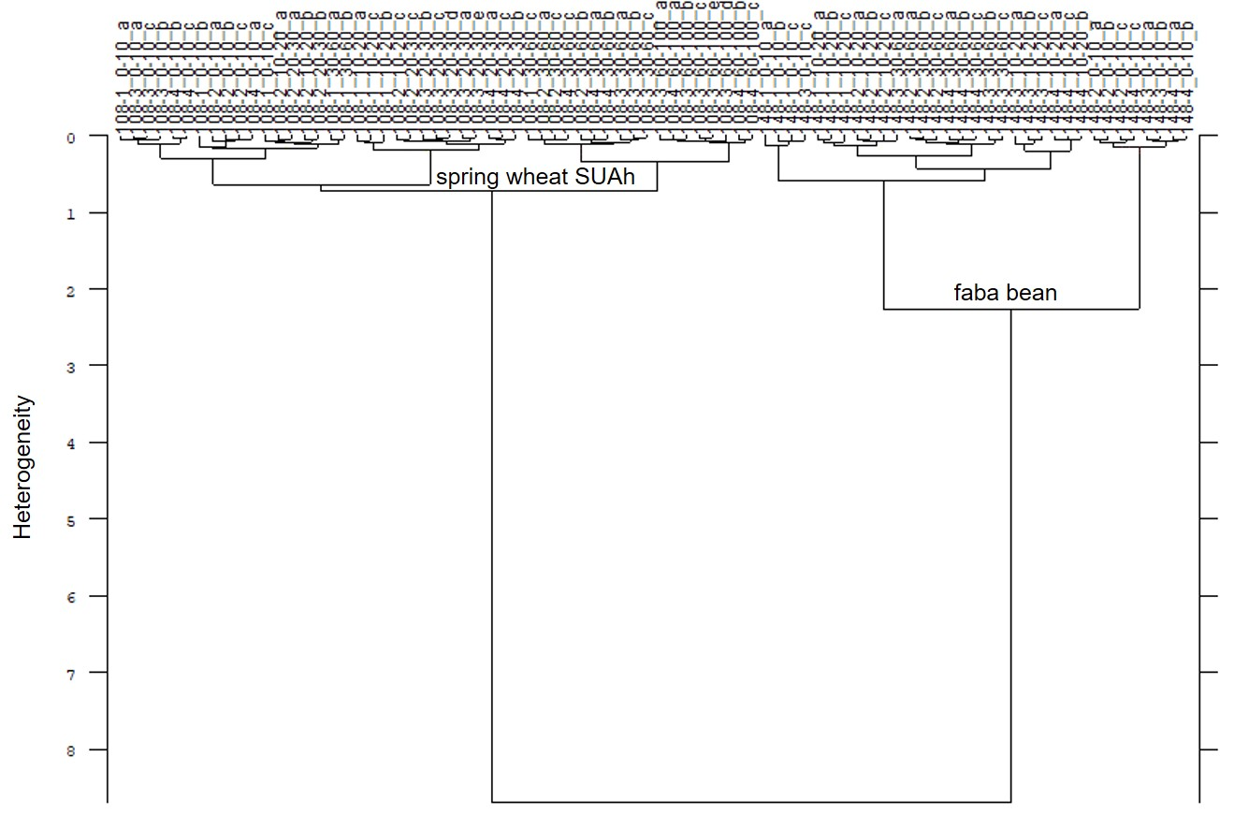
Figure S1: Cluster analysis of FTIR spectra of single species samples of dried and ground roots of spring wheat (cv. SU Ahab) and faba bean of the first sampling date. Cluster analysis was evaluated with the second derivative and vector normalization of the reduced frequence range (4000-3630 cm⁻¹, 1840-1480 cm⁻¹ and 1120-760 cm⁻¹), Ward’s algorithm and Euclidian distance.

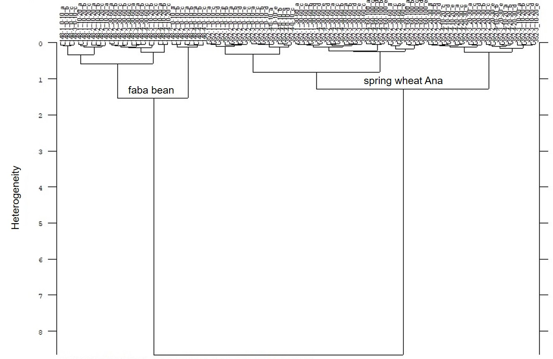
Figure S2: Cluster analysis of FTIR spectra of single species samples of dried and ground roots of spring wheat (cv. Anabel) and faba bean (cv. Fanfare) of the first sampling date. Cluster analysis was evaluated with the second derivative and vector normalization of the reduced frequence range (3700-3330 cm⁻¹, 1550-1300 cm⁻¹ and 1200-850 cm⁻¹), Ward’s algorithm and Euclidian distance.

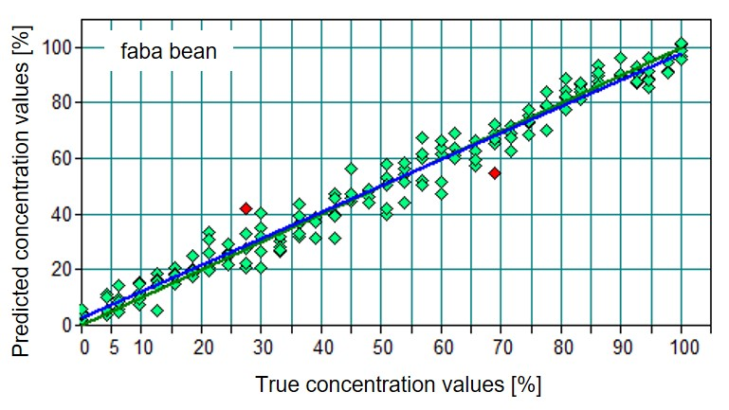
Figure S3: Predicted concentration values of faba bean (blue regression line) in comparison to the true (known) concentration values (green dots and green regression line) of the “artificial mixtures” of the model Ana – faba bean of the first sampling date. The red dots are outlier calculated by the model. The corresponding figure of spring wheat for the model SUAh – faba bean of the first sampling date as well as spring wheat – faba bean model of the second sampling date are very similar and therefore not shown.

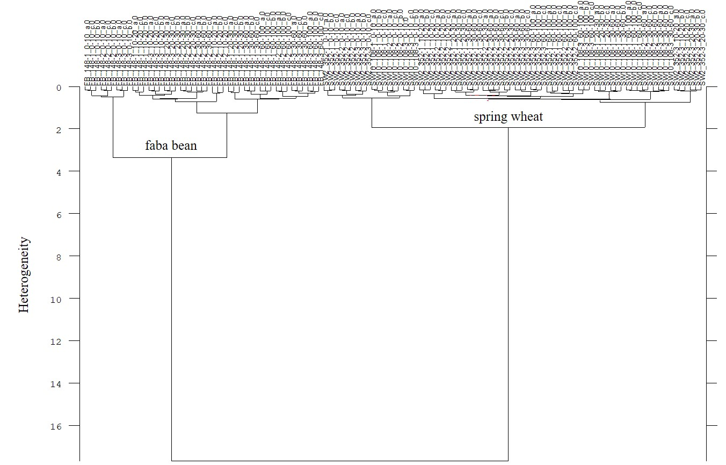
Figure S4: Cluster analysis of FTIR spectra of single species samples of dried and ground roots of both spring wheat varieties (Ana, SUAh) and faba bean of the second sampling date. Cluster analysis was evaluated with the second derivative and vector normalization of the reduced frequency range (3750-2750 cm⁻¹ and 1800-850 cm⁻¹), Ward’s algorithm and Euclidian distance.

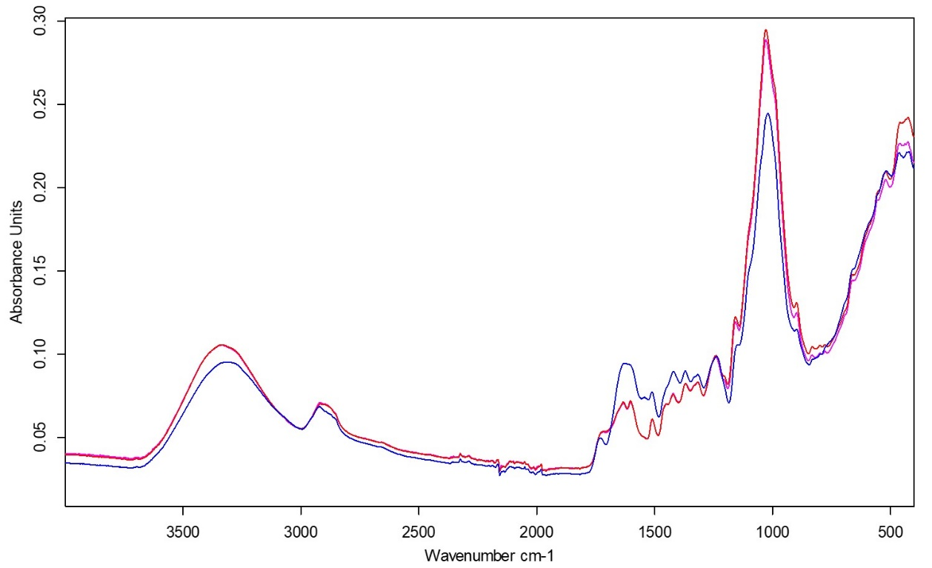
Figure. S5: Average FTIR spectra of faba bean (blue line) and spring wheat cv. SU Ahab (pink line) and spring wheat cv. Anabel (red line) at the second sampling date. The red and pink average FTIR spectra of the two spring wheat varieties coincide nearly in every wave number.

Table S2: Model details and statistical values for the models of spring wheat Ahab (SU Ahab) and faba bean (FB), as well as spring wheat Anabel (Ana) and faba bean at the first sampling date. Abbreviation: 1st der. – first derivative, SNV – vector normalization, R² - coefficient of determination (%), RPD – residual prediction deviation, RMSECV – root mean square error of cross validation, offset – offset of the regression line “predicted concentration values vs. true concentration values” for both species, slope– slope of the regression line “predicted concentration values vs. true concentration values”, RMSEP – root mean square error of prediction, SW – spring wheat.
first sampling date |  | SU Ahab - FB | Anabel - FB
Data pre-processing |  | 1st der. + SNV | 1st der. + SNV
Frequency range [cm⁻¹] |  | 3998 - 3636 | 3702 - 3328
 |  | 1841 - 1477 | 1547 - 1300
 |  | 1120 - 759 | 1202 - 849
Calibration | R² | 93.72 | 97.26
internal validation | RPD | 3.99 | 6.04
 | RMSECV | 7.49 | 4.94
 | Offset SW | 3.048 | 2.257
 | Offset FB | 3.377 | 2.404
 | Slope | 0.936 | 0.953
External validation | RPD | 3.33 | 4.23
 | RMSEP | 8.45 | 6.55
 | Offset SW | 0.309 | 5.906
 | Offset FB | 3.903 | 2.948
 | Slope | 0.958 | 0.911

Table S3: Model details and statistical values for the model of both spring wheat varieties (SW) and faba bean (FB) at the second sampling date. Abbreviation: 2nd der. – second derivative, SNV – vector normalization, R² - coefficient of determination (in %), RPD – residual prediction deviation, RMSECV – root mean square error of cross validation, offset – offset of the regression line “predicted concentration values vs. true concentration values” for both species, slope– slope of the regression line “predicted concentration values vs. true concentration values”, RMSEP – root mean square error of prediction, SW – spring wheat.
second sampling date |  | SW - FB
Data pre-processing |  | 2nd der. + SNV
Frequency range [cm⁻¹] |  | 3638 - 3277
 |  | 2920 - 2557
 |  | 2200 - 1839
 |  | 1479 - 759
Calibration | R² | 95.89
internal validation | RPD | 4.94
 | RMSECV | 6.02
 | Offset SW | 2.802
 | Offset FB | 2.426
 | Slope | 0.948
External validation | RPD | 4.73
 | RMSEP | 5.67
 | Offset SW | 2.077
 | Offset FB | 1.587
 | Slope | 0.963

Table S4. Spring wheat (wheat) and faba bean (bean) shoot traits (n=1) measured on two sampling dates and at harvest. cv. Stands for cultivar. The species and the total sowing density (SD) is given in %. Crop height is given in cm. Dry matter above- ground biomass (AGB), grain yield (GY), and straw are given in t ha⁻¹. Bean and Wheat nr. stand for number of plants per m².

abbr. | SW_SUAh_100 | SW_Ana_100 |  | FB _100 |  | FB_  33_SW_Ana_33 | FB_  33_SUAh_33 | FB_  50_Ana_50 | FB_  50_SUAh_50 | FB_  100_SUAh_100
6-8/06/2021
SW height | 48 | 49 |  |  | 56 |  | 55 | 57 | 56 | 54
FB height |  |  | 58 |  | 62 |  | 55 | 64 | 59 | 68
SW AGB | 2.6 | 3.1 |  |  | 1.8 |  | 1.7 | 2.6 | 2 | 2.3
FB AGB |  |  | 1.9 |  | 0.8 |  | 0.4 | 1.1 | 0.7 | 1.6
5-8/07/2021
Wheat nr. | 398 | 395 |  |  | 105 |  | 119 | 221 | 190 | 436
Bean nr. |  |  | 48 |  | 19 |  | 17 | 26 | 26 | 45
Wheat height | 79 | 75 |  |  | 75 |  | 80 | 78 | 83 | 85
Bean height |  |  | 105 |  | 92 |  | 88 | 94 | 95 | 100
Wheat AGB | 8 | 10 |  |  | 5.3 |  | 5.9 | 5.8 | 4.8 | 5.5
FB AGB |  |  | 6.6 |  | 2.7 |  | 2.6 | 3 | 3.7 | 4.7
Harvest (13/08/2021)
SW GY | 4 | 5.2 |  |  | 2.3 |  | 3 | 2.5 | 2.7 | 2.2
FB GY |  |  | 3.4 |  | 2.9 |  | 2.6 | 2 | 2.7 | 3.1
Total GY | 4 | 5.2 | 3.4 |  | 5.2 |  | 5.6 | 4.5 | 5.4 | 5.4
Proportion of FB of total GY, in % | 0 | 0 | 100 |  | 56 |  | 47 | 45 | 50 | 58
SW straw | 4.6 | 5.5 |  |  | 3 |  | 3.7 | 3.4 | 3.5 | NA
FB straw |  |  | 3.5 |  | 2.2 |  | 1.9 | 1.6 | 2.1 | NA
SW AGB | 8.6 | 10.7 |  |  | 5.3 |  | 6.7 | 5.9 | 6.2 | NA
FB AGB |  |  | 6.9 |  | 5.1 |  | 4.5 | 3.6 | 4.8 | NA
Proportion of FB of total AGB, in % |  |  | 100 |  | 49.0 |  | 40.2 | 37.9 | 43.6 | NA

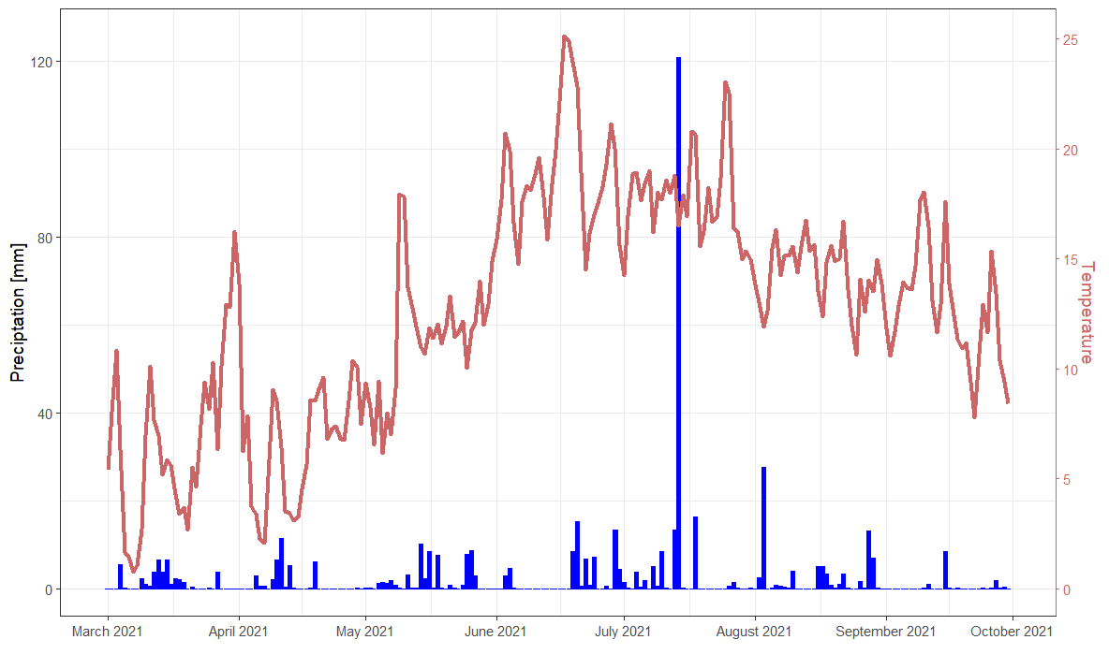Figure S6: Daily precipitation in mm (blue bars) and mean daily air temperature in °C in the study site at Campus Klein Altendorf, University of Bonn, Germany, from March 2021 to October 2021.

Table S5: Sum of the mean root mass (t ha⁻¹) for the soil depth 0-1m, as well as calculated increase in root mass, on sampling dates one (09/06/2021, flowering of spring wheat) and two (05/07/2021, flowering of faba bean).
Treatment | Sampling date 1 | Sampling date 2 | Increase (%)
FB_100 | 1.50 | 2.28 | 34
FB_100_SW_SUAh_100 | 1.17 | 1.98 | 41
FB_33_SW_Ana_33 | 1.83 | 2.30 | 20
FB_33_SW_SUAh_33 | 2.11 | 3.14 | 33
FB_50_SW_Ana_50 | 1.64 | 3.07 | 46
FB_50_SW_SUAh_50 | 2.03 | 2.57 | 21
SW_Ana_100 | 1.17 | 1.35 | 13
SW_SUAh_100 | 1.09 | 1.45 | 25

Table S6: Results of a two way Anova (alpha=0.05) including degrees of Freedom (Df), sum of squares (Sum Sq), Mean square (Mean Sq), F value and P value.
 | Df | Sum Sq | Mean Sq | F value | P (>F)
SD | 2 | 1.6316 | 0.8158 | 4.313 | 0.0331
Cultivar | 1 | 0.2848 | 0.2848 | 1.506 | 0.2387
SD:Cultivar | 1 | 0.1023 | 0.1023 | 0.541 | 0.4734
Residuals | 15 | 2.8372 | 0.1891

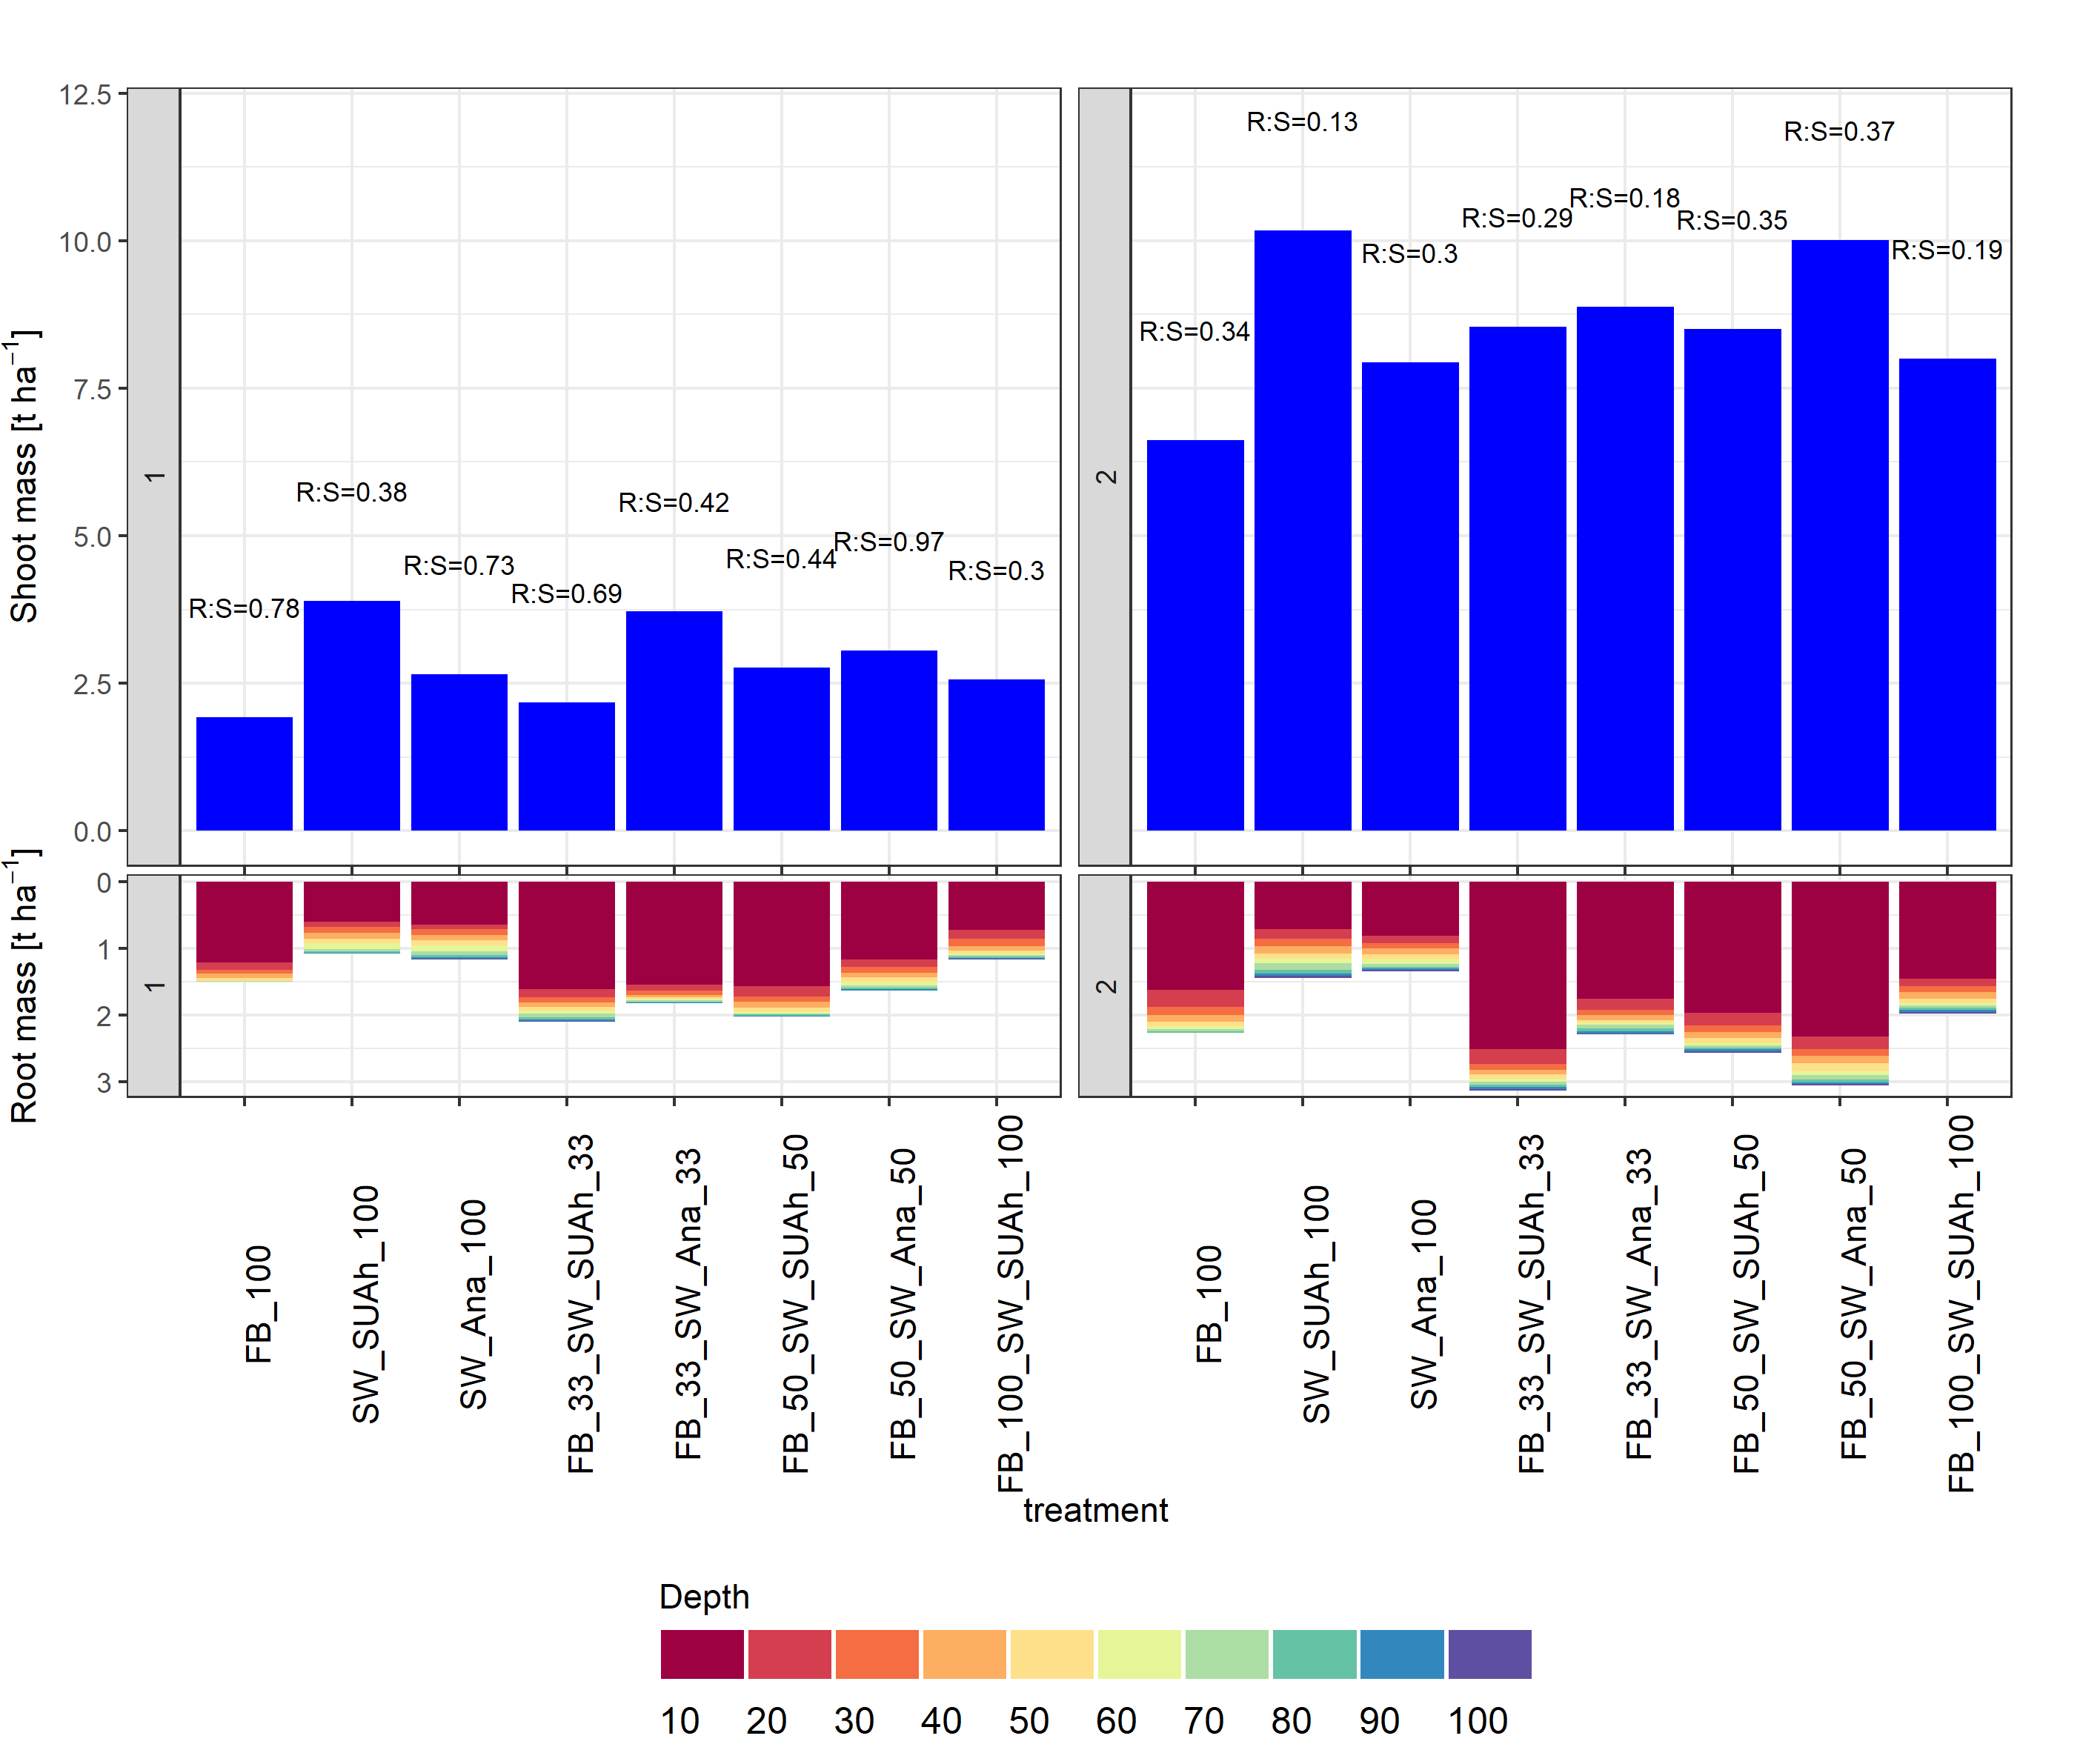
Figure S7: Total shoot (n = 1) and mean values of root mass (n=4) in t ha⁻¹ and root to shoot ratio (R:S) of sole faba bean, sole spring wheat and the intercrop treatments. Bars above represent shoot dry mass, bars below show root dry mass. Bar colours refer to different soil depth layers (10 cm intervals) from 0-100 cm. The panel in the left represents data from date one (09/06/2021) and the one on the right from sampling date two (05/07/2021).

Table S7: Mean (n=4) root length density (RLD, cm³ cm⁻³) per layer and cumulated for topsoil, upper and deeper subsoil on A) 09/06/2021) and B) 05/07/2021.

A)
mean RLD | Depth (cm)
Treatment | 10 | 20 | 30 | Sum  0-30 | 40 | 50 | 60 | Sum  30-60 | 70 | 80 | 90 | 100 | Sum  60-100 | Sum  0-100
FB_100 | 0.8 | 0.3 | 0.2 | 1.3 | 0.3 | 0.3 | 0.0 | 0.6 | 0.0 | 0.0 | 0.0 | 0.0 | 0.1 | 2
SW_SUAh_100 | 2.3 | 0.9 | 0.9 | 4.1 | 0.6 | 0.7 | 0.7 | 2.0 | 0.2 | 0.0 | 0.0 | 0.0 | 0.3 | 6.4
SW_Ana_100 | 2.4 | 0.8 | 1.1 | 4.3 | 1.0 | 0.9 | 0.9 | 2.8 | 0.9 | 0.4 | 0.1 | 0.1 | 1.5 | 8.6
FB_33_SW_Ana_33 | 2.0 | 0.8 | 0.9 | 3.8 | 0.4 | 0.4 | 0.5 | 1.3 | 0.3 | 0.2 | 0.1 | 0.1 | 0.7 | 5.8
FB_33_SW_SUAh_33 | 2.2 | 1.0 | 0.8 | 4.0 | 0.6 | 0.5 | 0.5 | 1.7 | 0.7 | 0.5 | 0.3 | 0.1 | 1.6 | 7.3
FB_50_SW_Ana_50 | 2.4 | 1.1 | 1.1 | 4.6 | 0.8 | 1.0 | 0.6 | 2.4 | 0.5 | 0.1 | 0.0 | 0.0 | 0.7 | 7.7
FB_50_SW_SUAh_50 | 2.2 | 1.1 | 0.8 | 4.1 | 0.9 | 0.9 | 0.4 | 2.2 | 0.4 | 0.2 | 0.1 | 0.0 | 0.8 | 7.1
FB_100_SW_SUAh_100 | 2.4 | 0.7 | 1.1 | 4.2 | 0.6 | 0.6 | 0.3 | 1.5 | 0.3 | 0.2 | 0.2 | 0.1 | 0.8 | 6.5

B)
Mean RLD | Depth (cm)
Treatment | 10 | 20 | 30 | Sum 0-30 | 40 | 50 | 60 | Sum 30-60 | 70 | 80 | 90 | 100 | Sum 60-100 | Sum 0-100
FB_100 | 1.9 | 0.7 | 0.7 | 3.3 | 0.6 | 0.6 | 0.2 | 1.5 | 0.2 | 0.2 | 0.1 | 0.0 | 0.4 | 5.2
SW_SUAh_100 | 5.7 | 2.3 | 2.2 | 10.2 | 1.9 | 1.7 | 1.5 | 5.0 | 1.5 | 0.9 |  | 0.4 | 2.8 | 18
SW_Ana_100 | 5.2 | 2.2 | 1.8 | 9.3 | 2.1 | 1.9 | 1.7 | 5.6 | 1.6 | 1.0 | 0.5 | 0.4 | 3.6 | 18.5
FB_33_SW_Ana_33 | 5.6 | 1.9 | 1.6 | 9.0 | 1.1 | 0.8 | 1.2 | 3.2 | 1.3 | 1.1 | 0.7 | 0.4 | 3.5 | 15.7
FB_33_SW_SUAh_33 | 6.5 | 2.4 | 2.0 | 10.9 | 1.4 | 1.3 | 1.2 | 4.0 | 1.7 | 1.3 | 0.9 | 0.7 | 4.6 | 19.5
FB_50_SW_Ana_50 | 6.7 | 2.3 | 2.3 | 11.3 | 2.0 | 2.5 | 1.6 | 6.0 | 1.4 | 0.9 | 0.5 | 0.5 | 3.3 | 20.6
FB_50_SW_SUAh_50 | 6.4 | 2.1 | 1.8 | 10.3 | 1.7 | 1.7 | 1.0 | 4.3 | 1.0 | 0.8 | 0.7 | 0.3 | 2.8 | 17.4
FB_100_SW_SUAh_100 | 6.6 | 1.5 | 1.8 | 9.9 | 1.3 | 1.2 | 0.9 | 3.4 | 0.9 | 1.0 | 0.8 | 0.4 | 3.0 | 16.3

Table S8: Observed and expected specific root length SRL (m g⁻¹) per layer and mean values for topsoil, upper and deeper subsoil on A) 09 /06/2021) and B) 05/07/2021.

A)

Mean of SRL | Depth (cm)
Treatment | 10 | 20 | 30 | mean 0-30 | 40 | 50 | 60 | mean 30-60 | 70 | 80 | 90 | 100 | mean 60-100 | mean  0-100 | Expected  0-100
FB_100 | 8 | 25.3 | 43.4 | 25.6 | 44.1 | 72.6 | 52.8 | 56.5 | 124.3 |  |  |  | 124.3 | 52.9
SW_SUAh_100 | 45 | 118.6 | 105.8 | 89.8 | 79.3 | 99.4 | 86.9 | 88.5 | 60.3 | 53.9 | 43.6 | NA | 52.6 | 85
SW_Ana_100 | 42.5 | 112.6 | 126.1 | 93.7 | 106.9 | 124.7 | 116.9 | 116.2 | 135.1 | 117.5 | 120.8 | 104.6 | 119.5 | 109.3
FB_33_SW_SUAh_33 | 13.8 | 81.7 | 110.4 | 68.6 | 95.2 | 114 | 110.6 | 106.6 | 127.8 | 132.5 | 107.9 | 84.1 | 113.1 | 93.4 | 45.507
FB_33_SW_Ana_33 | 13 | 95.5 | 141.8 | 83.4 | 121.4 | 207.2 | 219.6 | 182.7 | 201.1 | 207.1 | 151.3 | 108.3 | 166.9 | 142.8 | 53.526
FB_50_SW_SUAh_50 | 14.3 | 69.5 | 107.7 | 63.8 | 97.2 | 151.7 | 116.8 | 121.9 | 165.7 | 204 | 149 | NA | 172.9 | 103.3 | 68.95
FB_50_SW_Ana_50 | 16 | 107.7 | 114.3 | 79.3 | 131.4 | 131.4 | 141.8 | 134.9 | 163.1 | 133 | 98.1 | 75.6 | 117.4 | 115.1 | 81.1
FB_100_SW_SUAh_100 | 60.3 | 65.8 | 92.9 | 73 | 97 | 128.4 | 134.9 | 120.1 | 112.9 | 143.4 | 131.5 | 134.1 | 130.5 | 98.9 | 137.9

B)

Mean of SRL | Depth (cm)
Treatment | 10 | 20 | 30 | mean 0-30 | 40 | 50 | 60 | mean 30-60 | 70 | 80 | 90 | 100 | mean 60-100 |  | mean 0-100 |  | Expected  0-100
FB_100 | 19.4 | 31.7 | 38.4 | 29.8 | 37 | 51.6 | 52.5 | 47 | 70.5 | 73.3 | 91 | 97.6 | 83.1 |  | 56.3
SW_SUAh_100 | 48.1 | 130.8 | 124 | 101 | 111.5 | 118.4 | 125.7 | 118.5 | 131.7 | 150.1 | 193.5 | 175.4 | 162.7 |  | 130.92
SW_Ana_100 | 35.8 | 124.9 | 103.4 | 88 | 113.8 | 128.5 | 124 | 122.1 | 171.9 | 205.9 | 261.8 | 195.6 | 208.8 |  | 146.56
FB_33_SW_SUAh_33 | 17.7 | 75.3 | 129.3 | 74.1 | 121.1 | 132.6 | 156.3 | 136.7 | 173.9 | 218.7 | 205.1 | 218.4 | 204 |  | 144.84 |  | 61.78
FB_33_SW_Ana_33 | 52.1 | 104.5 | 114.7 | 90.4 | 105.8 | 160.2 | 235.1 | 167 | 192.4 | 175.6 | 234.3 | 215.5 | 204.5 |  | 159.02 |  | 66.94
FB_50_SW_SUAh_50 | 21.1 | 69.8 | 102.8 | 64.6 | 86.3 | 112.6 | 142.8 | 113.9 | 173.2 | 190.5 | 202.4 | 178.6 | 186.2 |  | 128.01 |  | 93.61
FB_50_SW_Ana_50 | 18.8 | 74.3 | 125.9 | 73 | 112.9 | 125.1 | 158.4 | 132.1 | 161.8 | 199.1 | 229.1 | 226 | 204 |  | 143.14 |  | 101.43
FB_100_SW_SUAh_100 | 32.8 | 64.8 | 79.2 | 58.9 | 82.7 | 127.4 | 153 | 121 | 172 | 209.6 | 187.4 | 147.1 | 179 |  | 125.6 |  | 187.22

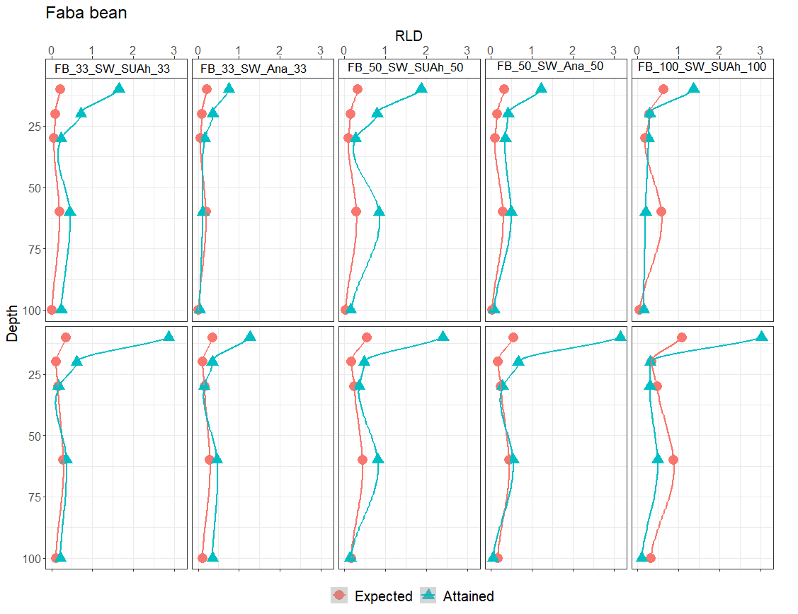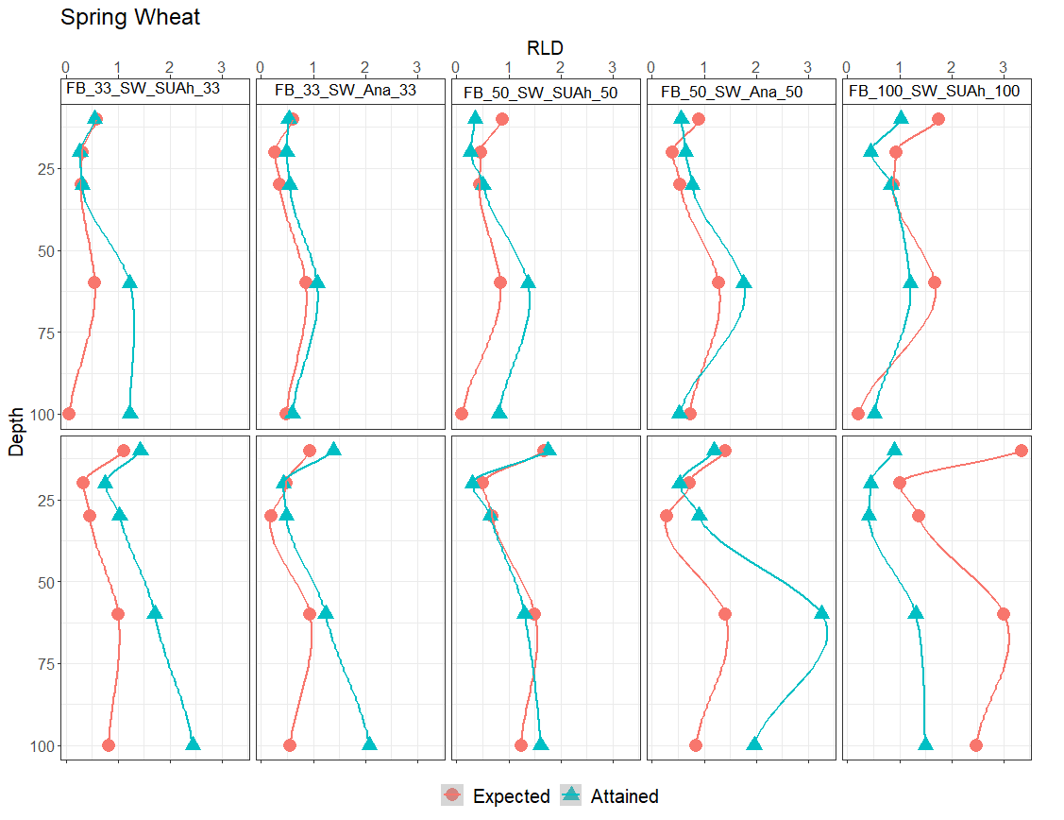
Figure S8: Expected vs attained values of mean root length density (RLD) (cm cm⁻³, n=4) of faba bean and spring wheat (top panels indicates 09/06/2021 and bottom panels indicates 05/07/2021) over the investigated soil depth (cm) in intercrops. Lines were smoothed.

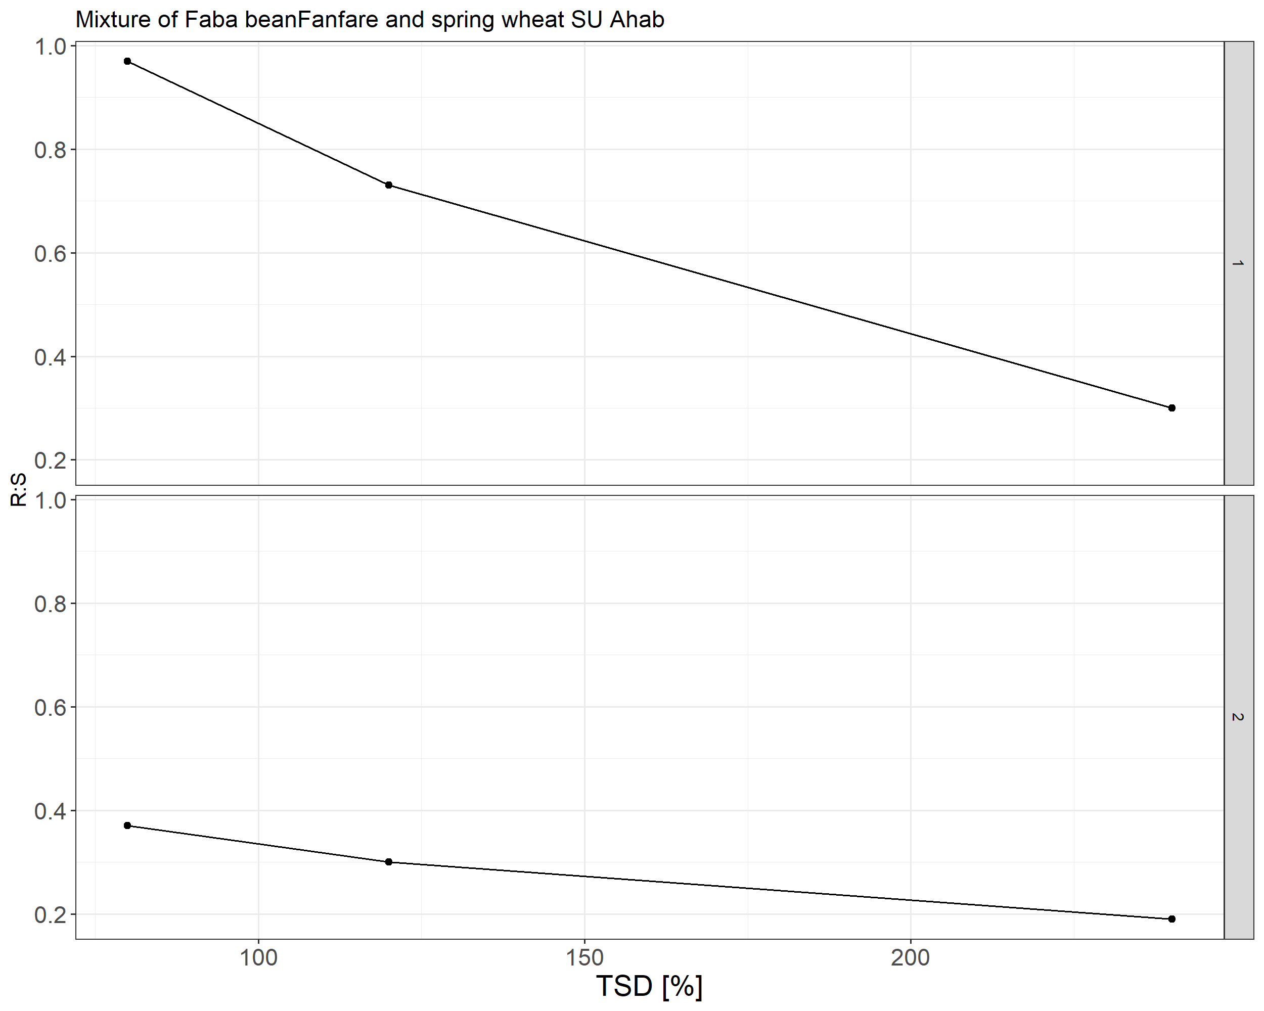
Figure S9: Root to shoot ratio as affected by total sowing density (TSD) for the faba bean (Fanfare) and spring wheat cv. SU Ahab intercrop treatments.

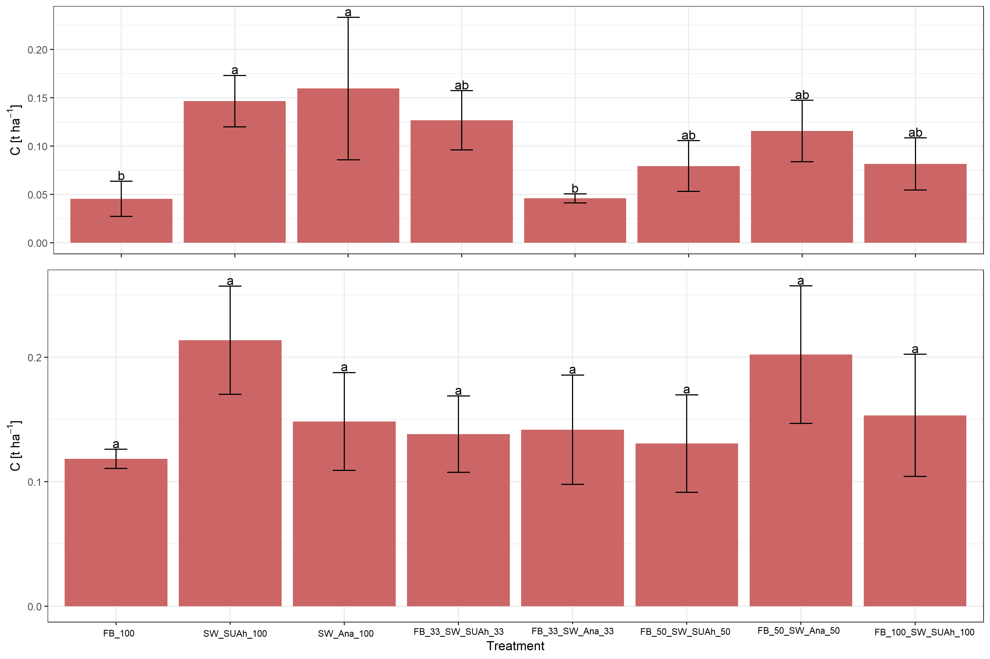

Figure S10: Deep soil (30-100 cm) root C (mean (n=4), not crop-specific) in t ha⁻¹, for sole faba bean and sole spring wheat, as well as for the intercrop treatments for three soil layers on date one (top panel) and date two (bottom panel). Different letters indicate significant differences comparing the cumulative root C over 30-60 cm and 60-100 cm soil layers (Anova, alpha=0.05, Tukey test).

