Beyond the surface: Exploring the mycobiome of Norway spruce under abiotic stress and with Heterobasidion parviporum

Blessing Durodola^{1,2}, Kathrin Blumenstein^{1,3}, Adedolapo Akinbobola¹, Anna Kolehmainen^{1,4}, Victor Chano², Oliver Gailing², and Eeva Terhonen^{1,5}

Supplementary figures

A  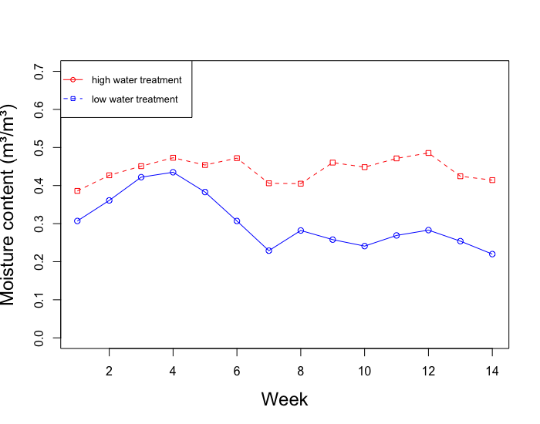 | B  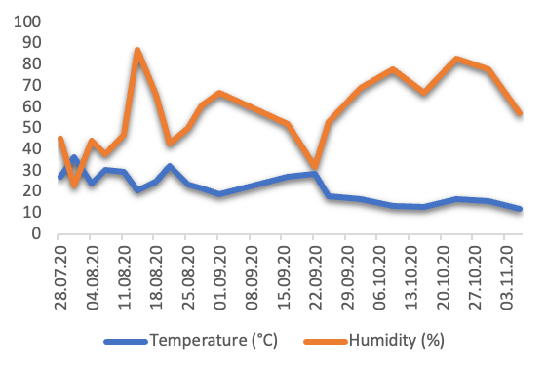
Fig. S1 Abiotic parameters measured during the experiment. A) soil moisture, B) atmospheric temperature and humidity.

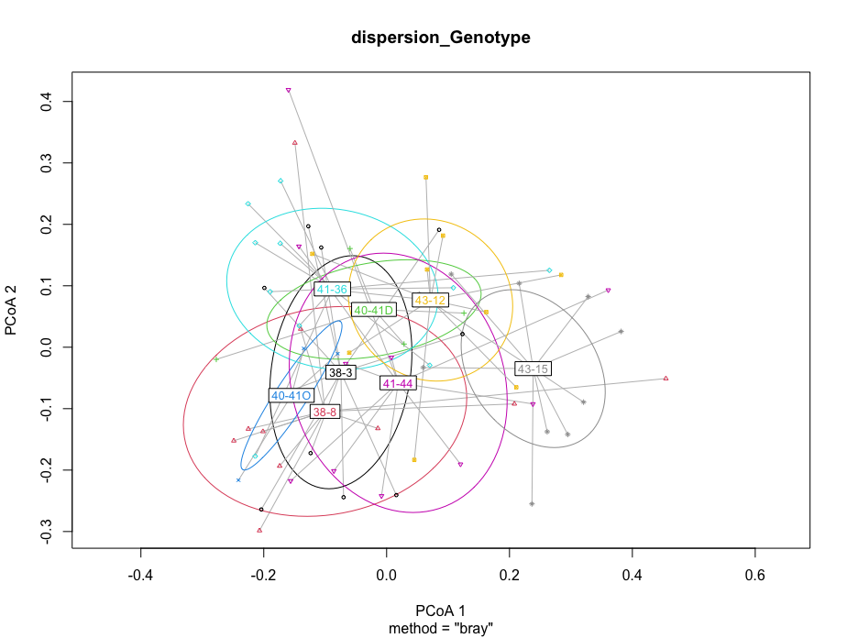
Fig. S2 Fungal communities among phloem genotypes based on Bray-Curtis.
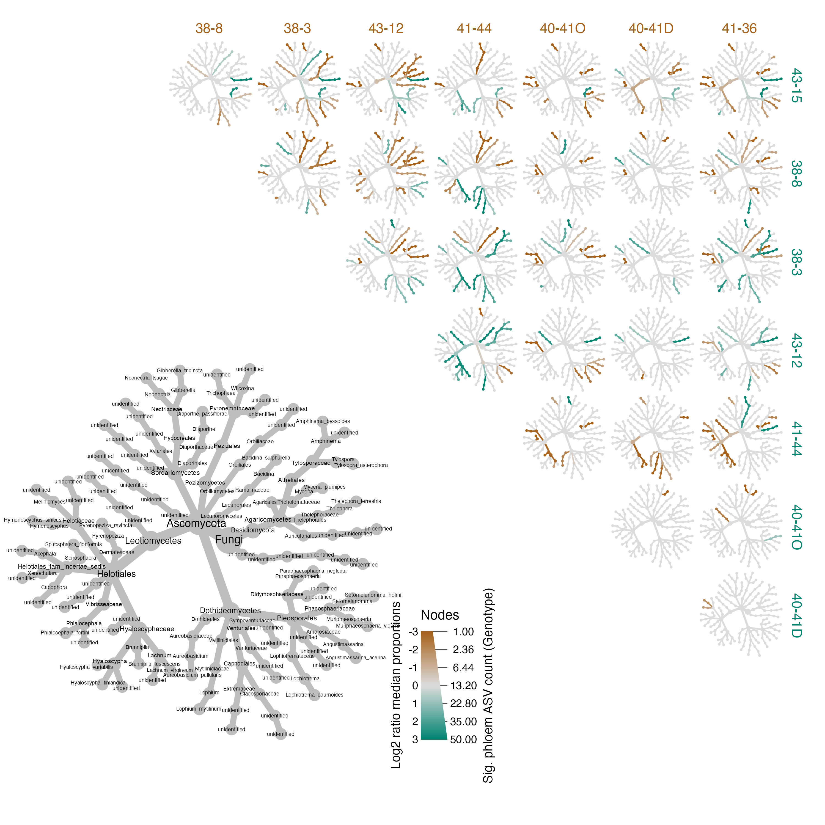 Fig. S3 Pairwise comparisons of the phloem mycobiome between the different genotypes. The colour of each taxon represents the log-2 ratio of median proportions of phloem ASV counts observed at each genotype. Taxa-coloured green are enriched in the genotypes shown in the rows, and those coloured cyan are enriched in the genotypes shown in the columns. The grey tree on the lower left serves as a key for the smaller unlabelled trees.

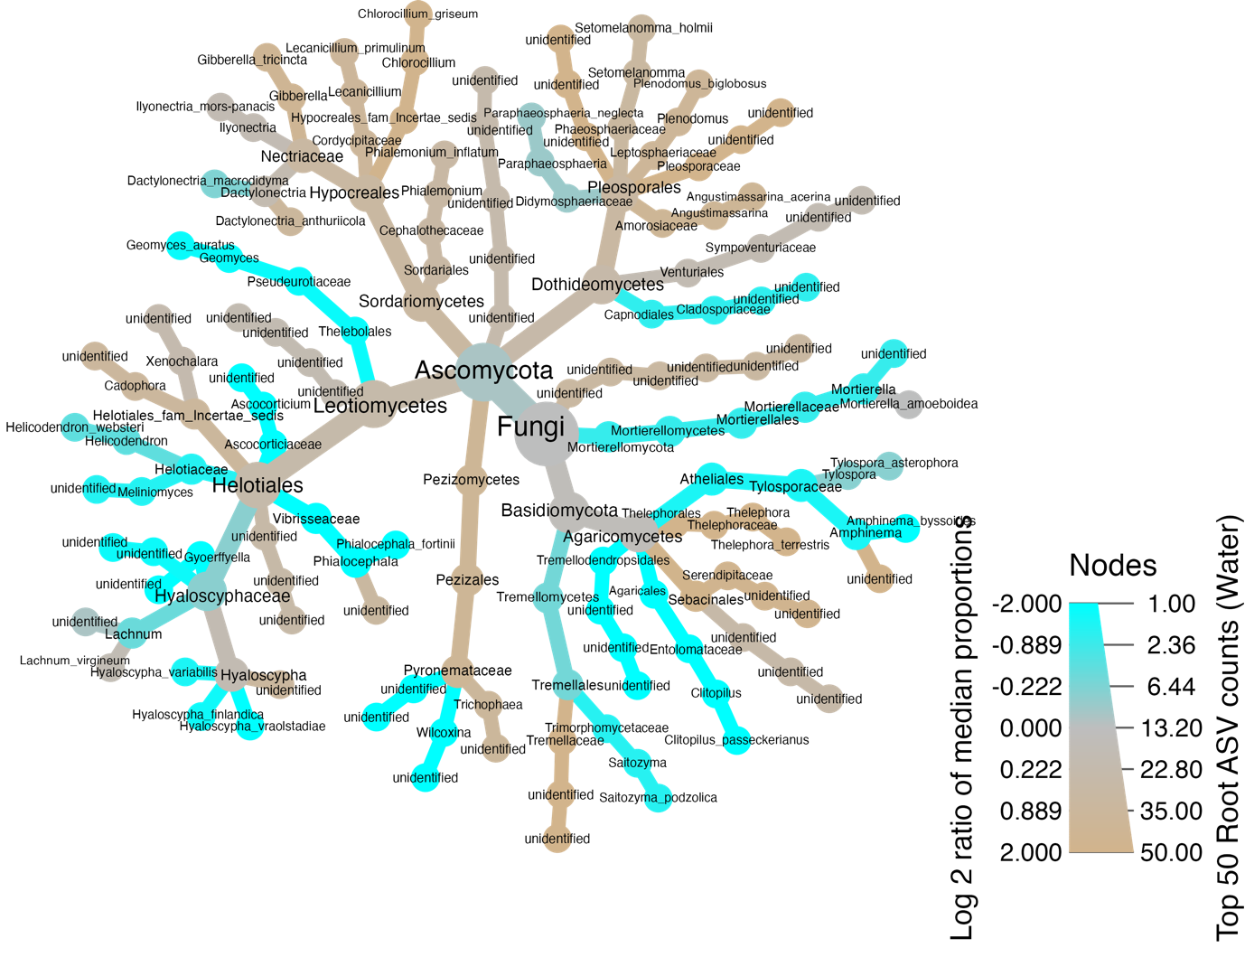
Fig. S4 Root mycobiome abundance according to watering groups. The colour of each taxon represents the log-2 ratio of median proportions of phloem ASV counts observed at each water treatment category. Taxa-coloured tan are more abundant in the optimum watering category, while taxa-coloured cyan are more abundant in low-water treated plants.

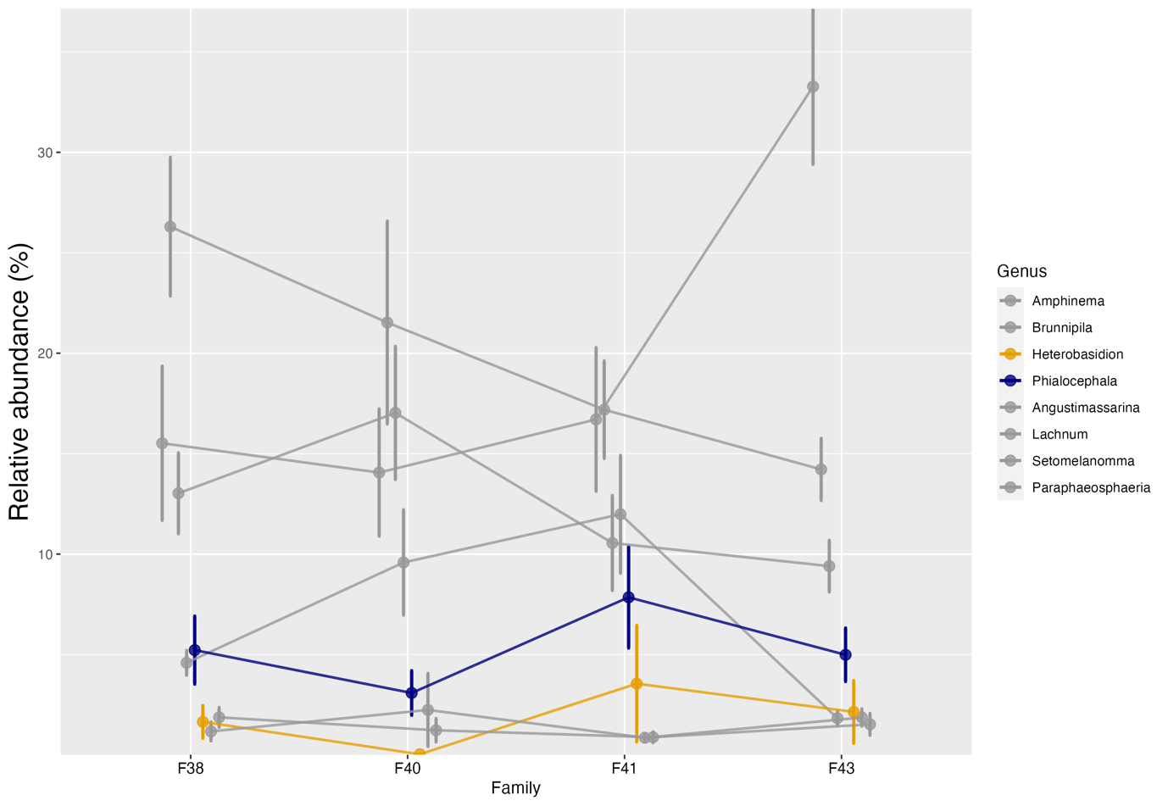Fig. S5 Relative abundance of taxa of the top eight fungi among families in the presence of H. parviporum highlighting only the pattern between Phialocephala and Heterobasidion genera. Connecting lines are included to visualize common patterns.

