Supplemental Information for
Ecological Toxicity Alleviation of Imazethapyr to Non-target Plant Wheat: Active Regulation Between Auxin and DIMBOA
Jinye Huang ¹, Jun Li ¹, Hui Chen ², Chensi Shen ³, Yuezhong Wen ^{1, *}

¹ MOE Key Laboratory of Environmental Remediation & Ecosystem Health, College of Environmental and Resource Sciences, Zhejiang University, Hangzhou 310058, China
² Ningbo Key Laboratory of Agricultural Germplasm Resources Mining and Environmental Regulation, College of Science and Technology, Ningbo University, Cixi 315300, China
³ College of Environmental Science and Engineering, Donghua University, Shanghai 201620, China

* Corresponding author: Yuezhong Wen
Email: wenyuezhong@zju.edu.cn
Tel.: +86-571-8898-2421
Fax: +86-571 -8898-2421

Table S1. Primer sequences for 10 DEGs and the internal reference gene β-actin.
Gene | Forward primer (5’-3’) | Reverse primer (5’-3’)
TraesCS7D02G051100 | GTGGTCATGTTGTTCACCTGC | CCTTTTGCCAGTAGCAAGCA
TraesCS6B02G056800 | CGGCTCGAGCTCACTTGTAG | GTCGTCGTCTTGGTGTCGAA
TraesCS4D02G295900 | AATTGGCTGCGTCAGGGTAA | CGCATACAGTAACAAATCCAGCA
TraesCS7A02G461700 | AAAGGCCCTCGCTTAATGCT | CGGATCACGGTACAGTTCCT
TraesCS7D02G277400 | GAGGTATTCGTCCCGCTCAT | CAGGTACGGCATTGCCATCT
TraesCS7B02G363100 | CAACTCGGCCACAAACTGTC | ACTCACAAGGGCTTGGGTTAT
TraesCS2A02G110200 | GGGTGGTAGACAATGCAAAGC | GGATCACAGCACGACCCTTT
TraesCS1D02G273500 | GTTTACGGAGGGAGTATTAGCCAT | GTTTGAGATATGGCATTACCACAGT
TraesCS2D02G528500 | CAACAGCATCGCCGTTTGAG | TGCTCTTACGCTCCAAGCAA
TraesCS4B02G346900 | CAAGGAGACCGTGCACAACTG | CAACGATGATCATGGCGTAGAGC
β-actin | AGGTACGTCCTTCGTGTAGAT | CTTCATGAGGTGGTCGCACA

Supplemental Figure Legends

Fig. S1. The effect of different exogenous treatments on the phenotype of wheat seedlings. The concentration of (R)-IM is 0.01 mg/L, and 0.1/1/10 indicates the concentrations of the external application of reagents (μM). IM: (R)-IM, DB: DIMBOA.

Fig. S2. Effects of different treatments on the growth index of wheat seedlings. (A) Effect of different concentrations of (R)-IM treatments on shoot length. Tested concentrations of (R)-IM were 0.002, 0.005, 0.01, and 0.05 mg/L. (B) Effect of external application of IAA and DIMBOA combined with (R)-IM on ferrous ion ratio. Tested concentration of combined (R)-IM treatment is 0.01 mg/L. 0.1/1/10 indicates the concentrations of the external application of reagents (μM). Different letters between the groups represent statistically significant differences (p-value < 0.05). Data are presented as the mean ± SD of three biological replicates (n=3). IM: (R)-IM; DB: DIMBOA.

Fig. S3. Effects of IAA, DIMBOA, and indole on the growth and defense systems under (R)-IM stress. (A) Chlorophyll content. (B) Fe (II), Fe (III), and total Fe contents. (C) CAT activity. (D) JA content. The concentration of (R)-IM is 0.01 mg/L. The concentrations of externally added IAA, DIMBOA, and indole were all 10 μM. Different letters presented between the groups represent statistically significant differences (p-value < 0.05). Data are presented as the mean ± SD of three biological replicates (n=3). FW: Fresh weight; IM: (R)-IM, DB: DIMBOA.

Fig. S4. Real-time quantitative polymerase chain reaction (qPCR) validation of differentially expressed genes (DEGs). Ten DEGs in the RNA extracts of the control and (R)-IM treatment groups were analyzed by qPCR. Fold change represents the ratio of gene expression levels between the (R)-IM treatment group and the control group. Results of qPCR are presented as the mean ± SD of three biological replicates (n=3). Correlation analysis of gene expression levels between transcriptome and qPCR indicates the accuracy of the transcriptome sequencing analysis of DEGs (R²=0.9838, p-value < 0.001).

Fig. S5. Regulation of plasma membrane (PM) H⁺-ATPase activity on wheat seedlings. (A) Effects of different concentrations of (R)-IM on PM H⁺-ATPase activity. (B) Effects of different concentrations of IAA/DIMBOA treatments combined with (R)-IM on PM H⁺-ATPase activity. Different letters between groups represent statistically significant differences (p-value < 0.05). Data are presented as mean ± SD of three biological replicates (n=3). IM: (R)-IM; FW: fresh weight; DB: DIMBOA.

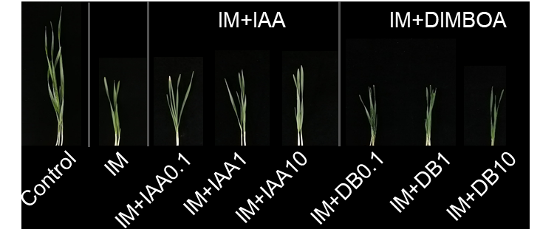
Fig. S1

Fig. S2

Fig. S3

Fig. S4

Fig. S5

