Table 1 Osiris calculations of drug-likness and drug-scores of compounds (1-15) reported from N. sativa

Compound | MW  (g/mole) | Toxicity risks^{[a]} |  |  |  | Drug score calculations^{[b]}
Compound | MW  (g/mole) | MUT | TUM | IRRI | REP | cLogP | cLogS | DL | DS
1 | 164.20 |  |  |  |  | 1.64 | -1.68 | -1.2 | 0.35
2 | 328.41 |  |  |  |  | 2.73 | -3.12 | 0.92 | 0.72
3 | 166.22 |  |  |  |  | 2.5 | -2.24 | -6.33 | 0.22
4 | 203.24 |  |  |  |  | 2.11 | -2.83 | -0.42 | 0.64
5 | 219.24 |  |  |  |  | 1.64 | -5.22 | -2.05 | 0.39
6 | 246.27 |  |  |  |  | -0.69 | -1.23 | 2.17 | 0.92
7 | 294.35 |  |  |  |  | 0.79 | -3.7 | -0.52 | 0.58
8 | 374.42 |  |  |  |  | -0.5 | -3.03 | -5.03 | 0.43
9 | 271.32 |  |  |  |  | 2.36 | -2.16 | 0.84 | 0.77
10 | 202.26 |  |  |  |  | -0.08 | -1.5 | 1.18 | 0.85
11 | 302.24 |  |  |  |  | 1.49 | -2.49 | 1.6 | 0.3
12 | 286.24 |  |  |  |  | 1.84 | -2.79 | 0.9 | 0.46
13 | 126.11 |  |  |  |  | 0.62 | -0.73 | -3.5 | 0.07
14 | 170.12 |  |  |  |  | 0.11 | -0.74 | 0.12 | 0.27
15 | 270.24 |  |  |  |  | 2.34 | -2.86 | 1.21 | 0.47

^{[a]} Not toxic: (), highly toxic: (), slightly toxic: (). REP: Reproductive effective, IRRIT: Irritant, TUM: Tumorigenic, MUT: Mutagenic. ^{[b]} DS: Drug-Score, DL: Drug Likeness, Sol: Solubility.

Table 2 Molinspiration prediction of Drug-Scores of compounds (1-15)

Compd | Structure | Molecular proprieties | Drug scores
1 | 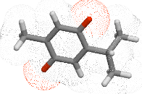 | cLogP 1.90  TPSA 34  MW 164  nOHNH 0  nviolations 0  volume 161 | GPCR ligand -1.40  Ion channel modulator -0.31  Kinase inhibitor -1.27  Nuclear receptor ligand -1.47  Protease inhibitor -1.45  Enzyme inhibitor -0.40
2 | 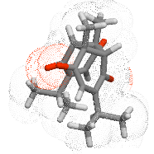 | cLogP 1.70  TPSA 68  MW 328  nOHNH 0  nviolations 0  volume 311 | GPCR ligand -0.18  Ion channel modulator -0.09  Kinase inhibitor -0.48  Nuclear receptor ligand 0.14  Protease inhibitor -0.10  Enzyme inhibitor 0.10
3 | 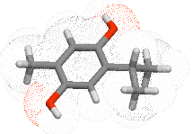 | cLogP 3.26  TPSA 41  MW 166  nOHNH 2  nviolations 0  volume 167 | GPCR ligand -0.92  Ion channel modulator -0.44  Kinase inhibitor -1.06  Nuclear receptor ligand -0.54  Protease inhibitor -1.17  Enzyme inhibitor -0.46
4 | 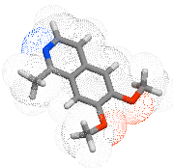 | cLogP 1.89  TPSA 31  MW 203  nOHNH 0  nviolations 0  volume 192 | GPCR ligand -0.47  Ion channel modulator -0.17  Kinase inhibitor -0.40  Nuclear receptor ligand -0.75  Protease inhibitor -0.64  Enzyme inhibitor -0.12
5 | 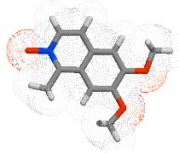 | cLogP 0.48  TPSA 44  MW 219  nOHNH 0  nviolations 0  volume 200 | GPCR ligand -0.09  Ion channel modulator 0.16  Kinase inhibitor 0.01  Nuclear receptor ligand -0.57  Protease inhibitor -0.20  Enzyme inhibitor 0.27
6 | 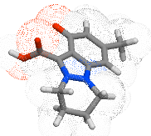 | cLogP 1.65  TPSA 64  MW 246  nOHNH 1  nviolations 0  volume 218 | GPCR ligand -0.15  Ion channel modulator -0.00  Kinase inhibitor -0.18  Nuclear receptor ligand -0.29  Protease inhibitor -0.57  Enzyme inhibitor 0.20
7 | 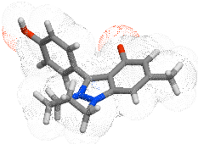 | miLogP -3.06  TPSA 52  MW 294  nOHNH 1  nviolations 0  volume 270 | GPCR ligand 0.12  Ion channel modulator 0.36  Kinase inhibitor -0.23  Nuclear receptor ligand -0.50  Protease inhibitor -0.28  Enzyme inhibitor 0.23
8 | 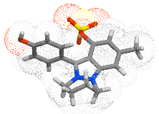 | miLogP -3.72  TPSA 95.48  MW 374.42  nOHNH 1  nviolations 0  volume 310.52 | GPCR ligand 0.10  Ion channel modulator 0.26  Kinase inhibitor -0.24  Nuclear receptor ligand -0.40  Protease inhibitor -0.16  Enzyme inhibitor 0.21
9 | 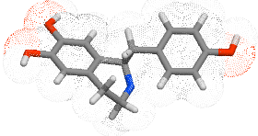 | miLogP 2.00  TPSA 72.71  MW 271  nOHNH 4  nviolations 0  volume 248 | GPCR ligand 0.25  Ion channel modulator 0.23  Kinase inhibitor -0.24  Nuclear receptor ligand -0.15  Protease inhibitor -0.04  Enzyme inhibitor 0.15
10 | 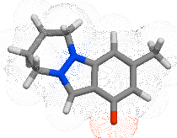 | miLogP 1.84  TPSA 27  MW 202  nOHNH 0  nviolations 0  volume 191 | GPCR ligand -0.35  Ion channel modulator -0.12  Kinase inhibitor -0.19  Nuclear receptor ligand -0.90  Protease inhibitor -0.92  Enzyme inhibitor -0.08
11 | 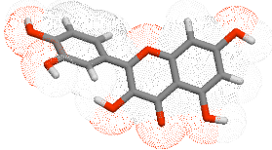 | miLogP 1.68  TPSA 131  MW 302  nOHNH 5  nviolations 0  volume 240 | GPCR ligand -0.06  Ion channel modulator -0.19  Kinase inhibitor 0.28  Nuclear receptor ligand 0.36  Protease inhibitor -0.25  Enzyme inhibitor 0.28
12 | 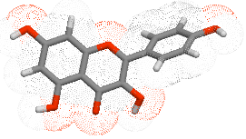 | miLogP 2.17  TPSA 111  MW 286  nOHNH 4  nviolations 0  volume 232 | GPCR ligand -0.10  Ion channel modulator -0.21  Kinase inhibitor 0.21  Nuclear receptor ligand 0.32  Protease inhibitor -0.27  Enzyme inhibitor 0.26
13 | 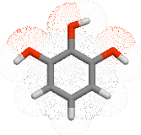 | miLogP 0.73  TPSA 61  MW 126  nOHNH 3  nviolations 0  volume 108 | GPCR ligand -2.18  Ion channel modulator -1.43  Kinase inhibitor -2.19  Nuclear receptor ligand -2.24  Protease inhibitor -2.40  Enzyme inhibitor -1.53
14 | 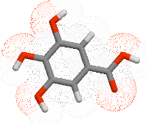 | miLogP 0.59  TPSA 98  MW 170  nOHNH 4  nviolations 0  volume 135 | GPCR ligand -0.77  Ion channel modulator -0.26  Kinase inhibitor -0.88  Nuclear receptor ligand -0.52  Protease inhibitor -0.94  Enzyme inhibitor -0.17
15 | 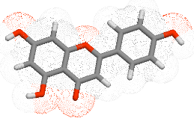 | miLogP 2.46  TPSA 91  MW 270  nOHNH 3  nviolations 0  volume 224 | GPCR ligand -0.07  Ion channel modulator -0.09  Kinase inhibitor 0.18  Nuclear receptor ligand 0.34  Protease inhibitor -0.25  Enzyme inhibitor 0.26

Table 3 Molinspiration calculations of drug-likeness and drug-scores of compounds (1-15)

Compd | Lipinski parameters calculations^{[a]} |  |  |  |  | Drug-likeness^{[b]}
Compd | TPSA | NONH | NV | VOL |  | GPCRL | ICM | KI | NRL | PI | EI
1 | 34 | 0 | 0 | 161 |  | -1.40 | -0.31 | -1.27 | -1.47 | -1.45 | -0.40
2 | 68 | 0 | 0 | 311 |  | -0.18 | -0.09 | -0.48 | 0.14 | -0.10 | 0.10
3 | 41 | 2 | 0 | 167 |  | -0.92 | -0.44 | -1.06 | -0.54 | -1.17 | -0.46
4 | 31 | 0 | 0 | 192 |  | -0.47 | -0.17 | -0.40 | -0.75 | -0.64 | -0.12
5 | 44 | 0 | 0 | 200 |  | -0.09 | 0.16 | 0.01 | -0.57 | -0.20 | 0.27
6 | 64 | 1 | 0 | 218 |  | -0.15 | -0.00 | -0.18 | -0.29 | -0.57 | 0.20
7 | 52 | 1 | 0 | 270 |  | 0.12 | 0.36 | -0.23 | -0.50 | -0.28 | 0.23
8 | 96 | 1 | 0 | 311 |  | 0.10 | 0.26 | -0.24 | -0.40 | -0.16 | 0.21
9 | 73 | 4 | 0 | 248 |  | 0.25 | 0.23 | -0.24 | -0.15 | -0.04 | 0.15
10 | 27 | 0 | 0 | 191 |  | -0.35 | -0.12 | -0.19 | -0.90 | -0.92 | -0.08
11 | 131 | 5 | 0 | 240 |  | -0.06 | -0.19 | 0.28 | 0.36 | -0.25 | 0.28
12 | 111 | 4 | 0 | 232 |  | -0.10 | -0.21 | 0.21 | 0.32 | -0.27 | 0.26
13 | 61 | 3 | 0 | 108 |  | -2.18 | -1.43 | -2.19 | -2.24 | -2.40 | -1.53
14 | 98 | 4 | 0 | 135 |  | -0.77 | -0.26 | -0.88 | -0.52 | -0.94 | -0.17
15 | 91 | 3 | 0 | 224 |  | -0.07 | -0.09 | 0.18 | 0.34 | -0.25 | 0.26
^{[a]} VOL: volume, NONH: number of OH---N or O---NH interaction, TPSA: Total molecular polar surface area, NV: number of violations of Lipinski rule of five. ^{[b]} EI: Enzyme inhibitor, PI: Protease inhibitor, NRL: Nuclear receptor ligand,GPCRL: GPCR ligand; ICM: Ion channel modulator; KI: Kinase inhibitor.

