A simple and rapid assay of lysosomal-targeting CDy6 for long-term real-time viability assessments in 2D and 3D in vitro culture models.
Chanhan Kang, Won-Soo Yun, Yun-Mi Jeong
Department of Mechanical Engineering, Tech University of Korea,237 Sangidaehak street, Si-heung city, Republic of Korea.
*Corresponding author: phdjeongym12@tukorea.ac.kr

Method

Absorbance measurement of CDy6
A stock solution of CDy6 were first prepared in PBS buffer at a concentration of 0.1 mM, then diluted with DMSO to a final concentration of 100 nM. The fluorescence excitation and emission spectra were measured using a Spectra Max M2 plate reader (Molecular Devices Corp, USA).
Fig. S1. Normalized absorption of CDy6.
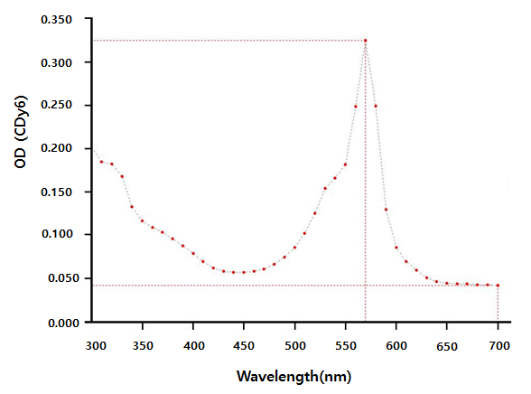

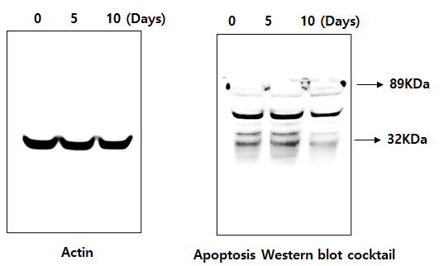
Fig. 7B. Raw data of western blot analysis.

