Supplementary Materials

Southernmost record of an epibiotic alga Pseudocladophora conchopheria (Sakai) Boedeker & Leliaert, 2012 (Cladophorales, Ulvophyceae) with the insights on the geographic genetic divergence and host shift.

Osamu Kagawa^{1*}, Van Tu Do^{2, 3}, Takeaki Hanyuda⁴, Satoshi Chiba⁵, Daishi Yamazaki⁶

¹ Graduate School of Life and Environmental Sciences, Marine Research Center, University of Tsukuba, 5-10-1, Shimoda, Shizuoka, 415-0025, Japan.
² Institute of Ecology and Biological Resources, Vietnam Academy of Science and Technology, Hanoi, Viet Nam
³ Graduate University of Science and Technology, Vietnam Academy of Science and Technology, Hanoi, Viet Nam
⁴ School of Marine Biosciences, Kitasato University, Kitazato, Minamiku, Sagamihara 252-0373, Japan
⁵ Graduate School of Life Science, Tohoku University, 41 Kawauchi, Aoba-ku, Sendai, Miyagi 980-0862, Japan.
⁶ Faculty of Science, Department of Life Area Environmental Science, Toho University, Miyama 2-2-1, Funabashi, Chiba, 274-8510 Japan

Figure S1
Lunalla granulata found in Ha Long Bay, Vietnam. An arrow indicates Pseudocladophora conchopheria.
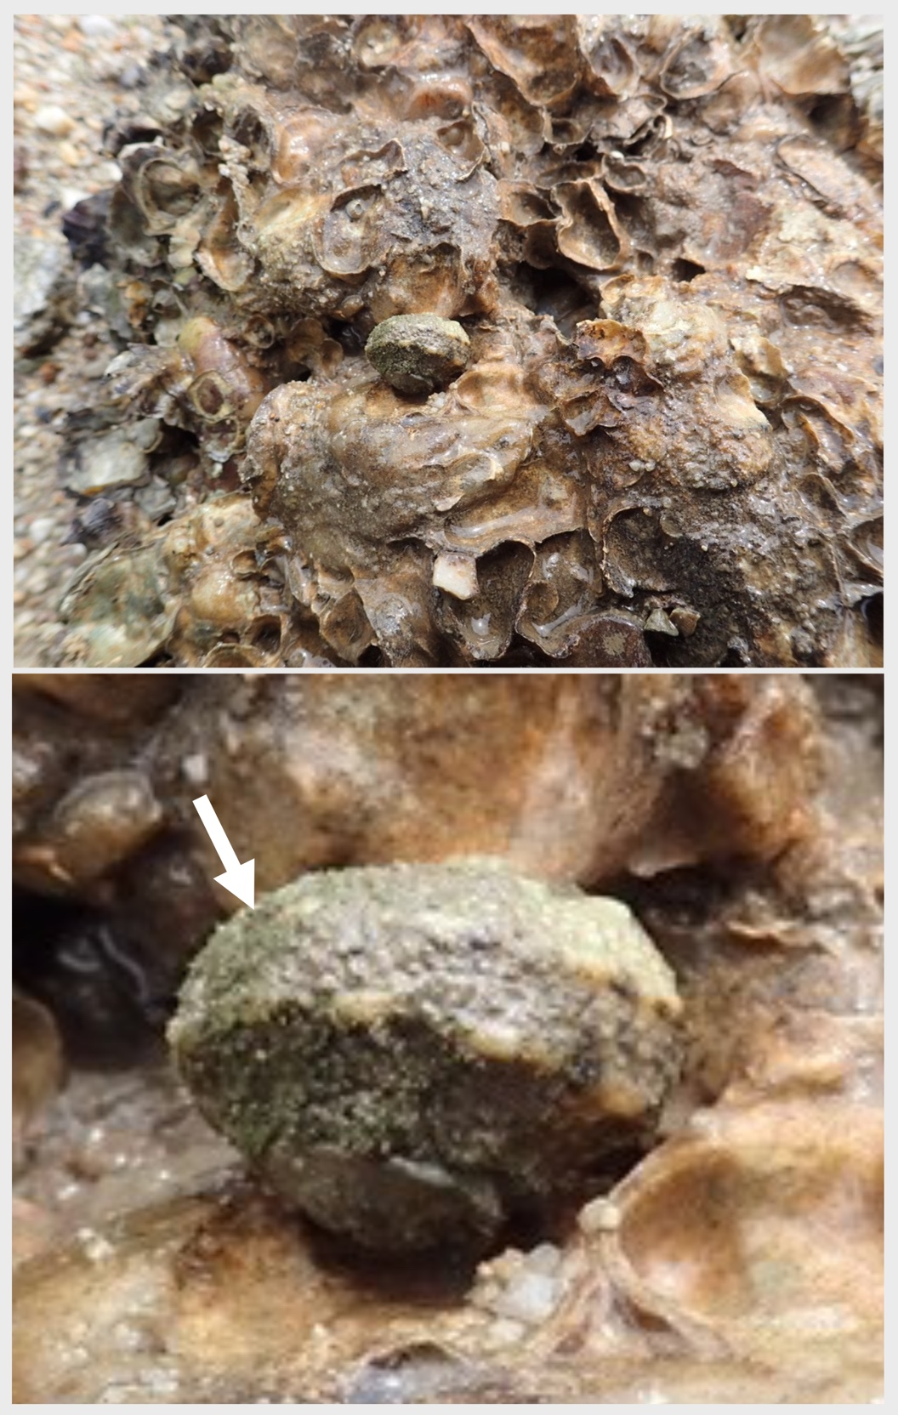
Figure S2
Distribution map of Pseudocladophora conchopheria and Lunella granulata. Stars mark where the recently discovered L. granulata-algae was found.

