Multiphase MoS₂ monolayer as a promising anode material for Mg-ion batteries
Nandhini Panjulingam, Senthilkumar Lakshmipathi*
Department of Physics, Atomistic Simulation Laboratory (ASL),
Bharathiar University, Coimbatore 641 046, Tamil Nadu, India
[*] Corresponding author: Senthilkumar Lakshmipathi Email: lsenthilkumar@buc.edu.in

Table S1. The Mg-S and Mg-Mo distances (Å) of one single metal atom adsorbed on the different sites of multiphase MoS₂ monolayer.

Sites | Bond interaction | Bond length (Å)
1T hollow | Mg-S15 | 2.32
1T hollow | Mg-S9 | 2.39
1T hollow | Mg-S14 | 2.32
1T hollow | Mg-Mo102 | 3.50
1T hollow | Mg-Mo97 | 3.50
1T hollow | Mg-Mo98 | 3.50
1T bridge | Mg-S3 | 2.41
1T bridge | Mg-S9 | 2.39
1T bridge | Mg-S4 | 2.39
1T bridge | Mg-Mo91 | 2.97
Interface | Mg-S1 | 2.33
Interface | Mg-S2 | 2.56
Interface | Mg-S3 | 2.32
1T top-S | Mg-S9 | 2.37
1T top-Mo | Mg-S9 | 2.39
1T top-Mo | Mg-S4 | 2.38
1T top-Mo | Mg-S3 | 2.39
1T top-Mo | Mg-Mo91 | 2.98
2H top-S | Mg-S | 2.51
2H center | Mg-S1 | 2.38
2H center | Mg-S2 | 2.35
2H center | Mg-S3 | 2.38
2H top-Mo | Mg-S64 | 2.42
2H top-Mo | Mg-S58 | 2.40
2H top-Mo | Mg-S66 | 2.37
2H top-Mo | Mg-Mo113 | 3.03

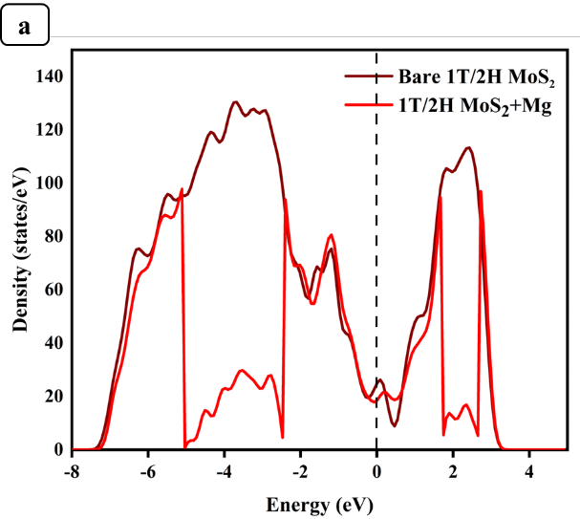 | 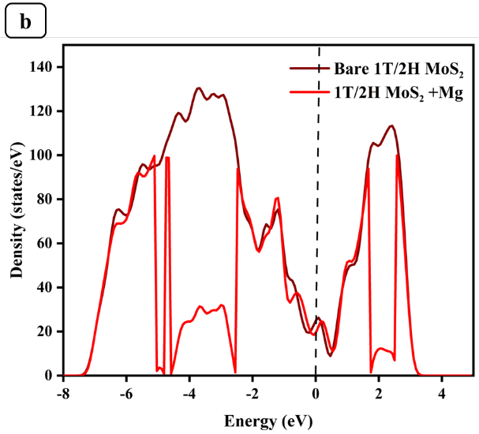
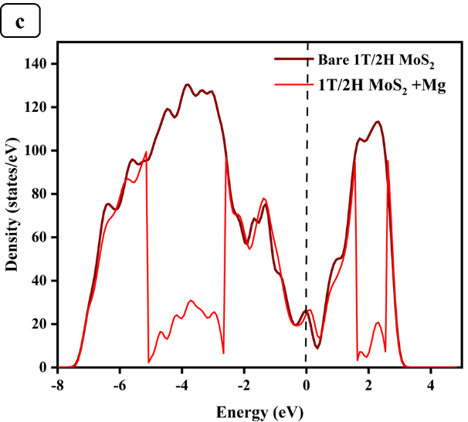 | 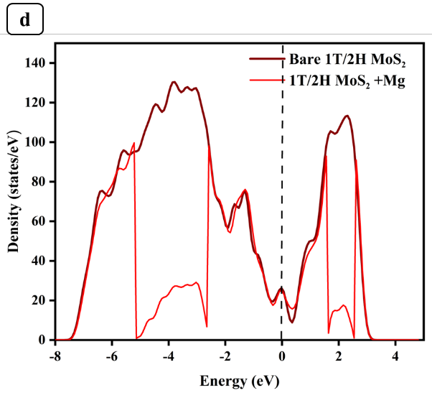
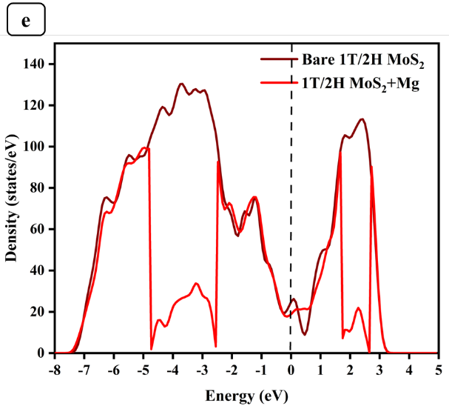 | 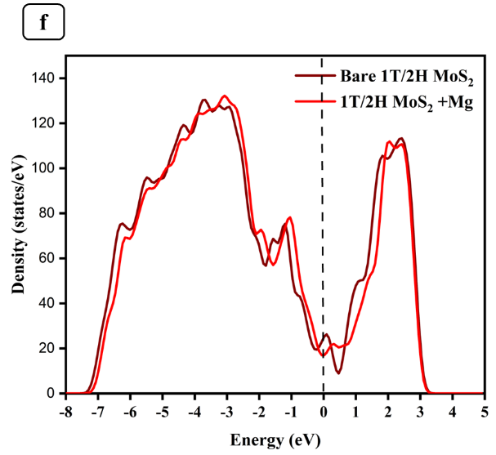
Figure S1. Density of states plot for multiphase MoS₂ + single Mg atom a) bridge site, b) interface c) 1T-Top S site, d) 1T-Top Mo site, e) 2H-Center, f) 2H-Top Mo Site

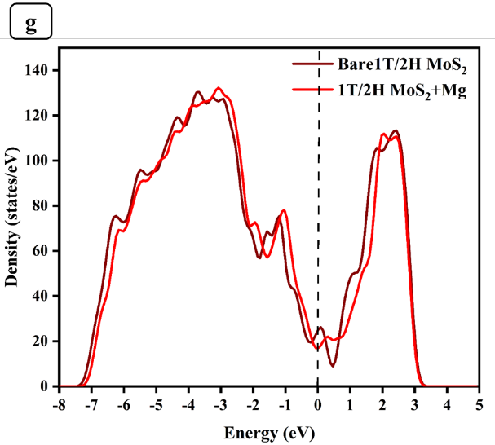

Figure S1. Density of states plot for multiphase MoS₂ + single Mg atom g) 2H- Top S site.

