Fig.S1 The CONSORT flow diagram
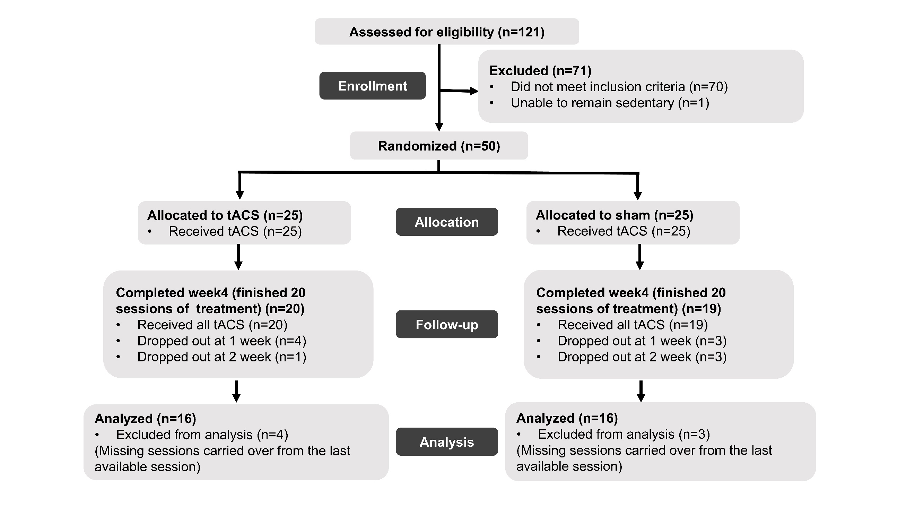
Table S1 The results of trials and components of rm-ANOVA (α=0.05).
 | Main effects |  | Interactions
 | Group | Time | Group*Time
Trials | $$F_{1,29}=0.109$$  p= 0.744 | $$F_{3,87}=1.124$$  p= 0.344 | $$F_{3,87}=1.777$$  p= 0.158
Components | $$F_{1,29}=0.591$$  p= 0.448 | $$F_{3,87}=2.087$$  p= 0.108 | $$F_{9,87}=0.513$$  p= 0.674

Table S2 Symptoms scores on baseline, week2, week4 and week6.
 |  | Baseline | Week2 | Week4 | Follow-up
PSYRATS (mean ± sd)
tACS  (n=16) | Auditory hallucinations | 33.94±4.49 | 28.88±5.95 | 25.38±7.68 | 24.94±7.47
tACS  (n=16) | Delusions | 18.12±4.62 | 16.25±5.58 | 13.50±4.20 | 11.88±5.16
tACS  (n=16) | Total Score | 52.06±8.14 | 45.12±11.10 | 38.88±1.09 | 36.81±11.31
Sham  (n=16) | Auditory hallucinations | 31.44±6.51 | 28.06±6.89 | 27.44±6.45 | 26.81±7.26
Sham  (n=16) | Delusions | 18.12±4.53 | 15.00±5.54 | 12.88±5.00 | 12.25±5.39
Sham  (n=16) | Total Score | 49.56±10.03 | 43.06±11.73 | 40.31±9.88 | 39.06±12.11
PANSS (mean ± sd)
tACS  (n=16) | Hallucinations（P3） | 6.00±0.63 | 5.69±0.79 | 5.31±1.01 | 4.88±1.15
tACS  (n=16) | Positive Symptoms | 25.19±3.75 | 23.94±4.77 | 22.75±4.82 | 21.12±6.39
tACS  (n=16) | Negative Symptoms | 26.62±7.04 | 26.88±6.18 | 27.00±5.79 | 26.00±6.84
tACS  (n=16) | General Psychopathology | 36.44±7.47 | 35.81±6.22 | 34.88±7.46 | 33.81±8.62
tACS  (n=16) | Total Score | 88.25±15.25 | 86.62±14.61 | 84.62±15.99 | 80.94±20.39
Sham  (n=16) | Hallucinations（P3） | 6.00±0.73 | 5.19±1.28 | 4.81±1.11 | 4.69±1.25
Sham  (n=16) | Positive Symptoms | 25.81±3.80 | 21.81±5.39 | 20.56±5.32 | 19.88±6.55
Sham  (n=16) | Negative Symptoms | 24.62±5.46 | 23.62±5.68 | 23.12±5.75 | 22.62±5.83
Sham  (n=16) | General Psychopathology | 38.38±10.24 | 36.25±8.55 | 32.75±7.61 | 31.56±8.05
Sham  (n=16) | Total Score | 88.81±16.39 | 81.69±16.16 | 76.44±16.46 | 74.06±18.32

