SUPPLEMENTARY MATERIALS
Table S1 Information on the 24 sampling sites with three invasion histories in lightly and severely disturbed habitats.
No. | Habitat | Invasion status | Estimated year of invasion | Latitude | Longitude | Description of site | Source
LN1 | Lightly | Uninvaded | N/A | 24°32'50.82"N | 101°1'48.55"E | Grassland | Ailao Mountain National Nature Reserve
LN2 | Lightly | Uninvaded | N/A | 24°32'38.28"N | 101°1'48.50"E | Shurb | Ailao Mountain National Nature Reserve
LN3 | Lightly | Uninvaded | N/A | 24°32'26.99"N | 101°0'45.42"E | Mixed forest | Ailao Mountain National Nature Reserve
LN4 | Lightly | Uninvaded | N/A | 24°31'21.71"N | 101°1'45.77"E | Mixed forest | Ailao Mountain National Nature Reserve
LR1 | Lightly | Short | 2013 | 24°32'20.28"N | 101°1'5.08"E | Gap due to tree fell | Ailao Subtropical Forest Ecosystem Research Station
LR2 | Lightly | Short | 2015 | 24°32'44.62"N | 101°1'52.48"E | Gap due to snow fell | Song et al. (2017)¹
LR3 | Lightly | Short | 2015 | 24°31'14.66"N | 101°0'44.12"E | Gap due to snow fell | Song et al. (2017)¹
LR4 | Lightly | Short | 2013 | 24°32'15.74"N | 101°0'34.66"E | Forest edge | Ailao Subtropical Forest Ecosystem Research Station
LL1 | Lightly | Long | 1980s | 24°31'4.22"N | 101°0'43.4"E | Gap due to lightning strikes | Ailao Subtropical Forest Ecosystem Research Station
LL2 | Lightly | Long | 1980s | 24°31'12.58"N | 101°0'48.51"E | Gap due to tree fell | Ailao Subtropical Forest Ecosystem Research Station
LL3 | Lightly | Long | 1990s | 24°32'34.37"N | 101°1'37.56"E | Gap due to tree fell | Ailao Subtropical Forest Ecosystem Research Station
LL4 | Lightly | Long | 1990s | 24°32'27.98"N | 101°1'26.44"E | Forest trail | Ailao Subtropical Forest Ecosystem Research Station
SN1 | Severely | Uninvaded | N/A | 24°31'49.83"N | 101°0'51.29"E | Firebreak side | Ailao Mountain National Nature Reserve
SN2 | Severely | Uninvaded | N/A | 24°31'45.27"N | 101°0'50.76"E | Firebreak side | Ailao Subtropical Forest Ecosystem Research Station
SN3 | Severely | Uninvaded | N/A | 24°32'24.01"N | 101°0'59.37"E | Gap due to landslid | Ailao Subtropical Forest Ecosystem Research Station
SN4 | Severely | Uninvaded | N/A | 24°31'33.52"N | 101°0'50.16"E | Firebreak side | Ailao Mountain National Nature Reserve
SR1 | Severely | Short | 2015 | 24°32'29.89"N | 101°1'6.59"E | Gap due to artificial broken | Ailao Mountain National Nature Reserve
SR2 | Severely | Short | 2016 | 24°31'8.13"N | 101°0'45.91"E | Gap due to landslide | Ailao Mountain National Nature Reserve
SR3 | Severely | Short | 2015 | 24°32'45.96"N | 101°1'26.08"E | Firebreak side | Ailao Mountain National Nature Reserve
SR4 | Severely | Short | 2014 | 24°31'6.86"N | 101°0'56.31"E | Firebreak side | Ailao Subtropical Forest Ecosystem Research Station
SL1 | Severely | Long | 1990s | 24°32'13.4"N | 101°1'32.96"E | Gap due to landslids | Ailao Mountain National Nature Reserve
SL2 | Severely | Long | 1980s | 24°31'7.53"N | 101°0'53.59"E | Gap due to landslids | Ailao Subtropical Forest Ecosystem Research Station
SL3 | Severely | Long | 1990s | 24°31'18.42"N | 101°0'46.58"E | Gap due to artificial broken | Ailao Mountain National Nature Reserve
SL4 | Severely | Long | 1995 | 24°31'8.11"N | 101°1'7.91"E | Gap due to landslids | Ailao Subtropical Forest Ecosystem Research Station
¹ Song, X., H. James Aaron, C. Brown, M. Cao, and J. Yang. 2017. Snow damage to the canopy facilitates alien weed invasion in a subtropical montane primary forest in southwestern China. Forest Ecology and Management 391:275-281.
See Fig. S1 for photographs of the sampling sites.

Table S2 Effects of habitats (n = 2), invasion periods (n = 3), and their interaction on aboveground mass and cover of Ageratina adenophora, and richness and Shannon index of native species
Variables | df | Cover of A. adenophora (%) |  | Aboveground mass of A. adenophora (g m⁻²) |  | df | Native species Shannon index |  | Native species richness
Variables | df | F-value | P-value | F-value | P-value | df | F-value | P-value | F-value | P-value
Habitat (H) | (1, 12) | 13.786 | 0.003 | 14.633 | 0.002 | (1, 18) | 59.963 | <0.001 | 59.627 | <0.001
Invasion period (IP) | (1, 12) | 0.517 | 0.486 | 3.764 | 0.076 | (2, 18) | 13.427 | <0.001 | 20.611 | <0.001
H × IP | (1, 12) | 10.311 | 0.007 | 6.739 | 0.023 | (2, 18) | 8.853 | 0.002 | 18.289 | <0.001

Table S3 Effects of habitats (n = 2), invasion periods (n = 3), and their interaction on soil chemical traits (two-way ANOVA)
Variables | Habitat (H) |  | Invasion period (IP) |  | H × IP
Variables | F-value | P-value | F-value | P-value | F-value | P-value
pH | 17.650 | 0.001 | 2.546 | 0.001 | 12.443 | <0.001
AN | 85.914 | <0.001 | 8.991 | <0.001 | 11.367 | 0.001
AP | 5.503 | 0.031 | 1.561 | 0.031 | 1.640 | 0.222
AK | 22.774 | <0.001 | 7.256 | <0.001 | 3.488 | 0.052
WC | 86.920 | <0.001 | 13.019 | <0.001 | 24.156 | <0.001
AK, available kalium content; AN, available nitrogen content; AP, available phosphorus content; WC, water content.

Table S4 Effects of habitats (n = 2), invasion periods (n = 2 or 3), and their interaction on total and specific PSFs of Ageratina adenophora
Variables | Total PSF |  |  | Specific PSF
Variables | df | F-value | P-value | df | F-value | P-value
Habitat (H) | (1, 18) | 8.000 | 0.011 | (1, 12) | 68.430 | 0.000
Invasion period (IP) | (1, 18) | 4.523 | 0.026 | (1, 12) | 0.024 | 0.879
H × IP | (1, 18) | 14.453 | <0.001 | (1, 12) | 9.503 | 0.009

Table S5 Pearson’s correlation coefficient between soil chemical traits and total PSF and specific PSF in sites with a short and long invasion histories, respectively
 | Short invasion history |  | Long invasion history
 | Total PSF | Specific PSF | Total PSF | Specific PSF
pH | 0.272 | 0.137 | 0.351 | 0.187
AN | 0.535 | -0.944** | -0.150 | -0.099
AP | -0.22 | 0.576 | -0.019 | 0.183
AK | 0.457 | -0.897** | -0.413 | -0.363
WC | 0.403 | -0.910** | -0.037 | -0.225
AK, available kalium content; AN, available nitrogen content; AP, available phosphorus content; WC, water content. **, P < 0.001.

Table S6 Permutational analysis of variance (PERMANOVA) testing potential predictors of
all soil fungal, potential pathogens and AM fungal community composition based on the Bray-Curtis dissimilarity on abundances from sequencing of soils with three invasion periods from two forest habitats
Model | Variable | Variation explained (%) | df | F - value | P - value
All soil fungi | Habitat | 2.76 | 1 | 0.70 | 0.84
 | Invasion period | 10.18 | 2 | 1.30 | 0.12
 | pH | 5.13 | 1 | 1.31 | 0.17
 | AN | 5.65 | 1 | 1.44 | 0.10
 | AK | 6.17 | 1 | 1.57 | 0.06
 | AP | 1.79 | 1 | 0.46 | 0.99
 | WC | 4.74 | 1 | 1.21 | 0.22
 | Residual | 58.78 | 15
 | Total | 100.00 | 23
Plant pathogens | Habitat | 5.63 | 1 | 1.32 | 0.07
 | Invasion period | 9.80 | 2 | 1.15 | 0.18
 | pH | 5.40 | 1 | 1.27 | 0.12
 | AN | 4.69 | 1 | 1.10 | 0.27
 | AK | 5.65 | 1 | 1.33 | 0.09
 | AP | 2.68 | 1 | 0.63 | 0.98
 | WC | 3.81 | 1 | 0.90 | 0.63
 | Residual | 63.79 | 15
 | Total | 100.00 | 23
Am fungi | Habitat | 4.93 | 1 | 1.10 | 0.28
 | Invasion period | 8.96 | 2 | 1.00 | 0.42
 | pH | 3.79 | 1 | 0.85 | 0.77
 | AN | 4.14 | 1 | 0.93 | 0.60
 | AK | 4.86 | 1 | 1.09 | 0.29
 | AP | 5.71 | 1 | 1.28 | 0.11
 | WC | 3.91 | 1 | 0.87 | 0.71
 | Residual | 62.64 | 15
 | Total | 100.00 | 23
AK, available kalium content; AN，available nitrogen content; AP, available phosphorus content; WC, water content.

Table S7 Results of Welch’s t‐test for each fixed effect contrast for genus of pathogens fungi
Habitat | Genus of pathogens | Contrast1: uninvaded vs. recently invaded |  | Contrast2: uninvaded vs. long invaded |  | Contrast2: recently vs. long invaded
Habitat | Genus of pathogens | Effect size | P-value | Effect size | P-value | Effect size | P-value
Lightly disturbed | Xylaria | -2.404 | 0.834 | -7.434 | 0.338 | -9.837 | 0.342
Lightly disturbed | Trichoderma | 17.882 | 0.513 | -52.527 | 0.101 | -34.646 | 0.038
Lightly disturbed | Torula | -6.197 | 0.393 | -0.138 | 0.391 | -6.335 | 0.384
Lightly disturbed | Strelitziana | -1.079 | 0.272 | 5.176 | 0.398 | 4.098 | 0.495
Lightly disturbed | Sphaerulina | -3.333 | 0.391 | 13.366 | 0.327 | 10.033 | 0.453
Lightly disturbed | Setophoma | 0.000 | 1.000 | 2.857 | 0.391 | 2.857 | 0.391
Lightly disturbed | Setophaeosphaeria | -7.144 | 0.395 | -0.276 | 0.391 | -7.420 | 0.379
Lightly disturbed | Pseudocercospora | 6.696 | 0.391 | -6.696 | 0.391 | 0.000 | 1.000
Lightly disturbed | Phaeosphaeria | -0.159 | 0.704 | 0.184 | 0.667 | 0.025 | 0.960
Lightly disturbed | Pezicula | 1.949 | 0.344 | 29.518 | 0.300 | 31.467 | 0.275
Lightly disturbed | Passalora | 2.232 | 0.391 | 5.923 | 0.528 | 8.155 | 0.391
Lightly disturbed | Paraphoma | 0.000 | 1.000 | 6.727 | 0.381 | 6.727 | 0.381
Lightly disturbed | Lectera | -6.528 | 0.391 | -0.304 | 0.391 | -6.832 | 0.372
Lightly disturbed | Golovinomyces | 9.207 | 0.391 | -9.207 | 0.391 | 0.000 | 1.000
Lightly disturbed | Dothiorella | -4.724 | 0.324 | -0.359 | 0.391 | -5.083 | 0.294
Lightly disturbed | Dendryphion | -7.397 | 0.193 | -0.193 | 0.391 | -7.590 | 0.184
Lightly disturbed | Cytospora | -0.467 | 0.683 | 9.080 | 0.355 | 8.612 | 0.378
Lightly disturbed | Coniella | 9.057 | 0.391 | -9.057 | 0.391 | 0.000 | 1.000
Lightly disturbed | Colletotrichum | -0.946 | 0.268 | 0.016 | 0.963 | -0.930 | 0.276
Lightly disturbed | Chalara | -0.523 | 0.691 | 9.942 | 0.321 | 9.419 | 0.343
Severely disturbed | Xylaria | -0.208 | 0.245 | -0.556 | 0.187 | 0.349 | 0.382
Severely disturbed | Trichoderma | 4.308 | 0.846 | 28.990 | 0.251 | -24.681 | 0.419
Severely disturbed | Torula | -0.472 | 0.533 | 0.035 | 0.928 | -0.507 | 0.473
Severely disturbed | Strelitziana | 2.916 | 0.127 | 1.743 | 0.349 | 1.172 | 0.314
Severely disturbed | Sphaerulina | 0.303 | 0.785 | 0.893 | 0.391 | -0.590 | 0.368
Severely disturbed | Setophoma | 0.497 | 0.525 | -2.337 | 0.475 | 2.834 | 0.391
Severely disturbed | Setophaeosphaeria | 0.600 | 0.525 | -0.821 | 0.542 | 1.421 | 0.234
Severely disturbed | Pseudocercospora | -4.317 | 0.532 | -14.164 | 0.380 | 9.848 | 0.548
Severely disturbed | Phaeosphaeria | -0.682 | 0.370 | -1.714 | 0.318 | 1.032 | 0.538
Severely disturbed | Pezicula | 13.211 | 0.392 | 13.256 | 0.391 | -0.046 | 0.183
Severely disturbed | Passalora | -0.024 | 0.391 | -0.133 | 0.391 | 0.108 | 0.477
Severely disturbed | Paraphoma | -1.515 | 0.578 | 0.941 | 0.379 | -2.456 | 0.370
Severely disturbed | Lectera | 0.176 | 0.596 | -0.356 | 0.495 | 0.533 | 0.266
Severely disturbed | Golovinomyces | 0.000 | 1.000 | 0.000 | 1.000 | 0.000 | 1.000
Severely disturbed | Dothiorella | -0.672 | 0.683 | -0.915 | 0.595 | 0.243 | 0.896
Severely disturbed | Dendryphion | 1.756 | 0.145 | 1.004 | 0.440 | 0.752 | 0.425
Severely disturbed | Cytospora | 0.408 | 0.130 | 0.296 | 0.246 | 0.112 | 0.358
Severely disturbed | Coniella | -0.011 | 0.391 | 0.000 | 1.000 | -0.011 | 0.391
Severely disturbed | Colletotrichum | -6.998 | 0.342 | -2.425 | 0.179 | -4.574 | 0.520
Severely disturbed | Chalara | -5.985 | 0.679 | -15.799 | 0.506 | 9.814 | 0.703

Table S8 Results of Welch’s t‐test for each fixed effect contrast for AM fungi
Habitat | Family of AM fungi | Contrast1: uninvaded vs. recently invaded |  | Contrast2: uninvaded vs. long invaded |  | Contrast2: recently vs. long invaded
Habitat | Family of AM fungi | Effect size | P-value | Effect size | P-value | Effect size | P-value
Lightly disturbed | Ambisporaceae | 16.546 | 0.47 | -4.999 | 0.515 | -21.546 | 0.353
Lightly disturbed | Archaeosporaceae | -3.818 | 0.593 | 1.793 | 0.789 | 5.611 | 0.374
Lightly disturbed | Claroideoglomeraceae | 0.949 | 0.391 | 22.042 | 0.35 | 21.093 | 0.368
Lightly disturbed | Diversisporaceae | 0.000 | 1.000 | 0.000 | 1.000 | 0.000 | 1.000
Lightly disturbed | Glomeraceae | -2.467 | 0.935 | -19.941 | 0.457 | -17.474 | 0.407
Severely disturbed | Ambisporaceae | 3.246 | 0.442 | -0.918 | 0.813 | -4.164 | 0.559
Severely disturbed | Archaeosporaceae | -9.279 | 0.405 | -10.192 | 0.189 | -0.914 | 0.221
Severely disturbed | Claroideoglomeraceae | 0.521 | 0.513 | 1.885 | 0.385 | 1.364 | 0.599
Severely disturbed | Diversisporaceae | 1.734 | 0.263 | -0.249 | 0.599 | -1.983 | 0.321
Severely disturbed | Glomeraceae | 27.287 | 0.066 | 45.666 | 0.018 | 18.379 | 0.089

Fig. S1.1 Map showing the 24 sites with three invasion periods of Ageratina adenophora at lightly and severely disturbed habitats in Xujiaba Reserve in Mt. Ailao, southwest China. SN, SR and SL represent the uninvaded, recently invaded (1−5 years) and long invaded (> 25 yars) sites in the severely disturbed habitat, respectively; LN, LR and LL represents the uninvaded, recently invaded (1−5 years) and long invaded (> 25 years) in the lightly disturbed habitat, respectively

Lightly disturbaed habitat | Uninvaded | 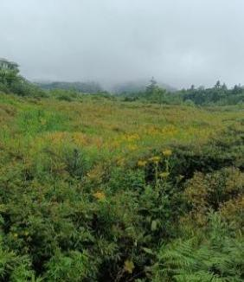  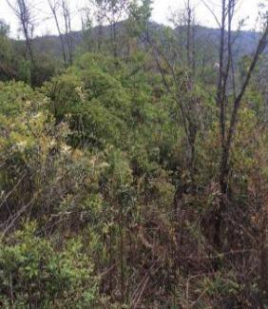  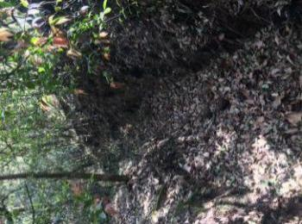  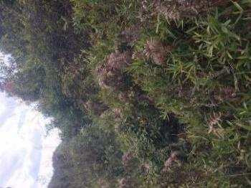  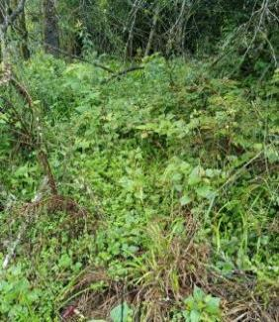  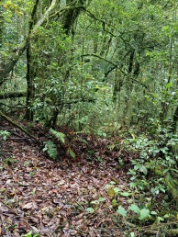  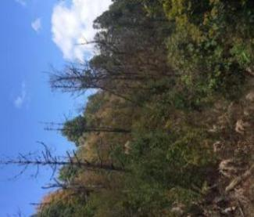  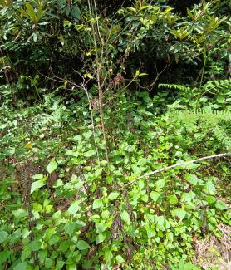  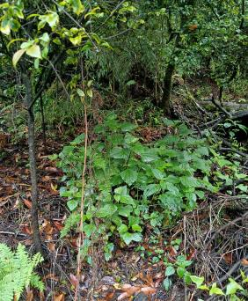  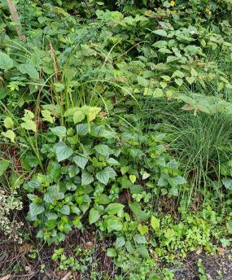  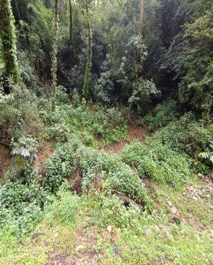  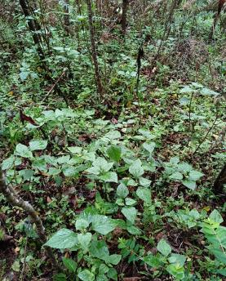
Lightly disturbaed habitat | Recently invaded
Lightly disturbaed habitat | Long invaded
Severely disturbed habitat | Uninvaded | 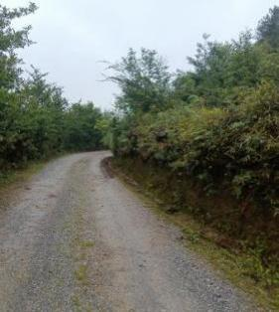  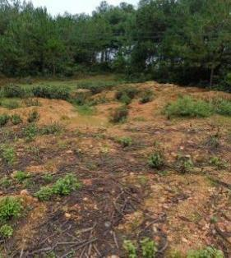  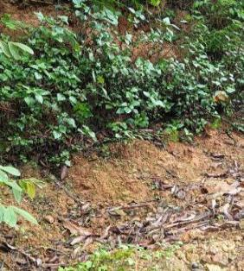  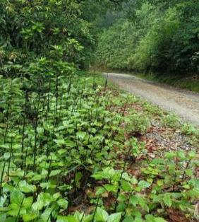  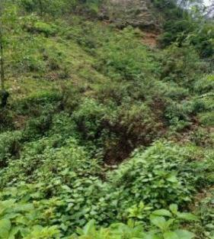  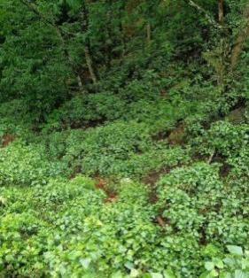  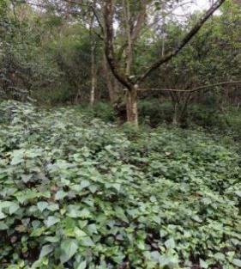  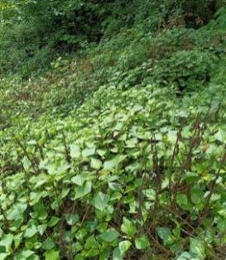  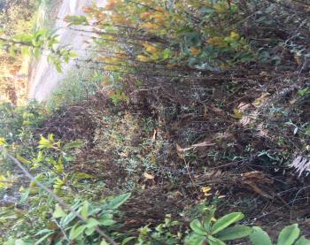  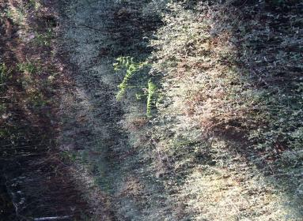  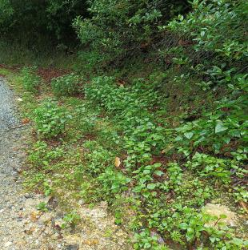  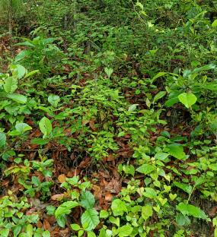
Severely disturbed habitat | Recently invaded
Severely disturbed habitat | Long invaded
Fig. S1.2 Photos of the sampling sites.

Fig. S2 Biomass of Agretina adenophora grown in sterile soil with live (grey bar) and sterile (white bar) soil inocula from uninvaded, recently invaded and long invaded (A) sites, and that in sterile soil with live soil inocula from uninvaded (black bar) and invaded (stripe bar) sites (B) in severely (left column) and lightly (right column) disturbed habitats. SN, SR and SL represent the non-invaded, recently invaded (1−5 years) and long invaded (> 25 years) sites, respectively in the severely disturbed habitat; LN, LR and LL represents the non-invaded, recently invaded (1−5 years) and long invaded (> 25 years) sites, respectively in the lightly disturbed habitat; *, **, *** indicate significant differences between paired bars at P < 0.05, P<0.001, P < 0.0001 level

Fig. S3 Non-metric multidimensional scaling (NMDS) analysis of the variations in soil fungal
community composition based on operational taxonomical units. Each of the 24 marks in the
NMDS plot corresponds to each of the 24 soil sampling sites. SN, SR, and SL represent the
uninvaded, recently invaded, and long invaded sites in the severely disturbed habitats,
respectively; LN , LR, and LL represent the uninvaded, recently invaded, and long invaded
sites in the lightly disturbed habitats, respectively

Fig. S4 The mean relative abundances of the top 20 genera of plant potential pathogens in soils from the sites with three invasion histories in the lightly (A) and severely (B) disturbed habitats. LN, LR and LL represent non-invaded, recently invaded (1−5 years) and long invaded (> 25 years) sites, respectively in the lightly disturbed habitat. SN, SR and SL represent the non-invaded, recently invaded (1−5 years) and long invaded (> 25 years) sites, respectively in the severely disturbed habitat. Results of statistical analysis see Table S7

Fig. S5 The mean relative abundances of the family of AM fungi in soils from the sites with three invasion histories in the lightly (A) and severely (B) disturbed habitats. LN, LR and LL represent the non-invaded, recently invaded (1−5 years) and long invaded (> 25 years) sites, respectively in the lightly disturbed habitat. SN, SR and SL represent the non-invaded, recently invaded (1−5 years) and long invaded (> 25 years) sites, respectively in the severely disturbed habitat. Results of statistical analysis see Table S8.

