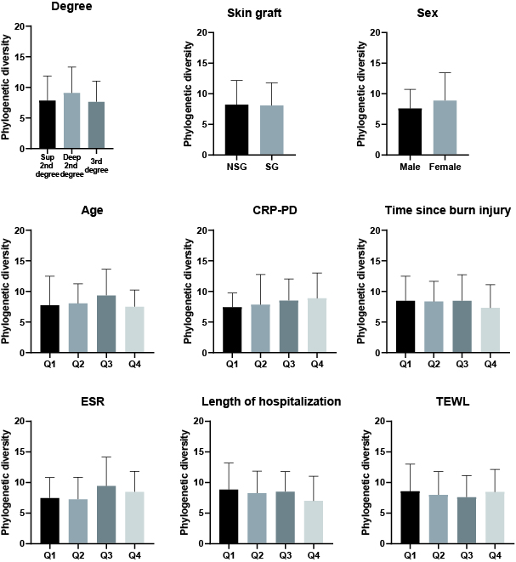
Supplementary Figure S1. Comparison of the alpha diversity of skin microbiota according to factors influencing pathological scar formation. Values are expressed as means ± standard deviation.

