Supplementary materials

Unusual specific interaction of RBD with zeolite induces rapid neutralization of SARS-CoV-2

Dan Li¹†, Shenxin Liu¹†, Miaojin Zhu²†, Zhang Tongtong³†, Lisha Yu¹†, Min He⁴†, Xutao Chen¹, Fangjun Wang⁴, Han Zhang⁵, Zhuang Liu⁵, Yifeng Shi⁶, Hao Chen¹, Wenzhao Zhang¹, Chaojie Shi¹, Tianhao Weng², Danrong Shi², Shihui Zou¹, Qi Wang^{1*}, Wei Chen^{3*}, Nanping Wu^{7*}, Hangping Yao^{2*}, Liping Xiao^{1*}, Jie Fan^{1*}

¹ Department of Chemistry, Zhejiang University, Hangzhou 310027, China.
² State Key Laboratory for Diagnosis and Treatment of Infectious Diseases, National Clinical Research Center for Infectious Diseases, Collaborative Innovation Center for Diagnosis and Treatment of Infectious Diseases, The First Affiliated Hospital, Zhejiang University School of Medicine, Hangzhou 310003, China.
³ Key Laboratory of Integrated Oncology and Intelligent Medicine of Zhejiang Province, the MOE Frontier Science Center for Brain Science & Brain-Machine Integration，Liangzhu Laboratory，Zhejiang University Medical Center, Department of Cell Biology, Department of Cardiology of the Second Affiliated Hospital, Zhejiang University School of Medicine, Zhejiang University, Hangzhou 310058, China
⁴ CAS Key Laboratory of Separation Sciences for Analytical Chemistry, Dalian Institute of Chemical Physics, Chinese Academy of Sciences, Dalian 116023, China
⁵ Institute of Functional Nano and Soft Materials, Jiangsu Key Laboratory for Carbon-Based Functional Materials and Devices, Soochow University, Suzhou 215123, China
⁶ Zeo-Innov Life Technology Co., Ltd., Hangzhou 310023, China.
⁷ Jinan Microecological Biomedicine Shandong Laboratory, Jinan, 250117, China.

† These authors contributed equally to this work.
*Corresponding author: jfan@zju.edu.cn; lpxiao@zju.edu.cn; qiwang@zju.edu.cn; jackweichen@zju.edu.cn; flwnp2013@163.com; yaohangping@zju.edu.cn.
Table S1. Copper content of Cu-zeolite (detected by inductively coupled plasma-mass spectrometry)
Samples | Ion-exchanging processª | Copper concentration  (wt%) |  |  |  | Average  (wt%)
Z0 | Na-zeolite | 0 | 0 | 0 | 0
Z1 | 200 ppm Cu | 1.22 | 1.45 | 1.13 | 1.27±0.17
Z2 | 600 ppm Cu | 3.19 | 3.63 | 3.72 | 3.51±0.28
Z3 | 1200 ppm Cu | 4.91 | 5.73 | 4.93 | 5.19±0.47
Z4 | 1200 ppm Cu *2(4h+5h) | 6.11 | 6.72 | 6.00 | 6.28±0.39
Z5 | 1200 ppm Cu *2(24h+24h) | 6.73 | 7.12 | 5.99 | 6.61±0.57
Z6 | 1200 ppm Cu *3 (24h+24h+24h) | 7.49 | 7.64 | 7.17 | 7.43±0.24

ª ion-exchanging concentration and processing time of each procedure.

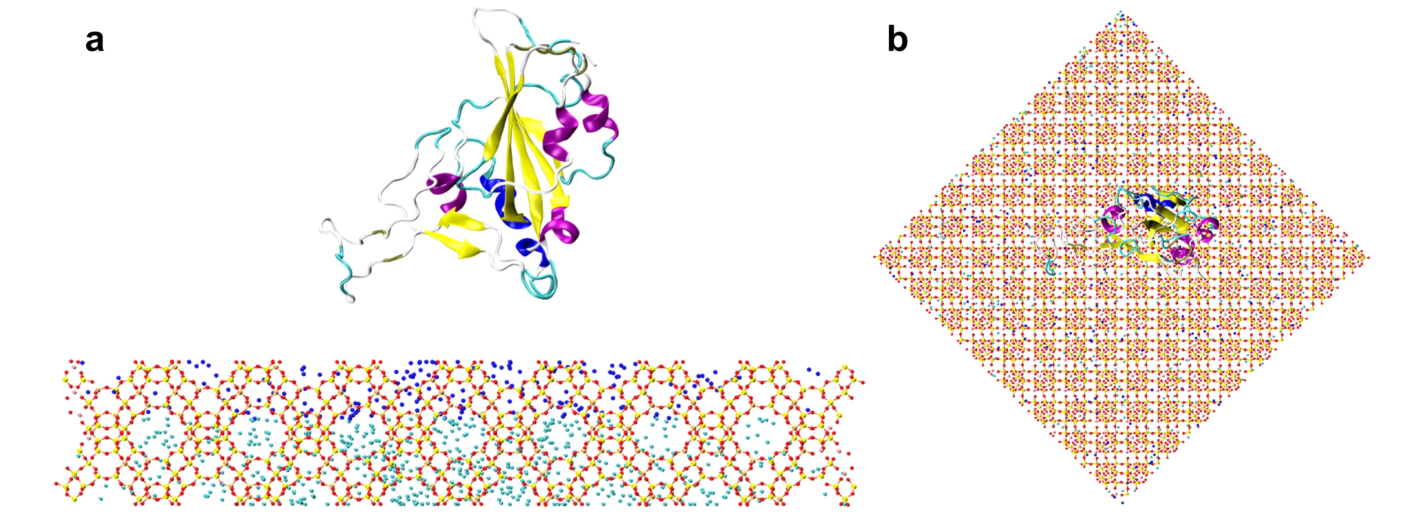
Figure S1. Initial conformation of Cu-zeolite -RBD system. (a) side view, (b) top view.

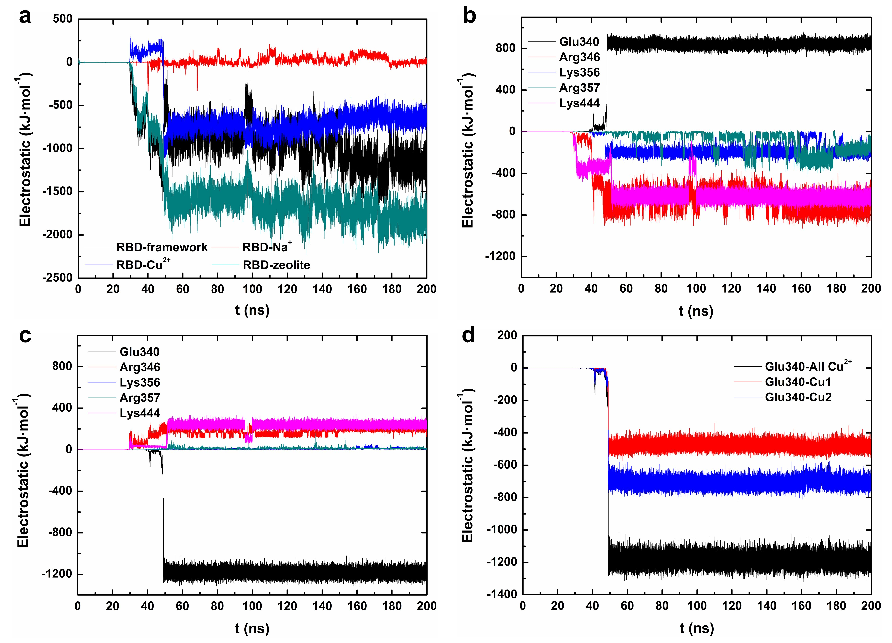
Figure S2. Electrostatic interaction energies in Cu-zeolite-RBD system. (a) between RBD and zeolite frameworks, ions and the whole, (b) between five key binding residues and zeolite frameworks, (c) between five key binding residues and Cu²⁺, (d) between E340 and the two Cu²⁺.
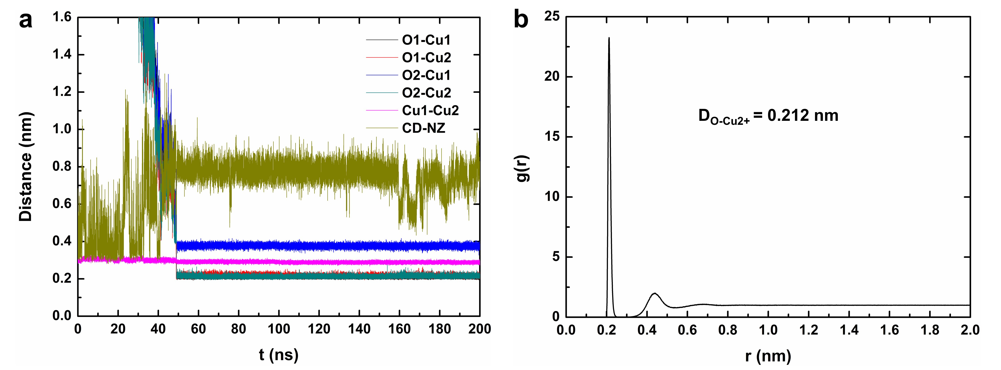
Figure S3. (a) Distances of E340, K356 and Cu²⁺ in Cu-zeolite-RBD system, (b) Radial distribution function of oxygen atom in water molecule around Cu²⁺ in Cu²⁺ aqueous solution.

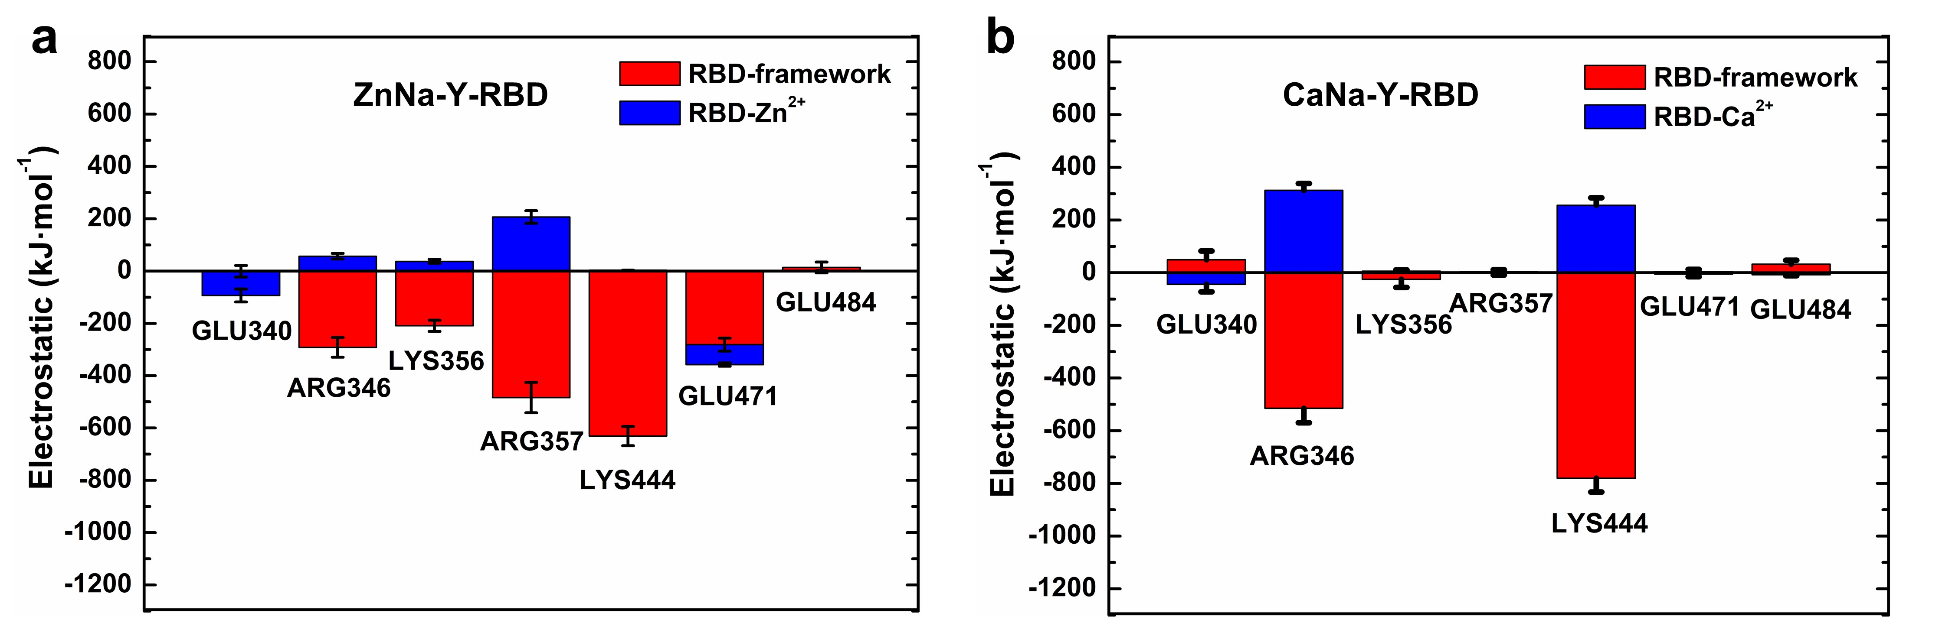
Figure S4. Key contact residues obtained from (a) Zn-zeolite-RBD, and (b) Ca-zeolite-RBD systems in MD simulations.

Table S2. Dimethyl labeling efficiency of lysine (Lys) on free S1, S1 interacted with Na-zeolite and Cu-zeolite.
K site | Control | Na-zeolite | Cu-zeolite
K356  K386  K417  K424  K444  K458&K462  K528&K529  K535&K537  K77 | 14±7%  7±12%  16±14%  38±1%  29±4%  40±3%  35±8%  28±2%  51±3% | 13±11%  12±13%  23±12%  25±0%*  18±2%*  24±3%*  68±29%  8±7%* | 0±0%*  0±0%  32±3%  44±2%*  31±1%  39±5%  42±4%  31±7%

Data values corresponded to mean ± standard deviation (SD), n = 3. All data are tested for significance with the control group. *P < 0.05, one-way analysis of variance (ANOVA).

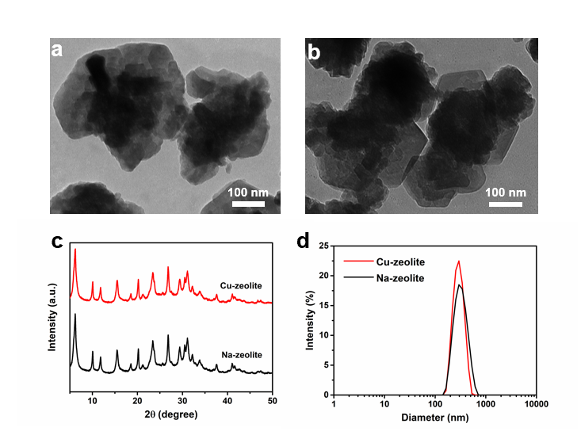
Figure S5. Chemical characterizations of the nanosized zeolite. TEM images of nanosized (a) Na-zeolite and (b) Cu-zeolite; (c) powder X-ray diffraction (XRD) and (d) dynamic light scattering (DLS) patterns of nano Na-zeolite and Cu-zeolite (ca. 300 nm).
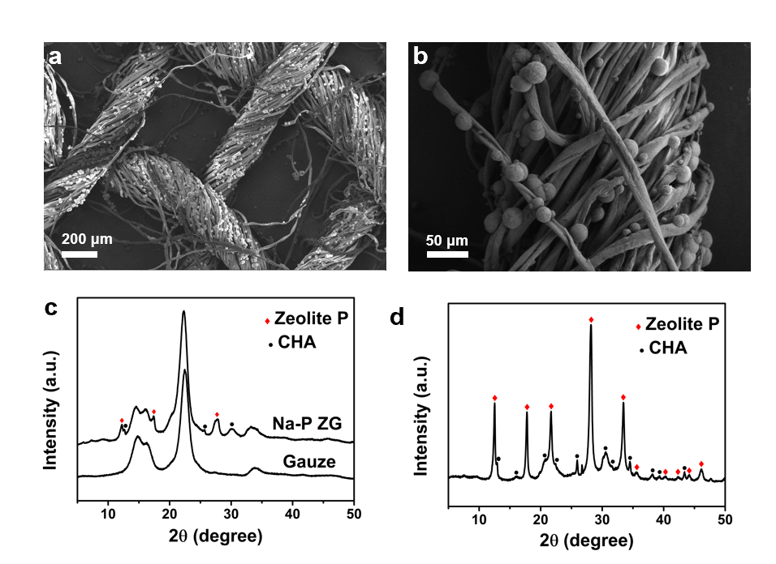
Figure S6. Characterization of Cu-ZG. (a, b) SEM images of Cu-ZG and (c,d) Cu-zeolite.
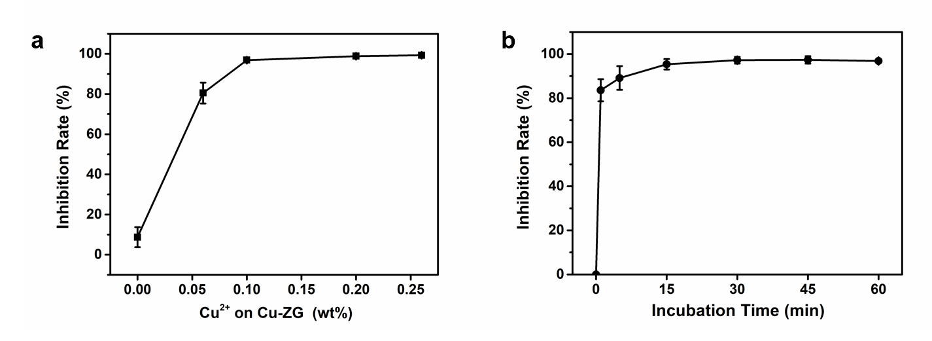
Figure S7. Inhibition rates of Cu-ZG as the function of (a) incubation time and (b) Cu contents. Data values corresponded to mean ± standard deviation (SD), n = 3. Error bars represent SD.
Figure S8. Fluorescence quantification analysis of hACE2-293T cells infected by pseudovirus with Na-ZG and Cu-ZG. Data values corresponded to mean ± standard deviation (SD), n = 5. Error bars represent SD. ***P<0.001, ns: not significant, one-way analysis of variance (ANOVA).

Figure S9. (a) Photograph of manufactured Cu-ZG-Mask and (b) the Cu-ZG-Mask sample (4×4 cm) for antiviral test.

