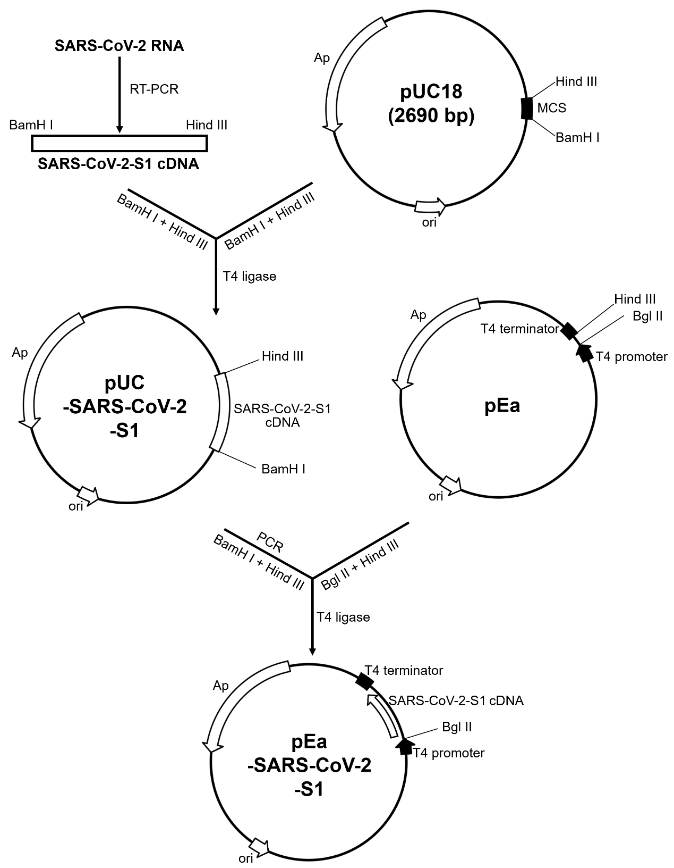
Fig. S1 Construction scheme of pEa-SARS-CoV-2-S1 plasmid.

Table S1 Gene ontology analysis for significantly altered genes-molecular function
Molecular function | Count | p-value
Protein binding | 28 | 8.5E-06
Sequence-specific DNA binding | 11 | 2.0E-05
Transcription factor activity | 10 | 1.3E-05
DNA binding | 10 | 3.1E-04
Identical protein binding | 8 | 2.8E-04
Transcription regulatory region DNA binding | 7 | 4.6E-04
Cytokine activity | 6 | 4.9E-03
Receptor binding | 6 | 1.5E-02
Oxidoreductase activity | 6 | 3.6E-02
Steroid hormone receptor activity | 5 | 1.7E-02
RNA polymerase II transcription factor activity | 5 | 7.9E-02

Table S2 Primer sequences for quantitative PCR reactions
Primer name | Primer sequence（5’-3’）
CXCR4 Forward | CTCCTCTTTGTCATCACGCTTCC
CXCR4 Reverse | GGATGAGGACACTGCTGTAGAG
CX3CR1Forward | CACAAAGGAGCAGGCATGGAAG
CX3CR1 Reverse | CAGGTTCTCTGTAGACACAAGGC
CCR5 Forward | TCTCTTCTGGGCTCCCTACAAC
CCR5 Reverse | CCAAGAGTCTCTGTCACCTGCA
CCR7 Forward | CAACATCACCAGTAGCACCTGTG
CCR7 Reverse | TGCGGAACTTGACGCCGATGAA
GNAI1 Forward | CCTGTTTCAACAGATCCCGAGAG
GNAI1 Reverse | TCGGGATGTAATTTGGTTGAGCTA
PI3K Forward | GAGAGCTTGGAGGACGATGATG
PI3K Reverse | CCACGCTTCAGCAGAAATCTGG
ERK Forward | ACACCAACCTCTCGTACATCGG
ERK Reverse | TGGCAGTAGGTCTGGTGCTCAA
AKT Forward | TGGACTACCTGCACTCGGAGAA
AKT Reverse | GTGCCGCAAAAGGTCTTCATGG
NF-κB Forward | GCAGCACTACTTCTTGACCACC
NF-κB Reverse | TCTGCTCCTGAGCATTGACGTC
FAS Forward | GGACCCAGAATACCAAGTGCAG
FAS Reverse | GTTGCTGGTGAGTGTGCATTCC
Bcl-2 Forward | ACGACCTCAACGCACAGTACGA
Bcl-2 Reverse | CCTAATTGGGCTCCATCTCGGG
PK Forward | TCAGGATGCGTCCACCAAGAAG
PK Reverse | TGTGTCCACGGCGGCAATCATC
PEK-1Forward | AGCACTGAGTGACTACGACCTG
PEK-1 Reverse | GATGTATCTGTAAACCACTTGTT
GAPDH Forward | GTCTCCTCTGACTTCAACAGCG
GAPDH Reverse | ACCACCCTGTTGCTGTAGCCAA

