Supplementary Experimental Procedures
Biochemical measurement
Serum levels of alanine aminotransferase (ALT), aspartate aminotransferase (AST), Albumin (ALB) and Lactic dehydrogenase (LDH) were measured with the kits according to the manufacturer’s instructions (Nanjing Jiancheng Bioengineering Institute, Nanjing, China).
Immunoblot
Cytoplasmic and nuclear proteins’ extraction were performed according to the manufacturer’s instructions (Minute™ Cytoplasmic and Nuclear Fractionation kit, sc-003). The total protein was extracted from primary hepatocytes and liver tissues as previously described.⁽¹⁾ Total protein concentration was determined using the Pierce®BCA Protein Assay kit (Thermo Scientific). Equal amounts of protein per sample were separated on 10% SDS-PAGE and transferred to polyvinylidene difluoride membranes. The membranes were blocked with 5% nonfat milk for 1 hour at room temperature, followed by probing with corresponding primary antibody over night at 4°C. Then, the membranes were incubated with HRP-conjugated secondary antibodies for 1 hour at room temperature. The specific bands were detected using ECL western blotting substrate (Merck millipore).
qRT-PCR Analysis
Total RNA was extracted from liver tissues using TRIzol reagent (Thermo) according to the manufacturer’s protocol (Invitrogen, USA) and subjected to complementary DNA synthesis. Reverse transcription products of different samples were amplified by LightCycle480 II (Roche) using QPCR Master Mix (LightCycler 480 SYBR Green I Master, Roche) according to the manufacturer’s instructions. Sequences of primers used in this study are summarized in Table S3.
Histology, Immunohistochemistry (IHC) and immunofluorescence
Connective tissue stain (Sirius Red), Hematoxylin-eosin (HE), and IHC were performed in formalin-fixed paraffin-embedded liver sections or snap-frozen liver pieces, as described previously.⁽¹⁾ Detailed information about antibodies used is summarized in Table S2.
Single cell RNA-Sequencing and Data analysis
Liver preparation into single cell suspension
To prepare single cell suspensions, mice liver was minced and digested using Collagenase II (Worthington Biochemical Corporation) and DNase (Sigma) and processed through the gentleMACS Dissociator (Miltenyl) utilizing a mouse liver protocol for processing. Following tissue dissociation, cells were passed through a 70 mm filter (Falcon, Corning), washed, and counted with a Cellometer Auto 2000 (Nexcelom).
Single Cell RNA-Sequencing
Single-cell suspensions were loaded onto a 10 × Chromium Controller (10 × Genomics) and library preparation was performed according to the manufacturer’s instructions for the Single Cell 3’ Library Gel Based-In-Emulsions (10× Genomics). Sequencing was performed on the Illumina HiSeq XTEN platform (Illumina, 150-bp paired-end protocol), according to the manufacturer’s protocol.
Data processing and clustering
Read processing was performed using the 10× Genomics workflow. Briefly, the Cell Ranger Single-Cell Software Suite v3.0.1 was used for demultiplexing, barcode assignment, and unique molecular identifier (UMI) quantification (https://software.10xgenomics.com/single-cell/overview/welcome). For cell subset assessment within the major cell types, cell subsets were reanalyzed separately. For each cell subset, the top 10 PCs of 20 re-analyzed PCs were used for tSNE construction, using the resolution 0.8 for graph-based clustering to identify the cell cluster.
ELISA assay of GSDMD-N and CXCL1
The concentration of GSDMD-N in the serum of human were determined by the use of ELISA kits (Jianglai Biological). CXCL1 in the culture medium of hepatocytes was measured by ELISA assay (ThermoFisher) according to the manufacturer’s instruction.
Hepatocyte and neutrophil isolation
Primary hepatocytes were freshly isolated from adult WT or Gsdmd^{-/-} mouse (20-25 g) according to a modified two-step collagenase perfusion method. ⁽²⁾ Briefly, the liver was perfused in situ under anesthesia with perfusion buffer (0.5 mM EDTA, 25 mM HEPES in no Ca²⁺, no Mg²⁺ and no phenol red HBSS) for 3-5 min at 37°C followed by perfusion with 25 μg/mL liberase in digestion Solution (25mM HEPES in HBSS with Ca²⁺, Mg²⁺ and phenol red) for 3-5 min Hepatocytes were released in Williams’E solution and filtered through a sterile nylon mesh (70 µm). The cell suspension was enriched and purified by low-speed centrifugation (50 g) and Percoll solution. The hepatocytes were cultured in Williams’ E medium with 10% fetal bovine serum (FBS). After 3 h the medium was replaced with fresh, prewarmed culture medium. Hepatocyte viability was determined by trypan blue exclusion and only preparations with a viability >90% were used.
Neutrophils were isolated from bone marrow of 7-10 week C57BL/6N mouse (20-25 g) according to previously published protocol. ⁽³⁾ Briefly, femur and tibia were placed in a perforated 600ul tube, and after high-speed centrifugation (15000 g) for 15 s at 4°C, the bone marrow was collected through the hole into a 1.5 mL centrifuge tube below. And then the erythrocytes were removed by resuspension with 0.2% sodium chlorie (NaCl) and 1.6% NaCl. Overlay the bone marrow cell suspension on the top of the density gradient (overlay 3 ml of Histopaque 1077 [Sigma-Aldric] on the 3 mL of Histopaque 1119 [Sigma-Aldric]) and centrifuge for 30 min at 2,000 rpm at 25°C without brake. The neutrophils were collected at the interface of Histopaque 1119 and Histopaque 1077 layers. Washed and cultured with 1640 medium supplemented with 10% FBS and antibiotics.
FACS sorting analysis
The non-parenchymal cells (NPC) were collected from flow-cytometric sorting according to the protocol provided by Manco et al. ⁽⁴⁾ In brief, mice livers were perfused as mentioned above. After the centrifugation of 50 g step, the NPCs were collected from supernatant and blocked by bovine serum and then incubated by indicated antibodies. We used Biosciences influx machine to isolate liver sinusoidal endothelial cells (SEC, CD32⁺CD11b⁻UV⁻PI⁻), monocyte-granulocyte (CD11b⁺CD32⁻UV⁻PI⁻), hepatic stellate cells (UV⁺CD11b⁻CD32⁻PI⁻) and T cell (CD3⁺CD45⁺PI⁻).
Hepatocytes treatment in vitro.
Freshly isolated murine hepatocytes cells were treated with GDC-0994 (1μM, MCE), or JNK-IN-8 (1μM, MCE), or SB 203580 (1μM, MCE), or Ac-YVAD-cmk (10 μM, MCE), or JSH-23 (25 μM, MCE), or CXCL1 Ab (5 μg/mL, R&D systems), or CXCL1 recombinant protein (200 ng/mlL NovoProtein), or disulfiram (20 μM, MCE) for 6 h or 24 h, and then exposed into 8 Gy irradiation.
Co-culture system of Neutrophils or LX-2 with hepatocytes
Neutrophil migration ability was determined by 24-well transwell migration assay. After 24 h, 1×10⁵ hepatocytes received radiation in the bottom chamber, 3-4×10⁵ neutrophils were added in the top chamber (3 μm pore size). Cells were incubated for additional 6 h at 37°C. Cells and medium from the lower chamber were harvested for the Ly6G-FITC incubation, and then followed by flowcytometry analysis. The migrated neutrophils were calculated by flowcytometry.
With the same cell numbers, non-irradiated or pre-irradiated hepatocytes (1×10⁵) were co-cultured with LX-2 (1×10⁵, 1:1) in both contact and non-contact manners for 3 days. All cells in the lower chamber in contact manner and cells in above chamber in non-contact manners were all collected and for WB analysis.

Co-immunoprecipitation (Co-IP)
For co-immunoprecipitation, cells were lysed with lysis buffer and the supernatant was incubated with antibody (anti-GSDMD, anti-stat5a and then participitated with protein A/G-agarose beads. The beads were washed with and boiled to isolate the protein. Further analysis was carried out by SDS-PAGE gels electrophoresis separation.
Chromatin immunoprecipitation (ChIP) assay
ChIP assay was conducted according to the manufacturer’s protocol (Millipore). In brief, cells (1.5×10⁶) were plated into 6 cm culture dishes with or without IR, and samples were harvested for cross-linking and sheared by sonication 24 hours later. The resultant chromatin fraction was immunoprecipitated using or negative control anti-IgG (Sigma) antibody. PCR amplification of purified DNA fragments was performed with the indicated specific primers. Forward primer: 5’-GCGTTAATCTGCCACACTCA; Reverse primer: 5’-GAACTGGTTAGAGGCTCTGA.
Plasmid transfection
GSDMD-FL plasmid were purchased from Genechem Company (Shanghai, China). The constructed plasmid was amplified and confirmed by sequencing. Adult mouse hepatocytes were then transfected for 6 h using Lipo 3000 reagent (ThermoFisher, L3000015) according to the manufacturer’s instructions.
Flowcytometry
Single cells of liver were obtained according to previously published protocol with some modifications. ⁽⁵⁾ Briefly, tissues passed through a 70 μm cell strainer in 1640 contain 2% FBS and were digested with 0.625 mg/mL collagenase D at 37°C agitation (200 rpm) for 30 min. The cell suspension was centrifuged at 50 g for 1 min to pellet the hepatocytes. The supernatant enriched liver leukocytes were centrifuged at 700 g for 10 min. The resulting pellet containing leukocytes was resuspended in 3 mL of ACK lysis buffer. Cells were then washed and ready for staining. Cells were then stained by mouse FVD-ef780, CD45-ef450, CD4-BV510, CD8-PE, CD11b-SB600, F4/80-APC, Ly6G-FITC antibody. Flow cytometry data were acquired with Thermofisher (Invitrogen attune nxt) and analyzed by FlowJo software (BD, San Jose, CA).
RNA-Sequencing from Liver Tissue
RNA was extracted from the liver of LT-RILD Gsdmd^{FL/FL} and Gsdmd^{∆Hep} mice (n= 5). Total RNA was isolated and purified using TRIzol reagent (Invitrogen, Carlsbad, CA, USA) following the manufacturer's procedure. After purification and validation, the cDNA libraries were constructed using a SuperScript™ II Reverse Transcriptase Kit (Invitrogen, 18064014) and sequenced using illumina Novaseq™ 6000 following the vendor's recommended protocol. RNA-seq FASTQ files were processed and evaluated through the Fastp software (https://github.com/OpenGene/fastp). After that, HISAT2 was run (https://ccb.jhu.edu/software/hisat2) to map reads to the reference genome of Homo sapiens. Then, all transcriptomes from all samples were merged to reconstruct a comprehensive transcriptome. After the final transcriptome was generated, StringTie and was used to estimate the expression levels of all transcripts. The differentially expressed mRNAs were selected with fold change > 2 or fold change < 0.5 and with parametric F-test comparing nested linear models (p value < 0.05) by R package edgeR.
QUANTIFICATION AND STATISTICAL ANALYSIS
All experiments were performed with at least three biological repeats. Analyses were conducted using Graphpad Prism 9.0 software. Results are expressed as the mean ± SEM as indicated, and analysed using Student’s t-test. Comparison of more than two groups was performed by one-way ANOVA with Dunnett’s multiple comparisons test. Groups with two variables were compared with two-way ANOVA with Tukey’s multiple comparisons test. Mann-Whitney test were used to evaluate whether there were any statically difference in terms of continuous variables. The correlations were detected using Spearman correlation. p <0.05 was considered statistically significant.

SUPPLEMENTAL FIGURES
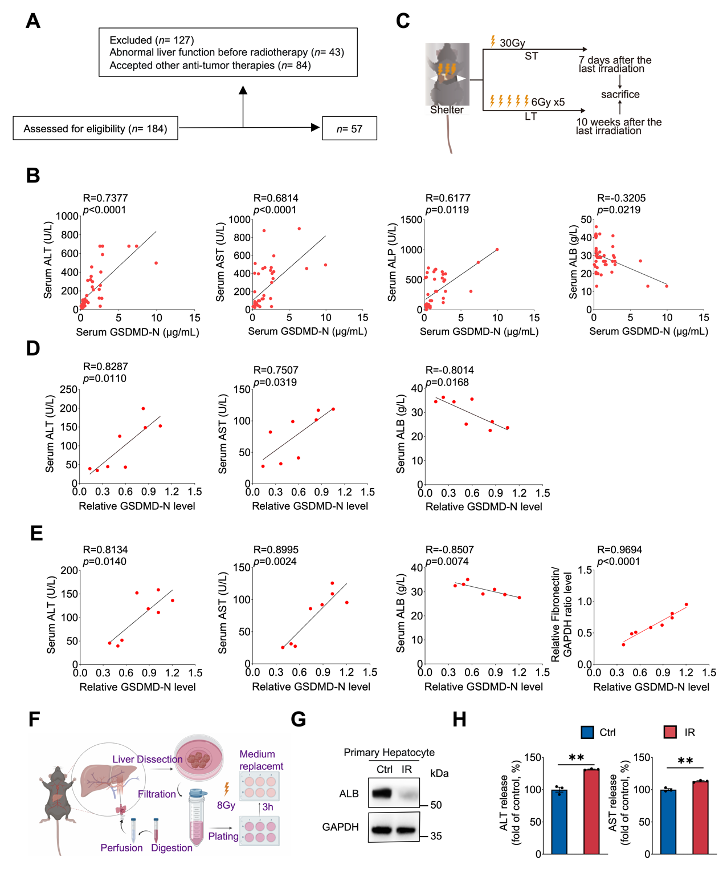FIGURE S1 Irradiation induced the injury of mice liver function and hepatocyte. (A) The inclusion and exclusion criteria for collecting the blood from patients with thoracic-abdominal and pelvic tumors. (B) Correlation between serum GSDMD-N level and serum ALT, AST, ALP and ALB level and were analyzed by Spearman correlation test. (C) Scheme of experimental design. C57BL/6J mice received one single 30 Gy hepatic irradiation or 5 doses of 6 Gy hepatic irradiation every two days, and mice were sacrificed and harvested at 7 days and 10 weeks after the last radiation to investigate short-term (ST) and long-term (LT) side effects, respectively. (D) Correlation between liver GSDMD-N level and serum ALT, AST, ALB level in ST group. (E) Correlation between liver GSDMD-N level and serum ALT, AST, ALB level and the expression of fibronectin in LT group. Spearman correlation test. (F) Scheme of experimental procedure of isolation primary hepatocyte. (G) Protein expression level of ALB in WT primary hepatocytes treated with or without 8 Gy irradiation. (H) Supernatants from control (Ctrl) and irradiated (IR) primary hepatocyte were collected for ALT (left) and AST (right) assay. Student’s t test. Data are shown as mean ± SEM (B, D-E, H, n= 3-6/group; G, at least 3 independent experiments), **p < 0.01.

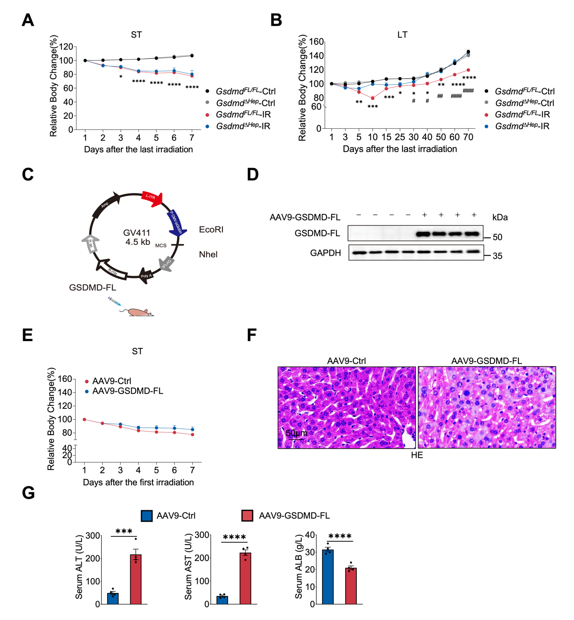FIGURE S2 GSDMD influence the severity of RILD.
(A) The body weight change of Gsdmd^{FL/FL} and Gsdmd^{∆Hep} mice after 30 Gy hepatic radiation during 7 days. (B) The body weight change of Gsdmd^{FL/FL} and Gsdmd^{∆Hep} mice after 6 Gy×5 hepatic radiation during 10 weeks. (C) Scheme of the tail vein injection of the AAV9-GSDMD-FL adeno-associated virus. (D) Gsdmd^{∆Hep} mice were re-expressed with GSDMD-FL and control vector. The expression of GSDMD-FL was analyzed by immunoblot. (E) The body weight change of AAV9-control and AAV9-GSDMD-FL mice were recorded after 30 Gy hepatic radiation. (F) Representative HE images of AAV9-control and AAV9-GSDMD-FL mice (Scale bars, 200×, 50 μm). (G) Serum ALT, AST, ALB and LDH content in AAV9-control and AAV9-GSDMD-FL mice received 30 Gy irradiation. Data represent the mean ± SEM (n= 3-6/group). p values were determined by Student’s t test (G) and two-way ANOVA Sidak’s multiple comparisons test (A, B and E). The black and pink point were Gsdmd^{FL/FL}-Ctrl vs Gsdmd^{FL/FL}-IR and Gsdmd^{FL/FL}-IR vs Gsdmd^{∆Hep}-IR respectively. *p <0.05, **p <0.01, ***p <0.001, ****p <0.0001. * Indicated the statical difference between Gsdmd^{FL/FL}-Ctrl and Gsdmd^{FL/FL}-ST/LT; #p <0.05, ##p <0.01, ###p <0.001, ####p <0.0001. # Indicated the statical difference between WT and Gsdmd^{-/-} in ST/LT.

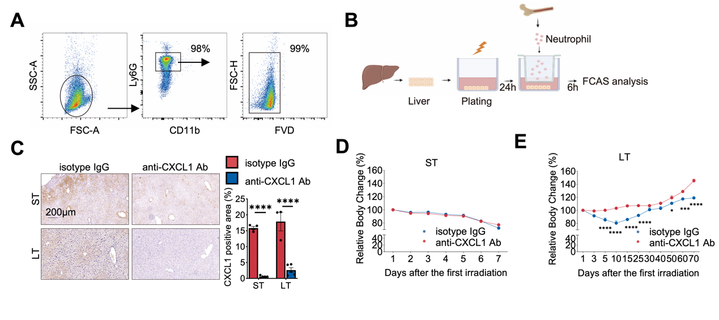FIGURE S3 Scheme of experimental procedure for cell co-culture. (A) The purity and activity of isolated neutrophil. (B) Scheme of experimental procedure for neutrophil chemotaxis assay. (C) Scheme of experimental procedure for two manners of non-contact (up) and contact (down) co-culture hepatocyte with HSCs.

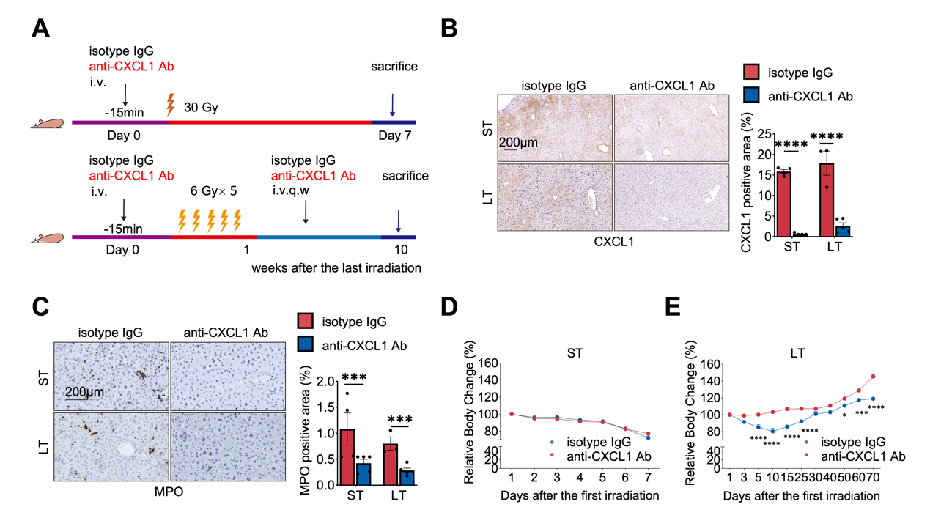FIGURE S4 referred to Figure 4 (A) Scheme of experimental design. Cohort of ST-RILD: An anti-CXCL1 antibody or IgG antibody (100 μg) was injected into the WT mice via mouse tail vein 15 min before 30 Gy hepatic irradiation. Mice were harvested at day 7 post radiation. Cohort of LT-RILD: An anti-CXCL1 antibody or IgG antibody (100 μg) was administrated into the WT mice 15 min before each 6Gy hepatic irradiation. After the last irradiation, 25 μg anti-CXCL1 antibody or IgG antibody was injected once a week. Mice were sacrificed 10 weeks after the last radiation. (B) Representative CXCL1 staining (left) and statistical analysis (right) of liver from mice treated with isotype-IgG and anti-CXCL1 Ab from AT-and LT-RILD mice (Scale bars, 40×, 500μm). One-way ANOVA plus Dunnett’s multiple comparisons test. (C) Detection of the neutrophil infiltration in liver of mice treated with isotype IgG antibody and anti-CXCL1 antibody. The positive area of MPO⁺ staining (left) and its statical analysis were presented in both ST- and LT-RILD cohort (right, n= 3-5 mice/group). One-way ANOVA plus Dunnett’s multiple comparisons test. (D-E) The body weight change of isotype-IgG and anti-CXCL1 Ab treated mice in ST- (left, D) and LT-RILD (right, E). Two-way ANOVA Tukey’s multiple comparisons test. Data are mean ± SEM (n= 3-6/group, average of 5 random HPF analyzed per animal). *p <0.05, ***p <0.001, ****p < 0.0001.

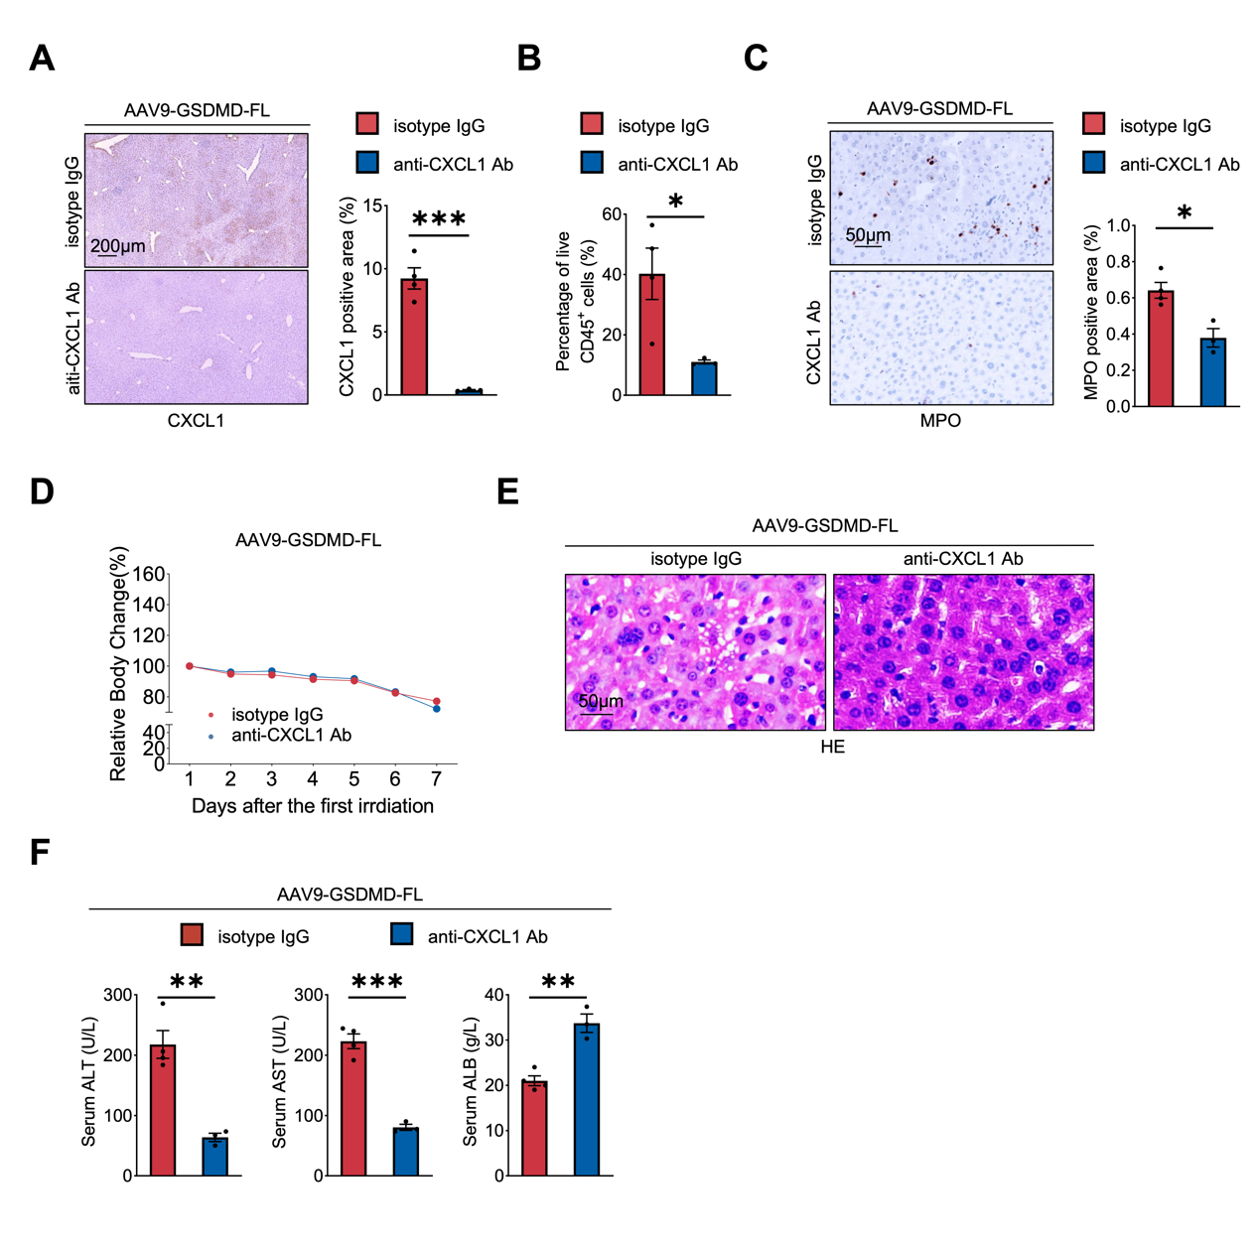FIGURE S5 referred to Figure 5. Gsdmd^{∆Hep} mice were re-expressed with GSDMD-FL by AAV-9-GSDMD-FL. After 2 weeks, anti-CXCL1 antibody or IgG antibody (100 μg) was injected into the mice via mouse tail vein 15 min before 30 Gy hepatic irradiation. Mice were harvested at day 7 post radiation. (A) Representative CXCL1 staining (left) and statistical analysis (right) of liver from mice treated with isotype-IgG and anti-CXCL1 Ab from AT-and LT-RILD mice (Scale bars, 40×, 200μm). Student’s t test. (B-C) Detection of the neutrophil infiltration in liver of mice treated with isotype IgG antibody and anti-CXCL1 antibody. The percentage of cells with CD11b⁺Ly6G⁺ with flow cytometry (B) and MPO staining (C) in both ST- and LT-RILD cohort (right, n= 3-5 mice/group). Student’s t test. (D) The body weight change of isotype-IgG and anti-CXCL1 Ab treated mice in ST-RILD. Two-way ANOVA Tukey’s multiple comparisons test. (E) Representative liver HE images from ST-RILD mice (Scale bars, 200×, 50 μm). (F) Serum levels of ALT, AST and ALB. n= 3-5 mice/group. Student’s t test. Data are expressed as mean ± SEM. *p <0.05, **p <0.01, ***p <0.001.

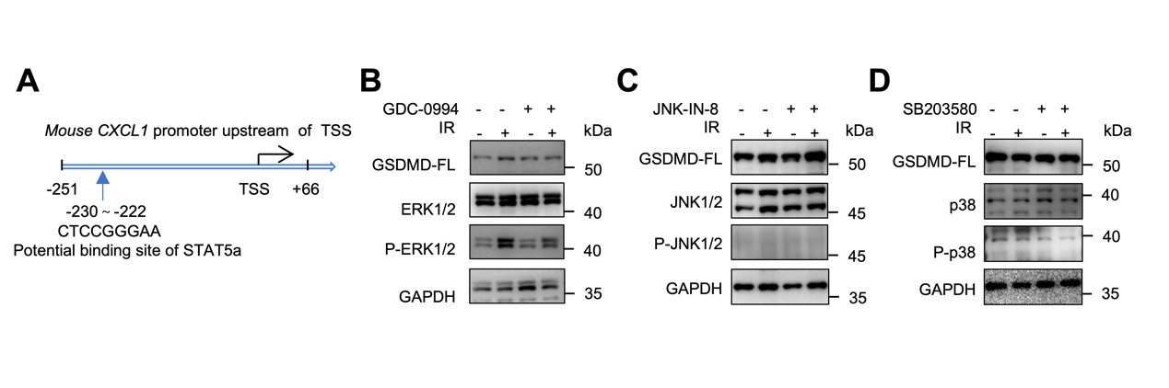FIGURE S6 referred to Figure 6. (A) Luciferase reporter assay was performed to measure the binding of stat5a at the the promoter region of Cxcl1 gene. (B-D) Hepatic protein levels of GSDMD-FL and ERK/JNK/p38 pathway between ERK inhibitor GDC-0994 (1 μM, A), JNK inhibitor JNK-IN-8 (1 μM, A), p38 inhibitor SB203580 (10 μM, C) and vehicle groups were evaluated by Immunoblot. Immunoblot analysis of GSDMD-FL and ERK/JNK/p38 pathway from hepatocytes

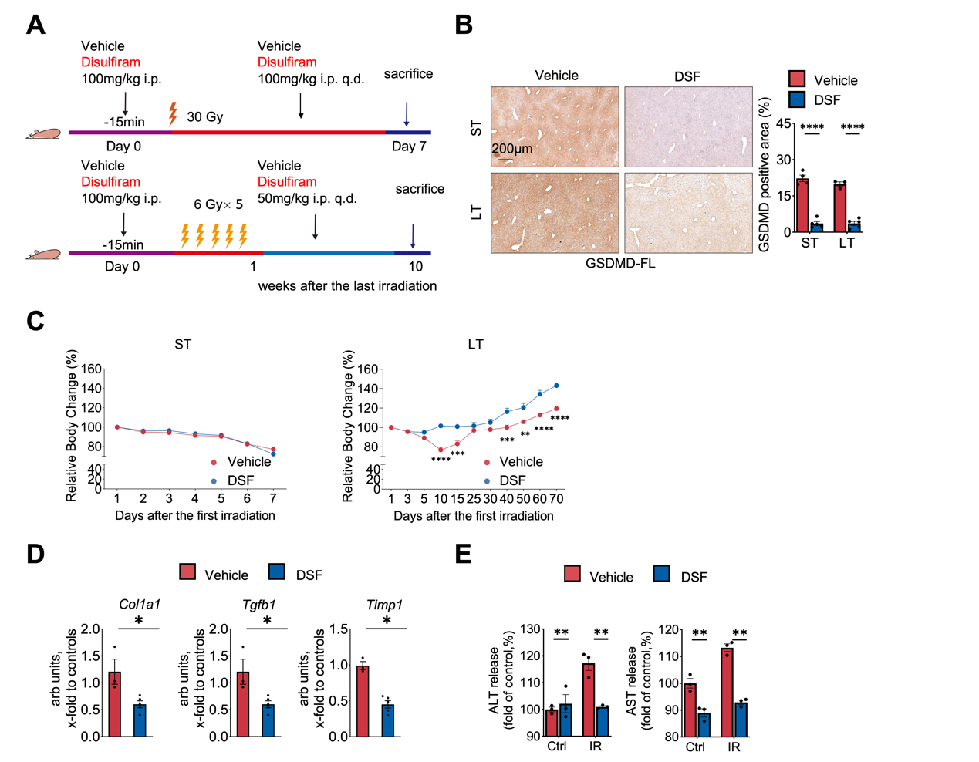FIGURE S7 referred to Figure 7. (A) Scheme of experimental design. Cohort of ST-RILD: DSF or vehicle (100 mg/kg) was intraperitoneally injected into the WT mice 15 min before 30 Gy hepatic irradiation. After the last irradiation, DSF or vehicle (100 mg/kg) was injected every day. Mice were harvested at day 7 post radiation. Cohort of LT-RILD: DSF or vehicle (100 mg/kg) was administrated into the WT mice 15 min before each 6 Gy hepatic irradiation. After the last irradiation, 50 mg/kg DSF or vehicle was injected once a week. Mice were sacrificed 10 weeks after the last radiation. (B) Representative GSDMD-FL staining of liver from mice treated with vehicle and disulfiram from ST- and LT-group (Scale bars, 40×, 200 μm). One-way ANOVA plus Dunnett’s multiple comparisons test. (C) The body weight change of vehicle and disulfiram treated mice after 30 Gy hepatic radiation during 7 days (left) and after 6 Gy×5 hepatic radiation during 10 weeks (right). Two-way ANOVA Tukey’s multiple comparisons test (D) Hepatic mRNA levels of Col1a1, Tgfb1 and Timp1 of LT-RILD mice. One-way ANOVA plus Dunnett’s multiple comparisons test. (E) Supernatants from vehicle or disulfiram pre-treated primary hepatocyte were collected for ALT (Left) and AST (Right). One-way ANOVA plus Dunnett’s multiple comparisons test. Data are mean ± SEM. *p <0.01, **p <0.01, ***p <0.001, ****p < 0.0001.

Table S1 Clinical characteristics of HCC patients received postoperative adjuvant radiotherapy
 | Postoperative adjuvant radiotherapy (n=20)
Age (year) | 66.0 (61.0-69.0)
Male (gender) | 12 (60.0%)
RT total dose (Gy) | 48 (35-50)
Fraction number | 22 (19-25)

Table S2 Clinical characteristics of patients with cancer received radiotherapy
 | patients with cancer received radiotherapy (n=57)
Age (year) | 58.0 (49.5-66.0)
Male(gender) | 31 (54.4%)
ALT | 254.5 (24.8-496.5)
AST | 323.0 (35.0-455.8)
ALP | 282.0 (94.0-557.3)
ALB | 30.5 (26.8-40.98)
LDH | 462.5 (218.8-562.8)
TBIL | 15.9 (12.6-50.0)
IV (stage) | 24 (42.1%)
Tumor type | Primary Liver cancer (32, 56.1%)
 | Metastatic Liver cancer (25, 43.9%)
IR total dose (Gy)  Fraction number | 45 (25-65)  15 (8-25)
ALBI grade | 1 (15, 26.3%)  2 (42, 73.7%)
NOTE. Continuous variables were expressed as median (interquartile range) and categorical data as frequencies. Mann-Whitney test were used to evaluate whether there were any statically difference. ALBI= ($\log_{10}{TBIL(mg/dL)}$× 17.1 × 0.66) + (ALB (g/dL) × 10 × -0.085).
Table S3 Antibodies used for WB, IHC, IF and flow cytometry
REGENT or RESOURCE | SOURCE | IDENTIFIER
Antibodies
GSDMD, WB, dil: 1/1000 | Abcam | Cat# ab219800
GSDMD-N, IHC, dil: 1/50 | Abcam | Cat# ab215203
ɑ-SMA, WB, dil: 1/1000 IHC, dil: 1/200, IF, dil: 1/200 | Cell signaling Technology | Cat# 19245
GAPDH, WB, dil: 1/5000 | Sigma | Cat# G9545
COL1A1, WB, dil: 1/1000 | Boster | Cat# BA0325
ALB, WB, dil: 1/1000 | Cell signaling Technology | Cat# 4929S
Stat5a, WB, dil: 1/1000 | Abcam | Cat# ab32043
P-stat5a, WB, dil: 1/1000 | SAB | Cat# 13386
LaminB1, WB, dil: 1/5000 | Proteintech | Cat# 12987
MPO, IHC, dil: 1/200 | Abcam | Cat# ab208670
CXCL1, IHC, dil: 1/100, IF, dil: 1/50 | Abcam | Cat# ab86436
GSDMD, IHC, dil: 1/200 | Abcam | Cat# ab209845
GSDMD, IF, dil: 1/30 | Santa cruz | Cat# 393656
CD3, IF, dil: 1/50 | Abcam | Cat# ab5690
CD11b, IF, dil: 1/100 | Biolegend | Cat# 101201
CD45ef450, Flow cytometry, dil: 1/100 | Invitrogen | Cat# 2281268
FVD-ef780, Flow cytometry, dil: 1/1000 | Invitrogen | Cat# 2062571
CD11bSB600, Flow cytometry, dil: 1/100 | Invitrogen | Cat# 2331071
F4/80-APC, Flow cytometry, dil: 1/100 | Invitrogen | Cat# 2123749
Ly6G-FITC, Flow cytometry, dil: 1/100 | Biolegend | Cat#127606
CD4-BV510, Flow cytometry, dil: 1/100 | BD Biosciences | Cat# 740105
CD8-PE, Flow cytometry, dil: 1/100 | Biolegend | Cat# 100707

Table S4 Primers used in real-time quantitative RT-PCR.
Primer name | Sense | Anti-sense
COL1A1 | CTGGCGGTTCAGGTCCAAT | TTCCAGGCAATCCACGAGC
Timp-1 | CGAGACCACCTTATACCAGCG | ATGACTGGGGTGTAGGCGTA
TGFβ1 | CCACCTGCAAGACCATCGAC | CTGGCGAGCCTTAGTTTGGAC
CXCL1 | ACTGCACCCAAACCGAAGTC | TGGGGACACCTTTTAGCATCTT
Nr1d1 | ACTTCCCACCATCACCTACTG | GGGGAGCTATCATCACTGAGA
Pik3ap1 | GTCCCGGATGCCTCTTTCTC | CACAAGTCATTTCCTGCCAGT
Camk1d | TTCGCAGTGAAGTGCATCCC | TTTCTAAGCACGGCAATCTCG
Rorc | TCCACTACGGGGTTATCACCT | AGTAGGCCACATTACACTGCT
IL-1β | GAAATGCCACCTTTTGACAGTG | TGGATGCTCTCATCAGGACAG
IL-18 | GACTCTTGCGTCAACTTCAAGG | CAGGCTGTCTTTTGTCAACGA

References
1. Wei G, Cao J, Huang P, An P, Badlani D, Vaid KA, Zhao S, et al. Synthetic human ABCB4 mRNA therapy rescues severe liver disease phenotype in a BALB/c.Abcb4(-/-) mouse model of PFIC3. J Hepatol 2021;74:1416-1428.
2. Charni-Natan M, Goldstein I. Protocol for Primary Mouse Hepatocyte Isolation. STAR Protoc 2020;1:100086.
3. Swamydas M, Lionakis MS. Isolation, purification and labeling of mouse bone marrow neutrophils for functional studies and adoptive transfer experiments. J Vis Exp 2013:e50586.
4. Manco R, Clerbaux LA, Verhulst S, Bou Nader M, Sempoux C, Ambroise J, Bearzatto B, et al. Reactive cholangiocytes differentiate into proliferative hepatocytes with efficient DNA repair in mice with chronic liver injury. J Hepatol 2019;70:1180-1191.
5. Lee J, Byun J, Shim G, Oh YK. Fibroblast activation protein activated antifibrotic peptide delivery attenuates fibrosis in mouse models of liver fibrosis. Nat Commun 2022;13:1516.

