Supporting information

A novel copper-based metal-organic framework: Synthesis, characterization and evaluation for the hydrogenation of furfural to furfuryl alcohol

Pamela S. Moyoª, Gift Mehlana^{b}*, Leah C. Matsinhaª* and Banothile C.E. Makhubelaª*
ªResearch Centre for Synthesis and Catalysis, Department of Chemical Sciences, University of Johannesburg, Auckland Park 2006, Johannesburg, South Africa.
^{b}Department of Chemical Sciences, Midlands State University, 9055 Senga Road, Gweru, Zimbabwe.
Author Information
Corresponding authors

Email*: leahmatsinha@uj.ac.za, mehlanag@staff.msu.ac.zw and bmakhubela@uj.ac.za.
Characterizations

b

e
DMSO-d₆
d c
a

Figure SI 1: ¹H NMR spectrum of L1.

10 9
7-2
8
1
DMSO-d₆

Figure SI 2: ¹³C{H} NMR spectrum of L1, recorded in DMSO-d₆.
m/z = 403.0918 for [M-H]⁻

Figure SI 3: HR-ESI-MS spectrum of ligand L1.
Figure SI 4: FT-IR spectra of L1.
1609 cm⁻¹
1683 cm⁻¹
NH = 3276 cm⁻¹
Figure SI 5: ¹H NMR spectrum of digested Cu-MOF recorded in DMSO-d₆.
H₂O
DMSO-d₆
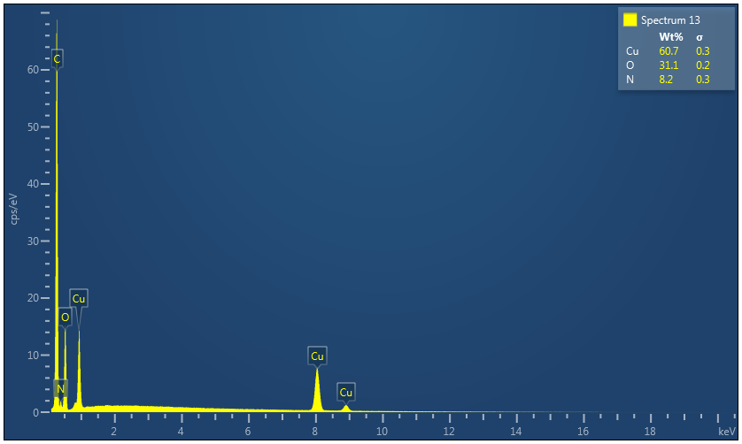Figure SI 6: EDX image for Cu-MOF.

Catalytic hydrogenation of furfural

Figure SI 7: A typical ¹H NMR of the hydrogenation of FF reaction using molecular H₂, temperature (140 ⁰C), methanol (5 mL), FF (2.5 mmol), Cu-MOF (33 µmol), time (24 hours) and DMF (internal standard) showing product of FA only, recorded in CDCl₃.
DMF+FF
FF+FA
FF
CDCI₃+ FA
FA
MeOH
MeOH
DMF

Figure SI 8: HR-TEM images for Cu-MOF before catalysis at (a) 200 nm and (b) 100 nm.

