Supplemental Materials
The effect of a political crisis on performance of community- and state-managed forests in Madagascar
Rachel A. Neugarten^{1,2*}, Ranaivo A. Rasolofoson³, Christopher B. Barrett^{4,5}, Ghislain Vieilledent⁶, Amanda D. Rodewald^{2,1}
¹Department of Natural Resources and Environment, Cornell University, 226 Mann Drive, Ithaca NY 14853 USA
²Cornell Lab of Ornithology, Cornell University, 159 Sapsucker Woods Rd, Ithaca, NY 14850
³Duke University Marine Laboratory, Nicholas School of the Environment, Duke University, 135 Duke Marine Lab Rd, Beaufort, NC 28516
⁴Charles H. Dyson School of Applied Economics and Management, Cornell University, Ithaca, NY 14853-7801, USA
⁵Jeb E. Brooks School of Public Policy, Cornell University, Ithaca, NY 14853-7801, USA
⁶AMAP, Univ Montpellier, CIRAD, CNRS, INRAE, IRD, Montpellier, FRANCE
*Corresponding author

S1. Test of parallel trends in the pre-crisis period
A key assumption of our analysis is that, in the absence of the political crisis, deforestation trends would have been similar in CFM and MNP areas (parallel trends assumption). The event study analysis controls for any difference in pre-crisis trends. Nonetheless, we tested this assumption by conducting a statistical test of significance of deforestation trends in CFM and matched MNP forest areas in the pre-crisis period. While this test was not necessary for our analysis, we were curious whether trends in the pre-crisis period were indeed similar in CFM and MNP. For the parallel trends test, we compared deforestation outcomes in CFM and matched MNP areas but focused only on the pre-crisis years (2005-2009) (Equation 3).
$$Y_{it}=β_{1}{CFM}_{i}+ τ_{1}{year}_{t}+τ_{2}{year}_{t}{CFM}_{i}+ψX_{it}+μ_{i}+ε_{it}$$ | (3)
Where all variables are defined the same way as in Equation 2, above, except for year_{t} (t=2005-2009 only). We used all the same time-variant controls described above, as well as individual fixed effects for each forest grid cell, and clustered standard errors at the site level.
We found no significant difference in deforestation trends between CFM and MNP in the pre-crisis years (2005-2009) (Fig. S11, Table S9). Both CFM and MNP were negatively associated with deforestation in the pre-crisis period (that is, they experienced less deforestation over time). This gives us even greater confidence in our findings of relative performance during and after the crisis period. Fig. S11 indicates that deforestation in CFM was declining faster than in MNP in the pre-crisis period, which would create a downward bias in any estimated difference in effect between CFM and MNP during or after the crisis. This indicates that our estimated difference in performance in the post-crisis period are, if anything, conservative.

Supplemental Figures
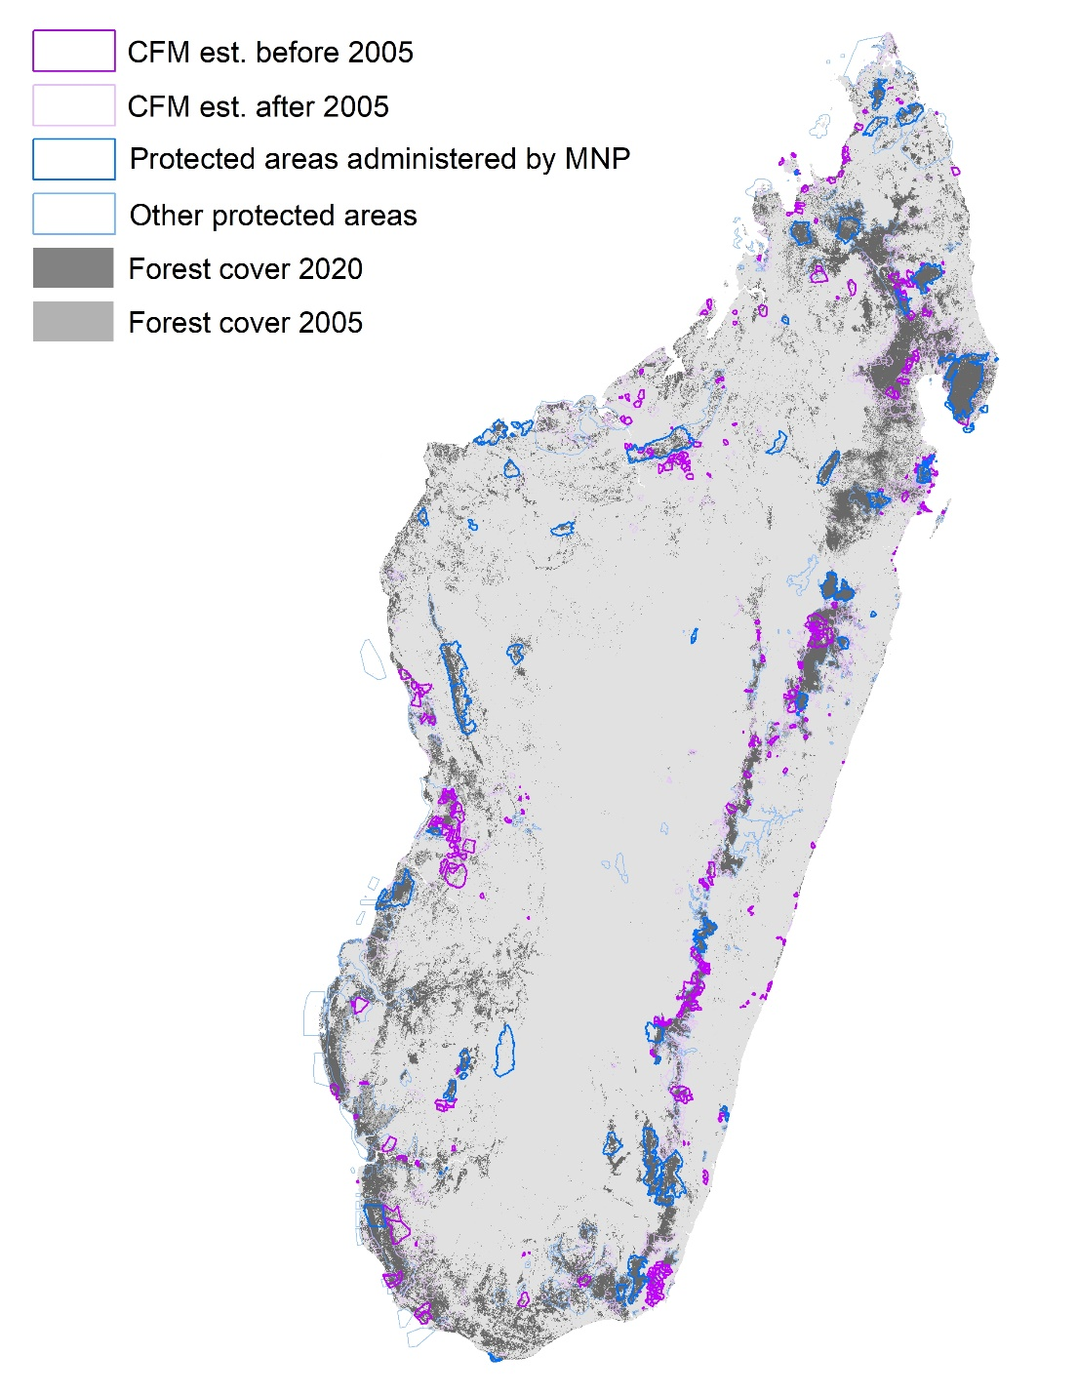

Fig. S1. Community Managed Forests (CFM), protected areas administered by Madagascar National Parks (MNP) and other protected areas
Community Forest Management areas (CFM) established before 2005 (bright purple), protected areas administered by Madagascar National Parks (MNP) also established before 2005 (bright blue). CFM established after 2005 (faint purple) and protected areas administered by other agencies (faint blue) were not included in this analysis. Forest cover 2020 (dark gray), forest cover 2005 (medium gray) and all other land cover classes (grassland, shrubland, cropland, and urban) (light gray).
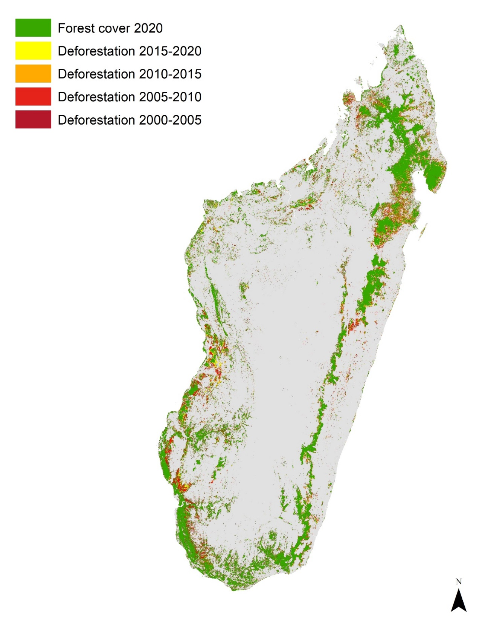

Fig. S2. Map of deforestation in Madagascar 2000-2020
Map of Madagascar’s forest cover in 2020 (green) and deforestation 2000-2005 (dark red), 2005-2010 (light red), 2010-2015 (orange), and 2015-2020 (yellow)

a)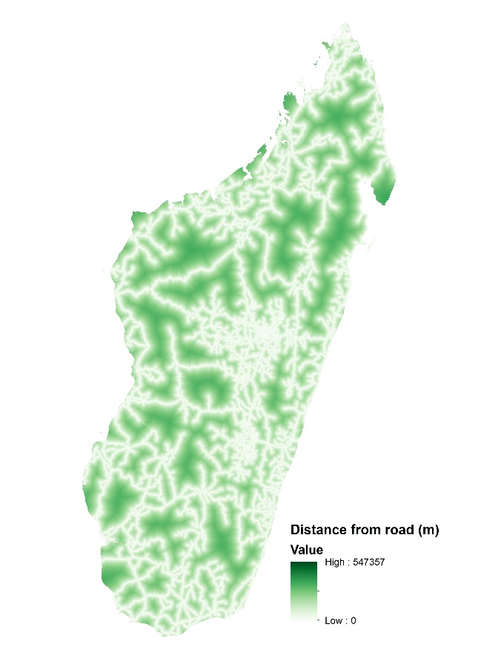b)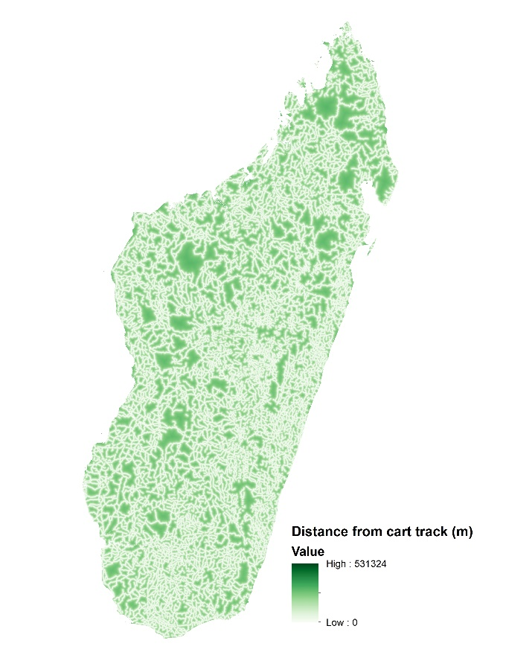
c)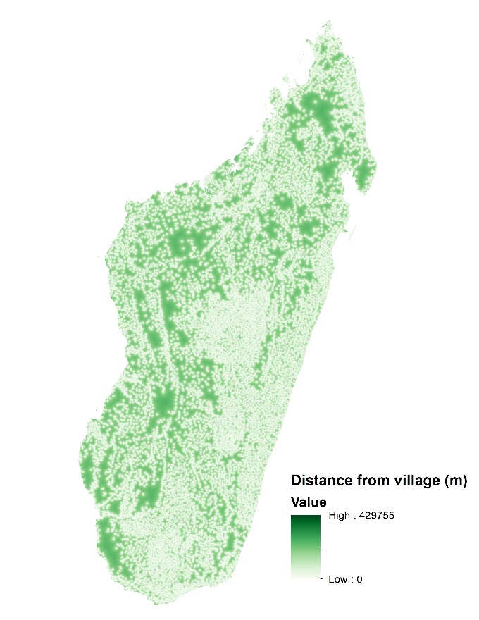d)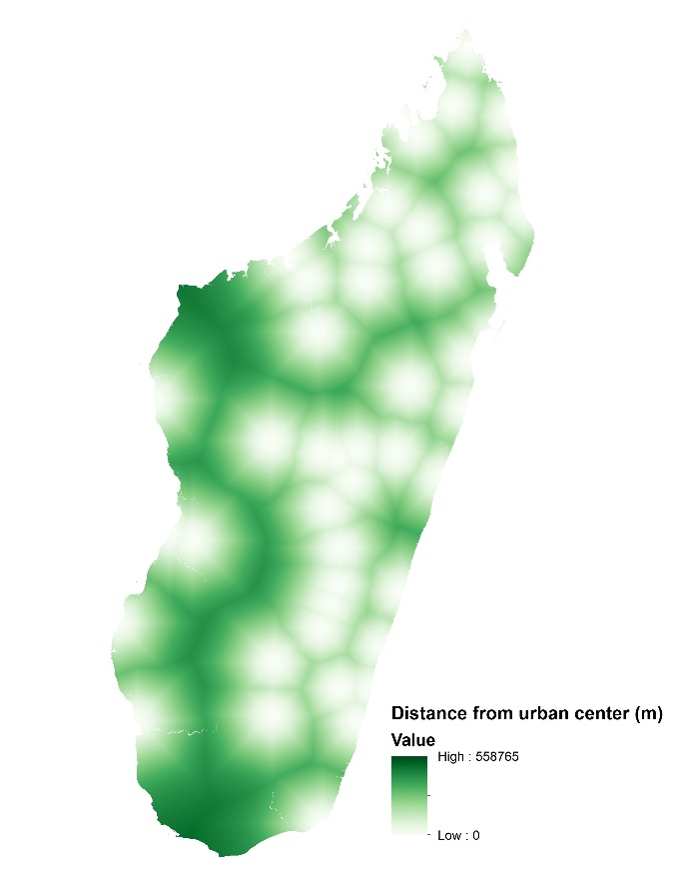

Fig. S3a-d Maps of covariates used for matching
a) Distance from nearest road, b) distance from nearest cart track, c) distance from nearest village, and d) distance from urban center, all measured in meters.
e)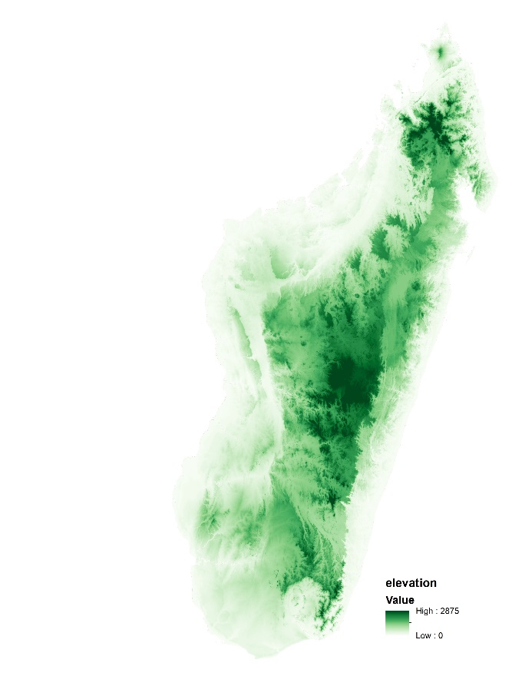f)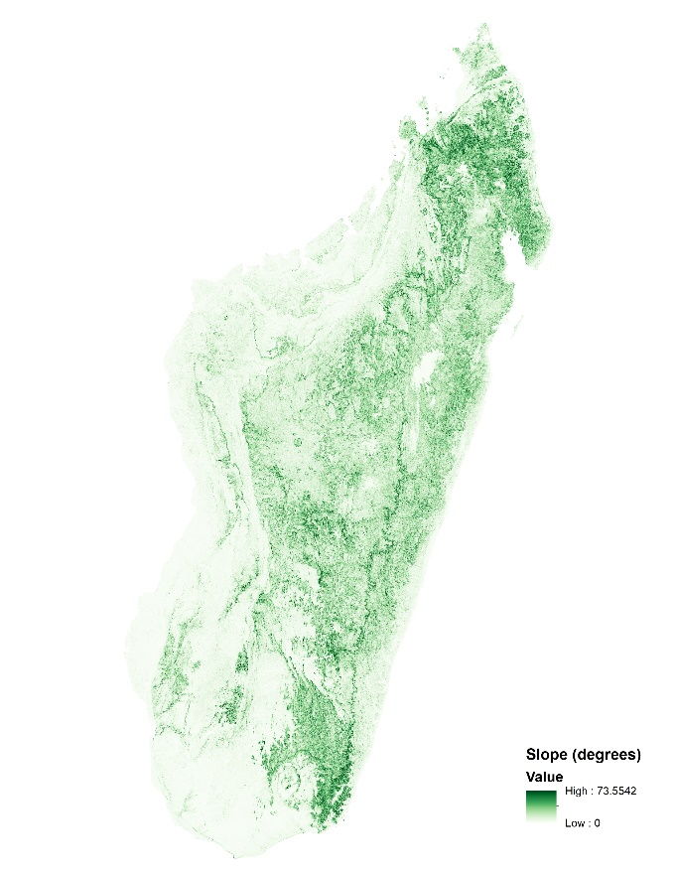 g)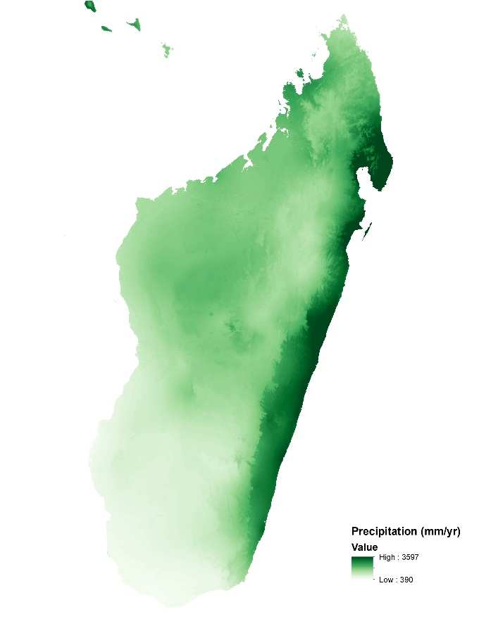h)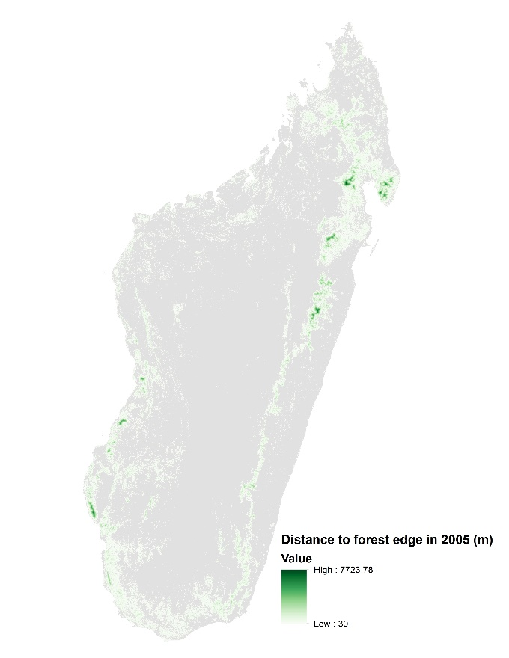

Fig. S3e-h Maps of covariates used for matching, continued
e) Elevation (meters) f) slope (percent), g) annual average precipitation 1970-2000 (mm/year), and h) distance to forest edge in the baseline year (2005) (meters)
i)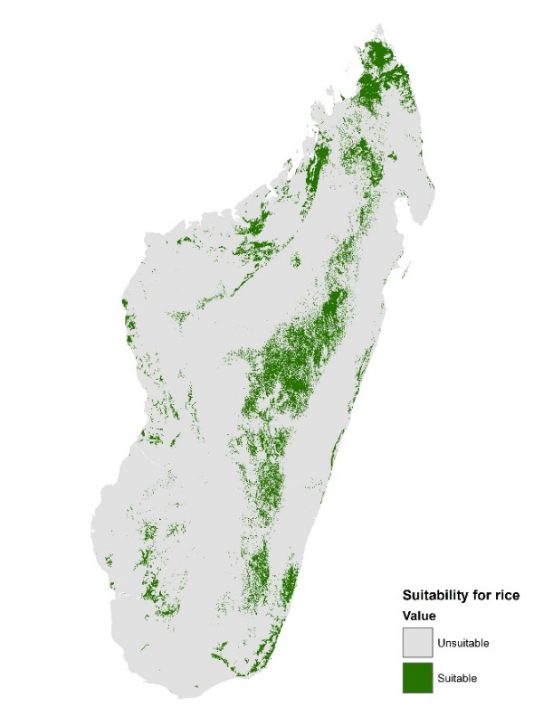j)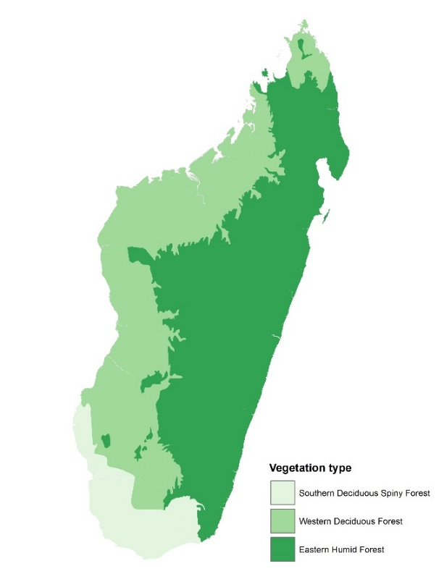
k)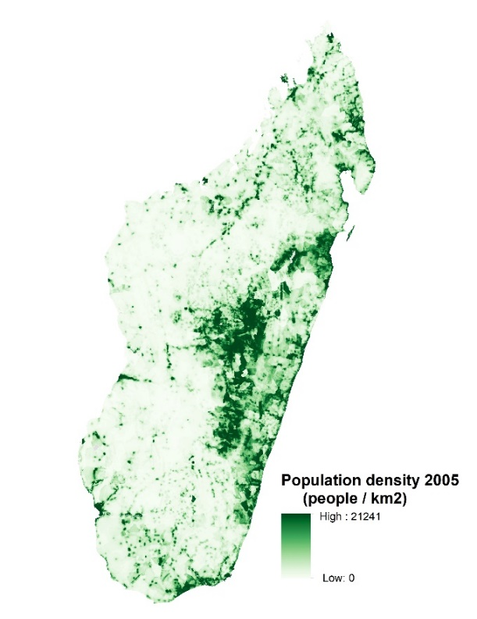

Fig. S3i-k Maps of covariates used for matching, continued
i) Suitability for rice agriculture (index of suitability) j) vegetation zone (Eastern humid forest, western deciduous forest, or southern deciduous spiny forest), k) population density in the baseline year (2005) (people per square kilometer).

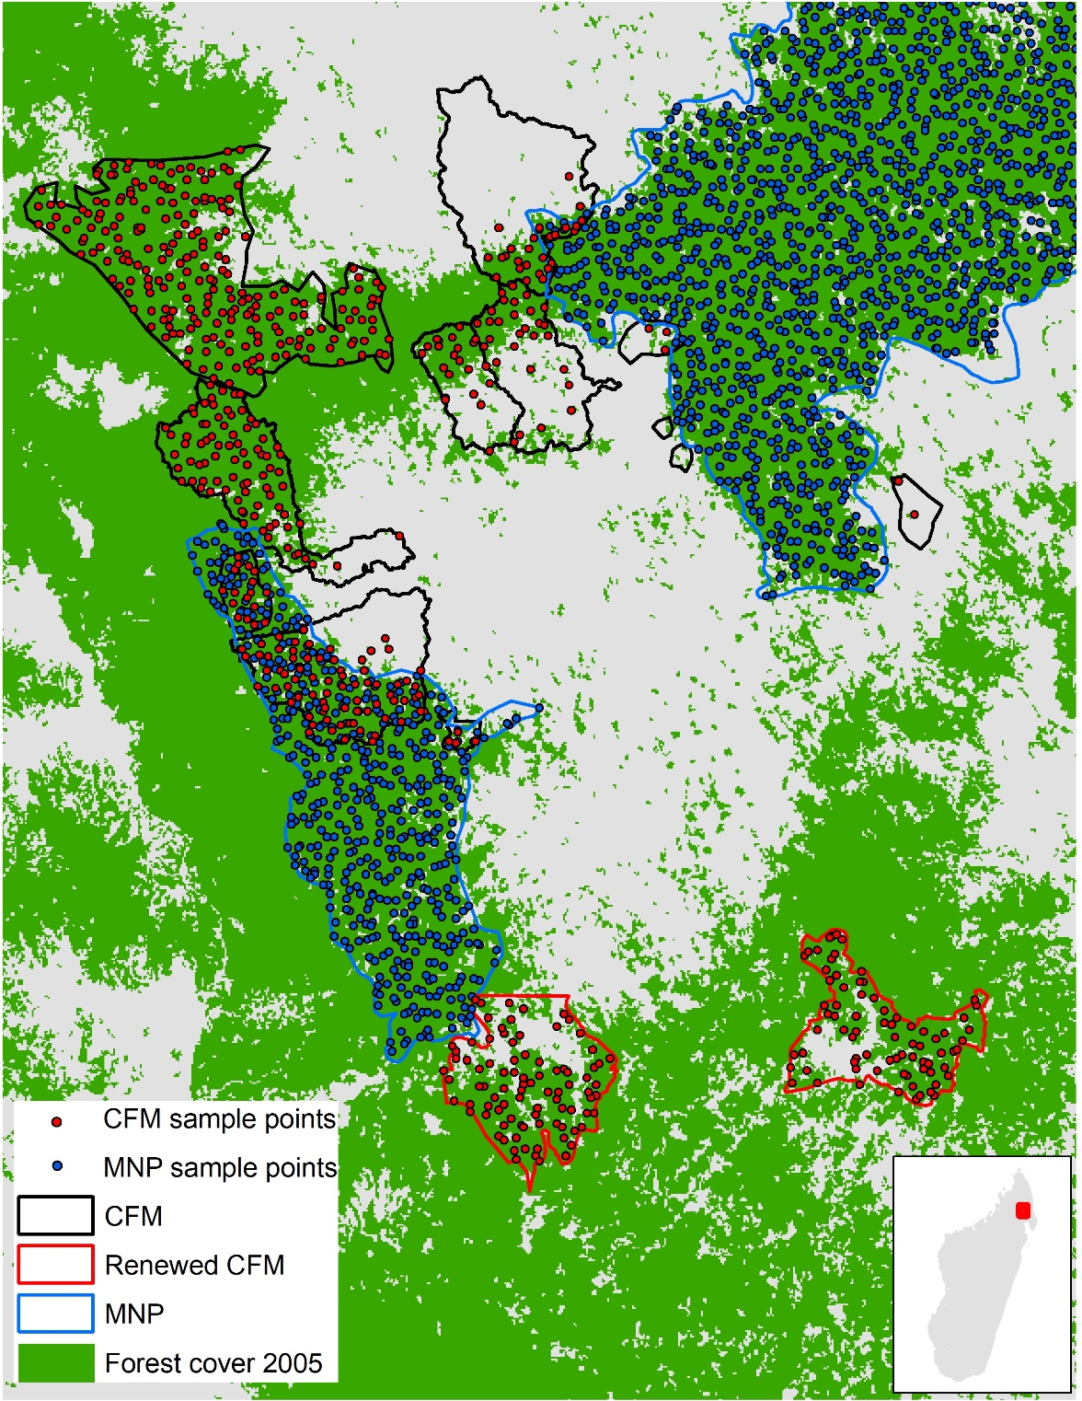

Fig. S4. Example of sample points, before matching
Example of randomly selected (unmatched) sample points within CFM (red) and MNP (blue), baseline (2005) forest cover shown in green. Sample points in overlapping CFM and MNP areas (as shown in center of this map) were excluded from the analysis. Map shows a portion of northeastern Madagascar (Marojejy National Park in the upper right, Anjanaharibe-Sud national park in the center-left.)
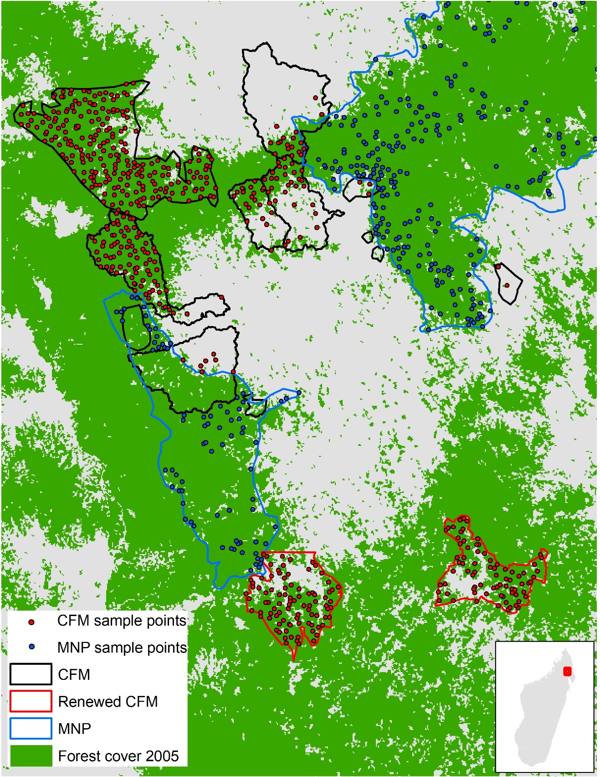

Fig. S5. Example of sample points, after matching
Sample points within CFM (red) and matched points within MNP (blue) with baseline (2005) forest cover shown in green. All CFM sample points were retained, but only MNP sample points that were similar to CFM sample points were included, as these represent a more useful counterfactual.
a)
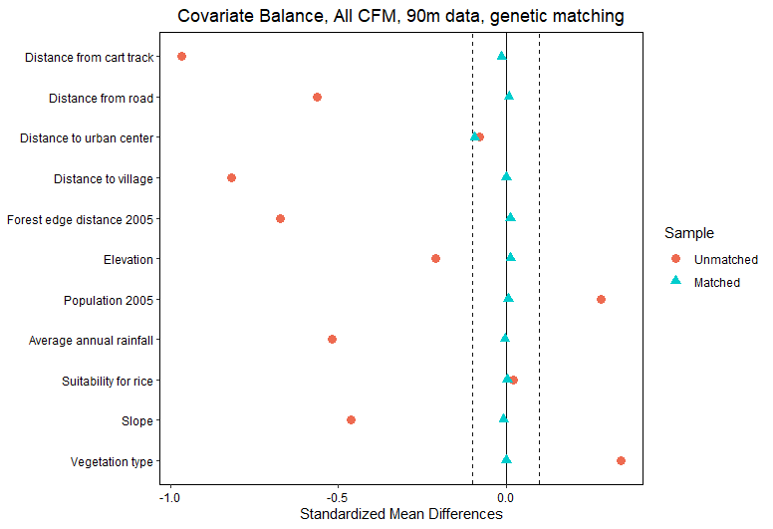
b)
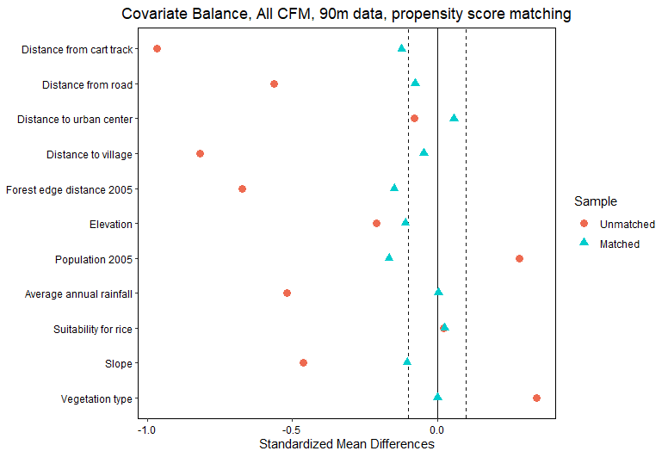

c)
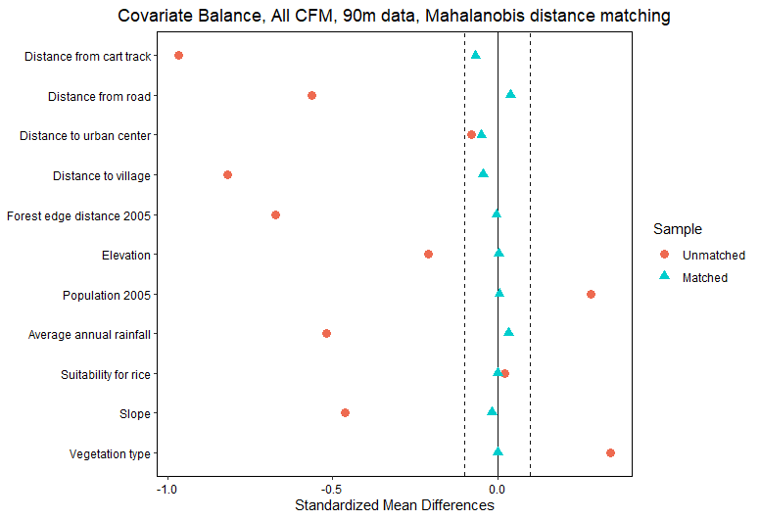

Fig. S6. Match balance results
Standardized mean differences among covariates before matching (red circles) and after matching (blue triangles), using (a) genetic matching, (b) propensity scores, (b) and (c) Mahalanobis distance matching. Black dotted line indicates a standardized mean difference value of 0.1. In all cases, we performed 1:1 matching with replacement, with exact matching on vegetation type, using the “MatchIt” package in R. Results shown are for all CFM data at 90 m resolution; additional matching results (renewed CFM, 270 m) were similar (not shown).

a)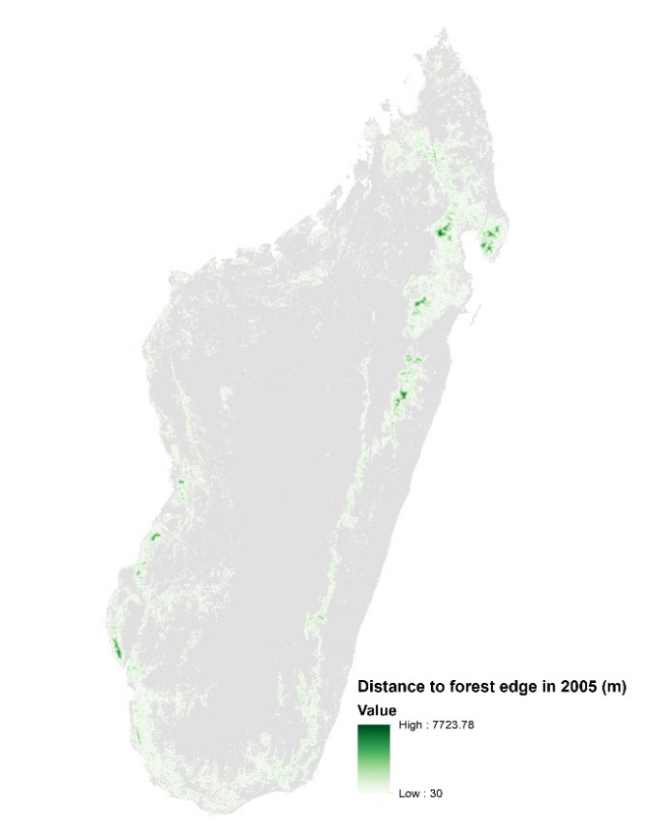b)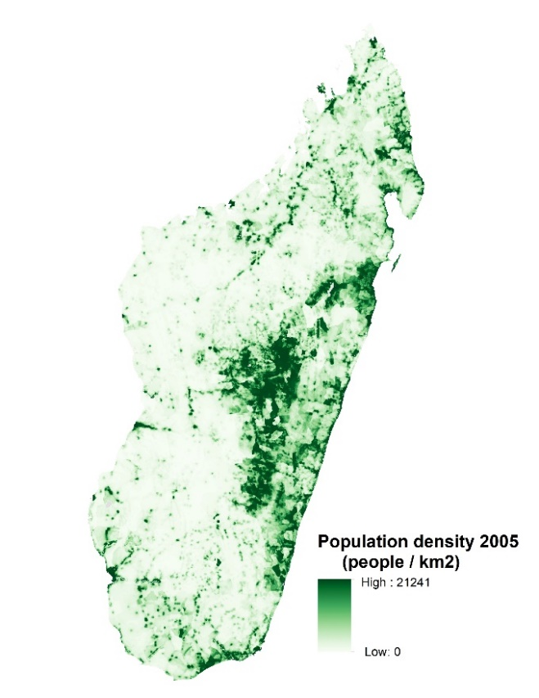
c)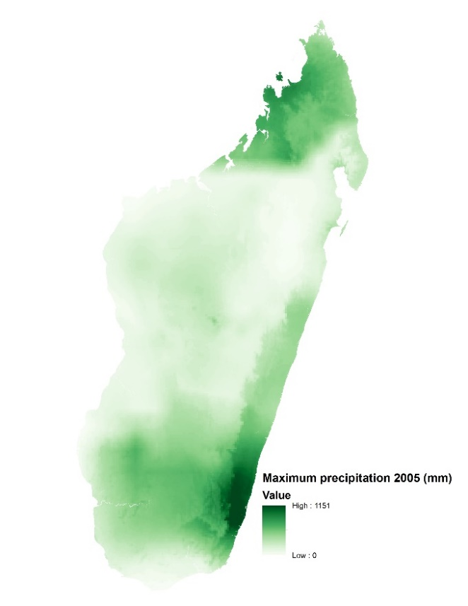d)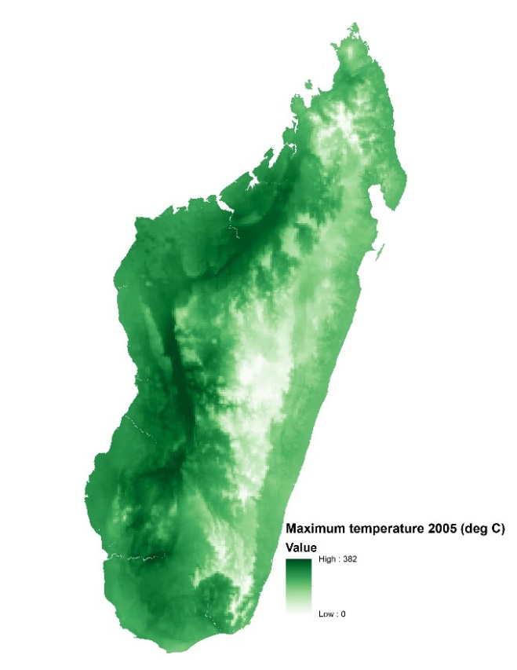

Fig. S7a-d. Maps of time-variant covariates used in event study analysis
a) Distance to forest edge (m), b) population density, c) maximum accumulated precipitation (mm), d) maximum temperature (degrees C). Selected maps shown for 2005 only, but full time series includes 2005-2020.

e)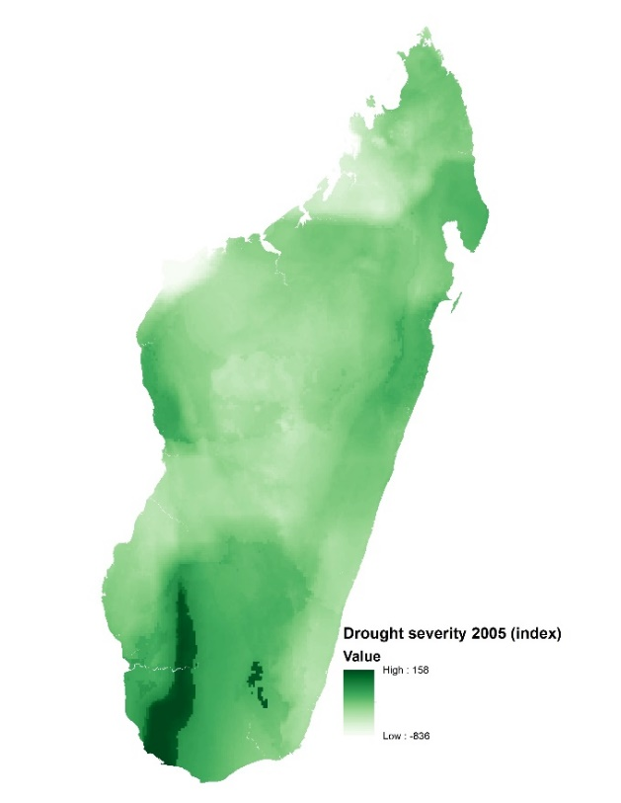f)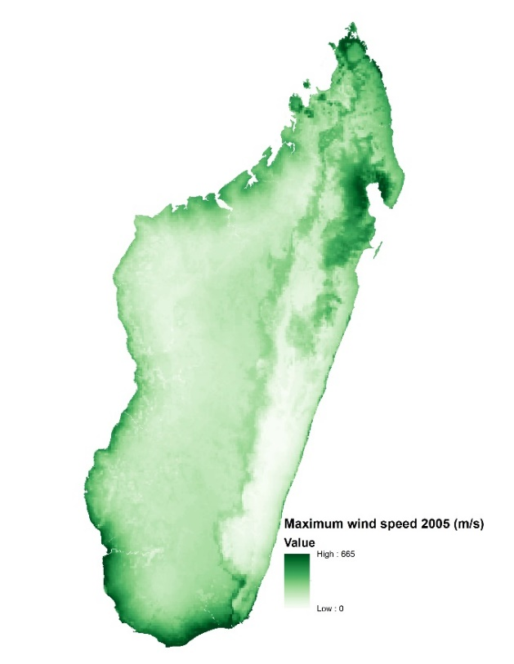
g)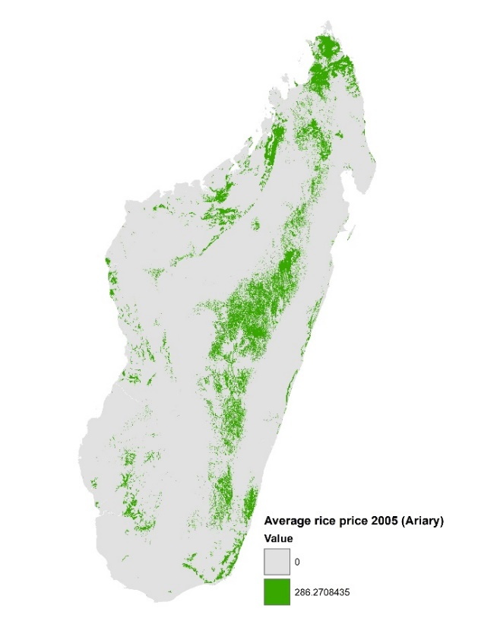h)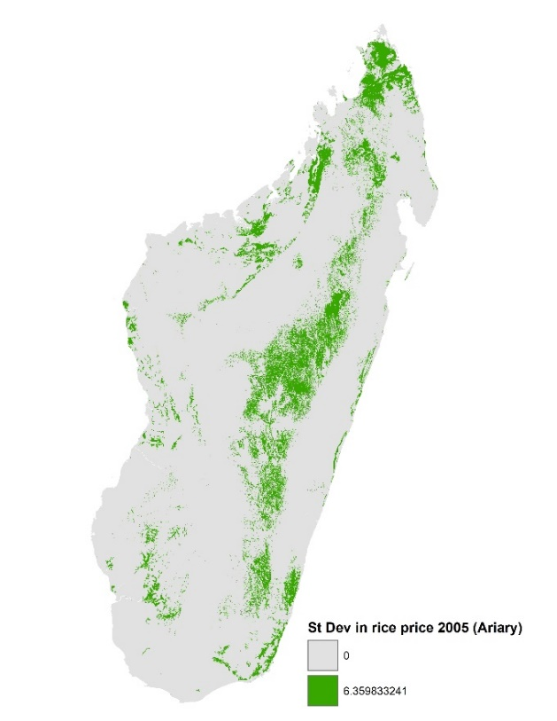

Fig. S7a-d. Maps of time-variant covariates used in event study analysis (continued)
e) Drought severity (Palmer Drought Index), f) maximum wind speed, g) average annual rice price for suitable rice areas (Madagascar currency), h) standard deviation in annual rice price. Maps shown for 2005 only, but full time series includes 2005-2020.

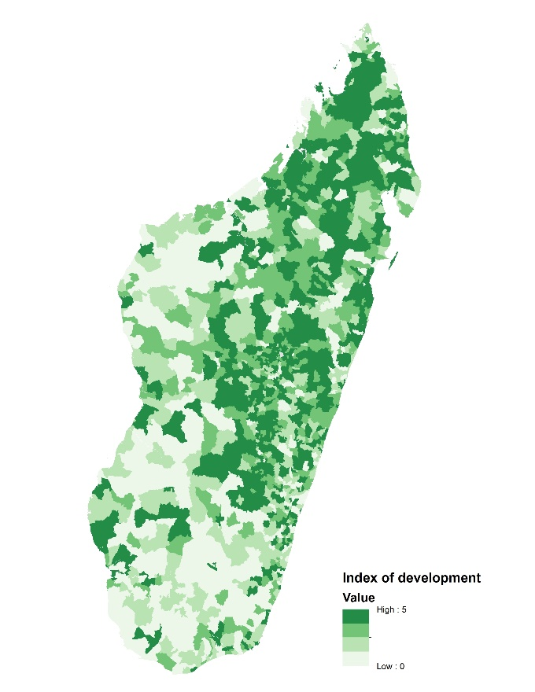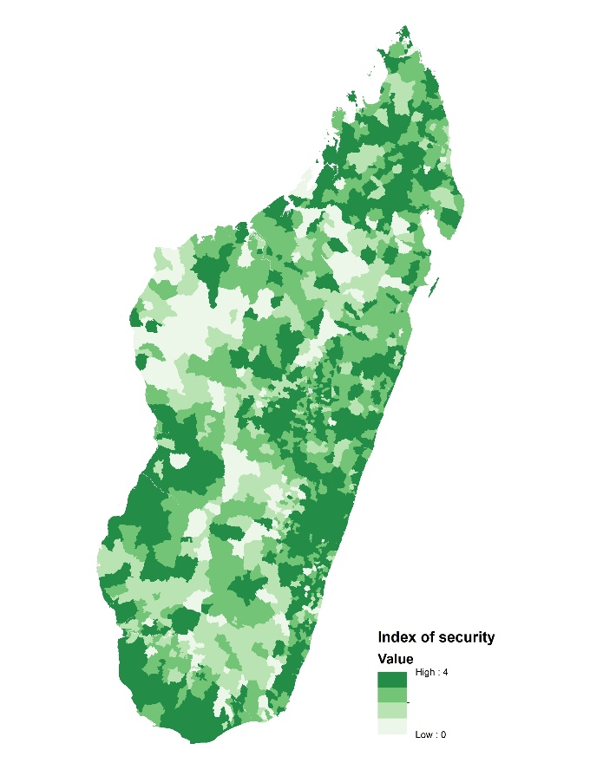

Fig. S8. Maps of commune-level index of development (left) and index of level of security / risk of theft (right) used for exploring heterogeneity of effects
Development level is estimated using an index of material assets. Index of security is based on a single indicator, “Security conditions and risk of theft of property”. Both datasets provided by Wu Yang, Conservation International, and are based on 2007 commune-level data collected by Moser et al. ¹.

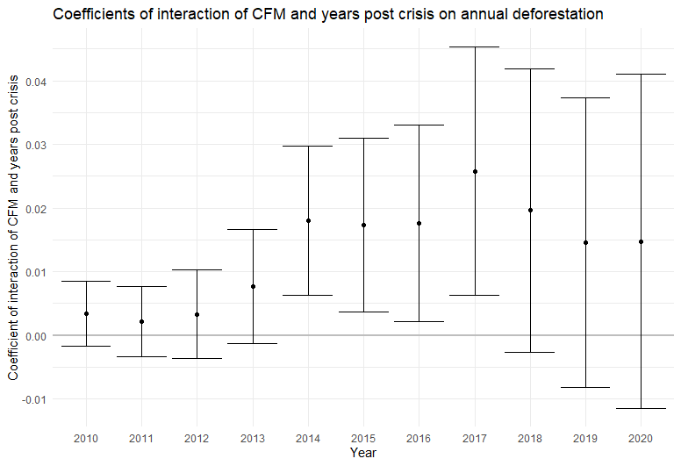

Fig. S9. Event study model 1: Effect of interaction between CFM and years post crisis on annual deforestation
Coefficients of interaction between CFM and years post crisis (2010-2020) on annual deforestation (all CFM, 90 m resolution). Values greater than zero indicate a positive impact on deforestation (worse performance of CFM relative to MNP). Error bars indicate 90% confidence intervals, where standard errors are clustered at the site level. See Equation 2 in the main text (Methods section) for details.

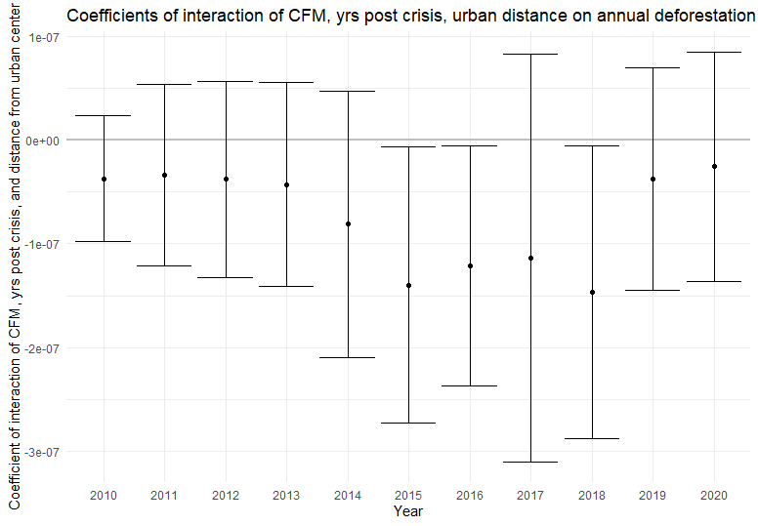

Fig. S10. Effect of distance from urban centers
Effect of interaction of CFM, years post crisis, and distance from urban center. Points below zero indicate a negative association with deforestation. Thus, CFM further from urban centers had lower deforestation than CFM closer to urban centers, and the difference was statistically significant in 2015, 2016, and 2018. See Table S5 for model equation and more details.
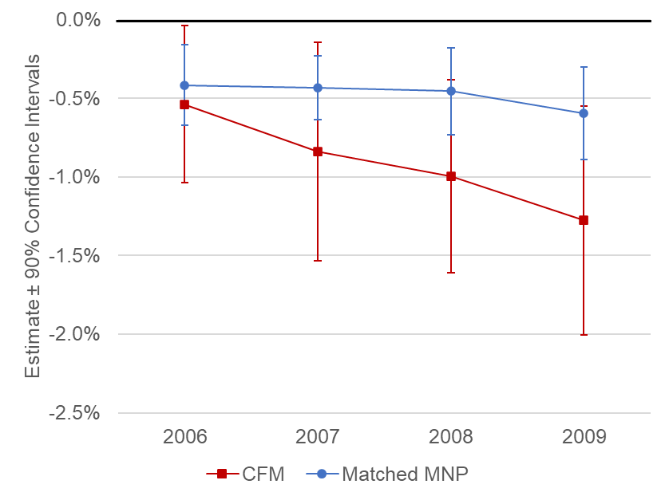

Fig. S11. Results of test of parallel trends in the pre-crisis period
Effects of CFM (red squares) or MNP (blue circles) on annual deforestation, after matching and controlling for time-variant covariates. Estimates below zero indicate a negative association with deforestation (that is, less deforestation over time). Error bars indicate 90% confidence intervals.

Supplemental Tables

Table S1. Forest cover in Madagascar 2000-2020
Forest cover in protected areas administered by Madagascar National Parks and established prior to 2005 (MNP), Community Forest Management areas established before 2005 (CFM), CFM for which contracts were renewed (a sub-set of all CFM sites), other protected and unprotected forests (Other forest) and total national forest cover (Total). “Other forest” includes unprotected forests as well as CFM established after 2005 and protected areas administered by NGOs or agencies other than MNP. “Total” includes all categories. Forest area in each year is reported in hectares.
year | MNP | CFM | (Renewed CFM) | Other forest | Total
2000 | 1,213,627 | 499,526 | 257,502 | 8,168,202 | 9,881,355
2001 | 1,211,591 | 498,262 | 256,892 | 8,138,936 | 9,848,789
2002 | 1,209,917 | 495,908 | 255,860 | 8,098,391 | 9,804,216
2003 | 1,209,114 | 491,744 | 254,291 | 8,053,920 | 9,754,778
2004 | 1,207,543 | 490,422 | 253,577 | 8,021,703 | 9,719,669
2005 | 1,206,329 | 487,901 | 251,933 | 7,974,623 | 9,668,854
2006 | 1,205,279 | 483,110 | 248,518 | 7,918,200 | 9,606,589
2007 | 1,201,077 | 478,852 | 245,987 | 7,839,204 | 9,519,133
2008 | 1,199,491 | 475,333 | 244,109 | 7,779,495 | 9,454,320
2009 | 1,197,905 | 472,293 | 242,327 | 7,705,125 | 9,375,323
2010 | 1,194,180 | 468,103 | 239,833 | 7,650,085 | 9,312,368
2011 | 1,190,754 | 464,297 | 237,909 | 7,570,724 | 9,225,775
2012 | 1,187,099 | 461,221 | 236,495 | 7,509,951 | 9,158,271
2013 | 1,183,056 | 455,830 | 233,692 | 7,414,854 | 9,053,740
2014 | 1,174,892 | 444,351 | 228,366 | 7,248,476 | 8,867,719
2015 | 1,169,980 | 435,157 | 223,672 | 7,153,093 | 8,758,230
2016 | 1,162,485 | 426,345 | 218,622 | 7,047,973 | 8,636,803
2017 | 1,151,026 | 410,458 | 210,180 | 6,874,295 | 8,435,778
2018 | 1,140,665 | 398,568 | 204,350 | 6,739,595 | 8,278,828
2019 | 1,132,449 | 391,280 | 201,721 | 6,640,802 | 8,164,530
2020 | 1,127,322 | 385,697 | 199,358 | 6,558,665 | 8,071,684

Table S2. Event study model 1 (all CFM, 90 m resolution)
Our first event study model takes the form (Equation 2, also described in the main text):
$$Y_{it}=β_{1}{CFM}_{i}+ τ_{1}{year}_{t}+τ_{2}{year}_{t}{CFM}_{i}+γ{YearsPostCrisis}_{t}+δCFM_{i}{YearsPostCrisis}_{t}+ψX_{it}+μ_{i}{ + ε}_{it}$$ | (2)

All variables are defined in the main text (Methods section).

OLS estimation, Dep. Var.: Annual deforestation
Observations: 372,032
Fixed-effects: UID: 23,252
Standard-errors: Clustered (cluster)
 | Variable | estimate | std.error | statistic | p.value | signif
1 | Year | -7.79E-04 | 2.79E-04 | -2.796 | 0.005 | **
2 | 2010 | 2.29E-03 | 1.19E-03 | 1.92 | 0.056 | .
3 | 2011 | 5.56E-03 | 1.77E-03 | 3.138 | 0.002 | **
4 | 2012 | 3.97E-03 | 1.29E-03 | 3.079 | 0.002 | **
5 | 2013 | 4.28E-03 | 1.65E-03 | 2.588 | 0.01 | *
6 | 2014 | 7.34E-03 | 2.33E-03 | 3.149 | 0.002 | **
7 | 2015 | 6.61E-03 | 2.30E-03 | 2.871 | 0.004 | **
8 | 2016 | 7.95E-03 | 2.68E-03 | 2.967 | 0.003 | **
9 | 2017 | 1.45E-02 | 5.12E-03 | 2.827 | 0.005 | **
10 | 2018 | 1.56E-02 | 6.28E-03 | 2.48 | 0.014 | *
11 | 2019 | 1.09E-02 | 3.49E-03 | 3.128 | 0.002 | **
12 | 2020 | 1.06E-02 | 5.27E-03 | 2.009 | 0.045 | *
13 | Distance from forest edge | -5.32E-05 | 8.45E-06 | -6.296 | 0 | ***
14 | Population density | -5.21E-06 | 4.07E-05 | -0.128 | 0.898
15 | Average rice price | -5.41E-09 | 3.57E-09 | -1.514 | 0.131
16 | Standard deviation in rice price | 2.16E-08 | 1.34E-08 | 1.615 | 0.107
17 | Drought severity (-) | -3.46E-06 | 1.94E-06 | -1.787 | 0.075 | .
18 | Maximum precipitation | 5.20E-06 | 2.90E-06 | 1.792 | 0.074 | .
19 | Maximum temperature | -6.50E-05 | 8.04E-05 | -0.808 | 0.42
20 | Maximum wind speed | -6.46E-06 | 1.22E-05 | -0.53 | 0.597
21 | CFM:Year | -1.69E-03 | 1.15E-03 | -1.477 | 0.141
22 | CFM:2010 | 3.13E-03 | 2.53E-03 | 1.236 | 0.217
23 | CFM:2011 | 1.22E-03 | 2.99E-03 | 0.407 | 0.684
24 | CFM:2012 | 3.18E-03 | 3.56E-03 | 0.895 | 0.372
25 | CFM:2013 | 7.28E-03 | 4.59E-03 | 1.587 | 0.113
26 | CFM:2014 | 1.79E-02 | 5.94E-03 | 3.018 | 0.003 | **
27 | CFM:2015 | 1.70E-02 | 6.91E-03 | 2.468 | 0.014 | *
28 | CFM:2016 | 1.75E-02 | 7.84E-03 | 2.237 | 0.026 | *
29 | CFM:2017 | 2.43E-02 | 1.02E-02 | 2.377 | 0.018 | *
30 | CFM:2018 | 1.84E-02 | 1.15E-02 | 1.6 | 0.11
31 | CFM:2019 | 1.45E-02 | 1.15E-02 | 1.256 | 0.21
32 | CFM:2020 | 1.48E-02 | 1.33E-02 | 1.119 | 0.264
Signif. codes: 0 '***' 0.001 '**' 0.01 '*' 0.05 '.' 0.1 ' ' 1
RMSE: 0.065427 Adj. R2: 0.024156
Within R2: 0.017623

Table S3. Event study model 1 variation (renewed CFM, 90 m resolution)
This model is identical to the model described above, but the sample of CFM forest pixels were selected only from a sub-set of CFM for which contracts were renewed. Statistical matching was performed separately and the same way as described above, so the matched dataset in this case reflects MNP forest pixels that are similar to renewed CFM forest pixels. The equation is identical to Equation 2. All below model variations were also performed for this renewed CFM dataset, with very similar results (not shown).

Observations: 380,352
Fixed-effects: UID: 23,772
Standard-errors: Clustered (cluster)
Variable | estimate | std.error | statistic | p.value | signif
Year | -3.26E-04 | 3.61E-04 | -0.904 | 0.367
2010 | -5.67E-04 | 1.37E-03 | -0.414 | 0.680
2011 | 2.64E-03 | 2.37E-03 | 1.114 | 0.267
2012 | 8.03E-04 | 2.10E-03 | 0.383 | 0.703
2013 | 1.21E-03 | 2.49E-03 | 0.485 | 0.629
2014 | 2.47E-03 | 2.63E-03 | 0.941 | 0.348
2015 | 2.43E-03 | 2.67E-03 | 0.908 | 0.365
2016 | 3.63E-03 | 3.82E-03 | 0.949 | 0.344
2017 | 6.21E-03 | 4.66E-03 | 1.333 | 0.185
2018 | 8.53E-03 | 5.69E-03 | 1.499 | 0.136
2019 | 5.68E-03 | 4.90E-03 | 1.160 | 0.248
2020 | 3.66E-03 | 5.69E-03 | 0.643 | 0.521
Distance from forest edge | -4.60E-05 | 1.02E-05 | -4.529 | 0.000 | ***
Population density | -4.33E-05 | 8.93E-05 | -0.485 | 0.629
Average rice price | -4.11E-09 | 5.03E-09 | -0.817 | 0.415
Standard deviation in rice price | 3.70E-08 | 2.74E-08 | 1.353 | 0.178
Drought severity (-) | -5.74E-06 | 3.10E-06 | -1.854 | 0.066 | .
Maximum precipitation | 6.39E-06 | 3.93E-06 | 1.626 | 0.106
Maximum temperature | -7.29E-05 | 7.62E-05 | -0.957 | 0.340
Maximum wind speed | -1.44E-05 | 1.42E-05 | -1.019 | 0.310
CFM:Year | -2.18E-03 | 1.63E-03 | -1.335 | 0.184
CFM:2010 | 5.47E-03 | 3.55E-03 | 1.541 | 0.125
CFM:2011 | 3.03E-03 | 3.97E-03 | 0.763 | 0.447
CFM:2012 | 4.97E-03 | 4.81E-03 | 1.034 | 0.303
CFM:2013 | 1.07E-02 | 6.31E-03 | 1.690 | 0.093 | .
CFM:2014 | 1.97E-02 | 7.44E-03 | 2.643 | 0.009 | **
CFM:2015 | 1.98E-02 | 8.64E-03 | 2.293 | 0.023 | *
CFM:2016 | 2.35E-02 | 1.04E-02 | 2.254 | 0.026 | *
CFM:2017 | 3.07E-02 | 1.18E-02 | 2.604 | 0.010 | *
CFM:2018 | 2.45E-02 | 1.46E-02 | 1.680 | 0.095 | .
CFM:2019 | 1.65E-02 | 1.64E-02 | 1.003 | 0.318
CFM:2020 | 1.77E-02 | 1.83E-02 | 0.970 | 0.334
Signif. codes: 0 '***' 0.001 '**' 0.01 '*' 0.05 '.' 0.1 ' ' 1
RMSE: 0.062737 Adj. R2: 0.022307
Within R2: 0.016042

Table S4. Event study model 1 variation (all CFM, 270 m resolution)
This model is identical to Event Study Model 1, above, but all analyses (sampling, statistical matching, and event study analysis) were performed at a coarser spatial resolution (270 m, instead of 90 m). The model equation is identical to Equation 2. All of the below variations on the model were also performed, with very similar results (not shown).

OLS estimation, Dep. Var.: Annual deforestation
Observations: 370,272
Fixed-effects: UID: 23,142
Standard-errors: Clustered (cluster)
Variable | estimate | std.error | statistic | p.value | signif
Year | -5.85E-04 | 1.94E-04 | -3.019 | 0.003 | **
2010 | 2.33E-03 | 1.31E-03 | 1.778 | 0.076 | .
2011 | 2.84E-03 | 1.19E-03 | 2.392 | 0.017 | *
2012 | 2.10E-03 | 9.69E-04 | 2.165 | 0.031 | *
2013 | 3.73E-03 | 1.60E-03 | 2.328 | 0.020 | *
2014 | 6.90E-03 | 2.32E-03 | 2.975 | 0.003 | **
2015 | 4.97E-03 | 1.57E-03 | 3.159 | 0.002 | **
2016 | 5.36E-03 | 2.29E-03 | 2.335 | 0.020 | *
2017 | 1.08E-02 | 4.74E-03 | 2.286 | 0.023 | *
2018 | 8.64E-03 | 2.80E-03 | 3.084 | 0.002 | **
2019 | 9.92E-03 | 3.44E-03 | 2.885 | 0.004 | **
2020 | 6.41E-03 | 3.01E-03 | 2.131 | 0.034 | *
Distance from forest edge | -5.34E-05 | 7.62E-06 | -7.001 | 0.000 | ***
Population density | 1.04E-05 | 3.62E-05 | 0.286 | 0.775
Average rice price | 1.43E-09 | 5.54E-09 | 0.258 | 0.797
Standard deviation in rice price | 2.84E-09 | 2.13E-08 | 0.133 | 0.894
Drought severity (-) | -2.92E-06 | 1.76E-06 | -1.658 | 0.098 | .
Maximum precipitation | 4.99E-06 | 2.89E-06 | 1.724 | 0.086 | .
Maximum temperature | -9.89E-05 | 6.62E-05 | -1.495 | 0.136
Maximum wind speed | -1.39E-06 | 1.16E-05 | -0.120 | 0.905
CFM:Year | -1.91E-03 | 1.06E-03 | -1.805 | 0.072 | .
CFM:2010 | 2.76E-03 | 2.30E-03 | 1.199 | 0.231
CFM:2011 | 3.64E-03 | 2.40E-03 | 1.517 | 0.130
CFM:2012 | 4.98E-03 | 3.17E-03 | 1.573 | 0.117
CFM:2013 | 8.73E-03 | 4.21E-03 | 2.073 | 0.039 | *
CFM:2014 | 1.89E-02 | 5.56E-03 | 3.406 | 0.001 | ***
CFM:2015 | 1.84E-02 | 6.10E-03 | 3.015 | 0.003 | **
CFM:2016 | 1.95E-02 | 7.23E-03 | 2.703 | 0.007 | **
CFM:2017 | 2.68E-02 | 9.60E-03 | 2.792 | 0.006 | **
CFM:2018 | 2.42E-02 | 9.57E-03 | 2.524 | 0.012 | *
CFM:2019 | 1.59E-02 | 1.08E-02 | 1.469 | 0.143
CFM:2020 | 1.83E-02 | 1.18E-02 | 1.553 | 0.121
Signif. codes: 0 '***' 0.001 '**' 0.01 '*' 0.05 '.' 0.1 ' ' 1
RMSE: 0.046067 Adj. R2: 0.065911
Within R2: 0.032132

Table S5. Event study model 2 (interaction term for distance from urban center) (all CFM, 90 m)
This variation on the event study model explores heterogeneity of outcomes based on distance from cities, by including an interaction term for distance from urban center:
$$Y_{it}=β_{1}{CFM}_{i}+ τ_{1}{year}_{t}+τ_{2}{year}_{t}{CFM}_{i}+γ{YearsPostCrisis}_{t}+δ(CFM_{i})({YearsPostCrisis}_{t})+θ({UrbanDistance)(YearsPostCrisis}_{t})+σ(CFM_{i})({UrbanDistance)(YearsPostCrisis}_{t})+ψX_{it}+μ_{i}{ + ε}_{it}$$ | (4)

All variables are defined as above, the new variable, “UrbanDistance” indicates the distance, in meters, of each forest grid cell (observation) from the nearest city². Also see Figure S8.

Results (all CFM, 90 m data):
OLS estimation, Dep. Var.: Annual deforestation
Observations: 372,032
Fixed-effects: UID: 23,252
Standard-errors: Clustered (cluster)
Variable | estimate | std.error | statistic | p.value | signif
Year | -7.77E-04 | 2.71E-04 | -2.868 | 0.004 | **
2010 | 1.48E-03 | 1.11E-03 | 1.339 | 0.181
2011 | 5.97E-03 | 2.26E-03 | 2.644 | 0.009 | **
2012 | 4.03E-03 | 1.24E-03 | 3.245 | 0.001 | **
2013 | 4.70E-03 | 1.74E-03 | 2.698 | 0.007 | **
2014 | 7.21E-03 | 2.19E-03 | 3.294 | 0.001 | **
2015 | 5.82E-03 | 2.31E-03 | 2.517 | 0.012 | *
2016 | 8.32E-03 | 2.83E-03 | 2.939 | 0.004 | **
2017 | 2.06E-02 | 7.73E-03 | 2.668 | 0.008 | **
2018 | 1.49E-02 | 6.11E-03 | 2.445 | 0.015 | *
2019 | 1.12E-02 | 3.87E-03 | 2.902 | 0.004 | **
2020 | 1.18E-02 | 6.14E-03 | 1.920 | 0.056 | .
Distance from forest edge | -5.23E-05 | 8.29E-06 | -6.316 | 0.000 | ***
Population density | -6.02E-07 | 3.91E-05 | -0.015 | 0.988
Average rice price | -6.32E-09 | 3.44E-09 | -1.835 | 0.067 | .
Standard deviation in rice price | 2.35E-08 | 1.35E-08 | 1.743 | 0.082 | .
Drought severity (-) | -3.42E-06 | 1.97E-06 | -1.735 | 0.084 | .
Maximum precipitation | 4.32E-06 | 2.89E-06 | 1.498 | 0.135
Maximum temperature | -4.90E-05 | 9.11E-05 | -0.538 | 0.591
Maximum wind speed | -2.55E-06 | 1.25E-05 | -0.204 | 0.838
CFM:Year | -1.70E-03 | 1.16E-03 | -1.474 | 0.141
CFM:2010 | 5.44E-03 | 3.79E-03 | 1.437 | 0.151
CFM:2011 | 3.18E-03 | 4.91E-03 | 0.648 | 0.517
CFM:2012 | 5.50E-03 | 5.78E-03 | 0.951 | 0.342
CFM:2013 | 9.84E-03 | 6.87E-03 | 1.434 | 0.152
CFM:2014 | 2.28E-02 | 8.68E-03 | 2.630 | 0.009 | **
CFM:2015 | 2.55E-02 | 9.94E-03 | 2.568 | 0.011 | *
CFM:2016 | 2.48E-02 | 1.05E-02 | 2.363 | 0.019 | *
CFM:2017 | 3.08E-02 | 1.49E-02 | 2.069 | 0.039 | *
CFM:2018 | 2.73E-02 | 1.38E-02 | 1.977 | 0.049 | *
CFM:2019 | 1.68E-02 | 1.40E-02 | 1.203 | 0.230
CFM:2020 | 1.65E-02 | 1.57E-02 | 1.049 | 0.295
2010:UrbanDistance | 1.24E-08 | 9.86E-09 | 1.253 | 0.211
2011:UrbanDistance | -6.40E-09 | 1.60E-08 | -0.400 | 0.689
2012:UrbanDistance | -1.78E-09 | 8.91E-09 | -0.200 | 0.842
2013:UrbanDistance | -6.60E-09 | 8.62E-09 | -0.765 | 0.445
2014:UrbanDistance | 1.61E-09 | 1.19E-08 | 0.135 | 0.893
2015:UrbanDistance | 1.14E-08 | 9.42E-09 | 1.213 | 0.226
2016:UrbanDistance | -7.50E-09 | 1.03E-08 | -0.726 | 0.468
2017:UrbanDistance | -9.54E-08 | 6.11E-08 | -1.560 | 0.120
2018:UrbanDistance | 7.65E-09 | 4.23E-08 | 0.181 | 0.857
2019:UrbanDistance | -6.03E-09 | 1.64E-08 | -0.368 | 0.713
2020:UrbanDistance | -1.99E-08 | 2.18E-08 | -0.916 | 0.360
CFM:2010:UrbanDistance | -3.71E-08 | 3.08E-08 | -1.205 | 0.229
CFM:2011:UrbanDistance | -3.35E-08 | 4.46E-08 | -0.752 | 0.453
CFM:2012:UrbanDistance | -3.79E-08 | 4.81E-08 | -0.788 | 0.431
CFM:2013:UrbanDistance | -4.27E-08 | 4.99E-08 | -0.856 | 0.393
CFM:2014:UrbanDistance | -8.10E-08 | 6.52E-08 | -1.243 | 0.215
CFM:2015:UrbanDistance | -1.40E-07 | 6.76E-08 | -2.067 | 0.039 | *
CFM:2016:UrbanDistance | -1.21E-07 | 5.90E-08 | -2.052 | 0.041 | *
CFM:2017:UrbanDistance | -1.14E-07 | 1.00E-07 | -1.137 | 0.256
CFM:2018:UrbanDistance | -1.47E-07 | 7.17E-08 | -2.047 | 0.041 | *
CFM:2019:UrbanDistance | -3.73E-08 | 5.47E-08 | -0.683 | 0.495
CFM:2020:UrbanDistance | -2.56E-08 | 5.61E-08 | -0.456 | 0.649
Signif. codes: 0 '***' 0.001 '**' 0.01 '*' 0.05 '.' 0.1 ' ' 1
RMSE: 0.065526 Adj. R2: 0.024955
Within R2: 0.0187

Table S6. Event study model 3 (interaction term for level of development, all CFM, 90 m)
This variation on the event study model explores heterogeneity of outcomes based on level of development of the fonkontany (smallest administrative unit of Madagascar):
$$Y_{it}=β_{1}{CFM}_{i}+ τ_{1}{year}_{t}+τ_{2}{year}_{t}{CFM}_{i}+γ{YearsPostCrisis}_{t}+δ(CFM_{i})({YearsPostCrisis}_{t})+λ({Development)(YearsPostCrisis}_{t})+ρ(CFM_{i})({Development)(YearsPostCrisis}_{t})+ψX_{it}+μ_{i}{ + ε}_{it}$$ | (5)

All variables are defined as above, the new variable, “Development”, an index of material assets, data provided by Wu Yang, Conservation International based on 2007 commune-level data originally collected by Moser et al.¹. Also see Fig. S8.

OLS estimation, Dep. Var.: Annual deforestation
Observations: 372,032
Fixed-effects: UID: 23,252
Standard-errors: Clustered (cluster)
Variable | estimate | std.error | statistic | p.value | signif
Year | -7.53E-04 | 2.76E-04 | -2.725 | 0.007 | **
2010 | 2.99E-03 | 1.50E-03 | 1.995 | 0.047 | *
2011 | 5.19E-03 | 2.01E-03 | 2.581 | 0.010 | *
2012 | 3.17E-03 | 1.36E-03 | 2.337 | 0.020 | *
2013 | 3.70E-03 | 1.66E-03 | 2.233 | 0.026 | *
2014 | 7.16E-03 | 2.80E-03 | 2.553 | 0.011 | *
2015 | 6.42E-03 | 2.67E-03 | 2.407 | 0.017 | *
2016 | 6.87E-03 | 2.59E-03 | 2.656 | 0.008 | **
2017 | 1.28E-02 | 6.06E-03 | 2.109 | 0.036 | *
2018 | 1.89E-02 | 9.70E-03 | 1.950 | 0.052 | .
2019 | 9.41E-03 | 3.47E-03 | 2.708 | 0.007 | **
2020 | 1.05E-02 | 6.83E-03 | 1.539 | 0.125
Distance from forest edge | -5.34E-05 | 8.26E-06 | -6.472 | 0.000 | ***
Population density | -8.81E-06 | 3.77E-05 | -0.234 | 0.815
Average rice price | -5.16E-09 | 3.44E-09 | -1.501 | 0.134
Standard deviation in rice price | 2.11E-08 | 1.33E-08 | 1.592 | 0.112
Drought severity (-) | -4.11E-06 | 2.00E-06 | -2.053 | 0.041 | *
Maximum precipitation | 4.91E-06 | 2.96E-06 | 1.661 | 0.098 | .
Maximum temperature | -9.90E-05 | 9.68E-05 | -1.023 | 0.307
Maximum wind speed | -7.77E-06 | 1.25E-05 | -0.623 | 0.534
CFM:Year | -1.68E-03 | 1.14E-03 | -1.476 | 0.141
CFM:2010 | 3.23E-03 | 2.67E-03 | 1.208 | 0.228
CFM:2011 | -1.15E-03 | 2.68E-03 | -0.428 | 0.669
CFM:2012 | 1.07E-03 | 2.80E-03 | 0.383 | 0.702
CFM:2013 | 4.34E-03 | 3.79E-03 | 1.144 | 0.253
CFM:2014 | 1.64E-02 | 5.63E-03 | 2.915 | 0.004 | **
CFM:2015 | 1.71E-02 | 6.39E-03 | 2.671 | 0.008 | **
CFM:2016 | 1.46E-02 | 6.96E-03 | 2.098 | 0.037 | *
CFM:2017 | 2.02E-02 | 1.03E-02 | 1.964 | 0.050 | .
CFM:2018 | 1.23E-02 | 1.30E-02 | 0.941 | 0.347
CFM:2019 | 1.18E-02 | 1.08E-02 | 1.098 | 0.273
CFM:2020 | 1.06E-02 | 1.32E-02 | 0.804 | 0.422
2010:Development | -1.61E-03 | 1.14E-03 | -1.415 | 0.158
2011:Development | 6.48E-04 | 2.07E-03 | 0.314 | 0.754
2012:Development | 1.34E-03 | 1.34E-03 | 0.997 | 0.319
2013:Development | 1.33E-03 | 9.32E-04 | 1.430 | 0.154
2014:Development | 2.76E-04 | 2.14E-03 | 0.129 | 0.897
2015:Development | 2.92E-04 | 1.40E-03 | 0.208 | 0.835
2016:Development | 2.21E-03 | 1.99E-03 | 1.112 | 0.267
2017:Development | 3.45E-03 | 5.35E-03 | 0.644 | 0.520
2018:Development | -8.03E-03 | 9.05E-03 | -0.887 | 0.376
2019:Development | 3.72E-03 | 2.67E-03 | 1.393 | 0.165
2020:Development | -5.38E-04 | 4.63E-03 | -0.116 | 0.907
CFM:2010:Development | -6.91E-04 | 3.41E-03 | -0.203 | 0.840
CFM:2011:Development | 6.49E-03 | 4.18E-03 | 1.552 | 0.122
CFM:2012:Development | 5.75E-03 | 4.02E-03 | 1.431 | 0.153
CFM:2013:Development | 8.06E-03 | 4.37E-03 | 1.845 | 0.066 | .
CFM:2014:Development | 3.84E-03 | 6.72E-03 | 0.571 | 0.569
CFM:2015:Development | -3.81E-04 | 6.08E-03 | -0.063 | 0.950
CFM:2016:Development | 8.06E-03 | 5.56E-03 | 1.451 | 0.148
CFM:2017:Development | 1.13E-02 | 1.08E-02 | 1.049 | 0.295
CFM:2018:Development | 1.57E-02 | 1.05E-02 | 1.504 | 0.133
CFM:2019:Development | 7.54E-03 | 5.42E-03 | 1.392 | 0.165
CFM:2020:Development | 1.11E-02 | 6.80E-03 | 1.629 | 0.104
Signif. codes: 0 '***' 0.001 '**' 0.01 '*' 0.05 '.' 0.1 ' ' 1
RMSE: 0.065538 Adj. R2: 0.024606
Within R2: 0.018349

Table S7. Event study model 4 (interaction term for level of security, all CFM, 90m)
This variation on the event study model explores heterogeneity of outcomes based on level of security / risk of theft of the fonkontany (smallest administrative unit of Madagascar):
$$Y_{it}=β_{1}{CFM}_{i}+ τ_{1}{year}_{t}+τ_{2}{year}_{t}{CFM}_{i}+γ{YearsPostCrisis}_{t}+δ(CFM_{i})({YearsPostCrisis}_{t})+π({Security)(YearsPostCrisis}_{t})+η(CFM_{i})({Security)(YearsPostCrisis}_{t})+ψX_{it}+μ_{i}{ + ε}_{it}$$ | (6)

All variables are defined as above, the new variable, “Security”, an indicator of security/risk of theft, used here as a proxy for the level of enforcement (e.g. of forest protection rules). Data provided by Wu Yang, Conservation International based on 2007 commune-level data originally collected by Moser et al. ¹.

Results:
OLS estimation, Dep. Var.: Annual deforestation
Observations: 372,032
Fixed-effects: UID: 23,252, vegtype: 3
Standard-errors: Clustered (cluster)
Variable | estimate | std.error | statistic | p.value | signif
Year | -7.80E-04 | 2.85E-04 | -2.735 | 0.007 | **
2010 | 1.47E-03 | 1.09E-03 | 1.343 | 0.180
2011 | 6.78E-03 | 2.12E-03 | 3.193 | 0.002 | **
2012 | 4.05E-03 | 1.29E-03 | 3.147 | 0.002 | **
2013 | 3.37E-03 | 1.60E-03 | 2.107 | 0.036 | *
2014 | 6.04E-03 | 2.11E-03 | 2.862 | 0.004 | **
2015 | 6.74E-03 | 2.78E-03 | 2.421 | 0.016 | *
2016 | 9.15E-03 | 3.16E-03 | 2.892 | 0.004 | **
2017 | 1.39E-02 | 6.63E-03 | 2.096 | 0.037 | *
2018 | 2.26E-02 | 1.05E-02 | 2.149 | 0.032 | *
2019 | 1.12E-02 | 3.73E-03 | 3.011 | 0.003 | **
2020 | 1.37E-02 | 7.76E-03 | 1.768 | 0.078 | .
Distance from forest edge | -5.36E-05 | 8.37E-06 | -6.410 | 0.000 | ***
Population density | -1.27E-05 | 4.31E-05 | -0.296 | 0.768
Average rice price | -6.05E-09 | 3.39E-09 | -1.787 | 0.075 | .
Standard deviation in rice price | 2.23E-08 | 1.30E-08 | 1.714 | 0.087 | .
Drought severity (-) | -3.62E-06 | 1.97E-06 | -1.841 | 0.066 | .
Maximum precipitation | 6.41E-06 | 2.87E-06 | 2.232 | 0.026 | *
Maximum temperature | -1.83E-05 | 7.11E-05 | -0.257 | 0.797
Maximum wind speed | -5.93E-06 | 1.17E-05 | -0.507 | 0.612
CFM:Year | -1.69E-03 | 1.16E-03 | -1.465 | 0.144
CFM:2010 | 3.24E-03 | 3.52E-03 | 0.920 | 0.358
CFM:2011 | 7.86E-04 | 4.74E-03 | 0.166 | 0.868
CFM:2012 | 3.05E-03 | 5.37E-03 | 0.568 | 0.570
CFM:2013 | 9.01E-03 | 6.51E-03 | 1.384 | 0.167
CFM:2014 | 1.91E-02 | 8.30E-03 | 2.300 | 0.022 | *
CFM:2015 | 1.61E-02 | 9.37E-03 | 1.716 | 0.087 | .
CFM:2016 | 1.42E-02 | 1.01E-02 | 1.411 | 0.159
CFM:2017 | 1.35E-02 | 1.27E-02 | 1.064 | 0.288
CFM:2018 | 8.48E-03 | 1.57E-02 | 0.540 | 0.589
CFM:2019 | 1.19E-02 | 1.34E-02 | 0.883 | 0.378
CFM:2020 | 1.06E-02 | 1.61E-02 | 0.662 | 0.509
2010:Development | 1.24E-03 | 1.57E-03 | 0.789 | 0.431
2011:Development | -2.20E-03 | 1.96E-03 | -1.120 | 0.264
2012:Development | 1.39E-04 | 1.21E-03 | 0.115 | 0.908
2013:Development | 1.21E-03 | 9.65E-04 | 1.256 | 0.210
2014:Development | 2.20E-03 | 2.12E-03 | 1.038 | 0.300
2015:Development | -4.50E-04 | 1.31E-03 | -0.343 | 0.732
2016:Development | -2.23E-03 | 2.14E-03 | -1.040 | 0.299
2017:Development | 1.14E-03 | 5.34E-03 | 0.214 | 0.831
2018:Development | -1.35E-02 | 9.56E-03 | -1.412 | 0.159
2019:Development | -1.06E-03 | 2.38E-03 | -0.445 | 0.656
2020:Development | -5.70E-03 | 5.48E-03 | -1.040 | 0.299
CFM:2010:Development | -1.10E-04 | 4.38E-03 | -0.025 | 0.980
CFM:2011:Development | 5.05E-04 | 5.29E-03 | 0.095 | 0.924
CFM:2012:Development | 3.11E-04 | 5.38E-03 | 0.058 | 0.954
CFM:2013:Development | -3.44E-03 | 5.73E-03 | -0.600 | 0.549
CFM:2014:Development | -2.25E-03 | 8.16E-03 | -0.276 | 0.783
CFM:2015:Development | 1.80E-03 | 7.58E-03 | 0.237 | 0.813
CFM:2016:Development | 6.54E-03 | 7.52E-03 | 0.869 | 0.385
CFM:2017:Development | 2.21E-02 | 1.25E-02 | 1.773 | 0.077 | .
CFM:2018:Development | 1.87E-02 | 1.22E-02 | 1.533 | 0.126
CFM:2019:Development | 5.07E-03 | 6.71E-03 | 0.755 | 0.451
CFM:2020:Development | 7.87E-03 | 8.39E-03 | 0.938 | 0.349
Signif. codes: 0 '***' 0.001 '**' 0.01 '*' 0.05 '.' 0.1 ' ' 1
RMSE: 0.06552 Adj. R2: 0.025152
Within R2: 0.018898

Table S8. Event study model 5 (interaction term for population density, all CFM, 90m)
This variation on the event study model explores heterogeneity of outcomes based on population density:
$$Y_{it}=β_{1}{CFM}_{i}+ τ_{1}{year}_{t}+τ_{2}{year}_{t}{CFM}_{i}+γ{YearsPostCrisis}_{t}+δ(CFM_{i})({YearsPostCrisis}_{t})+υ({Population)(YearsPostCrisis}_{t})+ο(CFM_{i})({Population)(YearsPostCrisis}_{t})+ψX_{it}+μ_{i}{ + ε}_{it}$$ | (7)

All variables are defined as above, the new variable, “Population”, a measure of population density (people per square kilometer) in the baseline year (2005) ³.

OLS estimation, Dep. Var.: Annual deforestation
Observations: 372,032
Fixed-effects: UID: 23,252
Standard-errors: Clustered (cluster)
Variable | estimate | std.error | statistic | p.value | signif
Year | -7.86E-04 | 2.81E-04 | -2.80 | 0.01 | **
2010 | 2.84E-03 | 1.48E-03 | 1.92 | 0.06 | .
2011 | 5.66E-03 | 1.92E-03 | 2.94 | 0.00 | **
2012 | 2.67E-03 | 1.51E-03 | 1.77 | 0.08 | .
2013 | 4.28E-03 | 1.78E-03 | 2.41 | 0.02 | *
2014 | 8.09E-03 | 2.60E-03 | 3.11 | 0.00 | **
2015 | 6.84E-03 | 2.62E-03 | 2.61 | 0.01 | **
2016 | 7.42E-03 | 2.95E-03 | 2.52 | 0.01 | *
2017 | 1.29E-02 | 5.23E-03 | 2.47 | 0.01 | *
2018 | 1.69E-02 | 7.79E-03 | 2.16 | 0.03 | *
2019 | 1.02E-02 | 3.75E-03 | 2.71 | 0.01 | **
2020 | 1.06E-02 | 6.26E-03 | 1.69 | 0.09 | .
Population density | 3.52E-06 | 6.48E-05 | 0.05 | 0.96
Distance from forest edge | -5.31E-05 | 8.46E-06 | -6.28 | 0.00 | ***
Average rice price | -5.50E-09 | 3.60E-09 | -1.53 | 0.13
Standard deviation in rice price | 2.15E-08 | 1.34E-08 | 1.61 | 0.11
Drought severity (-) | -3.26E-06 | 1.99E-06 | -1.63 | 0.10
Maximum precipitation | 5.36E-06 | 2.94E-06 | 1.82 | 0.07 | .
Maximum temperature | -7.05E-05 | 8.59E-05 | -0.82 | 0.41
Maximum wind speed | -6.88E-06 | 1.15E-05 | -0.60 | 0.55
CFM:Year | -1.69E-03 | 1.14E-03 | -1.48 | 0.14
CFM:2010 | 3.79E-03 | 2.74E-03 | 1.38 | 0.17
CFM:2011 | 5.39E-04 | 2.82E-03 | 0.19 | 0.85
CFM:2012 | 5.04E-03 | 3.22E-03 | 1.57 | 0.12
CFM:2013 | 7.58E-03 | 4.20E-03 | 1.81 | 0.07 | .
CFM:2014 | 1.96E-02 | 5.72E-03 | 3.42 | 0.00 | ***
CFM:2015 | 1.86E-02 | 6.57E-03 | 2.83 | 0.00 | **
CFM:2016 | 1.85E-02 | 7.35E-03 | 2.52 | 0.01 | *
CFM:2017 | 3.03E-02 | 1.01E-02 | 2.99 | 0.00 | **
CFM:2018 | 1.81E-02 | 1.20E-02 | 1.51 | 0.13
CFM:2019 | 1.52E-02 | 1.11E-02 | 1.37 | 0.17
CFM:2020 | 1.29E-02 | 1.33E-02 | 0.97 | 0.33
CFM:Population | -1.10E-05 | 1.46E-04 | -0.08 | 0.94
2010:Population | -2.40E-05 | 2.00E-05 | -1.20 | 0.23
2011:Population | -3.90E-06 | 2.63E-05 | -0.15 | 0.88
2012:Population | 5.90E-05 | 3.74E-05 | 1.58 | 0.12
2013:Population | 1.26E-06 | 2.18E-05 | 0.06 | 0.95
2014:Population | -2.97E-05 | 2.99E-05 | -0.99 | 0.32
2015:Population | -7.84E-06 | 2.92E-05 | -0.27 | 0.79
2016:Population | 2.26E-05 | 4.04E-05 | 0.56 | 0.58
2017:Population | 6.00E-05 | 6.69E-05 | 0.90 | 0.37
2018:Population | -4.48E-05 | 7.21E-05 | -0.62 | 0.54
2019:Population | 2.62E-05 | 4.49E-05 | 0.58 | 0.56
2020:Population | 1.15E-06 | 5.46E-05 | 0.02 | 0.98
CFM:2010:Population | -3.09E-05 | 4.47E-05 | -0.69 | 0.49
CFM:2011:Population | 3.16E-05 | 5.43E-05 | 0.58 | 0.56
CFM:2012:Population | -8.19E-05 | 5.90E-05 | -1.39 | 0.17
CFM:2013:Population | -1.24E-05 | 6.15E-05 | -0.20 | 0.84
CFM:2014:Population | -6.67E-05 | 7.70E-05 | -0.87 | 0.39
CFM:2015:Population | -6.15E-05 | 6.85E-05 | -0.90 | 0.37
CFM:2016:Population | -3.79E-05 | 7.18E-05 | -0.53 | 0.60
CFM:2017:Population | -2.26E-04 | 1.16E-04 | -1.95 | 0.05 | .
CFM:2018:Population | 1.37E-05 | 1.01E-04 | 0.14 | 0.89
CFM:2019:Population | -2.40E-05 | 7.50E-05 | -0.32 | 0.75
CFM:2020:Population | 6.41E-05 | 9.02E-05 | 0.71 | 0.48
Signif. codes: 0 '***' 0.001 '**' 0.01 '*' 0.05 '.' 0.1 ' ' 1
RMSE: 0.065548 Adj. R2: 0.024313
Within R2: 0.018057

Table S9. Results of test of parallel trends in the pre-crisis period
The coefficient of interest is the interaction between CFM and year. Results shown are from all CFM established before 2005, at 90 m spatial resolution.
OLS estimation, dependent variable: annual deforestation
Observations: 116,260
Fixed-effects: UID: 23,252
Standard-errors: Clustered
term | estimate | std.error | statistic | p.value | signif
year2006 | -4.17E-03 | 1.56E-03 | -2.674 | 0.008 | **
year2007 | -4.35E-03 | 1.23E-03 | -3.530 | 0.000 | ***
year2008 | -4.55E-03 | 1.68E-03 | -2.702 | 0.007 | **
year2009 | -5.95E-03 | 1.80E-03 | -3.309 | 0.001 | **
Distance to forest edge | -1.02E-04 | 3.14E-05 | -3.254 | 0.001 | **
Population density | 1.00E-04 | 8.19E-05 | 1.223 | 0.222
Average rice price | -7.67E-10 | 5.92E-09 | -0.130 | 0.897
Standard deviation in rice price | 8.91E-09 | 1.43E-08 | 0.623 | 0.534
Drought severity (-) | 2.99E-06 | 2.95E-06 | 1.015 | 0.311
Maximum precipitation | 3.03E-06 | 4.09E-06 | 0.742 | 0.459
Maximum temperature | -3.07E-05 | 1.73E-04 | -0.178 | 0.859
Maximum wind speed | -3.83E-05 | 2.48E-05 | -1.546 | 0.123
CFM:year2006 | -1.21E-03 | 3.19E-03 | -0.378 | 0.705
CFM:year2007 | -4.03E-03 | 4.47E-03 | -0.901 | 0.368
CFM:year2008 | -5.41E-03 | 4.08E-03 | -1.327 | 0.185
CFM:year2009 | -6.82E-03 | 4.18E-03 | -1.633 | 0.103
Signif. codes: 0 '***' 0.001 '**' 0.01 '*' 0.05 '.' 0.1 ' ' 1
RMSE: 0.047993 Adj. R2: 0.026602 Within R2: 0.010348

Supplemental References
1. Moser, C., Ralison, E., Randrianjatovo, J. F. & Ravelomanana, S. Enquête sur le suivi du recensement des communes de Madagascar Année 2007 (2007 Monitoring Census Survey of Madagascar Communes). Final Report. (2008).
2. Rasolofoson, R. A., Ferraro, P. J., Jenkins, C. N. & Jones, J. P. G. Effectiveness of Community Forest Management at reducing deforestation in Madagascar. Biological Conservation 184, 271–277 (2015).
3. WorldPop. Global High Resolution Population Denominators Project. https://dx.doi.org/10.5258/SOTON/WP00674 (2018).

