Supplementary Table 1. Contaminant concentrations (mg kg⁻¹ dry weight soil) in the soil collected from the gravel pit. Values that exceeded the limit set for “other soil uses” by our regional legislation (Basque Country, Spain, Law 4/2005) are marked with an asterisk.

 | Soil | Limit established by Law 4/2015
 | Soil | Industrial use | Public Park use | Other soil uses

Heavy metals
Arsenic | 6.80 | 200 | 200 | 30
Cadmium | < 2 | 50 | 50 | 5
Copper | 228 | 20,000 | 20,000 | 20,000
Chromium | 23.9 | 550 | 400 | 200
Chromium VI | < 2 | 15 | 10 | 8
Mercury | 8.25* | 40 | 15 | 4
Molybdenum | < 2 | 750 | 250 | 75
Nickel | 23.8 | 800 | 500 | 110
Lead | 267* | 1,000 | 450 | 120
Zinc | 864 | 20,000 | 20,000 | 20,000
Another inorganic compounds
Total cyanides | < 0.2 | 25 | 5 | 5
Volatile organic compounds
Benzene | < 0.02 | 10 | 5 | 0.1
Toluene | < 0.02 | 200 | 40 | 3
Ethylbenzene | < 0.02 | 100 | 20 | 2
o-Xylene | < 0.02 | - | - | -
m+p-Xylene | < 0.04 | - | - | -
Xylenes (sum) | < 0.06 | 200 | 40 | 4
Phenol | < 1 | 25 | 25 | 2.5
Polycyclic aromatic hydrocarbons (PAHs)
Anthracene | < 0.05 | 700 | 500 | 45
Benzo(a)pyrene | 0.04* | 2 | 2 | 0.02
Fluoranthene | < 0.05 | 80 | 60 | 8
Naphthalene | < 0.05 | 10 | 10 | 1
Acenaphthylene | < 0.05 | - | - | -
Benzo(a)anthracene | < 0.05 | 20 | 2 | 0.2
Fluorene | < 0.05 | 100 | 50 | 5
Pyrene | < 0.05 | 100 | 60 | 6
Benzo(b)fluoranthene | < 0.05 | 20 | 2 | 0.2
Benzo(k)fluoranthene | < 0.05 | 100 | 20 | 2
Chrysene | < 0.05 | 100 | 100 | 20
Dibenzo(a,h)anthracene | < 0.01 | 3 | 0.3 | 0.03
Indeno(1,2,3-c,d)pyrene | 0.0179 | 30 | 3 | 0.3
Phenanthrene | < 0.05 | - | - | -
Acenaphthene | < 0.05 | 100 | 60 | 6
Benzo(g,h,i)perylene | 0.0168 | - | - | -
PAHs (sum; 16 EPA compounds) | 0.668 | - | - | -
Chlorinated solvents
1,1-Dichloroethane | < 0.01 | 100 | 70 | 7
1,1,2-Trichloroethane | < 0.01 | 10 | 1 | 0.1
1,1,2,2-Tetrachloroethane | < 0.01 | 3 | 0.3 | 0.03
1,2-Dichloroethane | < 0.01 | 5 | 0.5 | 0.05
1,2-Dichlorobenzene | < 0.01 | 100 | 70 | 7
1,2-Dichloropropane | < 0.01 | 4 | 0.5 | 0.05
1,3-Dichloropropene | < 0.01 | 7 | 0.7 | 0.07
1,1-Dichloroethylene | < 0.01 | 1 | 0.1 | 0.01
2-Chlorophenol | < 1 | 100 | 10 | 1
2,4,5+2,4,6-Trichlorophenol | < 0.9 | 90 | 9 | 0.9
2,4-Dichlorophenol | < 0.1 | 10 | 1 | 0.1
1,2,4-Trichlorobenzene | < 0.01 | 90 | 9 | 0.9
1,4-Dichlorobenzene | < 0.01 | 40 | 4 | 0.4
Chloroform | < 0.1 | 5 | 3 | 0.7
Chlorobenzene | < 0.01 | 35 | 10 | 1
Pentachlorophenol | < 0.01 | 1 | 0.1 | 0.01
Trichloroethylene | < 0.01 | 70 | 7 | 0.7
Tetrachloroethylene | < 0.01 | 10 | 1 | 0.1
Carbon tetrachloride | < 0.01 | 1 | 0.5 | 0.05
Hexachlorobenzene | < 0.01 | 1 | 0.1 | 0.01
Hexachlorobutadiene | < 0.01 | 10 | 1 | 0.1
Hexachloroethane | < 0.01 | 9 | 0.9 | 0.09
Pesticides
Aldrin | < 0.01 | 1 | 0.1 | 0.01
Chlordane (sum; cis-trans) | < 0.01 | 1 | 0.1 | 0.01
Dieldrin | < 0.01 | 1 | 0.1 | 0.01
Endrin | < 0.01 | 1 | 0.1 | 0.01
α-Hexachlorocyclohexane | < 0.01 | 1 | 0.1 | 0.01
β-Hexachlorocyclohexane | < 0.01 | 1 | 0.1 | 0.01
δ-Hexachlorocyclohexane | < 0.01 | 1 | 0.1 | 0.01
4-4'-DDE | < 0.1 | 60 | 6 | 0.6
4-4'-DDT | < 0.1 | 20 | 2 | 0.2
4-4'-DDDD | < 0.1 | 70 | 7 | 0.7
Endosulfan-I | < 0.1 | 60 | 6 | 0.6
Endosulfan-II | < 0.1 | 60 | 6 | 0.6
Endosulfan (sum; I and II) | < 0.2 | 60 | 6 | 0.6
Endosulfan sulphate | < 0.1 | - | - | -
Polychlorinated biphenyls (PCBs)
PCB-118 | < 0.01 | - | - | -
PCB-180 | < 0.01 | - | - | -
PCB-138 | < 0.01 | - | - | -
PCB-153 | < 0.01 | - | - | -
PCB-28+31 | < 0.02 | - | - | -
PCB-52 | < 0.01 | - | - | -
PCB-101 | < 0.01 | - | - | -
PCBs (sum of 7 congeners) | 0.03* | 0.8 | 0.8 | 0.01
Others
Acetone | < 0.5 | 100 | 10 | 1
p-Chloroaniline | < 0.3 | 30 | 3 | 0.3
Styrene | < 0.01 | 100 | 100 | 20
Vinyl chloride | < 0.01 | 1 | 0.1 | 0.01
Heptachlor epoxide | < 0.01 | 1 | 0.1 | 0.01
Methylene chloride | < 0.1 | 60 | 6 | 0.6
Cresols (sum) | < 3 | 100 | 40 | 4
Petroleum hydrocarbons
Hydrocarbons C5-C6 | < 5 | - | - | -
Hydrocarbons C6-C8 | < 5 | - | - | -
Hydrocarbons C8-C10 | < 5 | - | - | -
Hydrocarbons C10-C12 | < 25 | - | - | -
Hydrocarbons C12-C16 | < 25 | - | - | -
Hydrocarbons C16-C21 | < 25 | - | - | -
Hydrocarbons C21-C35 | < 25 | - | - | -
Hydrocarbons C35-C40 | < 25 | - | - | -
Hydrocarbons C10-C40 | < 25 | 50 | 50 | 50

Supplementary Table 2. Effect of biological remediation treatments on soil microbial activity. Mean values (n = 3) ± standard deviations. Probability values from two-way ANOVA for “amendment” and “plant” factors and their interaction are shown. When double interaction is significant (p < 0.05), means with different letters represent significant differences among treatments according to Duncan’s test. N_{PM}: potentially mineralizable nitrogen; R: basal respiration; GLU: β-D-glucosidase; GLM: glucosaminidase; SUL: sulphatase; PHO: acid phosphatase; LEU: L-leucine-aminopeptidase; LAP: L-alanine-aminopeptidase; ns: non-significant; *: p < 0.05; **: p < 0.01; ***: p < 0.001.
Treatments | N_{PM} | R | GLU | GLM | SUL | PHO | LEU | LAP
Treatments | (mg N-NH₄⁺ kg⁻¹) | (mg CO₂ kg⁻¹ h⁻¹) | (µmol kg⁻¹ h⁻¹)
SS-BP | 18.8 ± 15.2 | 2.11 ± 0.41 | 513 ± 18 | 109 ± 9 | 64.85 ± 4.06 | 259 ± 4.5 | 494 ± 62.1 | 593 ± 122.0
SS-FA | 27.6 ± 1.75 | 2.41 ± 0.47 | 632 ± 42 | 138 ± 12 | 25.93 ± 2.23 | 232 ± 26.4 | 531 ± 10.6 | 621 ± 27.8
SS-MS | 36.5 ± 10.5 | 2.79 ± 0.53 | 711 ± 64 | 153 ± 2 | 48.64 ± 0.65 | 614 ± 55.1 | 552 ± 47.6 | 725 ± 34.8
SS-Un | 2.45 ± 0.45 | 1.56 ± 0.13 | 566 ± 29 | 133 ± 13 | 48.11 ± 2.92 | 262 ± 28.9 | 404 ± 33.5 | 541 ± 54.9
SM-BP | 33.2 ± 3.30 | 2.16 ± 0.18 | 660 ± 106 | 157 ± 35 | 46.75 ± 5.66 | 235 ± 47.2 | 416 ± 57.7 | 568 ± 52.9
SM-FA | 30.0 ± 3.68 | 1.74 ± 0.14 | 668 ± 53 | 146 ± 16 | 68.34 ± 18.76 | 274 ± 44.7 | 538 ± 22.4 | 619 ± 58.1
SM-MS | 34.9 ± 4.90 | 2.09 ± 0.21 | 664 ± 55 | 153 ± 5 | 42.82 ± 3.52 | 390 ± 45.3 | 443 ± 34.0 | 564 ± 55.7
SM-Un | 25.6 ± 3.03 | 1.55 ± 0.15 | 584 ± 74 | 144 ± 6 | 53.53 ± 5.56 | 202 ± 55.9 | 402 ± 37.2 | 517 ± 62.0
C-BP | 19.3 ± 0.44 | 1.72 ± 0.22 | 669 ± 61 | 147 ± 18 | 68.53 ± 19.18 | 275 ± 46.8 | 540 ± 29.7 | 621 ± 66.0
C-FA | 21.2 ± 1.87 | 1.49 ± 0.14 | 566 ± 32 | 98 ± 16 | 49.20 ± 8.02 | 178 ± 34.1 | 503 ± 10.3 | 505 ± 27.1
C-MS | 29.5 ± 2.79 | 2.51 ± 0.43 | 607 ± 71 | 136 ± 17 | 69.82 ± 4.12 | 497 ± 150 | 507 ± 43.4 | 527 ± 95.5
C-Un | 17.1 ± 3.34 | 1.24 ± 0.13 | 551 ± 16 | 126 ± 18 | 36.42 ± 7.95 | 171 ± 5.60 | 446 ± 34.2 | 524 ± 23.0
Amendment | *** | ** | ns | ** | ns | * | ** | *
Plant | *** | *** | * | ns | * | *** | *** | ns
Amend. x Plant | * | ns | * | * | *** | * | * | *

Supplementary Figure 1. Location (a) and delimitation (b) of the study area. The Green Belt of Vitoria-Gasteiz, Spain, is shown in green. Official orthophotos from the Basque Country Government (GeoEuskadi Viewer, 2020).
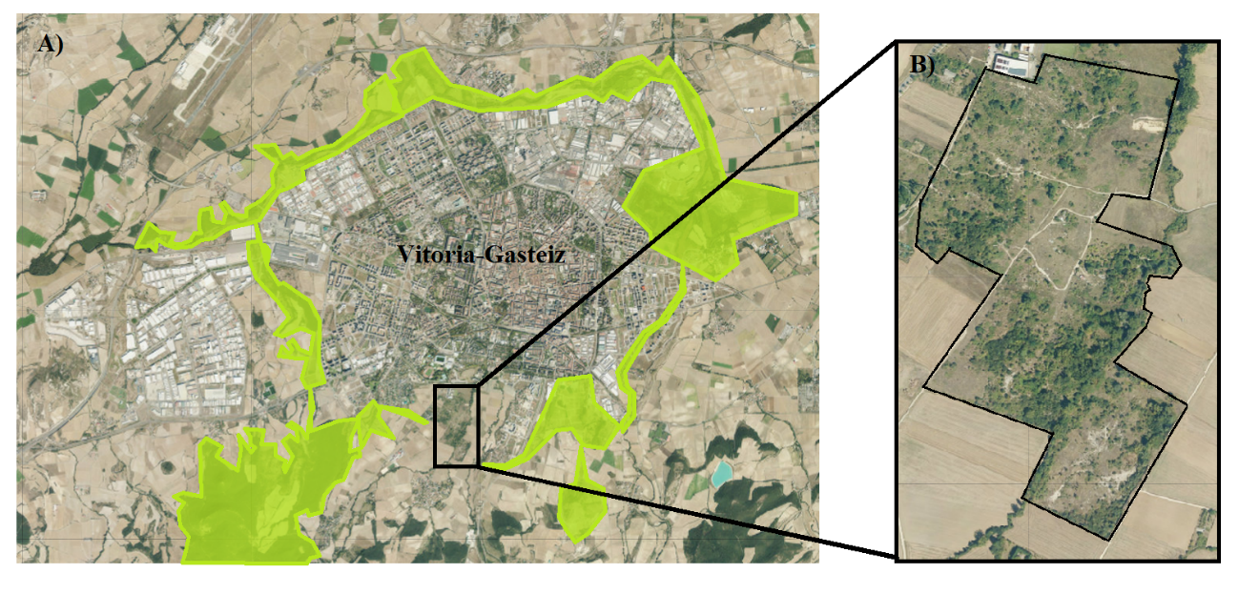

Supplementary Figure 2. Effect of plant growth on Biolog EcoPlates™ average well colour development (AWCD) data in the absence and presence of soil amendments (CSS: composted sewage; SMS: oyster mushroom spent mushroom substrate). Different letters represent significant (p < 0.05) differences among plant treatments.
