Supplementary figures and tables
Table S1. Pathological classification and number of spectral fingerprint measurements for each tumor type (WHO: World Health Organization; MNI: Montreal Neurological Institute-Hospital; MSH: Mount Sinai Hospital). Numbers in parentheses represent the samples that remain after applying a spectral quality factor cutoff.
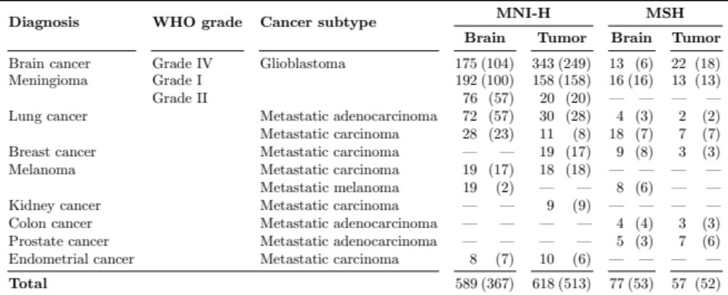
Table S2. Summary of clinical characteristics of the cohorts from the Montreal Neurological Institute- Hospital (MNI-H) and Mount Sinai Hospital (MSH).
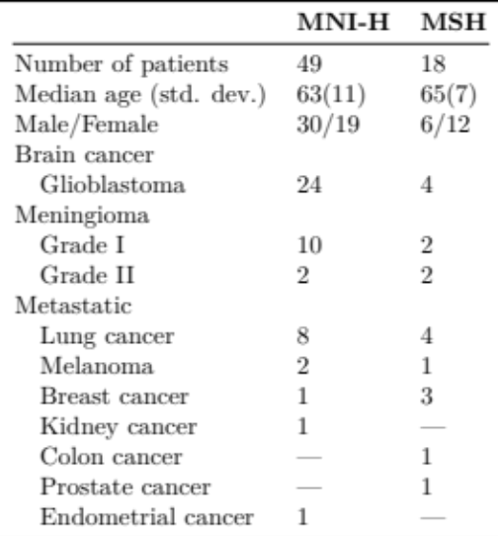

Table S3. Assignment of Raman-active biomolecular vibrational modes from literature. The features (peak center) assigned to “lipid” are in comparison to spectral fingerprints from purified brain lipids²⁸ including phosphatidylethanolamine, phosphatidylcholine and sphingomyelin.¹³ The features assigned to “protein” are in comparison to spectral fingerprints from purified proteins such as collagen.¹⁰ Legend: C-H: carbon-hydrogen single bonds, C=C: carbon-carbon double bonds (unsaturated), C-C: carbon-carbon bonds, CH₂: ethyl group, CH₃: methyl group.
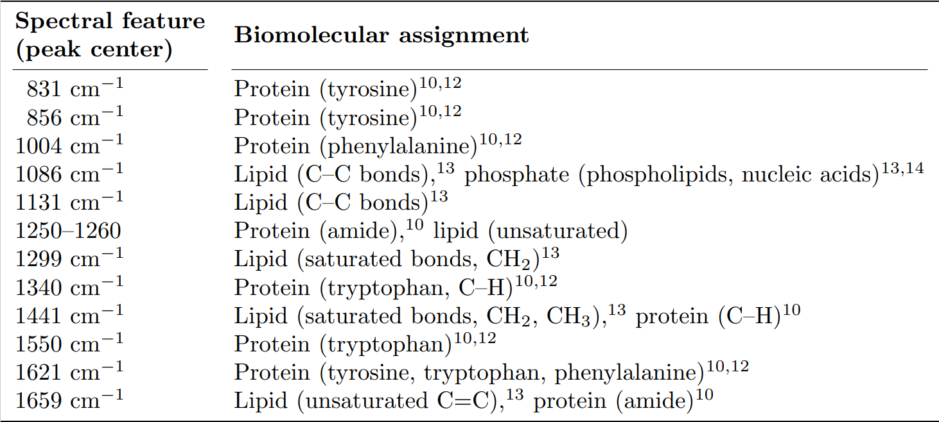

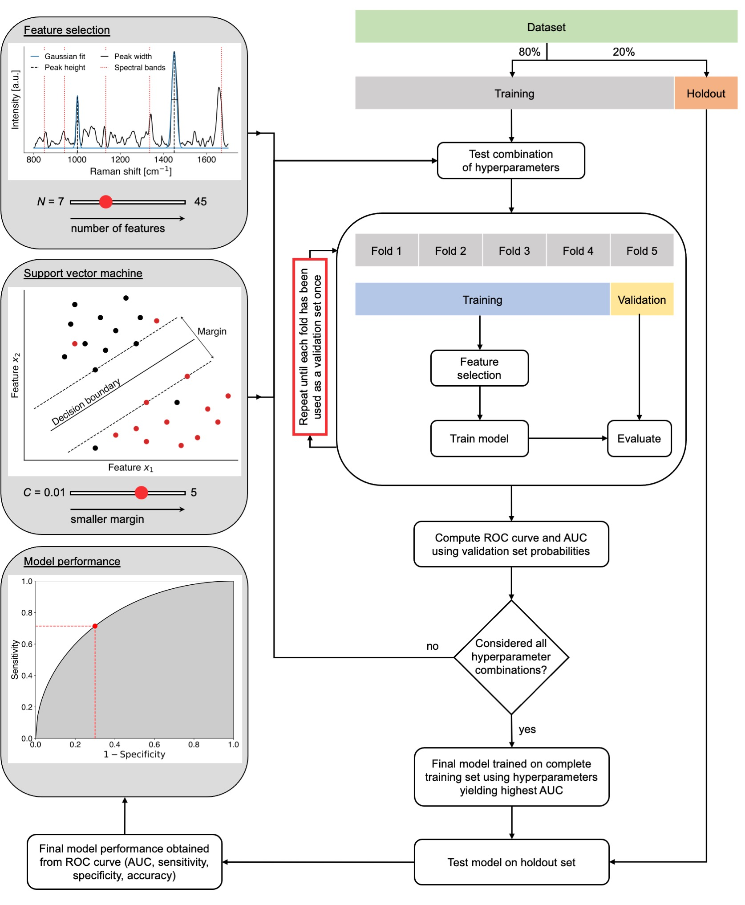
Supplementary Figure S1: Schematic diagram of the machine learning workflow. The first step consisted in splitting the dataset into training (80% of the whole dataset) and holdout (20% of the whole dataset) subsets. Feature selection and classification hyperparameters were optimized by generating machine learning models using support vector machines (SVM) for all predefined combinations of the hyperparameters N and C. The model performance associated with each combination was assessed using a 5-fold cross-validation technique based on ROC analyses comparing model predictions with the assigned pathology labels. The final model was trained on the complete training set using the hyperparameters that yielded the lowest number of false positives and false negatives. To evaluate the generalizability of the final model to new data, it was directly applied to the independent holdout set that was completely independent from the data used in the training/validation phase.
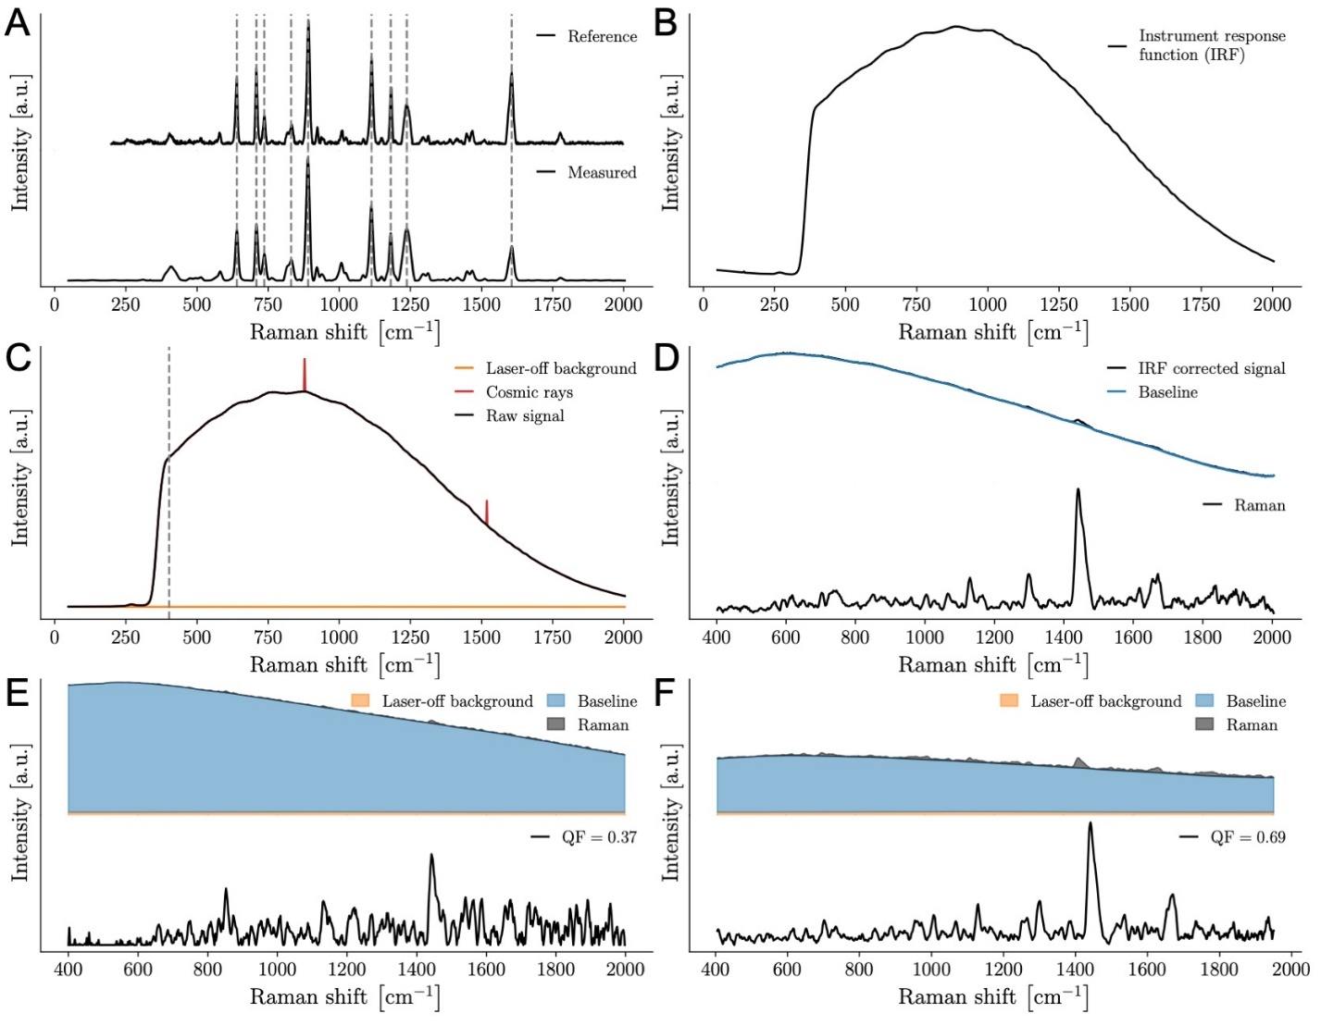
Supplementary Figure S2: (A-F) Data processing process. (A) Reference spectrum of polycarbonate used to convert CCD camera pixels into wavenumbers based on a polycarbonate spectrum measured with the Sentry system. (B) Instrument response function (IRF) measured with the system from the National Institute of Standards and Technology (NIST) Raman standard. (C) Dark count background acquired with the laser turned off and unprocessed (raw) in situ brain spectrum showing cosmic ray events. The grey dotted line designates the region that is truncated before further spectral pre-processing. (D) Spectrum after removal of cosmic rays and normalization with the IRF with the non-Raman baseline contribution isolated using the BubbleFiill shown in blue. The SNV-normalized Raman spectrum is shown at the bottom. Representation of one low quality spectrum (QF = 0.37) and one high quality spectrum (QF = 0.69).
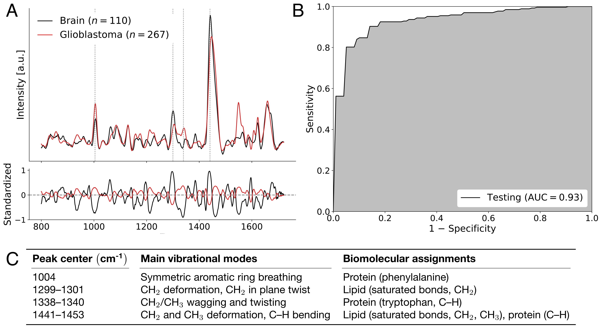
Supplementary Figure S3: (A-C) Machine learning model discriminating between spectral fingerprints from non-tumoral brain and glioblastoma. (A) Spectral fingerprints from all patients with glioblastoma. Main spectral features used in model building designated by dotted lines, with (C) peak location and biomolecular origin specified. Mean non-tumoral brain spectra are shown in black and glioblastoma spectra are shown in red. (B) Receiver operating curve (ROC) for the predictive model with area under curve (AUC). Legend: C-H: carbon-hydrogen single bonds, C=C: carbon-carbon double bonds (unsaturated), C-C : carbon-carbon bonds, CH₂: ethyl group, CH₃: methyl group.
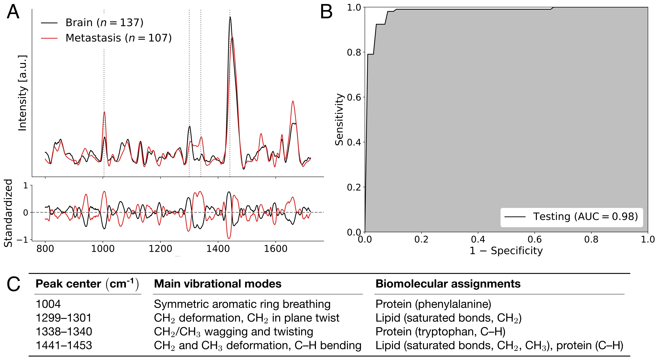
Supplementary Figure S4: (A-C) Machine learning model discriminating between spectral fingerprints from non-tumoral brain and metastases. (A) Spectral fingerprints from all patients with metastases. Main spectral features used in model building designated by dotted lines, with (C) peak location and biomolecular origin specified. Mean non-tumoral brain spectra are shown in black and metastases spectra are shown in red. (B) Receiver operating curve (ROC) for the predictive model with area under curve (AUC). Legend: C-H: carbon-hydrogen single bonds, C=C: carbon-carbon double bonds (unsaturated), C-C : carbon-carbon bonds, CH₂: ethyl group, CH₃: methyl group.
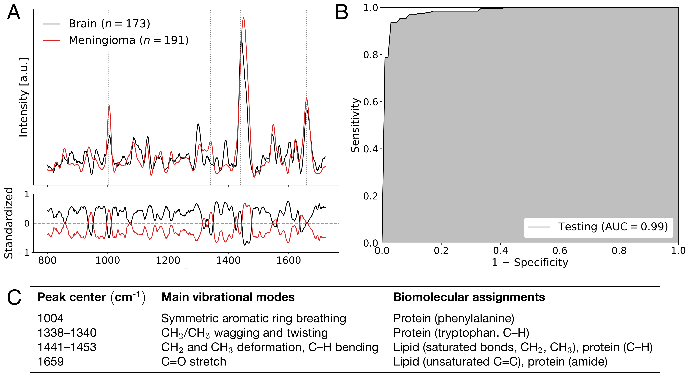
Supplementary Figure S5: (A-C) Machine learning model discriminating between spectral fingerprints from non-tumoral brain and meningioma. (A) Spectral fingerprints from all patients with meningioma. Main spectral features used in model building designated by dotted lines, with (C) peak location and biomolecular origin specified. Mean non-tumoral brain spectra are shown in black and meningioma spectra are shown in red. (B) Receiver operating curve (ROC) for the predictive model with area under curve (AUC). Legend: C-H: carbon-hydrogen single bonds, C=C: carbon-carbon double bonds (unsaturated), C-C : carbon-carbon bonds, CH₂: ethyl group, CH₃: methyl group.

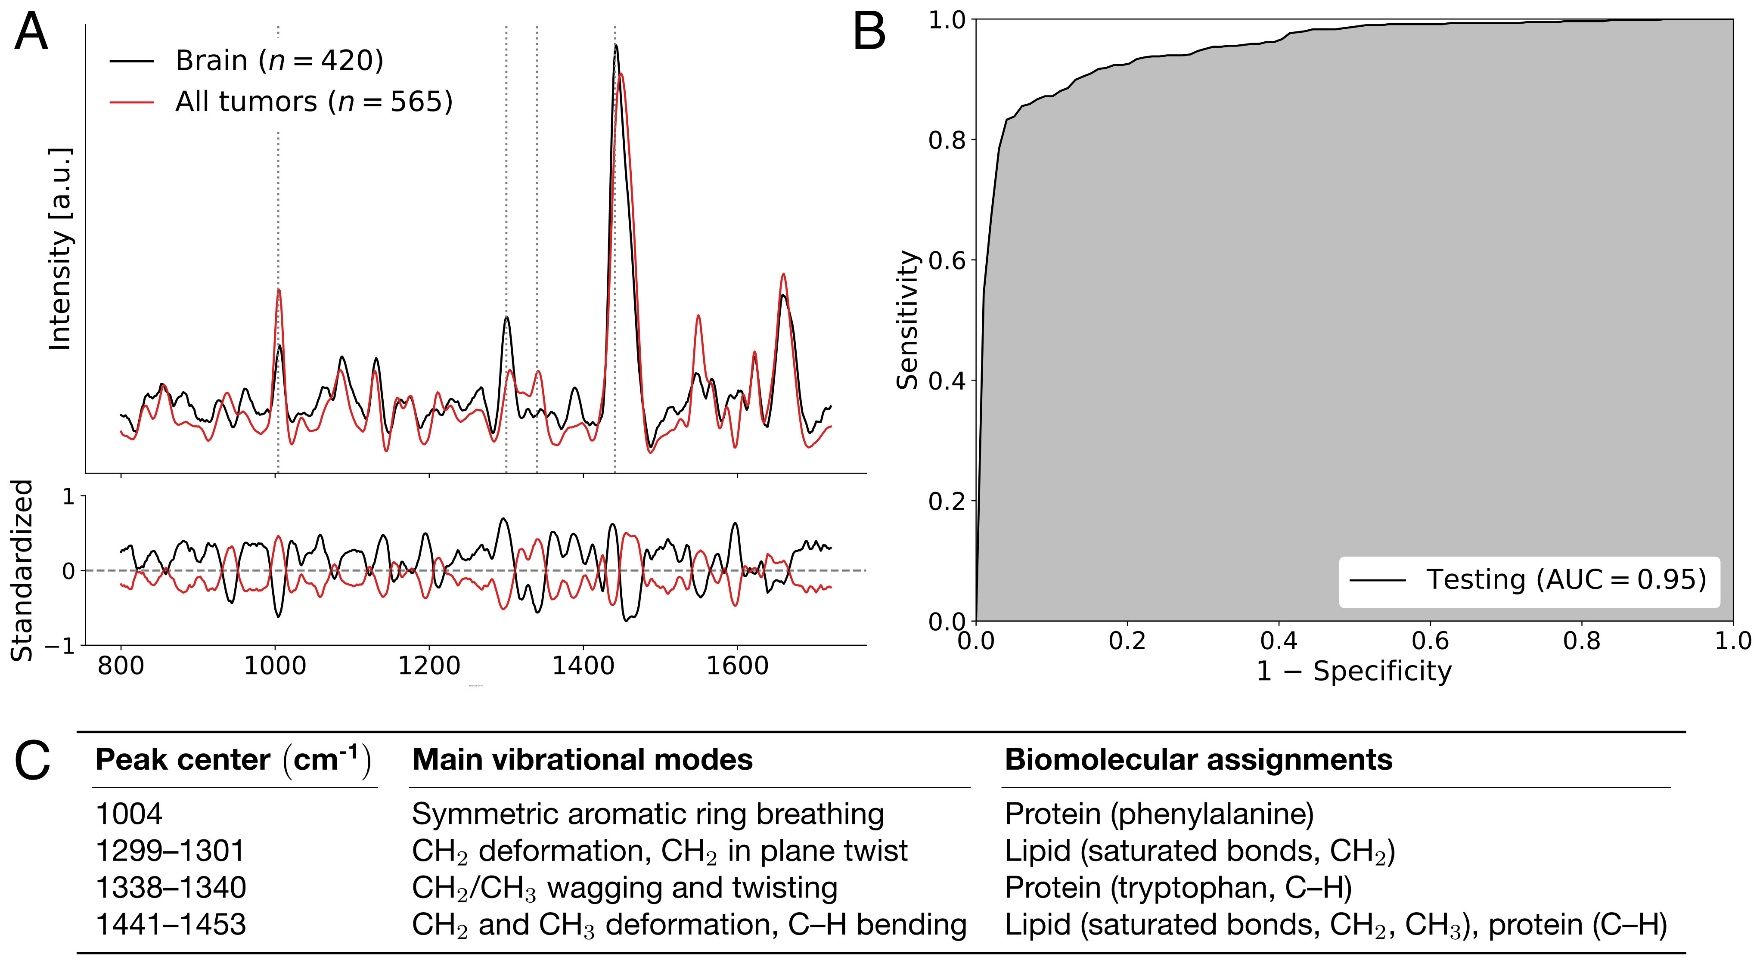
Supplementary Figure S6: (A-C) Machine learning model discriminating between Raman spectra from non-tumoral brain and tumor tissue independent of disease type. (A) Spectra fingerprints from all patients with main features used in model building designated by dotted lines. Mean non-tumoral brain tissue spectra are shown in black and tumor spectra are shown in red. (B) Receiver operating curve (ROC) for the predictive model with area under curve (AUC). Legend: C-H: carbon-hydrogen single bonds, C=C: carbon-carbon double bonds (unsaturated), C-C : carbon-carbon bonds, CH₂: ethyl group, CH₃: methyl group.

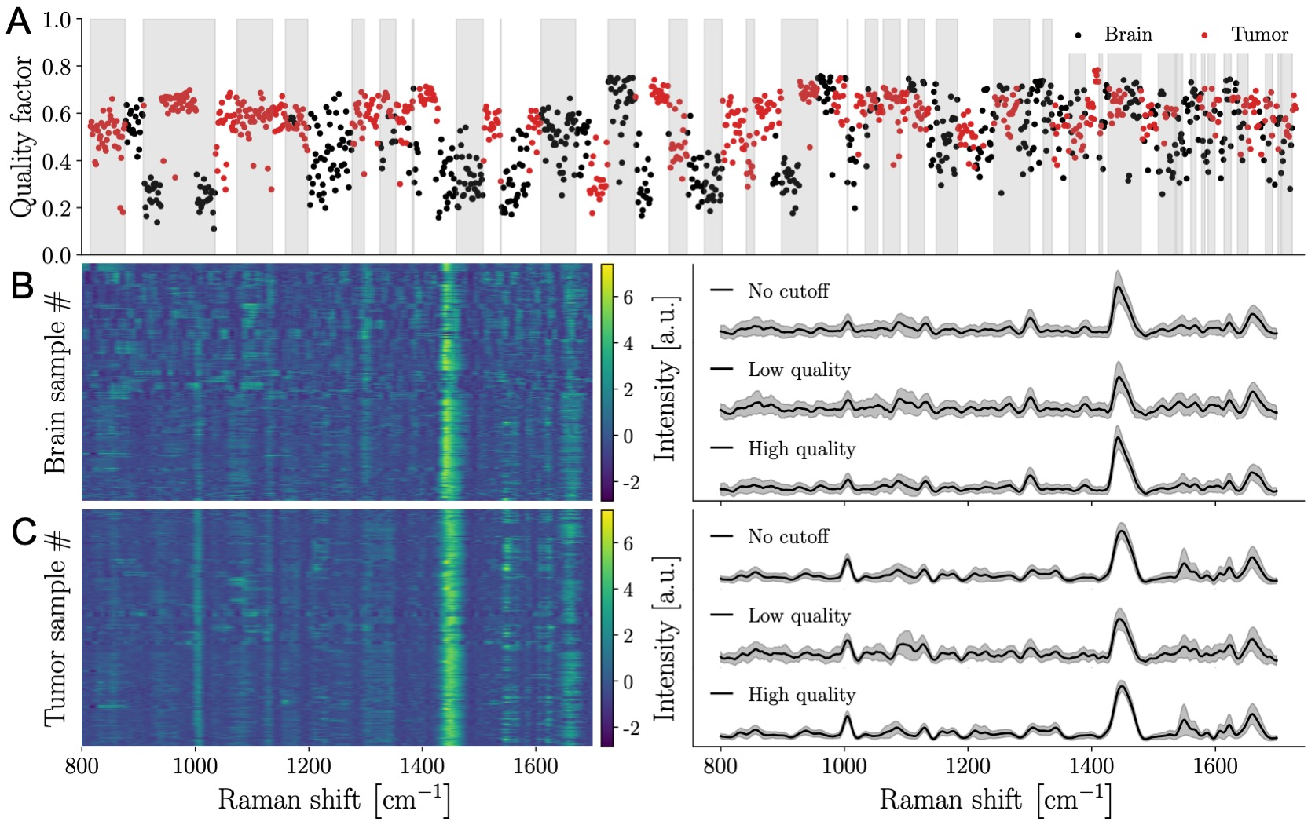
Supplementary Figure S7: (A-C) Depiction of the spectral quality factors for brain and tumor samples acquired with the Sentry system. (A) Quality factor (QF) distribution of all Raman spectra with alternating grey and white bands denoting different patients. (B) Spectrogram of Raman spectra from non-tumoral brain (left) and average Raman spectra with their variance (right). Average spectral fingerprints are shown for all samples (no QF cutoff) as well as for high and lower quality spectra. (C) Spectrogram of Raman spectra from tumor samples (left) and average Raman spectra with their variance (right). Higher quality spectra are associated with smaller levels of stochastic (photonic) noise leading to smaller inter-measurement variances.

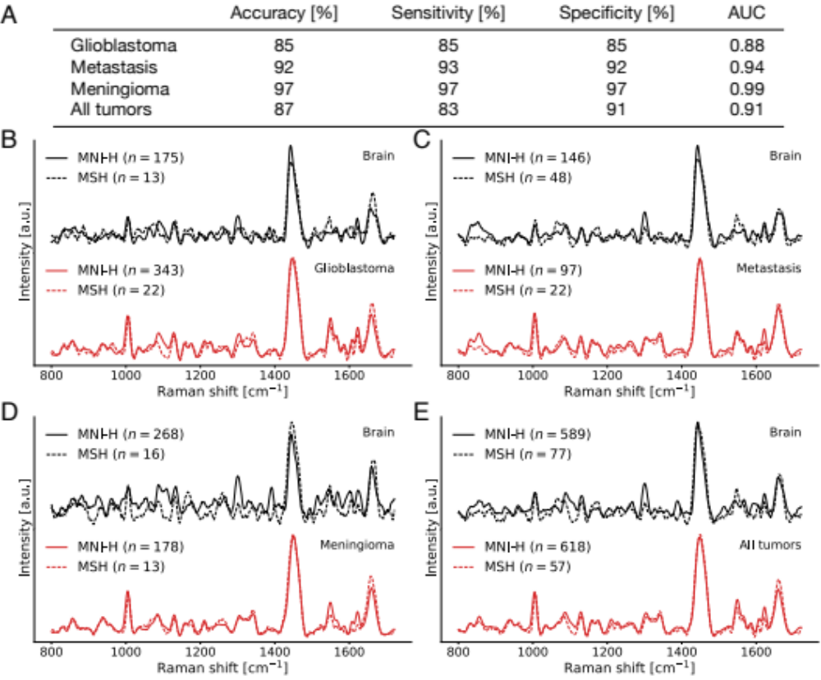
Supplementary Figure S8: (A-E) Machine learning model with no quality factor threshold applied to the data. (A) Table presenting all results from machine learning models discriminating between spectral fingerprints from non-tumoral brain and tumor in patients with different types of cancer. Spectral fingerprints were plotted for patients with (B) glioblastoma, (C) metastasis, (D) meningioma, and (E) all tumor types.

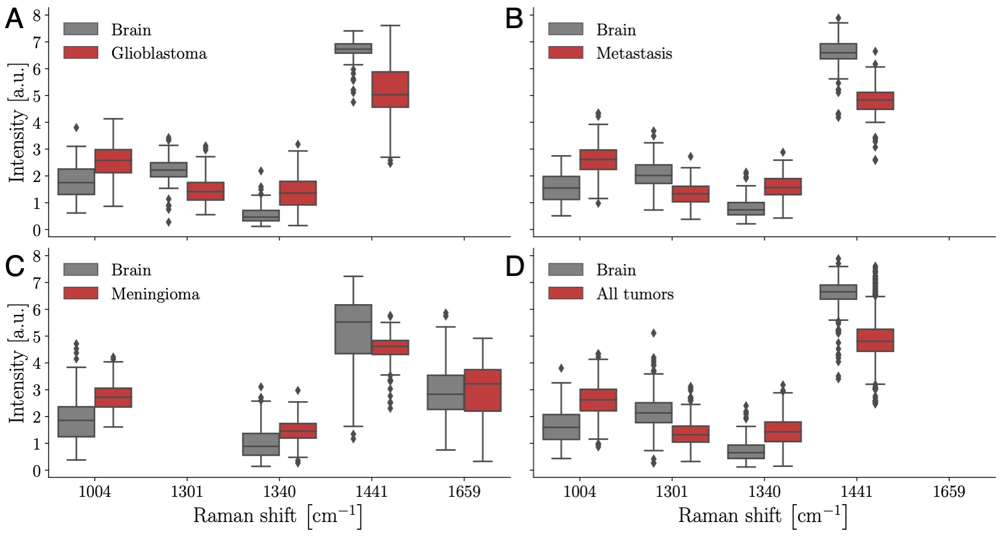
Supplementary Figure S9: (A-D): Box and whisker plots associated with the four most important bands selected by machine learning to distinguish non-tumoral brain from tumor: A) non-tumoral brain vs. glioblastoma, B) non-tumoral brain vs. metastases, B) non-tumoral brain vs. meningioma, C) non-tumoral brain vs. tumors (glioblastoma, metastases and meningioma measurements lumped together).

