Uptake of biocrust nitrogen by tree crops in a sandy soil agroecosystem
Clayton J. Nevins^{1,2}, Sarah L. Strauss¹, and Patrick W. Inglett²*
¹Soil Microbiology Laboratory, Southwest Florida Research and Education Center, Department of Soil, Water, and Ecosystem Sciences, Institute of Food and Agriculture Sciences, University of Florida, Immokalee, FL, USA.
²Wetland Biogeochemistry Laboratory, Department of Soil, Water, and Ecosystem Sciences, Institute of Food and Agriculture Sciences, University of Florida, Gainesville, FL, USA.
*Corresponding Author
E-mail address: pinglett@ufl.edu

Supplemental Material
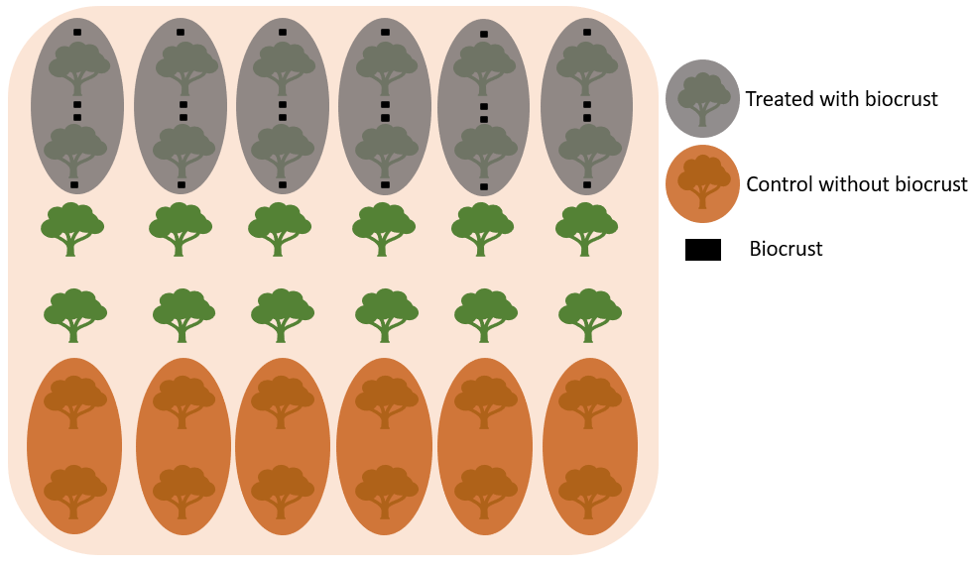
Figure S1. Illustration of the field trial design and biocrust locations at the at the University of Florida Southwest Florida Research and Education Center (Immokalee, Florida, USA).

Table S1. Predicted dry weight biomass of tree tissues averaged across trees with and without biocrust. (Mean ± SE, n = 12)
Tree tissue | Dry wt (kg)
Fruit | 2225.0 ± 73.3
Fibrous roots | 1448.3 ± 12.7
Medium roots | 3187.5 ± 138.8
Large roots | 3115.9 ± 231.4
Leaves | 2740.9 ± 33.5
Twigs | 3160.7 ± 242.9
Medium branches | 5059.5 ± 312.3
Large branches | 7642.6 ± 452.1
Trunk | 2063.6 ± 81.0

Table S2. Nitrogen concentration (%) of biocrust, subsoil, fibrous roots, and leaves in plots with biocrust and plots without biocrust (control) from before biocrust application (September 21, 2020) through harvest (February 26, 2021). (Mean ± SE, n = 6)
 | Biocrust | Subsoil (1-15 cm) |  | Fibrous roots |  | Leaves
 |  | Biocrust | Control | Biocrust | Control | Control | Biocrust
Sampling date | Nitrogen concentration (%)
September 21, 2020 | 0.43 ± 0.09 | 0.05 ± 0.00 | 0.07 ± 0.01 | 1.07 ± 0.06 | 0.93 ± 0.05 | 2.15 ± 0.06 | 2.25 ± 0.08
September 22, 2020 | 0.54 ± 0.14 | 0.04 ± 0.00 | 0.06 ± 0.00 | 0.95 ± 0.04 | 1.11 ± 0.07 | 2.15 ± 0.04 | 2.10 ± 0.07
September 24, 2020 | 0.58 ± 0.09 | 0.06 ± 0.01 | 0.06 ± 0.00 | 0.97 ± 0.03 | 1.12 ± 0.08 | 2.06 ± 0.04 | 2.18 ± 0.08
September 28, 2020 | 0.53 ± 0.07 | 0.05 ± 0.00 | 0.04 ± 0.00 | 0.95 ± 0.06 | 1.26 ± 0.06 | 2.03 ± 0.06 | 2.15 ± 0.10
October 19,  2020 | 0.53 ± 0.08 | 0.04 ± 0.00 | 0.05 ± 0.01 | 0.96 ± 0.05 | 1.14 ± 0.06 | 2.08 ± 0.07 | 2.22 ± 0.07
November 16, 2020 | 0.55 ± 0.06 | 0.04 ± 0.00 | 0.04 ± 0.00 | 0.86 ± 0.07 | 0.74 ± 0.06 | 2.34 ± 0.07 | 2.33 ± 0.09
January 11,  2021 | 0.47 ± 0.09 | 0.04 ± 0.00 | 0.05 ± 0.00 | 0.71 ± 0.06 | 1.10 ± 0.06 | 2.41 ± 0.07 | 2.46 ± 0.05
February 26, 2021 | 0.24 ± 0.03 | 0.07 ± 0.02 | 0.06 ± 0.01 | 0.75 ± 0.06 | 0.78 ± 0.04 | 2.72 ± 0.22 | 2.86 ± 0.11

Table S3. Nitrogen concentration (%) of tree organs in plots with biocrust and plots without biocrust (control) at harvest (February 26, 2021- March 2, 2021). (Mean ± SE, n = 6)
 | Biocrust | Control
Tree tissue | Nitrogen concentration (%)
Fruit | 1.29 ± 0.02 | 1.30 ± 0.04
Fibrous roots | 0.75 ± 0.06 | 0.78 ± 0.04
Medium roots | 0.91 ± 0.04 | 0.87 ± 0.04
Large roots | 1.14 ± 0.06 | 1.23 ± 0.09
Leaves | 2.72 ± 0.22 | 2.86 ± 0.11
Twigs | 1.55 ± 0.08 | 1.51 ± 0.03
Medium branches | 1.28± 0.02 | 1.31 ± 0.04
Large branches | 1.00 ± 0.02 | 1.00 ± 0.04
Trunk | 1.06 ± 0.08 | 1.15 ± 0.08

