Supplementary Information
A list of Supproting Information

Supplementary Fig.S1a MDD leave-one-out analysis
Supplementary Fig.S1b SCZ leave-one-out analysis

Figure S1a .SCZ leave-one-out analysis
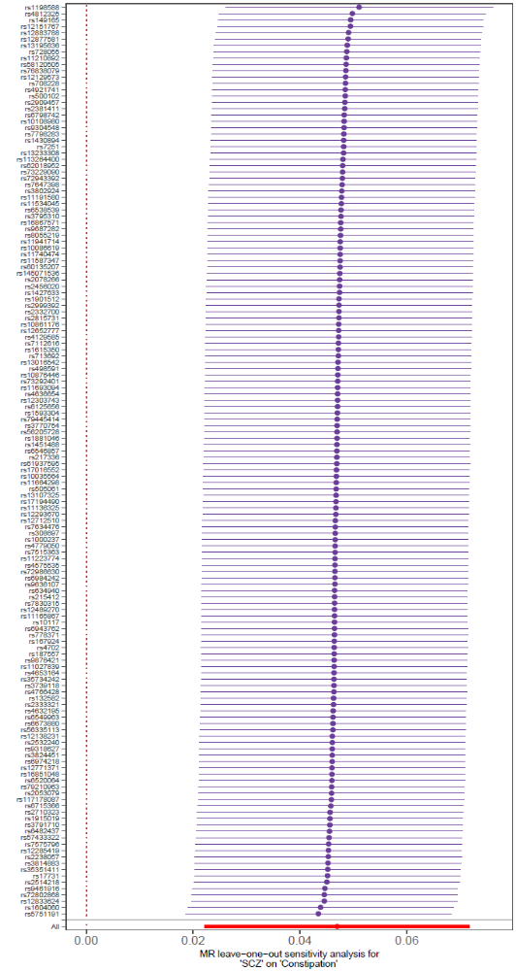
Figure S1b .MDD leave-one-out analysis
