Experimental Section
NMR Measurements
¹H NMR spectra were recorded on a Bruker AVANCE III spectrometer operating at 500 MHz. CDCl₃ was used as the solvent, and chemical shifts were reported relative to solvent residual signals.
SEC Measurements
SEC measurements were performed using a Waters e-2695 high-speed liquid chromatograph equipped with RI and UV detectors. THF was used as the eluent at a flow rate of 0.50 mL min⁻¹ at 40 °C and a Shodex KF-603 column was employed. The calibration curve was obtained with TSK standard polystyrenes (Tosoh Co.); the M_{w}(LS)s were 189000, 37200, 9490, 2500, and 589.
Rheological analyses
Rheological analyses were performed on an Anton Paar MCR 102 rheometer equipped with a Peltier temperature control device. Time-dependent analyses of G’ and G’’ for the PDMS samples with a thickness of 0.3 mm were conducted using a parallel plate with a diameter of 12 mm at a frequency of 5 Hz at 25 °C.
Tensile tests
Tensile tests were conducted on a Shimadzu AGS-X mechanical testing machine with a 5 N load cell operating at a crosshead speed of 100 mm min⁻¹ at room temperature. The tensile modulus (E), elongation at break (ε_{B}), tensile strength (σ_{T}), and fracture energy (Γ) of a specimen were calculated with TRAPEZIUM X software built into the instrument.
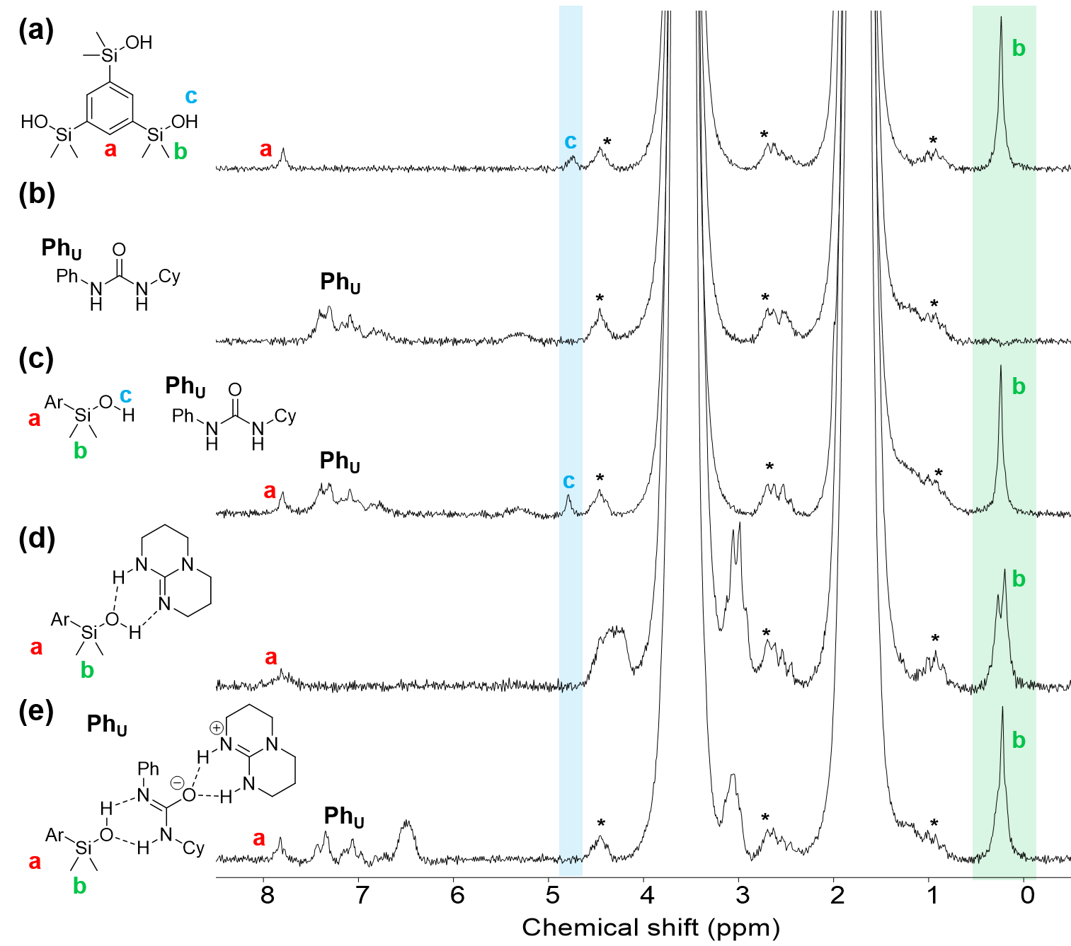
Supplementary Figure 1. ¹H NMR spectra (80 MHz, THF) of (a) I₃, (b) U(Cy), (c) I₃ + U(Cy) ([I₃] : [U(Cy)] = 1 : 3), (d) I₃ + TBD ([I₃] : [TBD] = 1 : 0.75), and (e) I₃ + TBD + U(Cy) ([I₃] : [TBD] : [U(Cy)] = 1 : 0.75 : 3). [I₃] = 0.018 M. The asterisks indicate satellite signals of two THF-derived signals appearing at 1.79 and 3.62 ppm.
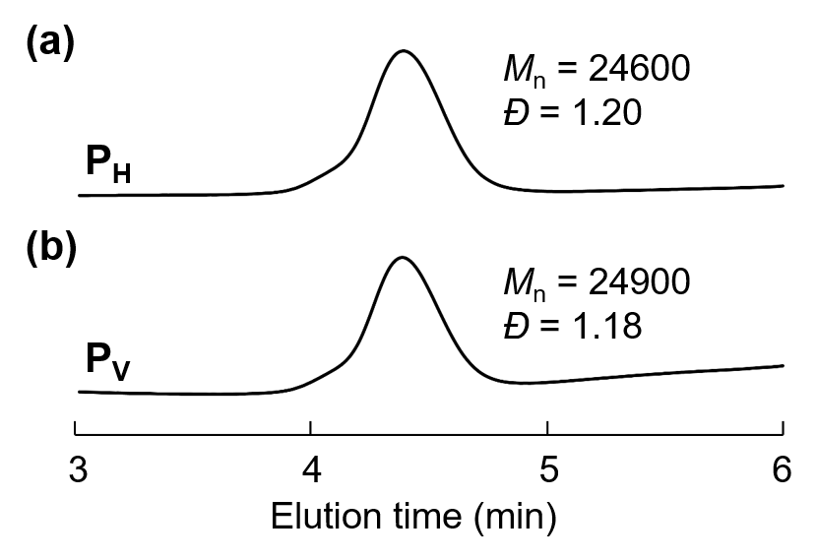
Supplementary Figure 2. SEC trace of (a) P_{H}. and (b) P_{V}.

