Supporting information paper “Tree Species Identity Drives Soil Carbon and Nitrogen Stocks in Nutrient-Poor Sites ”

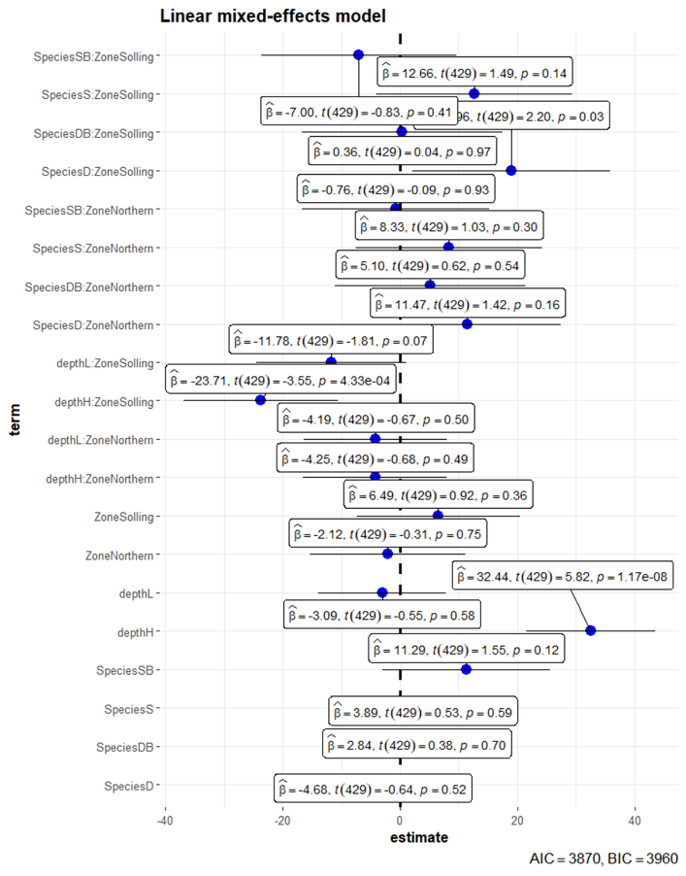
Figure S1. Linear mixed-effects model on organic horizon mass. The figure shows the estimate coefficient (β), t-test and significance p for each term included in the model. Species (D: Douglas fir, S: spruce; Be: beech; Douglas fir/beech: DB; and, spruce/beech: SB), Region (Southern sites [loamy soils] and Northern sites [sandy soils]) and depth (0-5, 5-10 and 10-30 cm]).

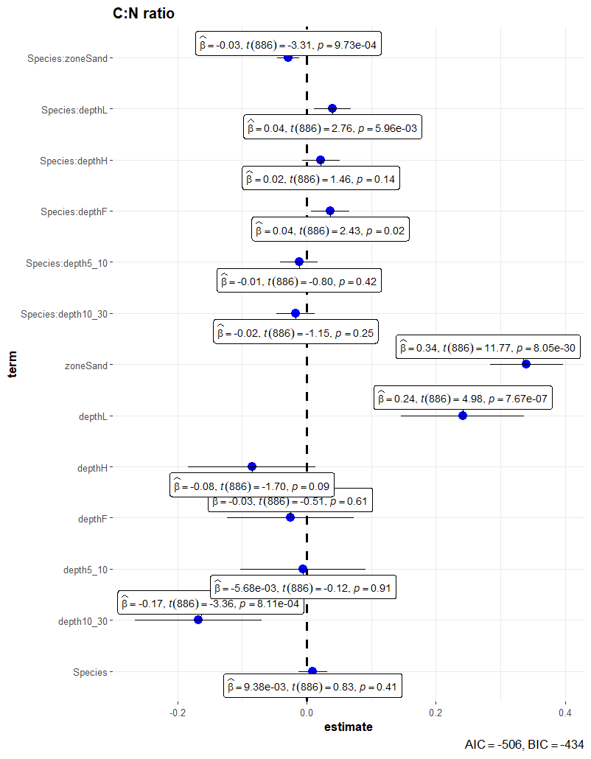
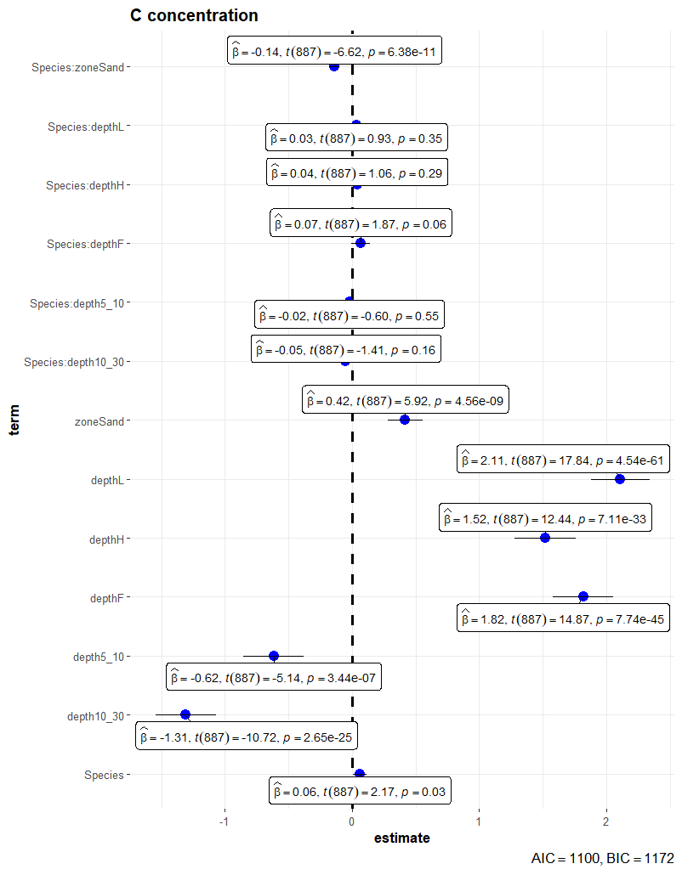
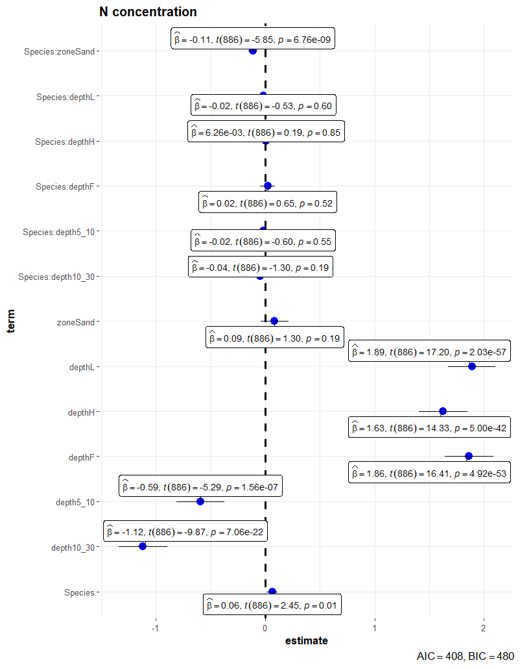
Fig.S2. Linear mixed-effects model on Carbon and N concentration, and CN ratio. The figure shows the estimate coefficient (β), t-test and significance p for each term included in the model. Species (D: Douglas fir, S: spruce; Be: beech; Douglas fir/beech: DB; and, spruce/beech: SB), Region (Southern sites [loamy soils] and Northern sites [sandy soils]) and depth (0-5, 5-10 and 10-30 cm]).

Table S1. Soil bulk density for each site and species, for individual depths.

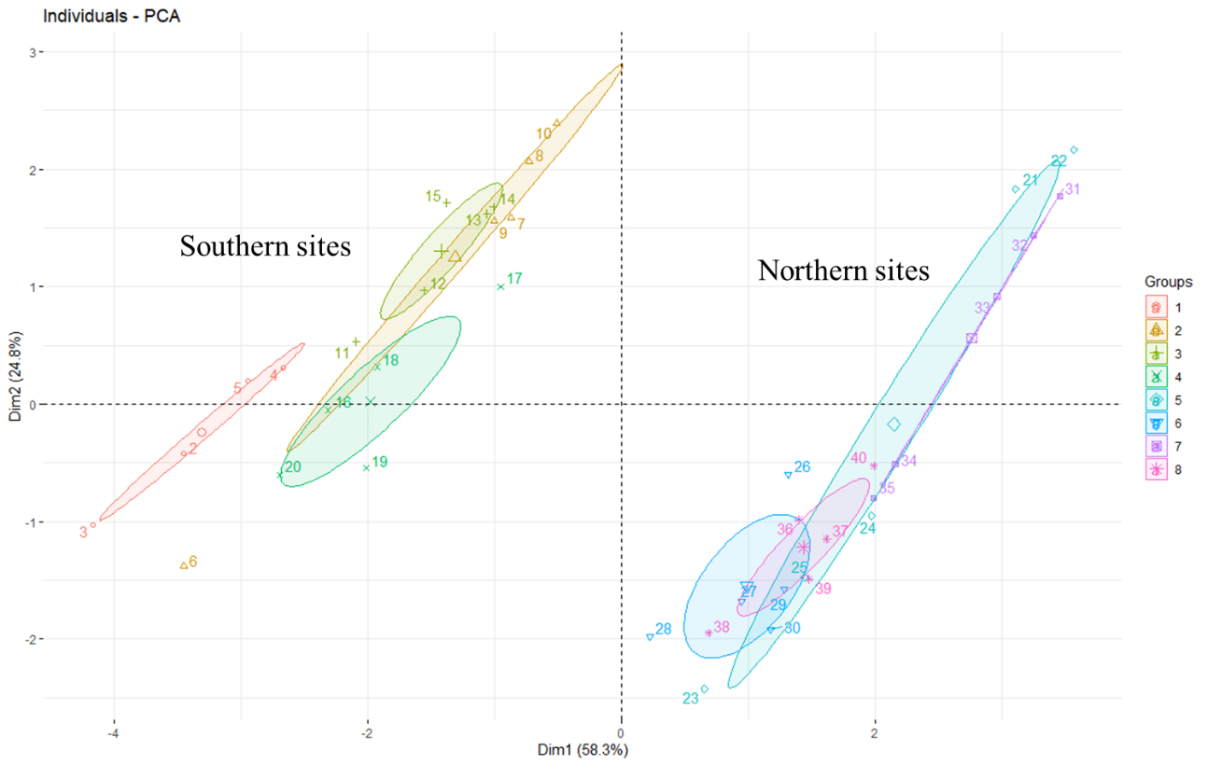

Fig S3. Sites grouping a) southern Lower Saxony, (Dassel, Winnefeld, and Nienover). The site 1 was not considered in our study. b) northern Lower Saxony, we selected four sites (Unterlüß, Nienburg, and Göhrde I and II)

