Supplementary Fig 1. Experimental girdling
- Procedure of experimental girdling and egg inoculation
- Morphology of intact, experimentally girdled, and recovered E. annuus plants 2 days post girdling.

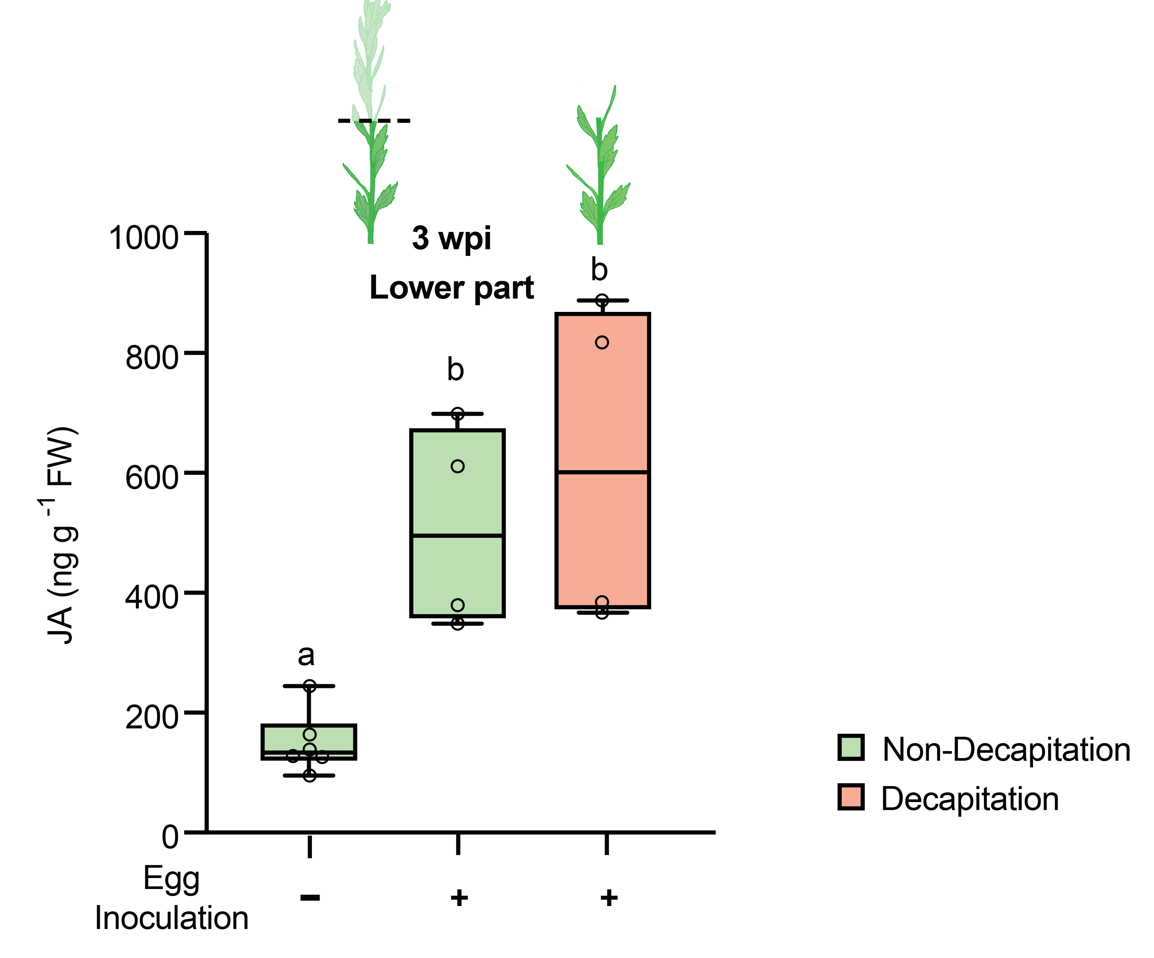
Supplementary Fig 2. JA contents in decapitated E. annuus stem upon P. rufiventris larval attack. Significant differences are indicated using different letters; p < 0.05; one-way ANOVA followed by Tukey’s HSD.

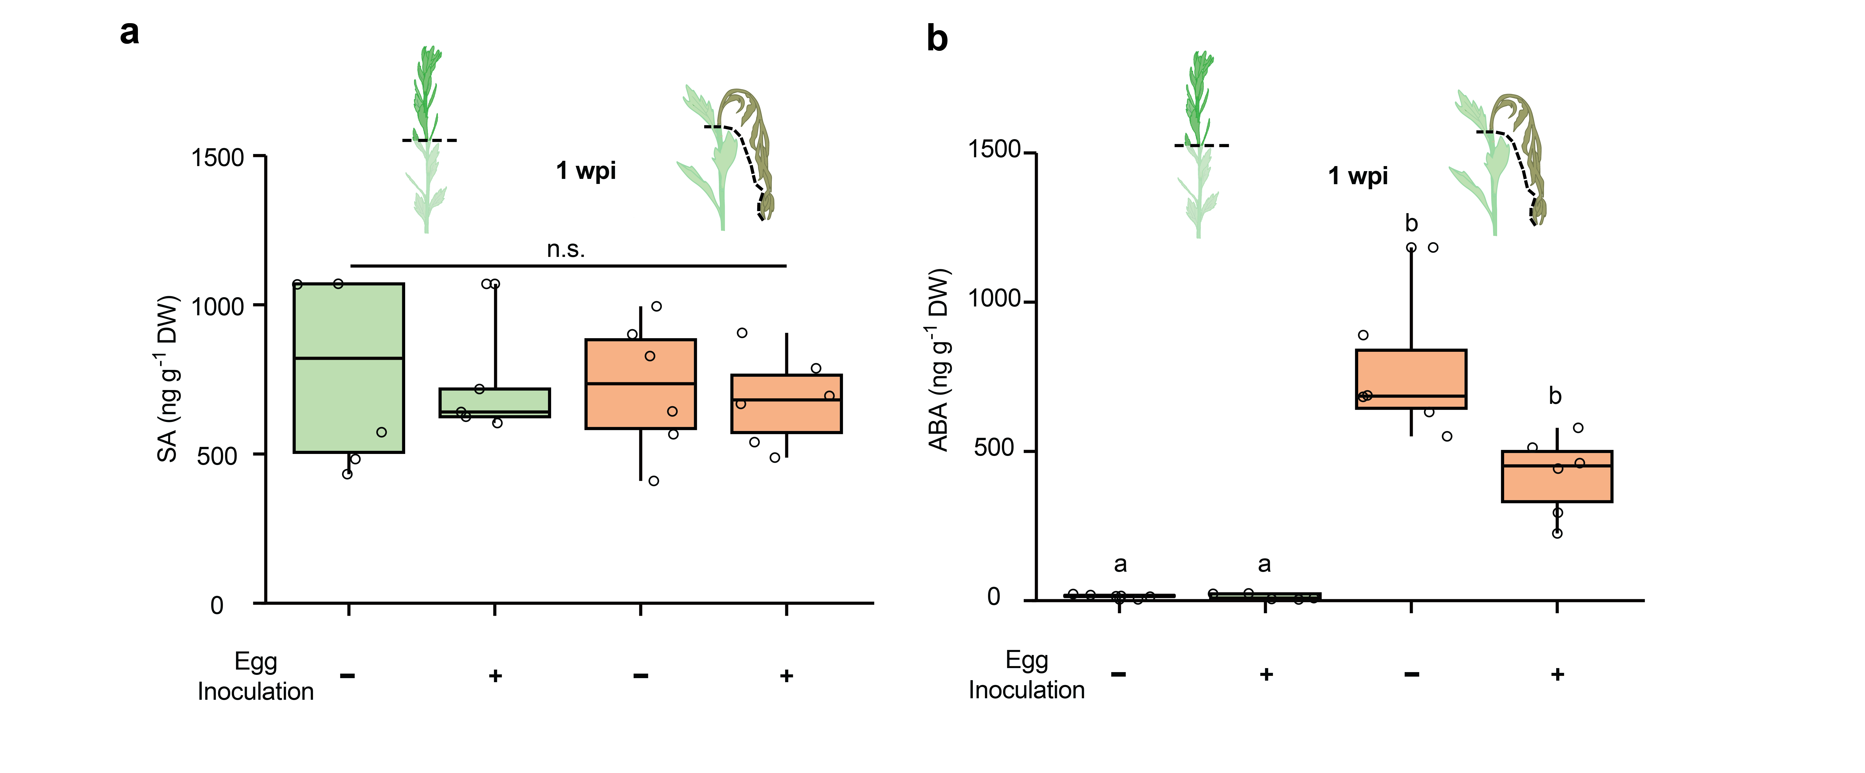
Supplementary Fig 3. Level of (a) salicylic acid and (b) abscisic acid measured at the upper part of the experimentally girdled and non-girdled stem of E. annuus. (n.s. no significant differences; different letters indicate significant differences)

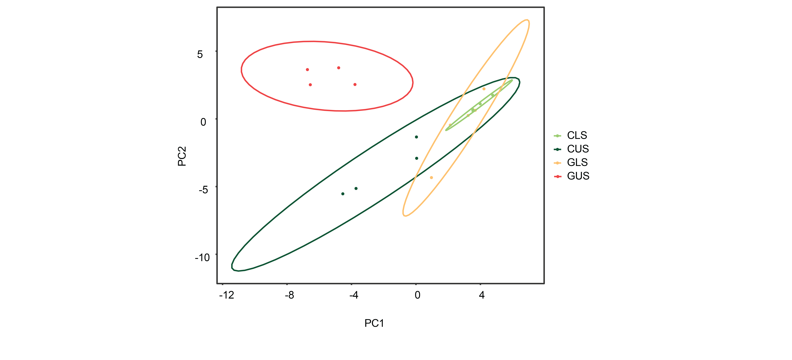
Supplementary Fig 4. Principal component analysis of the metabolic profiles of girdled and non-girdled stem of E. annuus. CLS, control lower stem; CUS, control upper stem; GLS, girdled lower stem; GUS, girdled upper stem.

Supplementary Fig 5. Total soluble sugar of upper and lower stem of E. annuus with and without experimental girdling. Boxes indicate the 1st and 3rd quantiles (significant differences are indicated as different alphabets; p < 0.05; one-way ANOVA). CLS, control lower stem; CUS, control upper stem; GLS, girdled lower stem; GUS, girdled upper stem.

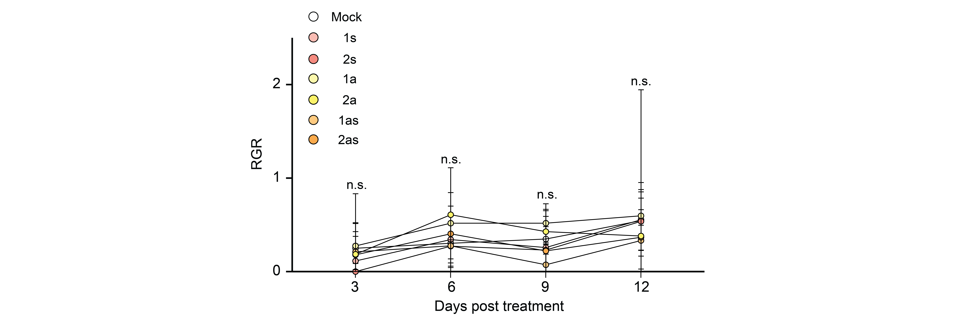
Supplementary Fig 6. Relative growth rate (RGR) of P. rufiventris beetles reared with artificial diets with and without sugar and amino acid supplementation. Error bars indicate standard errors (n.s., no significant differences; one-way ANOVA followed by Tukey’s HSD). Mock, no nutrient supplementation; 1s, 1x sugar; 2s, 2x sugar; 1a, 1x amino acids; 2a, 2x amino acids; 1as, 1x sugar and amino acids; 2as, 2x sugar and amino acids

