SUPPLEMENTARY INFORMATION
Large-Scale Synthesis of Defect-Free Phosphorene on Nickel Substrates: Enabling Atomistic Thickness Devices.
B. D. Tchoffo^{1,+}, I. Benabdallah^{1*,+}, A. Aberda¹, P. Neugebauer², A. Belhboub³, A. El Fatimy^{1 *}
¹ Institute of Applied Physics, Mohammed VI Polytechnic University, Lot 660, Hay Moulay Rachid, Ben Guerir, 43150, Morocco.
² Central European Institute of Technology, CEITEC BUT, Purkyňova 656/123, 61200 Brno, Czech Republic.
³ École Centrale Casablanca, Ville verte, Bouskoura, Casablanca, Morocco.
⁺ These authors contributed equally
*Corresponding author: ismail.benabdallah@um6p.ma, Abdelouahed.ELFATIMY@um6p.ma

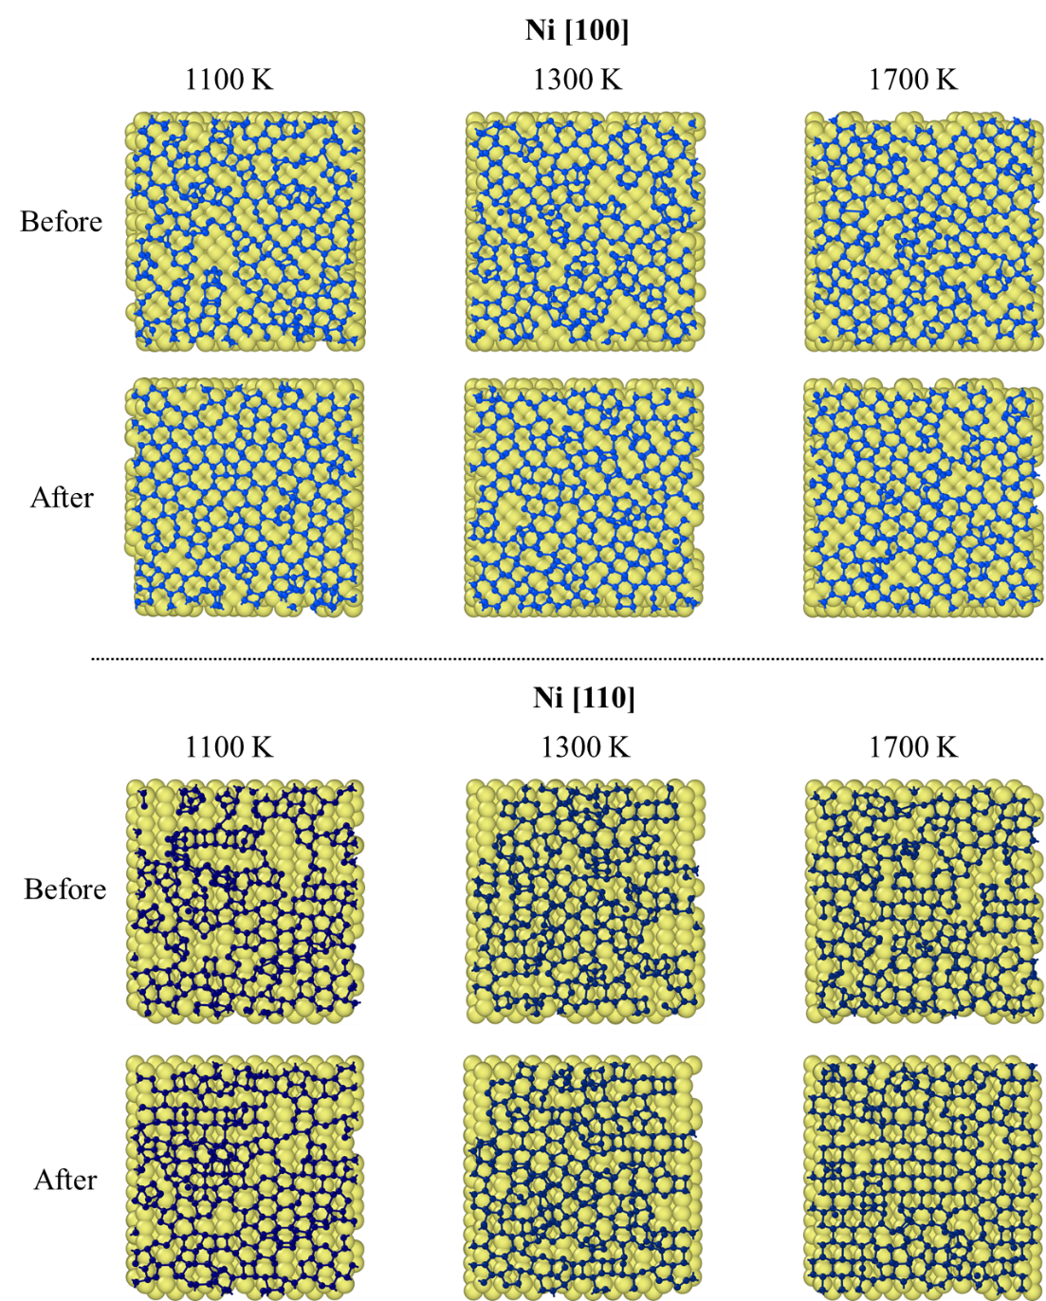

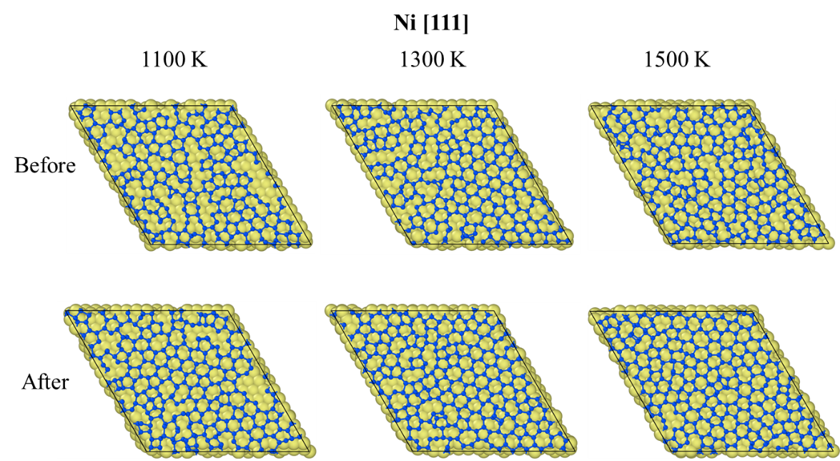
Figure S1 : (a) Top view of the final structure after heating to different temperatures before cooling

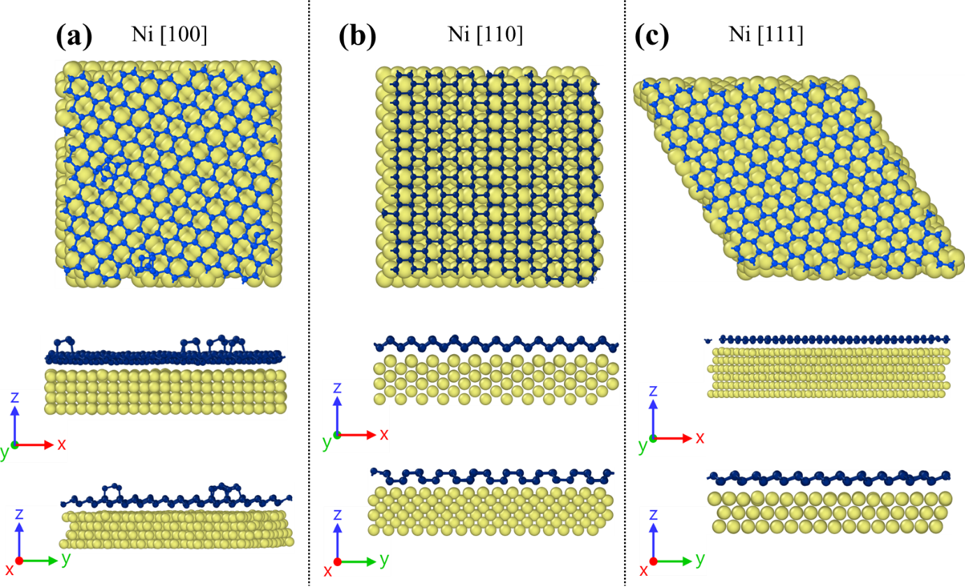
Figure S2: Top and Side view structures at 0.116 K/ps for Ni (100), (110) and (111).
Figures S2 (a), (b) and (d) shows the top and side views of the formed layer of β–P and γ–P on Ni (100), Ni (110) and Ni (111), respectively. The fact that the P₅ molecules play a crucial role as precursors for the formation of the phosphorene layer, the nature of the grown phosphorene also depends on the substrate surface. Therefore, this parameter allows a better selection and control for synthesizing to a precise allotrope.
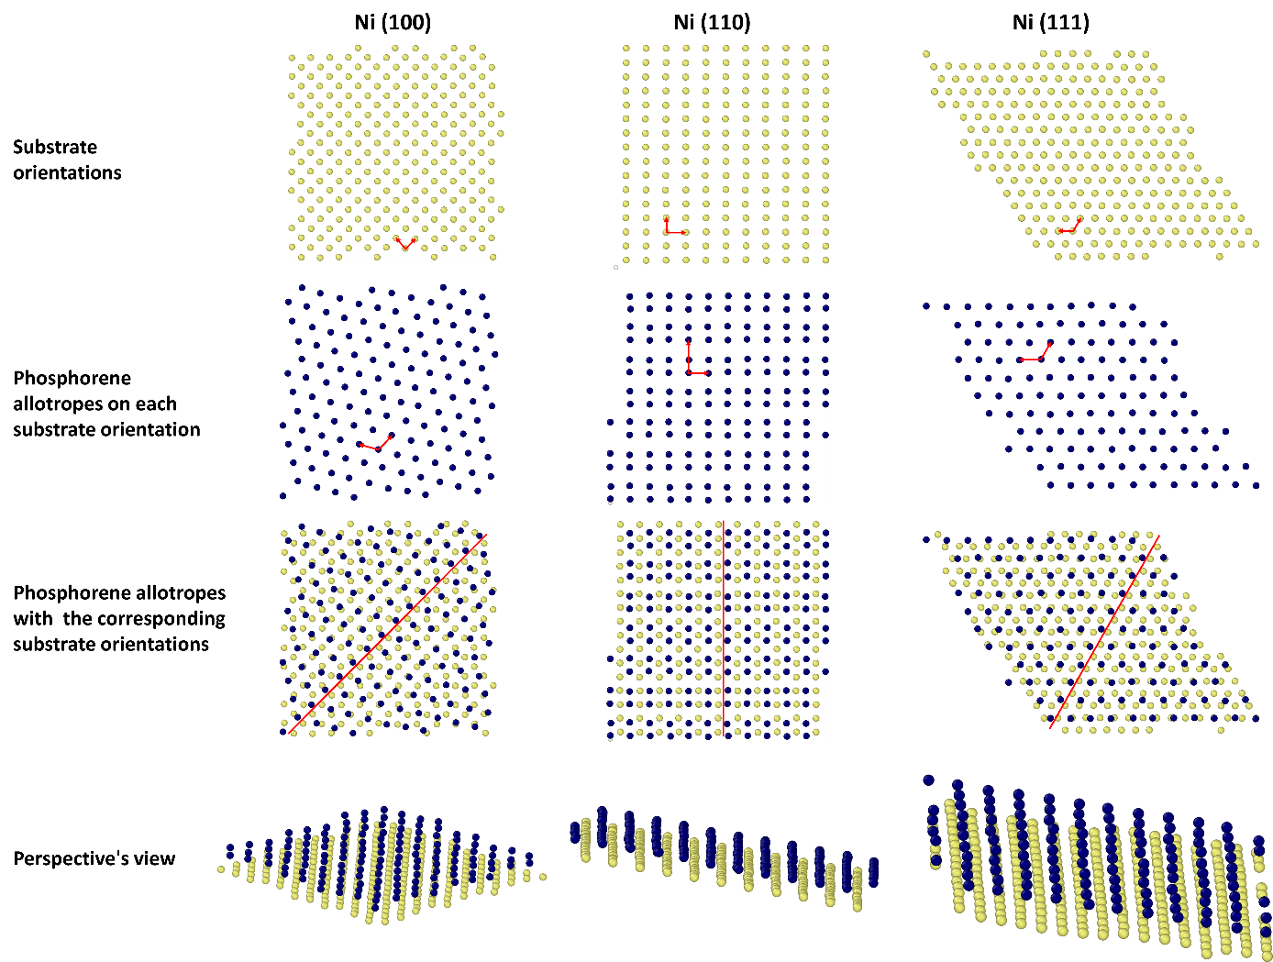
Figure S3: Top layer of the substrate and bottom layer of the phosphorene allotrope lattice, depicting the lattice orientations after deposition
Figure S3 shows the top and bottom layers of the corresponding substrate orientations and phosphorene allotropes, respectively, with their lattices after a cooling rate of 0.116 K/ps. Bauer & al. Showed that the growth layer on top of a substrate depends on the substrate’s lattice.¹ Moreover, the preferred orientation of the growth layer is the one where one of the most densely packed reticular rows of the substrate and the most densely packed rows of the formed layer is parallel. This is precisely what is shown in this figure, explaining why the b-P is preferable on the Ni(100) and Ni(111) and the g-P on the Ni(110).

Supplementary Video 1 : Phosphorus atoms deposition on a Ni (111) at 1300 K without cooling.
Supplementary Video 2 : Phosphorus atoms deposition on a Ni (111) with a fast cooling rate of 2.8 K/ps.
Supplementary Video 3 : Phosphorus atoms deposition on a Ni (111) with a slow cooling rate of 0.116 K/ps.
Supplementary Video 4 : Phosphorus atoms deposition on a Ni (110) with a slow cooling rate of 0.116 K/ps

Python methods
Graph theory model has been used to count the number of n-membered rings formed by phosphorus atoms at each timestep. A graph of the system was constructed at each timestep. Phosphorus atoms were considered nodes of the graph, while their bonds represented the edges. The number of elementary cycles of n nodes in the graph corresponds to that of the n-membered rings formed by phosphorus atoms. We limited the count to rings formed only by 3 to 8 atoms. Note that the graph provides only a 2D representation of the system, which can be inaccurate at the beginning of the simulation, where some 3D configurations appear, such as P4 molecules (tetrahedral) counted as P3 by our program.
We used Python3 with the Networkx library to model the graphs to implement this algorithm.

References:
- Bauer, E., & van der Merwe, J. H. Structure and growth of crystalline superlattices: From monolayer to superlattice. Physical review b, 33(6) (1986).

