Supplementary Table 1 lip function assessment scale
Dimension | Grading (higher score indicating better function)
1.Natural state
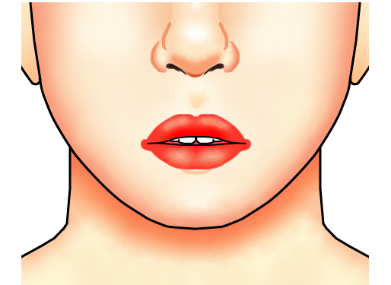 | 〇level 0：The lips are severely asymmetrical and the position is almost unchanged.
 | 〇level 1：Upper or lower lip retraction is severe, and the upper or lower lip is shaken when relaxed, but the patient does not realize.
 | 〇level 2：The upper or lower lip has a slight tremor when relaxed, but the patient occasionally tries to reset; or asymmetrical lips.
 | 〇level 3：Slight retraction of the upper lip or slight retraction of the lower lip, or slight misalignment, not obvious.
 | 〇level 4：The lips are naturally in the middle of the horizontal position, symmetrical, and naturally closed.
2.Drooling：
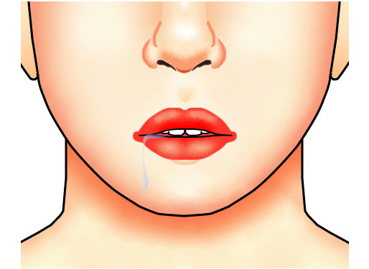 | 〇level 0：Out of control.
 | 〇level 1：Drool when the body leans forward or when distracted, slightly controlled.
 | 〇level 2：Just drool at the corners of the mouth and can be controlled slightly.
 | 〇level 3：The corners of the mouth are damp occasionally or slightly drool when drinking water or chewing.
 | 〇level 4：No drooling.
3.Lip and facial muscle strength examination：
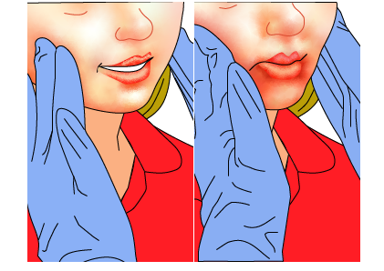 | 〇level 0：Refuse to do it.
 | 〇level 1：Cheeks are stiff, or keep smiling face, or muscles are tightly contract, making it difficult to make a grimace.
 | 〇level 2：Cheek muscles are soft, or easy to make a grimace.
 | 〇level 3：Upper lip retraction or lower lip retraction.
 | 〇level 4：The cheeks are relaxed at rest and the muscle strength is normal.
4.Lip closure movement：
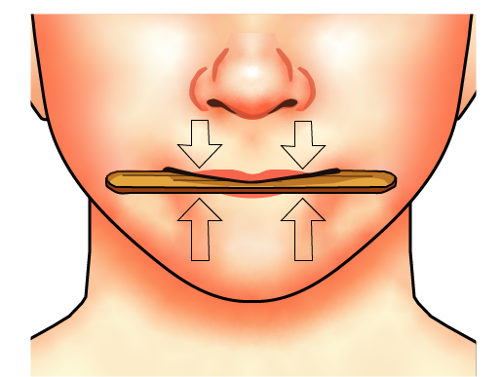 | 〇level 0: No reaction
 | 〇level 1: Lips can contact each other, try to pinch the tongue depressor but fail to hold it, or only can bite it with teeth.
 | 〇level 2: Effort is required when lips are tightly closed; Or Lips cannot clamp the tongue depressor more than 1 second.
 | 〇level 3：The lips can clamp the tongue depressor and but last no more than 3 seconds.
 | 〇level 4：The lips can clamp tongue depressor tightly and last more than 3 seconds.
5.Lip contact movement：
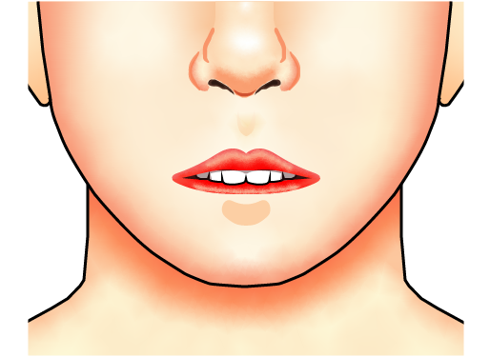 | 〇Level 0：No reaction
 | 〇Level 1: Try to abduce or pout the lip, but cannot finish, compensate or assist with eyes, head, or shoulders.
 | 〇Level 2：The upper teeth cannot bite the back of the lower lip, but they can bite the lower lip.
 | 〇Level 3: The upper teeth can bite the back of the lower lip but last no more than 3 seconds.
 | 〇Level 4: The upper teeth can bite the back of the lower lip and last more than 3 seconds.
6.Lip abduction movement：
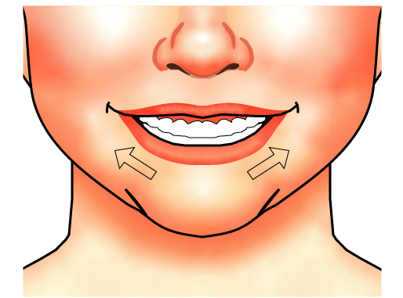 | 〇Level 0: No reaction.
 | 〇Level 1: Try to abduce, but cannot finish, compensate or assist with eyes, head, or shoulders.
 | 〇Level 2: Effort is required to abduce Lips, or the corner of the mouth cannot be raised; Or a small range of abduction, or stiffness or weakness in abduction
 | 〇Level 3: Lips can abduce but last no more than 3 seconds.
 | 〇Level 4: Lips can fully abduce, grin and last more than 3 seconds.
7.Lip pout movement：
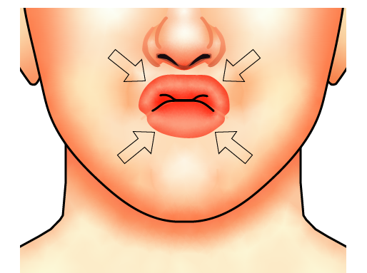 | 〇Level 0: No reaction.
 | 〇Level 1: Try to pout, but cannot finish, compensate or assist with eyes, head, or shoulders.
 | 〇Level 2: Effort is required to pout Lips; Or a small range of pout, or stiffness or weakness in pout.
 | 〇Level 3: Lips can pout but last no more than 3 seconds.
 | 〇Level 4: Lips can fully pout and last more than 3 seconds.
8. Lip abduction and pout alternating movement：
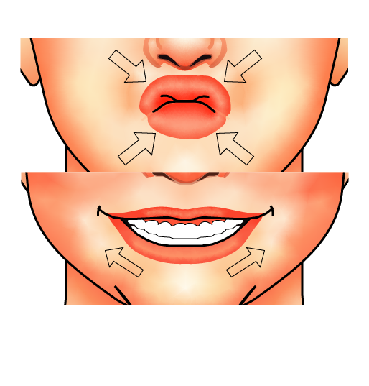 | 〇Level 0: No reaction.
 | 〇Level 1: Try to abduce or pout, but cannot finish, compensate or assist with eyes, head, or shoulders.
 | 〇Level 2: Can only finish one of abduction or pout movement; Or a small range of abduction or pout, or stiffness or weakness in abduction or pout.
 | 〇Level 3: Lips can continuously abduce and pout but no more than 3 times.
 | 〇Level 4: Lips can continuously abduce and pout more than 3 times.

Supplementary Table 2 Patients scar assessment scale
 | 1=no，not at all |  |  |  |  | yes，very much=10
 | 1 | 2 | 3 | 4 | 5 | 6 | 7 | 8 | 9 | 10
Has the scar been painful in the past two weeks? | ○ | ○ | ○ | ○ | ○ | ○ | ○ | ○ | ○ | ○
Has the scar been itching in the past two weeks? | ○ | ○ | ○ | ○ | ○ | ○ | ○ | ○ | ○ | ○
Is the scar color different from the color of your normal skin at present? | ○ | ○ | ○ | ○ | ○ | ○ | ○ | ○ | ○ | ○
Is the stiffness of the scar different from your normal skin at present? | ○ | ○ | ○ | ○ | ○ | ○ | ○ | ○ | ○ | ○
Is the thickness of the scar different from your normal skin at present? | ○ | ○ | ○ | ○ | ○ | ○ | ○ | ○ | ○ | ○
Is the scar more irregular than your normal skin at present? | ○ | ○ | ○ | ○ | ○ | ○ | ○ | ○ | ○ | ○
What is your overall opinion of the scar compared to normal skin? | ○ | ○ | ○ | ○ | ○ | ○ | ○ | ○ | ○ | ○

Supplementary Table 3 Observer scar assessment scale
 | 1=Normal skin |  |  |  |  | Worst scar imaginable=10
Parameter | 1 | 2 | 3 | 4 | 5 | 6 | 7 | 8 | 9 | 10 | Category
Vascularity | ○ | ○ | ○ | ○ | ○ | ○ | ○ | ○ | ○ | ○ | Pale/Pink/Red/Purple/Mix
Pigmentation | ○ | ○ | ○ | ○ | ○ | ○ | ○ | ○ | ○ | ○ | Hypo/Hyper/Mix
Thickness | ○ | ○ | ○ | ○ | ○ | ○ | ○ | ○ | ○ | ○ | Thicker/Thinner
Relief | ○ | ○ | ○ | ○ | ○ | ○ | ○ | ○ | ○ | ○ | More/Less/Mix
Pliability | ○ | ○ | ○ | ○ | ○ | ○ | ○ | ○ | ○ | ○ | Supple/Stiff/Mix
Surface area | ○ | ○ | ○ | ○ | ○ | ○ | ○ | ○ | ○ | ○ | Expansion/Contraction /Mix
Overall opinion | ○ | ○ | ○ | ○ | ○ | ○ | ○ | ○ | ○ | ○
Explanation：
The observer scale of the POSAS consists of six items (vascularity, pigmentation, thickness, relief, pliability and surface area).
All items are scored on a scale ranging from 1(‘like normal skin’) to 10(‘worst scar imaginable’)
The sum of the six items results in a total score of the POSAS observer scale. Categories boxes are added for each item. Furthermore, an overall opinion is scored on a scale ranging from 1 to 10.
All parameters should preferably be compared to normal skin on a comparable anatomic location.
Explanatory notes on the items:
vascularity: Presence of vessels in scar tissue assessed by the amount of redness, tested by the amount of blood return after blanching with a piece of Plexiglas.
Pigmentation: Brownish coloration of the scar by pigment(melanin); apply Plexiglas to the skin with moderate pressure to eliminate the effect of vascularity.
Thickness: Average distance between the subcutical-dermal border and the epidermal surface of the scar.
Relief: The extent to which surface irregularities are presented (preferably compared with adjacent normal skin).
Pliability: Suppleness of the scar tested by wrinkling the scar between the thumb and index finger.
Surface Area: Surface area of the scar in relation to the original wound area.
Supplementary Table 4 Clinical examination assessment scale
Assessment | Category | Explanation
Notched vermillion | 1 | A notch is visible from vermillion border
 | 2 | Continuous vermillion border without notch
Groove formation | 1 | A groove is visible from vermillion to chin
 | 2 | Continuous skin surface without groove
Sensory disorder | 1 | Anesthesia
 | 2 | Dysesthesia
 | 3 | Normal

Supplementary Table 5 Operation profile
Variables | Straight (n=22) | Z-shaped (n=22) | P value
Operation time (min) | 258.1 (±62.2) | 260.1 (±62.1) | 0.914ª
Reconstruction |  |  | 0.017^{b}
ALTFF | 20 (91%) | 12 (55%)
LDMCF | 0 (0%) | 5 (23%))
LAFF | 2 (9%) | 2 (9%))
RFFF | 0 (0%) | 2 (9%)
Neck dissection |  |  | 0.489^{b}
Undo | 1 (5%) | 2 (9%)
Unilateral RND | 12 (55%) | 15 (68%)
Bilateral RND | 8 (36%) | 4 (18%)
Unilateral SND | 1 (5%) | 1 (5%)
Mandible |  |  | 0.035^{b}
Undo | 0 (0%) | 1 (5%)
Mandibulotomy | 7 (32%) | 1 (5%)
Marginal mandibulectomy | 12 (55%) | 14 (64%)
Segmental mandibulectomy | 3 (14%) | 6 (27%)
ª P-values represents one way ANOVA, ^{b} P-value represent Mann-Whitney test. ALTFF anterolateral thigh perforator free flap, LDMCF latissimus dorsi myocutaneous free flap LAFF lateral arm free flap, RFFF radial forearm free flap, RND radical neck dissection, SND selective neck dissection.

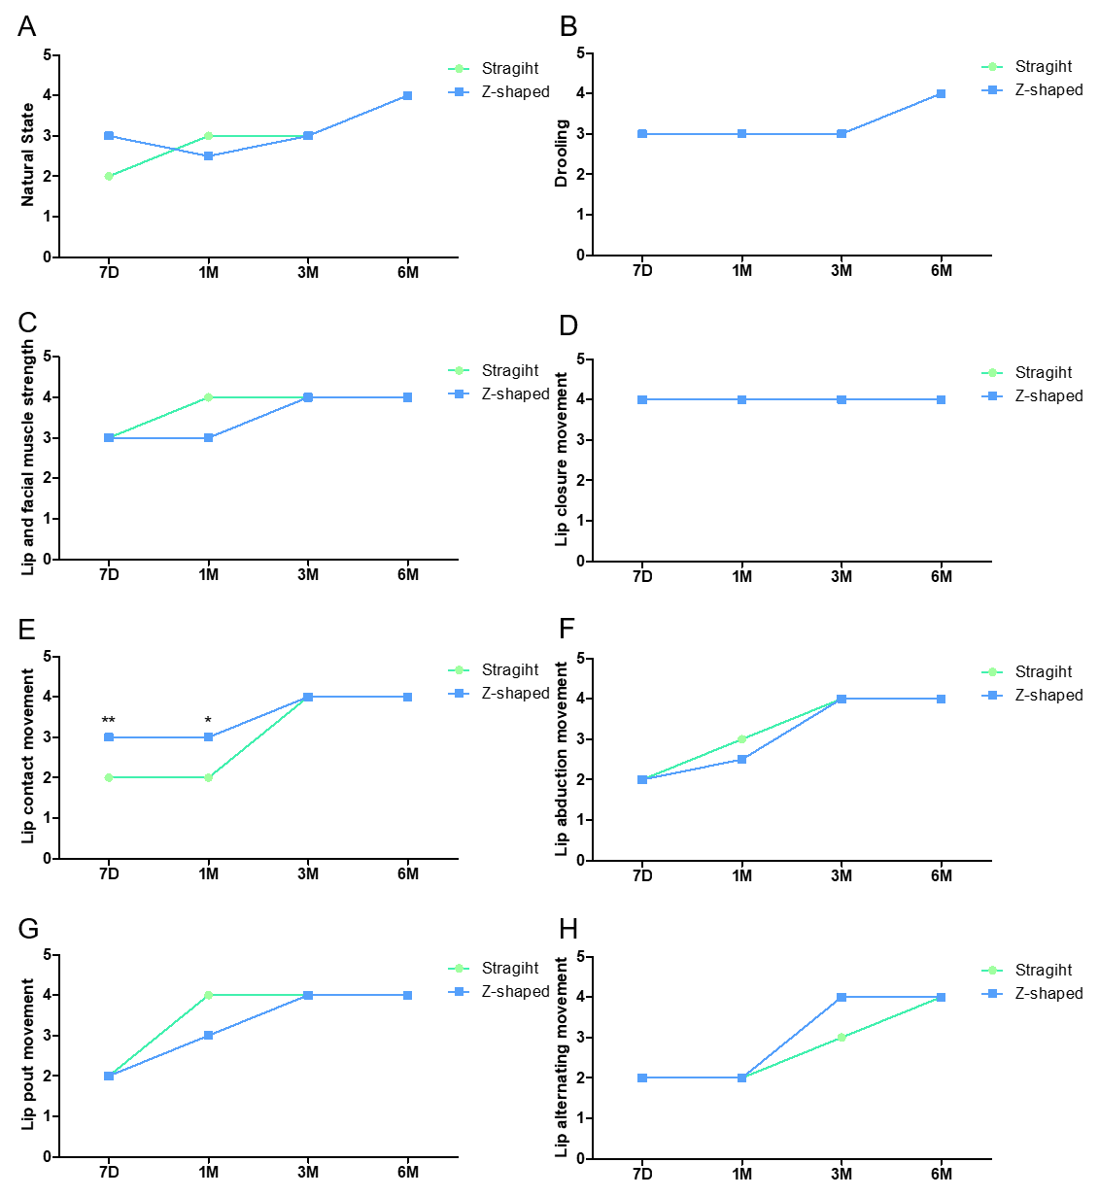
Supplementary Figure 1 Lip function assessment scale result. * represents P<0.05. ** represents P<0.01.
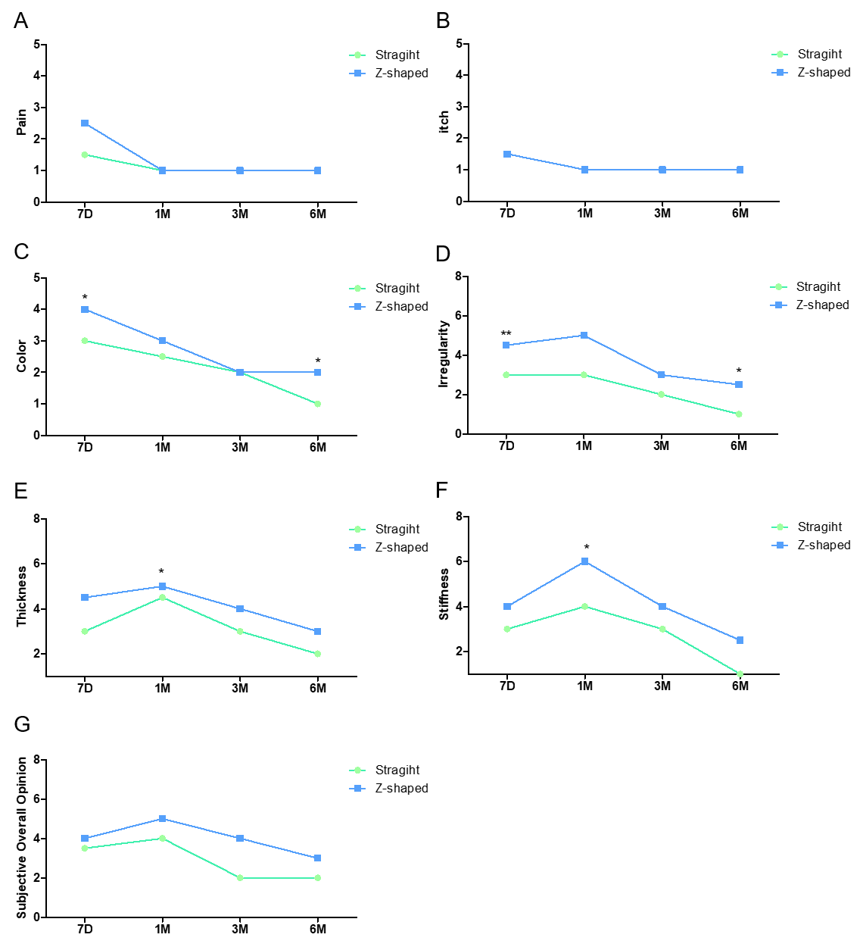
Supplementary Figure 2 Patient scar assessment scale results. * represents P<0.05. ** represents P<0.01.
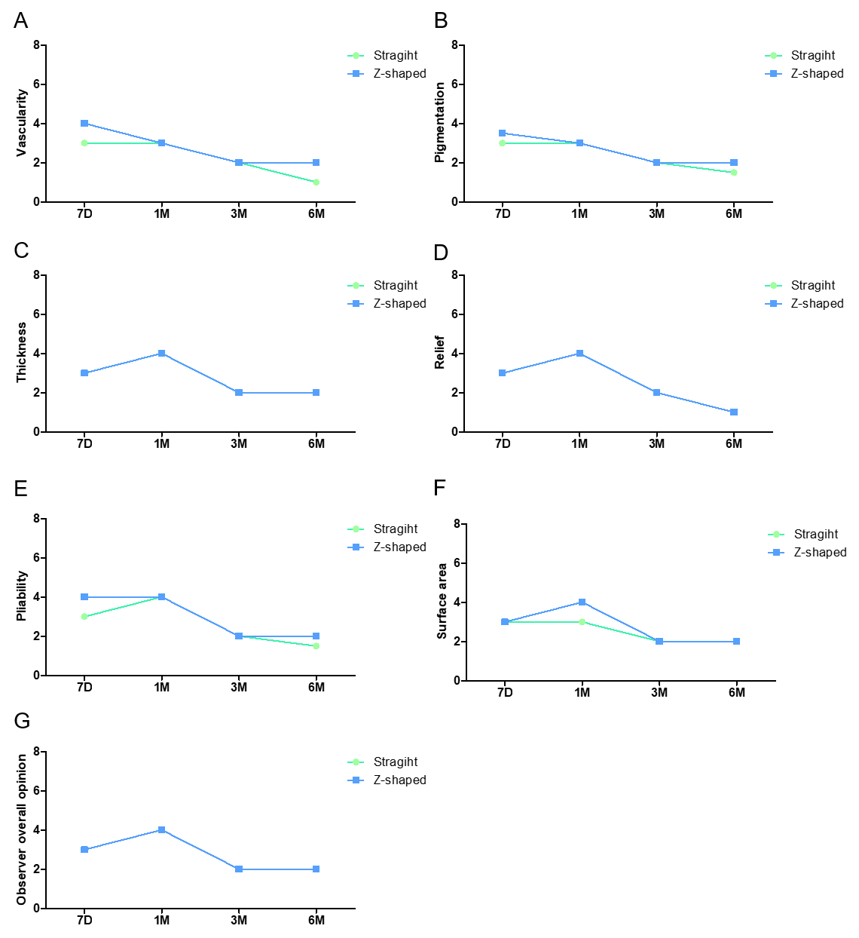
Supplementary Figure 3 Observer scar assessment results.

