Supporting Information for

Managing climate risks: New evidence from integrated analysis at the basin scale

Safa Baccourª, Jose Albiac^{b*}, Frank Ward^{c*}, Taher Kahil^{d}, Encarna Esteban^{e}, Javier Uche^{f}, Elena Calvo^{b}, and Daniel Crespo^{g}

ª Department of Agricultural and Natural Resource Economics, Agrifood Research and Technology Center of Aragón (CITA-DGA), Zaragoza 50059, Spain (baccour.safa@gmail.com )
^{b} Department of Economic Analysis, University of Zaragoza, Zaragoza, Spain (maella@unizar.es ; ecalvo@unizar.es )
^{c} Department of Agricultural Economics and Agricultural Business, New Mexico State University, Las Cruces, NM 88003, USA (fward@nmsu.edu )
^{d} Water Security Research Group, Biodiversity and Natural Resources Program, International Institute for Applied Systems Analysis (IIASA), A-2361 Laxenburg, Austria (kahil@iiasa.ac.at )
^{e} School of Social Sciences and Humanities, University of Zaragoza, Teruel, Spain (encarnae@unizar.es )
^{f} Department of Mechanical Engineering, University of Zaragoza, Zaragoza, Spain (javiuche@unizar.es )

^{g} School of Public Policy, University of California, Riverside, USA (crespo976@hotmail.com)

*Corresponding authors: Jose Albiac (maella@unizar.es) and Frank Ward (fward@nmsu.edu)

This file includes:

SM1. Study Site
SM2. Mathematical formulation of the hydro-economic model for analyzing the WEFE nexus
SM3. Model calibration
SM4. Generation of future climate water stress scenarios
SM5. Management strategies for climate resilience
SM6. Additional results: Water exchanges
SI References

SM1. Study Site
The Ebro River Basin is one of the main European Mediterranean basins located in northeastern Spain. The Ebro is the largest river in Spain, covering 85,600 km² and being home to 3.2 million inhabitants (Fig. S1). Renewable water resources amount to 15,000 million cubic meters (Mm³) per year, with 8,500 Mm³ of water withdrawals of which 7,680 for irrigation, 630 for urban networks, and 150 for direct industry abstractions. An intense development of water infrastructures took place during the twentieth century due to the large expansion of irrigation and a surge in economic development and industrialization. The consequence has been the growing pressure on water resources and the ensuing problems of water scarcity and water quality that has been aggravated by periodic droughts.
Water resources in the Ebro are managed by the Confederación Hidrográfica del Ebro, the federal water authority of the Ebro basin shared by nine states. A special characteristic of the water authority is the crucial role played by user and interest groups, which maintains the traditional culture of stakeholders’ cooperation. Users from every sector (irrigation, urban, industrial and hydropower), federal and state governments, municipalities, farmers’ unions, environmental associations, business associations, and workers unions are represented in the water authority, where they take and enforce governance decisions.
Water withdrawals in the Ebro are high, close to 60% of yearly stream flows, while the storage capacity in dams is the lowest (50% of stream flows) compared with water storage in all main Spanish basins (above 100% of stream flows in Tajo, Guadalquivir and Guadiana and around 200% in Segura and Júcar). Severe droughts in the Ebro occur about every 10 years in recent decades, with basin inflows falling up to 40%. The resulting damage costs are considerable, reaching around 400 million euros in 2005 (0.5% of GDP) (Hernández et al. 2013; Lines, Werner, and Bastiaanssen 2017), although the average yearly drought damages could be estimated at below 0.1% of GDP (Feyen et al. 2020). During periods of water scarcity, the interactions between climate and land use drivers, water infrastructure schemes and water withdrawals have led to social debates and conflicts among the Ebro basin sectors and locations, including farming, urban settlements, environmental flow protection, as well as between the federal water authority, states in the basin, and local administrations (Crespo et al. 2018).
Several studies identify a decreasing trend of annual stream flows during the second half of the twentieth century, from changes in both climate and revegetation from agricultural land abandonment (Garcia-Ruiz et al. 2011; Lopez-Moreno, Begueria, and Garcia-Ruiz 2006). During this century, climate change impacts from precipitations and temperature will reduce stream flows in a range between 12 and 24% by 2100 (CEDEX 2017b), although the range could increase to 20-35% when revegetation in the basin is considered (López-Moreno et al. 2014).
The adaptation strategies to current droughts and future water climate stress are being discussed among stakeholders in the basin. Irrigation districts and some industries are asking for more dam capacity in the basin, since withdrawals are high and the ratio storage to annual run-off is the lowest in Spanish basins. The problem with augmenting storage capacity is the strong opposition to building new dams from environmental NGOs by means of judicial litigation, with the support of a considerable part of public opinion. Other options being considered are on-farm storage, advanced irrigation systems, and drought resistant crops. However, on-farm storage competes with storage in large dams (Haro et al. 2022), and advanced irrigation systems could reduce basin stream flows (Grafton et al. 2018). In this analysis, the adaptation measures to droughts and climate change considered are water reallocation, increasing environmental flows, irrigation modernization, expanding dam storage, and water markets.
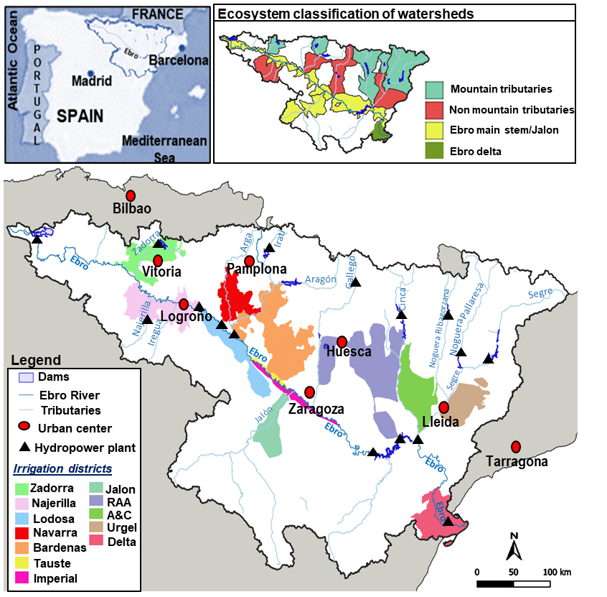

Fig. S1. Case study.

SM2. Mathematical formulation of the hydro-economic model for analyzing the WEFE nexus
An overview of the main equations of the hydro-economic model for assessing the WEFE nexus is presented in this section. The model integrates three components: (1) the hydrological component with a simplified hydrology circumventing full hydrological knowledge, (2) the regional component including all economic sectors, and (3) the environmental component with explicit ecosystem benefit functions for each river reach in the basin.
2.1. The hydrological component
The hydrological component is a reduced form hydrological setting of the Ebro basin, calibrated with observed stream flows. The reduced form hydrological model is a node-link network, in which nodes represent physical units impacting the stream system, and links represent the connection between these units (Baccour et al. 2021), (Fig. S2). The flows of water between nodes follow basic hydrologic concepts, such as mass balance and river flow continuity equations, both for surface flow interactions and reservoirs levels to ensure water conservation in each river gauge d, time t and month m, which guarantee the flow continuity in the basin. Those equations enable the hydrological connectivity between upstream and downstream nodes and supply and demand nodes in the Ebro River network and are represented as follows:
$${Wout}_{d,t,m }= {Win}_{d,t,m}+ {Wrel}_{d,t,m}^{res}- {Wloss }_{d,t,m} –{Div}_{d,t,m}^{IR}- {Div}_{d,t,m}^{URB}$$ | (1)
$${Win}_{d+1,t,m } = {Wout}_{d,t,m}+ r_{d,t,m}^{IR}∙ \left({Div}_{d,t,m}^{IR}\right)+ r_{d,t,m}^{URB} ∙ \left({Div}_{d,t,m}^{URB}\right)+ {RO}_{d+1,t,m}$$ | (2)
${Wout}_{d,t,m}≥ E_{d,t,m}^{min}$ | (3)
where equation 1 is the mass balance equation, with water outflow ${Wout}_{d,t,m }$at each river reach d in time period t and month m, equal to water inflow ${Win}_{d,t,m}$ plus upstream reservoir net releases${Wrel}_{d,t,m}^{res}$, minus water losses ${Wloss }_{d,t,m}$and diversions for irrigation ${Div}_{d,t,m}^{IR}$and urban activities${Div}_{d,t,m}^{URB}$. Equation 2 represents river flow continuity, where water inflow to the next river reach ${Win}_{d+1,t,m }$ is the sum of upstream water outflow ${Wout}_{d,t,m}$, return flows from irrigation districts $r_{d,t,m}^{IR}∙\left({Div}_{d,t,m}^{IR}\right)$and cities $r_{d,t,m}^{URB}∙\left({Div}_{d,t,m}^{URB}\right),$and flows entering the river reach from tributaries ${RO}_{d+1,t,m}$. Equation 3 specifies that water outflow ${Wout}_{d,t,m}$ from a river reach d must be equal or greater than the minimum environmental flow $E_{d,t,m}^{min}$ for the river reach.
Water use by irrigation districts and urban centers is the sum of water consumption, a proportion of water use, and return flows. For irrigated agriculture, water consumption is the water consumed by crops through plants' evapotranspiration. However, for hydropower and ecosystems, water use is the quantity of water flowing through turbines or wetland areas, and this quantity of water could be reused downstream.
Reservoir storage $Z_{res,t,m}$at each reservoir res, period t and month m, is equal to the sum of storage in previous month $Z_{res,t,m-1}$ and precipitation $P_{res,t,m}$, minus reservoir evaporation ${Evp}_{res,t,m}$and net releases (outflows minus inflows) from the reservoir ${Wrel}_{d,t,m}^{res}$ (Equation 4). Net water releases add flow to the downstream node in the river reach. The reservoir storage equations are represented as follows:
$Z_{res,t,m}$ = $Z_{res,t,m-1}+ P_{res,t,m}- {Wrel}_{d,t,m}^{res}- {Evp}_{res,t,m}$ | (4)
𝑍_{𝑟𝑒𝑠,t1,m1} = Z_{𝑟𝑒𝑠,0} | (5)
𝑍_{𝑟𝑒𝑠,t,m} ≤ ${Cmax}_{res}$ | (6)
𝑍_{𝑟𝑒𝑠,𝑡,m} ≥ ${Cmin}_{res}$ | (7)
${Evp}_{res,t,m}$ = ${Evprate}_{res} ∙ {Surf}_{res,t,m}$ | (8)
$P_{res,t,m} = {Prate}_{res } ∙$ ${Surf}_{res,t,m}$ | (9)
${Surf}_{res,t,m}$ = ${β1}_{res} ∙{ Z}_{res,t,m} +{β2}_{res} ∙ Z_{res,t,m}^{2} +{β3}_{res} ∙{ Z}_{res,t,m}^{3}$ | (10)
where equation 5 defines the initial conditions of reservoir storage 𝑍_{𝑟𝑒𝑠,t,m} at 𝑚 = 1 and t =1, and equations 6 and 7 constraint reservoir storage at the maximum ${Cmax}_{res}$ and minimum ${Cmin}_{res}$capacity of the reservoir. Equations 8 and 9 state the reservoir evaporation ${Evp}_{res,t,m}$and precipitation $P_{res,t,m}$, which are proportional to the reservoir surface area ${Surf}_{res,t,m}.$ The reservoir surface area is a polynomial relationship between reservoir area and reservoir storage (Equation 10).

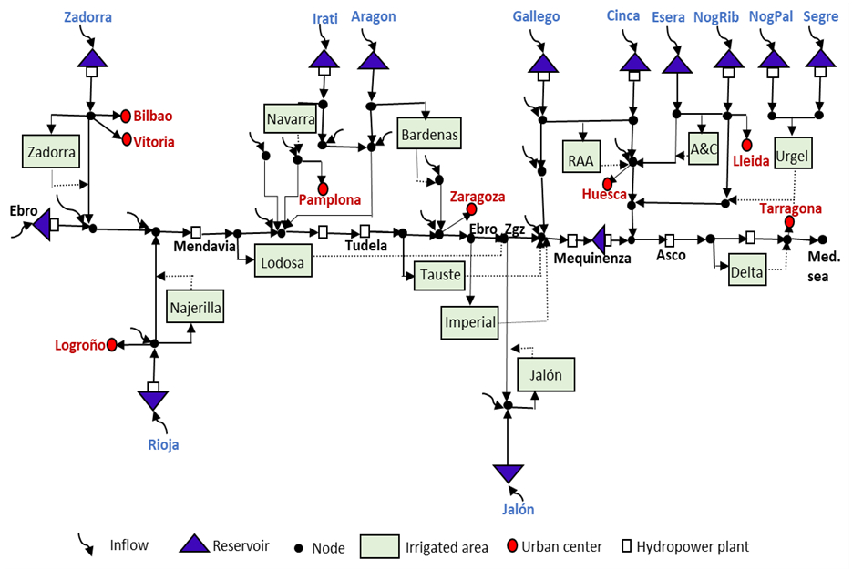
Fig. S2. Network of the Ebro Basin

The calibration of the hydrological component is undertaken based on the observed water stream flows, measured in selected gauge stations along the basin.
2.2. The economic component
The regional economic component maximizes economic benefits, with optimization programs for irrigation districts, hydropower plants, and urban centers.
Farm benefits
For irrigation, the program maximizes crop benefits at irrigation district scale, subject to technical and resource constraints. Yield functions are linear and decreasing in cropland area, with constant input and output prices. The optimization problem is as follows:
$$Max B_{k,t}^{IR}= \sum_{ij}{C_{ijkt}^{'(IR)} ∙ X_{ijkt}^{IR}}$$ | (11)
subject to
$$\sum_{i}{X_{ijkt}^{IR} ≤ {Tland}_{kj}; i:crop; j:flood, sprinkler,drip;k:irrigation district}$$ | (12)
$$\sum_{ij}{W_{ijk}} ∙{ X}_{ijkt}^{IR} ≤ {Twater}_{k}$$ | (13)
$$\sum_{ij}{L_{ijk} ∙{ X}_{ijkt}^{IR}} ≤ { Tlabor}_{k}$$ | (14)
$$X_{ijktm}^{IR} ≥ 0$$ | (15)
where $B_{k,t}^{IR}$ is private benefit in each irrigation district k at time t, and $C_{ijkt}^{'(IR)}$ is net income per hectare of crop i using irrigation technology j. The decision variable of the optimization problem is $X_{ijkt}^{IR}$, the area of crop i with irrigation system j. The irrigation technologies are surface, sprinkler and drip, which are used to irrigate field crops, vegetables and fruit trees. Field crops are irrigated by surface and sprinkler irrigation, while vegetables and fruit trees are irrigated by surface and drip irrigation.
Equation (12) is the land constraint and it represents the land available in each irrigation district k equipped with irrigation system j, ${Tland}_{kj}$. Equation (13) is the water constraint, where ${Twater}_{k}$ is the water available in each irrigation district k, and $W_{ijk}$ is the water requirement per hectare and per crop i with irrigation system j. The level of available water, ${Twater}_{k}$, is the variable linking the optimization program of irrigation districts and the hydrological component. Equation (14) is the labor constraint and it represents the labor available in each irrigation district k, ${Tlabor}_{k}$. $L_{ijk}$ is the labor requirement per hectare of crop i with irrigation system j. Equation (15) is the non-negativity constraint on crop acreage. Net income per hectare $C_{ijkt}^{'(IR)}$ is the difference between revenues and costs, and is defined as:
$$C_{ijkt}^{'(IR)}= P_{i}Y_{ijkt}- {CP}_{i}$$ | (16)
where $P_{i}$ is price of crop i, $Y_{ijkt}$ is yield of crop i under irrigation system j in irrigation district k, and ${CP}_{i}$ represents direct and indirect costs of crop i.
Positive mathematical programming (PMP) is used to calibrate crop production, following the approach by Dagnino and Ward (Dagnino and Ward 2012) for addressing the aggregation and over-specialization problems. The procedure estimates the parameters of the linear yield function using the first order conditions of profit maximizations.
Urban welfare
The benefits of the urban sector are calculated for the main cities in the basin. Benefits are obtained by maximizing the consumer and producer surplus for urban centers in the Ebro, subject to water supply and demand balance constraints. Water use in cities depend on the population growth in each city, increasing future urban welfare. The optimization problem is the following:
$$Max B_{u,t}^{URB}=[- \frac{1}{2} ∙ {b1}_{de,u} ∙ Q_{de,u,t}^{2} + {UR}_{u,t}]- {UC}_{u,t}$$ | (17)
subject to
$$Q_{de,u,t}- Q_{s,u,t} ≤ 0$$ | (18)
$$Q_{de,u,t} ; Q_{s,u,t} ≥ 0$$ | (19)
where urban welfare $B_{u,t}^{URB}$in each urban center u at time t is the sum of consumer surplus and urban revenue ${UR}_{u,t,s,p}$, minus urban production cost ${UC}_{u,t }$. $Q_{de,u,t}$ is demand of water in urban center u and ${b1}_{de,u}$ is the slope of the inverse water demand function. The inverse demand function is obtained by knowing the price of water, quantity of water, and price elasticity of demand in each urban center. Equation (18) indicates that water supply $Q_{s,u,t}$ is greater than or equal to demand $Q_{de,u,t}$ in year t. Water supply $Q_{s,u,t}$, is the variable linking the optimization program of urban centers and the hydrological component.
Energy benefits
Electricity generated at hydropower plants in the Ebro basin comes mostly from power plants in reservoirs that have an elevation drop, with some additional generation from run-of-the-river power plants. The water stored in dams is used to power turbines that convert the fallowing water into mechanical energy and then to electricity. Hydropower production in the Ebro basin comes from hydropower plants operated in most reservoirs in the basin, such as Ebro, Ulivarri, Grado-Mediano, Mequinenza, La Sotonera, Camarasa, Rialb-Oliana and Santa Ana, and from some “run-of-the-river” power plants located in the mainstream of the Ebro.
The benefit from hydroelectric production $B_{HPplant,t}^{HP}$is determined by maximizing the net income from energy generation. The hydropower benefit is equal to the amount of energy produced each month ${HPprod}_{HPplant,t,m}$ multiplied by the monthly electricity price ${Pelec}_{m}$, minus production costs C in the plant. The production features of each hydropower plant $HPplant$ are embedded in equations 21 to 23. Equation 21 shows the upper limit of water that can feed the turbines in plant $HPplant$ each month, which depends on the capacity of turbines. Equation 22 represents the head of each reservoir which is function of reservoir storage. Equation 23 relates the production of electricity in plant $HPplant$ with the water fed to the turbines, where $W_{HPplant,t,m}$ is fed water in Mm³, ${Prod}_{HPplant,t,m}$ is hydropower production per unit of water (GWh/Mm³), and $({H_{HPplant,t,m}}/{{Hmax}_{HPplant,t,m})}$ is the water level in the reservoir divided by the maximum reservoir water level. Equation 24 shows the hydropower plant's capacity to produce energy and limits the annual energy production by summing the hydropower generated each month.
$${{Max B}_{HPplant,t}^{HP}}_{ }= \sum_{m}{{HPprod}_{HPplant,t,m }∙ ({Pelec}_{m} – C)}$$ | (20)
subject to
$$W_{HPplant,t,m} ≤ {UpLimWater}_{HPplant,t,m}$$ | (21)
$H_{HPplant,t,m}=b_{1} Z_{resHP,t,m}+ {b_{2} Z_{resHP,t,m}}^{2}+ {b_{3} Z_{resHP,t,m}}^{3}$ where index resHP only includes reservoirs having hydropower plants | (22)
${HPprod}_{HPplant,t,m}={({H_{HPplant,t,m}}/{{Hmax}_{HPplant,t,m})} *W}_{HPplant,t,m}* {Prod}_{HPplant,t,m}$ | (23)
$$\sum_{m}{{HPprod}_{HPplant,t,m}} ≤ {THPprod}_{HPplant,t}$$ | (24)
2.3. The environmental component
The approach for establishing environmental flows is based on the habitat’s simulation analysis, where habitat suitability is related to water velocity, river depth, and riverbed composition. Habitat’s simulation methodology evaluates the environmental flow requirement, and accounts for hydrological, physical, mechanical proprieties, and biological relationships. The suitability values are assigned to the area of river reaches to determine the weighted usable area WUA. The river reach is divided into cells where river depth and water velocity are simulated for streamflow levels. The simulation results and riverbed composition by the cell are evaluated using indexes in the habitat preference function, which connects streamflow and habitat adequacy. The WUA is the sum of the suitability habitats index weighted by the size of the cell over the total area of river reach, determining the habitat potential to host some aquatic species given the river streamflow.
The benefits of ecosystem services can be estimated by finding the response of ecosystems to water flows, and then valuating the services provided by these ecosystems. This environmental benefits of aquatic ecosystem in the basin depend on the health status of ecosystems, where the relationship between the river’s habitat status and stream flows is expressed by the WUA (Lamouroux and Jowett 2005; Wilding et al. 2014). The relationship relating WUA with streamflow is a linear function with a plateau, which approximates well the empirical data provided by the Ebro basin authority on river reaches (CHE 2015). The variable ${WUA}_{e,t,m}$ is defined as the fraction of WUA over the maximum WUA attained in river reach e, so the variable range is between zero when flow is zero and one as flow rises. The WUA equation is given by:
$${WUA}_{e,t,m}={ ∝}_{e} {∙W}_{e,t,m}$$ | (25)
where ${WUA}_{e,t,m}$ depends on water flow $W_{e,t,m}$ at each river reach e, time t and month m. Parameter $∝_{e}$ has been estimated for each of the 14 river reaches e, based on the ecological studies of the Ebro basin authority for setting environmental flows (CHE 2015).
Equation 25 defines the health status ${EW}_{e,t,m,s,p}^{ecos}$of ecosystem ecos in river reach e, which is equal to ${WUA}_{e,t,m}$, and takes values between zero and one.
$${{EW}_{e,t,m}^{ecos}}_{ }= {WUA}_{e,t,m}$$ | (26)
The benefits of ecosystem services in each river reach are defined by:
$$B_{e,t}^{ecos} =\sum_{m}{{ EW}_{e,t,m}^{ecos} ∙ l_{e} ∙{EV}_{e}}$$ | (27)
where environmental benefits $B_{e,t}^{ecos}$ depend on the ecosystem health status ${EW}_{e,t,m}^{ecos}$ (between 0 and 1), multiplied by $l_{e}$ which is the length in kilometers of river reach e, and by ${EV}_{e}$ which is the economic valuation in €/km of ecosystem services in river reach e.
The economic valuation of ecosystem services ${EV}_{e}$is obtained from published studies in the literature. Values are usually given in euros per hectare and year for the riverbed, which can be converted to euros per kilometer by knowing the surface area of the river reach covered by water and the length of the river reach. Valuation of freshwater bodies and wetlands in the literature ranges from 20,000 to 75,000 €/ha per year of riverbed covered by water (TEEB 2010; Troy and Wilson 2006; Troy and Bagstad 2009). From this range we select an average value of 40,000 €/ha per year for ecosystems’ services in the Ebro. The area covered by water in the Ebro basin is 68,000 ha with a total length of 8,900 km, therefore the average value in euros per kilometer is 0.31 M€/km (40,000 €/ha•68,000 ha/8,900 km). However, ecosystems’ values are spatially heterogeneous in the basin, with values higher for mountain rivers than for streams in the valley (MARM 2010). Following the range of valuation in the literature, four valuation levels are chosen: a low value (0.12 M€/km) for river reaches with moderate environmental value in the main stem of the Ebro and some right bank tributaries, a medium value (0.31 M€/km) for non-mountain Ebro tributaries, a high value (0.77 M€/km) for mountain river reaches, and a very high value (1.95 M€/km) for the Ebro mouth where the Ebro Delta is located (Fig S3).
2.4. Optimization of the Ebro hydro-economic model
The optimization problem in the hydro-economic model maximizes the discounted net present value of social benefits added over sectors and periods. Social benefits are the sum of private and environmental benefits coming from water withdrawals at nodes for irrigated agriculture and urban centers, by water flowing through turbines that generate energy, and by environmental flows in river reaches that support aquatic ecosystems. The objective function takes the following form:
Max $\frac{\sum_{k,t}{B_{k,t}^{Irr}+ \sum_{u,t}{B_{u,t}^{Urb}+ \sum_{HPplant,t }{B_{HPplant,t}^{HP}+ \sum_{e,t }{B_{e,t}^{ecos} }} } }}{{(1+r)}^{t}}$ | (28)
subject to equations 1 to 26, and the constraints of water availability in the basin. $B_{k,t}^{Irr}$ is private benefit from irrigation district k, $B_{u,t}^{Urb}$ is urban economic surplus from urban center u, $B_{HPplant,t}^{HP}$ is hydropower benefit from hydropower plant HPplant, and $B_{e,t}^{ecos}$ is environmental benefit from river reach e. The discount rate r used in the analysis is 2%.

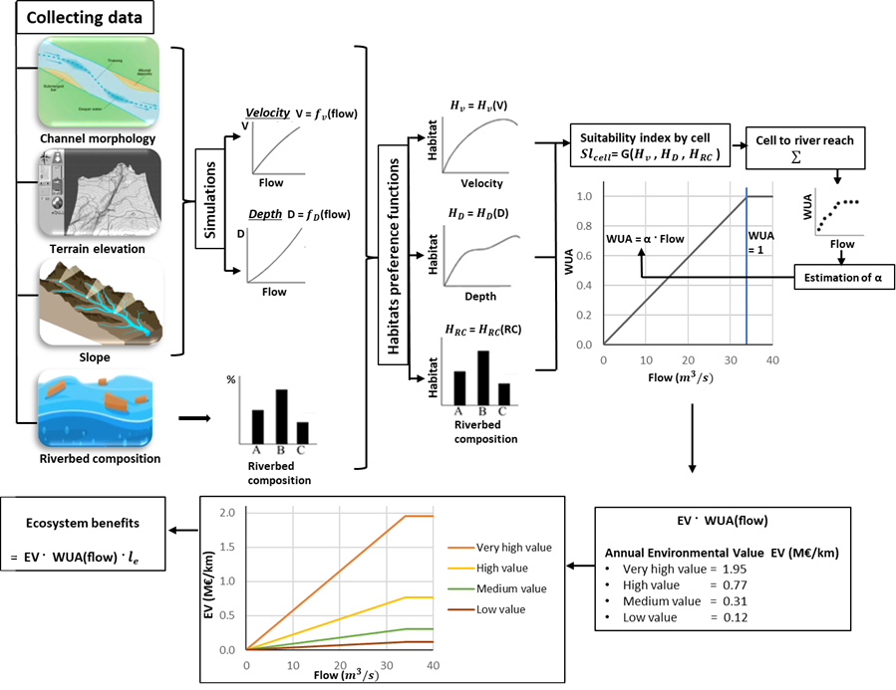
Fig. S3. Environmental benefit response using the WUA weighted usable area

SM3. Model calibration
Hydroeconomic models generally require a detailed calibration procedure before they can be used. The hydrologic and economic components of the Ebro model are calibrated using observed monthly stream flows, reservoir storages, and production acreage of crops.

Hydrologic calibration
The hydrologic calibration entails adjusting model parameters to replicate observable system states such as monthly streamflow and reservoir storage under baseline conditions. The predicted gauged flows and reservoir storages should replicate the historical data (15 streamflow gauges and 13 reservoirs in the Ebro Basin). The calibration procedure involves the introduction of auxiliary variables in each river reach to close the mass balance equation, since there are not observed inflows and outflows. The auxiliary variables account for non-observed flows, the difference between flows estimated with the model and flows measured at gauging stations. Unmeasured flows include upstream surface withdrawal and release not included in the network, groundwater percolation and discharge, or evaporation from open water surfaces. The calibration method needs considerable experimentation since the model is calibrated node by node from upstream to downstream nodes across the basin.
Economic calibration
Irrigated crop production and water use in urban centers are calibrated using a variant of “positive mathematical programming” (PMP). Agricultural crop production is calibrated to reproduce observed land and water use under the baseline scenario, addressing the aggregation and overspecialization problem (Howitt, 1995). The PMP procedure for agriculture follows the procedure of Dagnino and Ward (2012), where the information of the first-order conditions for profit maximization is used to identify the parameters of quadratic yield functions that reproduce observed production data.
The principle of Ricardian rent is used in yield functions by assuming that crop yields decrease as the scale of land in production increases. The first land in production has the highest yields, after which yields fall off as less suitable land enters production. While the approach simplifies the sources of declining yields, it captures much of the farm behavioral response. The yield function is linear and decreasing in the acreage of crop i under irrigation system j, and it is expressed by:
$$Y_{ijk}= {β0}_{ijk}+ {β1}_{ijk}X_{ijk}^{IR}$$ | (29)
where $Y_{ijk}$ is the yield of crop i under irrigation system j in irrigation district k, $X_{ijk}^{IR}$ is the decision variable of the optimization problem that represent the area of crop i with irrigation system j, and ${β0}_{ijk}$ and ${β1}_{ijk}$ are the yield function parameters. ${β0}_{ijk}$ is the crop yield for the first unit of land brought into production, and the ${β1}_{ijk}$ represent the marginal impact of additional land on average yields.
The innovative PMP calibration method developed for consumer surplus of the urban sector entails to replicate the observed water use behavior in each city. The predicted water use in each city is determined under the constraint that total revenues equal total costs, and the behavior of water use is derived from the first-order conditions for optimal water use.
In this study, the predicted water use in each city for the first year replicates the observed water use behavior. For later years, the predicted water use increases with population growth in each city.

SM4. Generation of future climate water stress scenarios
Future water stress in the Ebro basin is assessed using the inflow predictions by CEDEX (CEDEX 2017a). These predictions are obtained from temperature and precipitations projections of the regional climate model prepared by the meteorological federal agency for Spain (AEMET 2016), based on a set of general circulation models. The statistical delta change approach (Diaz-Nieto and Wilby 2005; Escriva-Bou, Pulido-Velazquez, and Pulido-Velazquez 2017; Fowler, Blenkinsop, and Tebaldi 2007) is applied to the historical inflow series by modifying the mean and standard deviation according to the CEDEX inflow predictions. The procedure generates future stream flows under climate water stress scenarios for 2040-2070 and 2070-2100 (CC-2070; CC-2100). The procedure involves the following steps:
1. The monthly historical data time series of each basin headwater $h_{d_{hw}t,m}$ is standardized using the corresponding monthly statistical parameters, where $d_{hw}$ indicates the subset of river reaches corresponding to basin headwaters.
$$SW_{d_{hw},t,m }\left(h_{d_{hw},t,m}\right)= \frac{\left|h_{d_{hw},t,m}- μ(h_{d_{hw},t,m})\right|}{σ(h_{d_{hw},t,m})}$$ | (30)
where $SW_{d_{hw},t,m }\left(h_{d_{hw},t,m}\right)$ is the standardized time series for each basin headwater $d_{hw}$, in year t and month m.
2. The average relative change in mean and standard deviation for the 12 months that correspond to the average year, is obtained for each climate scenario (CC-2070; CC-2100). The change is calculated from the mean and standard deviation of the historical series $h_{d_{hw},m}$ and the future series $f_{d_{hw},m}$, where the future series are the projections provided by CEDEX (2017).
$${∆μ}_{d_{hw},m}= \frac{\left[µ\left(f_{d_{hw},m}\right)-µ\left(h_{d_{hw},m}\right) \right]}{µ\left(h_{d_{hw},m}\right)} ; {∆σ}_{d_{hw},m}= \frac{\left[σ\left(f_{d_{hw},m}\right)-σ\left(h_{d_{hw},m}\right) \right]}{σ\left(h_{m}\right)}$$ | (31)
where ${∆μ}_{d_{hw},m}$ and ${∆σ}_{d_{hw},m}$are the changes in mean and standard deviation of month m in headwater $d_{hw}$. There is not significant and systematic change detected between the variances of historical and future series, and therefore the ${∆σ}_{d_{hw},m}$ are considered equal to zero.
3. Finally, the future time series for each climate scenario is obtained by applying the relative changes in statistical parameters to the historical standardized series. Thirty simulations are generated for climate scenarios, each with a time span of thirty years (30 simulations for CC-2070 and 30 simulations for CC-2100).

SM5. Management strategies for climate resilience
Cross-sectoral water management and enhanced climate resilience are needed to lessen future economic losses. Several recent contributions in the literature address climate resilience in river basins. The range of intervention measures found in the literature deal mostly with the agricultural sector, because irrigation represents 70% of withdrawals and 90% of water consumption both worldwide and in the Ebro basin. Recommendations include reducing demand, increasing supplies, dam storage and water transfers (Scanlon et al. 2017), better management and improved irrigation practices to reduce losses (Hoff et al. 2010), irrigation area expansion in water abundant regions (Elliott et al. 2014), and unconventional sources such as treated urban wastewater and desalinated seawater in coastal areas. As indicated above, protection of environmental flows has become an important issue in nexus studies to advance sustainable management.
Institutional cooperation (IC): IC is the primary management policy in the Ebro for water allocation. This current management by the Ebro basin authority is based on the effective involvement and cooperation of stakeholders. In this study, the IC policy is combined with a stronger protection of ecosystems, which is called environmental institutional cooperation (EIC). The current cooperation policy (IC) under drought conditions is that the basin authority reduces water allocations to irrigation districts in proportion to the fall in inflows. Also, environmental flows are lowered during droughts trying to abide by minimum thresholds. Allocations to urban networks and hydropower are reduced only in cases of a very severe drought. These water reallocations under drought are undertaken by the basin authority with stakeholders’ cooperation.
Environmental institutional cooperation (EIC): EIC would achieve a more sustainable management, by including the environmental benefits generated by stream flows in the basin. This implies higher environmental flows that enhance social welfare. The procedure for enlarging flows is that the basin authority purchases water for the river in order to maximize social benefits, the sum of both private and environmental benefits. The basin authority buys water for the different river reaches, by first selecting purchases in irrigation districts with less profitable crops, where the shadow price of water is low.
Irrigation modernization (IM): Farmers could face water scarcity and reduced water allocations from the basin authority during droughts by modernizing irrigation systems. Investments in modernization involve upgrading irrigation technologies, which enhance the efficiency of water use. All surface irrigation systems in irrigation districts are substituted by sprinkler and drip systems (except rice). The implementation of this policy should involve a cutback of water withdrawals by irrigation districts, because maintaining water withdrawals would increase crop evapotranspiration and reduce return flows (from more water demanding crops, double crops, or acreage expansion), with a fall in basin stream flows (Grafton et al. 2018). Advanced irrigation technologies increase yields and farmers’ revenue, although the costs of modernization are substantial. Both revenue and cost effects have been included in benefit calculations. The modernization policy is combined with the proportional reduction in allocations during droughts (farmers cooperation), and with the buying of water for environmental flows by the basin authority.
Enlarging dam storage capacity (EDS): The response to water scarcity by the basin authority is to protect basin storage through proportional reduction of water allocations. The substantial water withdrawals in the Ebro (60% of yearly stream flows) in relation with the low storage capacity in dams (50% of yearly stream flows), call for augmenting dam storage capacity. The increase in water storage in the basin is set at a 50% increase in dam storage capacity, and an increase of 25% in hydropower production. The investment costs are included in social benefits (42 M€/year in amortization costs). Also, the basin authority buys water for the river.
Water markets (WM): Farmers and urban centers receive reduced water allocations from the basin authority during droughts. Then these water allocations can be exchanged among irrigation districts and urban centers, maximizing the private benefits of water use. There is no direct exchange of water between sellers and buyers, but rather the sellers (irrigation districts) reduce withdrawals, and the buyers augment withdrawals in their respective river reaches. Water is traded between irrigation districts and urban centers, and the basin authority participates as well in the water market by acquiring water for the river. This policy enhances both private and environmental gains, so it is an appealing policy to capture the private benefits of markets while protecting ecosystems.

SM6. Additional results: Water exchanges

Table S1. Water exchanges between irrigation districts and water authority (CHE) for the EIC, IM and EDS policies.
 | Water sales by irrigation districts (Mm³)
Climate scenarios | CC-2070 |  |  | CC-2100
Policies | EIC | IM | EDS | EIC | IM | EDS
Bardenas | 172 | 211 | 172 | 150 | 182 | 150
A&C | 89 | 122 | 91 | 101 | 131 | 102
Imperial | 28 | 81 | 28 | 24 | 69 | 24
Jalon | 23 | 24 | 23 | 16 | 21 | 16
Lodosa | 10 | 52 | 10 | 6 | 42 | 6
Navarra | 44 | 53 | 44 | 38 | 45 | 38
Tauste | 2 | 12 | 2 | 2 | 10 | 2
Urgel | 118 | 190 | 117 | 96 | 162 | 97
Delta | 21 | 25 | 21 | 20 | 24 | 20
Rioja | 9 | 25 | 4 | 3 | 19 | 2
RAA | 146 | 181 | 147 | 169 | 202 | 169
Zadorra | 3 | 20 | 3 | 3 | 14 | 3
Water purchases by the water authority (CHE) | 665 | 996 | 662 | 628 | 921 | 629

Table S2. Water shadow prices in irrigation districts and costs of purchases by policy (EIC, IM and EDS) and climate scenario.
 | Shadow prices (€/m³) |  |  |  |  |  | Costs of water exchanges (M€)
Climate scenarios | CC-2070 |  |  | CC-2100 |  |  | CC-2070 |  |  | CC-2100
Policies | EIC | IM | EDS | EIC | IM | EDS | EIC | IM | EDS | EIC | IM | EDS
Bardenas | 0.02 | 0.04 | 0.02 | 0.03 | 0.06 | 0.02 | 2.7 | 9.2 | 2.6 | 4.2 | 11 | 3.6
A&C | 0.03 | 0.04 | 0.02 | 0.06 | 0.07 | 0.06 | 2.3 | 4.5 | 2.2 | 6.1 | 9.7 | 6
Imperial | 0.03 | 0.04 | 0.03 | 0.06 | 0.08 | 0.06 | 0.9 | 3.2 | 0.9 | 1.5 | 5.3 | 1.5
Jalon | 0.02 | 0.03 | 0.02 | 0.02 | 0.06 | 0.02 | 0.4 | 0.7 | 0.4 | 0.4 | 1.2 | 0.4
Lodosa | 0.05 | 0.06 | 0.05 | 0.11 | 0.12 | 0.10 | 0.5 | 3.3 | 0.5 | 0.6 | 5.2 | 0.6
Navarra | 0.02 | 0.05 | 0.02 | 0.04 | 0.07 | 0.04 | 0.8 | 2.5 | 0.9 | 1.5 | 3.2 | 1.5
Tauste | 0.03 | 0.04 | 0.03 | 0.06 | 0.08 | 0.06 | 0.1 | 0.4 | 0.1 | 0.1 | 0.8 | 0.1
Urgel | 0.02 | 0.06 | 0.03 | 0.04 | 0.1 | 0.06 | 1.8 | 10.6 | 3.2 | 4 | 16 | 5.4
Delta | 0.02 | 0.02 | 0.02 | 0.04 | 0.04 | 0.04 | 0.4 | 0.5 | 0.4 | 0.9 | 1 | 0.9
Rioja | 0.02 | 0.03 | 0.02 | 0.06 | 0.08 | 0.07 | 0.2 | 0.8 | 0.1 | 0.2 | 1.6 | 0.1
RAA | 0.02 | 0.03 | 0.02 | 0.03 | 0.05 | 0.03 | 2.6 | 4.9 | 2.7 | 5.7 | 9.7 | 5.4
Zadorra | 0.03 | 0.01 | 0.03 | 0.07 | 0.01 | 0.08 | 0.1 | 0.2 | 0.1 | 0.2 | 0.1 | 0.2
Purchases CHE |  |  |  |  |  |  | 13 | 41 | 14 | 25 | 65 | 26

Table S3. Water exchanges among sectors under the water markets policy by climate scenario.
Climate scenarios | CC-2070 | CC-2100
Water exports (+) and imports (-) by irrigation districts (Mm³)
Bardenas | 195 | 208
A&C | 90 | 100
Imperial | 22 | 25
Jalon | 27 | 21
Lodosa | -8 | -25
Navarra | 48 | 45
Tauste | 2 | 2
Urgel | 140 | 121
Delta | 37 | 64
Rioja | 12 | 6
RAA | 173 | 225
Zadorra | 4 | 2
Exports irrigation districts | 750 | 819
Imports irrigation districts | 8 | 25
Imports urban centers | 53 | 107
Imports CHE (water for the river) | 689 | 687
Water shadow prices (€/m³) | 0.03 | 0.06
Costs of purchases by CHE (M€) | 19 | 42

SI References

AEMET (2016) (Agencia Estatal de Meteorología). Proyecciones climáticas para el siglo XXI. Ministerio de Agricultura y Pesca, Alimentación y Medio Ambiente, Madrid.
Baccour S, Albiac J, Kahil T, et al. (2021) Hydroeconomic modeling for assessing water scarcity and agricultural pollution abatement policies in the Ebro River Basin, Spain, Journal of Cleaner Production, 327: 13.
CEDEX (2017a) (Centro de Estudios y Experimentación de Obras Públicas). Evaluación del impacto del cambio climático en los recursos hídricos y sequías en España. Anexo 1: Tendencias y cambio de estadísticos para cada proyección. MAPAMA, Madrid.
CEDEX (2017b) (Centro de Estudios y Experimentación de Obras Públicas). Evaluación del Impacto del Cambio Climático en los Recursos Hídricos y Sequías en España. Informe final. Julio de 2017. Centro de Estudios Hidrográficos. CEDEX. MAPAMA, Madrid.
CHE (2015) (Confederacion Hidrografica del Ebro). Plan Hidrologico de la Demarcacion Hidrografica del Ebro, Documentacion sobre Caudales Ecologicos. Zaragoza: CHE, Ministerio de Agricultura y Medio Ambiente (MAGRAMA).
Crespo D, Kahil T, Albiac J, et al. (2018) Análisis de la asignación sectorial y espacial del agua en la Cuenca del Ebro: impactos de la escasez y las sequías (No. ART-2018-107350).
Dagnino M, Ward FA (2012) Economics of Agricultural Water Conservation: Empirical Analysis and Policy Implications, International Journal of Water Resources Development, 28: 577-600.
Diaz-Nieto J, Wilby RL (2005) A comparison of statistical downscaling and climate change factor methods: Impacts on low flows in the River Thames, United Kingdom, Climatic Change, 69: 245-68.
Elliott J, Deryng D, Mueller C, et al. (2014) Constraints and potentials of future irrigation water availability on agricultural production under climate change, Proceedings of the National Academy of Sciences of the United States of America, 111: 3239-44.
Escriva-Bou A, Pulido-Velazquez M, Pulido-Velazquez D (2017) Economic Value of Climate Change Adaptation Strategies for Water Management in Spain's Jucar Basin', Journal of Water Resources Planning and Management, 143: 13.
Feyen L, Gosling S, Ciscar J, et al. (2020) Climate change impacts and adaptation in Europe. JRC PESETA IV final report. Publications Office of the European Union, Luxembourg. Doi: 10.2760/171121.
Fowler HJ, Blenkinsop S, Tebaldi C (2007) Linking climate change modelling to impacts studies: recent advances in downscaling techniques for hydrological modelling', International Journal of Climatology, 27: 1547-78.
Garcia-Ruiz JM, Lopez-Moreno JI, Vicente-Serrano SM, et al. (2011) Mediterranean water resources in a global change scenario, Earth-Science Reviews, 105: 121-39.
Grafton RQ, Williams J, Perry CJ, et al. et al. (2018) The paradox of irrigation efficiency', Science, 361: 748-50.
Haro MD, Palazon L, Zoumides C, et al. (2022) Optimal Implementation of Climate Change Adaptation Measures to Ensure Long-term Sustainability on Large Irrigation Systems, Water Resources Management: 16.
Hernández N, Gil M, Garrido A, et al. (2013) La sequía 2005-2008 en la Cuenca del Ebro: Vulnerabilidad, impactos y medidas de gestión. UPM-CEIGRAM, Madrid.
Hoff H, Falkenmark M, Gerten D, et al. (2010). Greening the global water system, Journal of Hydrology, 384: 177-86.
Lamouroux N, Jowett IG (2005) Generalized instream habitat models, Canadian Journal of Fisheries and Aquatic Sciences, 62: 7-14.
Lines C, Werner M, Bastiaanssen W (2017) The predictability of reported drought events and impacts in the Ebro Basin using six different remote sensing data sets, Hydrology and Earth System Sciences, 21: 4747-65.
Lopez-Moreno JI, Begueria S, Garcia-Ruiz JM (2006) Trends in high flows in the central Spanish Pyrenees: response to climatic factors or to land-use change?, Hydrological Sciences Journal-Journal Des Sciences Hydrologiques, 51: 1039-50.
López-Moreno JI, Vicente-Serrano SM, Zabalza J, et al. (2014) Respuesta hidrológica del Pirineo central al cambio ambiental proyectado para el siglo XXI. Pirineos 169:e004.
MARM (2010) (Ministerio de Medio Ambiente y Medio Rural y Marino). Valoracion de los activos naturales de España (VANE). MARM, Centro de Publicaciones, Madrid.
Scanlon BR, Ruddell BL, Reed PM, et al.(2017) The food-energy-water nexus: Transforming science for society, Water Resources Research, 53: 3550-56.
TEEB (2010) The Economics of Ecosystems and Biodiversity: Mainstreaming the Economics of Nature: A Synthesis of the Approach, Conclusions and Recommendations of TEEB. Ecological and Economic Foundation, Earthscan, London and Washington'.
Troy A, Bagstad K (2009) Estimating Ecosystem Services in Southern Ontario. Spatial Informatics Group, LLC 3248 Northampton Ct. Pleasanton, CA 94588 USA.
Troy A, Wilson MA (2006) Mapping ecosystem services: Practical challenges and opportunities in linking GIS and value transfer, Ecological Economics, 60: 435-49.
Wilding TK, Bledsoe B, Poff NL, et al. (2014) PREDICTING HABITAT RESPONSE TO FLOW USING GENERALIZED HABITAT MODELS FOR TROUT IN ROCKY MOUNTAIN STREAMS, River Research and Applications, 30: 805-24.

