Supplementary materials

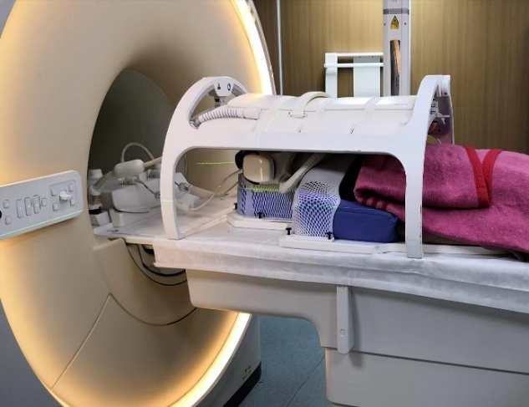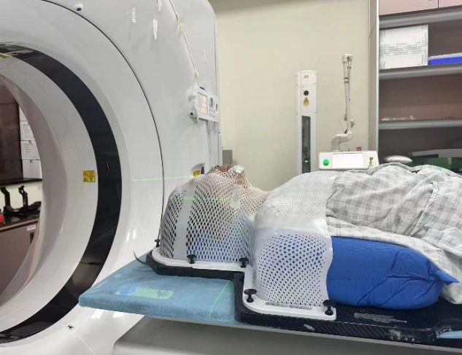
A
B
Supplementary Fig. 1. Schematic diagram of CT and MR scanning. (A) CT scan positioning and (B) MRI scan positioning.

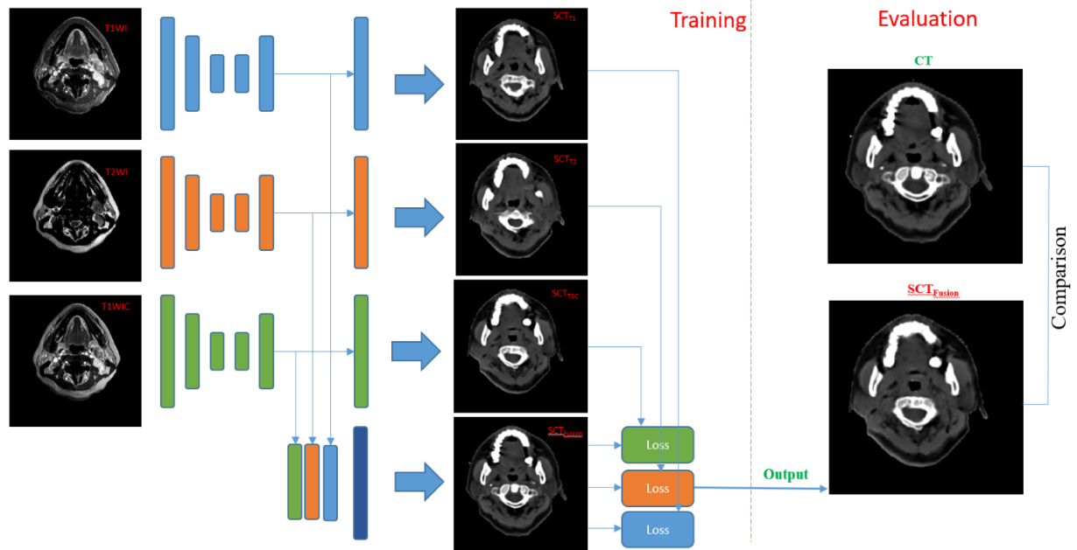

Supplementary Fig. 2. Schematic diagram of the multi-sequence MRI fusion network structure. SCT_{T1}, SCT_{T2}, and SCT_{T1C} are the synthetic CT images generated by the T1WI, T2WI, and T1WIC single-sequence training cycleGAN models, respectively. SCT_{Fusion} is the synthetic CT image generated by the multi-sequence MRI fusion network training model.
Supplementary Table 1. Scanning parameters for MRI sequences
Sequence | VP (mm³) | TE (ms) | TR (ms) | FA (º) | ST (mm) | Impulse Sequence
T1WI | 0.74×0.74×3 | 2.4 | 4.9 | 12° | 3 | Fast Field Echo(FFE)
T2WI | 0.90×1.04×3 | 110 | <4999 | 90° | 3 | Turbo Spin Echo(TSE)
T1WIC | 0.74×0.74×3 | 2.4 | 4.9 | 12° | 3 | Fast Field Echo(FFE)
Abbreviations: VP, Voxel patch; TE, Echo time; TR, Repetition time; FA, Flip angle; ST, Slice thickness; T1WI, T1-weighted sequence; T2WI, T2-weighted sequence; T1WIC, T1-weighted contrast-enhanced sequence; NA, not applicable.

Supplementary Table 2. Comparison between the DVH parameters in the radiotherapy plans
DVH | SCT_{Fusion} | SCT_{T1} | SCT_{T2} | SCT_{T1C}
All Parameters | 0.73%±0.73% | 0.98%±0.88% | 0.86%±0.80% | 1.07%±0.89%
Abbreviations: SCT_{T1}, SCT_{T1}, SCT_{T2}, and SCT_{Fusion} images are SCT images generated by single-sequence T1WI, T1WIC, T2WI, and multi-sequence (T1WI + T1WIC + T2WI) trained cycleGAN models, respectively. DVH, dose-volume histogram; SCT, synthetic CT.

Supplementary Table 3. Comparison between the Dice similarity coefficient (Dice) between manually delineated OARs on different SCT images and true CT images
OARs | SCT_{Fusion} | SCT_{T2} | SCT_{T1} | SCT_{T1C}
OR Brain Stem | 0.91±0.04 | 0.91±0.03 | 0.90±0.02 | 0.94±0.04
OR Spinal Cord | 0.77±0.06 | 0.74±0.05 | 0.72±0.06 | 0.80±0.08
OR OP Nerve-L | 0.63±0.08 | 0.63±0.10 | 0.63±0.10 | 0.71±0.24
OR OP Nerve-R | 0.66±0.07 | 0.64±0.06 | 0.64±0.08 | 0.68±0.15
OR Mandible-L | 0.92±0.03 | 0.87±0.07 | 0.91±0.03 | 0.93±0.04
OR Mandible-R | 0.94±0.02 | 0.92±0.03 | 0.92±0.03 | 0.94±0.03
OR TMJ-L | 0.80±0.11 | 0.77±0.07 | 0.84±0.07 | 0.84±0.10
OR TMJ-R | 0.75±0.12 | 0.74±0.11 | 0.76±0.13 | 0.87±0.06
OR Lens-L | 0.71±0.18 | 0.65±0.09 | 0.71±0.15 | 0.68±0.19
OR Lens-R | 0.68±0.14 | 0.67±0.10 | 0.75±0.17 | 0.68±0.22
OR Parotid-L | 0.93±0.03 | 0.91±0.02 | 0.93±0.03 | 0.91±0.03
OR Parotid-R | 0.92±0.01 | 0.91±0.02 | 0.93±0.01 | 0.92±0.02
Average Dice | 0.80±0.14 | 0.83±0.16 | 0.80±0.14 | 0.78±0.13
Abbreviations: SCT_{T1}, SCT_{T1}, SCT_{T2}, and SCT_{Fusion} images are SCT images generated by single-sequence T1WI, T1WIC, T2WI, and multi-sequence (T1WI + T1WIC + T2WI) trained cycleGAN models, respectively. CT, computed tomography; OAR, organs at risk; SCT, synthetic CT.

Image preprocessing:

- Background removal: During MR/CT image scanning, patients were immobilized using thermoplastic masks for the head and neck and fixation brackets. The scanned images included background images of the treatment table, a thermoplastic mask, and other fixation devices, which increased the computational load for image registration and introduced interference factors for feature learning during image conversion. Therefore, we employed binary segmentation and morphological processing methods were employed to remove the background outside the body contour (bBody) in the patient images, retaining only the images within the body range.
- Image cropping and interpolation: Given that the virtual CT has a pixel size of 512 × 512 with excessive background areas (air, mask, etc.) outside the head region, it is unsuitable for training the model. To retain the high resolution within the space of the original image and reduce GPU memory cost, MR and CT were symmetrically cropped and interpolated in the up, down, left, and right directions to 256 × 256, ensuring the region of interest remains at the center of the image.
- Bias field correction: MRI scans often exhibit intensity inhomogeneity owingdue to changes in the magnetic field. BecauseAs a result of these magnetic field variations, some parts of the image may appear brighter or darker when visualized; the mapping of these magnetic field variations is called the bias fields. In radiotherapy, changes in the MR image signal intensity caused by bias fields can affect the accurate identification and delineation of target areas and OAR, potentially introducing inter-sample errors in synthetic CT conversion. Therefore, this study used SimpleITK to perform a bias field correction (N4BiasFieldCorrection) on the MRI data ^{[23]} to reduce the interference of data from different magnetic fields at different times and spaces.
- Voxel matching: Voxel matching was performed separately for the virtual CT images and multi-sequence MRI images. For the virtual CT, the voxel values were limited between (-1000 and, -1500) to eliminate interference from abnormal voxel points, such as lead points and metal artifacts. The; the voxels within the body of different MRI sequences were matched and normalized using a linear histogram matching approach.

