Supplementary file 2 for figures S1 and S2
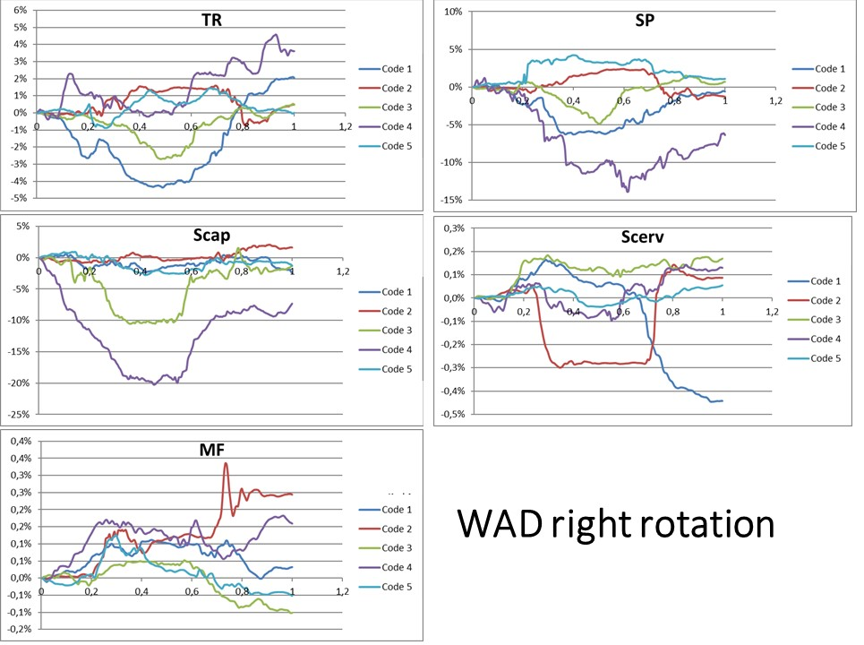
Figure S1a

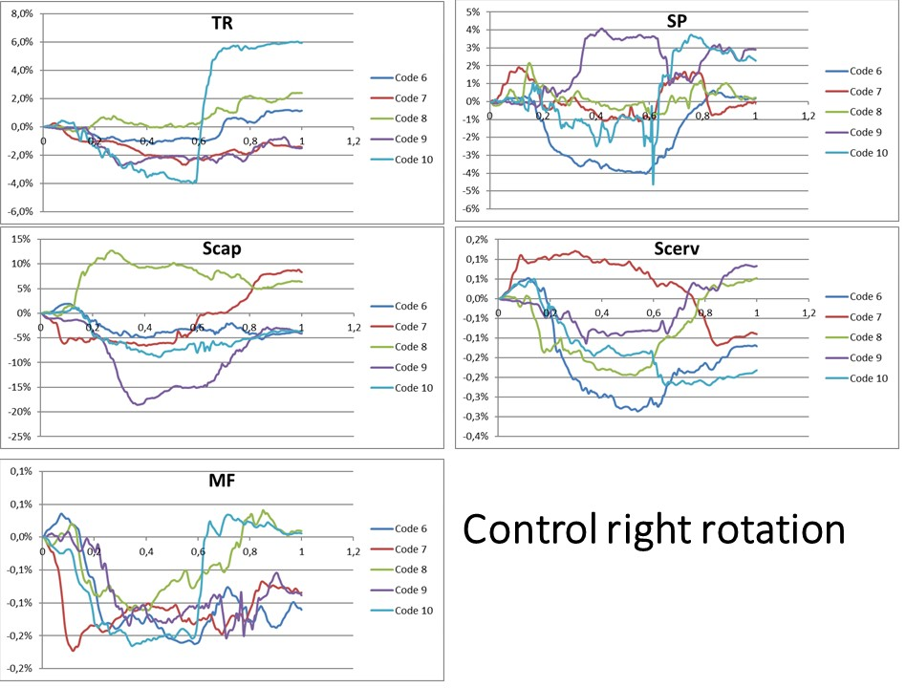
Figure S1b
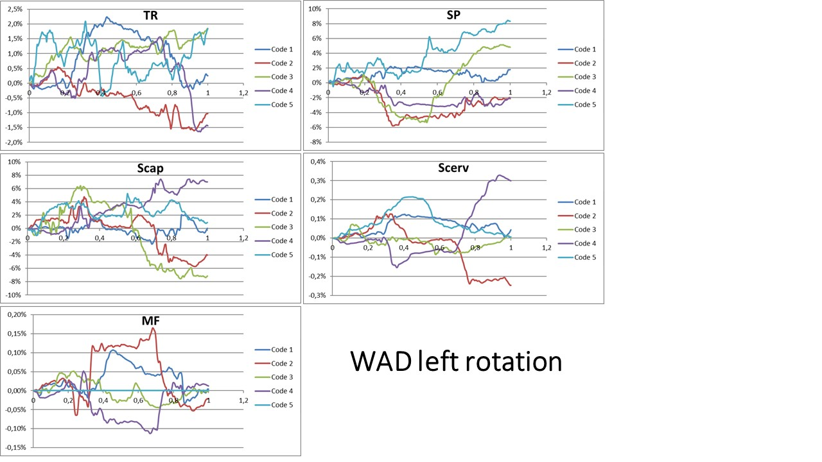
Figure S1c
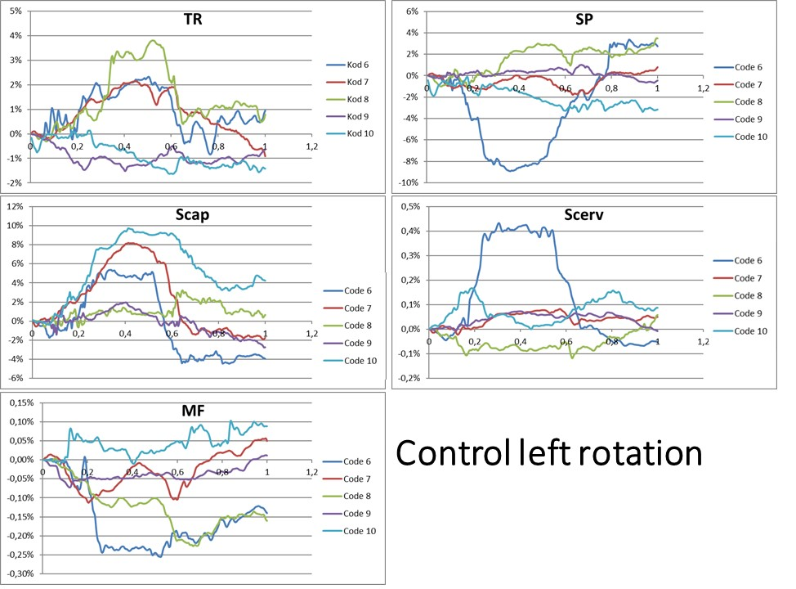
Figure 1d

Figure S1. Deformation curves in the five dorsal neck muscles in participants with whiplash-associated disorders (WAD) and healthy controls.
Codes 1 to 5 represent five individuals with chronic WAD and code 6 to 10 five healthy controls during the tenth neck rotation to the right and left. a) right rotation in WAD, b) right rotation in controls, c) left rotation in WAD, d) left rotation in controls; TR: Trapezius; SP: Splenius; Scap: Semispinalis capitis; Scerv: Semispinalis cervicis; and MF: Multifidus

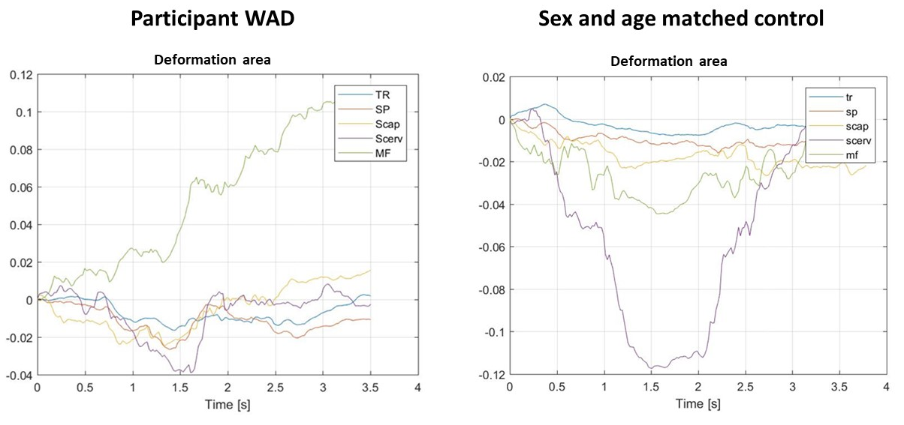

Figure S2. This diagram illustrates muscle deformation sequences during neck rotation to the right for the two different patterns of muscle deformation areas for one participant with WAD, and for one pain free participant, sex and age matched healthy control. A line represents the changes observed in the ROI (deformation %) in one muscle, during 20 degree right rotation. Muscle shortening is the region (area) below zero (negative values) and muscle elongation represents the region (area) above zero (positive values). The sum of negative and positive areas represents the total muscle deformation during one neck rotation, from neutral position of the head 20 degrees and back to midline. When the line crosses 0%, the muscle deformation shifts from shortening to elongation, or vice versa. (TR: Trapezius; SP: Splenius; Scap: Semispinalis capitis; Scerv: Semispinalis cervicis; and MF: Multifidus)

