Supplementary Materials for

Fungal toxin fusicoccin enhances plant growth by upregulating 14-3-3 interaction with plasma membrane H⁺-ATPase

H. Kiriyama, S. N. Kinoshita, Y. Hayashi, S. Kasuga, T. Kinoshita, H. Irieda, J. Ohkanda

Corresponding author: Junko Ohkanda, johkanda@shinshu-u.ac.jp

Table of Contents

Scheme S1 4
fig. S1 5
fig. S2 6
fig. S3 7
fig. S4 8
fig. S5 10
fig. S6 11
fig. S7 13
fig. S9 16
fig. S10 17
fig. S11 18
fig. S12 19
fig. S13 20
NMR Charts 21

Scheme S1
Scheme S1. Preparation of fluorescent fusicoccin derivative 1 and a control compound 2.
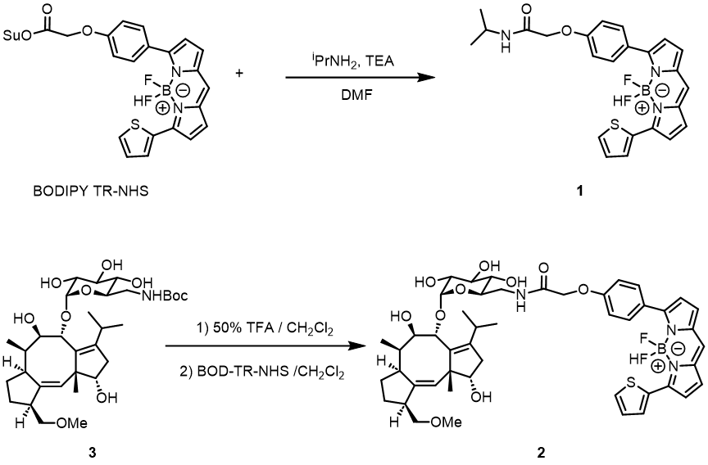

fig. S1
A
B
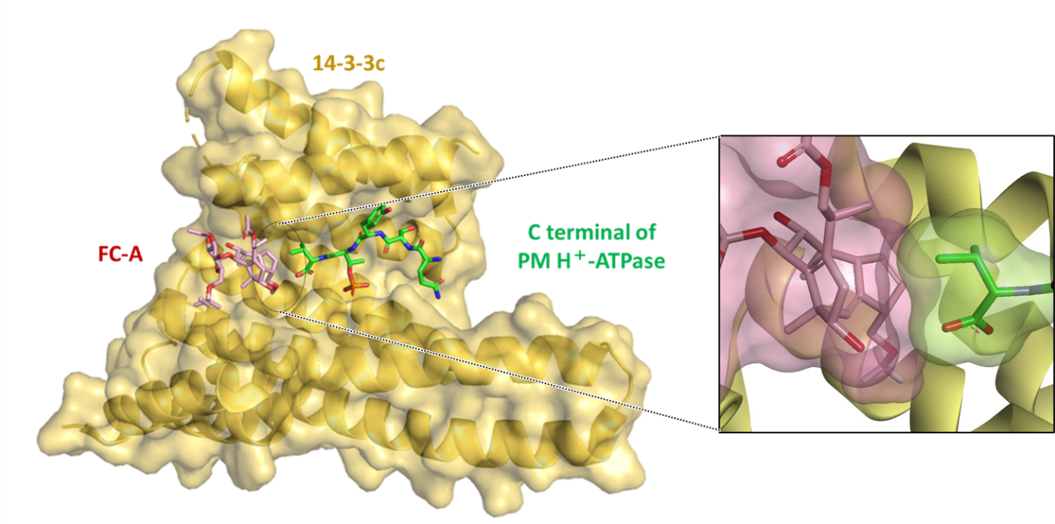

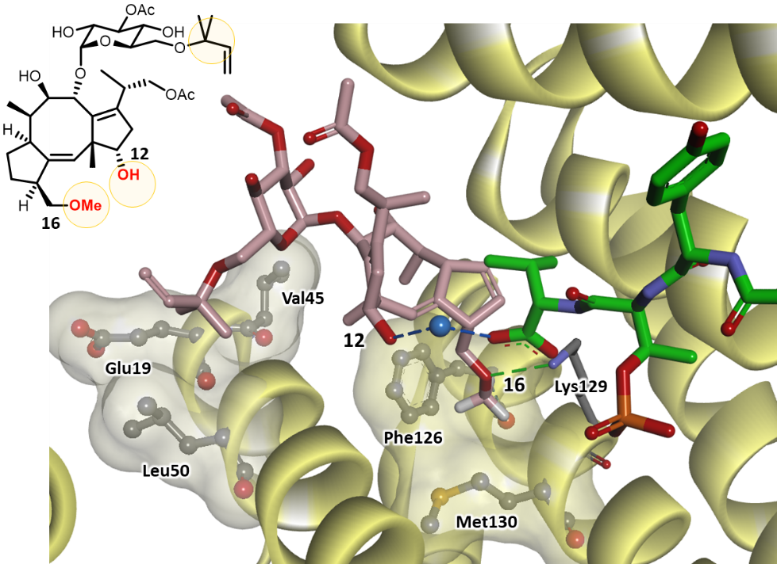
fig. S1. X-ray crystal structure of tobacco 14-3-3cbound to FC-A (pink rod) and C-terminal phosphorylated pentapeptide QSYpTV derived from plasma membrane H⁺-ATPase (1O9F) (11). (A) Whole structure. 14-3-3c (yellow ribbon with surface), FC-A (pink rod), and QSYpTV (green rod; pT = phosphothreonine). The interface between FC-A and the Val of QSYpTV is enlarged. (B) A close-up view for key interactions of FC-A and 14-3-3 and the C-terminal valine residue of the phosphopeptide in the crystal structure. Hydrophobic residues are shown in ball and stick model with pale yellow surface. Hydrogen bonds are shown in dash line. Water molecule is highlighted in blue (ball model).

fig. S2

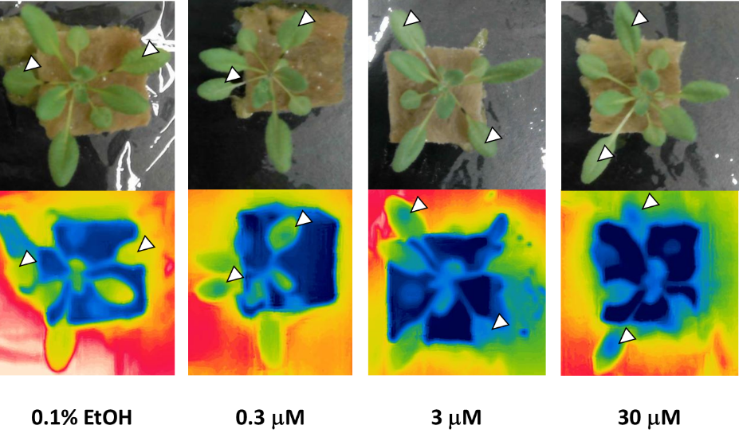
fig. S2. Thermographic images of Arabidopsis treated by FC-A droplets indicate decrease in temperature. 25-day-old Arabidopsis plants were kept in the dark at 24 °C overnight prior to chemical treatment. Two leaves were randomly selected, on each of which a droplet of 8 μL FC-A solution (0.1% EtOH, 0.05% Approach BI, 0.02% Sillwet L-77) was placed, and kept in the dark for 5 h, and subjected to measurement in the light.

fig. S3

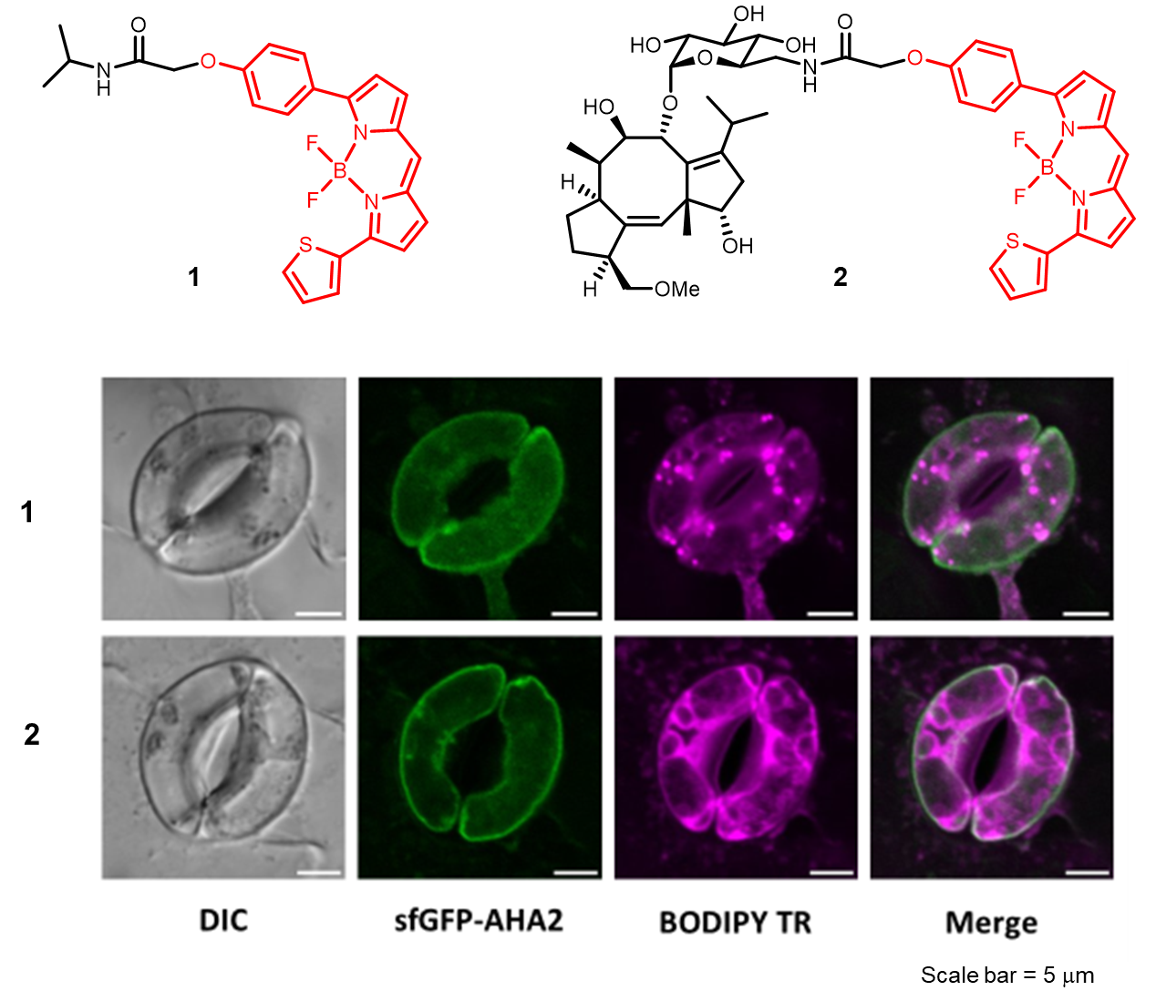
fig. S3. Confocal fluorescent imaging of guard cells of transgenic Arabidopsis expressing sfGFP-AHA2 treated with BODIPY-TR (1) or BODIPY TR-labeled FC (2).

fig. S4
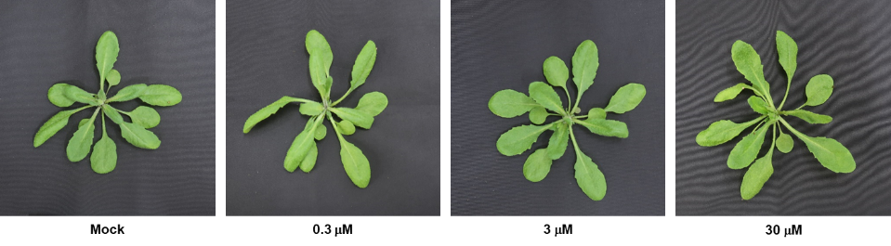

Replicate 1:
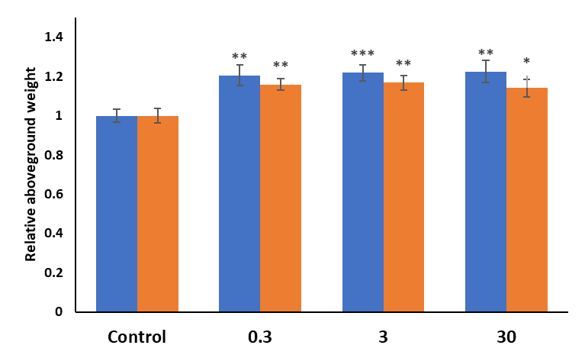

Replicate 2:

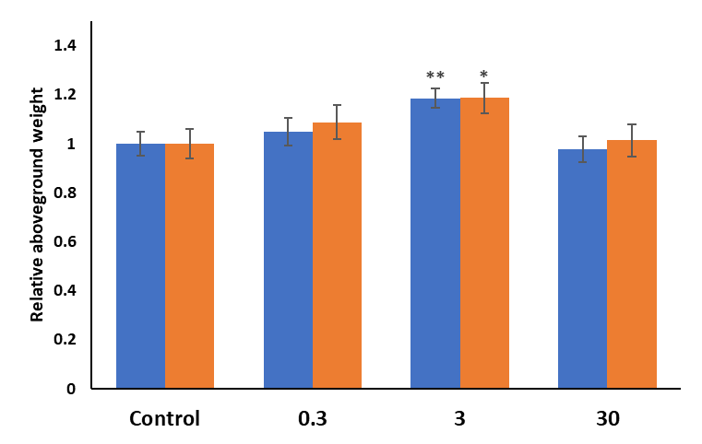

fig. S4. The results of independently replicated experiments: Evaluation of plant growth enhancement by fusicoccin-A. Effect of FC-A in Arabidopsis thaliana was evaluated by the same experimental protocol described for Fig. 3. n = 12 plants / group. Mean values were obtained from three independent experiments. Differences were detected by Student’s t test (*p < 0.05, **p < 0.01, ***p < 0.001).

fig. S5

Replicate 1

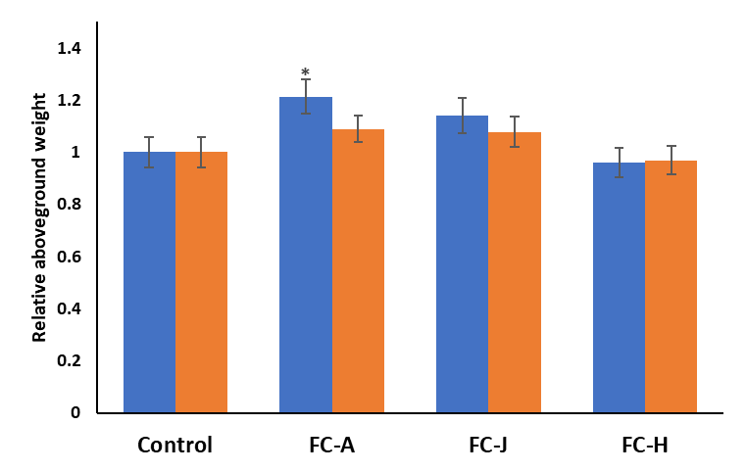
fig. S5. The results of independently replicated experiments: Evaluation of plant growth enhancement by FC-A, FC-J, and FC-H. Relative aboveground fresh and dry weights of 25-day-old plants. Error bars indicate standard error of mean (n = 12). Differences were detected by Student’s t test (*p < 0.05, **p < 0.01, ***p < 0.001).

fig. S6
Replicate 1
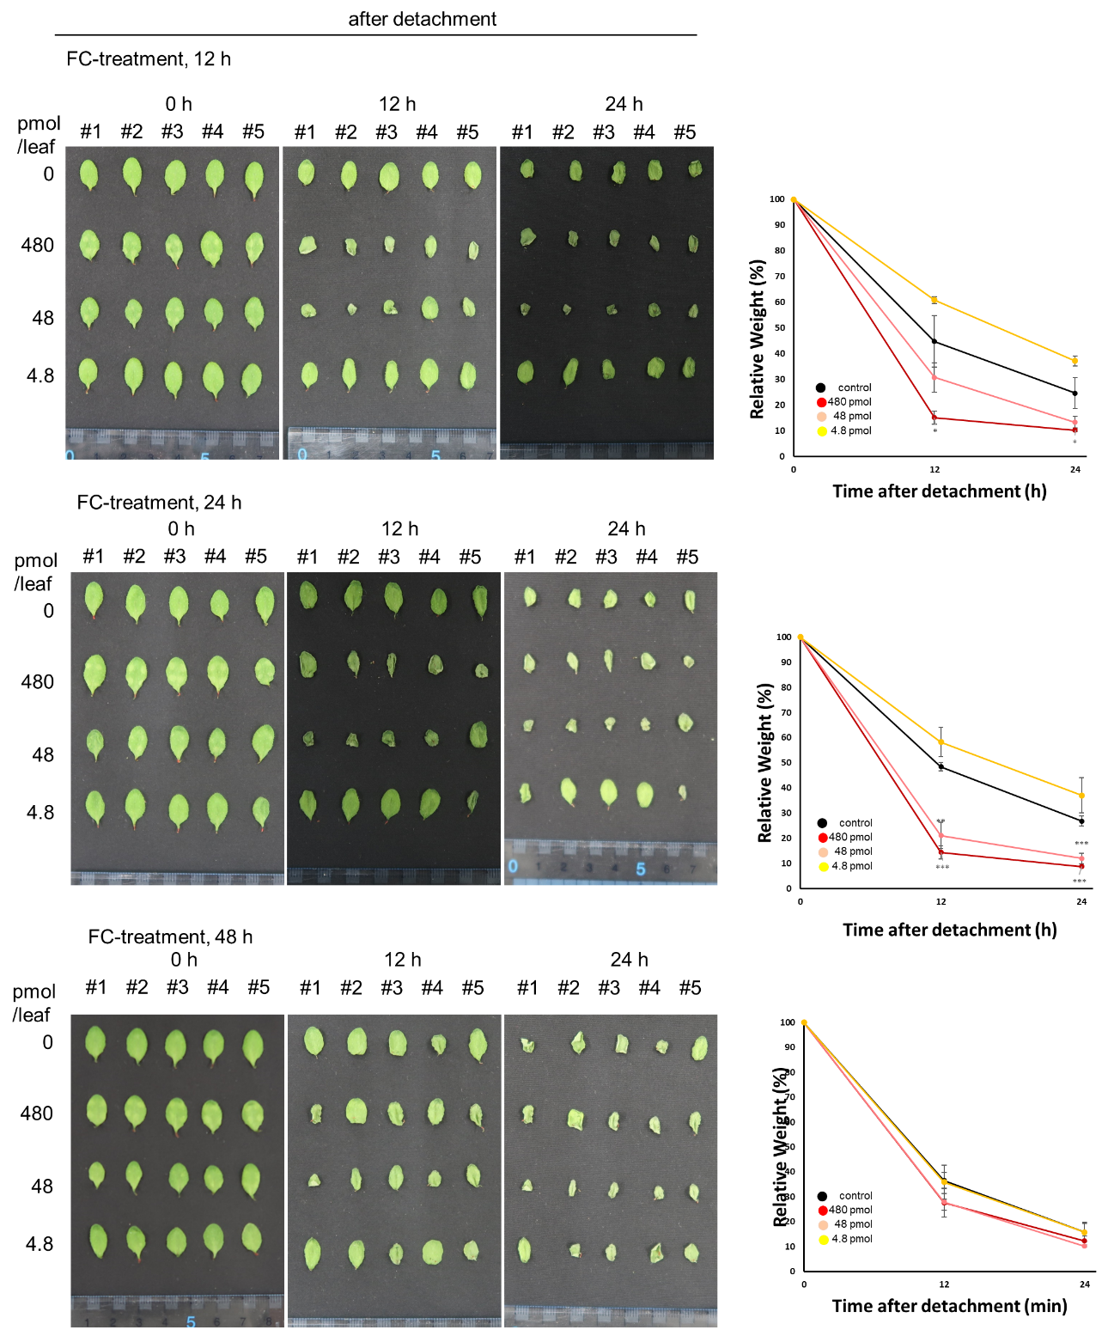
fig. S6. Time-course changes in weight of Arabidopsis leaves. The rate of weight loss increases in dose response manner after incubation with FC-A. Left: Rosette leaves of Arabidopsis plants treated with various amount of FC-A (0, 4.8, 48, and 480 pmol / leaf), incubated in the dark for 12, 24, or 48 h, detached from the plant, and images were recorded at 0, 12, and 24 h after the detachment. Leaves were harvested from five individual plants (#1-#5). Scale bars represent 2 cm. Right: Relative weight changes of the rosette leaves at 0, 12, and 24 h after the detachment. The difference in the rate of weight loss became no longer obvious after 48 h incubation with FC-A. Error bars represent the SEM (n = 5 plants). Differences were detected by Student’s t test (*p < 0.05, **p < 0.01, ***p < 0.001).

fig. S7

Replicate 1
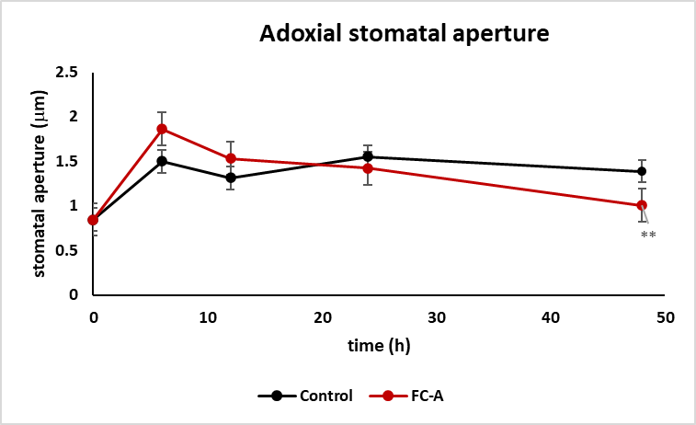
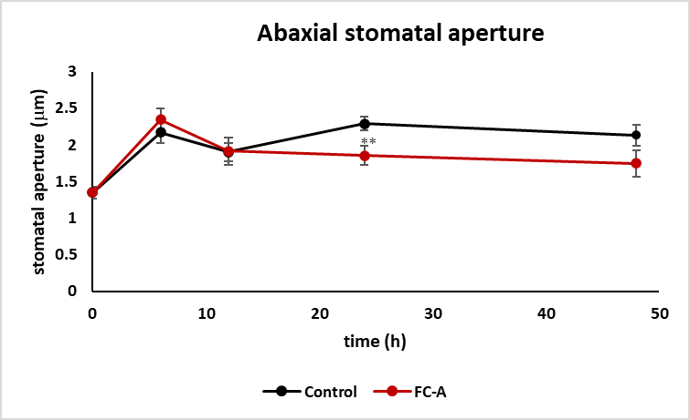

Replicate 2
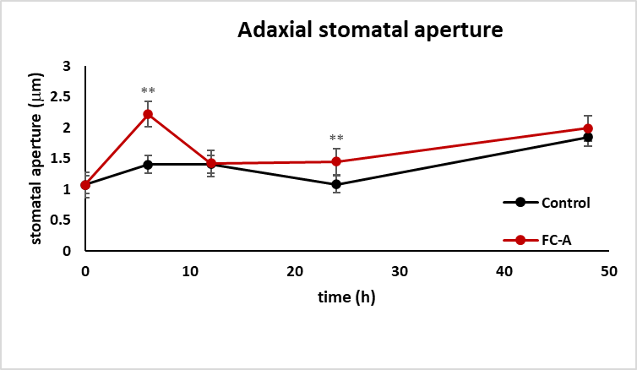

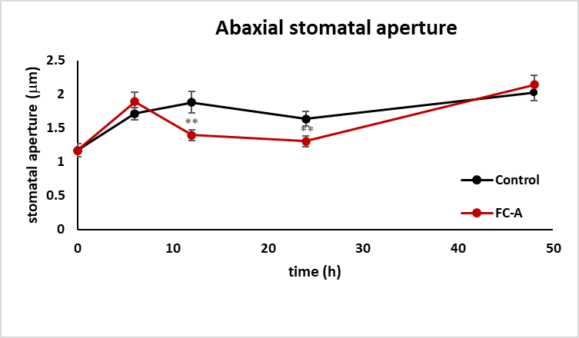

Fig. S7. Time-course changes in FC-A-induced stomatal opening in the epidermis. Error bars represent the SEM (n ≥ 30). Differences were detected by Student’s t test (*p < 0.05).
fig. S8
A

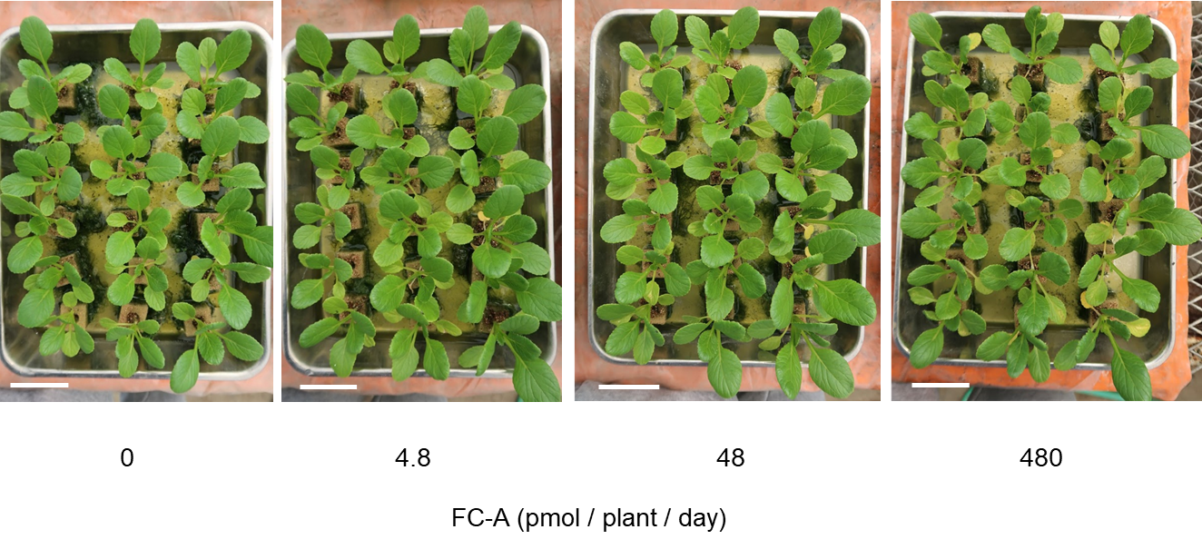
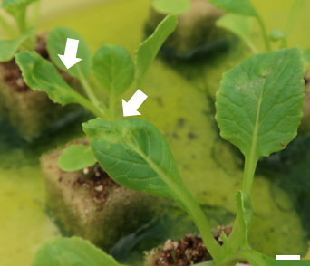
B

fig. S8. Komatsuna plants treated with FC-A. (A) Komatsuna plants treated with FC-A at Day-38. Komatsuna plants were treated with FC-A solution (8 μL each, 0.3-30 μM; 4.8 ~ 480 pmol·plant-1·day-1) or 0.1% EtOH solution containing 0.05% v/v of a spreading agent (approach® BI) once a day for 28-days. Scale bar = 5 cm. (B) Wilting leaves observed (white arrows) in the group of high dose treatment of FC-A at Day-38 (48 μl of 30 μM; 1,440 pmol ·plant⁻¹·day⁻¹). Scale bar = 1 cm.

fig. S9
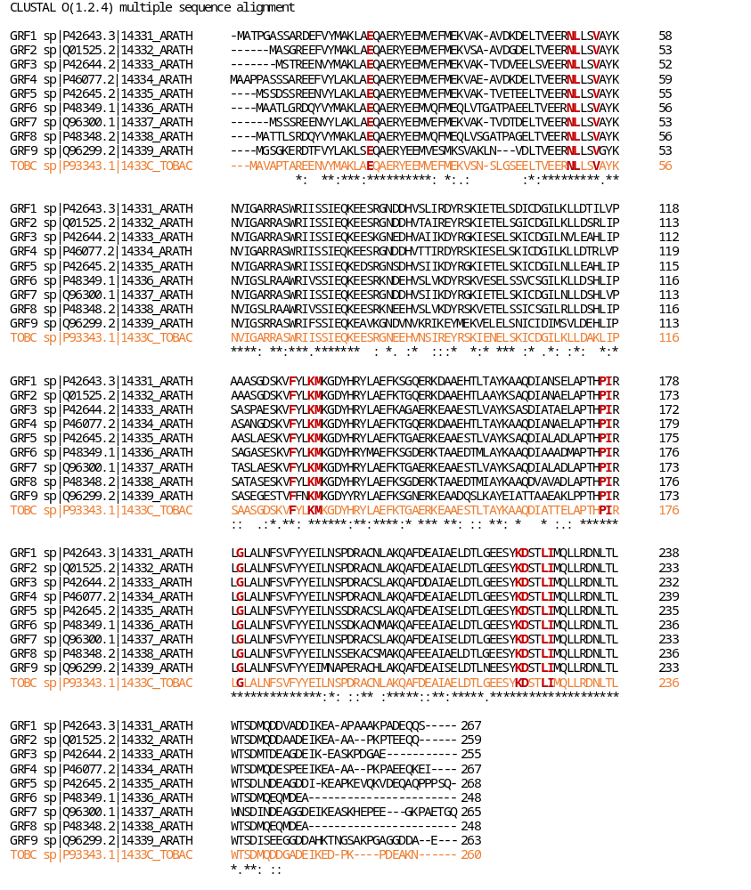
fig. S9. Amino acid sequence alignment of Arabidopsis 14-3-3 isoforms (GRF1-GRF9) and Tobacco 14-3-3c (orange). Letters highlighted in red in Tobacco 14-3-3 are the residues involving in contact with FC-A in the crystal structure of ternary complex (1O9F). These residues are fully conserved in all the Arabidopsis isoforms presented in this chart.

fig. S10

Dark: replicate 1

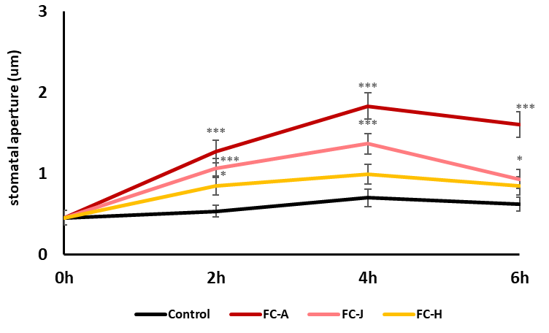

Dark: replicate 2

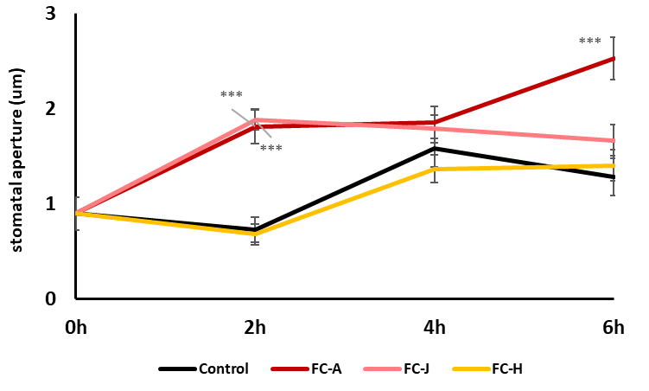
fig. S10. The results of independently replicated experiments: Evaluation of the stomatal opening of Arabidopsis cotyledons using FC-A, FC-J, and FC-H. Differences were detected by Student’s t test (*p < 0.05, **p < 0.01, ***p < 0.001).

fig. S11

Light: replicate 1

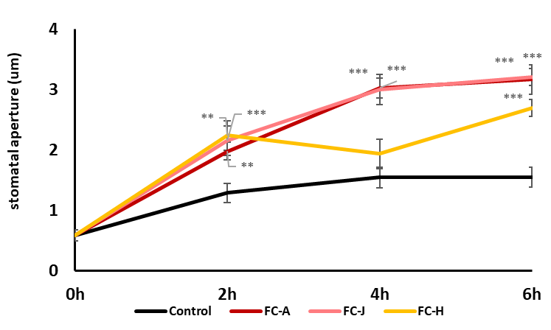

Light: replicate 2
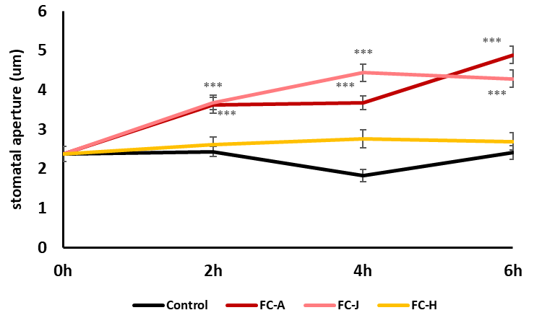

fig. S11. Evaluation of the stomatal opening of Arabidopsis cotyledons using FC-A, FC-J, and FC-H in the light. Differences were detected by Student’s t test (*p < 0.05, **p < 0.01, ***p < 0.001).

fig. S12

Replicate1
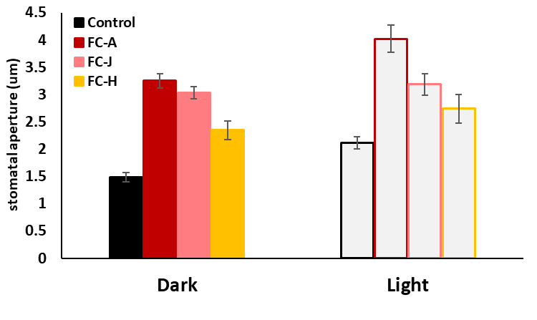

Replicate2
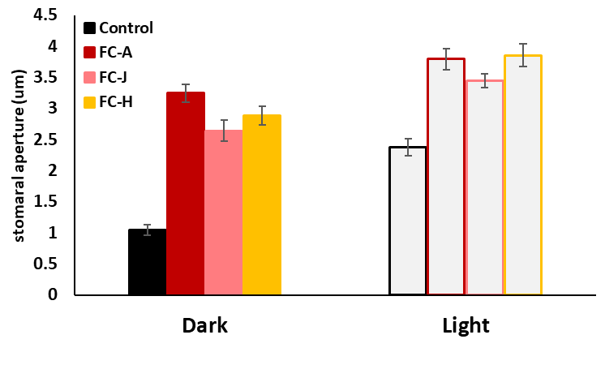

fig. S12. Evaluation of the stomatal opening of Arabidopsis rosette leaves using FC-A, FC-J, and FC-H in the dark and light. Differences were detected by Student’s t test (*p < 0.05, **p < 0.01, ***p < 0.001).

fig. S13

Co-immunoprecipitation
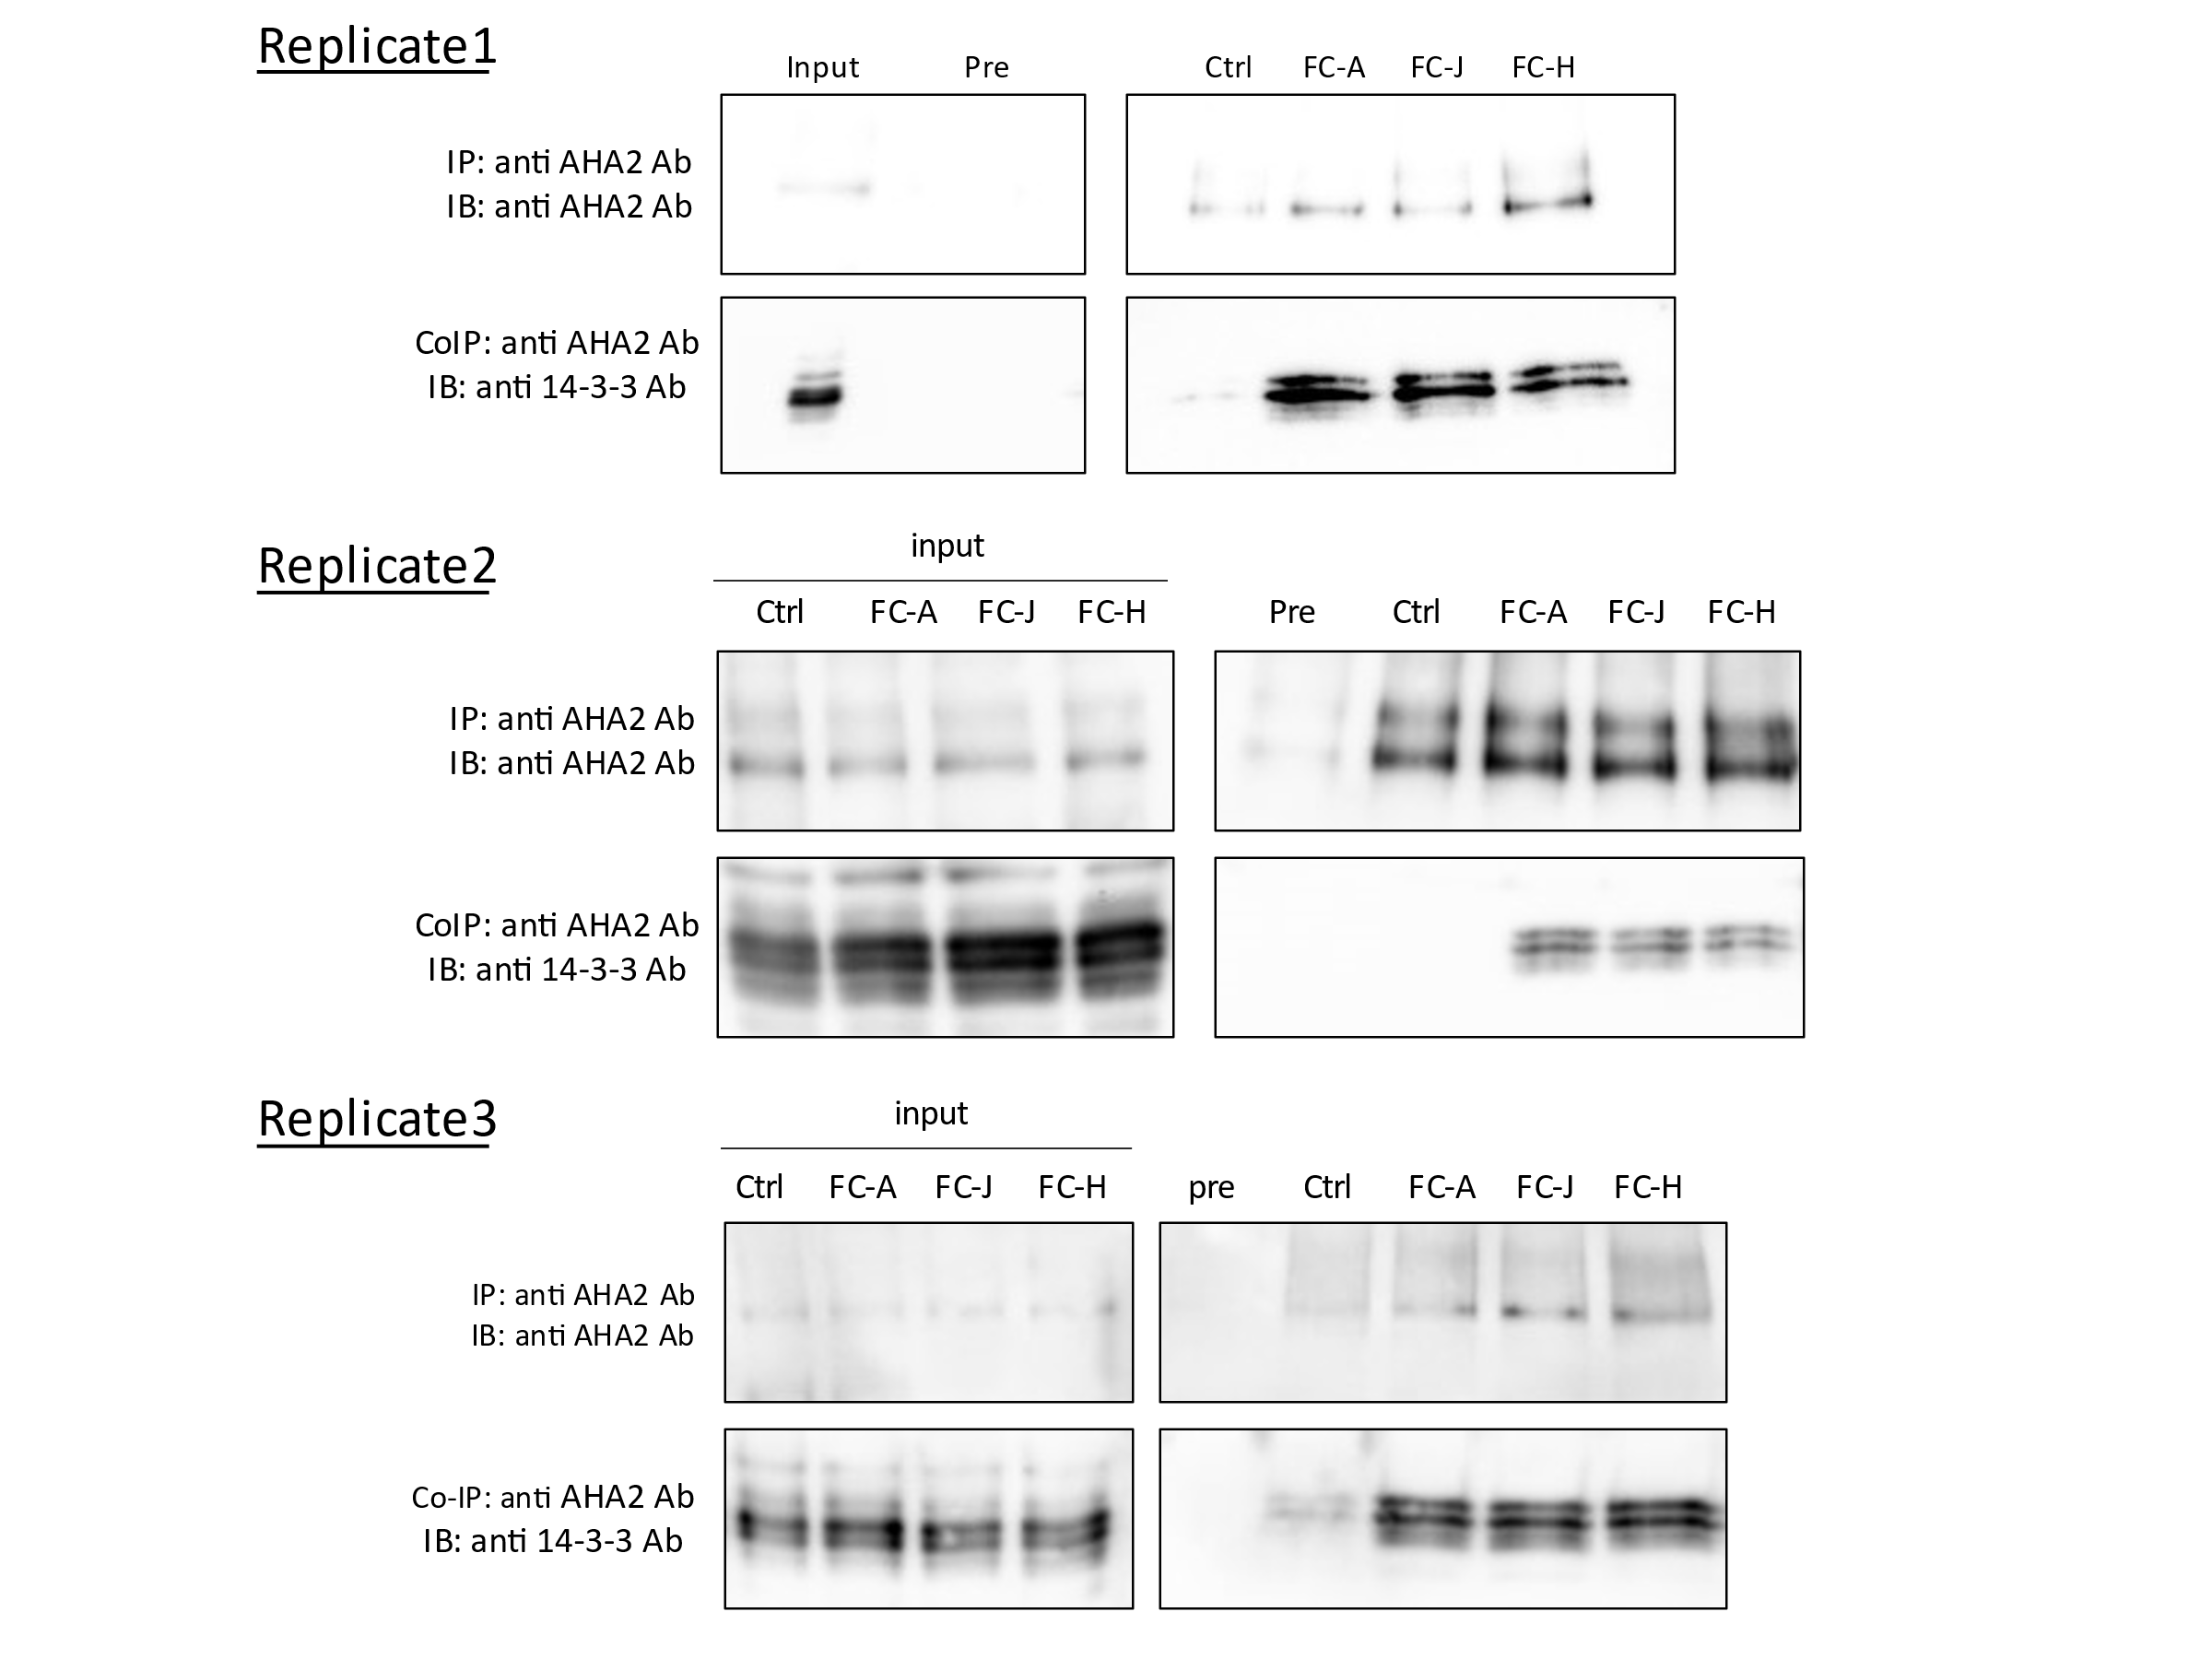

Phosphorylation level of pThr947 of AHA2
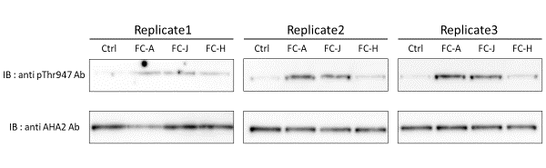

fig. S13. The results of independently replicated experiments: Coimmunoprecipitation and phosphorylation level of AHA2.

NMR Charts
