Population-based Evidence for Using Serum Neurofilaments as Individual Diagnostic and Prognostic Biomarkers in Amyotrophic Lateral Sclerosis

SUPPLEMENT

Table of contents
Section 1: Supplementary Methods 2
Supplement Figure 1: NF-ASSESS study population 2
Supplement Table 1: Demographic data – NF-ASSESS study population, ALS registry, and Case Control study 3
Supplement Table 2: Final diagnoses in disease mimics 4
Equations: 5
Supplement Figure 2: Logarithmic transformation of NfL levels 6
Supplement Figure 3: Logarithmic transformation of pNfH levels 7
Section 2: Supplementary Results 8
Supplement Table 3: baseline characteristics of disease mimics 8
Supplement Figure 4: Survival in ALS patients of the NF-ASSESS study 9
Supplement Table 4: NfL and pNfH reference values 10
Supplement Figure 5: Diagnostic performance of NfL by sex 11
Diagnostic properties of NfL in early disease stages 12
Supplement Figure 6: Baseline NfL levels across the El-Escorial status 13
Supplement Table 5: Characteristics in El-Escorial subgroups 14
Supplement Figure 7: NfL levels with regard to time since disease onset 15
Supplement Figure 8: Disease progression rates with regard to time since disease onset 16
Supplement Figure 9: NfL levels with regard to the ALSFRS-R score 17
Supplement Figure 10: NfL levels in early patients with high functional status 18
Diagnostic properties of NfL regarding disease mimics 19
Supplement Table 6: Disease Mimics 20
Supplement Figure 11: Individual survival across the NF-ASSESS Score categories 21
Supplement Figure 12: Comparison of Kaplan-Meier plots for NfL- and pNfH-based NF ASSESS Scores 22
Supplement Figure 13: Sex and Prognosis 23

Section 1: Supplementary Methods

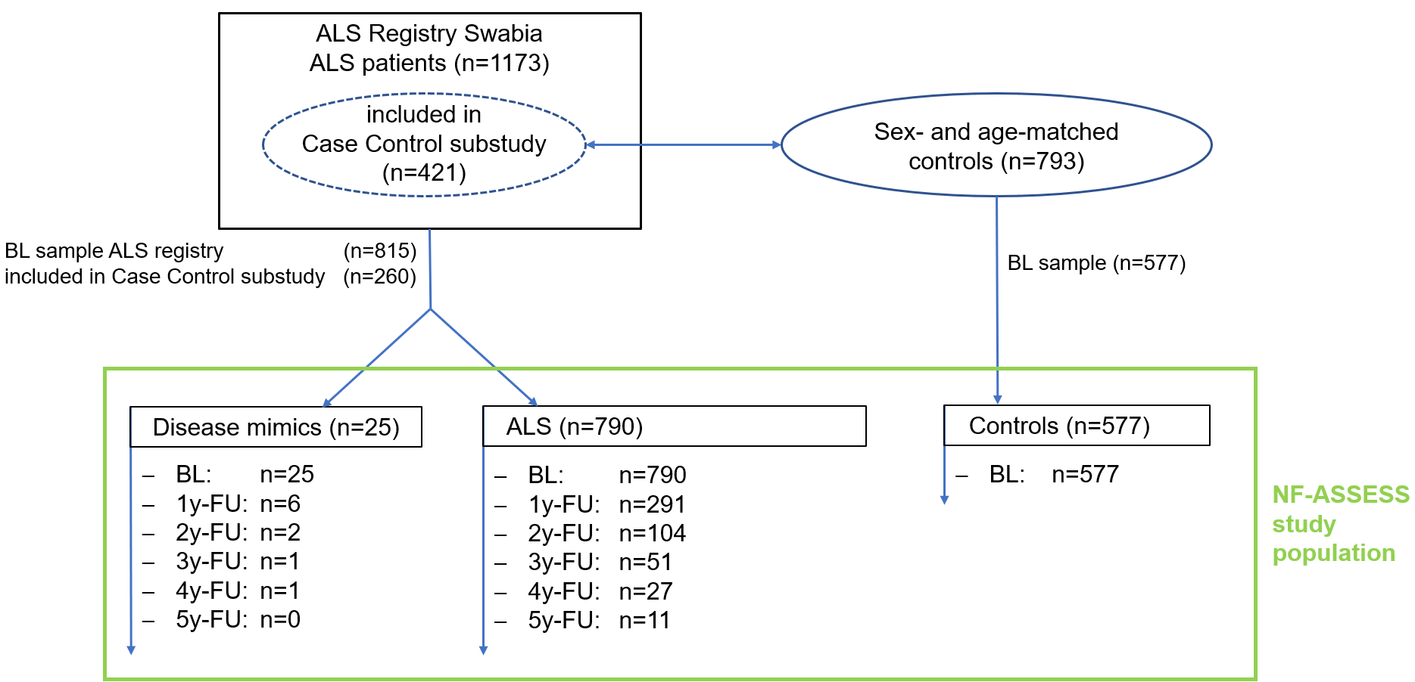

Supplement Figure 1: NF-ASSESS study population
This flow chart shows the numbers of ALS patients in the ALS Registry Swabia, the number of cases included in the Case Control substudy, the number of controls and the availability of baseline (BL) samples in each group. The NF-ASSESS study population (green box) is composed of disease mimics, ALS patients and controls with available baseline samples. For each group, the number of serum samples up to the 5-year follow-up (FU) is listed. Sex- and age did not significantly differ between the NF-ASSESS study population, the registry population and the Case Control substudy (see supplement Table 1).

Supplement Table 1: Demographic data – NF-ASSESS study population, ALS registry, and Case Control study

 |  | Controls
 | Study | NF-ASSESS |  |  |  | ALS Registry |  |  |  | Case Control Substudy
 |  | Count | Median | Percentile 25 | Percentile 75 | Count | Median | Percentile 25 | Percentile 75 | Count | Median | Percentile 25 | Percentile 75 | p
sex | male | 335 |  |  |  |  |  |  |  | 463 |  |  |  | 0.904
sex | female | 242 |  |  |  |  |  |  |  | 330 |  |  |  | 0.904
age at enrollment |  | 577 | 66.1 | 59.3 | 72.4 |  |  |  |  | 793 | 67.5 | 60.3 | 73.2 | 0.079
 |  | ALS
 | Study | NF-ASSESS |  |  |  | ALS Registry |  |  |  | Case Control Substudy
 |  | Count | Median | Percentile 25 | Percentile 75 | Count | Median | Percentile 25 | Percentile 75 | Count | Median | Percentile 25 | Percentile 75 | p
sex | male | 478 |  |  |  | 666 |  |  |  | 234 |  |  |  | 0.478
sex | female | 312 |  |  |  | 466 |  |  |  | 177 |  |  |  | 0.478
age at enrollment |  | 790 | 66.5 | 58.2 | 73.8 | 1132 | 67.6 | 59.0 | 74.8 | 411 | 67.4 | 58.4 | 73.8 | 0.141
 |  | Mimics
 | Study | NF-ASSESS |  |  |  | ALS Registry |  |  |  | Case Control Substudy
 |  | Count | Median | Percentile 25 | Percentile 75 | Count | Median | Percentile 25 | Percentile 75 | Count | Median | Percentile 25 | Percentile 75 | p
sex | male | 18 |  |  |  | 28 |  |  |  | 8 |  |  |  | 0.759
sex | female | 7 |  |  |  | 13 |  |  |  | 2 |  |  |  | 0.759
age at enrollment |  | 25 | 65.4 | 52.4 | 70.2 | 41 | 65.6 | 55.2 | 71.2 | 10 | 65.2 | 57.2 | 68.2 | 0.861

Supplement Table 2: Final diagnoses in disease mimics
ALS mimicking disease | n
Peripheral neuronal disease | 10
Myopathy / Myositis | 3
Other MND / FTLD | 2
Cerebral vascular pathology | 3
Myasthenia Gravis | 1
Benign Fasciculation Syndrome | 1
Cerebellar Syndrome | 2
Unsolved | 3

Equations:

- Disease progression rate at baseline [pt lost per month]:
$$\frac{\left(48 - ALSFRSR score at baseline\right)}{months between disease onset and baseline}$$

- Follow-up disease progression rate [pt lost per month]:
$$\frac{\left(ALSFRSR score at baseline - ALSFRSR score at last visit\right)}{months between baseline and last visit}$$

- Blood volume [L]
Male participants:
$$0.3669*{height\left[m\right]}^{3}+0.03219*weight \left[kg\right]+0.6041$$

Female participants:
$$1.20*BMI \left[\frac{kg}{m^{2}}\right]+0.23*age \left[y\right]-5.4$$

- Body fat [%]:
Male participants:
$$1.20*BMI \left[\frac{kg}{m^{2}}\right]+0.23*age \left[y\right]-16.2$$
Female participants:
$$1.20*BMI \left[\frac{kg}{m^{2}}\right]+0.23*age \left[y\right]-5.4$$

- Glomerular filtration rate (GFR) [mL/min/1.73m²]:
$$130*{\left(serum cystatin C \left[\frac{mg}{L}\right]\right)}^{-1.069}* {\left(age \left[y\right]\right)}^{-0.117}-7$$

- Control Z-Score:
$$\frac{Ln\left(neurofilament level^{ participant}\right) - MEAN ofLn\left(neurofilament level^{ all controls}\right)}{SD of Ln\left(neurofilament level^{ all controls}\right)}$$
- ALS Z-Score:
$$\frac{Ln\left(neurofilament level^{ participant}\right) - MEAN of Ln\left(neurofilament level ^{all ALS patients}\right)}{SD of Ln\left(neurofilament level^{ all ALS patients}\right)}$$

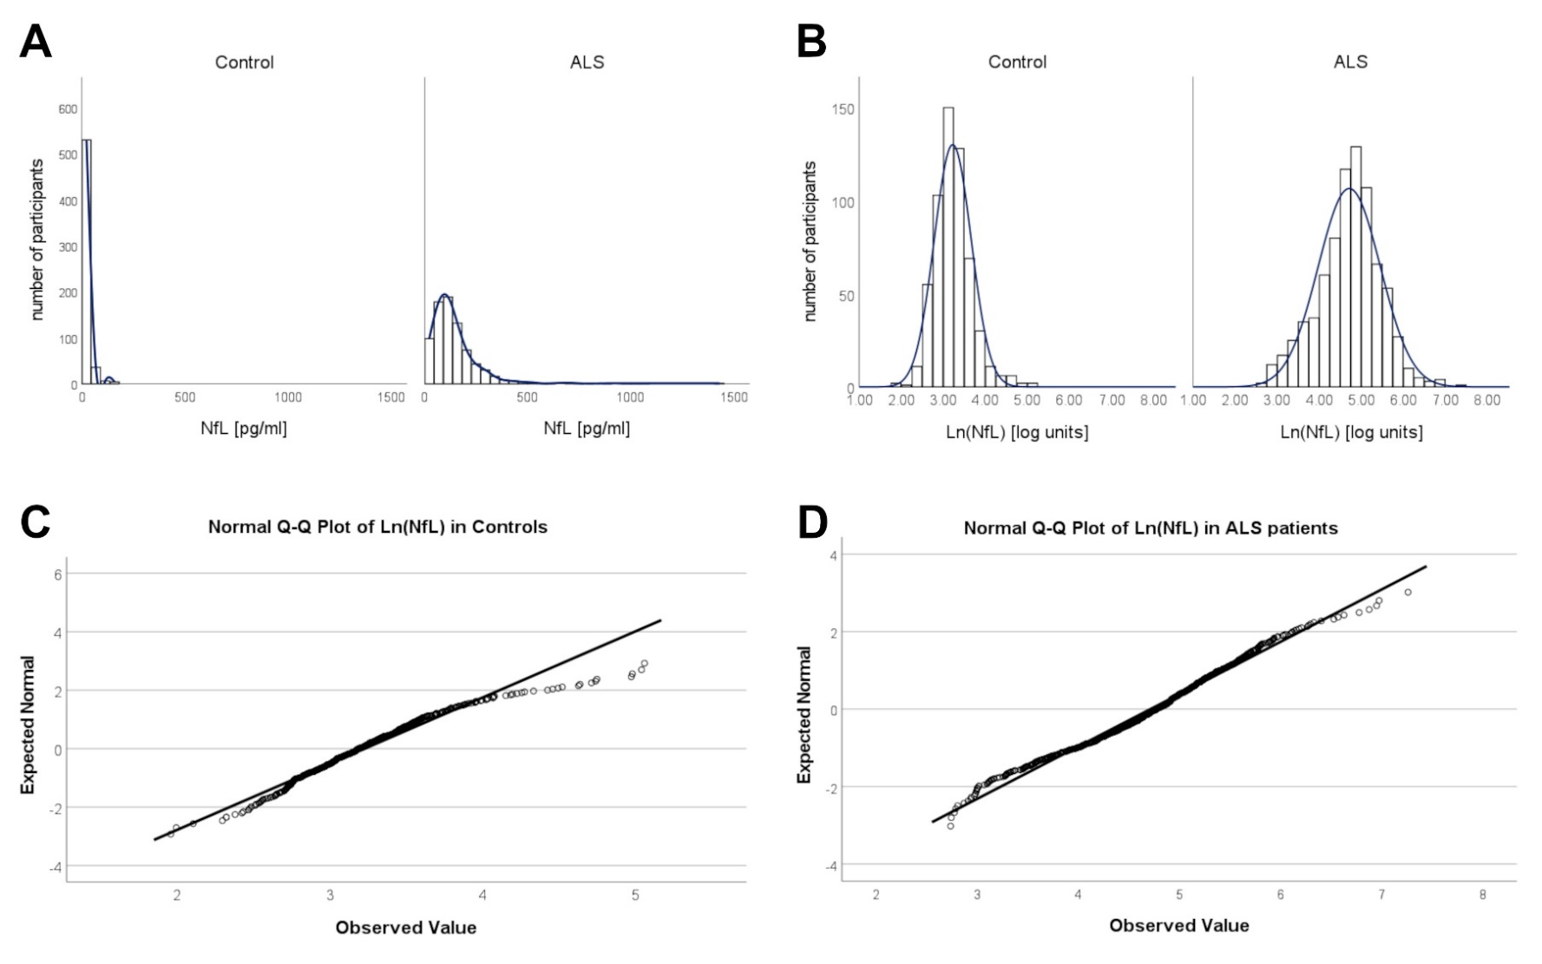

Supplement Figure 2: Logarithmic transformation of NfL levels
The histogram in Panel A shows a right-skewed NfL level distribution in controls and ALS patients before transformation. After natural logarithmic transformation the histogram shows a normal distribution (Panel B), confirmed by Q-Q plots (Panel C and D), which was used to compute the Control and ALS Z-Scores.
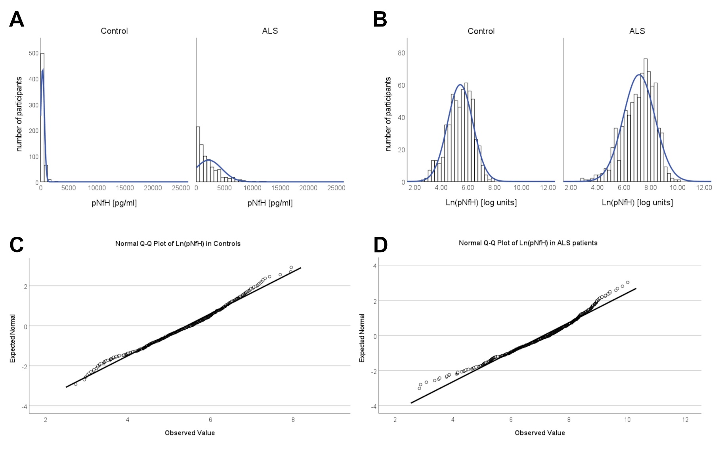

Supplement Figure 3: Logarithmic transformation of pNfH levels
The histogram in Panel A shows a right-skewed pNfH level distribution in controls and ALS patients. After natural logarithmic transformation the histogram shows a widely normal distribution (Panel B), confirmed by Q-Q plots (Panel C and D), which was used to compute the Control and ALS Z-Scores.

Section 2: Supplementary Results

Supplement Table 3: baseline characteristics of disease mimics
 |  | n | % | Median | Percentile 25 | Percentile 75
Characteristics | Female sex | 7 | 28
 | Male sex | 18 | 72
 | age [y] |  |  | 65.4 | 52.4 | 70.2
 | BMI [kg/m²] |  |  | 27.13 | 24.13 | 29.40
 | disease duration baseline [months] |  |  | 14.5 | 10.3 | 25.4
 | ALSFRS-R sum score [pt] |  |  | 43 | 40 | 45
 | disease progression at baseline |  |  | 0.33 | 0.20 | 0.41
El Escorial | suspected | 14 | 56
 | possible | 6 | 24
 | possible (lab. supported) | 3 | 12
 | probable | 2 | 8
 | definite | 0 | 0
Onset site | not certain | 1 | 4
 | bulbar | 8 | 32
 | cervical | 5 | 20
 | thoracic | 3 | 12
 | lumbar | 8 | 32
Phenotype | progressive bulbar palsy | 4 | 16
 | primary lateral sclerosis (PLS) | 1 | 4
 | progressive muscular atrophy (PMA) | 6 | 24
 | classical ALS | 14 | 56
 | flail arm variant | 0 | 0.0

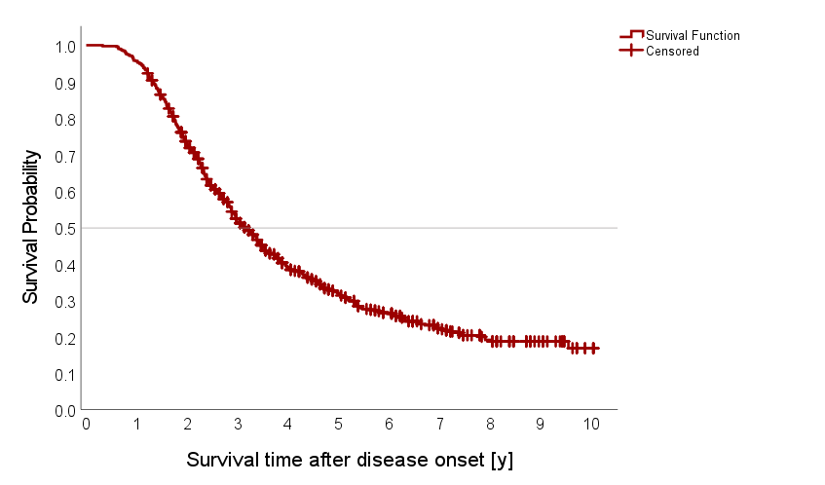

Supplement Figure 4: Survival in ALS patients of the NF-ASSESS study
The Kaplan-Meier plot shows survival probability after disease onset for all patients with ALS in the NF-ASSESS study. The median survival time after disease onset was 3.15 (95%CI 2.94 - 3.36) years.

Supplement Table 4: NfL and pNfH reference values
 |  | NfL
Controls |  |  |  |  |  |  | Test for significance  against previous age group
agegroup | n |  | mean Ln(NfL)  [log units] | SD Ln(NfL)  [log units] | mean raw NfL  [pg/ml] | difference to previous  agegroup in [pg/ml] | p | adj p (Bonferroni)
≤ 50 | 50 |  | 2.84 | .29 | 18
51 - 60 | 104 |  | 2.95 | .31 | 20 | 2 | 0.125 | 1
61 - 70 | 206 |  | 3.17 | .36 | 26 | 6 | <0.001 | <0.001
71 - 80 | 186 |  | 3.43 | .36 | 33 | 7 | <0.001 | <0.001
80+ | 30 |  | 3.93 | .50 | 58 | 25 | <0.001 | 0.003
overall | 576 |  | 3.23 | .44 | 28 | - | - | -
ALS
agegroup | n |  | mean Ln(NfL)  [log units] | SD Ln(NfL)  [log units] | mean raw NfL  [pg/ml] | difference to previous  agegroup [pg/m] | p | adj p (Bonferroni)
≤ 50 | 68 |  | 4.42 | .76 | 108
51 - 60 | 168 |  | 4.61 | .78 | 133 | 25 | 0.073 | 0.73
61 - 70 | 260 |  | 4.72 | .67 | 139 | 6 | 0.231 | 1
71 - 80 | 247 |  | 4.79 | .74 | 159 | 20 | 0.263 | 1
80+ | 47 |  | 5.04 | .74 | 207 | 48 | 0.065 | 0.645
overall | 790 |  | 4.71 | .74 | 145 | - | - | -

 | pNfH
Controls |  |  |  |  |  |  | Test for significance  against previous age group
agegroup |  | n | mean Ln(NfL)  [log units] | SD Ln(NfL)  [log units] | mean raw NfL  [pg/ml] | difference to previous  agegroup in [pg/ml] | p | adj p (Bonferroni)
≤ 50 |  | 50 | 4.91 | .91 | 191
51 - 60 |  | 103 | 5.14 | .91 | 245 | 54 | 0.189 | 1.000
61 - 70 |  | 205 | 5.33 | .91 | 298 | 53 | 0.104 | 1.000
71 - 80 |  | 184 | 5.71 | .90 | 429 | 131 | <.001 | <.001
80+ |  | 30 | 6.17 | .78 | 644 | 215 | 0.029 | 0.288
overall |  | 572 | 5.42 | .95 | 339 | - | - | -
ALS
agegroup |  | n | mean Ln(NfL)  [log units] | SD Ln(NfL)  [log units] | mean raw NfL  [pg/ml] | difference to previous  agegroup [pg/m] | p | adj p (Bonferroni)
≤ 50 |  | 67 | 6.62 | 1.29 | 1421
51 - 60 |  | 168 | 7.12 | 1.18 | 2129 | 708 | 0.006 | .059
61 - 70 |  | 259 | 7.13 | 1.09 | 2070 | -59 | 0.814 | 1.000
71 - 80 |  | 246 | 7.23 | 1.23 | 2463 | 393 | 0.179 | 1.000
80+ |  | 47 | 7.36 | 1.19 | 2813 | 350 | 0.627 | 1.000
overall |  | 787 | 7.13 | 1.19 | 2195 | - | - | -

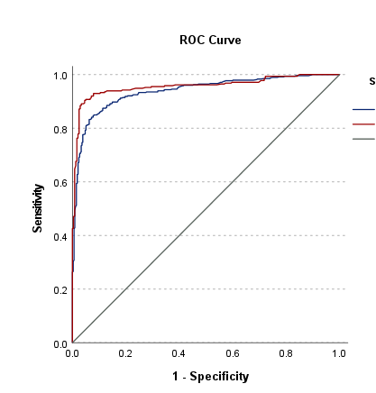

Male
Female
Reference line

Supplement Figure 5: Diagnostic performance of NfL by sex
We observed a superior diagnostic utility of NfL in female patients (red line) compared to male patients (blue line) with ALS displayed in this receiver operating characteristic (ROC) curve.

Diagnostic properties of NfL in early disease stages
As ALS is a clinical diagnosis, biomarkers supporting the diagnosis are most valuable in early disease stages in which the clinical phenotype is still developing. We evaluated the diagnostic performance of serum NfL in patients with ALS in an early stage with regard to the El-Escorial status, time since disease onset, and the ALSFRS-R, as a measure of the patient's functional status.
We found slightly higher median Ln(NfL) levels in patients with probable or definite ALS compared to suspected, possible, or possible laboratory supported ALS (Supplement Figure 6), which, however, could be explained by correspondingly higher disease progression rates at baseline in these subgroups (Supplement Table 5). The diagnostic performance of NfL in patients with suspected, possible, or possible laboratory supported ALS was slightly lower (ROC AUC 0.933) than for probable and definite ALS (ROC AUC 0.966).
With regard to the disease duration at baseline, we observed that patients with shorter time since disease onset had higher NfL levels (Supplement Figure 7) and higher disease progression rates (Supplement Figure 8). In contrast, we saw a negative correlation between the ALSFRS-R sum scores at baseline and NfL (Supplement Figure 9). Both findings represent the well-known phenomenon of patients with an aggressive ALS disease course being diagnosed earlier. Therefore, we additionally looked for patients who, at baseline, were in the first year after disease onset and simultaneously had a high functional status (ALSFRS-R sum score ≥ 41 pt; Supplement Figure 10). Here the diagnostic performance of NfL was still very good (ROC AUC 0.931 in patients with an ALSFRS-R score ≥ 45 pt; ROC AUC 0.952 in patients with an ALSFRS-R score of 41 – 44 pt).

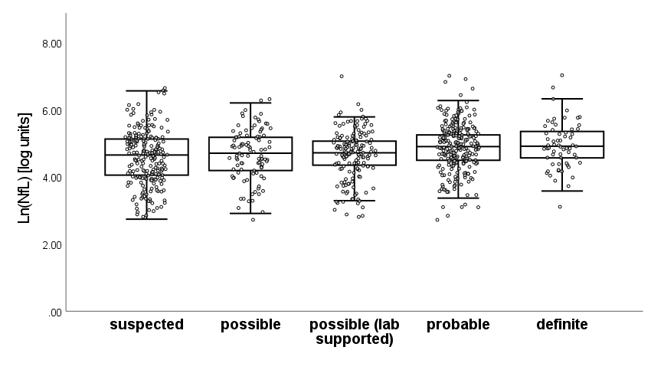

Supplement Figure 6: Baseline NfL levels across the El-Escorial status
Boxplots with overlaid dots for individual patients showing the baseline Ln(NfL) levels for patients with ALS with regard to their El-Escorial status.

Supplement Table 5: Characteristics in El-Escorial subgroups
Baseline |  | Ln(NfL)  [pg/ml] |  | disease progression at baseline  [pt lost per month]
 |  | Mean | SD | Median | Percentile 25 | Percentile 75
El Escorial Status | suspected | 4.59 | 0.77 | 0.73 | 0.40 | 1.13
El Escorial Status | possible | 4.64 | 0.73 | 0.55 | 0.32 | 1.07
El Escorial Status | possible (lab supported) | 4.63 | 0.71 | 0.69 | 0.36 | 1.16
El Escorial Status | probable | 4.85 | 0.71 | 0.82 | 0.49 | 1.57
El Escorial Status | definite | 4.95 | 0.69 | 1.09 | 0.57 | 2.04

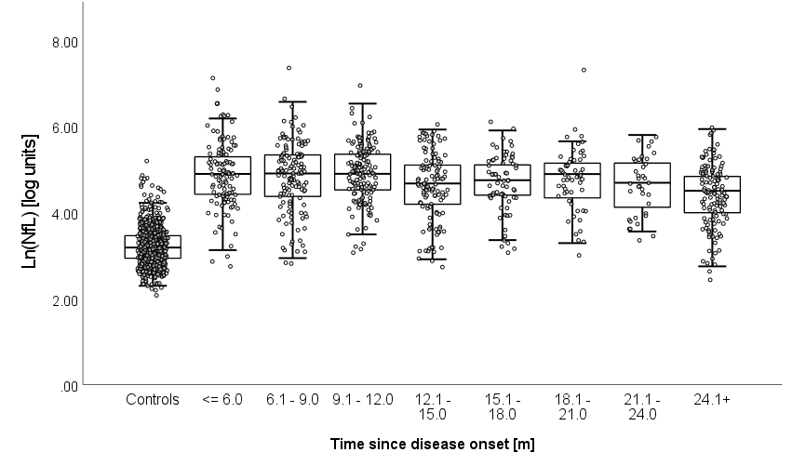

Supplement Figure 7: NfL levels with regard to time since disease onset
Boxplots with overlaid dots for individual patients showing the baseline Ln(NfL) levels for patients with ALS with regard to the time passed since disease onset in months.

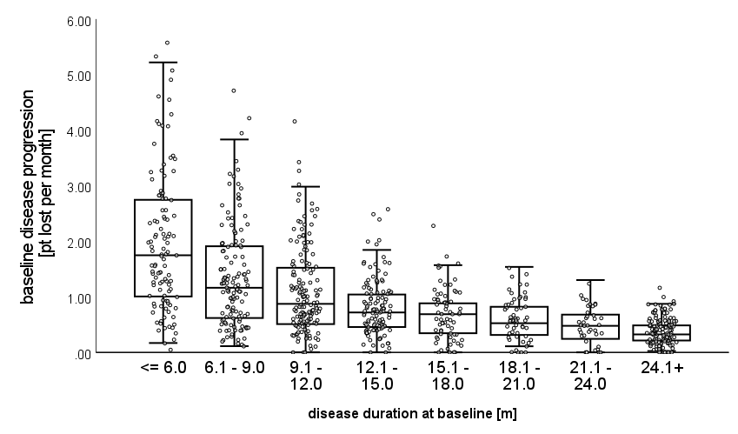

Supplement Figure 8: Disease progression rates with regard to time since disease onset
Boxplots with overlaid dots for individual patients showing the baseline disease progression rates for patients with ALS with regard to the time passed since disease onset in months.

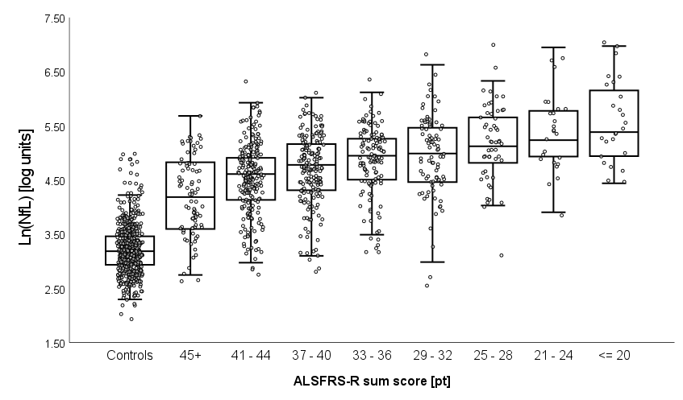

Supplement Figure 9: NfL levels with regard to the ALSFRS-R score
Boxplots with overlaid dots for individual patients showing the baseline NfL levels of patients with ALS with regard to the baseline ALSFRS-R sum score in comparison to the matched control group.

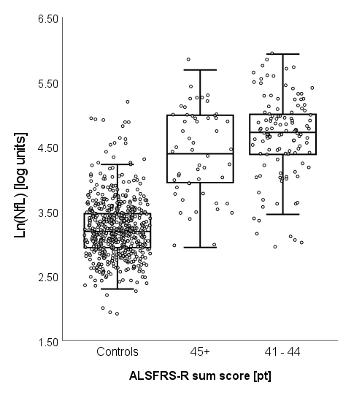

Supplement Figure 10: NfL levels in early patients with high functional status
Boxplots with overlaid dots for individual patients showing the baseline NfL levels of patients with ALS in the first year after disease onset and an ALSFRS-R sum score ≥ 41 points in comparison to the matched control group.

Diagnostic properties of NfL regarding disease mimics
Another purpose of diagnostic biomarkers is to differentiate disease mimics from the actual disease. In the disease mimics group (n = 25), NfL levels were slightly but not significantly higher than in controls (age-adjusted Control Z-Score +0.61 (SD ±1.50); p = 0.312) but considerably lower than in patients with ALS (age-adjusted Control Z-Score +4.31 (SD ±2.27); p<0.001). However, final diagnoses and individual NfL values for the disease mimics were heterogeneous (see Supplement Table 6), and larger groups are needed to determine the diagnostic utility of serum NfL in specific differential diagnostic constellations.

Supplement Table 6: Disease Mimics
Mimicking disease | NfL | Age-adjusted  Control Z-Score | ALS Z-Score
Peripheral neuronal disease
#1 | 123 | 5.99 | 0.13
#2 | 12.2 | -1.16 | -2.99
#3 | 40.2 | 1.44 | -1.38
#4 | 25.4 | -0.55 | -2.00
#5 | 38.6 | 1.32 | -1.44
#6 | 51.6 | 1.40 | -1.04
#7 | 51.9 | 1.42 | -1.04
#8 | 63 | 2.67 | -0.77
#9 | 23.6 | -0.03 | -2.10
#10 | 27.2 | 1.61 | -1.91
 | Mean: | 1.41 | -1.45
Myopathy / Myositis
#11 | 54.1 | 3.35 | -0.98
#12 | 32.3 | 1.69 | -1.68
#13 | 11.9 | -1.52 | -3.03
 | Mean: | 1.18 | -1.90
Other MND / FTLD
#14 | 6.17 | -3.52 | -3.92
#15 | 14.6 | -1.34 | -2.75
 | Mean: | -2.43 | -3.33
Cerebral vascular pathology
#16 | 29.7 | 0.60 | -1.79
#17 | 35.3 | -0.72 | -1.56
#18 | 18.3 | -0.13 | -2.45
 | Mean: | -0.08 | -1.93
Myasthenia Gravis
#19 | 36.3 | 0.44 | -1.52
 | Mean:
Cerebellar Syndrome
#20 | 30 | 0.63 | -1.78
#21 | 37.2 | 0.50 | -1.49
 | Mean: | 0.57 | -1.63
Benign Fasciculation Syndrome
#22 | 6.81 | -3.18 | -3.78
Unsolved
#23 | 16.5 | -0.12 | -2.59
#24 | 85.2 | 2.78 | -0.37
#25 | 52.1 | 3.23 | -1.03
 | Mean: | 1.96 | -1.33
Overall | Mean: | +0.67 | -1.81

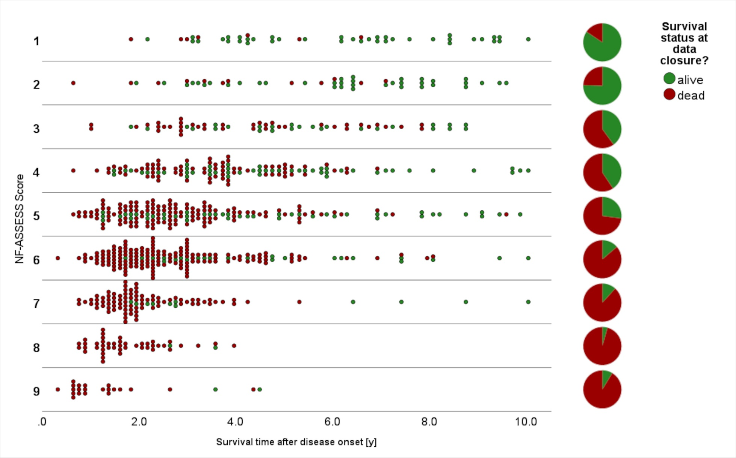

Supplement Figure 11: Individual survival across the NF-ASSESS Score categories
The dot plot shows the individual survival status and survival time at data closure across the NF ASSESS Score categories. The pie charts show the overall survival status in the given category at data closure.
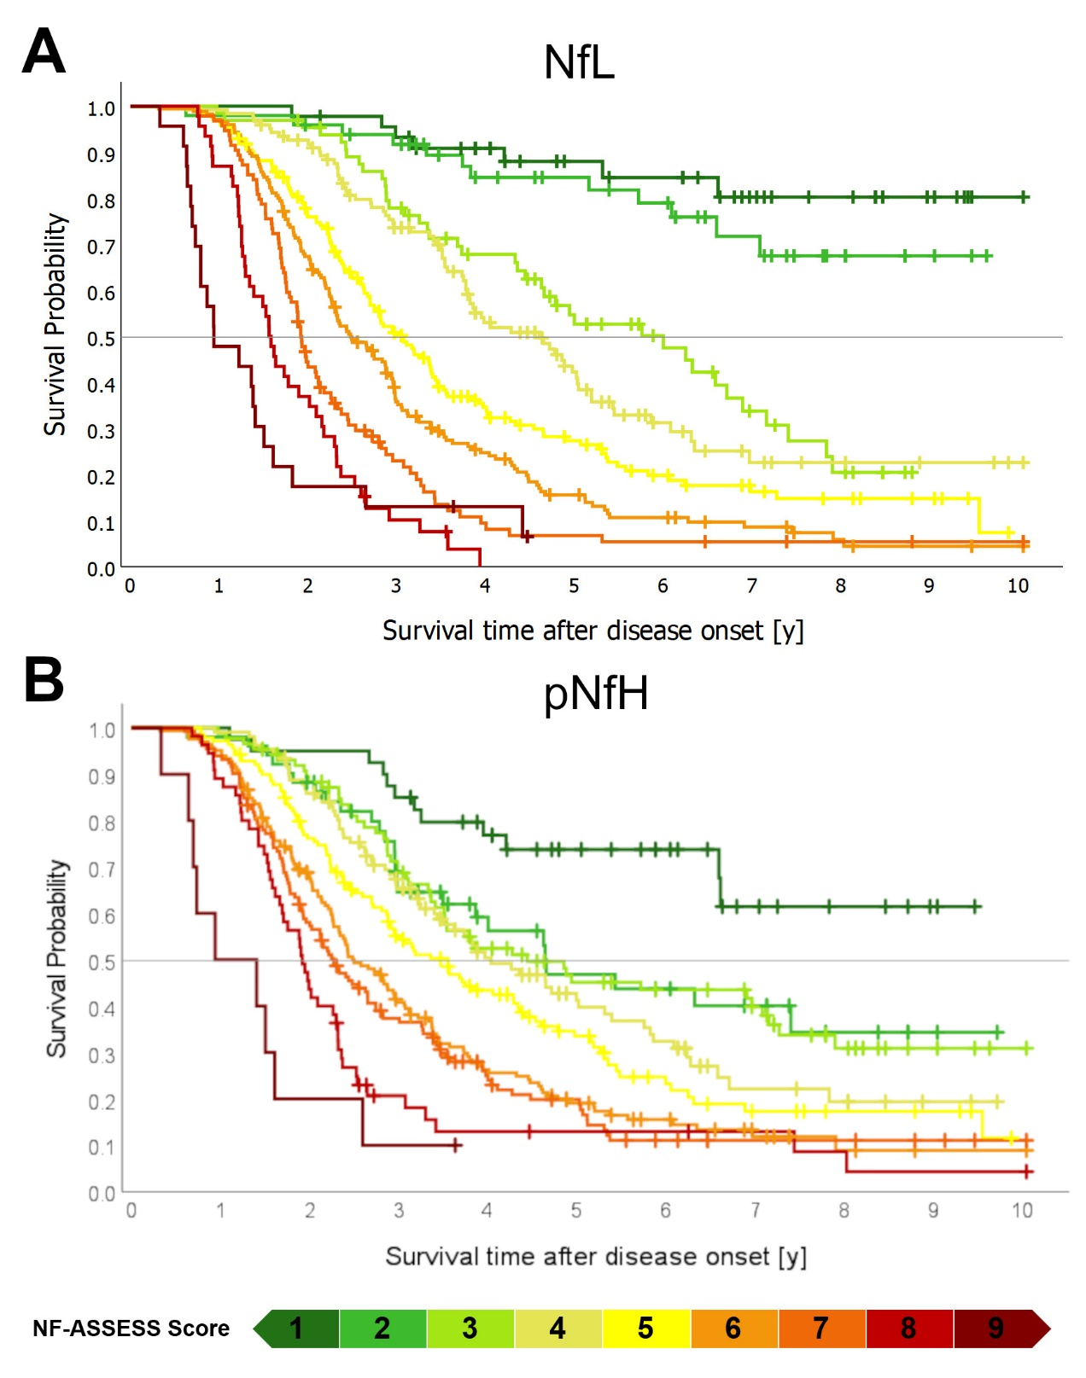

Supplement Figure 12: Comparison of Kaplan-Meier plots for NfL- and pNfH-based NF ASSESS Scores
The Kaplan-Meier plots show survival probabilities after disease onset across the NF-ASSESS Score derived from NfL-based ALS Z-Scores (Panel A) and pNfH-based ALS Z-Scores (Panel B). NF-ASSESS Score groups are represented by respective colors. The NfL-derived NF-ASSESS Score enables us to distinguish 9 different prognostic groups, whereas the pNfH-derived NF-ASSESS Score shows the same trend for the categories but performs worse with considerable overlaps of the survival curves.
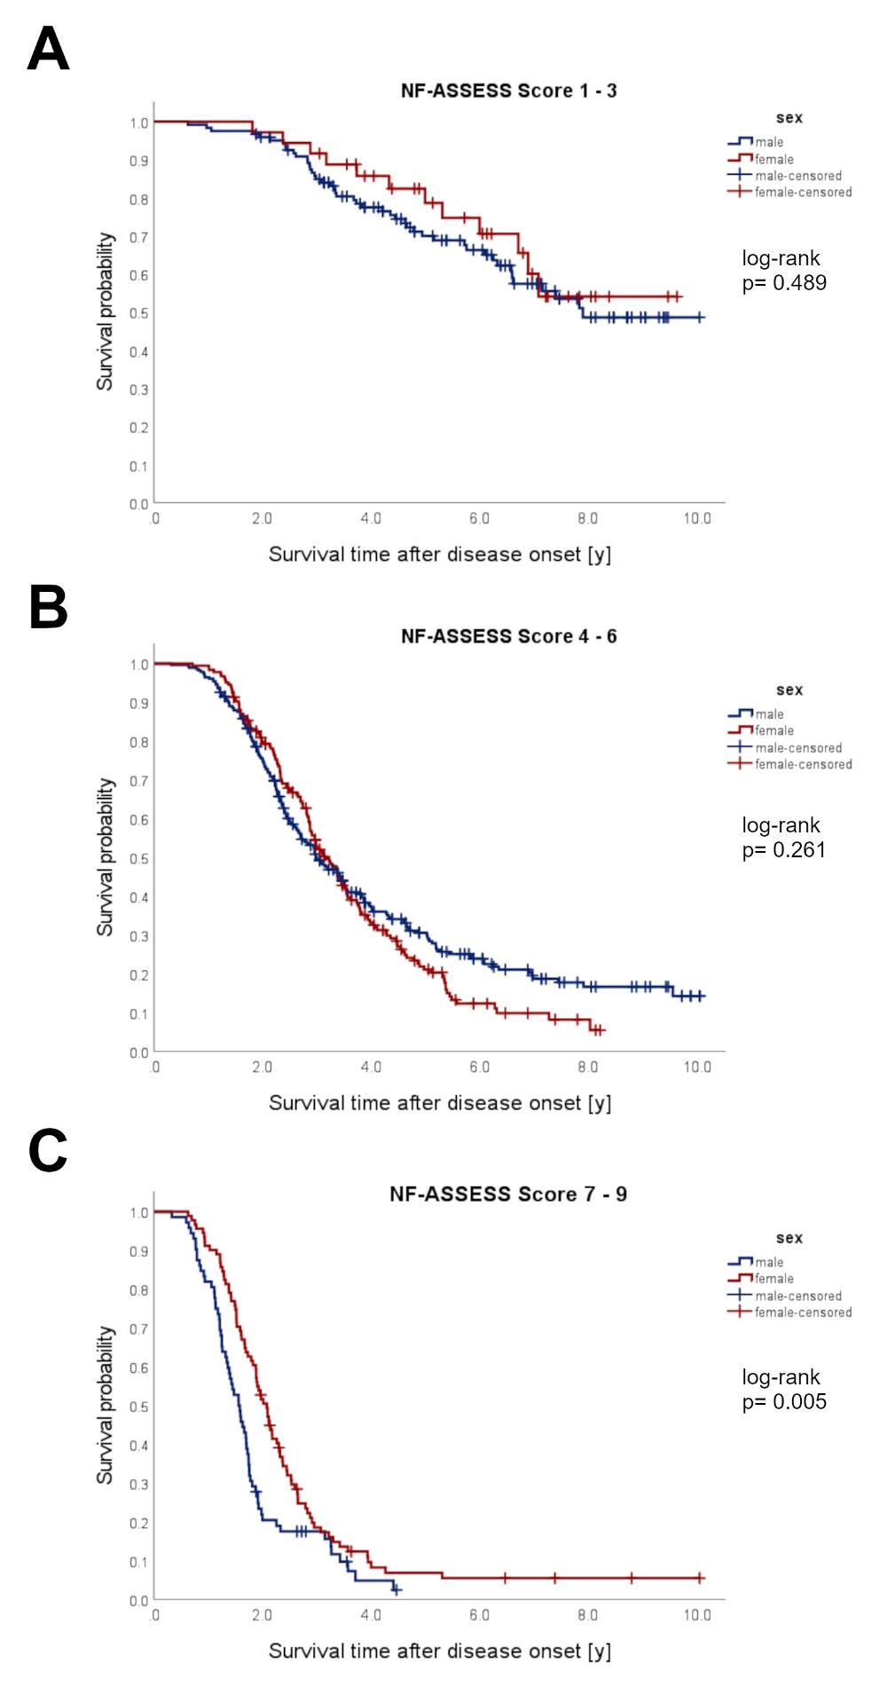

Supplement Figure 13: Sex and Prognosis
The Kaplan-Meier plots compare survival for female (red) and male (blue) sex in patients with NfL-based NF-ASSESS Scores of 1 – 3 (Panel A), 4 – 6 (Panel B), and 7 – 9 (Panel C).

