SUPPORTING INFORMATION
Pyrazoline-based fluorescent probe: Synthesis, Characterization, Theoretical Simulation, and Detection of picric acid
Promila Sharmaª, Mohamad Yusufª, Ashok Kumar Malik^{a*}
ªDepartment of Chemistry, Punjabi University, Patiala-147002
*Corresponding author: malik_chem2002@yahoo.co.uk (A.K.M)

SUPPLEMENTARY SECTION 1

S.S.1 Synthesis of chalcone (2E)-1-(2-hydroxyphenyl)-3-(4-methoxyphenyl)prop-2-en-1-one) (CP).
Chalcone CP was prepared by treating o-hydroxyacetophenone (5.00 g, 0.036 mol) with p-methoxybenzaldehyde (4.8 g, 0.036 mol) and NaOH (1.0 g, 0.024 mol) in ethanol (25 mL). The mixture was stirred for 6 hours while maintaining a 0-6 °C temperature. A reddish mass was obtained which was kept in the refrigerator overnight. The reaction mixture was then poured into iced-HCl to provide a yellow solid. The yellow solid was filtered and thoroughly washed with water and dried. The crude product thus obtained was recrystallized from CHCl₃: MeOH (1:1) to yield a pure compound PC.
Yield 83%; Colour-yellow shining solid; m.p. 82-84°C; IR: υ_{max} (cm⁻¹) 3419 (O-H), 3025 (aromatic C-H), 2970 & 2840 (methylene C-H), 1606 (C=O), 1582 (C=C); ¹H-NMR (400 MHz, CDCl₃): δ 12.95 (1H, s, OH), 7.90 (2H, dd), 7.60 (2H, d), 7.52 (1H, d, H-3, J=15Hz), 7.48 (1H, m), 7.01 (1H, d, J=15Hz), 6.93 (3H, m), 3.58(3H, s, -OCH₃); GC-MS: 254 (M⁺, 100%)

Figure-S.S.1: FTIR spectrum of CP.

Figure-S.S.2: ¹H-NMR spectrum of CP.

Figure-S.S.3: Mass Spectra of CP.

FIGURES OF SUPPLEMENTARY DATA

Figure-S1: FTIR spectrum of BP.

Figure-S2: ¹H-NMR spectrum of BP.

Figure-S3: ¹C- NMR spectrum of BP.

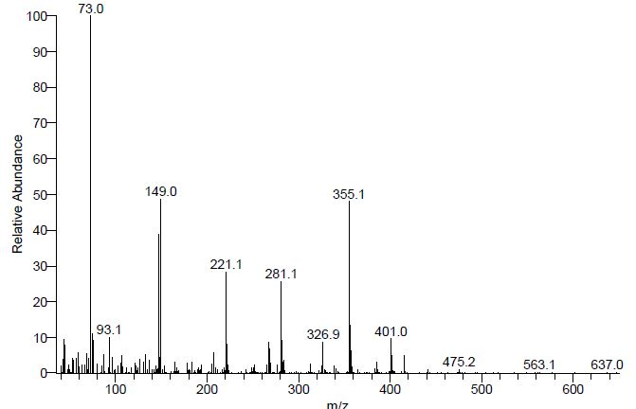

Figure-S4: Mass Spectra of BP.

Figure-S5: Excitation of PA ions and Fluorescence Emission of BP.

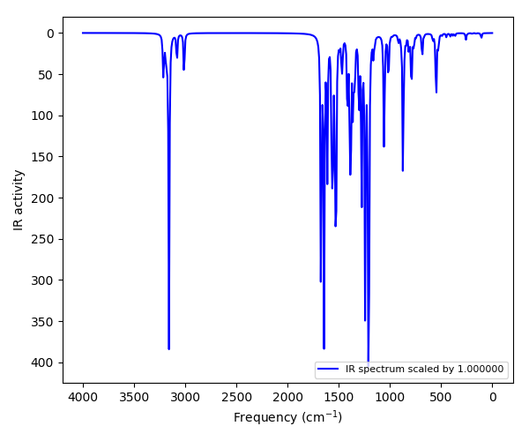

Figure-S6: Theoretical FT-IR spectrum of chalcone CP.

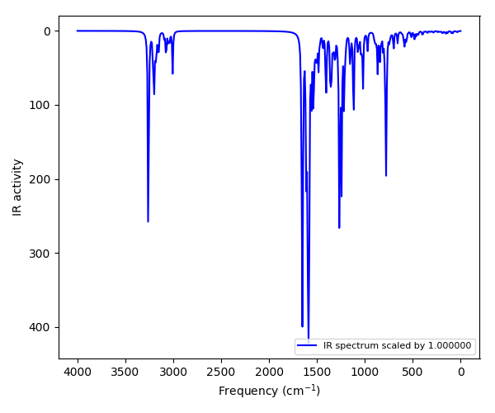

Figure-S7: Theoretical FT-IR spectrum of pyrazoline BP.

TABLES OF SUPPLEMENTARY DATA

Table S1: Detection of PA in different water samples by compound BP.

