CXXC5 Mitigates P. gingivalis-inhibited Cementogenesis by influencing Mitochondrial Biogenesis

Li Ma^{1,2}, Huiyi Wang¹, Xin Huang¹, Hantao Huang¹, Yan Peng¹, Heyu Liu¹, Xiaoxuan Wang^{1,2},Zhengguo Cao^{1,2,*}

¹State Key Laboratory of Oral & Maxillofacial Reconstruction and Regeneration, Key Laboratory of Oral Biomedicine Ministry of Education, Hubei Key Laboratory of Stomatology, School & Hospital of Stomatology, Wuhan University, Wuhan, China
²Department of Periodontology, School & Hospital of Stomatology, Wuhan University, Wuhan, China

Corresponding Author:
Zhengguo Cao, Department of Periodontology, School & Hospital of Stomatology, Wuhan University, 237 Luoyu Road, Hongshan District, Wuhan, 430079, China.
Tel: +86-27-87686212
Email: caozhengguo@whu.edu.cn

Appendix

RNA isolation, DNA extraction, and qPCR
TRIzol ® reagent and PrimeScript RT Reagent Kit were used for isolation of total RNA and reverse transcription, respectively. TaKaRa MiniBEST Universal Genomic DNA Extraction Kit was applied to extract and purify genomic DNA. qPCR was completed on Applied Biosystems QuantStudio 6, with ChamQ SYBR qPCR Master Mix, primers, and templates (complementary-DNA or genomic-DNA). Primers for mouse Il-6, Bsp, Osx, Ocn, Cxxc5, Ppargc1a, Nrf1, Tfam, mt-Nd1, mt-Cox1, and Gapdh were synthesized by Sangon Biotech (Appendix Table 2). Data were normalized to that of the internal control Gapdh, and the 2^{-ΔΔCT} method was used for statistical analysis.

Western blotting
Adherent cells were lysed by M-PER mammalian protein extraction reagent, and cellular lysates were centrifugated at 4 °C to remove deposits and to collect total proteins. The loading quantity of each sample was equal (20–40 μg) on SDS-PAGE, and proteins were then transferred onto PVDF membranes (Millipore). After blockade with nonfat milk for 1.5 h, these membranes were incubated with primary antibodies (anti-PGC-1α, anti-NRF1, anti-TFAM, anti-CXXC5, anti-BSP, anti-Osterix, anti-OCN, or anti-β-actin) overnight at 4 °C, and matched secondary antibodies (anti-rabbit and anti-mouse) for 1 h at room temperature. The bands were detected with an enhanced chemiluminescence detection kit or Supersignal West Femto Trial kit and visualized in the Odyssey LI-COR scanner.

Appendix figures
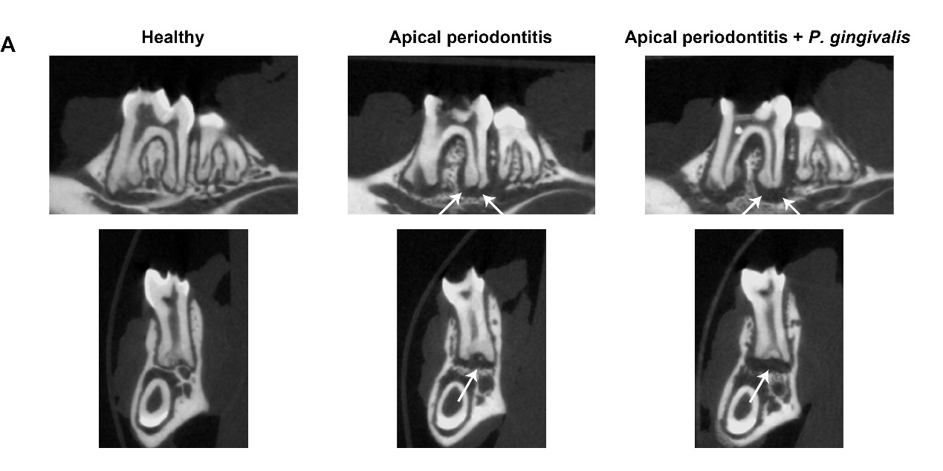
Appendix Figure 1. Apical periodontitis mouse models are successfully established.
(A) Micro-CT images showed evident apical bone destruction in the AP group and extended bone resorption in the AP plus P. gingivalis group.

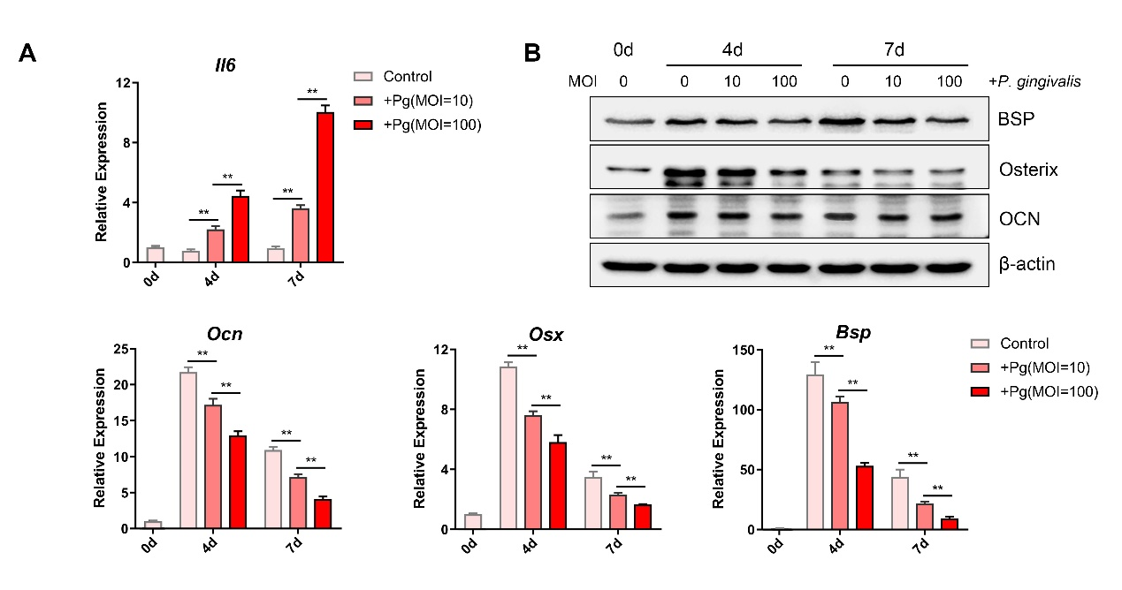
Appendix Figure 2. Negative effects of P. gingivalis on cementoblast differentiation.
(A, B) Cementoblasts were co-cultured with P. gingivalis (MOI = 0, 10, 100) for 0, 4, and 7 days. Expressions of Il-6, Ocn, Osx, and Bsp was detected by qPCR, and protein levels were displayed by western blotting. Data are the mean ± SD. *P < 0.05, and **P < 0.01.

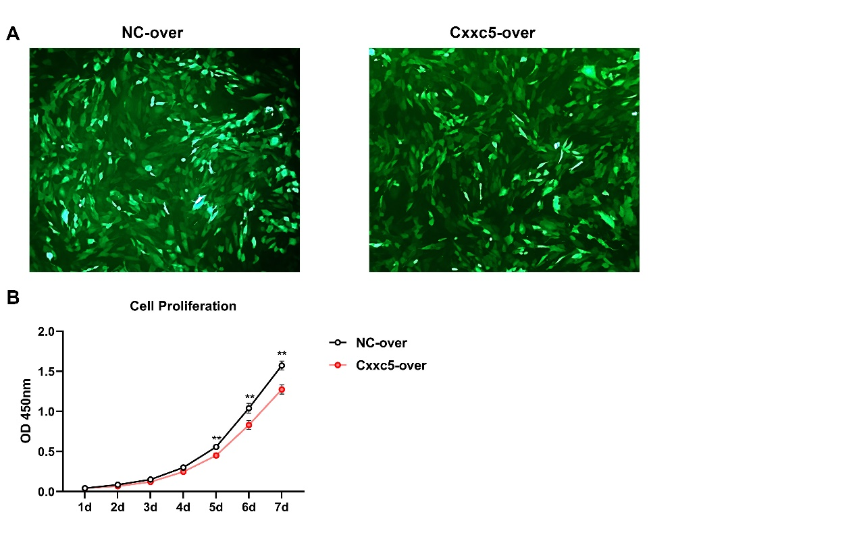
Appendix Figure 3. Characteristics of lentiviral-transfected OCCM cells.
(A) Bright green fluorescence was observed to confirm the transfection efficiency after lentiviral transfection of NC-over and Cxxc5-over. (B) Cell proliferation of control and Cxxc5-over cementoblasts was monitored in OIM for 7 days by the CCK-8 assay. Data are the mean ± SD. *P < 0.05, and **P < 0.01.
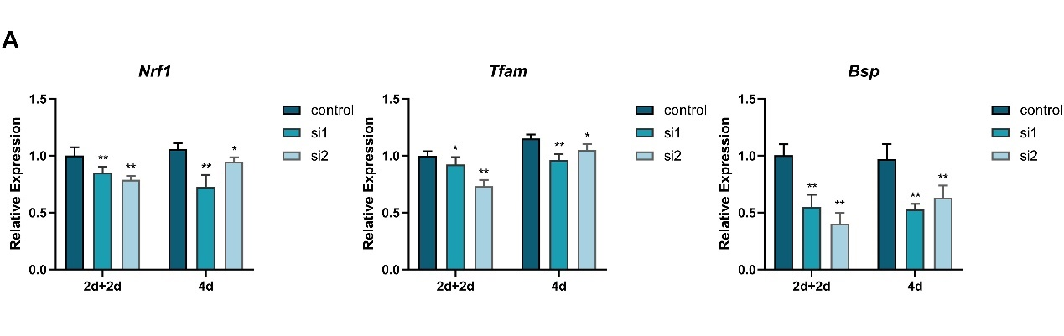
Appendix Figure 4. Effects of two transfection methods on downstream gene expression.
(A) Effects of two transfection methods and different siRNAs for Ppargc1a on mRNA expression of Nrf1, Tfam, and Bsp. Data are the mean ± SD. *P < 0.05, and **P < 0.01.

Appendix Tables

Appendix Table 1. Sources of reagents
Reagents | Source | Identifier
Chemicals
tryptic soy broth | BD Bacto, New Jersey, USA | Cat#BD-211825
yeast extract | Oxoid, Basingstoke, UK | Cat#LP0021
menadione | Sangon Biotech, Shanghai, China | Cat#A606528-0005
hemin | Yuanyebio, Shanghai, China | Cat#S19203
blood agar plate | Land Bridge Technology, Beijing, China | Cat#PB003A
carboxymethylcellulose sodium | Sigma-Aldrich, St. Louis, MO, USA | Cat#C9481
Hematoxylin staining solution | Servicebio, Wuhan, China | Cat#G1004
Eosin staining solution | Servicebio, Wuhan, China | Cat#G1001
Anti-fade fluorescence mounting medium with DAPI | HelixGen, Guangzhou, China | Cat#HNFD-02
DMEM/High glucose | HyClone, Utah, USA | Cat#SH30243.01
Fetal bovine serum | EVERY GREEN, Hangzhou, China | Cat#13011-8611
Trypsin | HyClone, Utah, USA | Cat#SH30042.01
L-Ascorbic acid | Sigma-Aldrich, St. Louis, MO, USA | Cat#A4544
β-glycerophosphate disodium salt hydrate | Sigma-Aldrich, St. Louis, MO, USA | Cat#G9422
RNAiso Plus (TRIzol) | TaKaRa, Japan | Cat#9108
PrimeScript RT Reagent Kit with gDNA Eraser | TaKaRa, Japan | Cat#RR047
ChamQ SYBR qPCR Master Mix | Vazyme Biotech Co., Ltd., Nanjing, China | Cat#Q311-02
M-PER mammalian protein extraction reagent | Thermo Fisher Scientific, Waltham, MA, USA | Cat#78503-1
Enhanced BCA Protein Assay Kit | Beyotime Biotechnology, Shanghai, China | Cat#P0010
SDS-PAGE kit | Servicebio, Wuhan, China | Cat#G2003-50T
Enhanced chemiluminescence detection kit | Advansta Inc., Menlo Park, CA, USA | Cat#K-12045-D10
SuperSignal West Femto trial kit | Thermo Fisher Scientific, Waltham, MA, USA | Cat#34094
BCIP/NBT Alkaline Phosphatase Color Development Kit | Beyotime Biotechnology, Shanghai, China | Cat# C3206
Alizarin Red S | Sinopharm Chemical Reagent, Co., Ltd., Shanghai, China | Cat#71001954
Hexadecylpyridinium chloride monohydrate | Yuanyebio, Shanghai, China | Cat#S48862
Polybrene | HANBIO, Shanghai, China | Cat#HB-PB-1000
INTERFERin transfection reagent | PolyPlus, France | Cat#409
Cell Counting Kit-8 (CCK-8) | Dojindo Molecular Technology, Japan | Cat# CK04
MiniBEST Universal Genomic DNA Extraction Kit Ver.5.0 | TaKaRa, Japan | Cat#9765
CellTiter-Glo Luminescent Cell Viability Assay | Promega, Madison, USA | Cat#G7570
Antibodies for Western Blotting (Working Concentration)
Anti-PGC-1α (1:1000) | Novus Biologicals, Colorado, USA | Cat#NBP1-04676
Anti-NRF1 (1:1000) | Abcam, Cambridge, England | Cat# ab175932
Anti-TFAM (1:2000) | Proteintech, Wuhan, China | Cat# 22586-1-AP
Anti-CXXC5 (1:1000) | Cell Signaling Technology, Danvers, MA, USA | Cat#84546
Anti-BSP (1:1000) | Cell Signaling Technology, Danvers, MA, USA | Cat#5468
Anti-Osterix (1:1000) | Abcam, Cambridge, England | Cat# 22552
Anti-OCN (1:500) | Abcam, Cambridge, England | Cat#ab93876
Anti-β-actin (1:15000) | Proteintech, Wuhan, China | Cat#66009-1-AP
Anti-mouse (1:8000) | Proteintech, Wuhan, China | Cat#SA00001-1
Anti-rabbit (1:10000) | Proteintech, Wuhan, China | Cat#SA00001-2

Appendix Table 2. Primer sequences used for qPCR
gene | Primer sequences forward/reverse
Il-6 | CCACTTCACAAGTCGGAGGCTTA/  CCAGTTTGGTAGCATCCATCATTTC
Bsp | GAGCCTCGTGGCGACACTTA/  AATTCTGACCCTCGTAGCCTTCATA
Osx | CCTCTCGACCCGACTGCAGATC/ AGCTGCAAGCTCTCTGTAACCATGAC
Ocn | GAGGACCATCTTTCTGCTCACT/  CGGAGTCTGTTCACTACCTTATTG
Cxxc5 | AGGCAGGAGGAACAGACA/  GTGCTTTGAGGTAGGGTTG
Ppargc1a | GAATCAAGCCACTACAGACACCG/ CATCCCTCTTGAGCCTTTCGTG
Nrf1 | GGCAACAGTAGCCACATTGGCT/  GTCTGGATGGTCATTTCACCGC
Tfam | ATTCCGAAGTGTTTTTCCAGCA/  TCTGAAAGTTTTGCATCTGGGT
mt-Nd1 | TCAACCCTAGCAGAAACAAACC/  GGCCGGCTGCGTATTCTAC
mt-Cox1 | TCAGTATCGTATGCTTCAACAAATTTAGA/  TGGTTCCTCGAATGTGTGATATG
Gapdh | GGAGATTGTTGCCATCAACGA/ GAAGACACCAGTAGACTCCACGACA

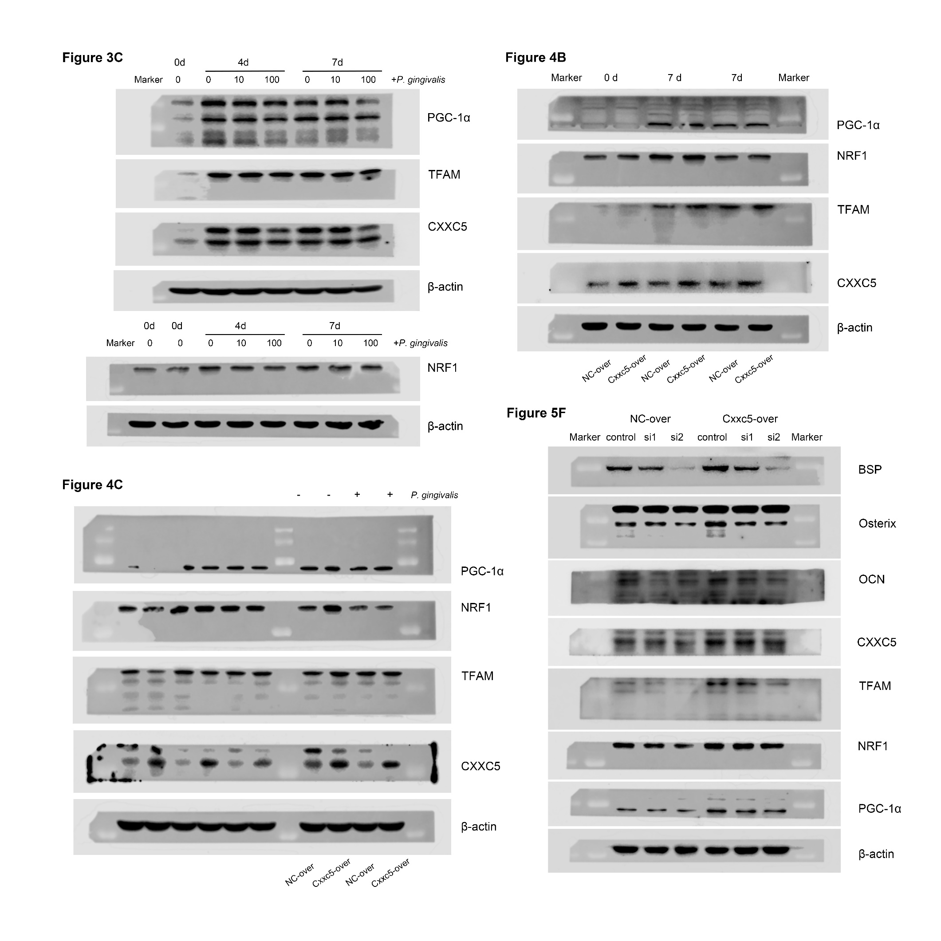
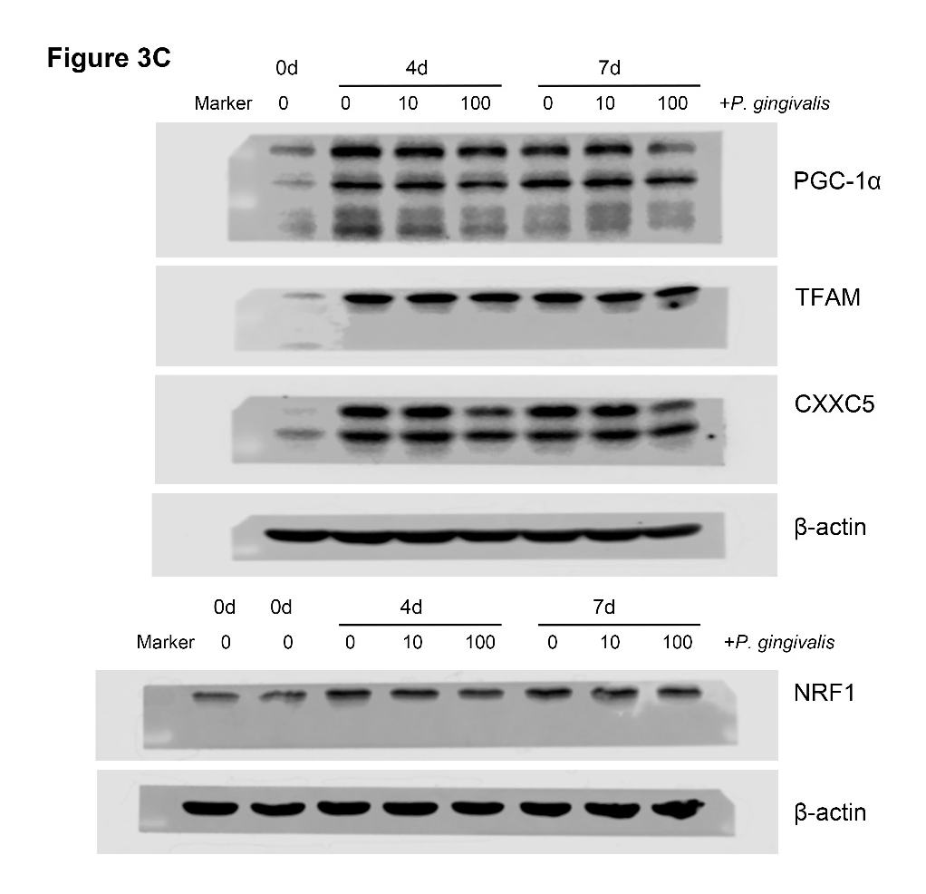
Western blots raw images

