Optical model for Spectroscopic ellipsometry
According to ref [1] to have minimal oxide we have to reach maximal value of <ε₂> in the region around 4.8eV. The highest value they mentioned 25.2 correspond to minimal oxide.
After 2 min etching in concentrated HCl the spectra were not changed anymore, therefore it can be concluded we have reached minimal oxide thickness. Which is not less than 1.6 nm and it is different for different samples.
Optical properties of GaAs in the region 0.5-5.1 eV can be described by series of critical-point energies. These are E₀, E₀+Δ₀, E₁, E₁+Δ₁, E₂, E₂+Δ₂ (Figure 1s).
Additionally the contribution of free electrons to light scattering is described by Drude component to complex dielectric function. The corresponding dielectric function ε(E) for ellipsometric data analysis can be formulated in the form of the following equation:
$ε\left(E\right)=ε_{1}\left(E\right)+i∙ε_{2}(E)$,
where the real part of dielectric permittivity is $ε_{1}\left(E\right)=-\frac{{\left(\frac{E_{p}}{E}\right)}^{2}}{1+{\left(\frac{E_{Γ}}{E}\right)}^{2}}$, the imaginary part of dielectric permittivity is $ε_{2}\left(E\right)=\frac{E_{Γ}}{E}\frac{{\left(\frac{E_{p}}{E}\right)}^{2}}{1+{\left(\frac{E_{Γ}}{E}\right)}^{2}}$, and parameters $E_{p}$ and $E_{Γ}$ are the plasma energy and the broadening which is related to the scattering frequency.
Optical model for AIII-BV was developed by Adachi [2]. It consists of main interband transitions E₀, E₀+Δ₀, E₁, E₁+Δ₁, E₂, E₂+Δ₂ (Figure 1s).
Г₈→Г₆ optical transitions Adachi 3D M0: This type of Adachi model dielectric function (MDF) [2-6] can be used to describe the spectral dependence of dielectric constant of (diamond and zinc-blende structure) semiconductor crystals, when the direct interband E₀, E₀ + Δ₀ transitions are dominants and separated with high symmetry as three dimensional (3D) M₀ critical points (CP’s) in the band structure. In this approach the dispersion mechanism includes the effect of discrete and continuum excitonic transitions.
In this model A₀, E₀, and Г₀ are the transition amplitude, position and broadening, A_{0x} is the 3D discrete exciton strength, G₀ is the 3D exciton Rydberg energy, A_{0C} is the 3D continuum exciton strength and E_{0C}~ E₀ is the ground state exciton energy.

L_{4,5}→L₆ optical transitions Adachi 2D M0: In case of zinc-blende-structure semiconductor crystals the contributions of E₁, E₁+Δ₁ type direct band gap transitions (along the <111> directions in the Brillouin zone) to the complex dielectric function usually can be treated by two dimensional (2D) M₀ critical point (CP) approximation, such as the Adachi 2D-M₀ model dielectric function (MDF) [2-6].
In this model the quantities B₁, Г₁ and E₁ are respectively, strength, broadening and energy of transition at the 2D-M₀ critical point, as well as B_{1x} is the 2D exciton strength and G₁ is the 2D Rydberg energy.

X₇→X₆ optical transitions Adachi DHO: The dispersion what is originated from E₂, E₂+Δ₂ structure transitions in zinc-blende-type semiconductors is generally investigated by the model dielectric function (MDF) of damped harmonic oscillator (DHO) [2-6].
In this model C₂ and Г are respectively the strength of the interaction between oscillator and the electromagnetic wave (photon) and damping factor of the oscillator as well as E₂ is the position of the Lorentzian-like shape what is provided by the DHO model on the spectrum of dielectric constant.

Г₈→L₆ and Г₈→X₆ indirect optical transitions Adachi IBGT: The transitions between solid states which are not vertical on the energy-band diagram are called as indirect band gap transitions (IBGT). It occurs, e.g. in case of Si, Ge semiconductor materials. This two-step transition process can be studied by second order perturbation theory [6], which describes the coupling of electron-photon and electron-phonon interactions.
In this model D is the indirect-transition strength parameter, E_{g} is the indirect-gap energy, E_{c} is the high-energy cut off and Г is the damping energy of the indirect transitions.

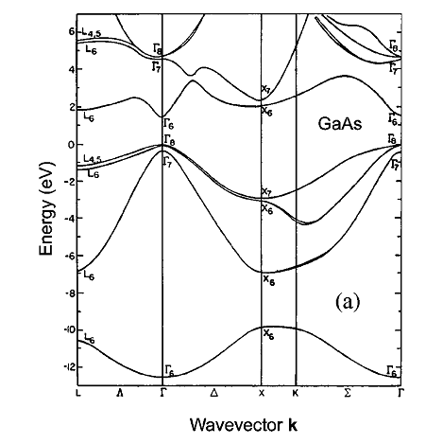
Figure 1s. Conduction and valence band energies as a function of wave vector [7-9].

PS. The datasets used and/or analysed during the current study available from the corresponding author on reasonable request.

[1] P. Lautenschlager, M. Garriga, S. Logothetidis, M. Cardona, Interband critical points of GaAs and their temperature dependence, Physical Review B, 35 (1987) 9174.
[2] S. Adachi, Model dielectric constants of gap, gaas, gasb, inp, inas, and insb, Physical review B, 35 (1987) 7454.
[3] S. Adachi, Model dielectric constants of Si and Ge, Physical review B, 38 (1988) 12966.
[4] H.Y.H. Yoshikawa, S.A.S. Adachi, Optical constants of ZnO, Japanese Journal of Applied Physics, 36 (1997) 6237.
[5] T. Kawashima, S. Adachi, H. Miyake, K. Sugiyama, Optical constants of CuGaSe 2 and CuInSe 2, Journal of applied physics, 84 (1998) 5202-5209.
[6] S. Adachi, Effects of the indirect transitions on optical dispersion relations, Physical review B, 41 (1990) 3504.
[7] M.L. Cohen, J.R. Chelikowsky, Electronic structure and optical properties of semiconductors, Springer Science & Business Media, 2012.
[8] I. Vurgaftman, J.á. Meyer, L.á. Ram-Mohan, Band parameters for III–V compound semiconductors and their alloys, Journal of applied physics, 89 (2001) 5815-5875.
[9] J. Blakemore, Semiconducting and other major properties of gallium arsenide, Journal of applied physics, 53 (1982) R123-R181.

