A click-based electrocorticographic brain-computer interface enables long-term high-performance switch-scan spelling

Supplementary Materials

Table of Contents
Supplementary Notes
Supplementary Note 1 | Exploratory nature of the clinical trial. Page 3
Supplementary Note 2 | Safety of the study device. Page 3
Supplementary Note 3 | Recording viability of the study device. Page 3
Supplementary Note 4 | BCI functionality of the study device. Page 4
Supplementary Note 5| Retraining a new brain-click detection after performance drop. Page 4
Supplementary Note 6 | Selecting the optimal voting threshold. Page 5
Supplementary Figures
Supplementary Fig. 1 | Training paradigm. Page 6
Supplementary Fig. 2 | Cue-aligned spectrograms of upper-limb electrodes. Page 7
Supplementary Fig. 3 | Alignment of power trial rasters. Page 8
Supplementary Fig. 4 | Correlation increase of HG power in re-aligned signals. Page 9
Supplementary Fig. 5 | Correlation analysis of channel 112 using re-aligned trials. Page 10
Supplementary Fig. 6 | Labelling trial-averaged re-aligned HG power. Page 11
Supplementary Fig. 7 | Classification model architecture. Page 12
Supplementary Fig. 8 | User interface of communication board. Page 13
Supplementary Fig. 9 | User interface of switch-scanning speller. Page 14
Supplementary Fig. 10 | Timelines of brain-click use after training. Page 15
Supplementary Fig. 11 | Performance decline roughly 4 months post-training. Page 16
Supplementary Fig. 12 | Deviation in movement-aligned high-gamma power. Page 17
Supplementary Fig. 13 | Long-term use of a fixed retrained brain-click detector. Page 18
Supplementary Fig. 14 | Performance evaluation across all voting thresholds. Page 19
Supplementary Fig. 15 | Switch-scanning spelling performance with a retrained click detector. Page 20
Supplementary Fig. 16 | Normalized saliency values. Page 21
Supplementary Tables
Supplementary Table 1 | Experimental parameters for training data collection. Page 22
Supplementary Videos Descriptions
Supplementary Video 1 | Switch-scan control of communication board. Page 22
Supplementary Video 2 | Switch-scan spelling. Page 22
References Page 23
Supplementary Notes
Supplementary Note 1. Exploratory nature of the clinical trial.
The clinical trial from which the results in this study are being reported is a single-center Phase 1 early feasibility trial to investigate the safety and preliminary efficacy of an investigational brain-computer interface (BCI) device. No more than 5 participants are planned to be enrolled and implanted. Due to the exploratory nature of the study, the primary outcomes are stated in general terms evaluating the safety and recording viability of the implanted device, as well as preliminary assessment of BCI functionality enabled by the device. The metrics and statistics for BCI functionality are not predefined due to the limited number of trial participants and the exploratory nature of the study with respect to strategies for achieving BCI functionality. Nevertheless, the results reported in each participant are to be evaluated to the highest statistical rigor in keeping with comparable studies, which also limited to individual participants^{1–6}.

Supplementary Note 2. Safety of the study device.
To date, there have been no adverse events related to the study device or study participation, and the participant has consented to continue the study. At this time the device has been implanted for more than a year and continues to be used for research purposes.

Supplementary Note 3. Recording viability of the study device.
The implant recording viability was assessed by visual inspection of the channel raw voltage signals as well as by measuring electrode impedances. Visual inspection of the voltage signals occurred at the beginning of each session, while electrode impedances were measured once per week.

Voltage signals were visually inspected for the presence of noise, signal amplitudes exceeding the digital bit-range of the recording hardware, signals with unusually low amplitude, or presence of movement artifact. Throughout the study, there were no fewer than 124 viable channels. Suboptimal signal quality was observed in four channels (chan19, chan38, chan48, and chan52, Fig. 1b) all of which were located on the electrode grid covering cortical speech areas. However only chan38 was consistently marked for suboptimal signal quality throughout the duration of the trial.

It is important to note that the decision to exclude chan38 from model training was made only after the initial click detection algorithm was deployed for real-time use. Meanwhile chan19, chan48, and chan52 were never marked for poor signal quality during data collection for initial model training but were marked as such later in the trial. The click detection algorithm trained without features from these channels (Supplementary Note 5) performed comparably to the model trained with these channel features included (see Results: Decoder retraining due to transient performance drop). Indeed, features from these four channels provided minimal contributions to classification (Supplementary Fig. 16) and by themselves produced a mean classification accuracy of 55.2% (chance 50%) using repeated 10-fold cross validation (see Methods: Channel contributions and offline classification comparisons).

Electrode impedances were measured using the Impedance Tester tool on Central Suite (Blackrock Neurotech Corp.). Particularly, electrodes whose impedance values exceeded a 15 kΩ threshold by an order of magnitude were compared to channels with suboptimal signal quality and would be additionally excluded from analysis if they were not already marked by visual inspection. To date, chan38 has presented with an impedance consistently roughly two orders of magnitude higher than the 15 kΩ threshold. On one session chan121 also presented with a similarly high impedance.

Supplementary Note 4. BCI functionality of the study device.
The goal of this aspect of the study is to demonstrate control of external devices through speech and/or motor strategies, as well as a performance assessment of each strategy. Because of the exploratory nature of the study and the limited number of participants, specific strategies, tasks, performance metrics, and longitudinal assessments were not predefined. Rather, we anticipated that these methods would evolve during the trial and would be customized to each participant. Likewise, we did not formalize a statistical analysis plan in the protocol. In keeping with this protocol, the present work demonstrates a proof-of-concept spelling system controlled by attempted grasping movements and an ECoG-based BCI in a single participant. Our approach to reporting these results is similar to that of numerous published single-subject studies of implantable BCI functionality^{1–6}.

Supplementary Note 5. Retraining a new brain-click detection algorithm after performance drop.
We collected three blocks of training data using the “Go” task as described in Methods: Training task. Each block consisted of 60 trials during which the participant attempted to make a grasping motion, and each trial was followed by an interstimulus interval (ISI) during which the participant remained still and fixated his gaze on a crosshair in the center of the monitor. The ISI length was randomly chosen between 3.5-4.5 s. Each block started with a 30 s rest period during which the participant was instructed to remain still with his gaze fixated on a “Rest” stimulus. In total, 180 trials were collected for a total of almost 15 min of data. All three blocks were collected on the same day. Neural signals were recorded by the Neuroport system with a sampling rate of 2 kHz. We excluded four channels (chan19, chan38, chan48, chan52) due to poor raw voltage signal quality determined by visual inspection. High gamma (HG) features were computed and re-aligned for inter-trial variability as described in Methods: Feature extraction and label assignment. We assigned grasp labels to ECoG feature vectors falling between 0.4 s and 1.2 s post-cue for each trial and rest labels to all other feature vectors. We used the model architecture and techniques described in Methods: Model design and training to train our model. During spelling sessions, video of the participant’s right hand was collected at 60 frames per second (FPS) during all sessions with the retrained algorithm.

Supplementary Note 6. Selecting the optimal voting threshold.
We defined the optimal voting threshold as the one that produced the highest F₁-score:

$$F_{1}= \frac{2N_{TP}}{2N_{TP}+N_{FP}+N_{FN}}$$

where $N_{TP}$ and $N_{FP}$ are the number of true and false positive clicks respectively, and $N_{FN}$ is the number of missed clicks. $N_{FN}$ can be rewritten as $N_{attempted grasps}-N_{TP}$, and so our F₁-score can be rewritten as:
$$F_{1}= \frac{2N_{TP}}{N_{TP}+N_{FP}+N_{attempted grasps}}$$

The F₁-scores for all voting thresholds are calculated using the total numbers of attempted grasps, true and false positives across all six sessions with the retrained brain-click detector:
Voting threshold | 2/7 | 3/7 | 4/7 | 5/7 | 6/7 | 7/7
N_{attempted grasps} | 597 | 582 | 476 | 421 | 423 | 461
N_{TP} | 563 | 519 | 435 | 382 | 399 | 382
N_{FP} | 57 | 23 | 20 | 13 | 14 | 0
F₁-score | 0.925 | 0.923 | 0.934 | 0.936 | 0.955 | 0.906

The 6-vote threshold produced the highest F₁-score of 0.955.

Supplementary Figures

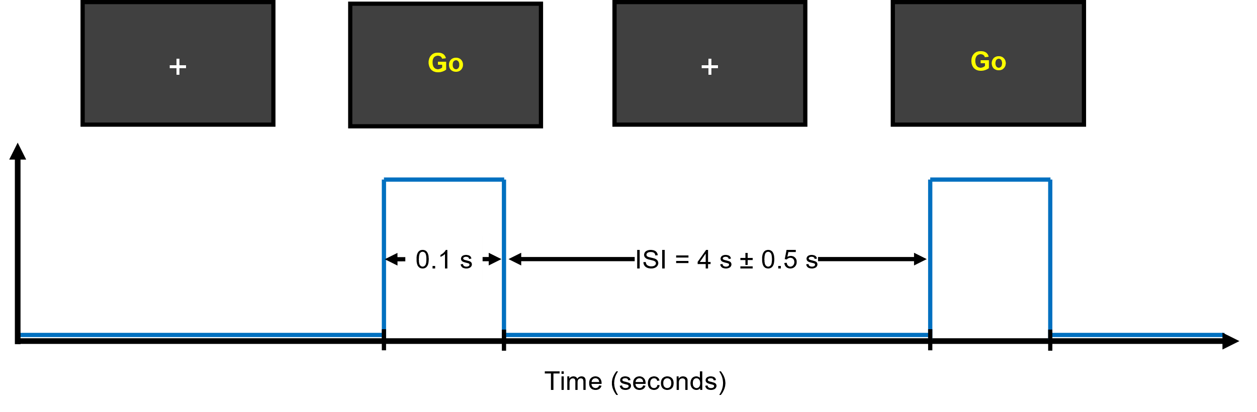
Supplementary Fig. 1 | Training paradigm. As the participant was seated in a chair with his forearms on the armrests, he was instructed to attempt a brisk grasp with his right hand immediately after the visual stimulus “Go” appeared on the monitor. One trial consisted of one 100 ms “Go” stimulus followed by an interstimulus interval (ISI) during which a centered white crosshair remained in the center of the monitor. The length of each ISI was randomly chosen between a lower and upper bound (3.5 - 4.5 s or 3 - 6 s, see Supplementary Table 1) to reduce anticipatory behavior.

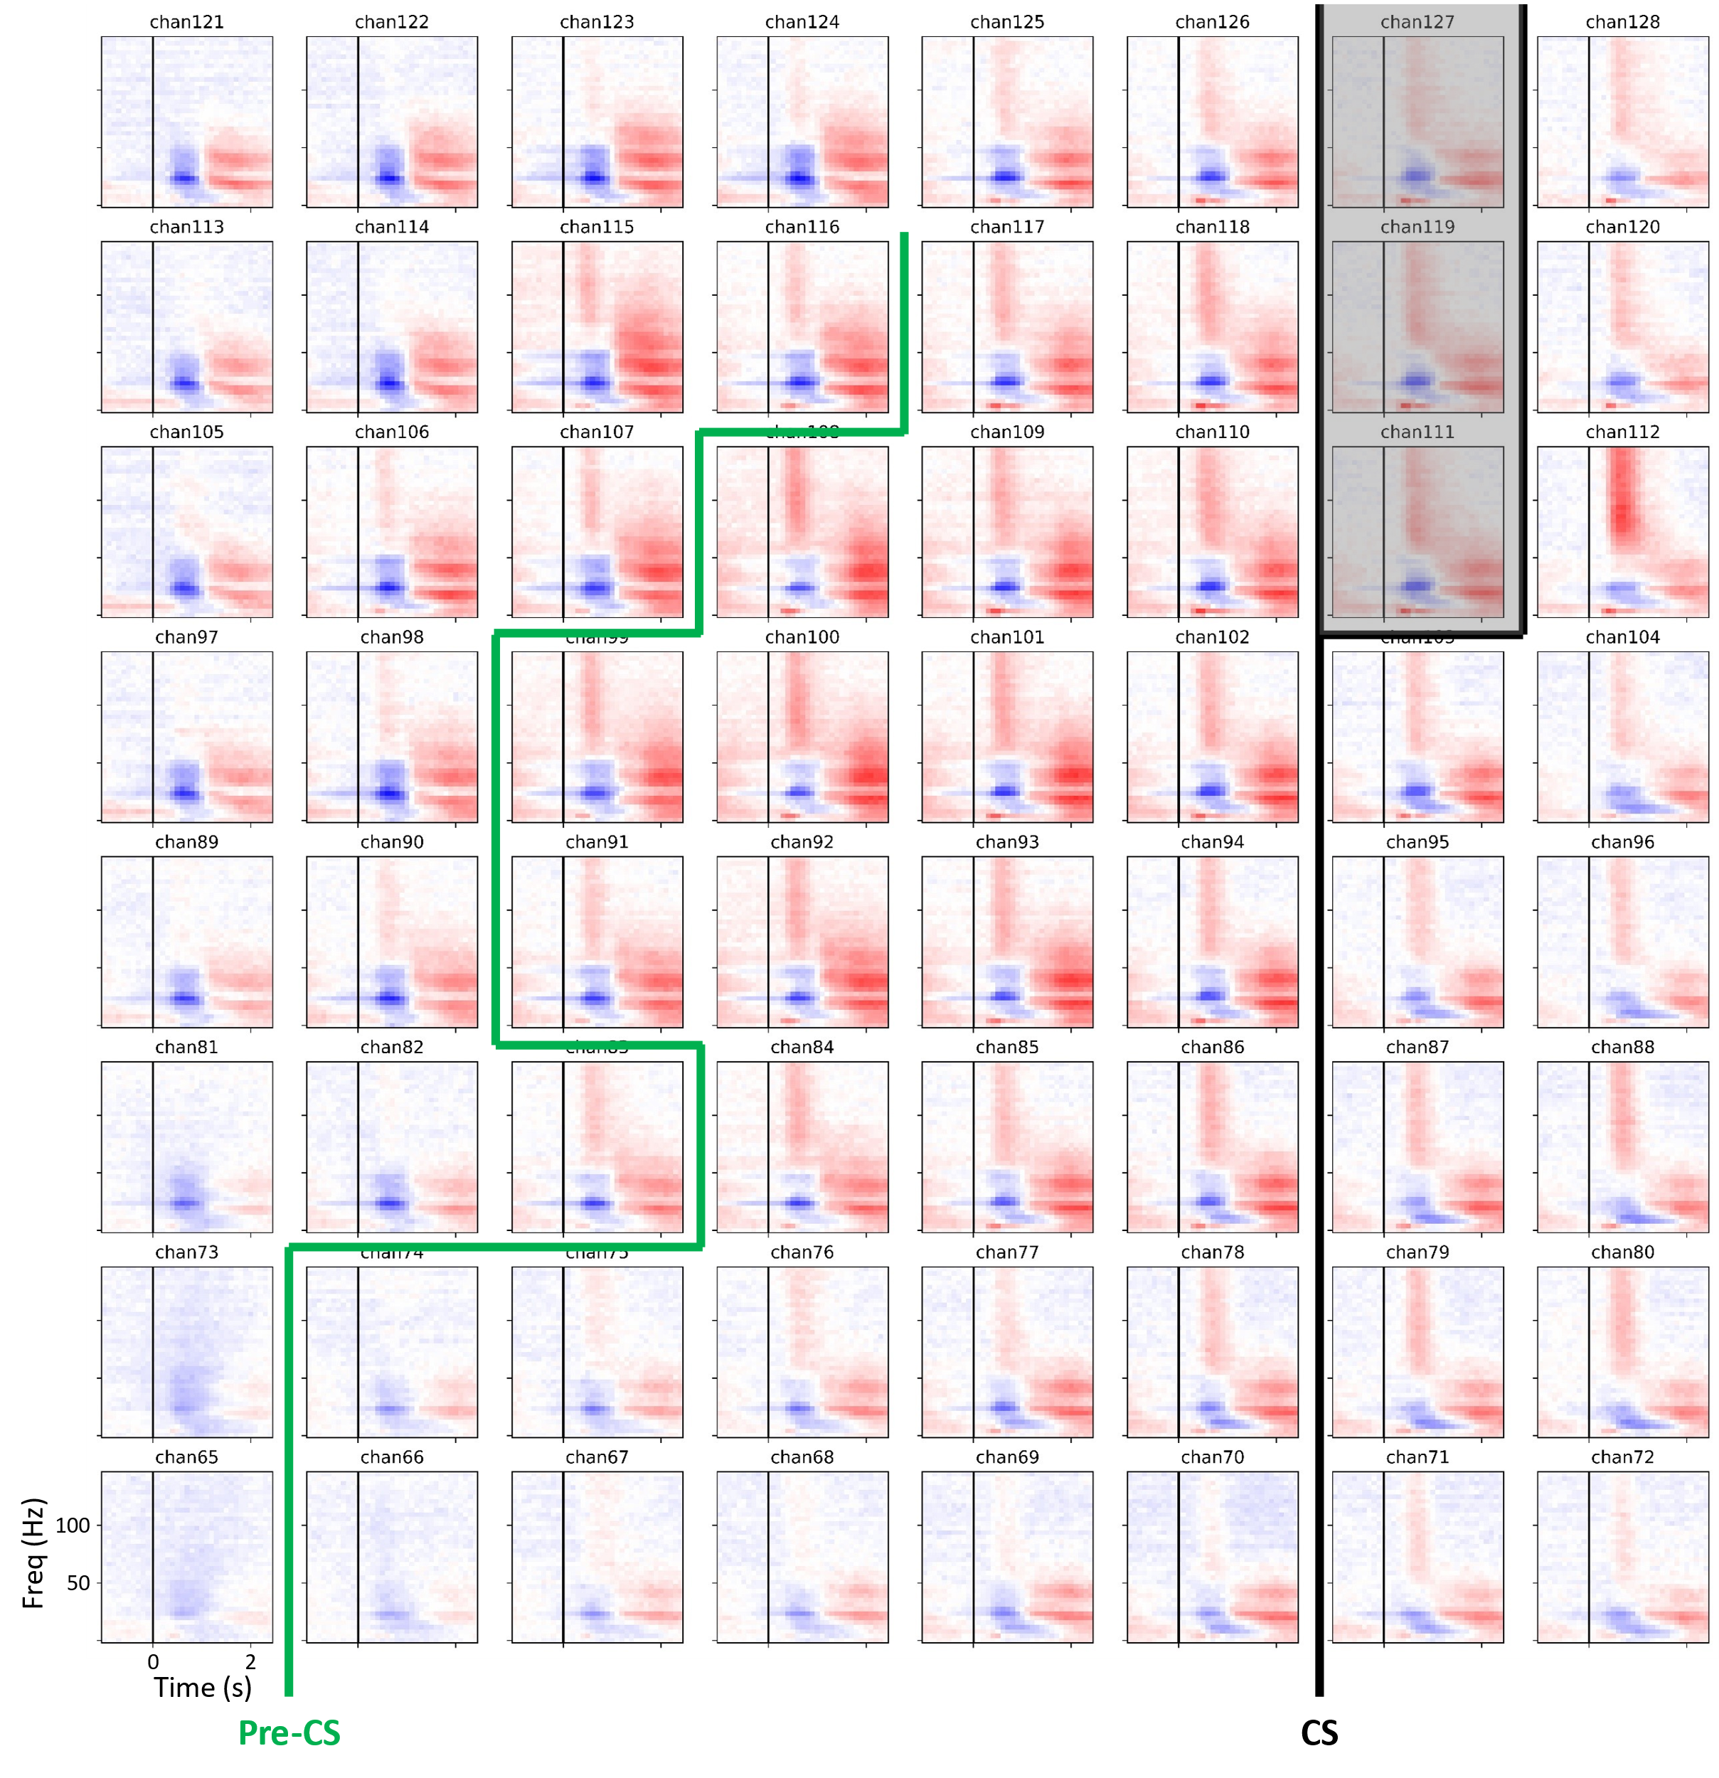
Supplementary Fig. 2 | Cue-aligned spectrograms of upper-limb electrodes. Across trials from all training blocks for the original click detector, the cue-aligned trial-averaged spectrogram for all electrodes in the upper-limb grid is shown (-1 to 2.5 s post-cue). The vertical black lines for each electrode represent cue onset. Spectral power at each frequency is standardized to the statistics of the 1 min calibration period. The slightly increased broadband activity observed in some channels’ pre-cue interval is likely due to the relatively heightened baseline activity during the training paradigm. The HG increase is followed by a low frequency rebound, which across many channels (especially in the center of the grid) reaches 100 Hz. The approximate central sulcus location is delineated by a thick black line (CS) and widens at the top such that electrodes B111, B119, and B127 are over it. The pre-central sulcus is delineated by a thick green line (Pre-CS).

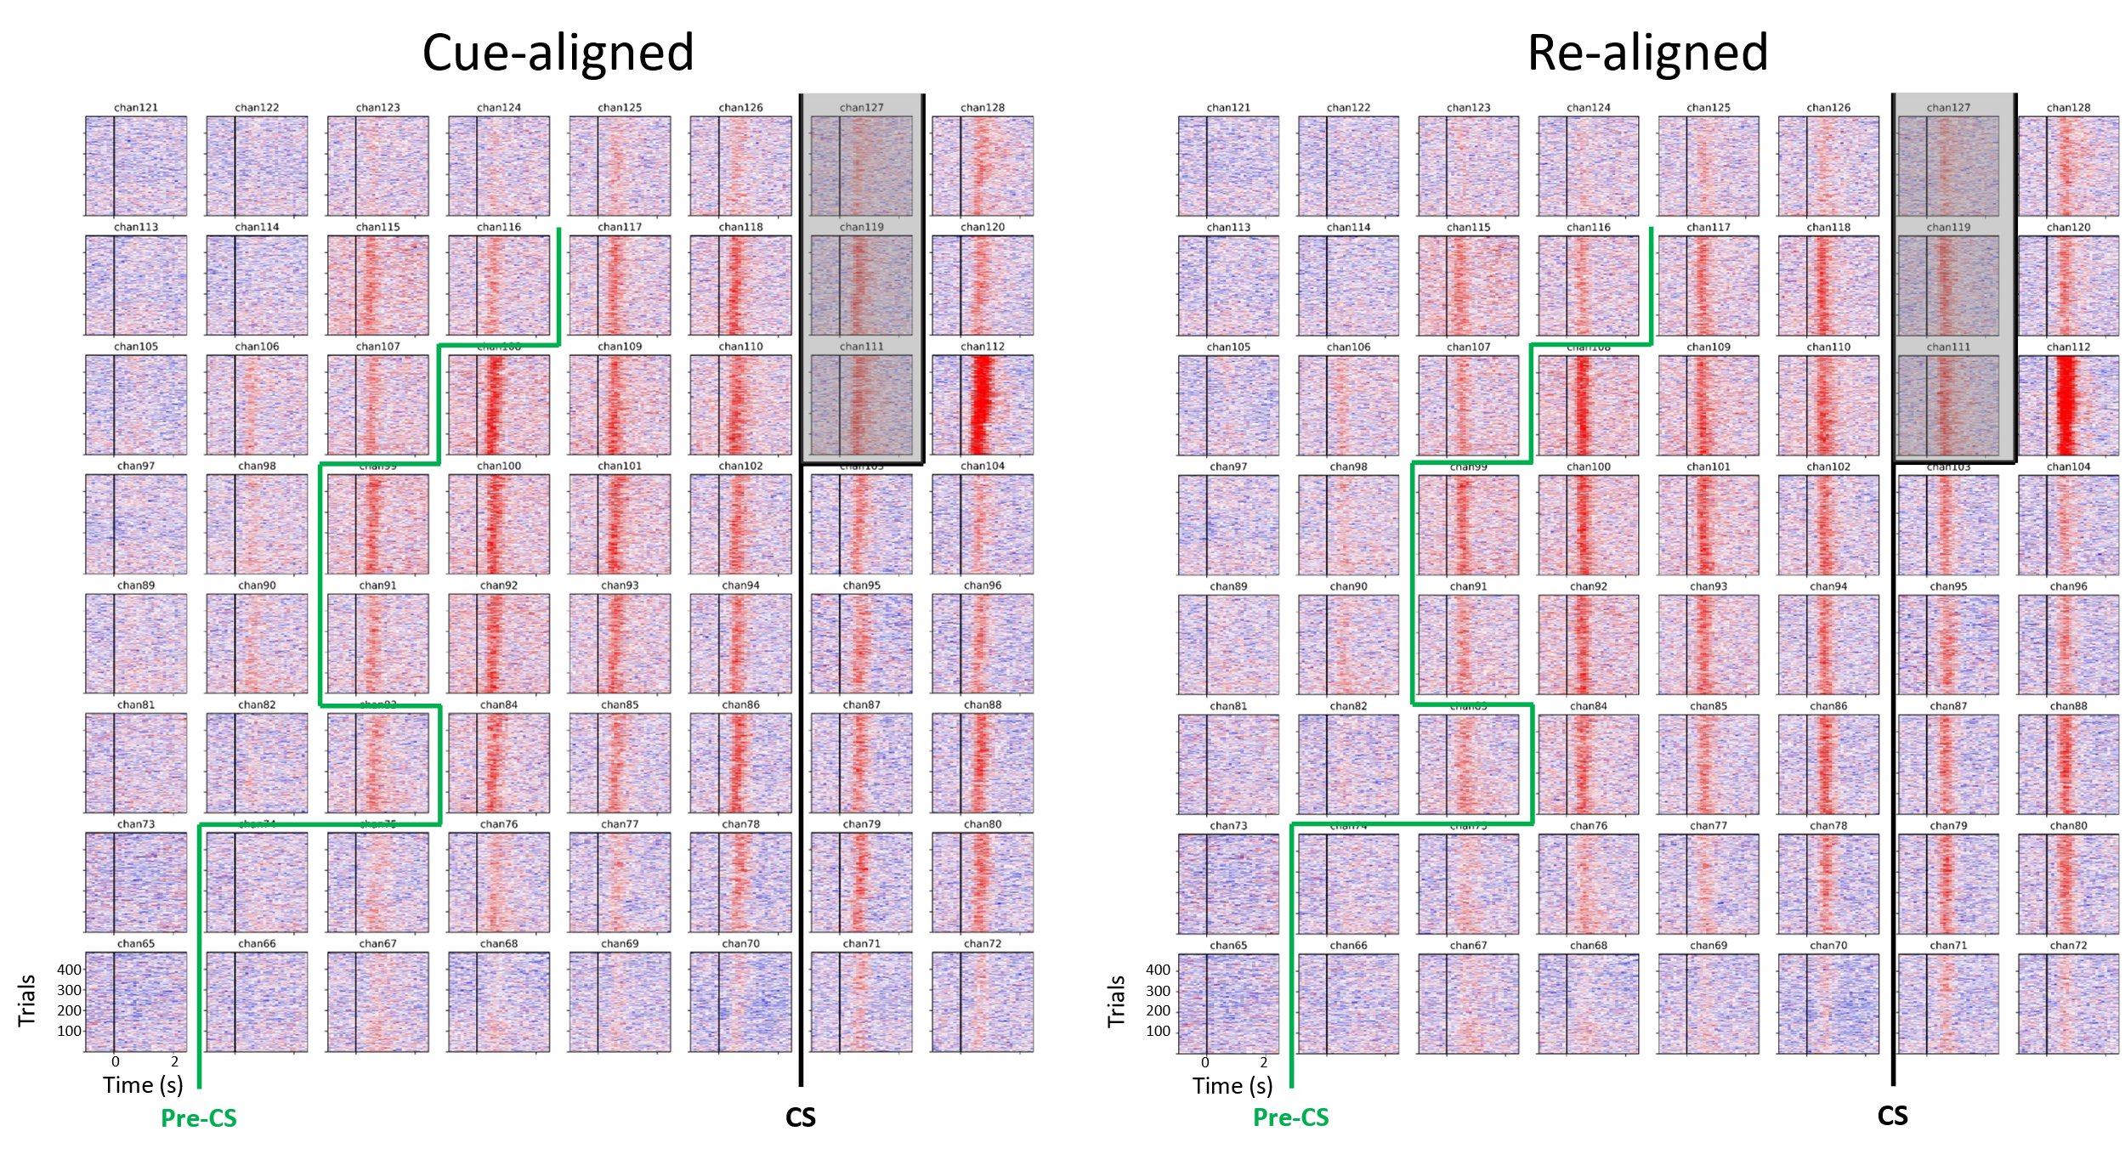
Supplementary Fig. 3 | Alignment of power trial rasters. Across all training blocks for the original click detector, the cue-aligned HG power (110-170 Hz) for each trial is shown for all electrodes in the upper-limb grid (Cue-aligned). To account for inter-trial variability (especially for reaction delay in attempted movements), HG power between -1 s and 2.5 s post-cue from channels 86, 88, 94, 101, 102, 108, 109, 110, 112 were used to compute a per-trial shift, which was then used to re-align the HG power across all electrodes (Re-aligned). The approximate central sulcus location is delineated by a thick black line (CS) and widens at the top such that electrodes 111, 119, and 127 are over it. The pre-central sulcus is delineated by a thick green line (Pre-CS).

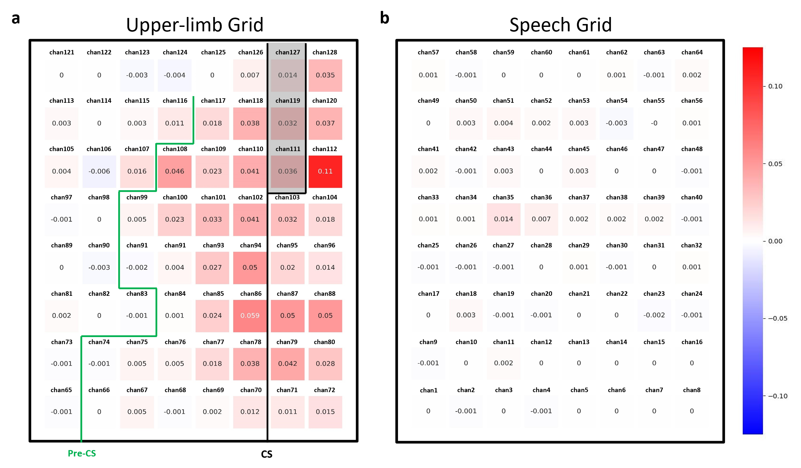
Supplementary Fig. 4 | Correlation increase of HG power in re-aligned signals. The change in correlation between the re-aligned and cue-aligned HG power trials for each electrode. Electrodes in the upper-limb grid (a) generally increased their inter-trial HG power correlation, whereas those in the speech grid (b) generally stayed the same. The central sulcus (CS) is delineated by a thick black line and widens at the top such that electrodes 111, 119, and 127 are over it. The pre-central sulcus (Pre-CS) is delineated by a thick green line.
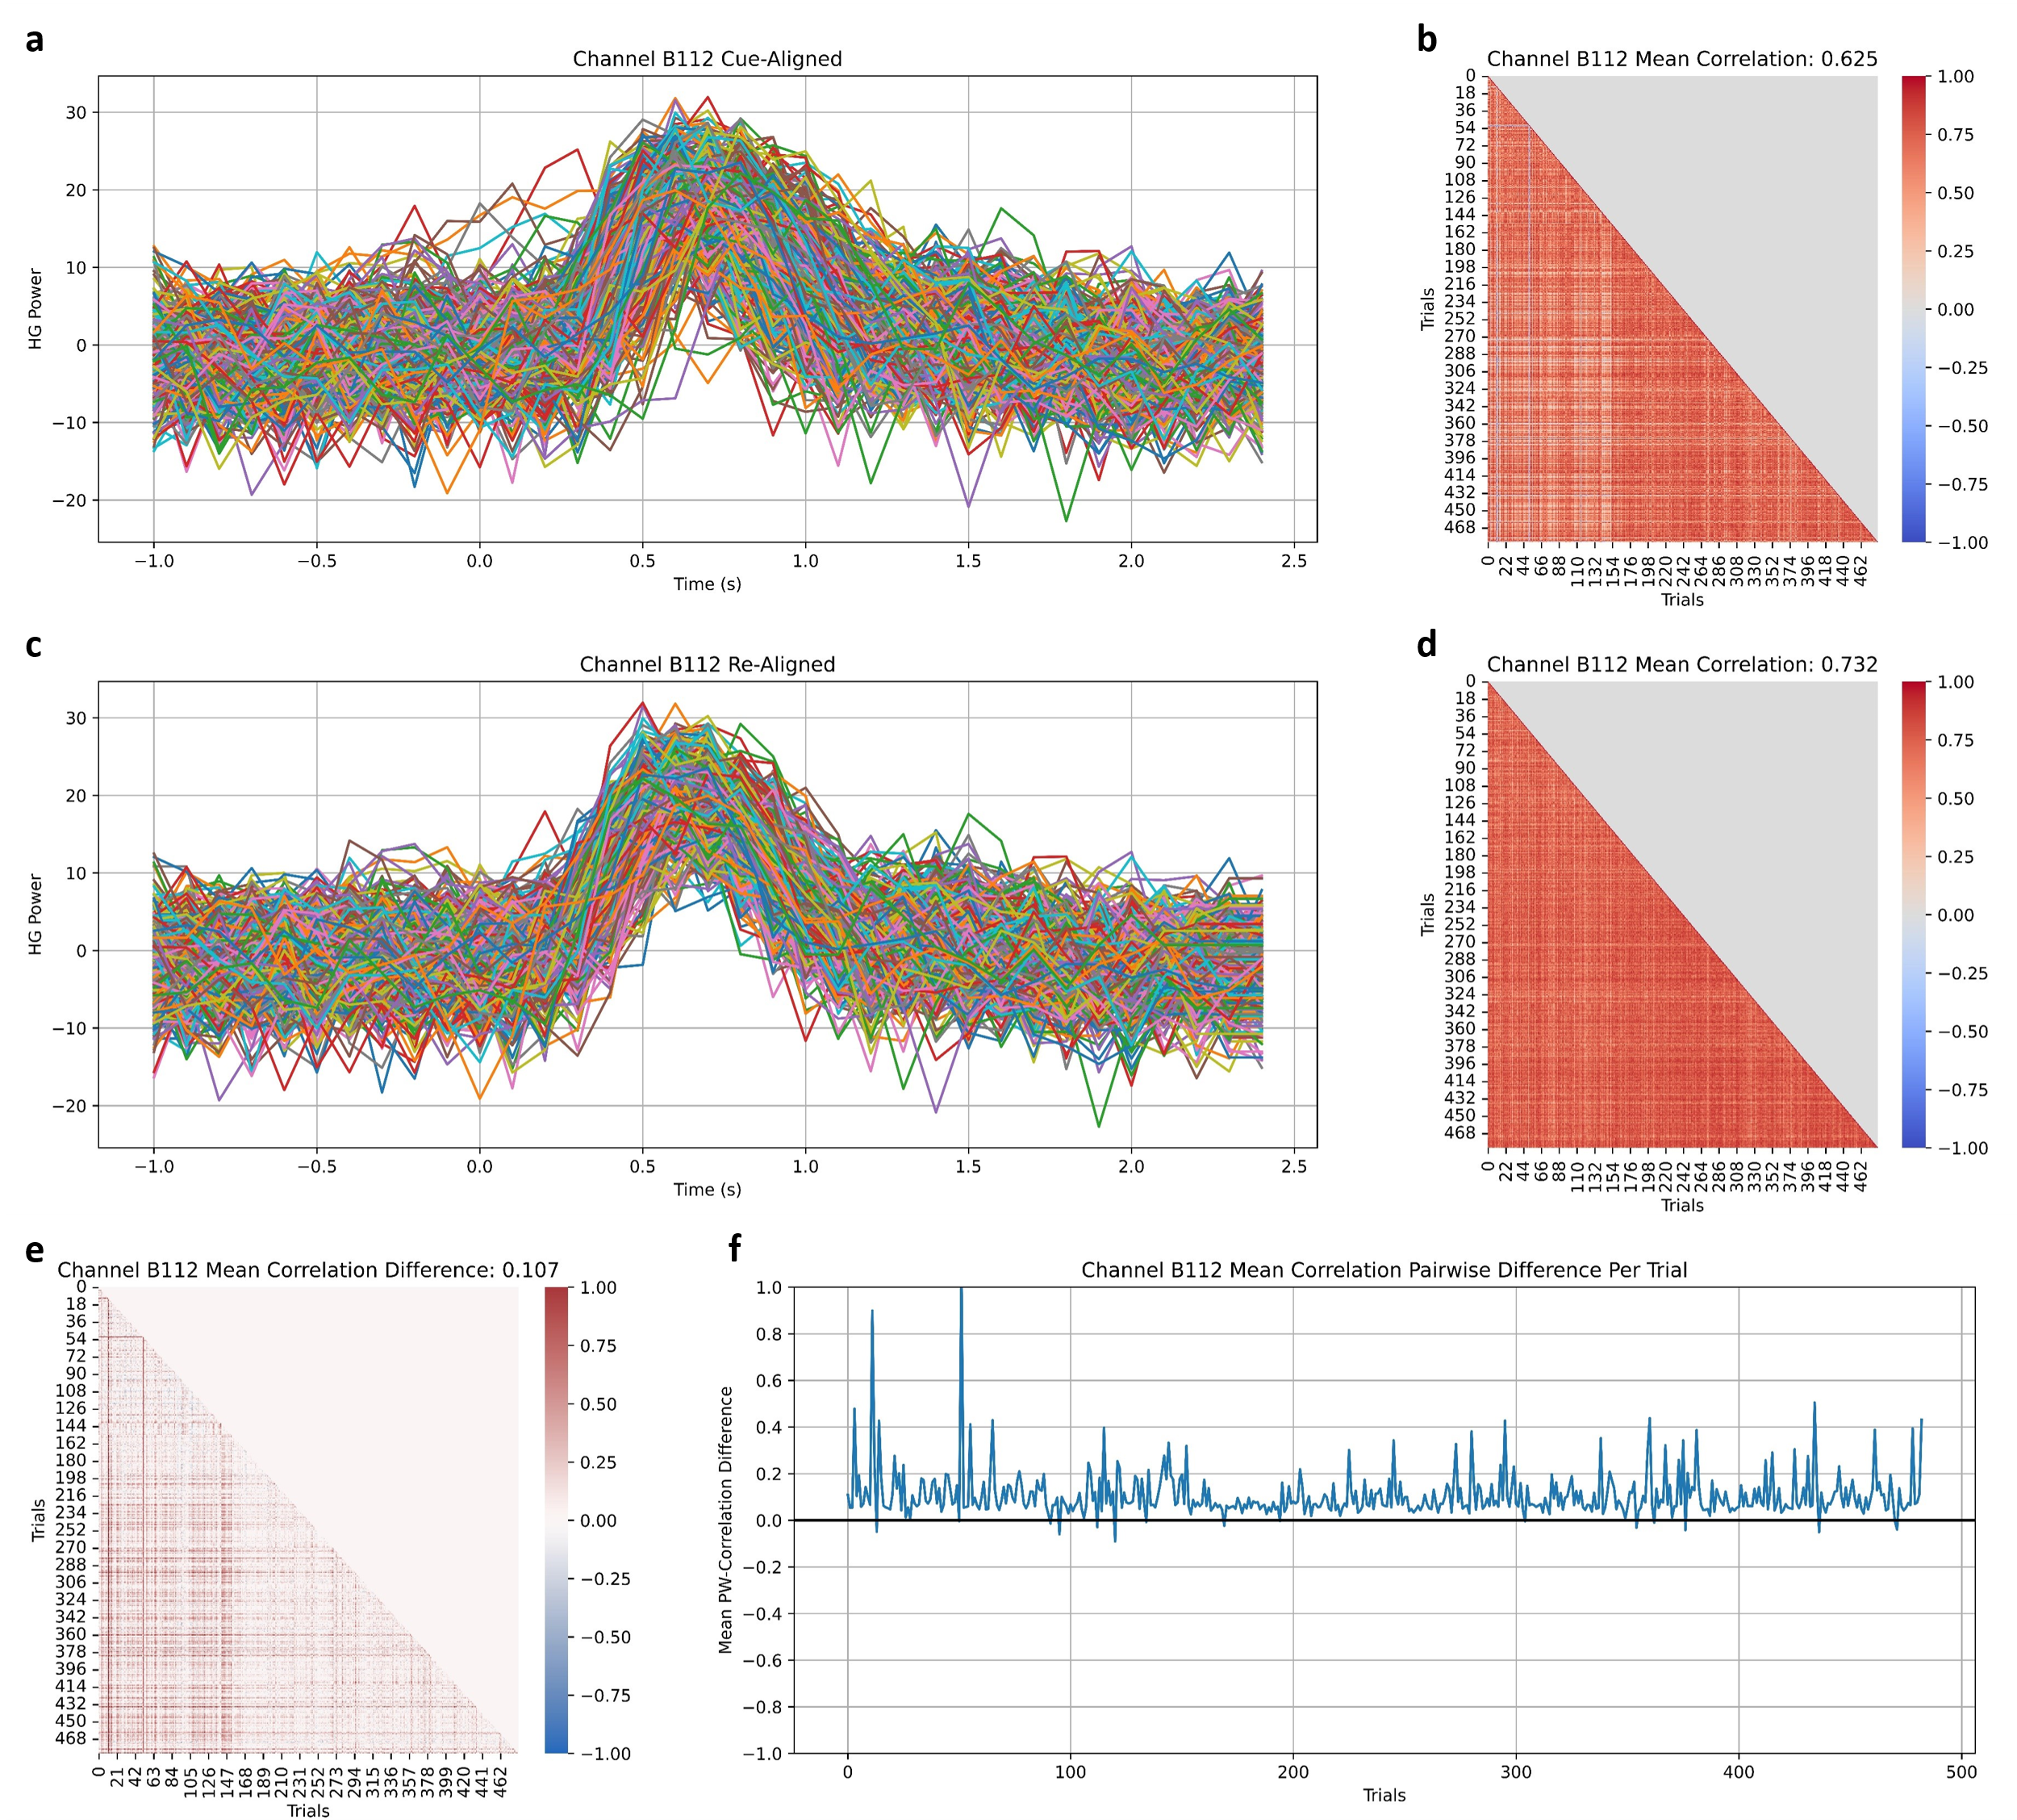
Supplementary Fig. 5 | Correlation analysis of channel 112 using re-aligned trials. Channel 112 is presented as an example of increased inter-trial correlation of HG power after re-alignment. (a) Cue-aligned HG power across all trials. (b) Pair-wise correlation between all trials for channel 112. The mean correlation is computed by taking the mean of all inter-trial correlation values and is computed similarly in (d) and (e). (c) Re-aligned HG power across all trials. (d) Increased pair-wise correlation between all trials. (e) Difference between Re-aligned and Cue-aligned HG power across all trials. (f) Mean pair-wise correlation change for each trial. For one trial, the mean pair-wise correlation change is computed by taking the mean of correlations between the HG power for that trial with those from all other trials.

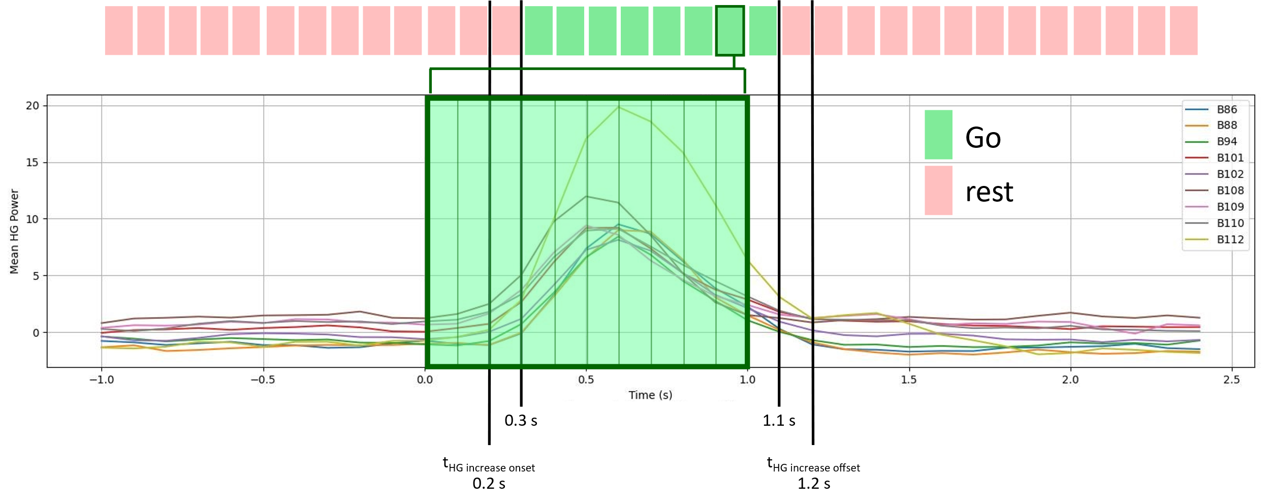
Supplementary Fig. 6 | Labelling trial-averaged re-aligned HG power. Trial-averaged re-aligned HG power is shown for each of the channels that were used to compute the per-trial shift. Each 100 ms feature vector between 0.3 s and 1.1 s post-cue was labelled grasp while all other time points were labelled rest. The outlined grasp label at 0.9 s (dark green outline) displays an average representation of 1 s time history from the subset of channels used to train the original click detector.

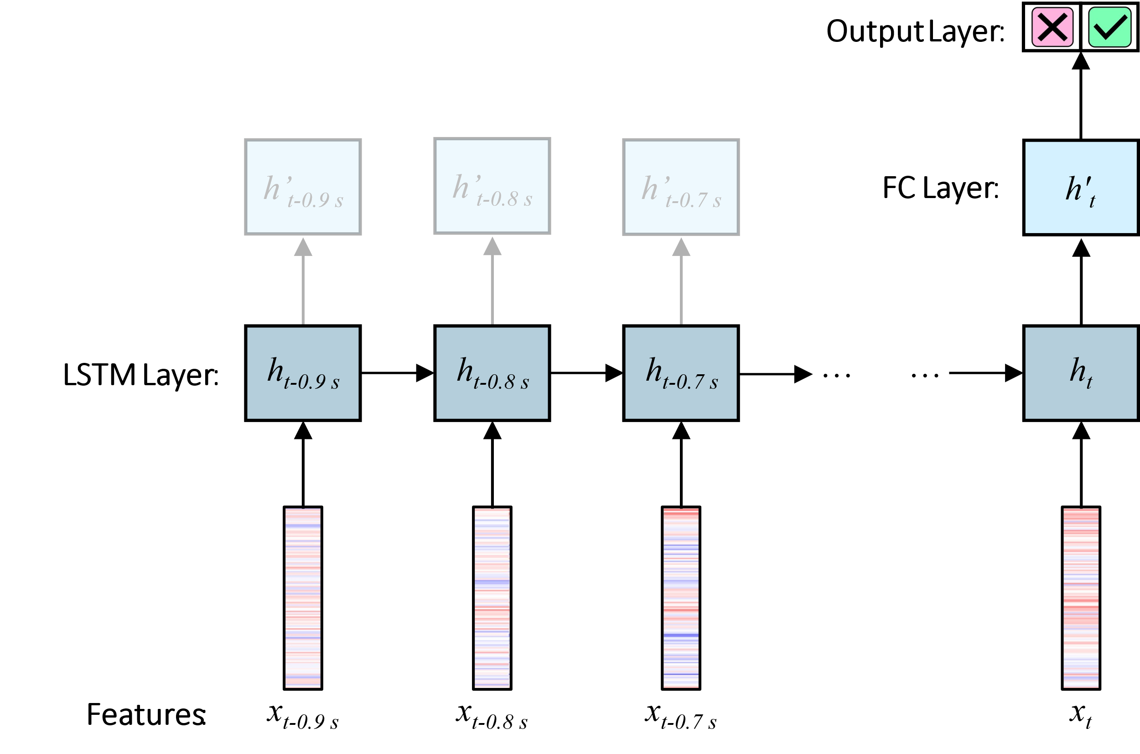
Supplementary Fig. 7 | Classification model architecture. We used a recurrent neural network that utilizes long short-term memory (LSTM) cells in a many-to-one configuration to predict output probabilities. The architecture of the network is comprised of 3 layers: 1 LSTM layer with 25 units followed by 2 fully-connected layers with 10 and 2 units, respectively, that incorporate eLU and softmax activation functions for non-linear transformations. We trained this network on high-gamma power sequences with a fixed length of 1 s and a framesize of 100 ms using backpropagation through time (BPTT). Here, we relied on the Adam optimizer with an initial learning rate of 10e-4. In total, the network was trained for 75 epochs and a batch size of 45.

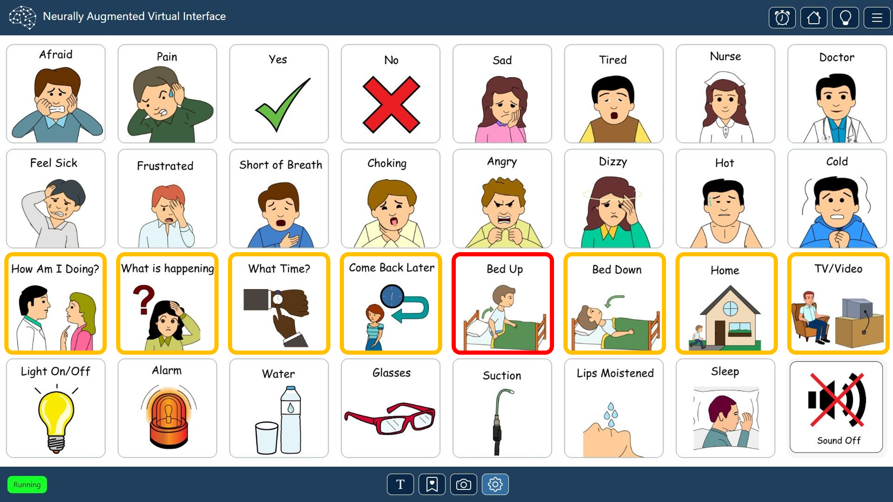
Supplementary Fig. 8 | User interface of communication board. The participant was instructed to select an experimenter-cued graphical button from a 4x8 grid by timing his brain-clicks to the appropriate highlighted row or column during the switch-scanning cycle. Switch-scanning started by sequentially highlighting each row in green (not shown) for 1 s until the participant brain-clicked on the row containing the cued button. Once a row was selected, all eight buttons in that row became outlined in gold and then each column was sequentially highlighted for 1 s in red. Once the participant selected a button by brain-clicking, the button became green for 1 s before the switch-scanning process was reset at row 1 and the participant received another cue.

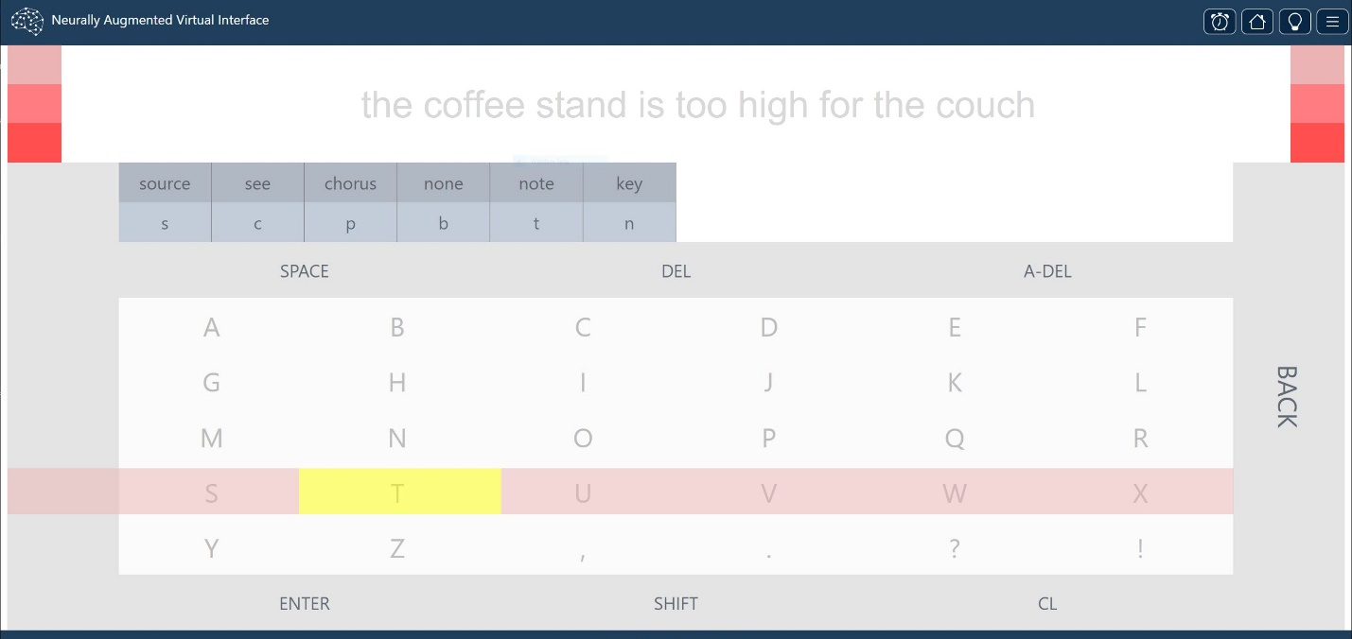
Supplementary Fig. 9 | User interface of spelling application. The participant was instructed to spell the sentence prompt (gray text) by timing his brain-clicks to the appropriate highlighted row or column during the switch-scanning cycle. The switch scanning process started by sequentially highlighting the three red pre-selection markers on either side of the sentence, where each highlight lasted 1 sec. This was to allow our participant a brief preparation period in case he wanted to select row 1. Rows 1-8 were then scanned sequentially until the participant brain-clicked on the row containing the appropriate letter or word. Rows 1 and 2 displayed our language model’s most likely words and letters based on what the participant had already spelled. Row 3 allowed the participant to add a space, delete a letter or space, or delete an autocompleted word or letter (SPACE, DEL, and A-DEL keys respectively). Rows 4-8 contained all alphabetical letters (and some grammatical symbols) in case the desired letter was not suggested in Row 2. Once a row was selected, the gray pre-selection column on the left was highlighted in yellow for 1 sec to allow the participant a brief preparation period in case he wanted to select column 1. Buttons in the selected row were then sequentially highlighted in yellow for 1 s. At the end of each sequence of column highlights, the BACK key was highlighted to allow the participant to exit the row if it was selected accidentally. Brain-clicking on any button (highlighting it green for 1 s) within any row would reset the switch-scanning process at Row 1. The participant finalized the sentence by selecting the ENTER button in Row 8. The SHIFT (for letter capitalization) and CL buttons (for erasing the spelled words) were functional but not used during the testing sessions. If the participant had not selected any of the eight rows, the switch-scanning process was reset to Row 1.

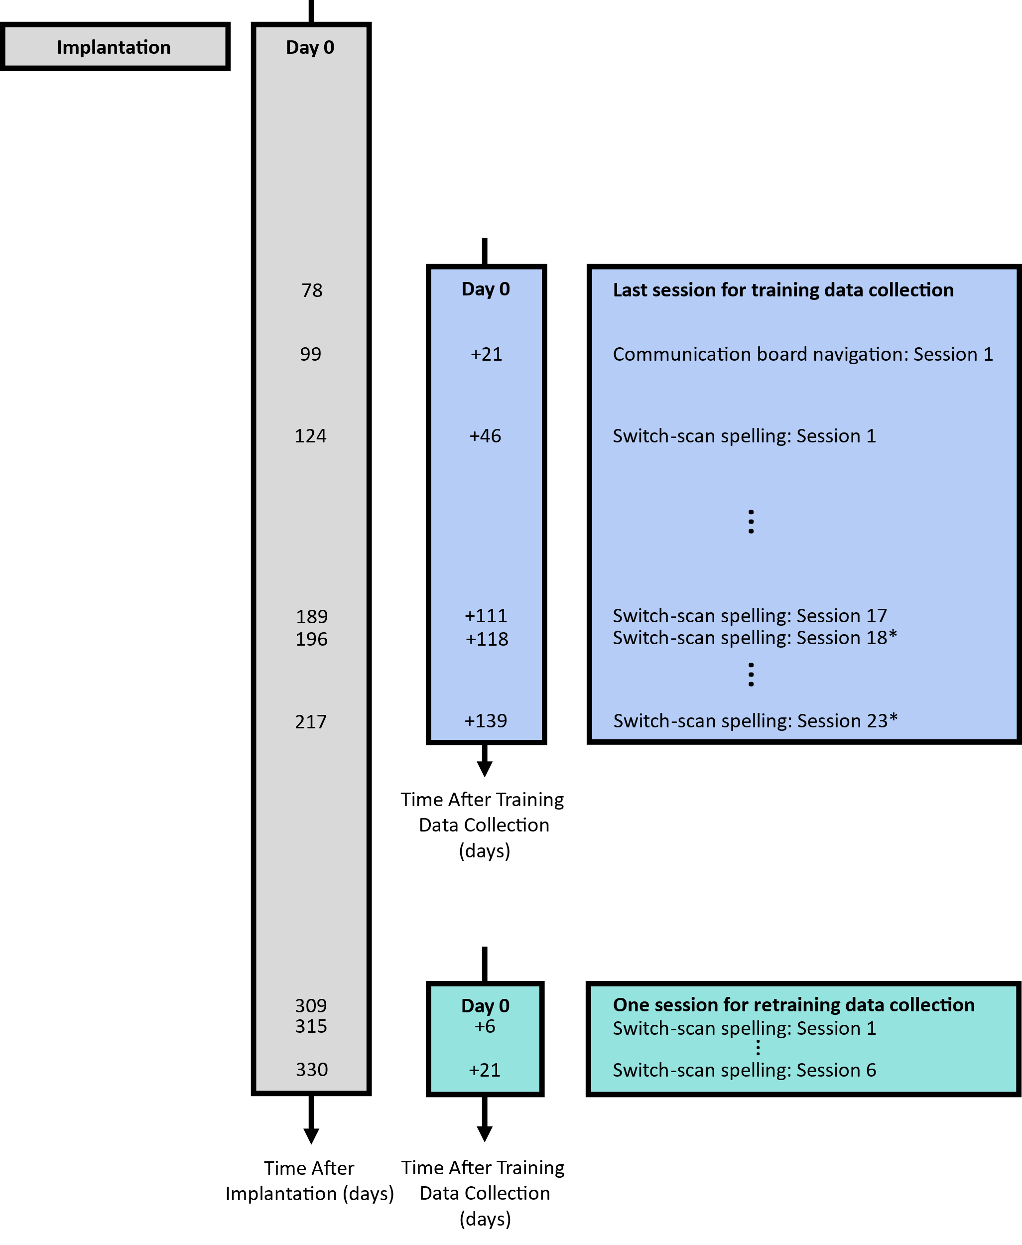
Supplementary Fig. 10 | Timelines of brain-click use after training. Timeline of training and testing sessions relative to the surgical implantation (grey) where the implantation date is denoted as Day 0. Timeline of brain-click usage with the communication board and spelling interface (blue) relative to the last session of data collection for training the original click detector. Timeline of brain-click usage with the spelling interface (teal) relative to the only session of data collection for retraining a new classification model. The last day of data collection relative to the original and retrained models is denoted by Day 0. Note asterisks (Sessions 18-23 in which the original click detector was used) represent sessions in which brain-click detection performance was suboptimal.

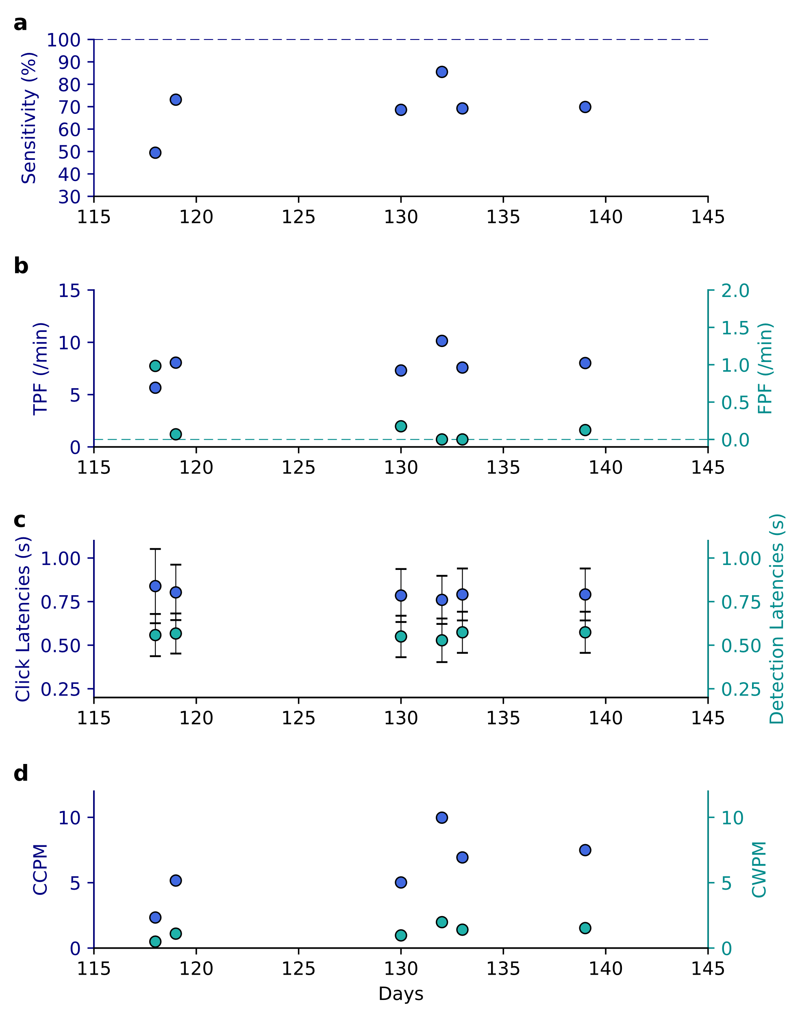
Supplementary Fig. 11 | Performance decline roughly 4 months post-training. For each day a 4-vote threshold was used. (a) Sensitivity of grasp detection for each session. (b) True-positive and false-positive frequencies (TPF and FPF) measured as detections per minute. (c) Average latencies with standard deviation error bars of grasp onset to detection and to click. (d) Correct characters/words per minute (CCPM/CCWP).

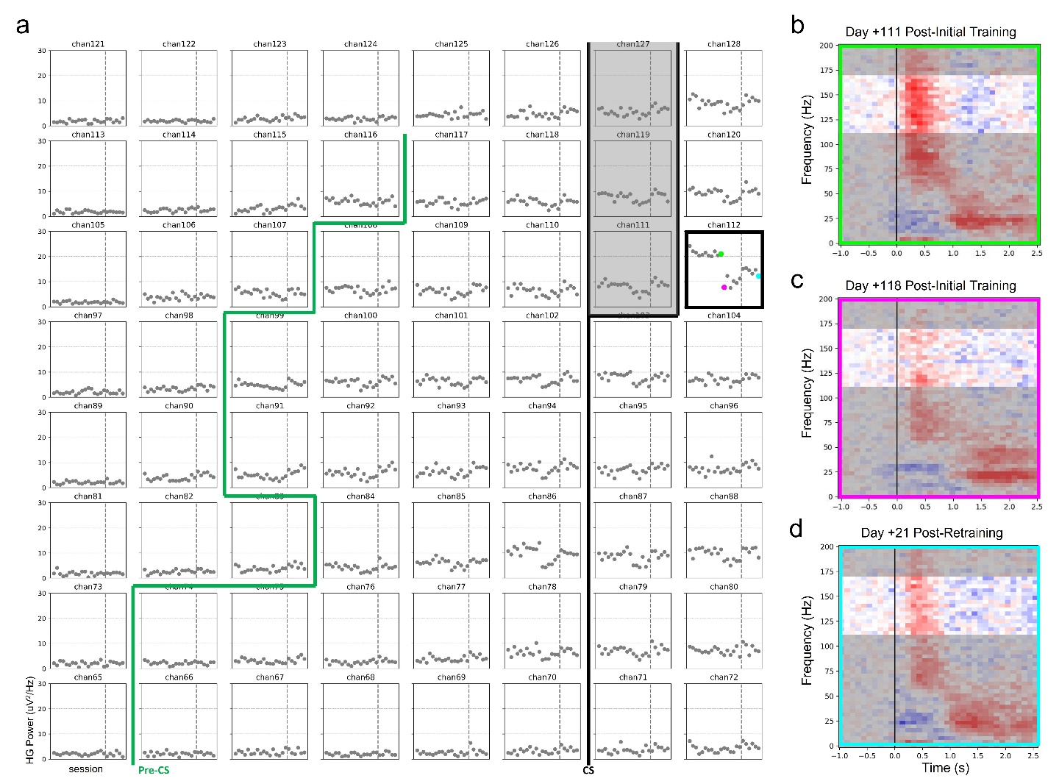
Supplementary Fig. 12 | Deviation in movement-aligned high-gamma power. (a) Peak median HG power across all sessions. For each channel, a dot represents the peak HG power of the median HG power trace of the first 30 movement-aligned HG power traces from one spelling session. The dashed vertical line splits the peak HG power values prior to training a new click detector (left of dashed line) and after training a new click detector (right of dashed line). The largest drop in peak median HG power was from channel 112 (outlined in black), the most salient channel for decoding. The green, pink, and blue dots are peak median HG power values from the last day prior to performance drop, first day of decreased performance, and last day with newly trained click detector respectively. The central sulcus is delineated by a thick black line (CS) and widens at the top such that electrodes 111, 119, and 127 are over it. The pre-central sulcus is delineated by a thick green line (Pre-CS). (b) Average spectrogram of the first 30 movement-aligned trials from the last spelling session prior to performance drop. HG spectral power between 110-170 Hz is highlighted. (c) Average spectrogram of the first 30 movement-aligned trials from the first spelling session during performance drop. (d) Average spectrogram of the first 30 movement-aligned trials from the last spelling session after training a new click detector.

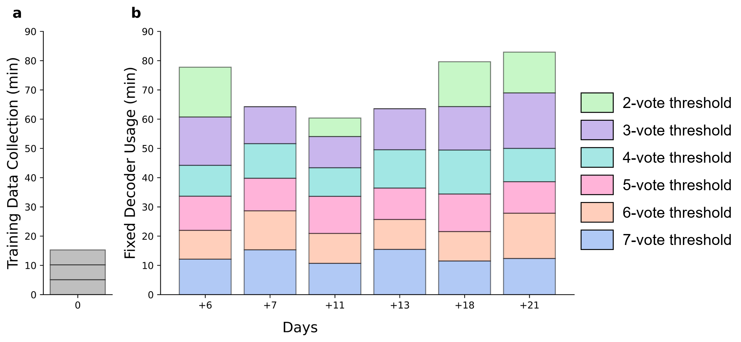
Supplementary Fig. 13 | Long-term use of a fixed retrained brain-click detector. (a) Training data was collected on one session where the three sub-bars each represent a separate block of training data collection. (b) The retrained fixed decoder was used by the participant with the complete range of voting thresholds on almost all days after retraining. For each day, each sub-bar represents a separate spelling block of 3 sentences. The horizontal axis spanning both (a) and (b) represents the number of days after the last day of training data collection (day 0).

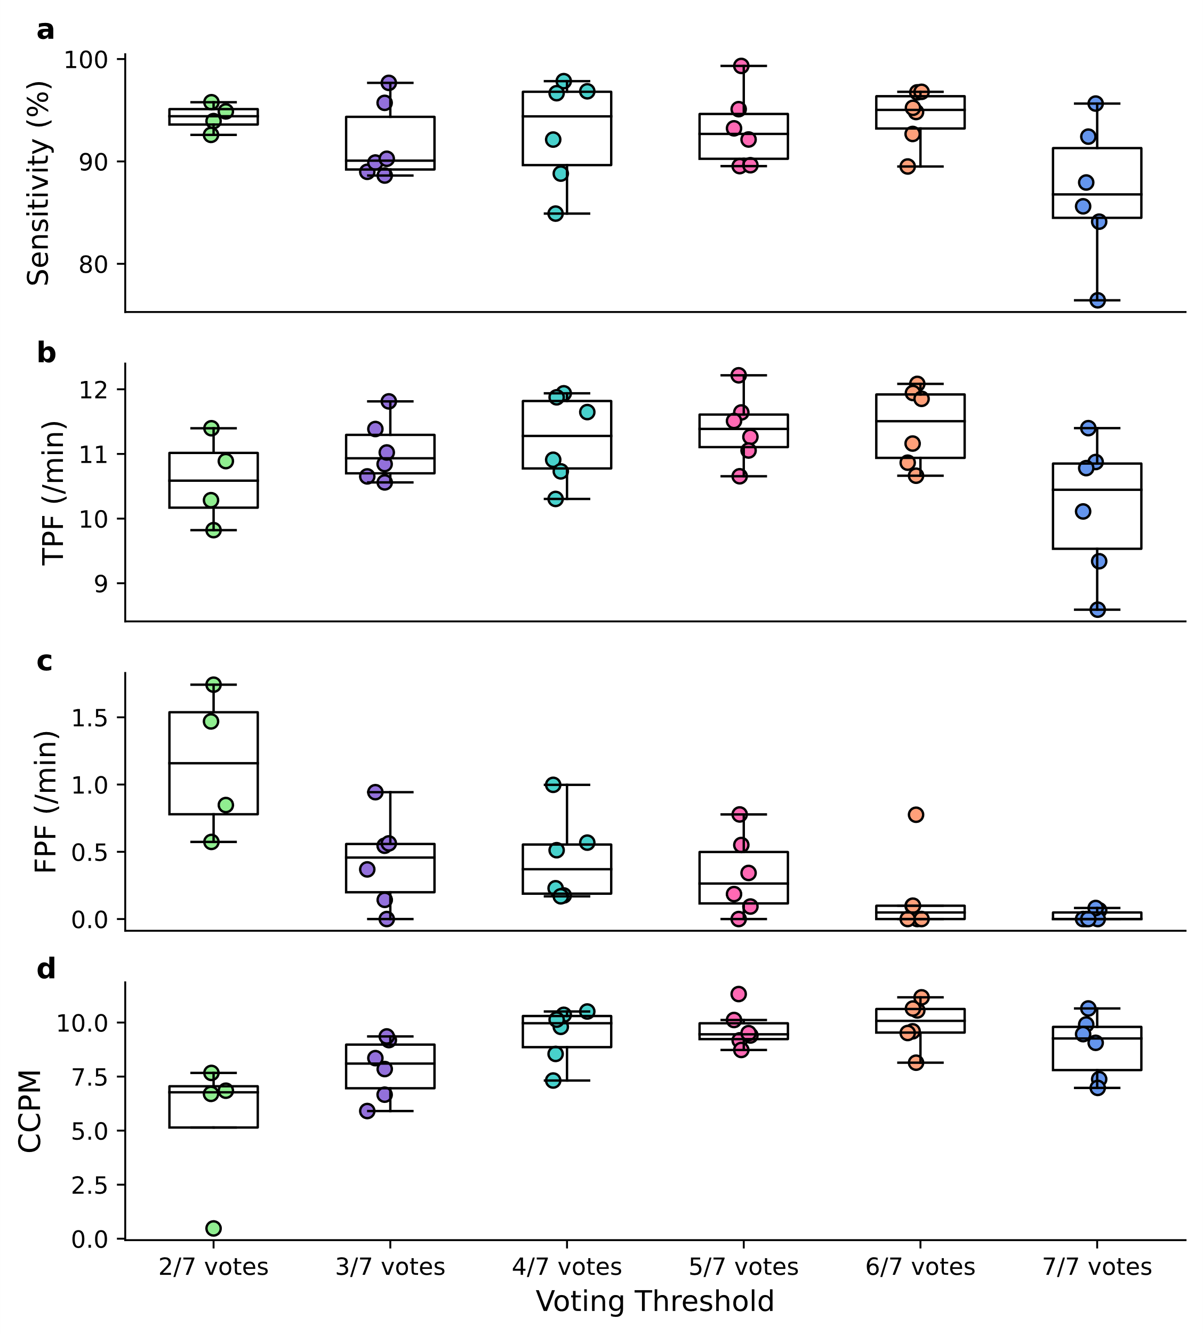
Supplementary Fig. 14 | Performance evaluation across all voting thresholds. Voting thresholds ranging from 3/7 to 7/7 votes were evaluated on 6 sessions whereas the 2-vote threshold was evaluated only on 4 sessions. Sensitivity of grasp detection (a) true positive frequency (b) false positive frequency (c), and CCPM (d) observed with each voting threshold. Note that all above evaluations were performed using the retrained click detector.
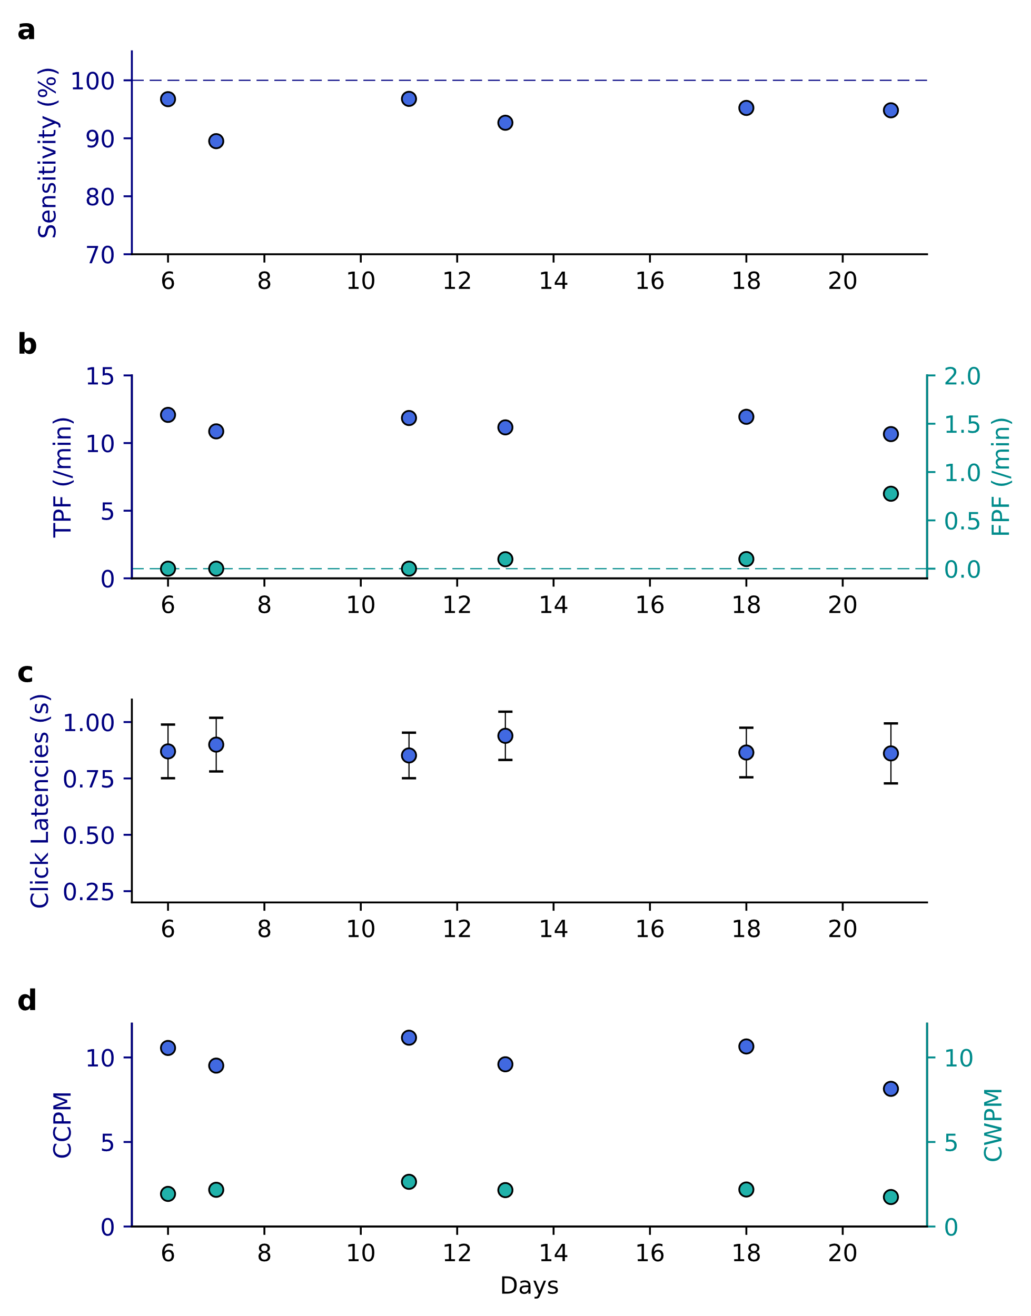
Supplementary Fig. 15 | Switch-scanning spelling performance with a retrained click detector. All performance metrics are shown using the 6-vote threshold. (a) Sensitivity of grasp detection for each session. (b) True-positive and false-positive rates (TPF and FPF respectively) measured as detections per minute. (c) Average latencies with standard deviation error bars of grasp onset to algorithm detection and to on-screen click. (d) Correct characters/words per minute (CCPM/CWPM).

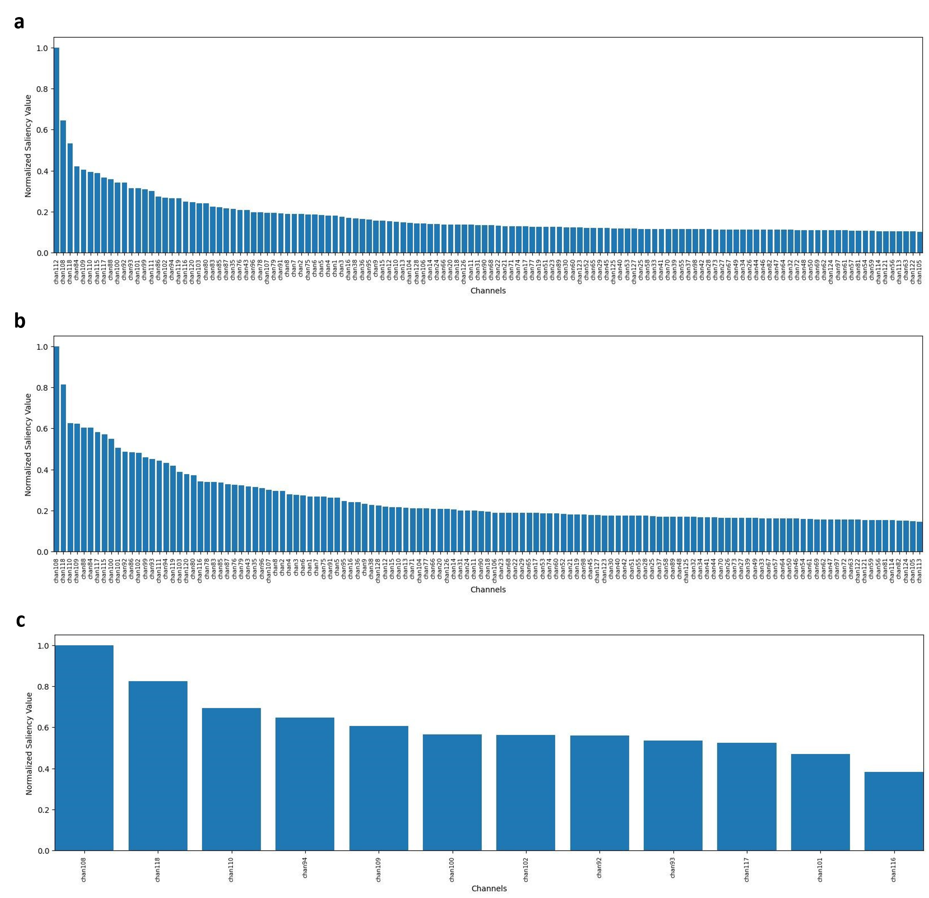
Supplementary Fig. 16 | Normalized saliency values. Normalized saliency values of each channel in descending order from a model trained on (a) all channels, (b) all channels excluding chan112, and (c) a 4x3 subset covering cortical hand-knob.

Supplementary Tables

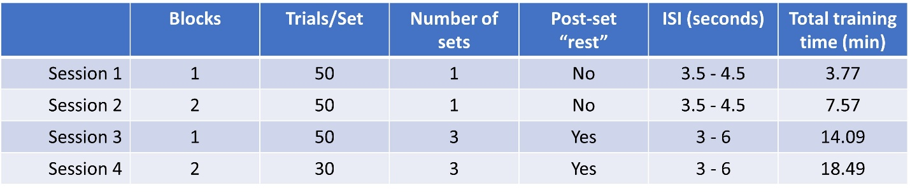
Supplementary Table 1 | Experimental parameters for training data collection. For each block during sessions 1 and 2 the participant performed one set of 50 trials whose ISIs were jittered between 3.5-4.5 s. For each block during sessions 3 and 4, we introduced a 90 s rest period after each of three sets of trials during which the participant was asked to remain still and fixate his eyes on a Rest stimulus. On session 4, we reduced the number of trials/set from 50 to 30 due to the participant’s difficulty in focusing throughout the duration of the task. The ISI for sessions 3 and 4 was jittered between 3 - 6 s to further reduce anticipatory behavior. The above sessions were used to train the original click detector.

Supplementary Video Descriptions

Supplementary Video 1 | Switch-scan control of a communication board.
Using a switch-scanning paradigm, the participant navigates to one of 32 symbols on the communication board. The participant must time his attempted grasps such that the click occurs when the desired row or column is highlighted in red. The scan rate across rows and columns is 1 switch/1.5 s. Once a row or column is selected, it turns yellow or green respectively.

Supplementary Video 2 | Switch-scan spelling.
Using a switch-scanning paradigm, the participant navigates to the appropriate letter on the static keyboard or suggested letter or word to complete the prompted sentence (gray). The participant must time his attempted grasps such that the click occurs when the desired row or column is highlighted. The scan rate across rows and columns is 1 switch/1 s. After the sentence is complete, the participant clicks ENTER at the bottom of the screen.

References

1.Metzger, S. L. et al. Generalizable spelling using a speech neuroprosthesis in an individual with severe limb and vocal paralysis. Nat Commun 13, 6510 (2022).
2.Silversmith, D. B. et al. Plug-and-play control of a brain–computer interface through neural map stabilization. Nat Biotechnol 39, 326–335 (2021).
3.Benabid, A. L. et al. An exoskeleton controlled by an epidural wireless brain–machine interface in a tetraplegic patient: a proof-of-concept demonstration. The Lancet Neurology 18, 1112–1122 (2019).
4.Ajiboye, A. B. et al. Restoration of reaching and grasping movements through brain-controlled muscle stimulation in a person with tetraplegia: a proof-of-concept demonstration. The Lancet 389, 1821–1830 (2017).
5.Vansteensel, M. J. et al. Fully Implanted Brain–Computer Interface in a Locked-In Patient with ALS. N Engl J Med 375, 2060–2066 (2016).
6.Collinger, J. L. et al. High-performance neuroprosthetic control by an individual with tetraplegia. The Lancet 381, 557–564 (2013).

