Screening for primary aldosteronism on and off interfering medications
Appendix
Xiaoyu Li^{1a} MD, Jiayu Liang^{1a} MD, Jinbo Hu¹MD, PhD, Linqiang Ma¹ MD, PhD, Jun Yang²³ PhD, Aipin PhD, Ying Jing¹ MD, Ying Song¹ MD, PhD, Yi Yang¹ MD, PhD, Zhengping Feng¹ MD, PhD, Zhipeng Du¹ MD, Yue Wang¹ MD, PhD, Ting Luo¹ MD, PhD, Wenwen He¹ MD, Xiaoyu Shu^{2#}MD, PhD, Shumin Yang^{1#}MD, PhD, Qifu Li^{1#}MD, PhD, on behalf of the Chongqing Primary Aldosteronism Study (CONPASS) GroupZhang⁴ †

Appendix methods
Statistical analysis
Sample size calculation
PASS 11.0 was used to calculate the sample size in the prospective study. Based on the area under the receiver–operator characteristics curve (AUC) of ARR results in the retrospective analysis, the procedure of Inequality Tests for Two ROC Curves was used. A sample of 120 from the PA group and 200 from the EH group would achieve 81% power to detect a difference of 0.0700 between a diagnostic test with an area under the receiver–operator characteristics curve (AUC) of 0.81 and another diagnostic test with an AUC of 0.88 using a two-sided z-test at a significance level of 0.05. The data are continuous responses. The AUC is computed between false positive rates of 0.000 and 1.000. The ratio of the standard deviation of the responses in the negative group to the standard deviation of the responses in the positive group for diagnostic test 1 is 1.000 and for diagnostic test 2 is 1.000. The correlation between the two diagnostic tests is assumed to be 0.600 for the positive group and 0.600 for the negative group.
Sensitivity analyses
We conducted several sensitivity analyses to assess the reproducibility and robustness of the findings. Firstly, as βblockers might cause an opposite effect on PAC, PRC and ARR to ACEI/ARB and CCB, we reanalyzed data when patients using βblockers were excluded. Secondly, ACEI/ARB and CCB were the most commonly used antihypertensive drugs while diuretics showed opposite effect on PAC to ACEI/ARB and CCB, therefore, we reanalyzed data when patients using diuretics and/orβblockers were excluded. Thirdly, those using only one antihypertensive drug were also analyzed.

Appendix results
Table S1. Characteristics of the subjects with unilateral primary aldosteronism
 | Retrospective cohort | Prospective cohort
 | (n=88) | (n=24)
Age (y) | 48.0 (42.0-57.0) | 51.0 (41.0-56.0)
Female, n (%) | 57 (64.8) | 8 (33.3)
BMI (kg/m²) | 24.1 (21.4-26.4) | 23.7 (22.6-25.4)
SBP (mm Hg) | 153.0 (138.0-165.5) | 155.5 (137.0-174.8)
DBP (mm Hg) | 95.0 (86.0-102.8) | 89.0 (80.0-106.0)
Duration of hypertension (y)  Resistant hypertension, n (%) | 5.5 (2.0-10.0)  17 (19.3) | 6.0 (3.0-11.0)  7 (29.2)
Hypokalemia, n (%) | 82 (93.2) | 18 (75.0)
Serum K⁺ (mmol/L) | 3.2 (2.9-3.6) | 3.7 (3.3-4.0)
PAC-post CCT (pg/ml) | 316.5 (202.3-499.3) | 168.0 (146.3-282.5)
Medication
ACEI/ARB, n (%) | 43 (48.9) | 13 (54.2)
β blockers, n (%) | 17 (19.3) | 5 (20.8)
CCB, n (%) | 76 (86.4) | 16 (66.7)
Diuretics, n (%) | 26 (29.5) | 17 (70.8)
DDD | 1.5 (1.0-2.6) | 1.0 (0.6-2.3)
Data were expressed as % or median (interquartile range). BMI: body mass index; SBP: systolic blood pressure; DBP: diastolic blood pressure; CCT: captopril challenge test; ACEI: angiotensin-converting enzyme inhibitors; ARB: angiotensin receptor blockers; CCB: calcium–channel blocker. DDD: defined daily dose. Hypokalemia is defined as serum potassium<3.5mmol/L.

Table S2. Characteristics of the subjects with unilateral primary aldosteronism missed by ARR on and/or off interfering medications
 | Age (y) |  | Gender | SBP/ DBP  (mmHg) | Hypokalemia | Adrenal CT | On interfering medications |  |  |  | Off interfering medications
 |  |  |  |  |  |  | PAC (pg/ml) | PRC (μIU/ml) | ARR (pg/μIU) | Drugs (Daily Dose) | PAC (pg/ml) | PRC (μIU/ml) | ARR (pg/μIU) | Drugs (Daily Dose)
Retrospective cohort
NO.1 | 48 |  | Male | 151/97 | Yes | Right nodule, 11mm | 92.9 | 120.0 | 0.8 | Amlodipine 5mg, Irbesartan 150mg | 393.0 | 19.0 | 20.7 | Doxazosin 8mg
NO.2 | 44 |  | Male | 156/98 | Yes | Left nodule, 17mm | 302.0 | 55.2 | 5.5 | Nifedipine 30mg,Irbesartan 150mg | 235.0 | 16.6 | 14.2 | Doxazosin 8mg,Diltiazem180mg
NO.3 | 48 |  | Female | 131/85 | Yes | Left nodule, 15mm | 100.0 | 17.7 | 5.6 | Spironolactone 240mg | 434.0 | 0.4 | 1085.0 | Doxazosin 6mg,Diltiazem180mg
NO.4 | 54 |  | Female | 155/86 | No | Left nodule, 9mm | 127.0 | 14.1 | 9.0 | Nifedipine 60mg,Irbesartan 150mg,Metoprolol 12.5mg | 202.0 | 7.0 | 28.9 | Doxazosin 8mg,Diltiazem90mg
NO.5 | 31 |  | Female | 154/97 | Yes | Left nodule, (11mm) with hyperplasia | 159.0 | 16.3 | 9.8 | Spironolactone 40mg,Nifedipine 30mg | 251.0 | 18.1 | 13.9 | Doxazosin 4mg,Diltiazem90mg
NO.6 | 51 |  | Female | 147/91 | Yes | Left nodule,10mm | 251.0 | 11.5 | 21.8 | Nitrendipine10mg | 232.0 | 12.2 | 19.0 | Doxazosin 4mg,Diltiazem90mg
NO.7 | 66 |  | Female | 129/68 | Yes | Right nodule, 17mm | 155.0 | 5.4 | 28.7 | Nifedipine 20mg | 136.0 | 8.1 | 16.8 | Doxazosin 4mg,Diltiazem90mg
NO.8 | 55 |  | Male | 197/112 | Yes | Left nodule,10mm | 336.0 | 3.8 | 88.4 | Nifedipine 60mg,Doxazosin 8mg,Metoprolol 23.75mg | 281.0 | 17.0 | 16.5 | Doxazosin 8mg,Diltiazem270mg
Prospective cohort
NO.9 | 31 |  | Male | 136/82 | No | Left hyperplasia | 186.0 | 39.0 | 4.8 | Nifedipine 30mg,Valsartan 80mg,Spironolactone 20mg | 153.0 | 1.2 | 127.5 | drug withdrawal
NO.10 | 38 |  | Female | 165/88 | No | Left nodule,  9mm | 664.0 | 68.6 | 9.7 | Amlodipine 5mg,Losartan 100mg,Hydrochlorothiazide 12.5mg,Bisoprolol 5mg,Spironolactone 40mg | 495.0 | 0.5 | 990.0 | Terazosin 2mg
NO.11 | 56 |  | Male | 183/100 | Yes | Right nodule 18mm, left nodule 15mm | 128.0 | 11.5 | 11.1 | Amlodipine 10mg,Losartan Potassium 100mg,Spironolactone 40mg | 151.0 | 8.3 | 18.2 | Terazosin 2mg,Diltiazem 180mg
NO.12 | 43 |  | Male | 100/67 | Yes | Left nodule  10mm | 566.0 | 46.4 | 12.2 | Amlodipine 5mg,Losartan Potassium 50mg,Spironolactone 20mg | 323.0 | 1.5 | 215.3 | Diltiazem 180mg
NO.13 | 49 |  | Female | 116/60 | Yes | Bilateral multiple nodules | 145.0 | 10.5 | 13.8 | Spironolactone 20mg | 203.0 | 0.9 | 225.6 | Diltiazem 180mg
NO.14 | 58 |  | Female | 140/80 | Yes | Left hyperplasia | 250.0 | 14.8 | 16.9 | Amlodipine 2.5mg,Metoprolol 47.5mg,Spironolactone 20mg | 151.0 | 6.9 | 21.9 | Diltiazem 180mg
SBP: systolic blood pressure; DBP: diastolic blood pressure; CT: computed tomography; PAC: plasma aldosterone concentration; PRC: plasma renin concentration; ARR: aldosterone renin ratio. Hypokalemia is defined as serum potassium<3.5mmol/L.

Table S3. Characteristics of the subjects after excluding β blockers users
 | Retrospective cohort |  |  | Prospective cohort
 | EH (n=63) | PA (n=168) | P value | EH (n=171) | PA (n=103) | P value
Age (y) | 52.0 (40.0-61.0) | 50.5 (43.0-60.0) | 0.915 | 50.0 (40.0-60.8) | 53.0 (44.0-58.5) | 0.216
Female, n (%) | 41 (65.1) | 114 (67.9) | 0.689 | 89 (52.0) | 50 (48.5) | 0.510
BMI (kg/m²) | 24.7 (23.1-27.4) | 24.4 (22.0-26.7) | 0.123 | 25.0 (23.4-27.1) | 24.5 (23.4-27.3) | 0.547
SBP (mm Hg) | 145.0 (136.0-155.0) | 149.5 (137.0-160.0) | 0.200 | 150.0 (133.6-164.0) | 150.0 (139.0-162.0) | 0.694
DBP (mm Hg) | 88.0 (78.0-95.0) | 92.5 (83.0-101.0) | 0.032 | 91.0 (82.0-100.0) | 89.0 (80.0-100.0) | 0.195
Duration of hypertension (y) | 3.0 (1.0-10.0) | 6.0 (2.0-10.0) | 0.017 | 3.0 (2.0-7.3) | 7.0 (3.0-12.0) | <0.001
Resistant hypertension, n (%) | 3 (4.8) | 18 (10.7) | 0.161 | 10 (5.8) | 10 (9.7) | 0.234
Serum K⁺ (mmol/L) | 3.9 (3.7-4.2) | 3.4 (3.0-3.9) | <0.001 | 4.1 (3.9-4.3) | 3.9 (3.6-4.2) | 0.003
Hypokalemia, n (%) | 14 (22.2) | 132 (78.6) | <0.001 | 25 (14.6) | 35 (34.0) | <0.001
PAC-post CCT (pg/ml) | 72.5 (50.8-102.5) | 216.5 (131.3-358.8) | <0.001 | 67.7 (49.0-87.9) | 146.0 (112.0-186.0) | <0.001
Medication
ACEI/ARB, n (%) | 34 (54.0) | 77 (45.8) | 0.270 | 103 (60.2) | 58 (56.3) | 0.523
CCB, n (%) | 50 (79.4) | 143 (85.1) | 0.293 | 115 (67.3) | 71 (68.9) | 0.773
Diuretic , n (%) | 7 (11.1) | 45 (26.8) | 0.011 | 34 (19.9) | 44 (42.7) | <0.001
DDD | 1.5 (1.0-2.0) | 1.3 (1.0-2.0) | 0.118 | 1.0 (1.0-2.0) | 1.3 (1.0-2.0) | 0. 609
UPA, n (%) |  | 71 (42.3) |  |  | 19 (18.4)
Data were expressed as % or median (interquartile range). EH: essential hypertension; PA: primary aldosteronism; BMI: body mass index; SBP: systolic blood pressure; DBP: diastolic blood pressure; CCT: captopril challenge test; ACEI: angiotensin-converting enzyme inhibitors; ARB: angiotensin receptor blockers; CCB: calcium–channel blocker. DDD: defined daily dose. UPA: unilateral primary aldosteronism. Hypokalemia is defined as serum potassium<3.5mmol/L. P values represent the comparison between EH and PA.

Table S4. Sensitivity and specificity of ARR after excluding β blockers users
ARR cutoff (pg/μIU) | Off interfering medications |  |  | On interfering medications
ARR cutoff (pg/μIU) | Sensitivity (95%CI) | Specificity (95%CI) |  |  |  | Sensitivity (95%CI) |  | Specificity (95%CI)
Retrospective Cohort
10 | 0.99 (0.97-1.00) |  | 0.40 (0.28-0.53) |  | 0.91 (0.86-0.95) |  | 0.54 (0.41-0.67)
20 | 0.90 (0.85-0.94) |  | 0.63 (0.50-0.75) |  | 0.80 (0.73-0.86) |  | 0.70 (0.57-0.81)
30 | 0.84 (0.77-0.89) |  | 0.73 (0.60-0.83) |  | 0.70 (0.63-0.77) |  | 0.79 (0.67-0.89)
40 | 0.77 (0.70-0.83) |  | 0.75 (0.62-0.85) |  | 0.63 (0.55-0.70) |  | 0.86 (0.75-0.93)
Prospective Cohort
10 | 1.00 (0.96-1.00) |  | 0.44 (0.37-0.52) |  | 0.84 (0.76-0.91) |  | 0.60 (0.52-0.68)
20 | 0.80 (0.71-0.87) |  | 0.66 (0.58-0.73) |  | 0.60 (0.50-0.70) |  | 0.79 (0.72-0.85)
30 | 0.68 (0.58-0.77) |  | 0.75 (0.68-0.82) |  | 0.43 (0.33-0.53) |  | 0.88 (0.82-0.92)
40 | 0.60 (0.50-0.70) |  | 0.81 (0.74-0.86) |  | 0.32 (0.23-0.42) |  | 0.92 (0.87-0.95)
ARR: aldosterone-renin ratio.CI: confidence interval.

Table S5. Characteristics of the subjects after excluding diuretics and/or β blockers users
 | Retrospective cohort |  |  | Prospective cohort
 | EH (n=56) | PA (n=123) | P value | EH (n=137) | PA (n=59) | P value
Age (y) | 51.0 (38.5-59.8) | 52.0 (44.0-61.0) | 0.372 | 50.0 (41.0-61.0) | 53.0 (47.0-58.0) | 0.185
Female, n (%) | 37 (66.1) | 82 (66.7) | 0.938 | 70 (51.1) | 31 (52.5) | 0.929
BMI (kg/m²) | 24.8 (23.1-28.0) | 24.4 (22.0-27.0) | 0.072 | 25.0 (23.5-27.5) | 24.8 (23.7-27.4) | 0.910
SBP (mm Hg) | 145.0 (136.0-155.0) | 147.0 (137.0-159.0) | 0.452 | 150.0 (139.0-165.0) | 150.5 (139.2-162.0) | 0.935
DBP (mm Hg) | 87.5 (78.5-99.0) | 92.0 (83.0-100.0) | 0.096 | 91.0 (83.8-100.5) | 89.5 (81.5-100.0) | 0.332
Duration of hypertension (y) | 3.0 (0.6-9.5) | 6.0 (2.0-10.0) | 0.004 | 3.0 (2.0-7.8) | 7.0 (3.0-12.0) | <0.001
Serum K⁺ (mmol/L) | 4.0 (3.7-4.2) | 3.4 (3.0-3.9) | <0.001 | 4.1 (3.9-4.3) | 3.9 (3.7-4.2) | 0.005
Hypokalemia, n (%) | 12 (21.4) | 94 (76.4) | <0.001 | 18 (13.1) | 17 (28.8) | 0.009
PAC-post CCT (pg/ml) | 72.5 (50.6-100.0) | 208.0 (127.0-355.0) | <0.001 | 63.2 (46.3-84.7) | 143.0 (105.0-188.0) | <0.001
Medication
ACEI/ARB, n (%) | 29 (51.8) | 51 (41.5) | 0.198 | 78 (56.9) | 34 (57.6) | 0.928
CCB, n (%) | 46 (82.1) | 112 (91.1) | 0.086 | 99 (72.3) | 49 (83.1) | 0.107
DDD | 1.5 (1.0-2.0) | 1.0 (1.0-1.5) | 0.020 | 1.0 (1.0-2.0) | 1.3 (1.0-2.0) | 0.121
UPA, n (%) |  | 51 (41.5) |  |  | 6 (10.2)
Data were expressed as % or median (interquartile range). EH: essential hypertension; PA: primary aldosteronism; BMI: body mass index; SBP: systolic blood pressure; DBP: diastolic blood pressure; CCT: captopril challenge test; ACEI: angiotensin-converting enzyme inhibitors; ARB: angiotensin receptor blockers; CCB: calcium–channel blocker. DDD: defined daily dose. UPA: unilateral primary aldosteronism. Hypokalemia is defined as serum potassium<3.5mmol/L. P values represent the comparison between EH and PA.

Table S6. Sensitivity and specificity of ARR after excluding diuretics and/or β blockers users
ARR cutoff (pg/μIU) | Off interfering medications |  |  | On interfering medications
ARR cutoff (pg/μIU) | Sensitivity (95%CI) |  | Specificity (95%CI) |  |  | Sensitivity (95%CI) |  | Specificity (95%CI)
Retrospective Cohort
10 | 0.99 (0.96-1.00) | 0.39 (0.27-0.53) |  |  | 0.92 (0.86-0.96) |  | 0.48 (0.35-0.62)
20 | 0.89 (0.83-0.94) | 0.63 (0.49-0.75) |  |  | 0.79 (0.71-0.86) |  | 0.66 (0.52-0.78)
30 | 0.82 (0.74-0.88) | 0.71 (0.58-0.83) |  |  | 0.71 (0.62-0.79) |  | 0.77 (0.64-0.87)
40 | 0.76 (0.67-0.83) | 0.71 (0.58-0.83) |  |  | 0.61 (0.52-0.70) |  | 0.84 (0.72-0.92)
Prospective Cohort
10 | 1.00 (0.94-1.00) | 0.47 (0.38-0.55) |  |  | 0.83 (0.71-0.92) |  | 0.61 (0.53-0.70)
20 | 0.75 (0.62-0.85) | 0.68 (0.59-0.76) |  |  | 0.58 (0.44-0.70) |  | 0.80 (0.73-0.87)
30 | 0.63 (0.49-0.75) | 0.78 (0.70-0.85) |  |  | 0.42 (0.30-0.56) |  | 0.90 (0.83-0.94)
40 | 0.56 (0.42-0.69) | 0.82 (0.74-0.88) |  |  | 0.29 (0.18-0.42) |  | 0.94 (0.89-0.97)
ARR: aldosterone-renin ratio.CI: confidence interval.

Figure S7. Characteristics of the subjects only using calcium–channel blocker
 | Retrospective cohort |  |  | Prospective cohort
 | EH (n=21) | PA (n=66) | P value | EH (n=54) | PA (n=24) | P value
Age (y) | 52.0 (31.5-57.5) | 50.5 (43.0-60.0) | 0.535 | 55.5 (45.0-64.8) | 57.0 (50.5-62.0) | 0.557
Female, n (%) | 13 (61.9) | 45 (68.2) | 0.595 | 34 (63.0) | 12 (50.0) | 0.241
BMI (kg/m²) | 24.7 (23.8-28.7) | 24.2 (21.8-27.0) | 0.162 | 24.9 (23.4-27.4) | 25.1 (23.8-27.4) | 0.762
SBP (mm Hg) | 145.0 (133.5-154.0) | 147.0 (136.8-158.3) | 0.728 | 151.0 (140.0-168.0) | 152.5 (139.8-167.0) | 0.777
DBP (mm Hg) | 88.0 (80.0-96.0) | 91.0 (81.0-100.0) | 0.410 | 90.4 (80.0-100.0) | 86.5 (80.0-100.8) | 0.987
Duration of hypertension (y) | 1.0 (0.3-6.0) | 5.0 (1.9-10.0) | 0.027 | 3.0 (2.0-8.0) | 7.0 (3.3-12.0) | 0.011
Serum K⁺ (mmol/L) | 3.9 (3.7-4.2) | 3.2 (2.9-3.8) | <0.001 | 4.1 (3.9-4.3) | 3.8 (3.4-4.2) | 0.009
Hypokalemia, n (%) | 7 (33.3) | 54 (81.8) | <0.001 | 8 (14.8) | 10 (41.7) | 0.009
PAC-post CCT (pg/ml) | 69.7 (49.1-98.5) | 221.0 (134.3-411.0) | <0.001 | 68.6 (52.5-84.6) | 143.0 (97.5-187.5) | <0.001
DDD | 1.0 (1.0-1.0) | 1.0 (0.6-1.0) | 0.172 | 1.0 (1.0-1.0) | 1.0 (1.0-1.2) | 0.521
UPA, n (%) |  | 31 (47.0) |  |  | 3 (12.5)
Data were expressed as % or median (interquartile range). EH: essential hypertension; PA: primary aldosteronism; BMI: body mass index; SBP: systolic blood pressure; DBP: diastolic blood pressure; CCT: captopril challenge test; DDD: defined daily dose. UPA: unilateral primary aldosteronism. Hypokalemia is defined as serum potassium<3.5mmol/L. P values represent the comparison between EH and PA.

Table S8. Sensitivity and specificity of ARR in the subjects only using calcium–channel blocker

ARR cutoff (pg/μIU) | Off interfering medications |  |  | On interfering medications
ARR cutoff (pg/μIU) | Sensitivity (95%CI) |  | Specificity (95%CI) |  |  | Sensitivity (95%CI) |  | Specificity (95%CI)
Retrospective Cohort
10 | 1.00 (0.95-1.00) | 0.52 (0.30-0.74) |  |  | 0.95 (0.87-0.99) |  | 0.52 (0.30-0.74)
20 | 0.91 (0.81-0.97) | 0.62 (0.38-0.82) |  |  | 0.80 (0.69-0.89) |  | 0.71 (0.48-0.89)
Prospective Cohort
10 | 1.00 (0.86-1.00) | 0.33 (0.21-0.47) |  |  | 0.88 (0.68-0.97) |  | 0.41 (0.28-0.55)
20 | 0.71 (0.49-0.87) | 0.57 (0.43-0.71) |  |  | 0.58 (0.37-0.78) |  | 0.67 (0.53-0.79)
ARR: aldosterone-renin ratio.CI: confidence interval.

Table S9. Characteristics of the subjects only using β blockers
 |  | PA |  |  | EH
Number |  | NO. 1 | NO.2 | NO.3 | NO.4 |  | NO.5 | NO.6 | NO. 7 | NO.8 | NO.9
Cohort |  | retrospective | retrospective | prospective | prospective |  | retrospective | prospective | prospective | prospective | prospective
Age (y) |  | 37 | 70 | 35 | 57 |  | 56 | 46 | 65 | 48 | 66
Gender |  | Female | Male | Female | Female |  | Male | Male | Male | Male | Female
SBP/DBP (mm Hg) |  | 182/122 | 171/104 | 143/101 | 129/74 |  | 163/100 | 155/106 | 170/80 | 139/96 | 197/123
Duration of hypertension (y) |  | 5 | 11 | 1 | 1 |  | 0 | 6 | 11 | 4 | 3
Hypokalemia |  | No | Yes | Yes | No |  | No | No | No | No | No
Adrenal CT |  | Normal | Left nodule14mm | Right nodule (5mm)with left hyperplasia | Not completed |  | Not completed | Not completed | Not completed | Left nodule19mm | Not completed
PAC-post CCT (pg/ml) |  | 173.0 | 199.0 | 188.0 | 127.0 |  | 101.0 | 68.0 | 94.3 | 98.9 | 50.3
On interfering medications | PAC | 172.0 | 261.0 | 121.0 | 204.0 |  | 93.0 | 116.0 | 204.0 | 70.4 | 53.9
On interfering medications | PRC | 0.5 | 0.4 | 0.5 | 3.7 |  | 2.6 | 15.7 | 4.5 | 62.7 | 0.5
On interfering medications | ARR | 344.0 | 652.5 | 242.0 | 55.1 |  | 35.8 | 7.4 | 45.3 | 1.1 | 107.8
Off interfering medications | PAC | 153.0 | 172.0 | 432 | 225.0 |  | 95.0 | 98.2 | 142.0 | 106.0 | 54.5
Off interfering medications | PRC | 8.6 | 1.5 | 13.3 | 3.6 |  | 7.0 | 15.9 | 15.4 | 56.7 | 1.8
Off interfering medications | ARR | 17.8 | 114.7 | 32.5 | 62.5 |  | 13.6 | 6.2 | 9.2 | 1.9 | 30.3
PA: primary aldosteronism; EH: essential hypertension; BMI: body mass index; SBP: systolic blood pressure; DBP: diastolic blood pressure; CT: computed tomography; CCT: captopril challenge test; PAC: plasma aldosterone concentration; PRC: plasma renin concentration; ARR: aldosterone-renin ratio. Hypokalemia is defined as serum potassium<3.5mmol/L.

Figure S1. PAC, PRC and ARR on and off interfering medications after excluding β blockers users
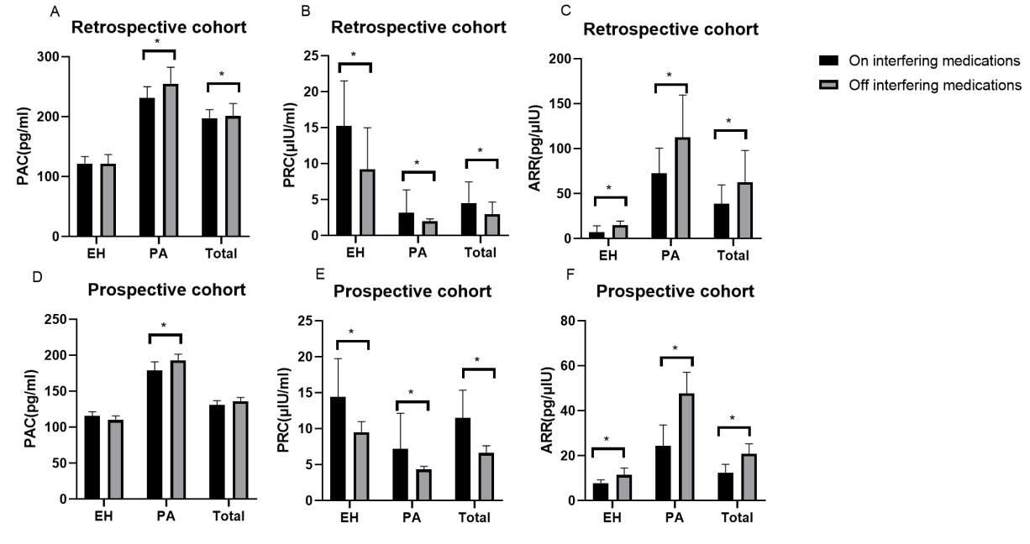
PA: primary aldosteronism; EH: essential hypertension; PAC: plasma aldosterone concentration; PRC: plasma renin concentration; ARR: aldosterone-renin ratio. *p<0.05

Figure S2. Receiver operating characteristic curve for the aldosterone-to-renin ratio on and off interfering medications after excluding β blockers users
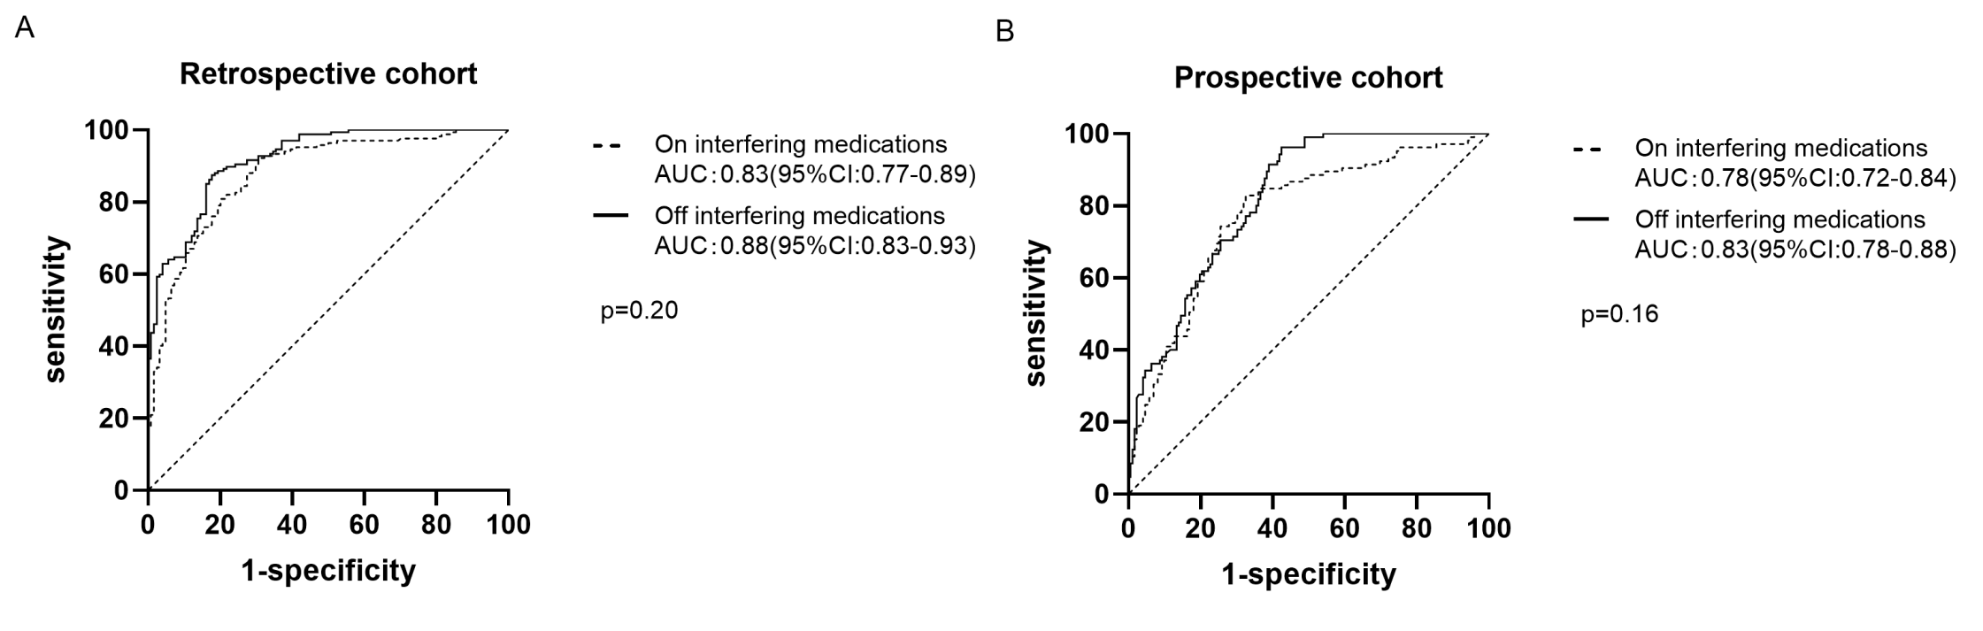

Figure S3. PAC, PRC and ARR on and off interfering medications after excluding diuretics and/or β blockers users
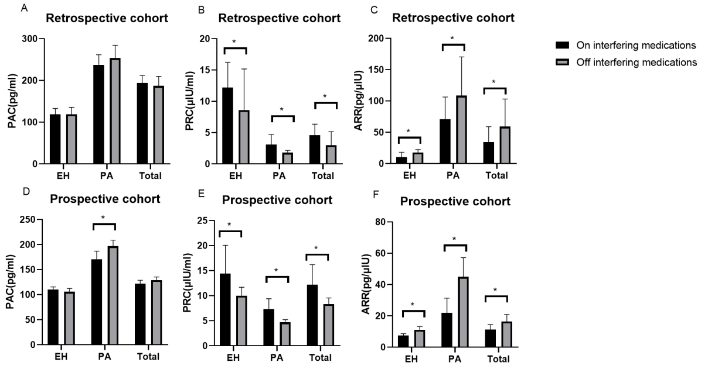
PA: primary aldosteronism; EH: essential hypertension; PAC: plasma aldosterone concentration; PRC: plasma renin concentration; ARR: aldosterone-renin ratio. *p<0.05

Figure S4. Receiver operating characteristic curve for the aldosterone-to-renin ratio on and off interfering medications after excluding diuretics and/or β blockers users
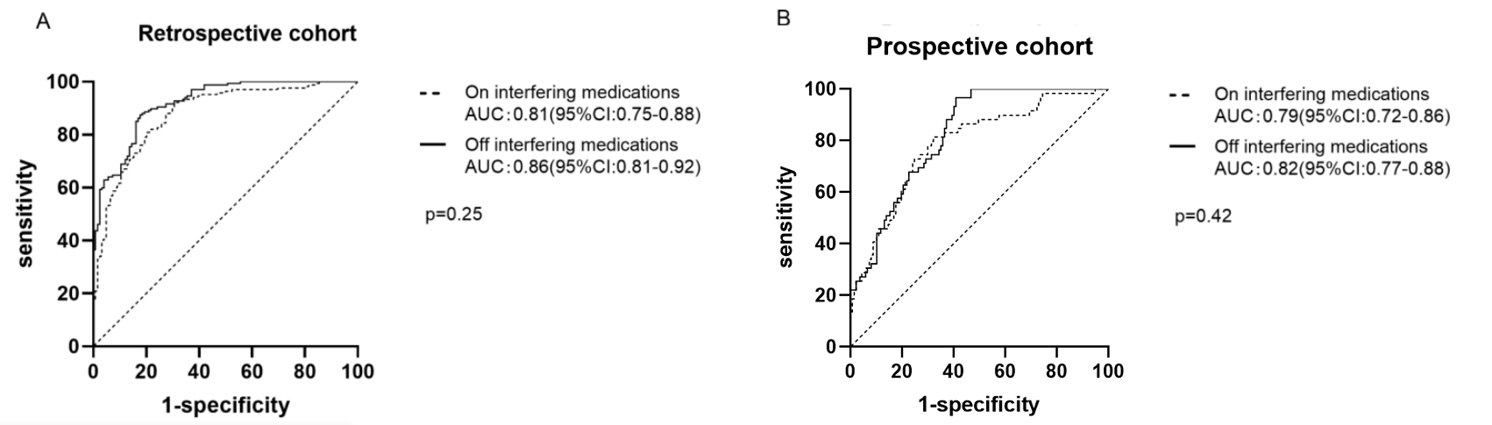

Figure S5. PAC, PRC and ARR on and off interfering medications in patients only using CCB

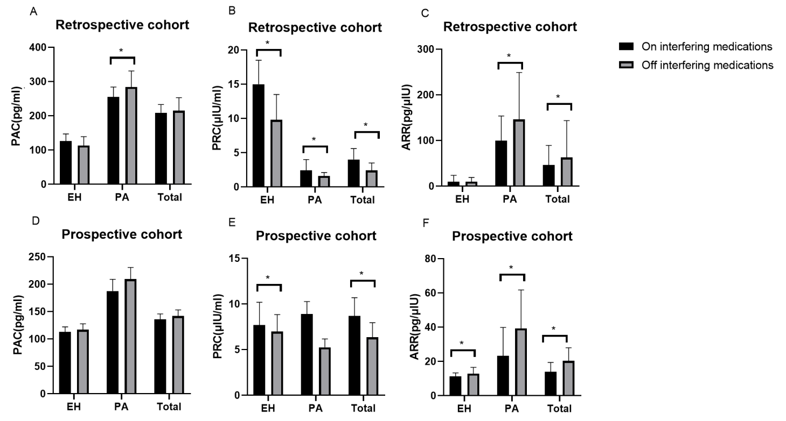
PA: primary aldosteronism; EH: essential hypertension; PAC: plasma aldosterone concentration; PRC: plasma renin concentration; ARR: aldosterone-renin ratio. *p<0.05

