International Journal of Clinical Oncology
Effectiveness of Magnetic Resonance Imaging/Ultrasound-Guided Target Biopsy in Detecting Clinically Significant Prostate Cancer

Gaku Kurokawa¹*, Keiichiro Mori¹, Hiroshi Sasaki¹, Juria Nakano¹, Yusuke Takahashi¹, Kosuke Iwatani¹, Fumihiko Urabe¹, Shunsuke Tsuzuki¹, Yusuke Koike¹, Shun Sato², Hiroyuki Takahashi², Kenta Miki¹, Takahiro Kimura¹

¹Department of Urology, The Jikei University School of Medicine, Tokyo, Japan
²Department of Pathology, The Jikei University School of Medicine, Tokyo, Japan
*Corresponding author.
gkurokawa.jikei@gmail.com
Department of Urology, The Jikei University School of Medicine, Tokyo, Japan
TEL: 0334331111
Fax: 0354011879

Online resource 1. Rates of PCa and CSPC detection in SB, TB, and SB + TB.

 | SB | TB | SB+TB | SB vs TB p value | SB vs SB+TB p value | TB vs SB+TB p value
No Pca | 157(47.9) | 135(41.2) | 118(35.9) | 0.08 | 0.002 | 0.17
non-CSPC | 43(13.1) | 28(8.5) | 33(10.1) | 0.06 | 0.22 | 0.5
CSPC | 128(39.0) | 165(50.3) | 177(54.0) | 0.004 | <0.001 | 0.35
CSPC, clinically significant prostate cancer; SB, systematic biopsy; TB, targeted biopsy.

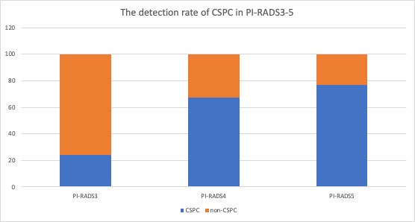

Online resource 2. Detection rate of CSPC in PI-RADS3-5.
CSPC: clinically significant prostate cancer.

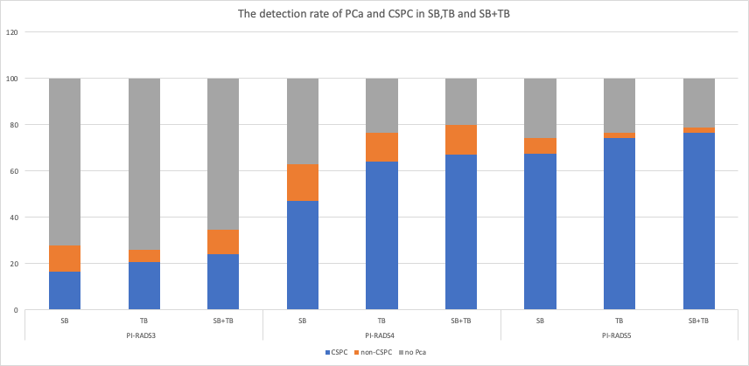

Online resource 3. Detection rates of PCa and CSPC in the SB, TB, and SB+TB groups.
CSPC, clinically significant prostate cancer; SB, systematic biopsy; TB, targeted biopsy.

