Fig. 1S: Comparison in the Q-Q profiles between GRAMMAR-Lambda and the four competing methods. The simulated phenotypes are controlled by 40, 200, 1,000 QTNs with the low, moderate and high heritabilities in 1) human and 2) maize.

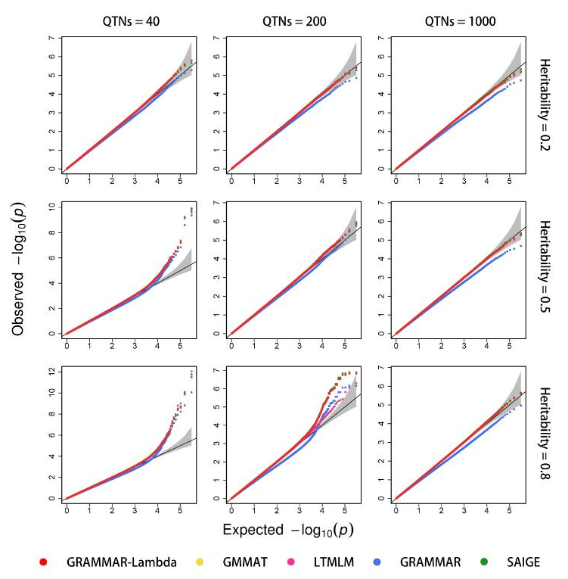

(1)

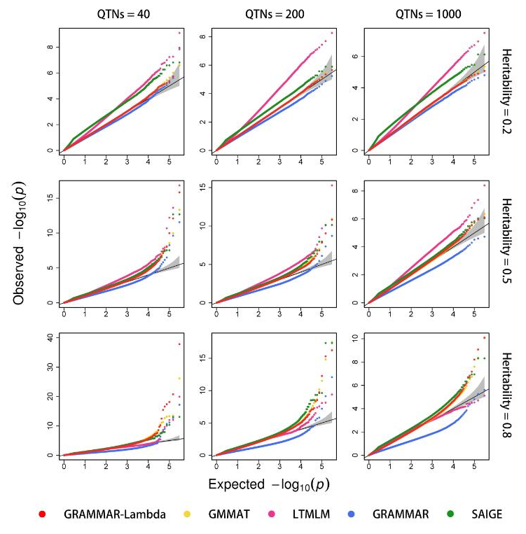

(2)

Fig. 2S: Comparison in the ROC profiles between GRAMMAR-Lambda and the four competing methods. The ROC profiles are plotted using the statistical powers to detect QTNs relative to the given series of Type I errors. Here, the simulated phenotypes are controlled by 40, 200, 1,000 QTNs with the low, moderate and high heritabilities in 1) human and 2) maize.

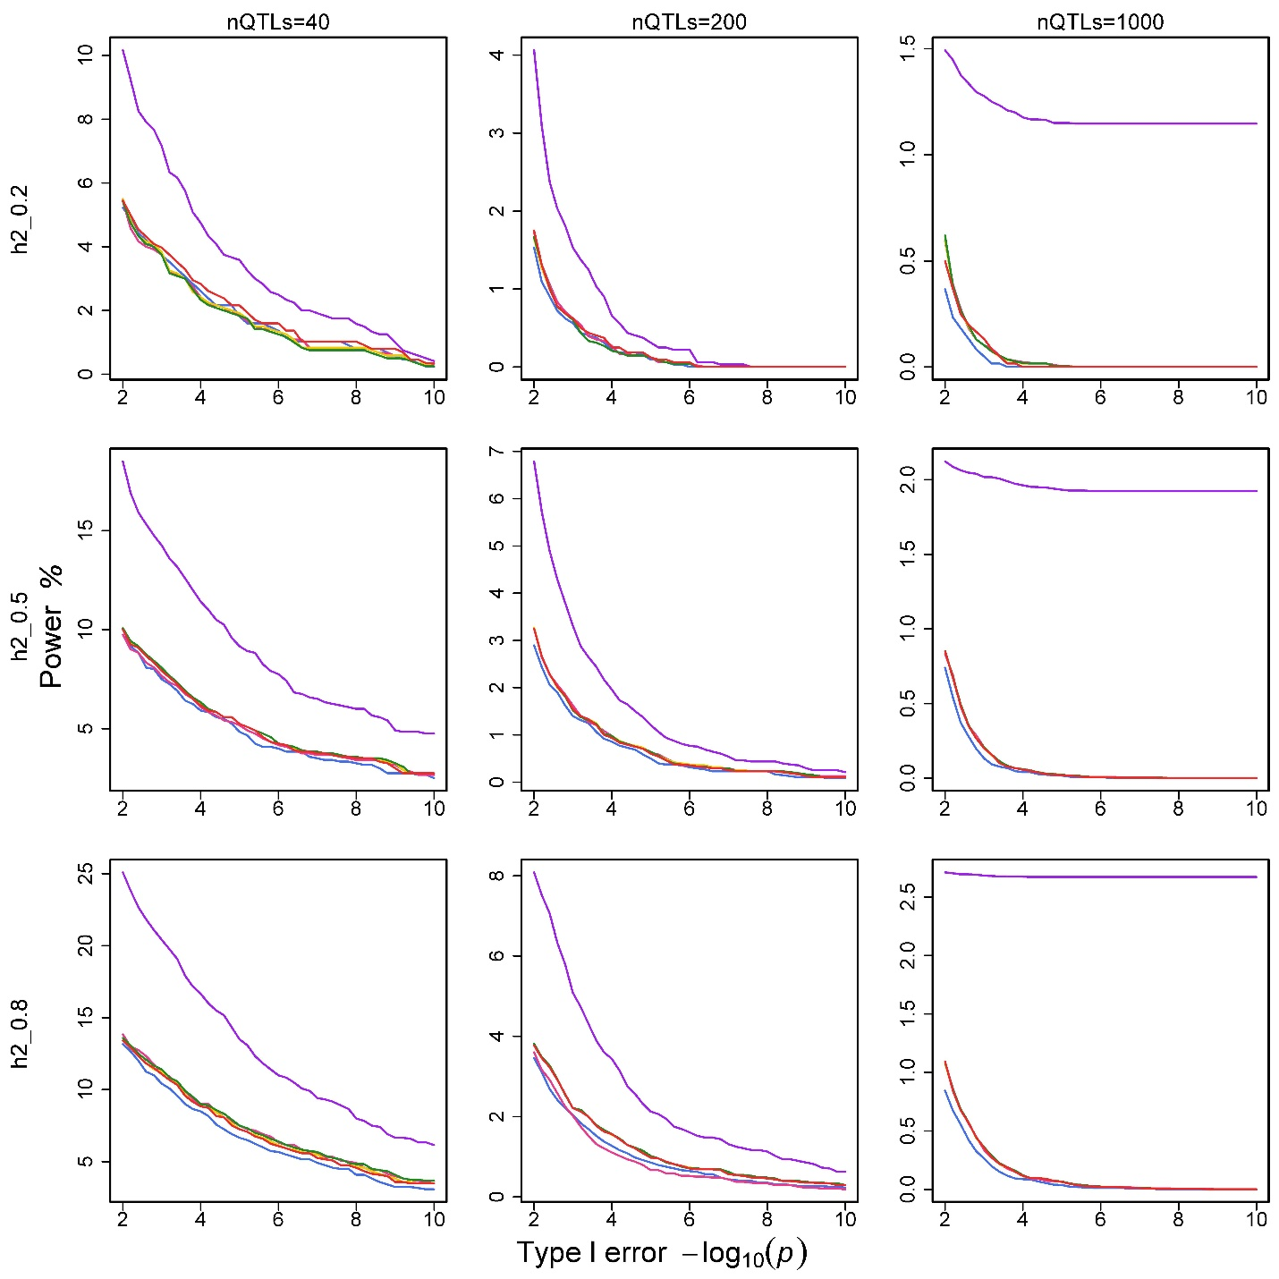

(1)

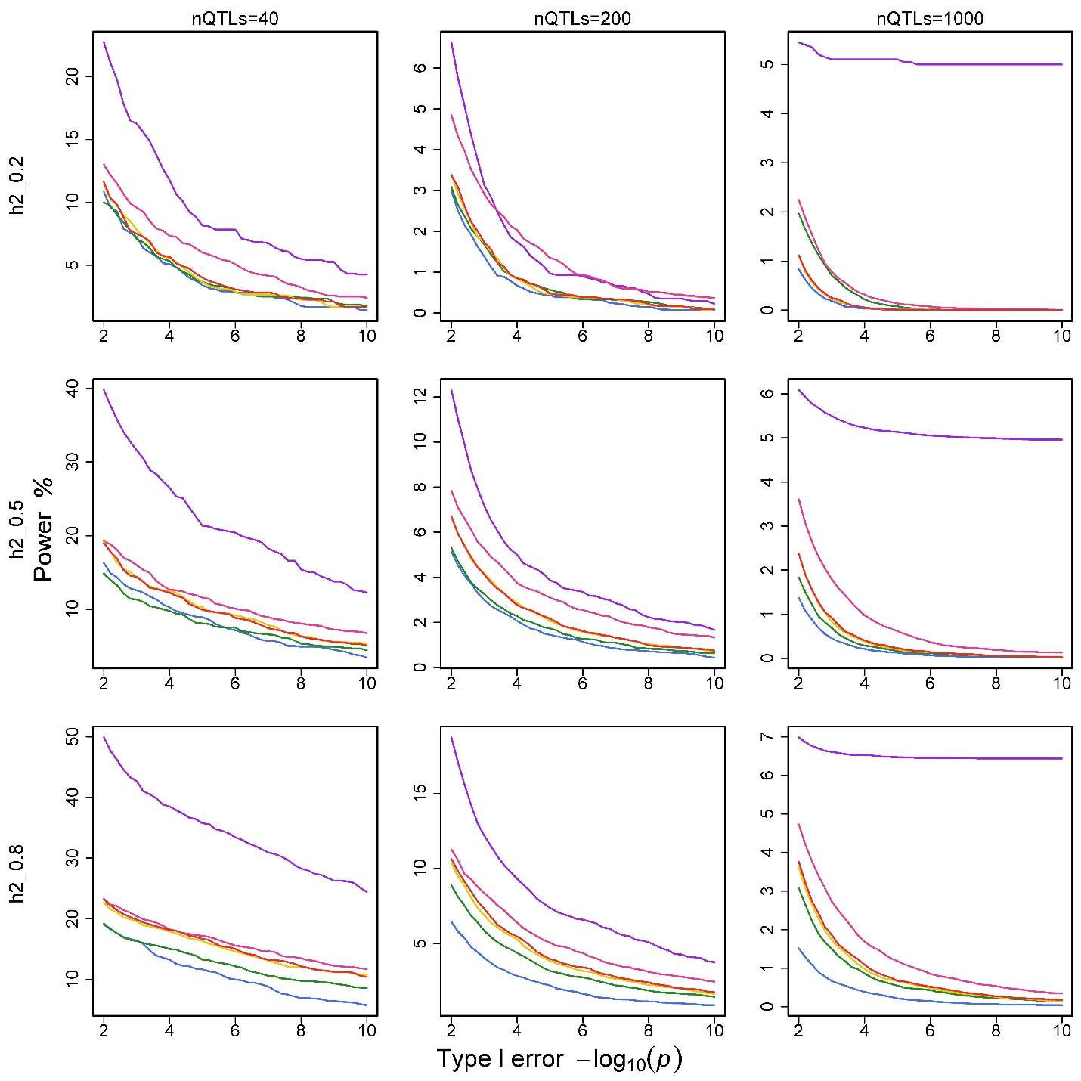

(2)

Fig. 3S: Sensitivity of Q-Q profiles to the specified heritabilities for GRAMMAR-Lambda by using entire and sampling markers. The simulated phenotypes are controlled by 200 QTNs with the low, moderate and high heritabilities in human and maize.

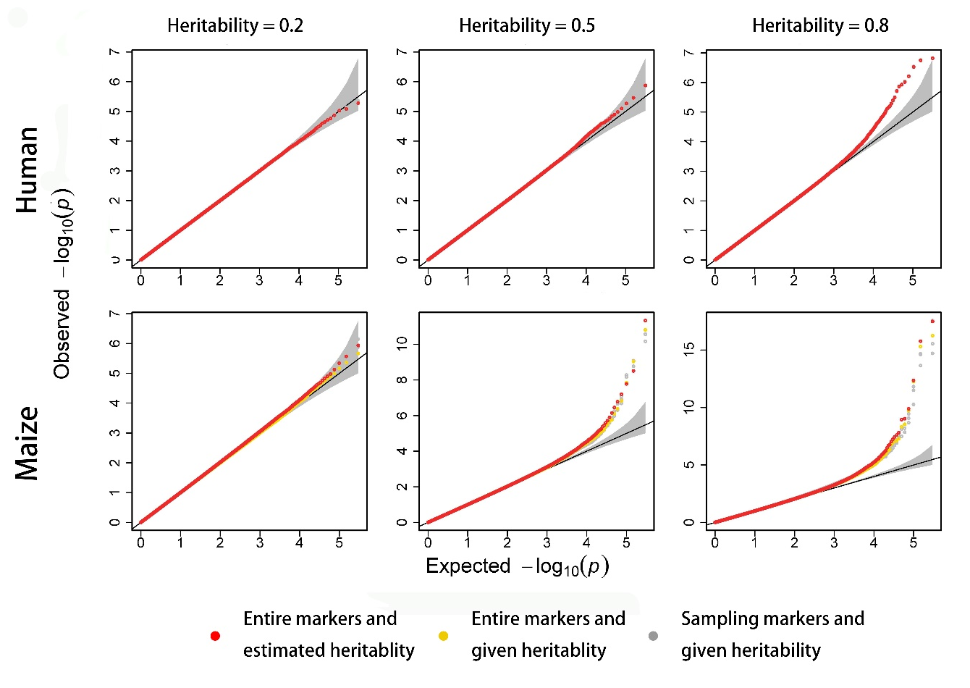

Fig. 4S: Changes in Q-Q profiles with the number of sampling SNPs for GRAMMAR-Lambda. The simulated phenotypes are controlled by 200 QTNs with low, moderate and high heritabilities in human and maize.

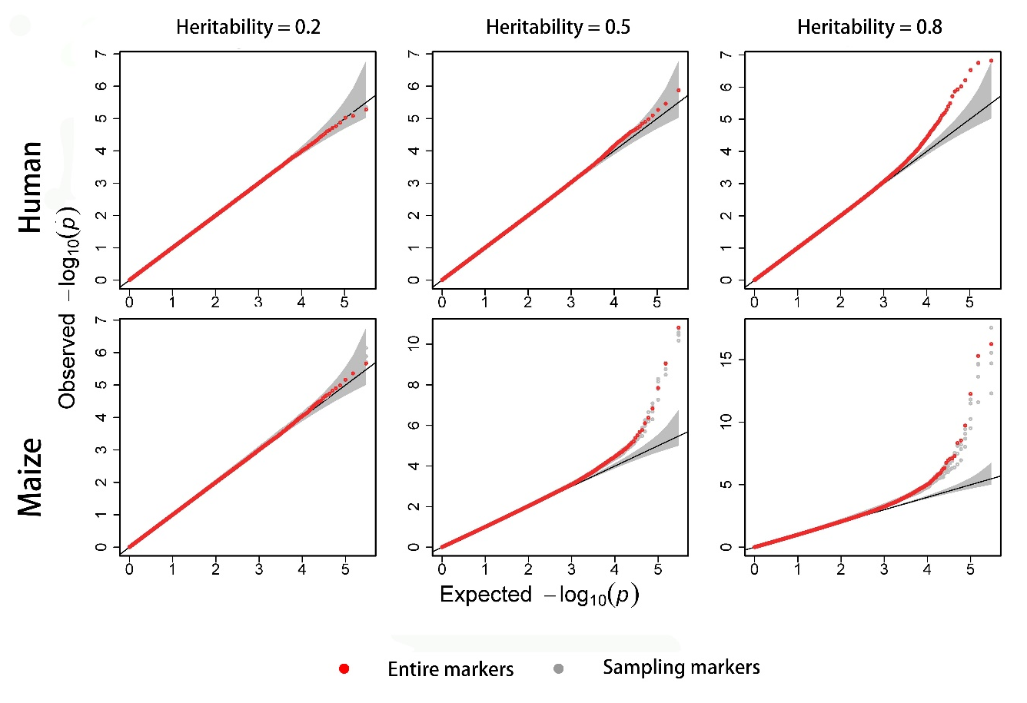

Fig. 5S: Changes in ROC profiles with the number of sampling SNPs for GRAMMAR-Lambda. The simulated phenotypes are controlled by 200 QTNs with low, moderate and high heritabilities in human and maize.

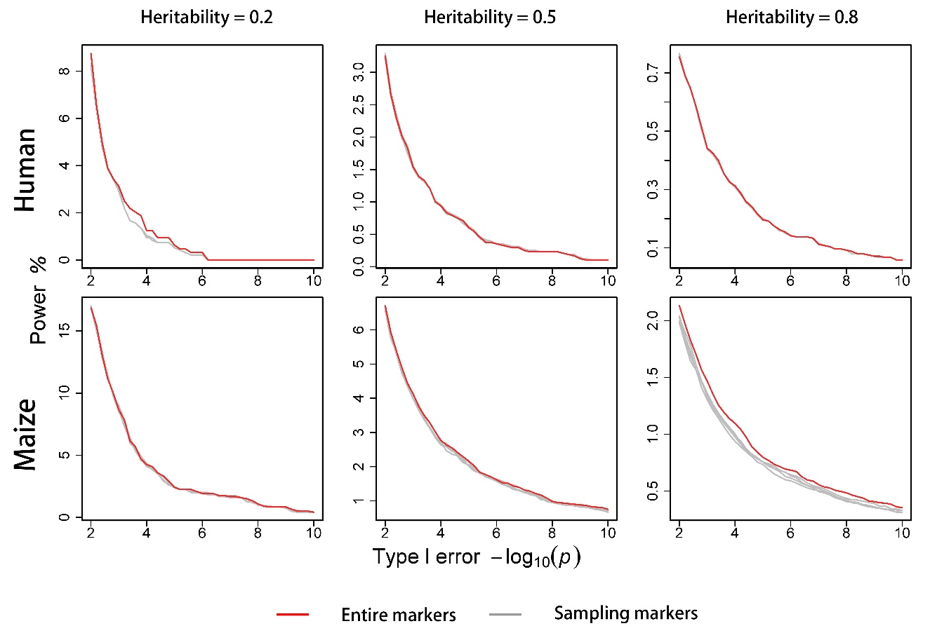

Fig. 6S: Manhattan and Q-Q profiles for 1) BD; 2) CAD; 3) HT; 4) RA; 5) T1D and 6) T2D under standard quality control. The bottom is for joint association analysis

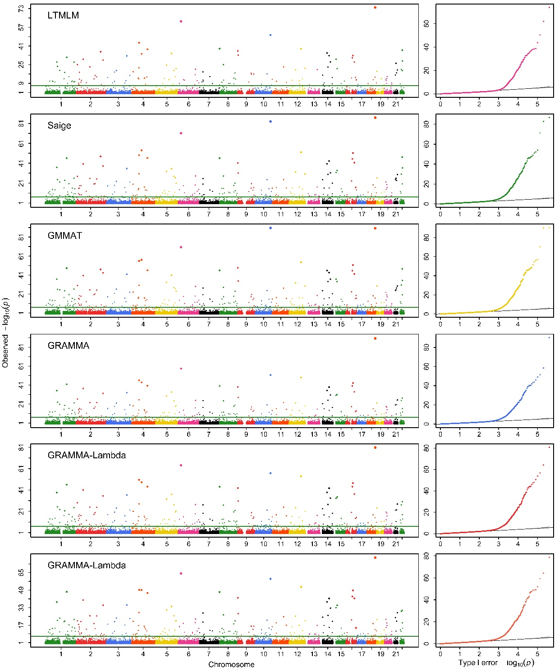

(1)

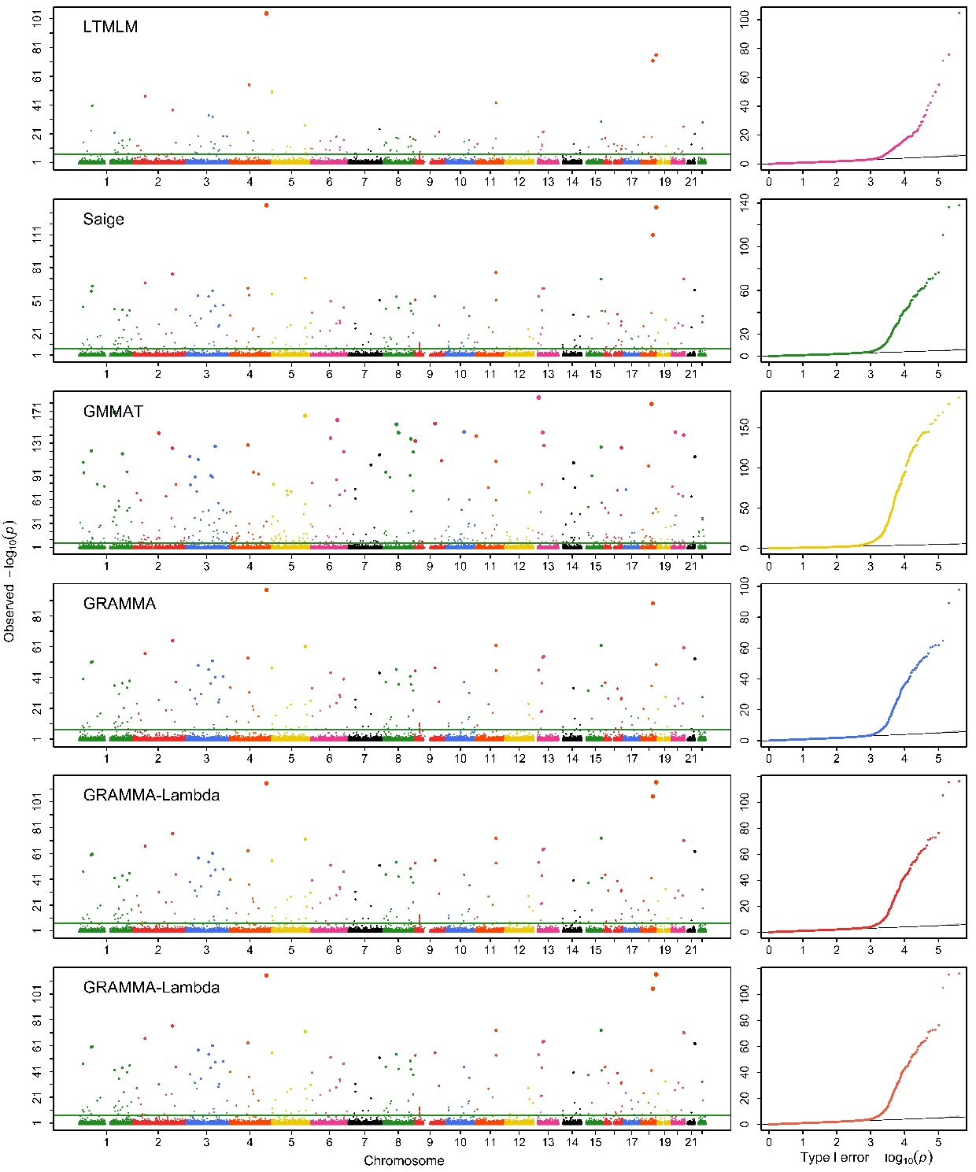

(2)

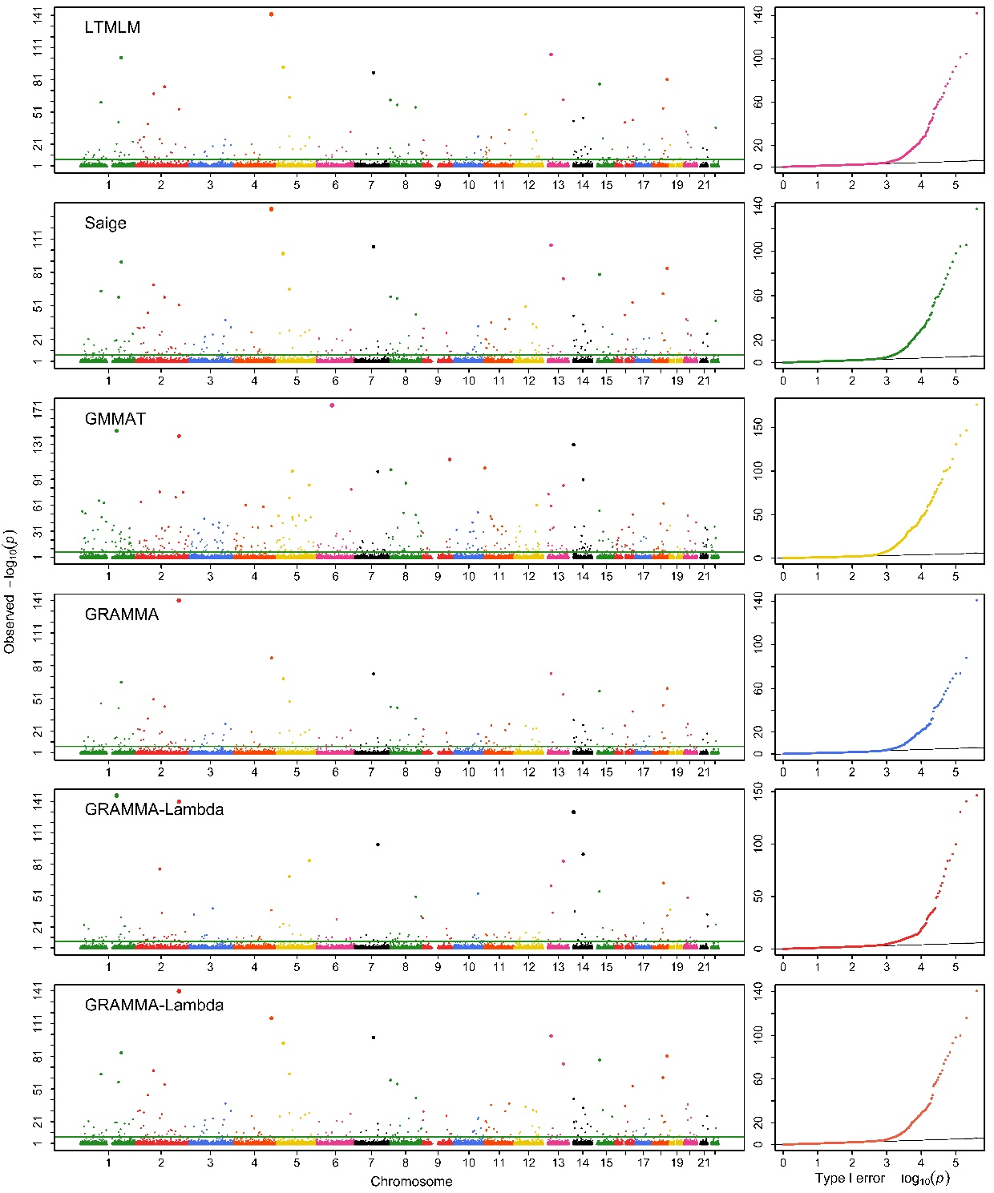

(3)

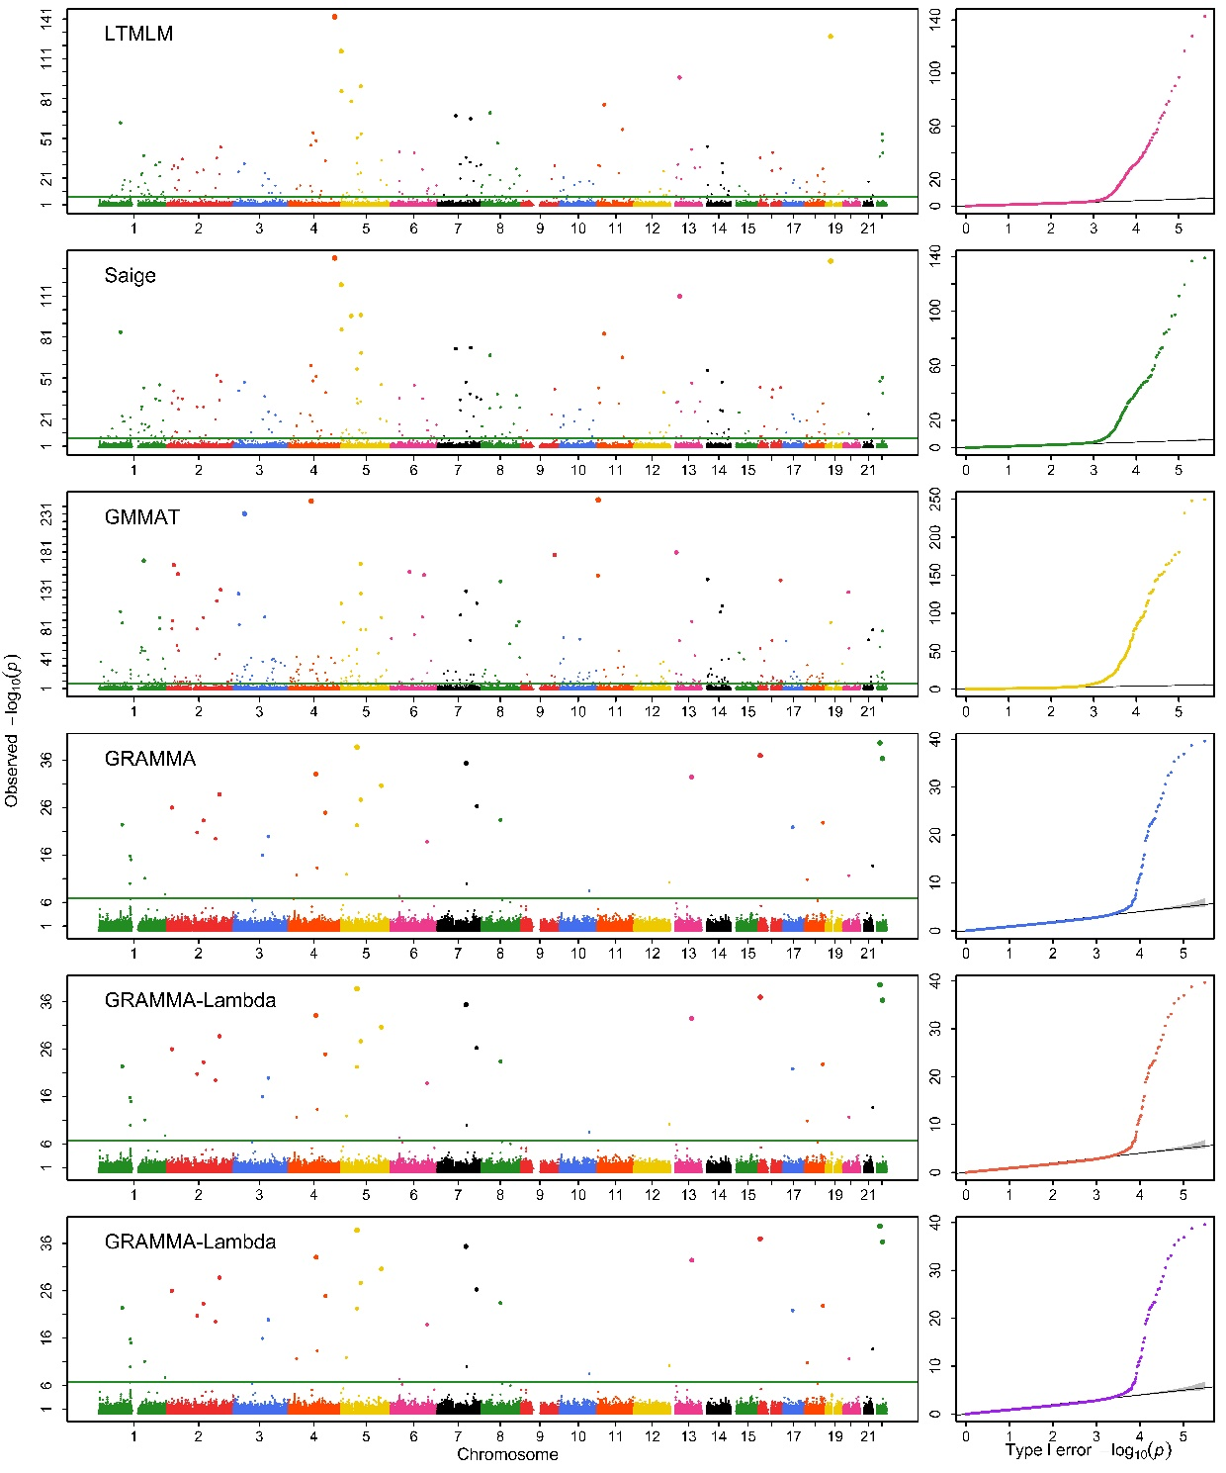

(4)

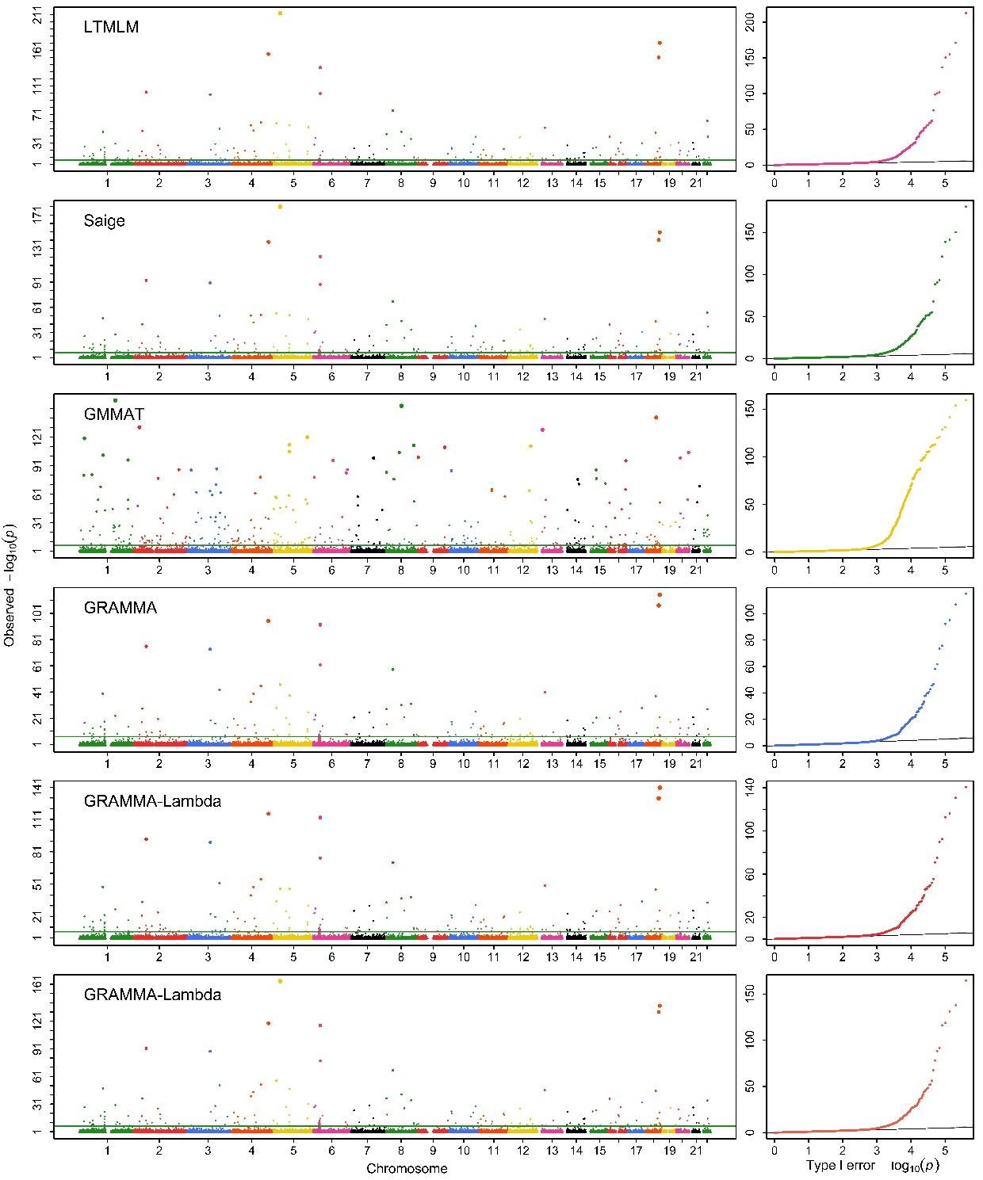

(5)

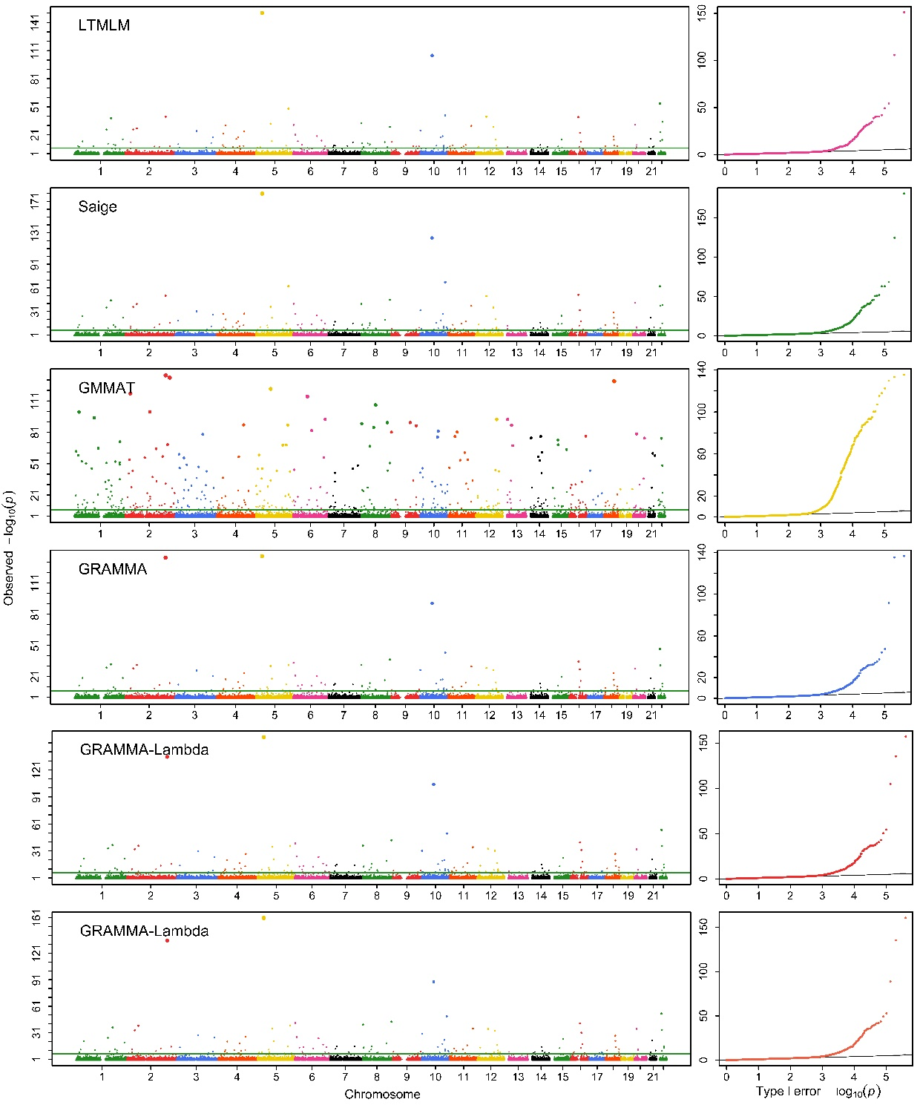

(6)

Fig. 7S: Manhattan and Q-Q profiles obtained with GRAMMAR-Lambda that uses entire markers to estimate genomic heritability and GBVs (upper), and uses sampling markers to estimate only GBVs with given specified heritability, a test at once (middle) and joint association analysis (lower) for 1) BD; 2) CAD; 3) HT; 4) RA; 5) T1D and 6) T2D under standard quality control

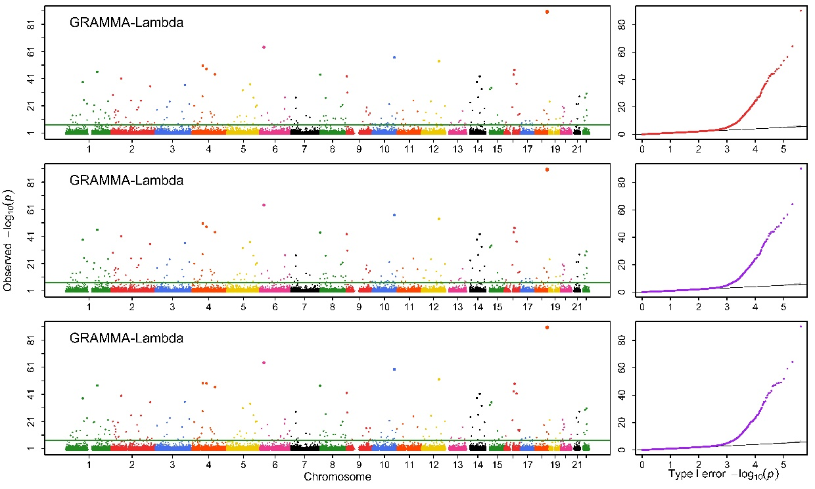
(1)

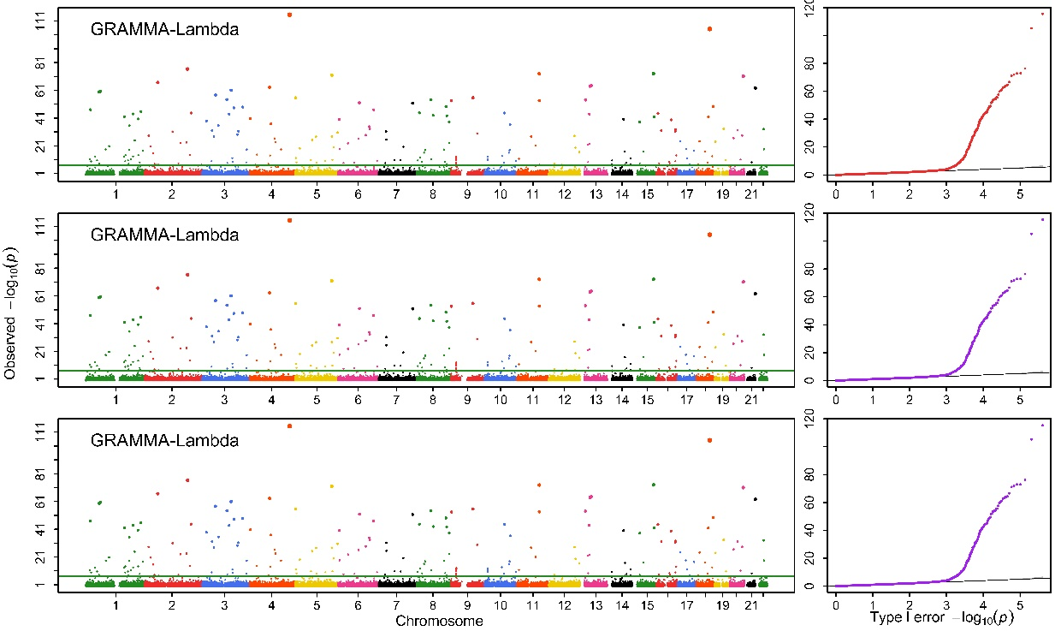

(2)

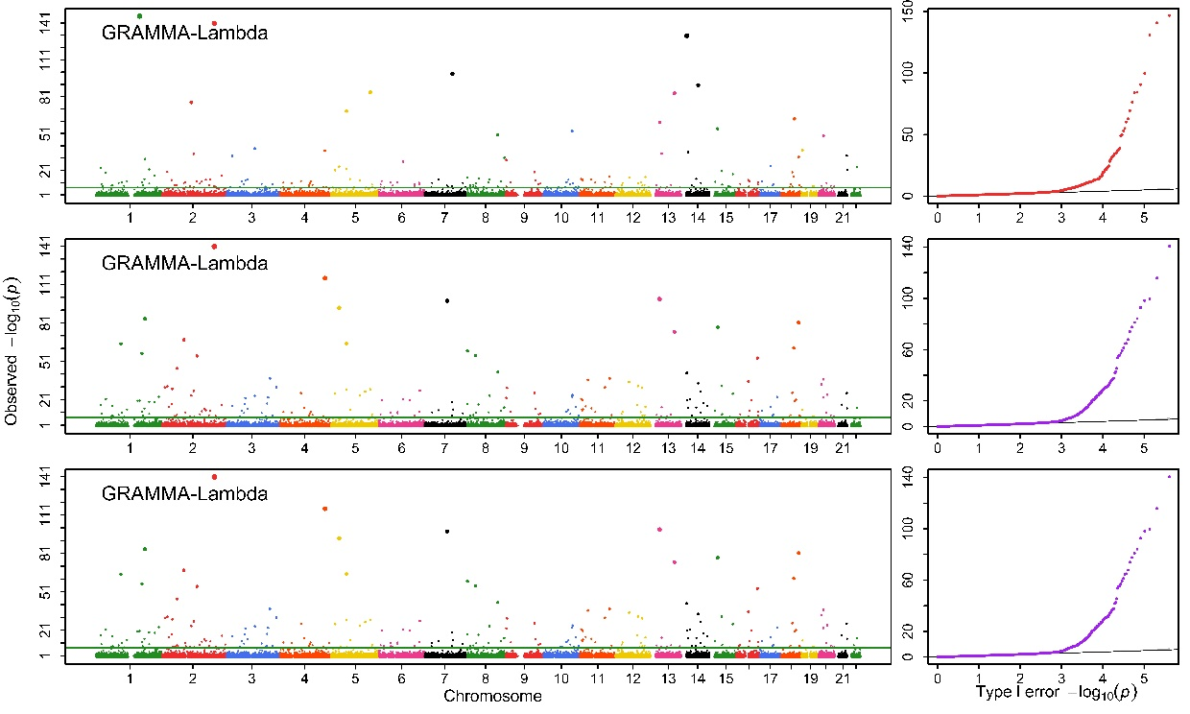

(3)

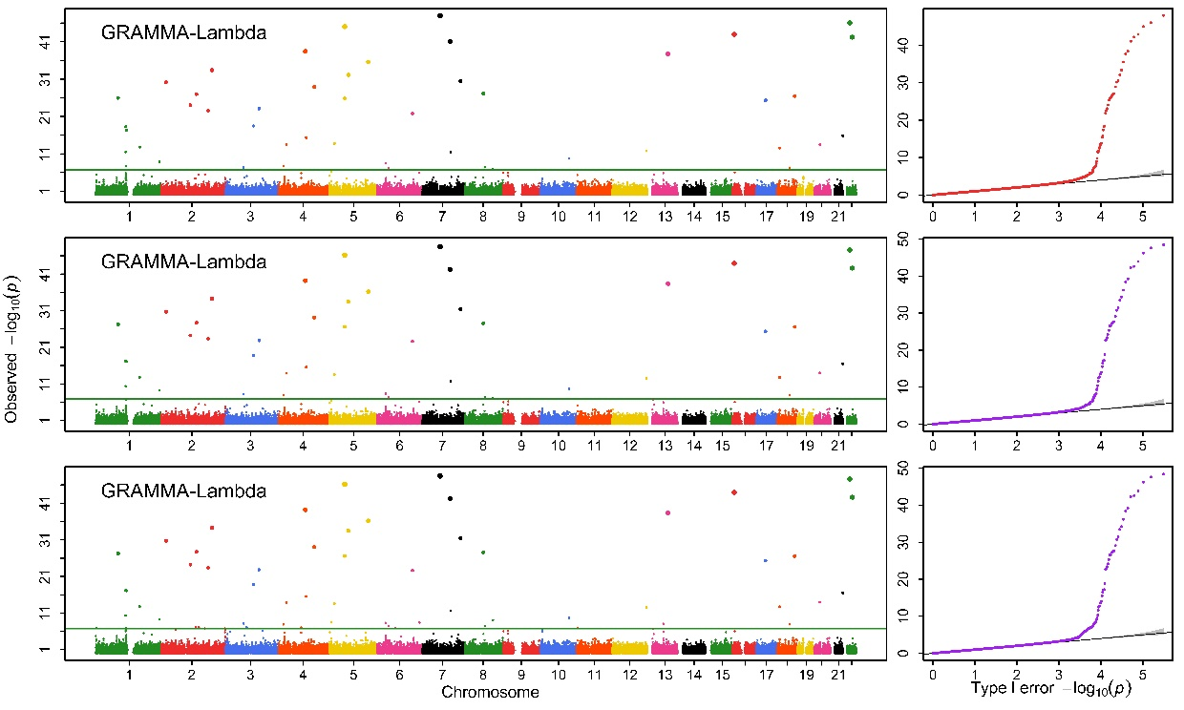

(4)

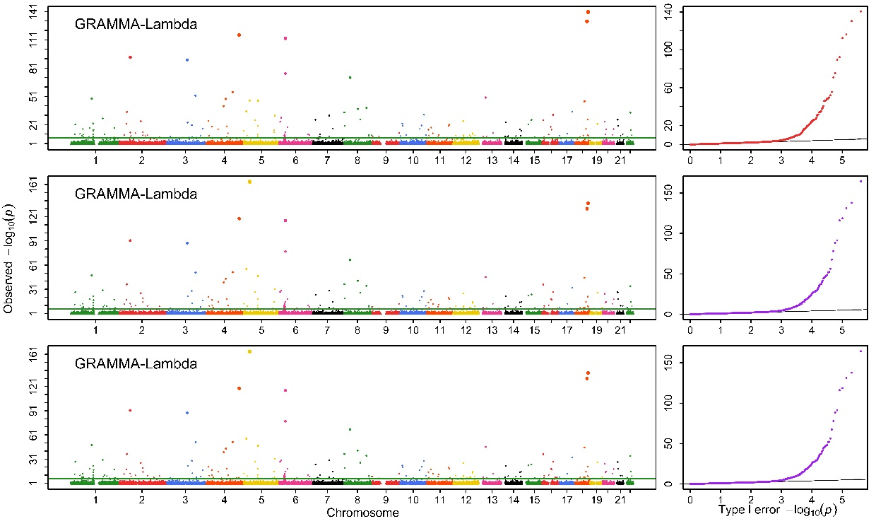

(5)

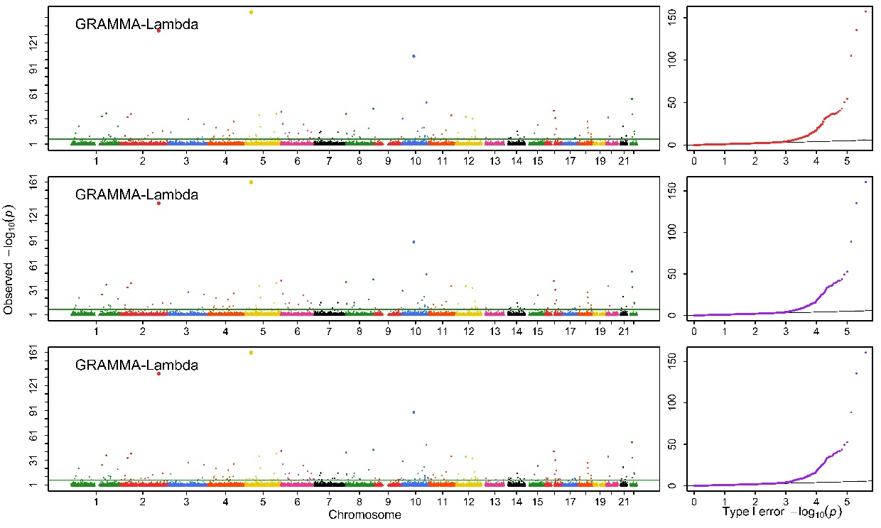

(6)

Fig. 8S: Manhattan and Q-Q profiles for 1) BD; 2) CAD; 3) HT; 4) RA; 5) T1D and 6) T2D under strict quality control. The bottom is for joint association analysis

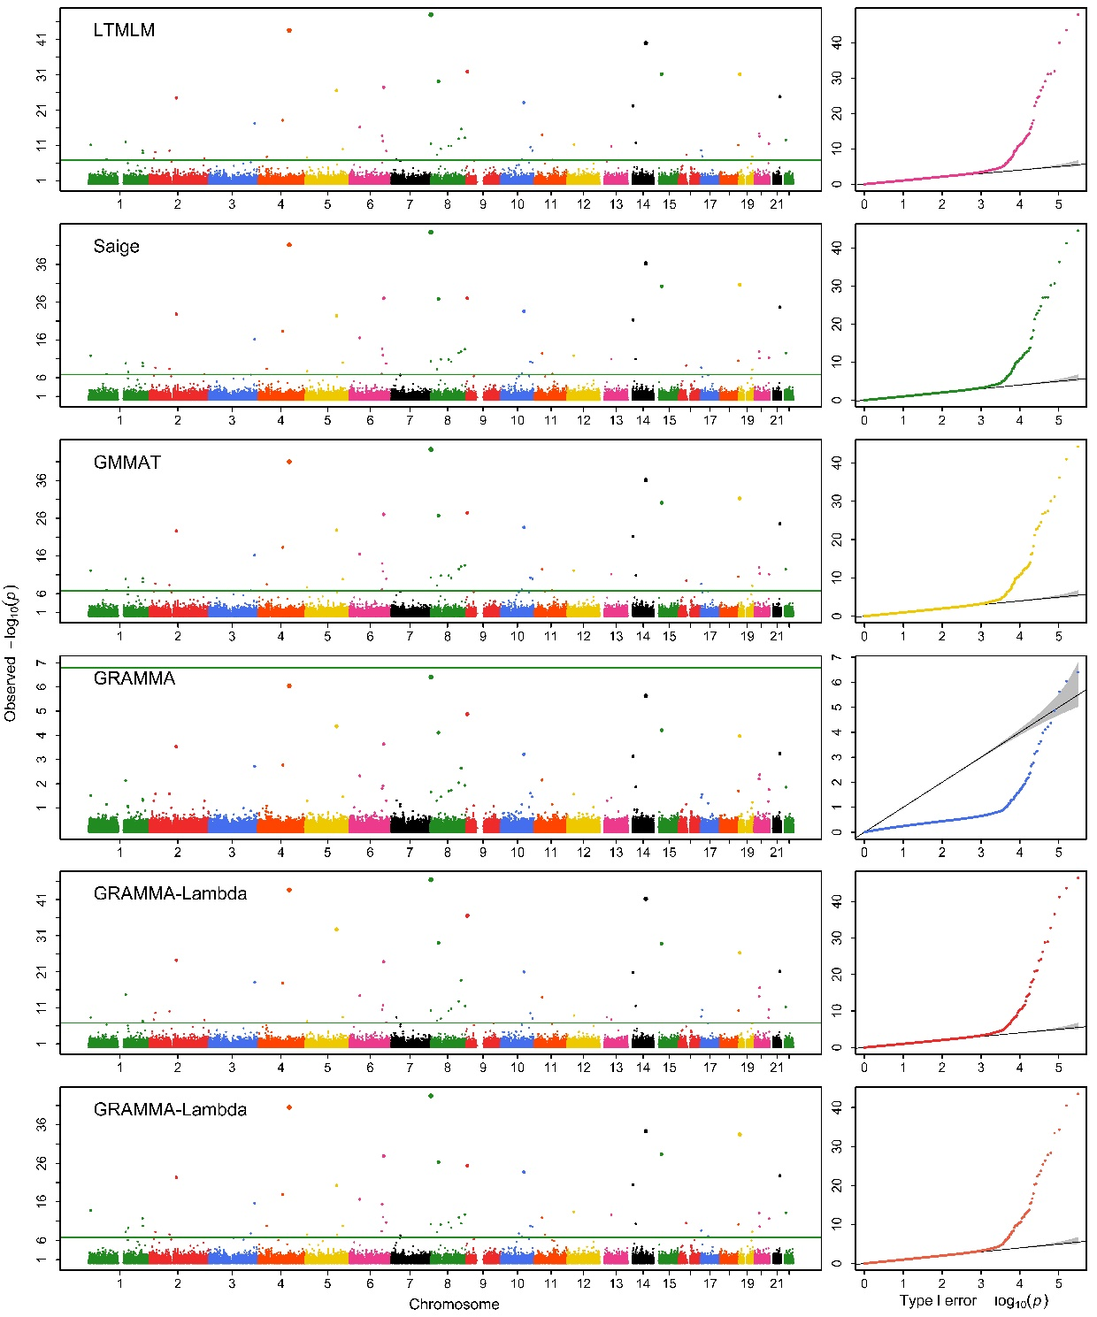

(1)

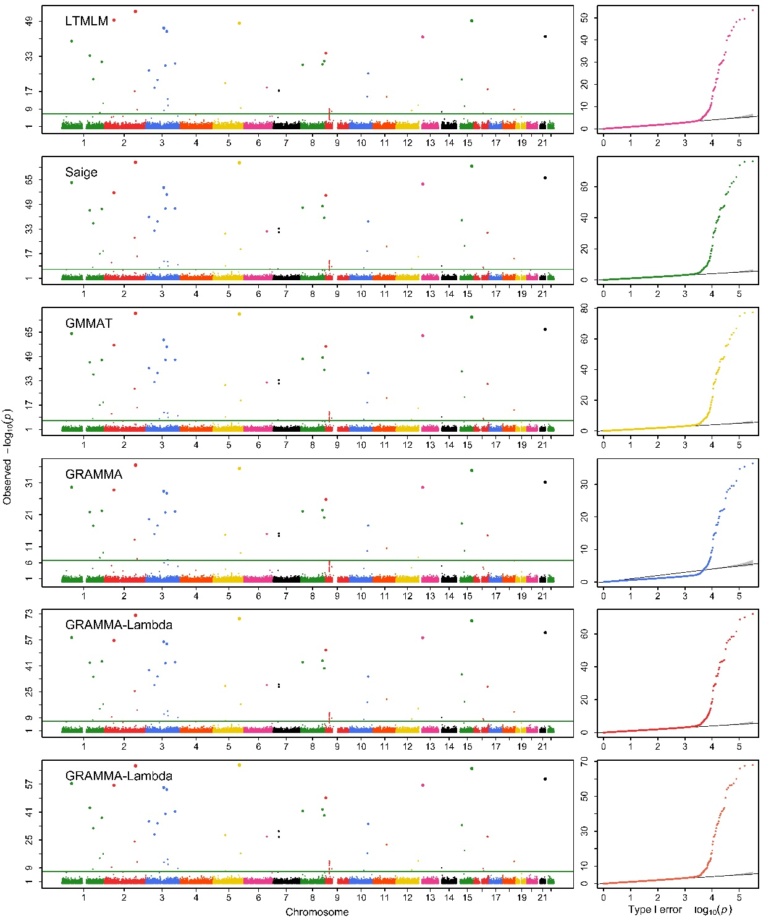

(2)

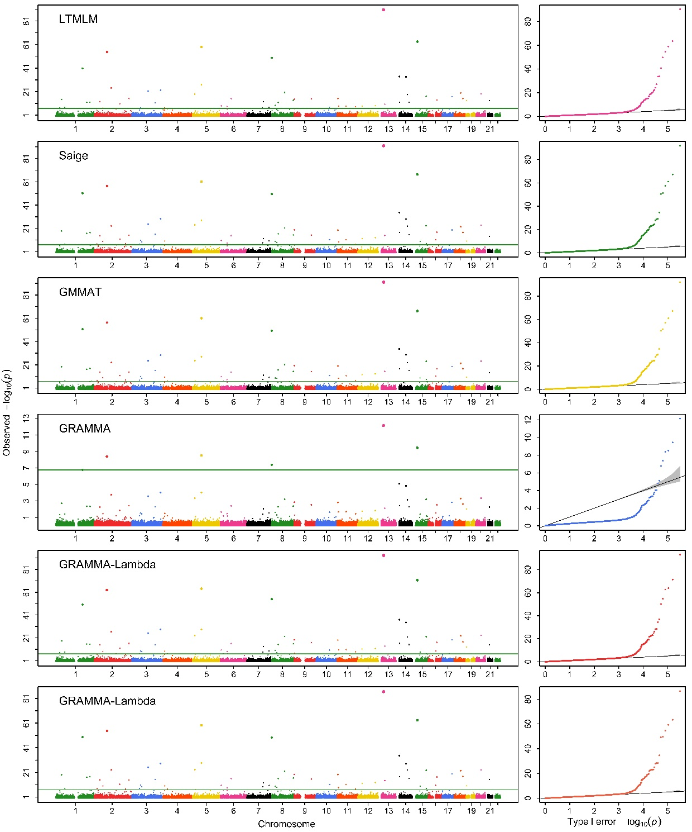

(3)

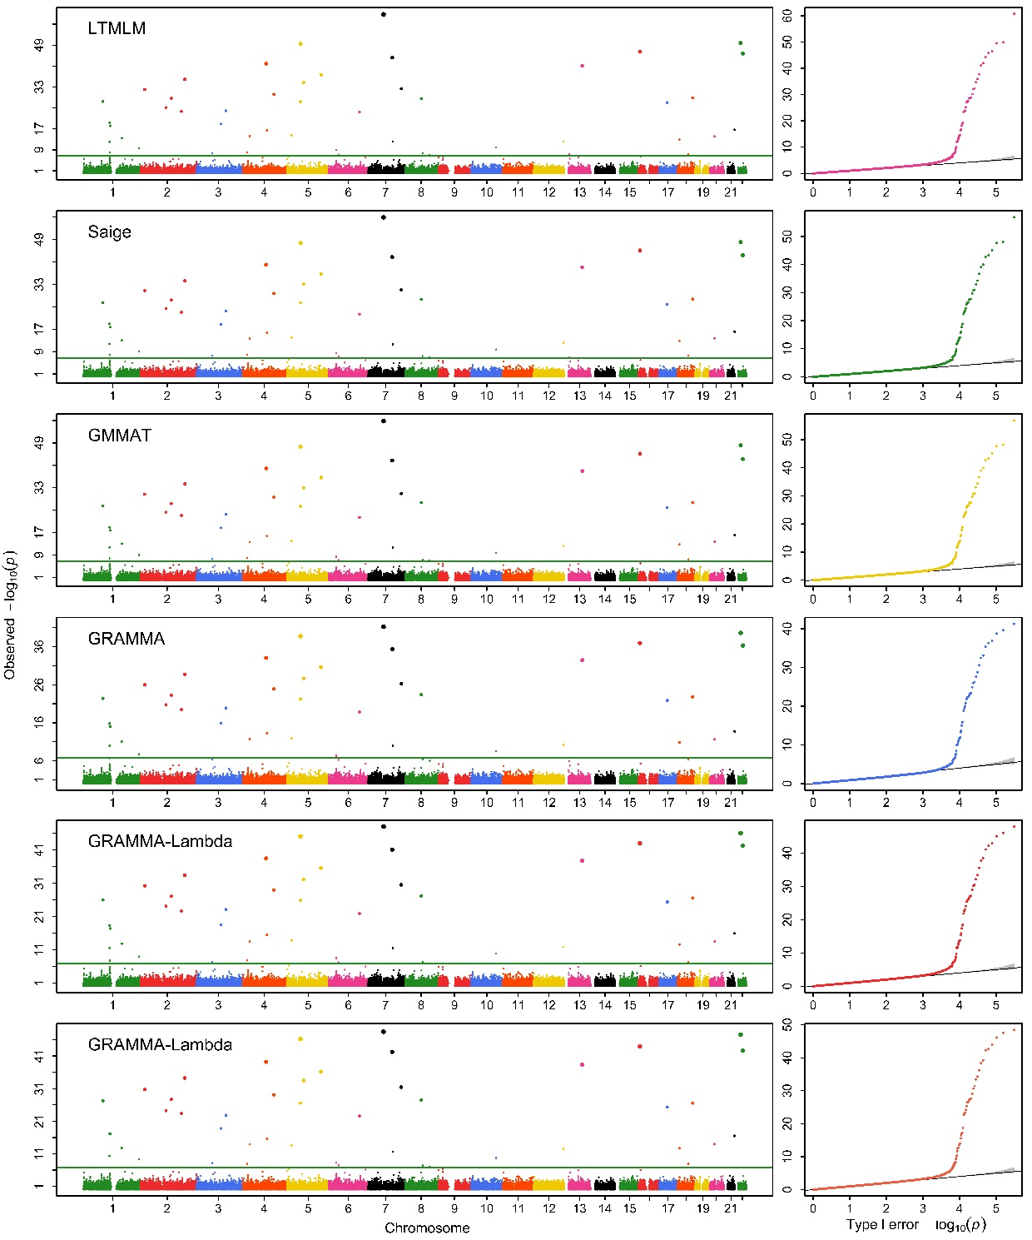

(4)

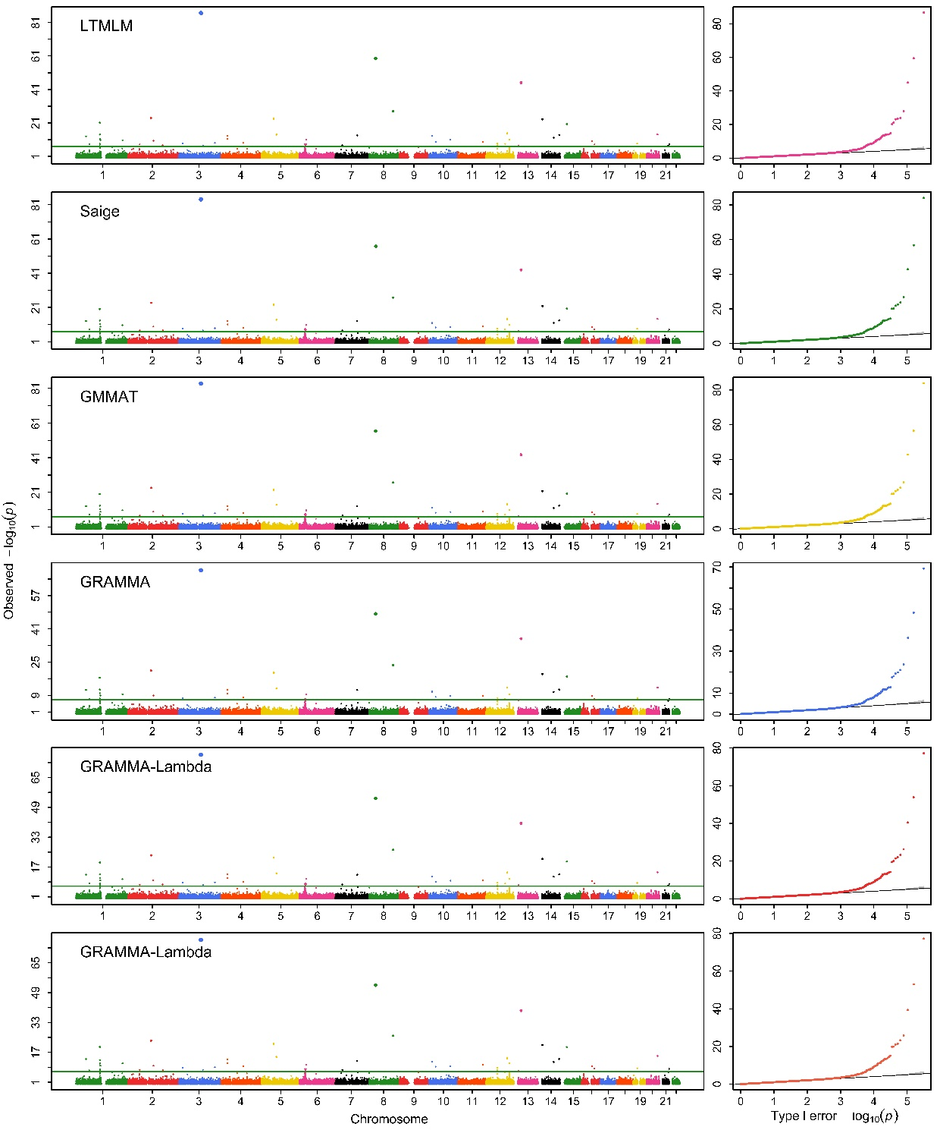

(5)

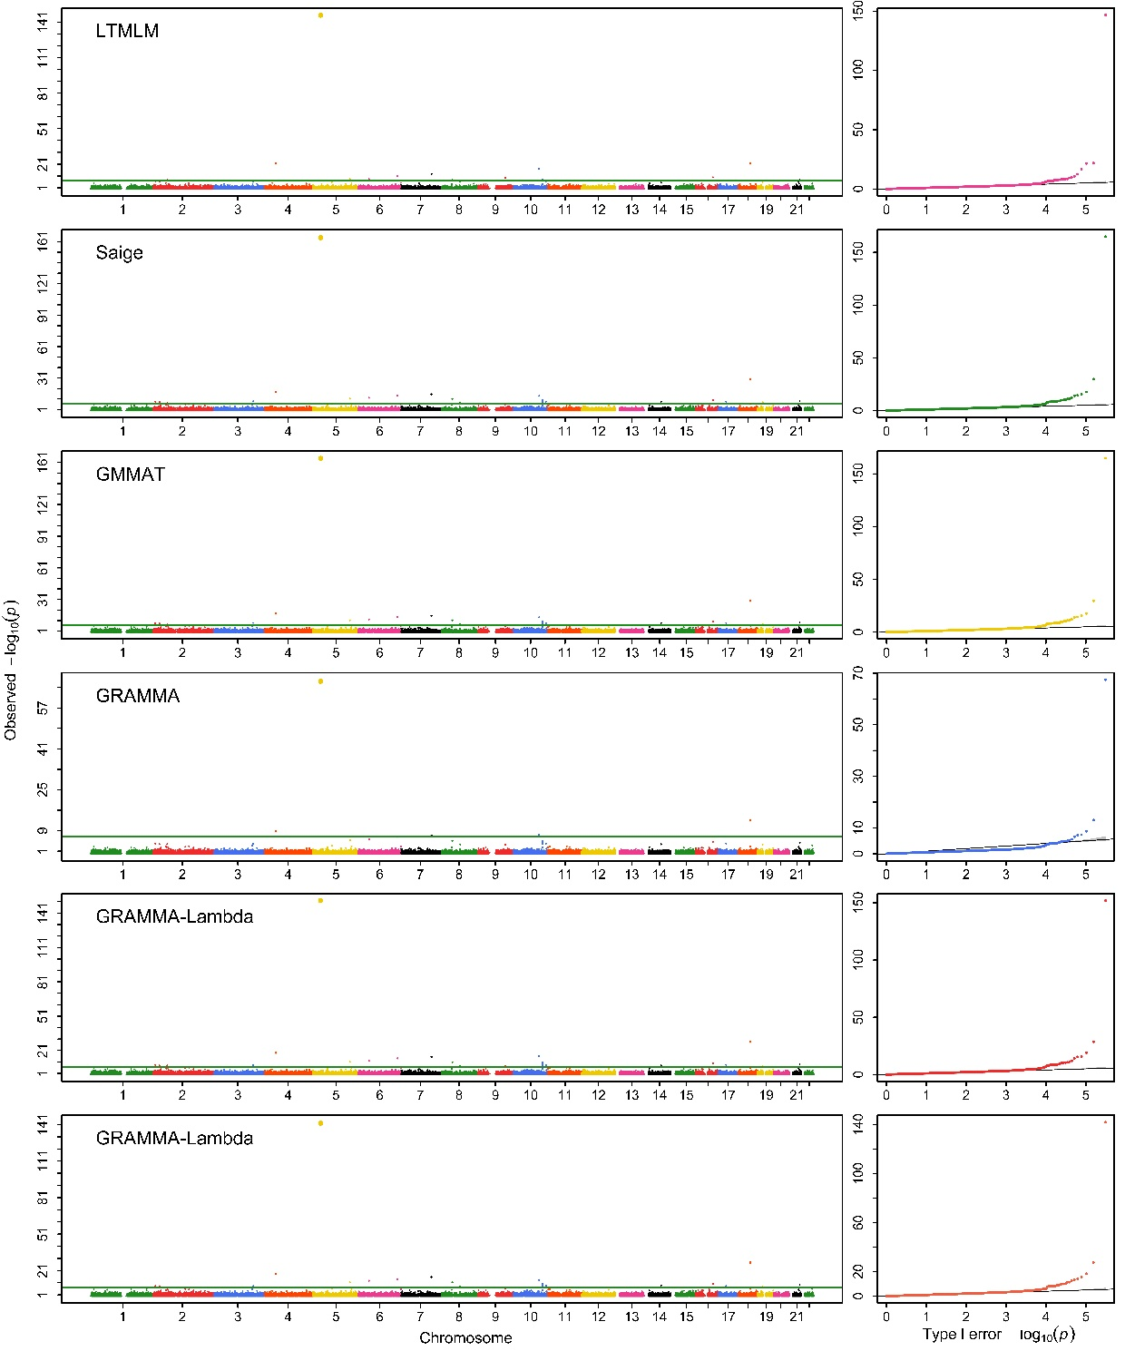

(6)

Fig. 9S: Manhattan and Q-Q profiles obtained with GRAMMAR-Lambda that uses entire markers to estimate genomic heritability and GBVs (upper), and uses sampling markers to estimate only GBVs with given specified heritability, a test at once (middle) and joint association analysis (lower) for 1) BD; 2) CAD; 3) HT; 4) RA; 5) T1D and 6) T2D under strict quality control

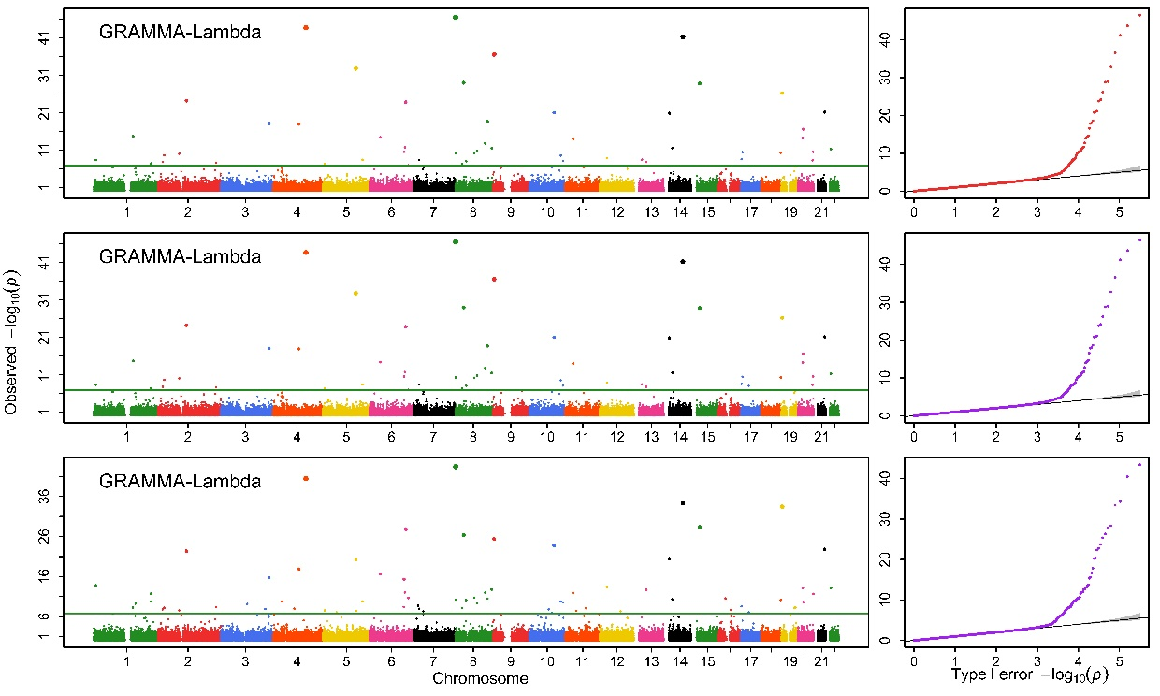

(1)

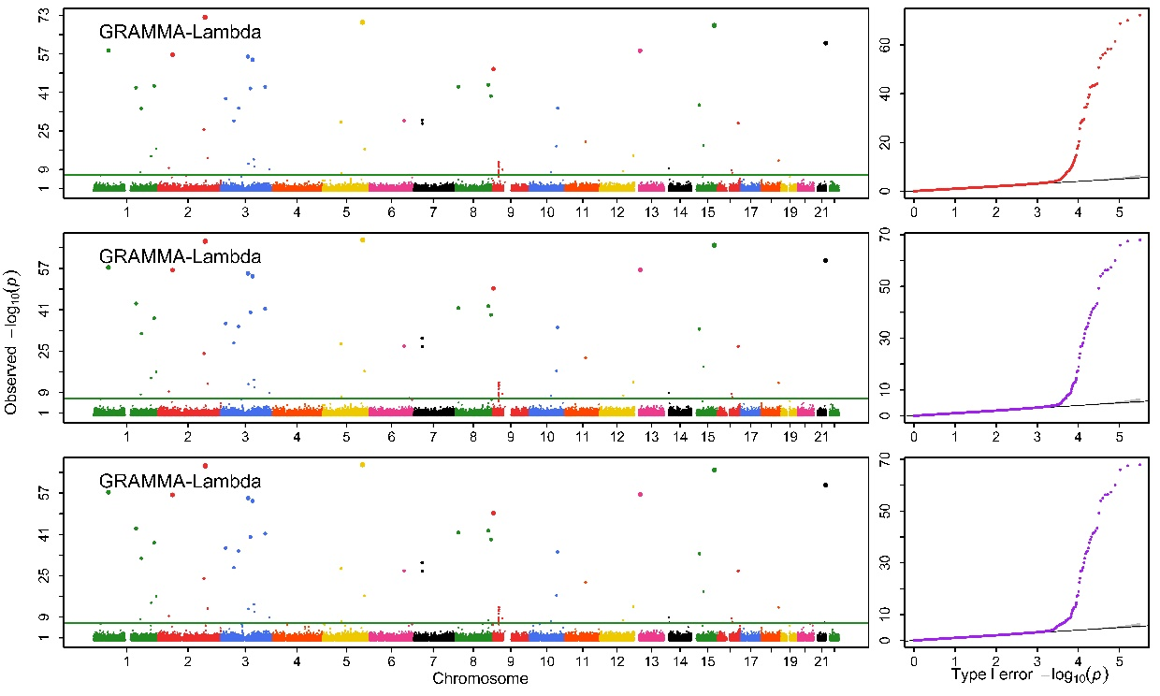

(2)

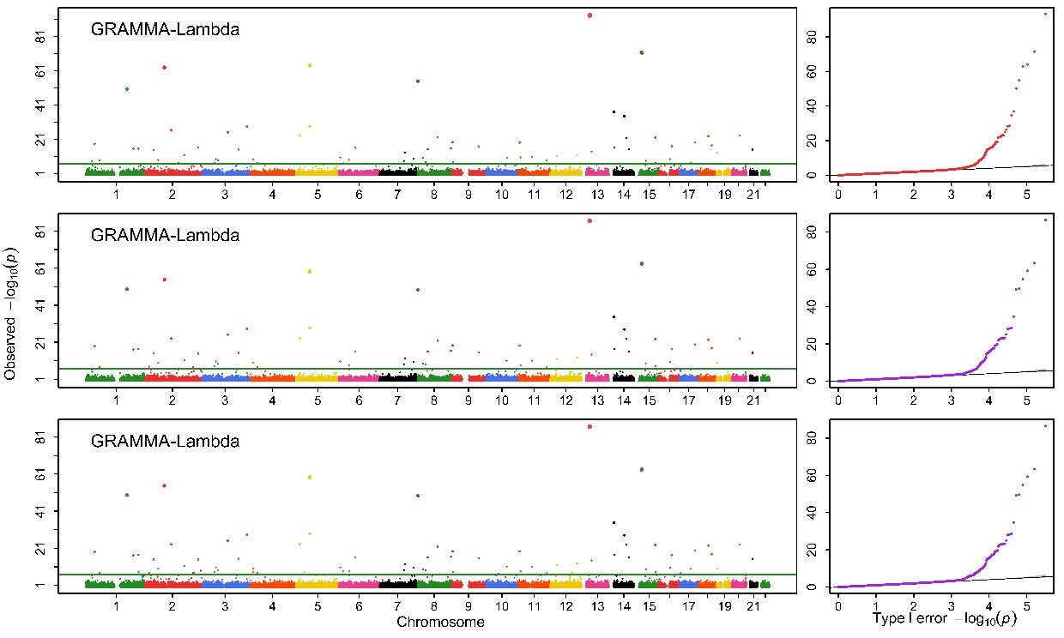

(3)

(4)

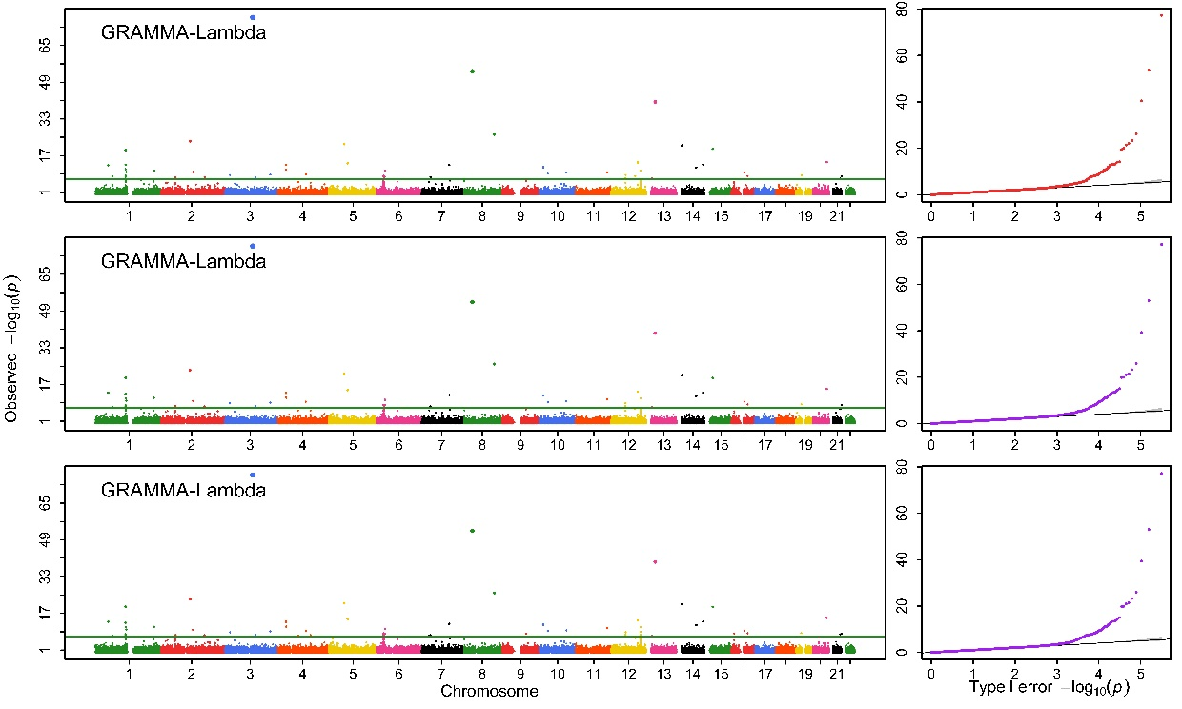

(5)

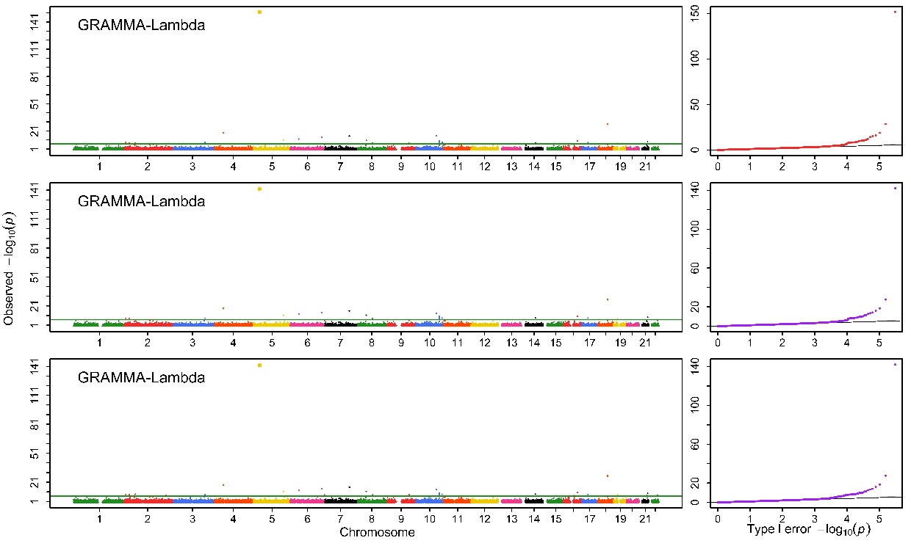

(6)

Table 1S. Genomic control values obtained with the five competing methods for all the simulated phenotypes
Dataset | Method | 0.2 |  |  | 0.5 |  |  | 0.8
Dataset | Method | 40 | 200 | 1000 | 40 | 200 | 1000 | 40 | 200 | 1000
Human | GRAMMAR-Lambda | 0.998(0) | 1(0) | 1(0) | 1(0) | 1(0) | 1(0) | 1(0) | 1(0) | 1(0)
 | GRAMMAR | 0.939(0) | 0.943(0) | 0.919(0) | 0.920(0.001) | 0.936(0.001) | 0.916(0) | 0.909(0.003) | 0.873(0) | 0.892(0)
 | LTMLM | 1(0.002) | 1.001(0.002) | 1.001(0.002) | 1(0.008) | 1.001(0.007) | 1.001(0.004) | 1(0.028) | 0.991(0.025) | 1.002(0.017)
 | GMMAT | 0.995(0) | 0.997(0) | 0.997(0) | 0.997(0) | 0.997(0) | 0.999(0) | 0.997(0) | 1(0) | 0.999(0)
 | SAIGE | 0.997(0.001) | 1(0.001) | 1(0) | 1(0.002) | 0.999(0.001) | 1.001(0) | 1(0.003) | 1.001(0.001) | 1.001(0)
Maize | GRAMMAR-Lambda | 1(0) | 1(0) | 1(0) | 1(0) | 1(0) | 1(0) | 1(0) | 1(0) | 1(0)
 | GRAMMAR | 0.907(0.031) | 0.885(0) | 0.917(0) | 0.781(1.686) | 0.745(0) | 0.999(0) | 0.531(0.001) | 0.556(0) | 0.529(0)
 | LTMLM | 1.576(0.482) | 1.370(0.097) | 1.261(0.09) | 1.216(0.094) | 1.239(0.183) | 1.539(0.196) | 1.080 (0.52) | 1.144(0.499) | 1.112(0.258)
 | GMMAT | 0.998(0.031) | 0.998(0.032) | 0.997(0) | 0.997(0.164) | 0.998(0) | 1.228(0) | 0.991(0) | 0.995(0) | 0.997(0)
 | SAIGE | 1.956(0.480) | 1.536(0.481) | 1.975(0.480) | 1.368(0.685) | 1.335(0.522) | 1.331(0.480) | 1.343(0.580) | 1.366(0.455) | 1.423(0.458)

Table 2S. Computing complexity (Computing time/ Memory footprint, Min/Gb) of the four competing methods for the six diseases analyzed
Disease | Population | SNPs | LTMLM | SAIGE | GMMAT | GRAMMAR-Lambda¹ | GRAMMAR-Lambda²
CAD | 4,992 | 409,517 | 26.14/33.1 | 15.60/1.2 | 6.78/2.1 | 1.09/0.4 | 0.21/0.6
RA | 5,003 | 409,924 | 27.46/33.1 | 15.19/1.2 | 6.82/2.1 | 1.02/0.4 | 0.22/0.6
T1D | 5,004 | 409,674 | 27.31/33.1 | 14.162/1.2 | 6.78/2.1 | 1.00/0.4 | 0.22/0.6
T2D | 5,003 | 409,805 | 25.83/33.1 | 15.223/1.2 | 6.54/2.1 | 1.09/0.4 | 0.21/0.6
HT | 5,005 | 409,742 | 28.61/33.1 | 14.67/1.2 | 6.57/2.1 | 1.03/0.4 | 0.23/0.6
BD | 5,002 | 409,642 | 26.88/33.1 | 14.85/1.2 | 6.74/2.1 | 1.04/0.4 | 0.22/0.6

1 represents GRAMMAR-Lambda using entire markers and 2 that using the sampling markers

