Supplementary Information

Biosynthesis of apigenin glucosides in engineered Corynebacterium glutamicum
Obed Jackson Amoah¹, Su Yeong Ma¹, Samir Bahadur Thapa¹, Hue Thi Nguyen¹, Morshed Md Zakaria¹, Jae Kyung Sohng^{1,2}**
¹Department of Life Science and Biochemical Engineering, Sun Moon University, 70 Sunmoon-ro 221, Tangjeong-myeon, Asan-si, Chungnam 31460, Republic of Korea
²Department of Pharmaceutical Engineering and Biotechnology, Sun Moon University, 70 Sunmoon-ro 221, Tangjeong-myeon, Asan-si, Chungnam 31460, Republic of Korea

Corresponding author:
Prof. Jae Kyung Sohng
Tel: +82(41)530-2246
Email: sohng@sunmoon.ac.kr
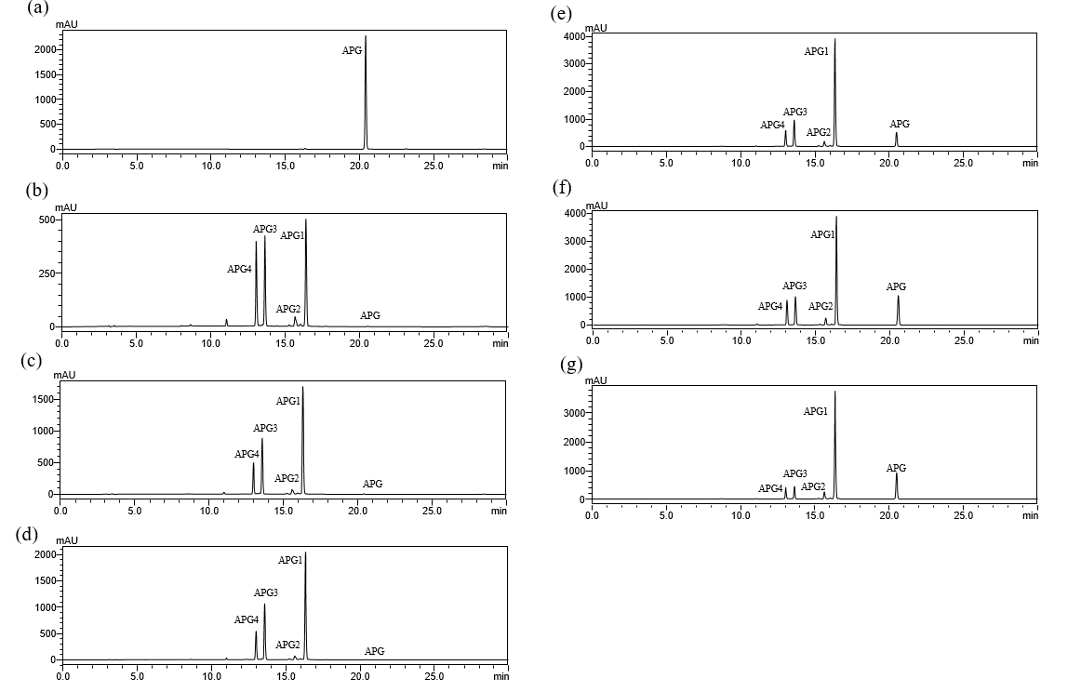

Figure S1. HPLC profiles for the production of apigenin glucosides with different concentrations of apigenin; (a) Apigenin standard; (b) 2 mM; (c) 4 mM; (d) 5 mM; (e) 8 mM; (f) 10 mM and (g) 12 mM with CgIBR-2

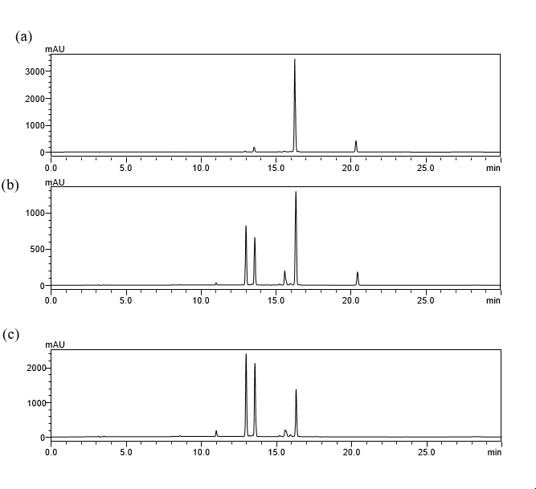

Figure S2. HPLC profile for the production of apigenin glucosides under different temperatures conditions with 5 mM of apigenin; (a) 25℃; (b) 33℃ and (c) 37℃.

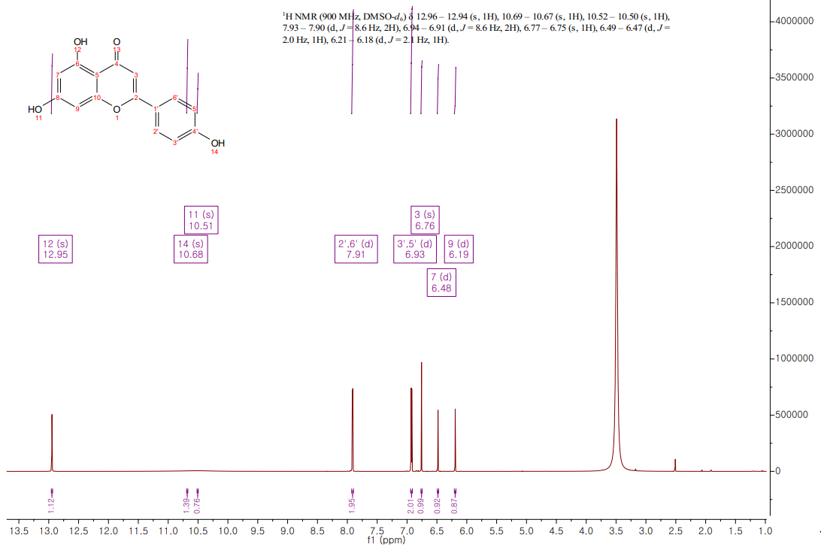

Figure S3. ¹H NMR of apigenin standard

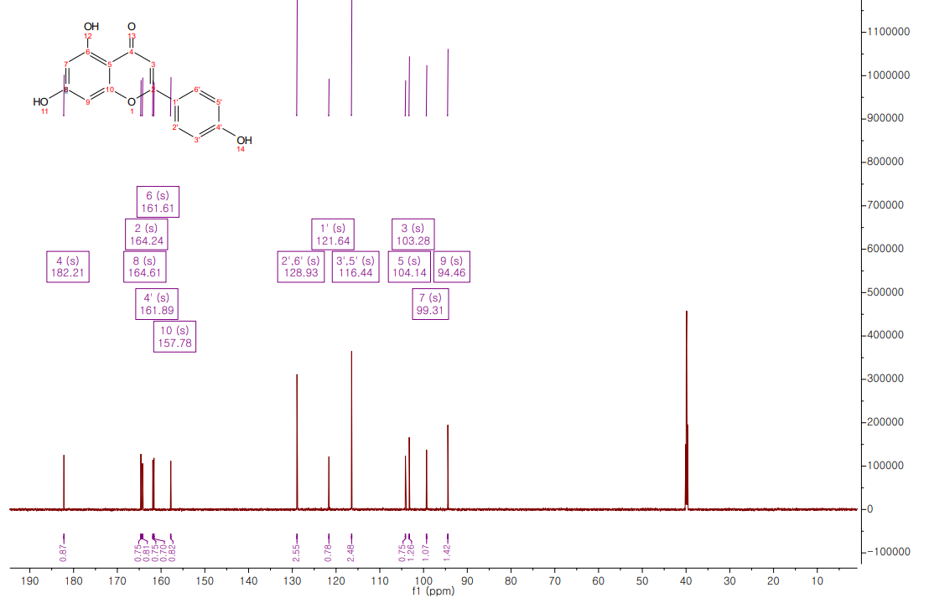
Figure S4. ¹³C NMR of apigenin standard

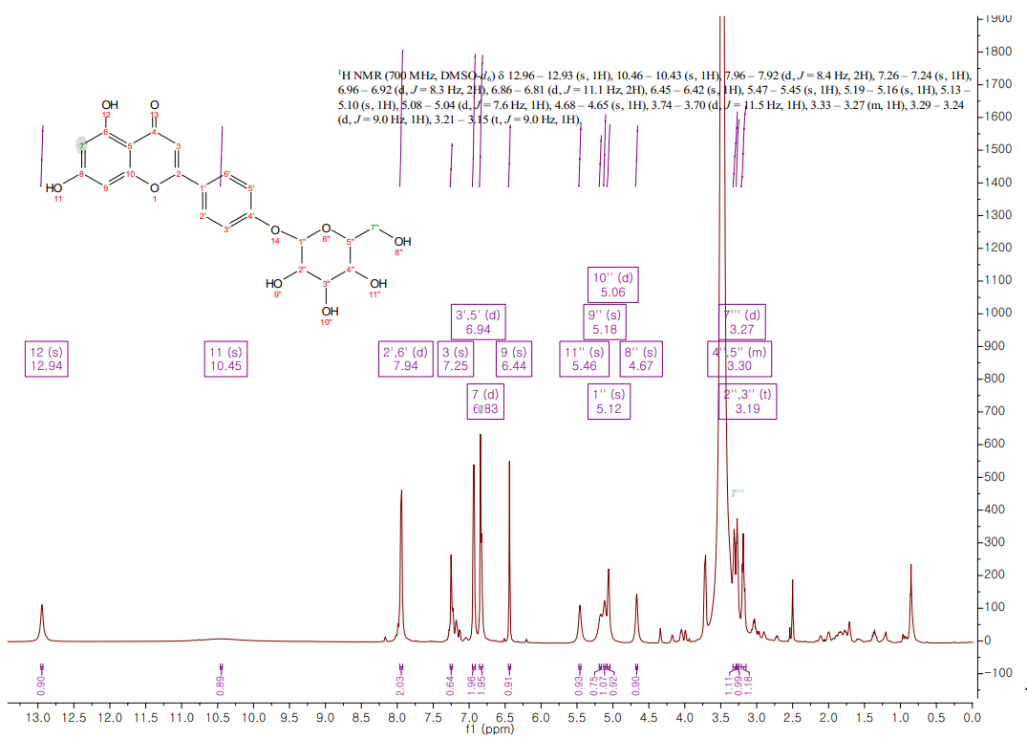
Figure S5. ¹H NMR of APG1

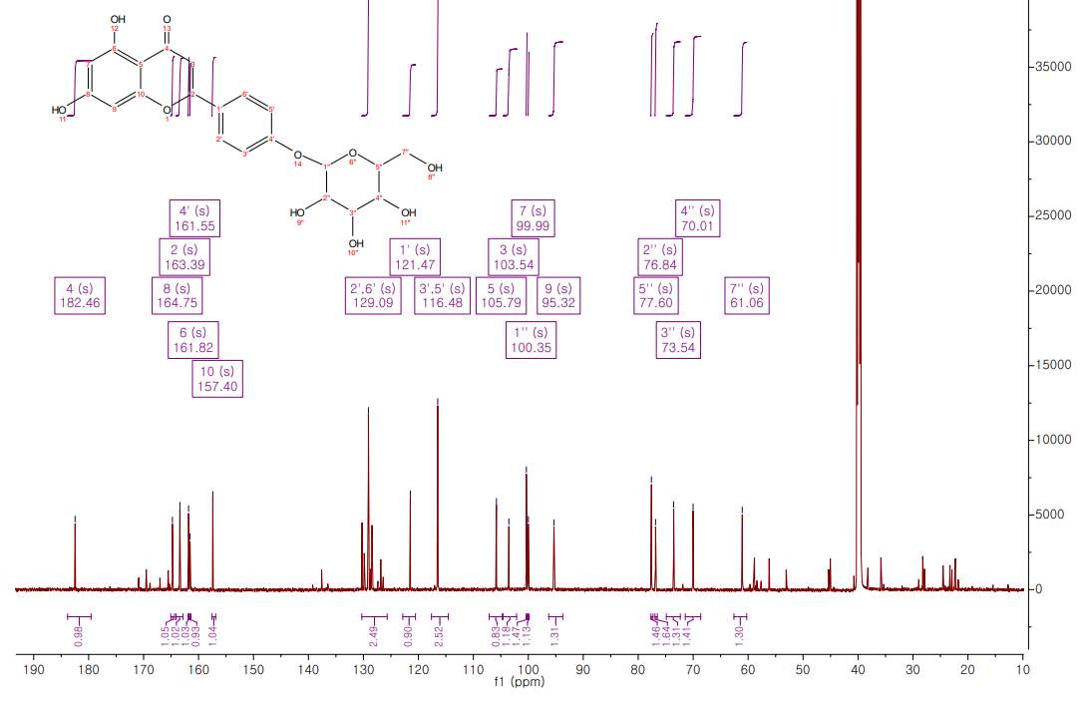
Figure S6. ¹³C of APG1

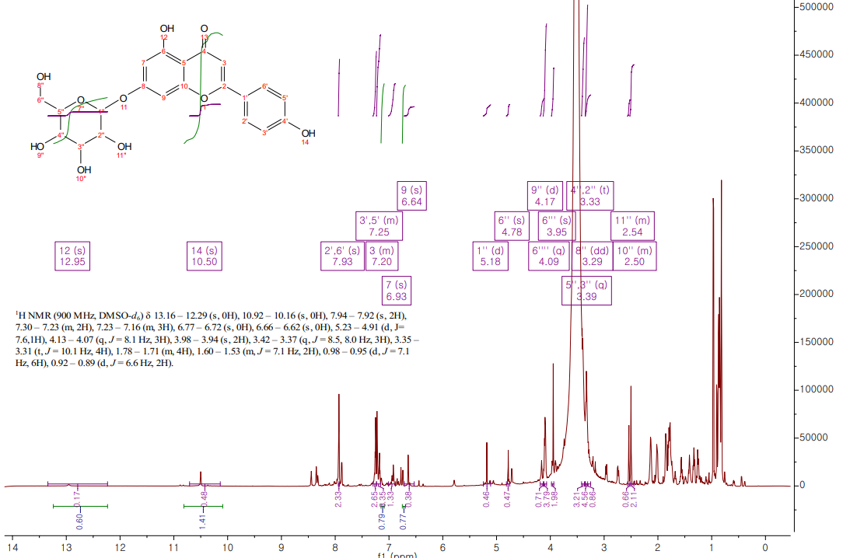

Figure S7. ¹H NMR of APG2

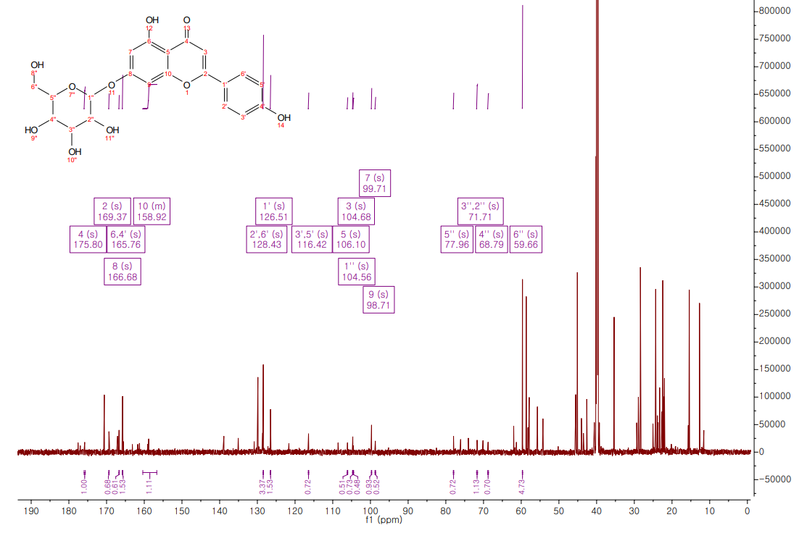
Figure S8. ¹³C of APG2

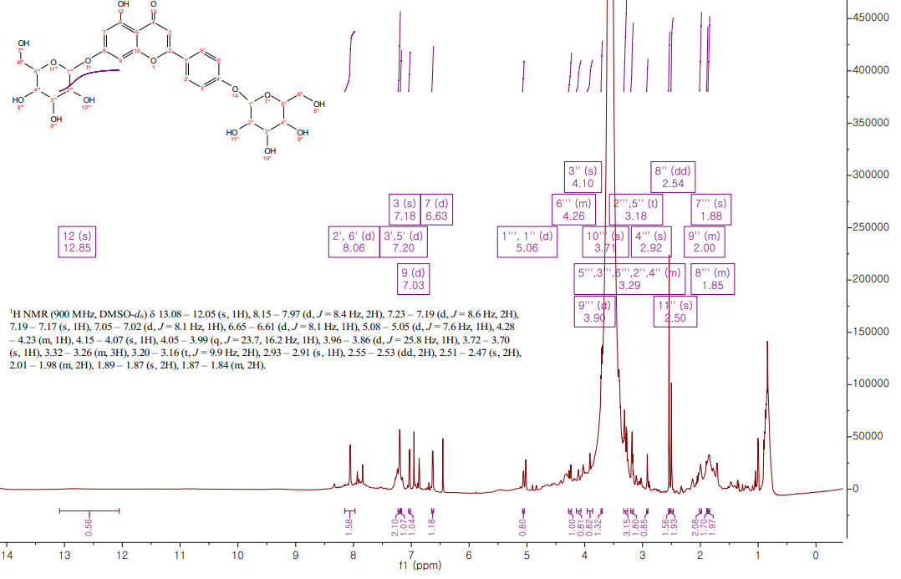
Figure S9. ¹H NMR of APG3

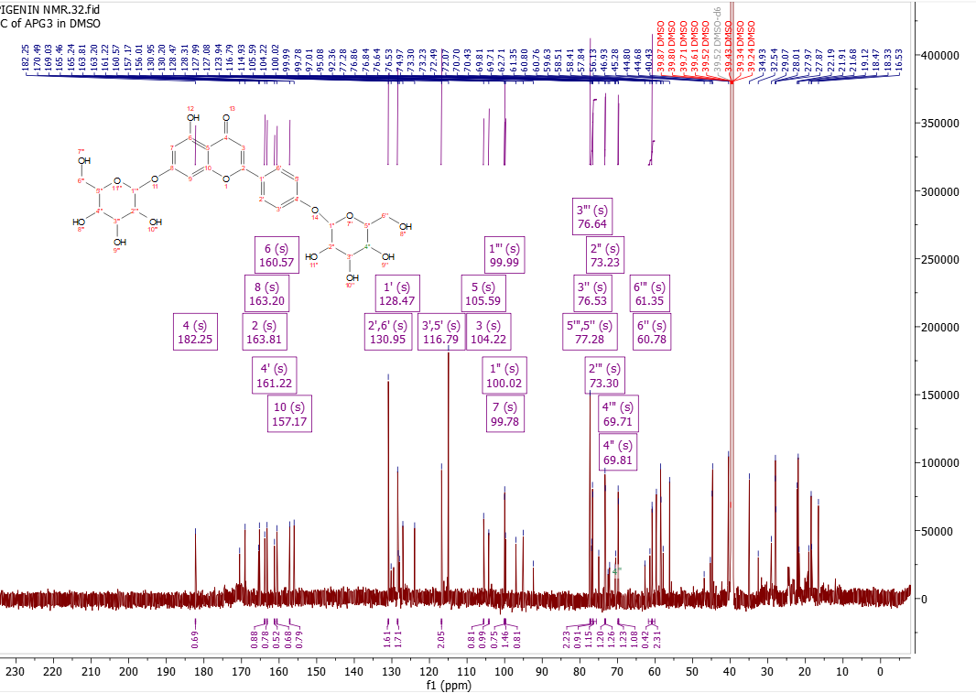
Fig. S10 ¹³C Spectra of APG3

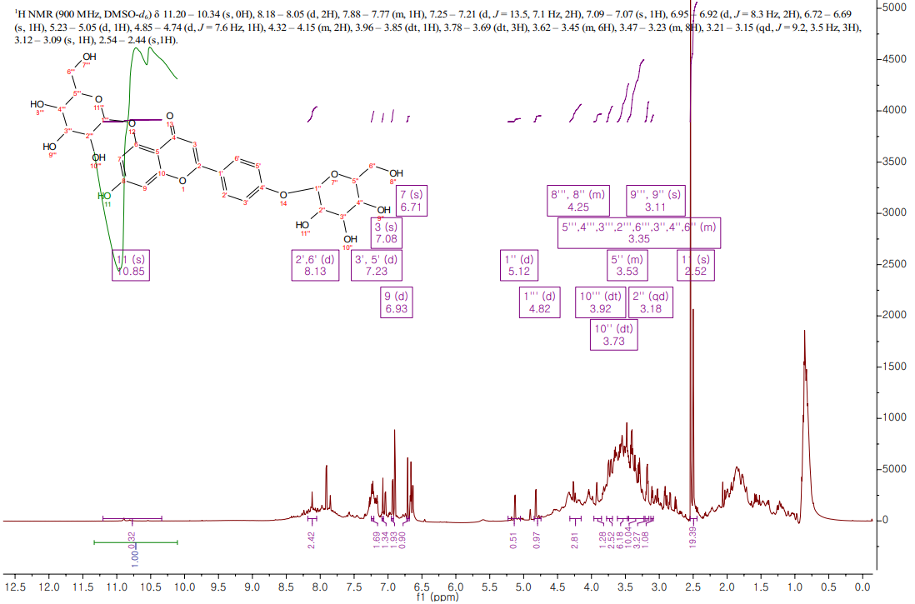
Fig. S11 ¹H NMR spectra of APG4

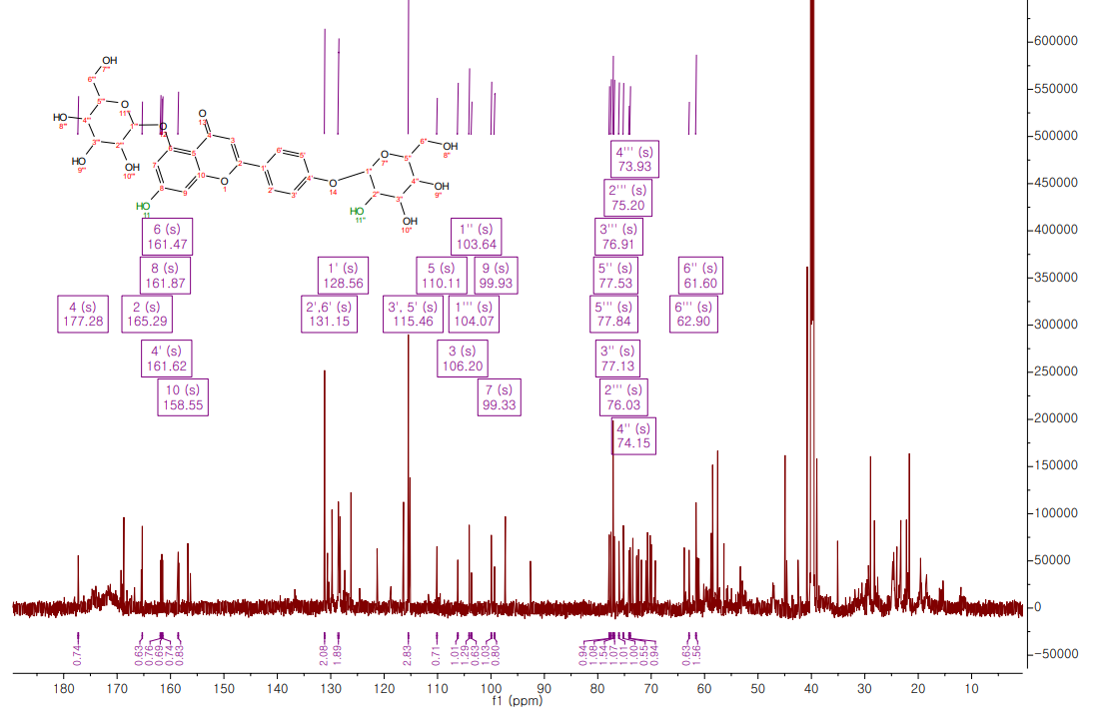
Fig. S12 ¹³C Spectra of APG4

Table S1; Strains and plasmids used
Strains and plasmids | Relevant Characteristics |  | Source or references
Strains
E. coli XL1Blue |  | Δ(mcrA)183  Δ(mcrCB-hsdSMR-mrr)173 endA1 supE44 thi-  1 recA1 gyrA1 gyrA96 relA1 lac [F' proAB lacIqZΔM15  Tn10 9Tetr)] |  | Stratagene
C. glutamicum |  | Wild type strain, ATCC 13032 |  | ATCC
CgIBR- 1 |  | C. glutamicum harboring pSKSM-Y |  | This study
CgIBR- 2 |  | C. glutamicum harboring pSKSM-YGP |  | This study
Plasmids
pGEM®-T easy vector |  | E. coli general cloning vector, amp^{r} |  | Promega (USA)
pSK003 |  | Km^{R}; C. glutamicum/E. coli shuttle vector. (P_{sod}, pBL1, oriV_{C.g}., oriV_{E.c}). |  | Our lab
pSKSM |  | pSK003+P_{tac}+LacI |  | [39]
pSKSM-Y |  | pSK003+P_{tac}+LacI+ydhE |  | This study
pSKSM-YGP |  | pSKSM harboring ydhE, galU1, and pgm |  | This study

Table S2; Primers used for this study
Name | Sequence (5’-3’)
GalU1-F | TAGTCTAGAAAGGAGATATACAATGAGTTTGCCTATCGATGAG
GalU1-R | CTGCGGCCGCCTATTTTACTTGAGAATCGTCTGCAATACG
Pgm-F | CTGCGGCCGCAAGGAGATATACAATGGCACATGAACGCGCCGG
Pgm-R | AGCTGCAGTTACTGTCCGAGTACTTCGCTGACCAA

