Supplementary document
In this appendix, the design of samples R2, R3, and R4 are reviewed which was previously discussed in [42].

Design of sample R2
R2 included 6 similar sets of three sizes of defects (Ø, H = 200 µm, Ø, H = 150 µm, and Ø, H = 100 µm), as shown in Figure A.1.

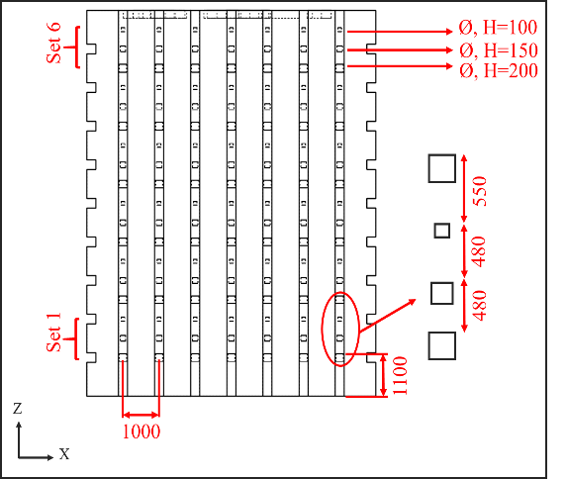
Figure A.1: 2D cross-sections of samples showing the distribution of the artificial voids in samples: (a) R2 which is including 6 similar sets of three sizes of defects (Ø, H = 200 μm, Ø, H = 150 μm, and Ø, H = 100 μm) [42] (Published under an open access CC BY 4.0 license)

Design of sample R3
R3 included 3 similar sets of six sizes of defects (the diameter: Ø = 320 µm, Ø = 280 µm, Ø = 240 µm, Ø = 200 µm, Ø = 160 µm, and Ø = 120 µm and the height: H = 200 µm), as shown in Figure A.2.
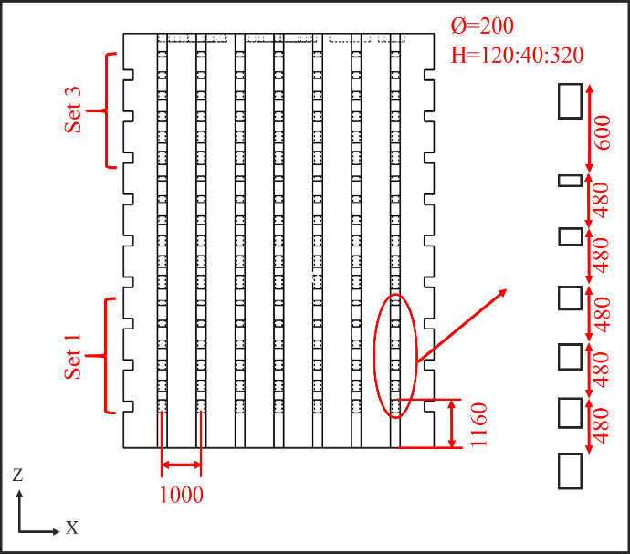
Figure A.2: R3 which is including 3 similar sets of six sizes of defects (the diameter: Ø = 320 μm, Ø = 280 μm, Ø = 240 μm, Ø = 200 μm, Ø = 160 μm, and Ø = 120 μm and the height: H = 200 μm)[42] (Published under an open access CC BY 4.0 license)

Design of sample R4
R4 included 6 similar sets of three sizes of defects (Ø = 200 µm, Ø = 150 µm, and Ø = 100 µm), as shown in Figure A.3.
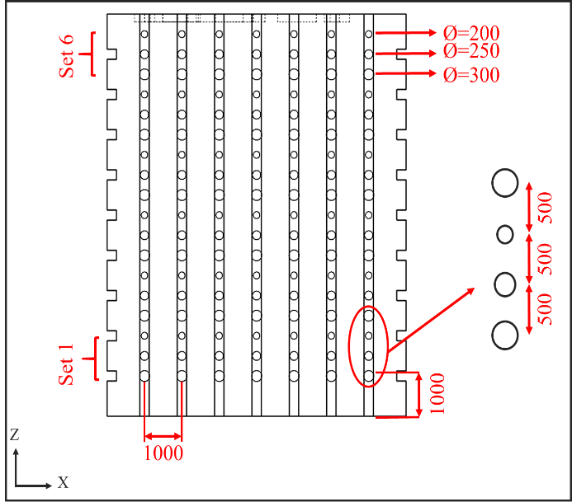
Figure A.3: 4 which is including 6 similar sets of three sizes of defects (Ø = 300 μm, Ø = 250 μm, and Ø = 200 μm) [42] (Published under an open access CC BY 4.0 license)

Location of samples in the build plate
Samples R2, R3, and R4 were printed eight times at different locations of the build plate with respect to the direction of the gas flow and the re-coater, as demonstrated in Figure A.4.
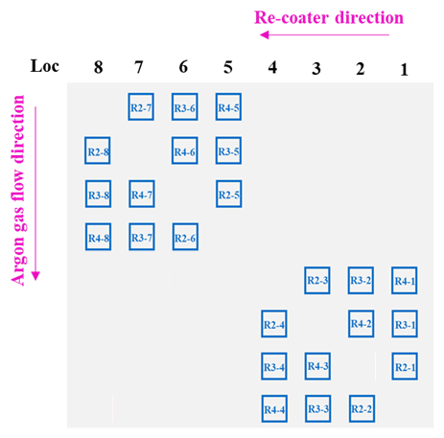
Figure A.4: Samples R2, R3, and R4 layout on the build plate in eight different locations [42] (Published under an open access CC BY 4.0 license)

