Protective efficacy of Zika purified inactivated virus vaccination during pregnancy in marmosets
In-Jeong Kim^{1*}, Olga Gonzalez², Michael P. Tighe¹, Paula A. Lanthier¹, Madeline J. Clark¹, Kelsey L. Travis¹, Kathleen G. Lanzer¹, Derek T. Bernacki¹, Frank M. Szaba¹, Rafael A. De La Barrera³, Vincent Dussupt^{4, 5, 6}, Letzibeth Mendez-Rivera^{4, 5, 6}, Shelly Krebs^{4, 5, 6}, Corinna N. Ross², Stephanie D. Mdaki^{2†}, Kathleen M. Brasky², Donna Layne-Colon², Suzette D. Tardif ², Stephen J. Thomas⁷, Kayvon Modjarrad⁴, Marcia A. Blackman¹, and Jean L. Patterson^{2*}

Methods

Purification of human polyclonal immunoglobulin G from vaccinees and normal donors
Serum samples from flavivirus naïve individuals having received three ZPIV immunizations were selected based on high ZIKV neutralizing antibody geometric mean titers³². Samples from two study visit days (252 and 308), one- and three-months post third ZPIV dose, respectively, from 19 individual donors, were heat-inactivated, centrifuged at 20,000×g for 5 min and pooled. Normal human serum was obtained commercially (Sigma, H4522) and was confirmed negative for ZIKV neutralization. All materials were diluted 10:1 with 10X PBS pH7.4 and loaded on custom Protein G Sepharose (Cytiva, 17061801) columns by recirculating the flow-through up to four times. After extensive washes in 1X PBS pH 7.4, bound IgG were eluted with 0.5M Acetic Acid, pH 3.0, quickly neutralized with 3M Tris, concentrated and buffer exchanged to 1X PBS pH7.4 and sterile filtered. Quantitation of material was performed on a Nanodrop spectrophotometer using IgG setting. Purity was assessed by SDS-PAGE and identity confirmed by western blot (Figure S2). Endotoxin levels were measured using a LAL assay (Lonza). Purified materials were functionally tested for ZIKV neutralization (Table S1).

Passive transfer of hu-pIgG in marmoset during pregnancy
Three female marmosets between 2-2.5 years old were enrolled for the study and cared for the same as the marmosets for the vaccine study as described in the Materials and Methods. At egd 65, two females were sedated and intravenously infected with a single dose of 25 mg hu-pIG on day 0, egd 65 or one female was injected with two doses of 20 mg at egd 65 and 69. Two hours after antibody transfer, the marmosets were intramuscularly inoculated with 2.5 x10⁵ PFU of ZIKV-BR twice at egd 65 and 69. At 14 dpi (edg 79), females were sedated with ketamine (15mg/kg IM) and euthanized for further examination as described elsewhere in the Materials and Methods.

Results
Polyclonal human immunoglobulin G used for the passive transfer study was prepared as described in Materials and Methods. The quantitative and qualitative characteristics of the purified IgG are indicated in Table S1 and figure S1.
Table S1. Summary IgG Purification from ZPIV vaccinees and normal donors
Donor | Conc. (mg/ml) | Volume (ml) | Total Conc. (mg) | Endotoxin (EU/ml) | ZIKV MN₅₀ titer
ZPIV vaccinees | 47.7 | 7.0 | 333.9 | 0.078 | 16,674
Normal | 47.6 | 9.9 | 471.24 | 0.145 | <10

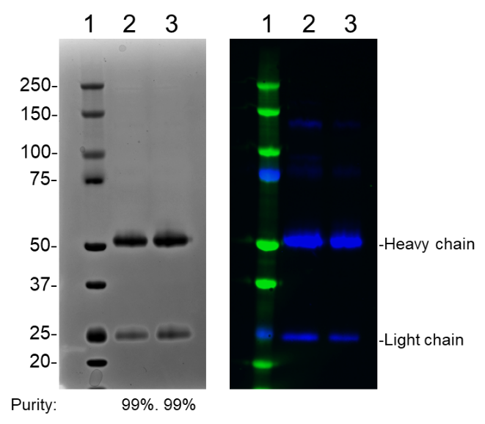
Figure S1. SDS-PAGE analysis of purified materials.
IgG purified from sera from ZPIV vaccinees (lane 2) and normal human (lane 3) were analyzed by SDS-PAGE in reduced condition for total protein: Coomassie stain (left) and western blot for human IgG (right). Lane 1 indicates molecular weights (kDa) of the protein marker.

Passive antibody transfer fails to protect marmosets against ZIKV infection
Maternal antibodies transferred through breast-feeding can protect newborns who are at high risk for ZIKV infection and developing CZS because their immunity is not yet fully developed^{1,2}. We examined whether passive transfer of hu-pIgG into pregnant marmosets was protective against ZIKV infection. Based on the results of the mouse study, the minimum dose required for complete protection is 1 mg dose, equivalent to 37 mg kg⁻¹ body weight. Two pregnant marmosets (pIgG1 and pIgG2) received a single dose of 25 mg (eq. 50 mg kg⁻¹ body weight) (figure S2, A). Despite different treatments, viral RNA copies in maternal lymph nodes were similar with the untreated controls (ZVC1 and ZVC2), suggesting that the virus may shed in lymph nodes (figure S2, B). Viral RNA copies in the placentas and fetal tissues (n=3) of the marmoset, pIgG3, that received two doses of 20 mg were reduced compared with untreated controls but not in the fetal tissues (n=5) of two marmosets that received a single dose of 25 mg (figure S2, C-E). Due to the limited sample size, statistical analysis is not warranted.

Antibody response in the recipients after passive transfer in marmosets
Neutralizing antibody titers in pIgG 3 (log10 MN₅₀, 1.9) remained relatively low than titers of pIgG1 and pIgG2, and the control ZVC2 (log10 MN₅₀ > 3.0) by 9 dpi. However, neutralizing antibody titers in all marmosets became comparable by 14 dpi (figure S3, A) regardless of different treatments, suggesting delayed host antibody response by the passive antibody transfer.
Because of the cross-species reactivity, it was not possible to discern human IgG (adoptively transferred antibody) from marmoset IgG (recipient). We could partially discern the donor and host antibodies based on the time elapsed after antibody transfer and ZIKV infection. Antibodies detected earlier than 5 dpi were likely predominantly donor IgGs, since it is too soon for the recipient to generate detectable primary antibody response, whereas IgG detected after 9 dpi would be predominantly recipient-derived antibody generated by active immunity. Indeed, relatively high IgG levels were detected at day 0, 2 hours after antibody administration prior to ZIKV infection, in pIgG1 and pIgG2 marmosets than pIgG3 marmoset (figure S3, B). However, at 14 dpi, ZIKV-specific IgM titers in the recipients, pIgG 1-3, became comparable with the titers in control ZVC marmosets (figure S3, C). The results suggest that the passive antibody transfer failed to prevent ZIKV infection, and the virus elicited a primary antibody response in the recipients. At least, the recipient received two doses of antibody transfer showed IgG titer close to the limit of detection. Together with reduced viral burden in fetal tissues, these results suggest that higher doses or more frequent administration of the antibody are required to confer protection against ZIKV infection.

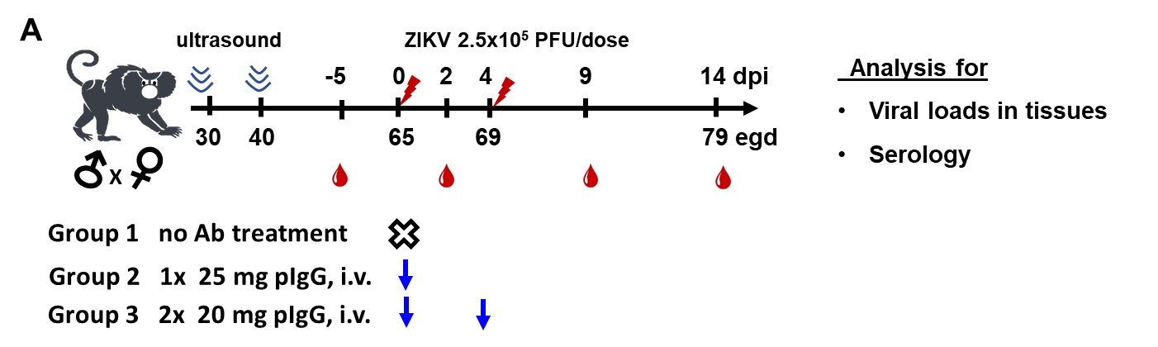

Figure S2. Protective effect of antibody transfer against perinatal ZIKV challenge in marmosets
Two hours prior to ZIKV infection, pregnant marmosets were injected with 0 mg (n=2), a single dose of 25 mg (n=2) and two doses of 20 mg (n=1) at days 0 and 4, estimated gestational day 65 and 69. All marmosets were i.m. injected with 2.5 x10⁵ PFU of ZIKV-BR at egd 65 and 69 and examined at 14 dpi, egd 79. Viral RNA copies were quantified in maternal mesenteric lymph nodes (B), placenta (C), fetal heads (D) and fetal body (E) using qRT-PCR. All individual samples were tested in duplicate reactions. Symbols represent the mean of duplicates per sample. For fetal tissues (D and E), the number of fetuses examined are 5, 5, and 3 per 0 mg, 1x, 25 mg, and 2x, 20 mg treatment, respectively. No statistical difference in viral loads in fetal tissues between untreated and treated groups was detected in D and E (P > 0.05).

Figure S3. Antibody response in pregnant marmosets after perinatal ZIKV challenge
Serum samples prepared at indicated days after antibody transfer were examined for neutralizing activity using a microneutralization assay (A), and ZIKV-specific IgG titers (B), and marmoset IgM titers in the recipients at 14 dpi (C) using Luminex assay. Dotted lines indicate the highest serum dilution 1:5 or 1:10 examined. Based on background signal, MFI values equal to or higher than 120 or 150 were used to determine end-point reciprocal serum titers for IgM and IgG specific for ZIKV, respectively. Due to the limited samples size, statistical analysis is not feasible.

References
1 Mavigner, M. et al. Postnatal Zika virus infection is associated with persistent abnormalities in brain structure, function, and behavior in infant macaques. Sci Transl Med 10, doi:10.1126/scitranslmed.aao6975 (2018).
2 Raper, J. et al. Long-term alterations in brain and behavior after postnatal Zika virus infection in infant macaques. Nat Commun 11, 2534, doi:10.1038/s41467-020-16320-7 (2020).

