APPENDIX
Control palbociclib with fulvestrant
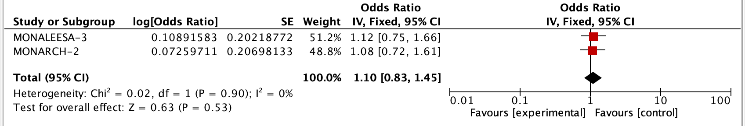
Control palbociclib with AI/tamoxifen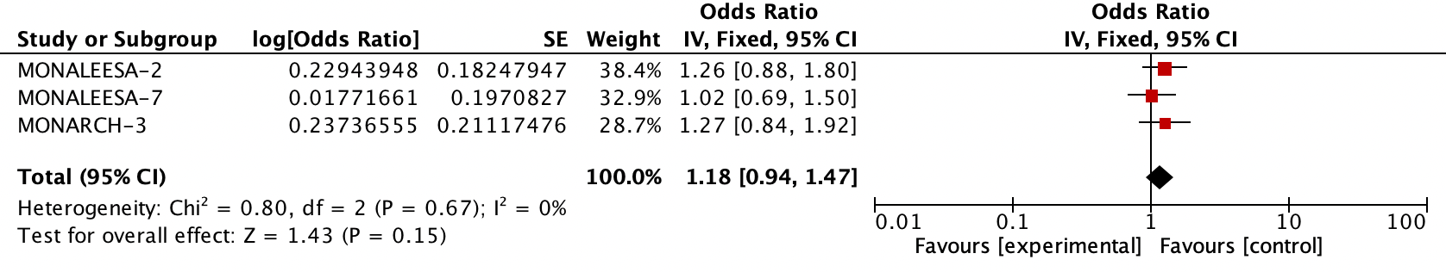
Control ribociclib with fulvestrant
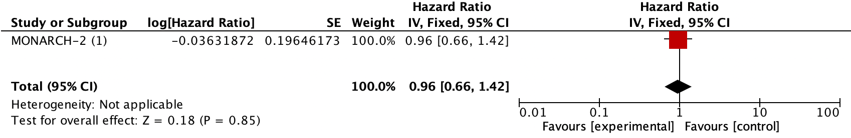
Control ribociclib with AI/tamoxifen
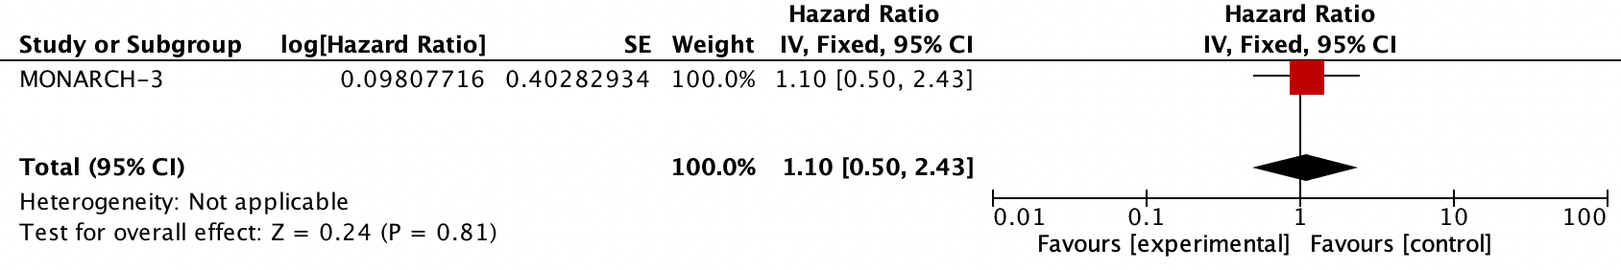
Control abemaciclib with fulvestrant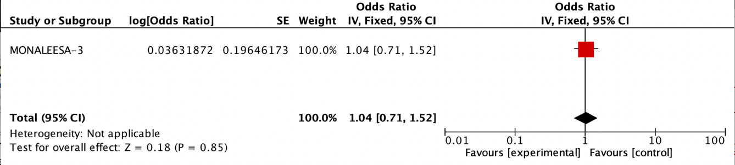

Palbociclib (control) versus Abemaciclib with fulvestrant side effect profile
(MONARCH 2 vs PALOMA-3)
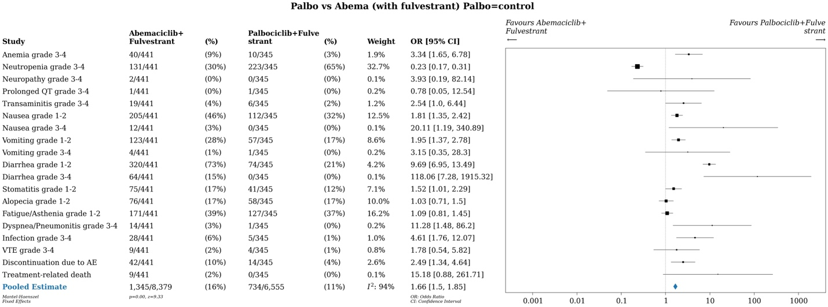

Palbociclib (control) vs Abemaciclib with AI side effect profile
(MONARCH 3 and PALOMA-2)
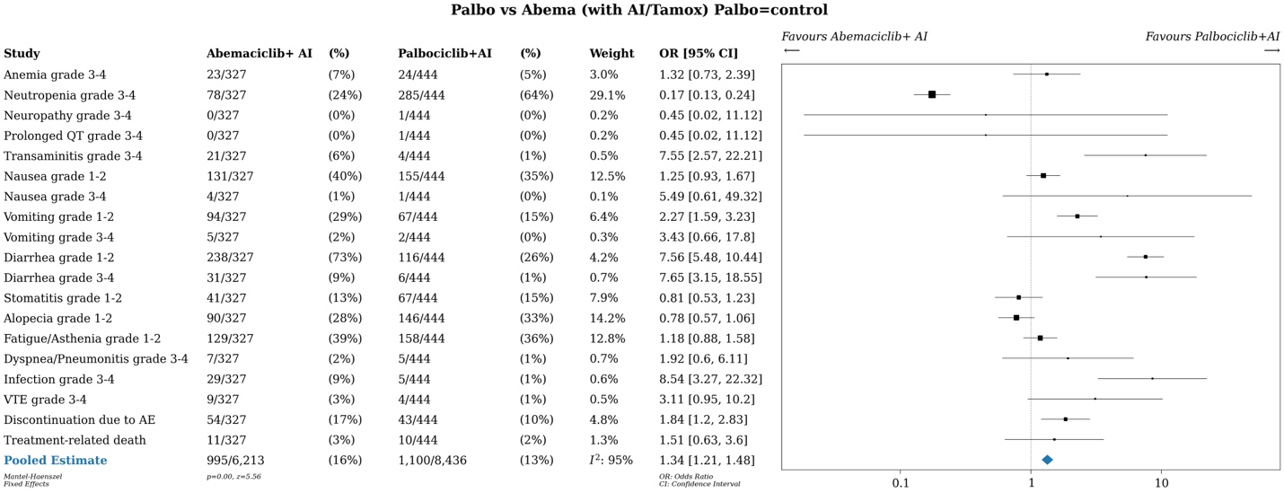

Palbociclib (control) vs Ribociclib with fulvestrant side effect profile
(MONALEESA 3, PALOMA 3)
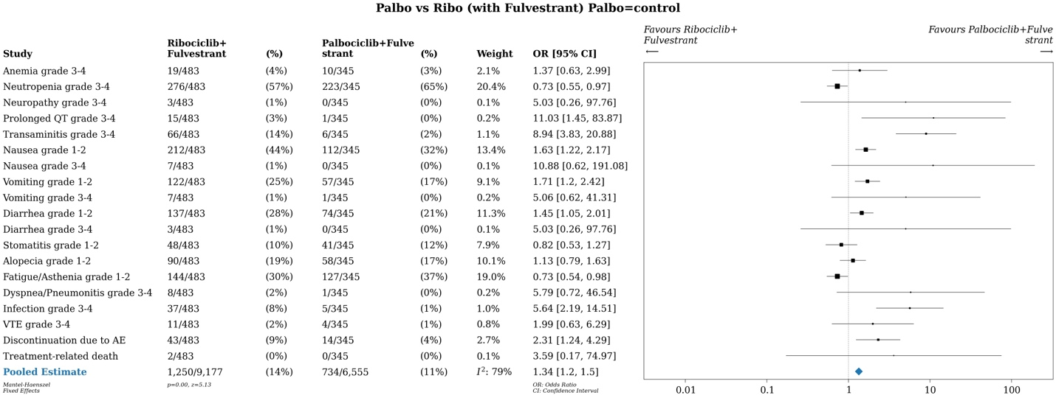

Palbociclib (control) vs Ribociclib with AI/tamoxifen side effect profile (PALOMA-3 vs MONALEESA-2 and -7 (combined))
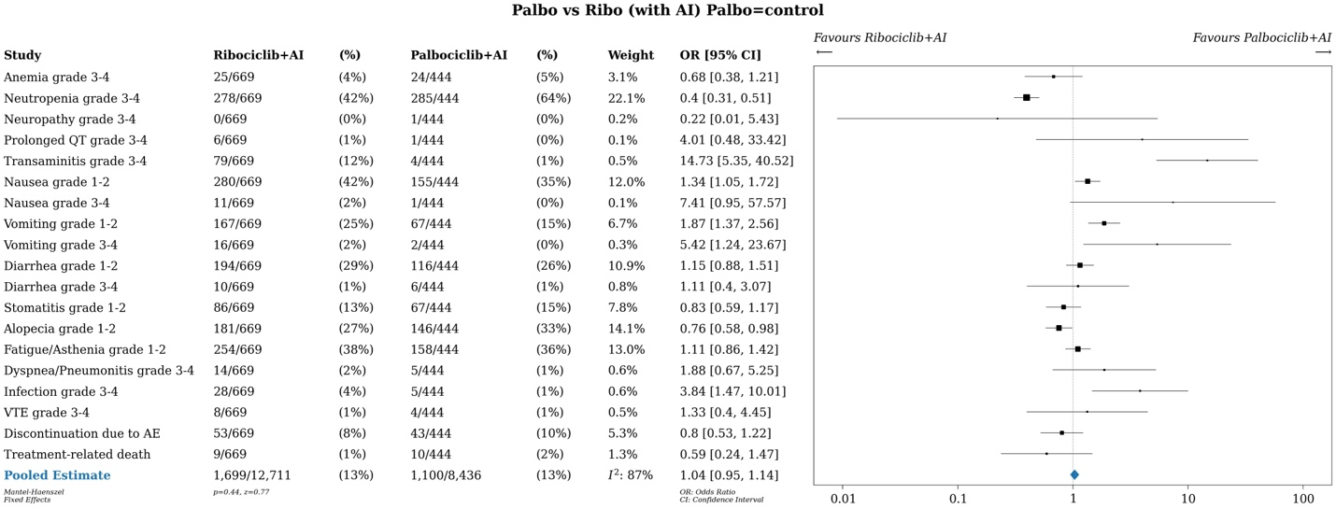

Ribociclib (control) vs Abemaciclib with fulvestrant side effect profile
(MONALEESA 3, MONARCH 2)
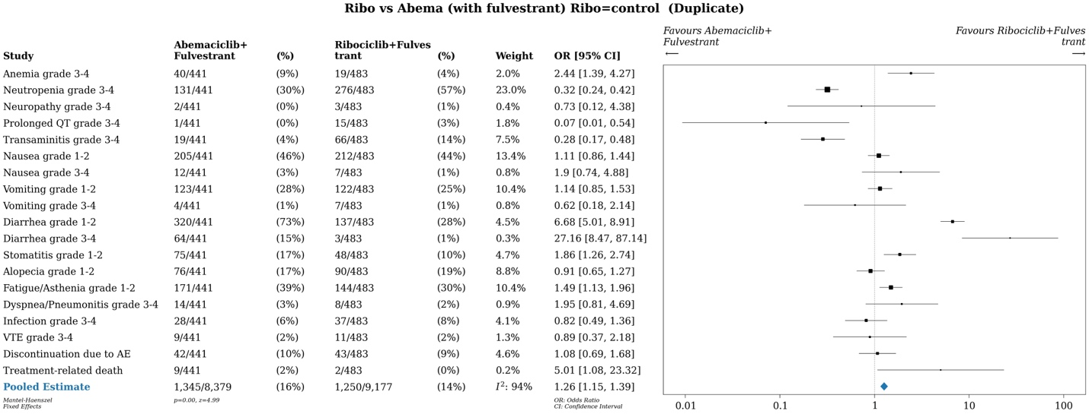

Ribociclib (control) vs Abema with AI/tamoxifen side effect profile
(MONARCH 3 vs MONALEESA-2 and -7 (combined))
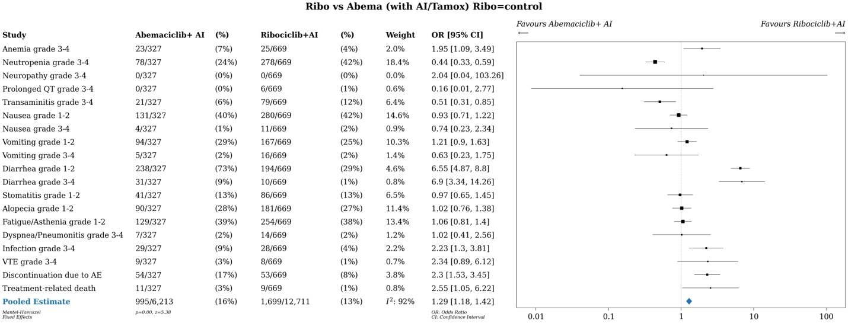

Ribociclib (control) vs Abema discontinuation
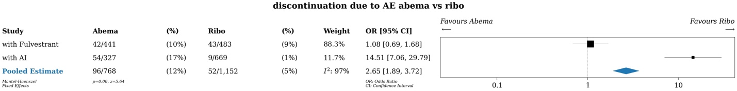
Ribociclib (control) vs Abema death due to AE
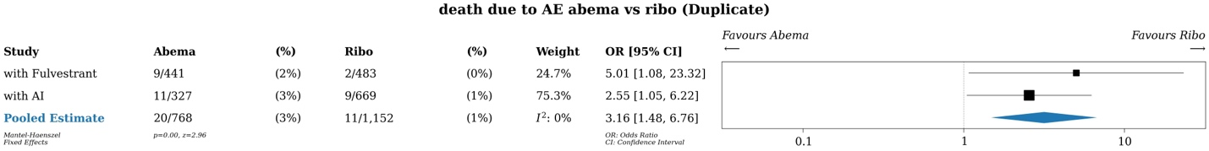

Palbociclib (control) vs Ribo discontinuation
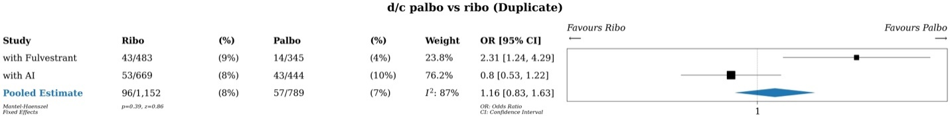

Palbociclib (control) vs Ribo death due to AE
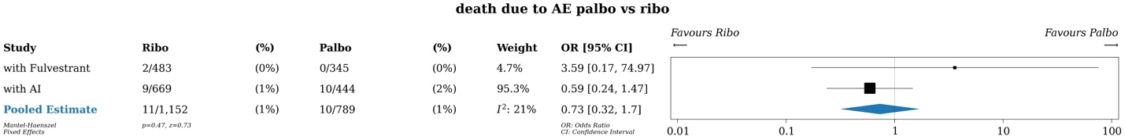

Palbociclib (control) vs Abema discontinuation
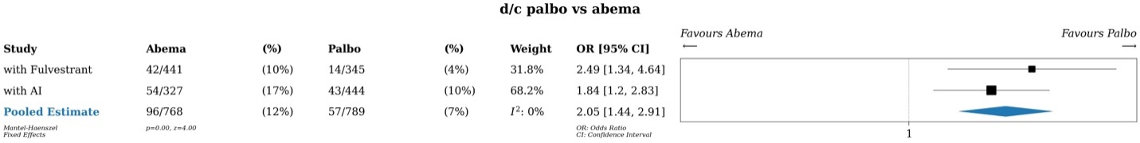
Palbociclib (control) vs Abema death due to AE
