Zika purified inactivated virus (ZPIV) efficacy in pregnant human stat 2 knock-in mice: Neutralizing antibodies as correlates of protection
In-Jeong Kim^{1*}, Michael P. Tighe¹, Paula A. Lanthier¹, Madeline J. Clark¹, Rafael A. De La Barrera², Vincent Dussupt^{3,4,5}, Letzibeth Mendez-Rivera^{3,4,5}, Shelly J. Krebs^{3,4,5}, Kelsey L. Travis¹, Timothy C. Low-Beer¹, Tres S. Cookenham¹, Kathleen G. Lanzer¹, Derek T. Bernacki¹, Frank M. Szaba¹, Amanda A. Schneck¹, Jerrold Ward⁶, Stephen J. Thomas⁷, Kayvon Modjarrad³, and Marcia A. Blackman¹

Materials and Methods

Purification of human polyclonal immunoglobulin G from vaccinees and normal donors
Serum samples from flavivirus naïve individuals having received three ZPIV immunizations were selected based on high ZIKV neutralizing antibody geometric mean titers¹⁵. Samples from two study visit days (252 and 308), one- and three-months post third ZPIV dose, respectively, from 19 individual donors, were heat-inactivated, centrifuged at 20,000×g for 5 min and pooled. Normal human serum was obtained commercially (Sigma, H4522) and was confirmed negative for ZIKV neutralization. All materials were diluted 10:1 with 10X PBS pH7.4 and loaded on custom Protein G Sepharose (Cytiva, 17061801) columns by recirculating the flow-through up to four times. After extensive washes in 1X PBS pH 7.4, bound IgG were eluted with 0.5M Acetic Acid, pH 3.0, quickly neutralized with 3M Tris, concentrated and buffer exchanged to 1X PBS pH7.4 and sterile filtered. Quantitation of material was performed on a Nanodrop spectrophotometer using IgG setting. Purity was assessed by SDS-PAGE and identity confirmed by western blot (Figure S2). Endotoxin levels were measured using a LAL assay (Lonza). Purified materials were functionally tested for ZIKV neutralization (Table S1).
Results
Polyclonal human immunoglobulin G used for the passive transfer study was prepared as described in Materials and Methods. The quantitative and qualitative characteristics of the purified IgG are indicated in Table S1 and figure S1.
Table S1. Summary IgG Purification from ZPIV vaccinees and normal donors
Donor | Conc. (mg/ml) | Volume (ml) | Total Conc. (mg) | Endotoxin (EU/ml) | ZIKV MN₅₀ titer
ZPIV vaccinees | 47.7 | 7.0 | 333.9 | 0.078 | 16,674
Normal | 47.6 | 9.9 | 471.24 | 0.145 | <10

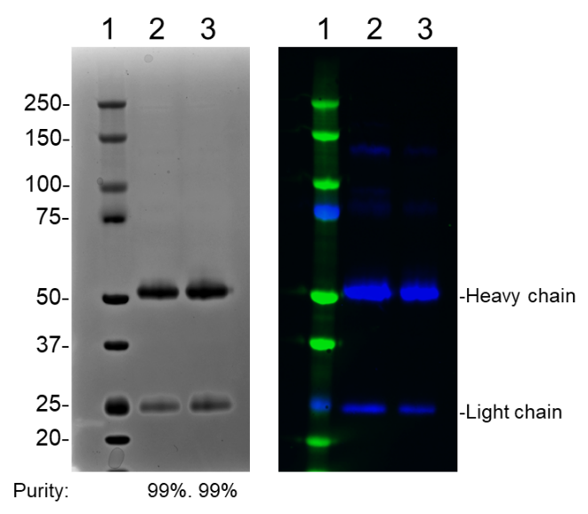
Figure S1. SDS-PAGE analysis of purified materials.
IgG purified from sera from ZPIV vaccinees (lane 2) and normal human (lane 3) were analyzed by SDS-PAGE in reduced condition for total protein: Coomassie stain (left) and western blot for human IgG (right). Lane 1 indicates molecular weights (kDa) of the protein marker.

